Touch Screen
Product ID: touch screen
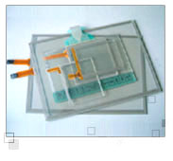
Cost effective solution and easy to use resistive touch screen technology,
which can be operated in commercial, medical or industrial applications
and children's toys. We offer digital,analog and capacitivetouch screens.
Specifications:
- Matrix Type
  - -Operation Voltage：DC5V
- -Activation Force：10g~100g
- -Surface Hardness：3H
- -Operating Humidity：15%~85%RH
- -Operation & Storage Temp：-20~+70 degree
- -Structure： Film +Film /Film + Glass /Film + Film + Glass
- -Various Standard Sizes： 1.4"~21"
- -Finger Touch：1 Million touches(For 4 Wire &Matrix)
- -Finger Touch：35 Million touches (For 5 Wire)
- -Transparency：82+/-5%
- -Linearity：1.5% less (Analog)
- -Pen Hitting：100,000 touches
- -Contact Bounce：5ms
  - Capacitive Type
    - -Operation Voltage:DC5V
  - -Size Range: 5"~21"
  - -Activation Method: Finger
  - -Activation Force: 90%(AR coating finished)
  - -Operation Temp: -20 ~ +70 degree (20%RH ~ 85% RH)
  - -Storage Temp: -40 ~ +85 degree (10%RH ~ 90% RH)
  - -Constant Temperature / Humidity:70 degree
  - (90%RH,1500hrs )
  - -Surface Hardness: >7H
  - -Life Time: 200 million touches
Features:
.Resisitive type/Capacitive type
Main Products:
Membrane Swtiche, Touch Screen, Silicone Rubber
http://www.spectrah.com/product/touch_screen_resistive_4_wire_touch_screen_tr4_series/resistive_4_wire_touch_screen_catalog.pdf

http://www.elcomdesign.com/contact-us.htm

Spectrah 4-wire touch products offer customer a wide range of glass size, ease of integration, responsiveness, and high reliability and durability. They are the ideal solution for POS, voting machine, and industrial automation. Spectrah also provides complete signal controllers, cable kits, and excellent technical support to help customers easily integrate touch panel in the display systems.

Resistive 4-wire Touch Screen TR4-03811030 (Size: 3.8”, Frame Size: 95mm x 69.5mm)

Resistive 4-wire Touch Screen TR4-05714050 (Size: 5.7”, Frame Size: 132.5mm x 104.7mm)

Resistive 4-wire Touch Screen TR4-06414082 (Size: 6.4", Frame Size: 146.90mm x 117.20mm)

Resistive 4-wire Touch Screen TR4-07014030 (Size:TBD)

Resistive 4-wire Touch Screen TR4-08414055 (Size: 8.4", Frame Size: 188.9mm x 141.7mm)

Resistive 4-wire Touch Screen TR4-10414055 (Size: 10.4”, Frame Size: 225.4mm x 174.0mm)

Resistive 4-wire Touch Screen TR4-12114055 (Size: 12.1”, Frame Size: 263.0mm x 199.0mm)

Resistive 4-wire Touch Screen TR4-305814061 (Size: 5.88", Frame Size: 140.00±0.30mm x 104.00±0.30mm)

Resistive 4-wire Touch Screen TR4-310319056 (Size: 10.39", Frame Size: 225.21±0.38mm x 171.59±0.38mm)

Resistive 4-wire Touch Screen TR4-405714050 (Size: 5.7”, Frame Size: 132.5mm x 140.7mm)

Resistive 4-wire Touch Screen TR4-406414035 (Size: 6.4”, Frame Size: 142.0mm x 110.6mm)

Resistive 4-wire Touch Screen TR4-407014070 (Size: 7.0”, Frame Size: 165.0mm x 104.0mm)

Resistive 4-wire Touch Screen TR4-408414050 (Size: 8.4”, Frame Size: 186.2mm x 142.0mm)

Resistive 4-wire Touch Screen TR4-410414050 (Size: 10.4”, Frame Size: 225.3mm x 174.0mm)

Resistive 4-wire Touch Screen TR4-412114150 (Size: 12.1”, Frame Size: 261.4mm x 198.8mm)
http://www.allproducts.com/computer/onetouch/capacitive_touch_screen_t01.html
http://picinf.blogspot.com/2010/03/multiplexed-led-display-4-digit-with.html

VB6 RS-232 serial communication example program
Many student asked for VB6 program for serial communication.
This is a short lesson or tutorial on the development of your own application program for computer to send and recive data from microcontroller (any, the microcontroller side program is not discussed here).
What you need is written in steps;
Step # 1:
You need a computer with visual basic 6 plat form installed on it.
Open the VB6 application from programs to write a code.
You will notice following message on screen, choose Standard exe and press OK,( This is default)
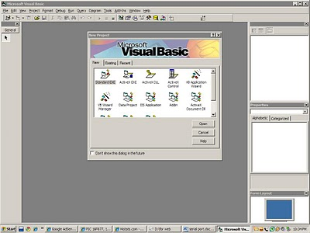STEP#2:
Here a form is open, you will need to add a component required for serial communication. Normally it is not visible in tools and we have to bring it in tools from components. This VB6 library built in.
1. right click on the bar of tools available for you to use on left side of the application and press add components. OR
2. Press control+T to open the component window OR
3. Go to project menu and click on components
By using either way , you will open the component window as shown below.
Now Find "Microsoft comm control 6" and check the option and press "OK"
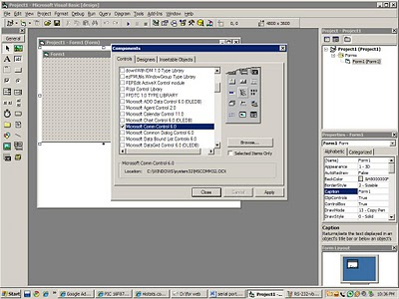STEP#3
Place the texts boxes and command buttons by drag and drop method from tool bar. Resize them. and make the form as shown in the figure below.
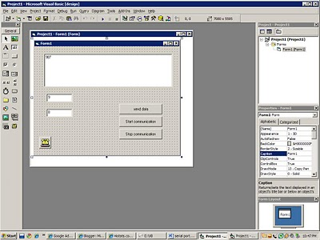STEP#4
copy the following code and paste it in the code section and compile , run it.
You can receive the byte stream of any length. the incoming string will be shown in text1. Then i have use Mid function to split the string to acquire one byte and then shown in the other text boxes.
In this program i have send only one byte , but you can send as many as you wish.
The com setting is 9600,N,8,1 mean baud rate is 9600, the byte will of 8 bits and one stopping bit and now parity bit is used ion this communication. Make you micro controller set accordingly.
Enjoy it, if you want to ask any questions , please write in comments. I will check and answer them.
Option Explicit
Dim strInBuff as String ' The incoming data from the serial port will be stored in this string
Dim temp1 as Integer ' The only one parameter in this program you will send out from PC
Private Sub Form_Load()
With MSComm1
.CommPort = 1
.RThreshold = 1
.RTSEnable = True
.Settings = "9600,N,8,1"
.InputLen = 127
.SThreshold = 1
' .PortOpen = True
End With
temp1 = 100 ' You can declar and use as many varaible whose value is required to send from ' 'PC but here as only one is required , so i have declared only one.
End Sub
'When some data is recived in the serial port of the PC (computer) the following function will be excecuted
Private Sub MSComm1_OnComm()
' Different events are occured , when data come , these includes some errors also (if they occur in communication, but normally RS-232 have not problems)
Select Case MSComm1.CommEvent
' Errors
Case comEventBreak
Case comEventCDTO
Case comEventCTSTO
Case comEventDSRTO
Case comEventFrame
Case comEventOverrun
Case comEventRxOver
Case comEventRxParity
Case comEventTxFull
Case comEventDCB
' Events
Case comEvCD
Case comEvCTS
Case comEvDSR
Case comEvRing
Case comEvReceive
' The data (incoming from outside world to PC through RS-232 port is stored in
''MSComm1.Input , which is a string, each time we read from this
strInBuff = MSComm1.Input
' after reading it requires free from any data, otherwise all the data will be gathhered and it will
'overflow, result in runtime error
MSComm1.Input = ""
Text1.text = strInBuff ' what ever we get is displayed in a text
Text2.text = Asc(Mid(strInBuff , 1, 1)) ' getting one byte and speratly displaying in other
'text for other possible use, for this MID function is used
Text3.text = Asc(Mid(strInBuff , 2, 1))
Case comEvSend
Case comEvEOF
End Select
End Sub
' if you wish to send a byte to microcontroller from pc, then use following code, and in the same
'way using loop or other methods you can send more bytes, if u need??
Private Sub Command3_Click()
MSComm1.OutBufferCount = 0
MSComm1.Output = Chr$(temp1)
End Sub
' opening the com port for communication with microcontroller or other world
Private Sub Command1_Click()
If (MSComm1.PortOpen = False) Then
MSComm1.PortOpen = True
End If
End Sub
' closing the com port if its no need for further communication
Private Sub Command2_Click()
If (MSComm1.PortOpen = True) Then
MSComm1.PortOpen = False
End If
End Sub
' at the form closing or exit or unloading, again port is rechecked, if it is open then it will close 'now, for the use of any other program
' This important, and many user or programmer forget this point. otherwise you will need to 'restart the computer for again use of this serial port even in this program or any other program.
Private Sub Form_Unload(Cancel As Integer)
If (MSComm1.PortOpen = True) Then
MSComm1.PortOpen = False
End If
End Sub
8051 Project, 8051 projects,ADC0804,adc0808,adc0809,microcontroller projects, at89c51 projects, 8051 serial port communication

