CONTENTS

- ABSTRACT
- INTODUCTION
- HISTORY
- PURPOSE OF INVENTION
- DESGIN CONSIDERATION
- WORKING OF FPP
- ADVANTAGES
- DISADVANTAGES
- FUTURE OF FPP
- CONCLUSION
- REFERENCES

FLOATING POWER PLANT

1.0 ABSTRACT

The Inventor of floating power plant equipment had the privilege, after years of work on big and Voluminous rivers in the North of Brazil, to analyze the behavior of river water, with respect to the velocity and force of the water, in times of flood and drought. Also to acquire sufficient knowledge of and reconcile the potential energy of the river water, This is studied by the means of the mechanics of fluids and mechanical engineering. This resulted in the design of a Floating power plant with equipment capable of generating electric energy on a large scale without prejudicing in any way the environment or the Region in which the invention may be installed. Innumerable possibilities were explored. By the application of invention as well as the benefits which would be brought to society on the whole. With the birth of this idea he commenced Gathering resources to place invention into practice.

Later prototypes were built and installed in the course of a small river close to the city of Belo Horizonte. These inventions will REVOLUTIONIZE ON A WORLD WIDE BASIS THE METHODS UTILIZED IN THE GENERATION OF ELECTRIC ENERGY. Soon after the installation of Floating Power Plant in the seas and oceans saw daylight in order to harness the abundant energy in them through tides and waves.

This seminar report takes you through the history of evolution of Floating Power Plant, an introduction to how an FPP works and its future.

- INTRODUCTION
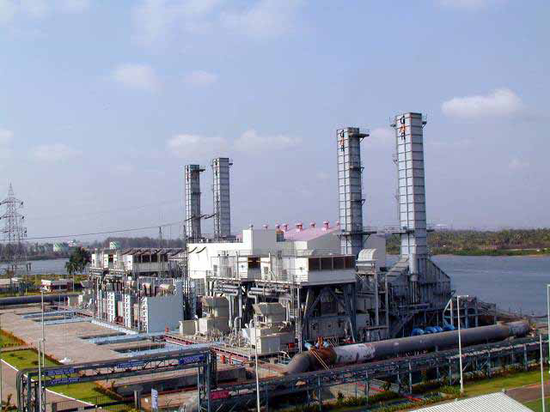

A floating power plant includes a hull having a structure suitable for being movable at sea; A plurality of watertight bulkheads placed in the hull to a height of a freeboard deck, thus partitioning the interior of the hull into a plurality of watertight chambers; A power generating equipment for generating electricity, the power generating equipment including a plurality of parts separately installed in the watertight chambers; and a duct arranged to pass over the freeboard deck to couple the parts of the power generating equipment installed in the watertight chambers to each other. The floating power plant can economically supply electricity to a specific district or to a specific facility that temporarily uses electricity, and can minimize limitations caused by environmental regulations, and can be used as an emergency electric power source. A Floating power plant is one which works both on wind and wave power.

Generally, power plants comprise equipment for converting thermal energy or mechanical energy into electrical energy, rotate a turbine using an energy source, such as water, oil, coal, natural gas, or nuclear power, and generate electricity using a power generator connected to the turbine. Such power plants have typically been classified into water power plants, steam power plants, nuclear power plants, etc. according both to the kind of energy source used in the power plants and to the power generation method. Furthermore, tidal power plants, using tidal energy, wind power plants, using wind energy, geothermal power plants, using subterranean heat energy, solar power plants, using solar energy, and magneto-hydrodynamic (MHD) power plants, using magneto-hydrodynamic energy have been actively studied in recent years for practical use thereof as power plants in the future.

Furthermore, in the case of a specific district, where a great quantity of electricity must be temporarily used, or of a district under development, which requires a great quantity of electricity, it is necessary to build a new power plant at the district to meet the electricity requirements of the district because there is no alternative plan. However, the installation of a new power plant in such a district must be accompanied by high investment and time consumption. Furthermore, if the amount of electric power consumption is remarkably reduced, or if the facilities using the electricity are removed, so that the use of electricity is discontinued, the power plant built in the specific district suffers from economic inefficiency.
In an effort to solve the problem, electricity may be supplied to the specific district by extending the existing electric power supply network. However, the extension of the power supply network limits the quantity of electricity that can be supplied to a district.
Waller Marine has played an important role in the reintroduction of the Floating Power Plant (FPP) since the late 1980’s when the Company was asked to inspect the power barge “Impedance”; a barge constructed with steam generating technology that was first used in the Philippines by the US Army in 1940.Since that time, Waller has been involved in development, design, construction and operations of numerous power barge projects using all available generating technologies, different fuels and cooling systems.

3.0 History

Floating power plants have been around for a long time. In fact, one of the early units, the 30MW "Impedance" is still in operation drawing board. Why the renewed interest in FPPs these past 15 years? The initial answer was the need to install fast, reliable capacity in countries experiencing severe capacity shortages.

Countries in South East Asia, particularly the Philippines, South America and the Caribbean found themselves desperately short of power as their economies expanded. This situation was due in large part to the long neglect of utility infrastructure and lack of funding for such projects. Consequently, state-owned electrical utilities turned to the private sector for a quick fix and external Build-Own-Transfer (BOT) contractual arrangements. Many of these contracts were signed with companies that offered power generation barges, one of the few vehicles that would induce commercial financing for power-generating facilities in countries that could not or would not provide sovereign guarantees of payment.

Delivered to the site, the FPP, already tested and ready for operation, required only to be attached to it's moorings, fast track permitting process that mainly considered exhaust and thermal emissions. The need to overcome land use by water borne transport and transfer, eliminating requirements for fuel trucks, pipelines and landslide storage.

FPPs were constructed during a flurry of opportunity in the early 90's using a variety of generating technologies. Since most projects were fuel driven, the availability and cost of heavy fuel oil being prevalent, opportunity was created for medium and slow speed diesel technology, which took the lion's share of all the early FPP projects

In fact one of the earlier units, constructed in 1940 by the US Army Corp of Engineers, a 30 MW steam generation facility and put into service in the Philippines, is still in operation at a site in Ecuador. Since then, the idea has lain dormant; in fact it was not until the early 1990s when acute power shortages were being experienced in several countries in South America and SE Asia that the concept was revisited. This spurred the construction of several power barges designed with medium and slow speed diesel engines burning heavy fuel oil, with installations in Guatemala, Honduras, the Dominican Republic and the Philippines.
Heavy fuels were selected as the fuel of choice mainly due to cost and availability, with consideration being given to simply meeting World Bank emissions standards being made at the time. Single barge designs ranged from 30MW up to100 MW.

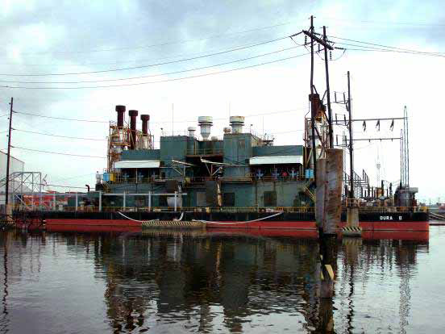
66 MW FPP - Philippines

Shortly thereafter, designers looked to gas turbine generation for mounting on floating structures and a series of power barges were built using industrial turbines with capability to operate on diesel fuel or natural gas. These units found their initial employment in the Philippines, Bangladesh and Kenya, with maximum single barge output of 105 MW.
They have since been moved for service in the Dominican Republic and Ecuador. In the early 2000s, the capacity of the floating power plant was pushed to a much higher level with the design and construction of a 220 MW combined cycle power barge that was installed in India. This barge used aero-derivative gas turbine technology with heat recovery, inlet air chilling and a steam turbine generator producing a highly efficient plant that initially used naphtha as a fuel. Floating power barge designs are now charting new territory with projects on the boards with capacities up to 550 MW using technologies that include combined cycle with industrial and aero-derivative gas turbines and Integrated Gasification combined cycle (IGCC) schemes. Greater consideration is also being given to emissions and different fuels, particularly as the cost of oil increases to higher levels. LNG, CNG and coal fueled projects are now being considered for installation on FPPs.
In 2000, what is currently the largest FPP in the world was installed in Mangalore, on the west coat of India.

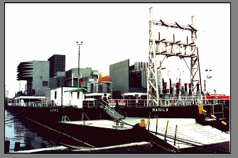
105 MW FPP- Bangladesh

4.0 Purpose of Invention
In recent years, power plants have become recognized as harmful facilities, so it is necessary to pay careful attention to trends of public opinion of local inhabitants or of nongovernmental organizations (NGO), in addition to consideration of the conditions at locations. Thus, the determination of the locations of the power plants may be accompanied by further practical limitations.

Furthermore, in the case of a specific district, where a great quantity of electricity must be temporarily used, or of a district under development, which requires a great quantity of electricity, it is necessary to build a new power plant at the district to meet the electricity requirements of the district because there is no alternative plan. However, the installation of a new power plant in such a district must be accompanied by high investment and time consumption. Furthermore, if the amount of electric power consumption is remarkably reduced, or if the facilities using the electricity are removed, so that the use of electricity is discontinued, the power plant built in the specific district suffers from economic inefficiency. In an effort to solve the problem, electricity may be supplied to the specific district by extending the existing electric power supply network. However, the extension of the power supply network limits the quantity of electricity that can be supplied to the district.

Accordingly, the present invention has been made keeping in mind the above problems occurring in the related art, and an object of the present invention is to provide a floating power plant, which does not require separate adjacent piers for the supply of generating fuel or separate flumes for water, but is freely movable on the sea.

Another object of the present invention is to provide a floating power plant, which can economically supply electricity to a specific district or to a specific facility that temporarily uses electricity, and which minimizes the limitations caused by environmental regulations, and can be used as an emergency electric power source.

5.0 Design Considerations

The design of an FPP marries the engineering protocols of the Marine and Power Generation Industries. It operates like a ship at sea only requiring fuel for it’s generating machinery. The FPP is not designed to sit in waters that are aggravated by waves however, that make it move like a vessel at sea, but rather they are designed for service in protected inland waters such as rivers, lagoons, or ports.

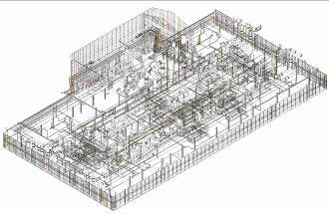
Internals of a 220 MW FPP

The barge, constrained in its moorings, can thus move vertically with the tides, river levels or storm surges, without any rotational motion. The overall design and construction process are reviewed and surveyed by third party organizations, the international Classification Societies, such as Lloyds Register, the American Bureau of Shipping and others, that not only ensure engineering compliance with Class Rules, but also compliance with international protocols concerning pollution and emissions. The completed vessel receives a Classification as a “Power Barge”.

The power barge is the integration of the technical elements of two industries, marine and power generation. While diesel engines have been installed on ships for electrical generation and propulsion since the diesel engine was invented, this is not generally the case for the gas turbine, particularly the industrial gas turbine, for which special consideration is needed for hull and foundation loading, stress and vibration.

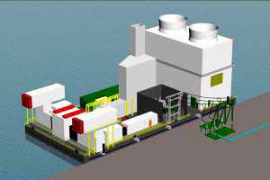
80 MW FPP
However with modern structural marine engineering and construction capabilities coupled with and understanding of power generation concepts, the two industry technologies can be fully integrated to perform their intended functions while a float.

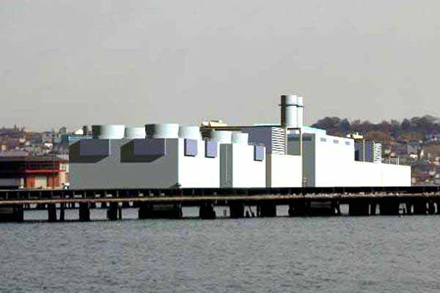
530 MW FPP

6.0 Working of a FPP
The structure of this invention boils down to being a floating platform and a rotor with blades placed around the diameter. These blades are staggered in alternate rows and placed in a transverse section of the river.

The floating platform, which we also call a float, has various functions:
1) It is equipped with submerged lateral guides to direct the river water, forming a channel and forcing the river water against the rotor and the blades of the turbine, exerting on it, a constant pressure, causing the turbine to rotate because of the volume of water.
2) It permits the adjustment of the height of the equipment above the surface of the river.
3) It has in its construction slip bearings that permit the adjustment of the depth of immersion of the turbine in the river.
4) It permits the movement of all of the equipment on the surface of the river.
5) It is fitted with equipment that permits it to be in its operating position.
6) Owing to its great size it works as a counter weight, stabilizing the unit.
7) It prevents undesirable materials from entering the rotor of the turbine.
8) It has automatic adjustments in case there are variations in the water level.

In the first stage, it is shown by means of a diagram and a photograph of the prototype, a floating turbine on the surface of the river without the blades being submersed in the water.
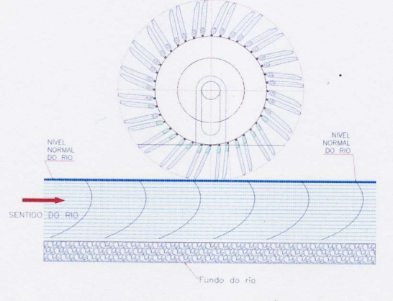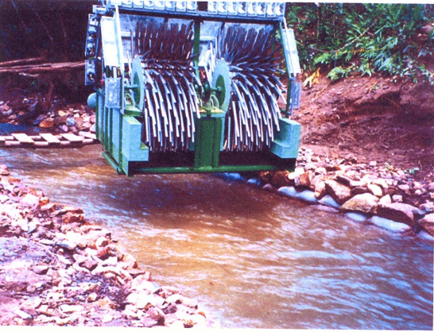

Normal level of River – Flow of River – River Bed, (Fig 1)

Points that must be observed in the illustrations and photograph of the prototype are,
1) Rotor of the turbine above the surface of the river.
2) River water in its normal course without alterations.
3) The velocity of the river without interference

For the second stage of this process we will immerse the floating turbine in the river, where we will describe the behavior of the water, utilizing the amount of water available in the river, the velocity of the water and the changes that will occur according to the depth utilized and occupied by the turbine.

On immersing the equipment, we notice that the first change is nothing more than the displacement of river water proportional to the mass of the floating turbine in its physical space. It is important that this displacement occurs because the volume of the river water flowing continues in its bed, taking its natural course, will encounter the turbine and part of this volume will be temporarily held up, and there will be a small elevation of the level of the water dammed in front of same. Until there is an equilibrium between the volume which is exerting pressure on the blades, (volume on entry), and the volume which is exerting pressure on the body and blades of the turbine (volume on exit) there will be an increase in the velocity of the river water.

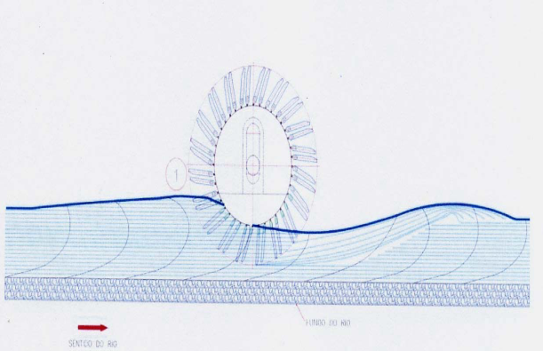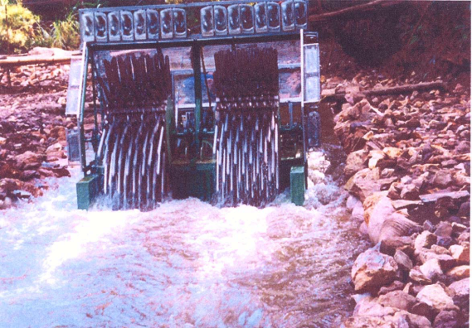
Photograph of the front of the prototype with two turbines. (Fig 2)

Apparently we will not perceive great changes in the river, but if we do a better analysis of the above diagram, we will see a line on the surface of same, or further, a change in the behavior of the river. In position Fig2 we will see the beginning of a percentage of the water being dammed in front of the turbine. The reason for this is due to a reduction in the velocity of the water in front of the turbine as a result of the cross section occupied by the blades, which are submersed, holding up the normal flow of river water in the same bed as before but without obstructions.
As an aside, we can diminish the length of the blades and increase the diameter of the body of the turbine, where we will see an even greater displacement of river water, because of an increase in the mass of the turbine. It can be shown that various alternatives in the construction of floating power stations, as well as total control with regard to the use of water to generate electric energy.
Following the displacement of water, let us describe the functioning of the blades on the body of the turbine, as well as their movement within the water.

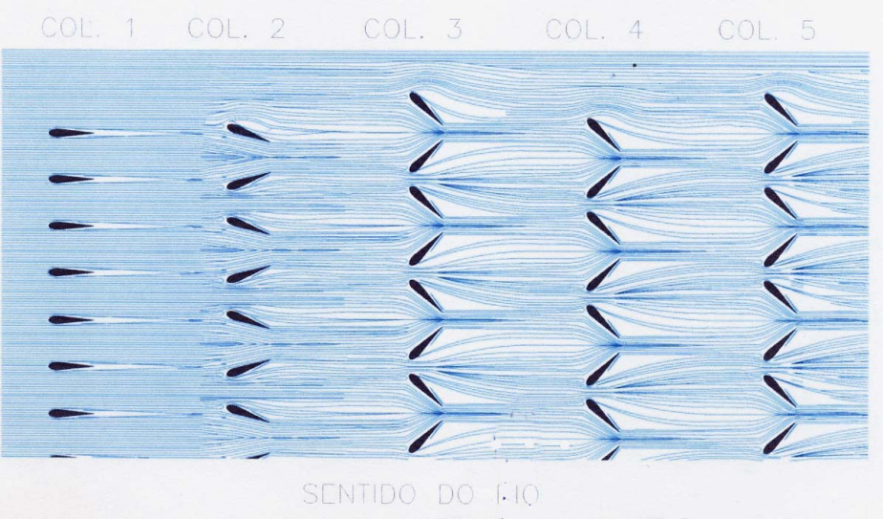

When a turbine starts rotating propelled by the pressure exerted by the river water, the First row of blades to enter the river must be in the position shown in column 1, cutting the water and thus avoiding a natural braking imposed by the water. In columns 3, 4 and 5 showing the 4 positions that the blades must acquire as a result of the turbine revolving on its axle during rotation. These blades have their own axles, coupled devices, that permit us to control all the rotary movements about its own axle, closing them to increaser the area of contact with the water of the river, as well as opening them, when their cycle in the water. This characteristic is of great importance as in this manner we can control the forces exerted by the water on the turbine, consequently generating enough energy, without compromising the apparatus of the equipment, and with an excellent yield.
,

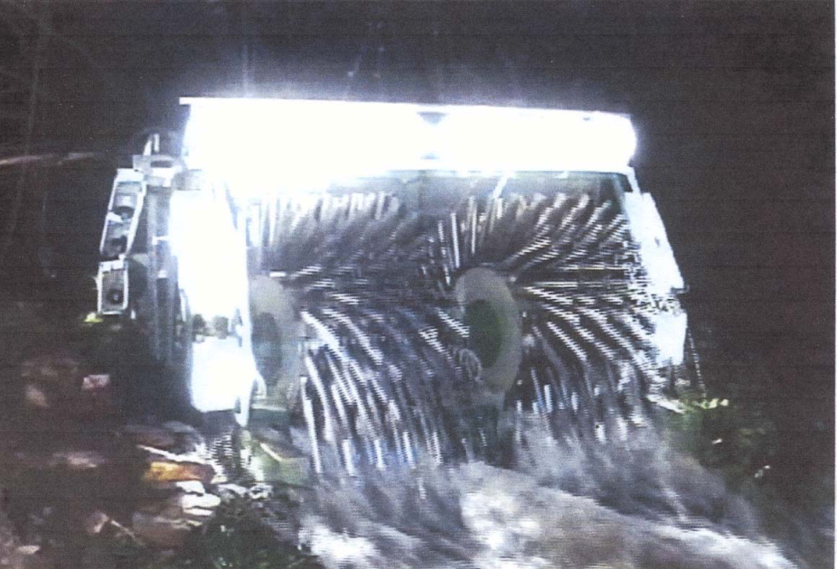

A night time photograph showing two turbines generating electricity, and the behavior of the water after passing through them.

7.0 ADVANTAGES OF FPP
- Floating power plant can freely movable at sea or river.
- The Floating power plant can economically supply electricity to a specific district or to a specific facility that temporarily uses electricity, and can minimize limitations caused by environmental regulations, and can be used as an emergency electric power source.
- The floating power plant is freely movable on the sea, so that the power plant is not limited to the place. Thus, the floating power plant can be moved to any district having facilities requiring electricity or can generate electricity on the open sea or river
- Floating power plant overcomes problems of conventional land power plants and, particularly, solves the problem of the waste of land caused by construction of power plants on land, and thus reduces environmental pollution.

8.0 DISADVANTAGES OF FPP

- FPP as a problem with end-user power demand and supply not being synchronized.
- The access to the installations is critical when working off-shore.
- Infrastructure is costly when working off-shore.

9.0 FUTURE OF FPP

The original rational for the early FPP today remains fast track capacity where you need it at low financial risk, but new reasons are surfacing that are taking the FPP to higher levels of capacity and complexity.
Restricted, high demand areas, such as New York City, where land restrictions preclude power plant construction and additional transmission is limited, can accommodate FPPs. The technical and commercial driver for FPP project is to convert associated power to energy source that is more easily transported to shore. This concept of offshore FPPs may be expanded to provide electrical power to offshore platforms and other production units thus eliminating the need for platform based generation and reducing overall emissions. This latter strategy is being implemented in the Norwegian sector of the North Sea. Additionally the concept can be extended to provide power to future offshore installation, such as those contemplated for the importation of LNG and CNG in the Gulf of Mexico.
The FPP, being of modular, transportable design is also finding application to land based power generation. Since the world shipbuilding industry trends toward the lowest cost producer, FPPs are modular power plant units which can be constructed in the shipyards of Korea, Japan or China. Projects are being developed using barge structures to support diesels, gas turbines and CFB boilers, constructed in Asian shipyards for permanent land including the United States. The use of low cost labor and the efficiencies of machinery and equipment installation produced in a shipbuilding conventional plant installation in high cost countries.
More than 60 floating power stations are in operation around the world, deploying some 4 GW at continental shores where electricity is most needed. Though these feature a variety of power sources (including nuclear, gas and heavy fuels), most are power barges - they do not have their own propulsion systems and would have to be towed to desired locations. Some are of extraordinary size or feature novel designs. The largest of these, for example, is a 200 MW unit at Mangalore, southwest India, according to Waller Marine, Inc. The maritime services provider is also currently carrying out design work on an even larger project, a 520 MW combined-cycle facility that will provide power to New York City.

10.0 CONCLUSION

SOURCES

- WWW.WIKIPEDIA.COM
- WWW.GOOGLE.COM
- WWW.FLOATINGPOWERPLANT.COM
- www.wallermarine.com

