**ABSTRACT**

The ritual of exchanging business cards could become a thing of the past after Japanese researchers devised a way to swap data just through a handshake through a technology named *“***RED TACTON***” .*This advanced technology is used in various fields which is beneficial in our day to day life such as in medical and commercial applications where Red Tacton can provide high value-added communication*.*

According to Nippon Telegraph and Telephone Corporation (NTT), your whole body is the perfect conductor for electronic data, meaning that information such as music and films could be downloaded in seconds via your elbow. The device uses optical electric field sensors that look for similar electric fields on other bodies. When contact is made, the data goes through the body with a small amount of voltage, winding up in a portable terminal such as a mobile .The Red Tacton chips will be embedded in machines and contain a transmitter and receiver built to send and accept any form of data stored in a digital format *.*The chips can take any type of file such as mp3 music file or mail and convert it into a form that takes the form of digital pulses that can be read and passed through a body’s electric field. The chips in receiver devices read these changes and convert the file back into its original form.

**CHAPTER 1**

**INTRODUCTION**

* 1. **HISTORY**

**RED TACTON was developed** on 30 August 2005 by a seven-person research team led by Yuichi Kado, executive manager of the Smart Devices Laboratory at NTT's Microsystems Integration Laboratories, in Atsugi, west of Tokyo.

The initial ways for the data transmission is done through wired networks. The speed of transmitting data is in terms of kilobytes per second and the accuracy is affected by the non linearity and disturbances of the media (That is in wires). Later this task is performed by wireless networks. The speed is not much accelerated but the accuracy is developed. To attain high speed and accuracy a new concept of data transmission is coming into existence that contains human surface area as a media. The powerful and minute electric field present on the human surface can be used as media for transmission of data. This typical task is achieved by using the device REDTACTON.

Using a transmitter embedded in, say, a PDA, REDTACTON sends a 5-volt pulse along the surface of the body. The human body shunts most of this electricity to the ground, resulting in a weak electric field that can be modulated to carry signals. The receiver is located either on another part of the body—a component of a hands-free headset, perhaps—or nearby, say, in an acquaintance's PDA. As it senses modulations in the electric field, the receiver decodes them to recover the data.

**CHAPTER 2**

**RED TACTON**

Red- Warmth, T- Touch, and Acton- Action stands for RED TACTON. NTT combined “Touch and Action” to coin the term Tacton, and then added the word Red – ‘a warm color ’ to emphasize Warm and Cordial communications, creating the name Red Tacton. Instead of relying on electromagnetic waves or light waves to carry data, RED TACTON uses weak electric fields on the surface of the body as a transmission medium.

RED TACTON is a new Human Area Networking technology that uses the surface of the human body as a safe, high-speed network transmission path. Technically, it is completely distinct from wireless and infrared. A transmission path is formed at the moment a part of the human body comes in contact with a RED TACTON transceiver. Using RED TACTON, communication starts when terminals carried by the user or embedded in devices are linked in various combinations according to the user's natural, physical movements. Communication is possible using any body surfaces, such as the hands, fingers, arms, feet, face, legs or torso. REDTACTON works through shoes and clothing as well.

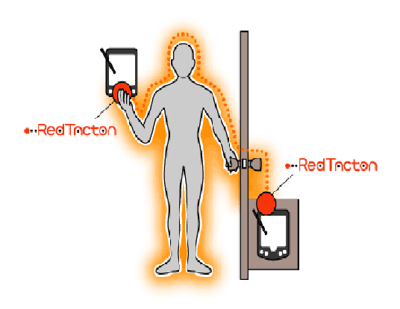

**Fig 2.1 shows a person opening a door with the help of an RED TACTON device.**

**2.1 HOW RED TACTON WORKS?**

|  |
| --- |
| Red Tacton can achieve duplex communication over the human body at a maximum speed of 10 Mbps. Red Tacton transmitter induces a weak electric field on the surface of the body. |
|  |

The electric field sensor (transistor or photonic electric field sensor) detects electric field that reaches the Red Tacton receiver. Red Tacton receiver senses the changes in the weak electric field on the surface of the body caused by the transmitter .Red Tacton relies upon the principle that the optical properties of an electro-optic crystal can vary according to the changes of a weak electric field. Red Tacton detects changes in the optical properties of an electro-optic crystal using a laser and converts the result to an electrical signal in an optical receiver circuit. The transmitter sends data by inducing fluctuations in the minute electric field on the surface of the human body. Data is received using a photonic electric field sensor that combines an electro-optic crystal and a laser light to detect fluctuations in the minute electric field. The naturally occurring electric field induced on the surface of the human body dissipates into the earth. Therefore, this electric field is exceptionally faint and unstable. The photonic electric field sensor developed by NTT enables weak electric fields to be measured by detecting changes in the optical properties of an electro-optic crystal with a laser beam.

*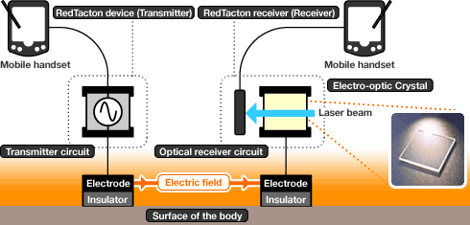*

**Fig 2.2 working principle of Red Tacton.**

|  |
| --- |
|  |

**2.2 MECHANISM OF COMMUNICATION WITH RED TACTON.**

The transmitter sends data by inducing fluctuations in the minute electric field on the surface of the human body. Data is received using a photonic electric field sensor that combines an electro-optic crystal and a laser light to detect fluctuations in the minute electric field.The naturally occurring electric field induced on the surface of the human body dissipates into the earth. Therefore, this electric field is exceptionally faint and unstable.  The super-sensitive electric field sensing technology measures the weak electric fields induced by the super-efficient alternating electric field induction technology developed by NTT.

Using a novel electro-optic sensor, Nippon Telegraph and Telephone Corporation (NTT) has already developed a small PCMCIA card-sized prototype REDTACTONtransceiver. REDTACTON enables the first practical Human Area Network between body-centered electronic devices and PCs or other network devices embedded in the environment via a new generation of user interface based on totally natural human actions such as touching, holding, sitting, walking, or stepping on a particular spot. REDTACTON can be used for intuitive operation of computer-based systems in daily life, temporary one-to-one private networks based on personal handshaking, device personalization, security, and a host of other a REDTACTON doesn’t introduce an electric current into the body instead; it makes use of the minute electric field that occurs naturally on the surface of every human body. A transmitter attached to a device, such as an MP3 player, uses this field to send data by modulating the field minutely in the same way that a radio carrier wave is modulated to carry information.

Receiving data is more complicated because the strength of the electric field involved is so low. REDTACTON gets around this using a technique called electric field photonics: A laser is passed though an electro-optic crystal, which deflects light differently according to the strength of the field across it. These deflections are measured and converted back into electrical signals to retrieve the transmitted data.

|  |
| --- |
| http://www.redtacton.com/en/images/pix.gif |

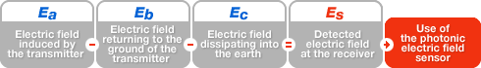

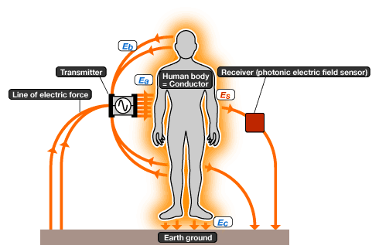

**Fig 2.3 shows the various electric fields on the surface of our body induced by the RED TACTON device. Only a portion of the induced electric field is sensed by the receiving RED TACTON device. The remaining electric fields are dissipated to the ground.**

**2.3 RED TACTON TRANSCEIVERS**

Fig 2.4 below shows the block diagram of a RED TACTON transceiver. The signal from the interface is sent to the data sense circuit and the transmitter circuit. The data sense circuit senses the signal and if the data is present it sends control signal to the transmitter which activates the transmitter circuit. The transmitter circuit varies the electric field on the surface of our body. This change in the electric field is detected by the electro-optic sensor. The output of the electro-optic sensor is given to the detector circuit, which in turn given to the interface of the receiving RED TACTON device.

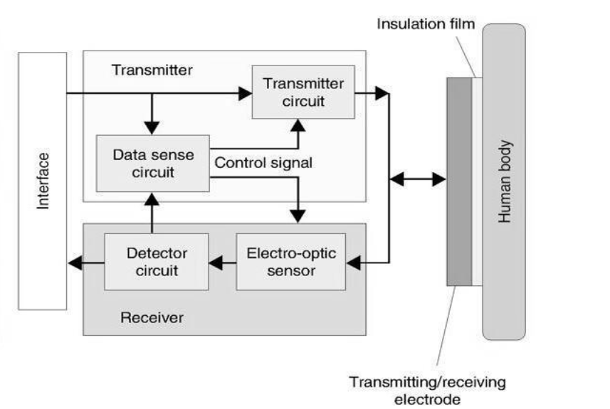

**Fig 2.4 Block diagram of Red Tacton transceiver.**

**CHAPTER 3**

**PROTOTYPES**

NTT has made three types of prototypes

|  |  |
| --- | --- |
| Prototypes | **Red Tacton Transceiver(PC card type)**  Communicationspeed:10Mbps  Protocols: TCP/IP  Communication method: Half-duplex.  Interface: PCMCIA |
| Prototypes | **Red Tacton Transceiver(Hub type)**  Communicationspeed:10Mbps  Protocols :TCP/IP  Communication method : Half-duplex  Interface: RJ45 |
| Prototypes | **Red Tacton Transceiver(Box type)**  (under constructions) |

**CHAPTER 4**

**FEATURES OF RED TACTON**

**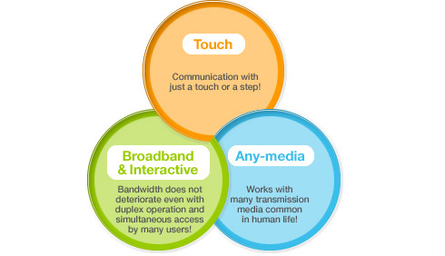**

**4.1 TOUCH**

Touching, gripping, sitting, walking, stepping and other human movements can be the triggers for unlocking or locking, starting or stopping equipment, or obtaining data. Using Red Tacton, communication starts when terminals carried by the user or embedded in devices are linked in various combinations through physical contact according to the human's natural movements.

**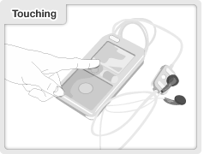**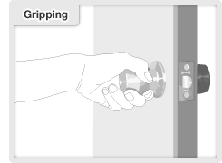

**Fig 4.1 Touching Fig 4.2 Gripping**

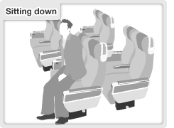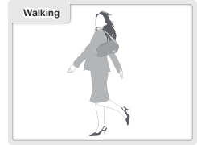

**Fig 4.3 Sitting down Fig 4.4 Walking**

**4.2 BROADBAND & INTERACTIVE**

Duplex, interactive communication is possible at a maximum speed of 10Mbps. Because the transmission path is on the surface of the body, transmission speed does not deteriorate in congested areas where many people are communicating at the same time .Taking advantage of this speed, device drivers can be downloaded instantly and execute programs can be sent.

|  |  |
| --- | --- |
| Communication speed can deteriorate in crowded spaces due to a lack of bandwidth  (wireless LAN) | Device drivers can be downloaded instantly and executable programs can be quickly sent.  (REDTACTON) |

**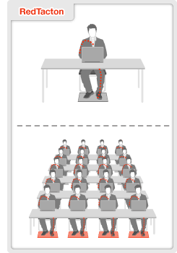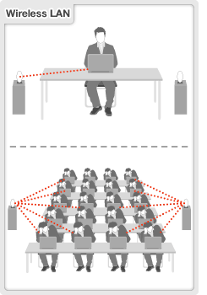**

**Fig 4.5 Difference between Red Tacton and Wireless LAN**

**4.3 ANY MEDIA**

In addition to the human body, various conductors and dielectrics can be used as transmission media. Conductors and dielectrics may also be used in combination.

A communication environment can be created easily and at low-cost by using items close at hand, such as desks, walls, and metal objects. But there is one limitation on the length of the conductor to be propagated, on installation locations, and on the thickness of the dielectric to be passed through.

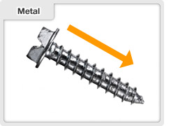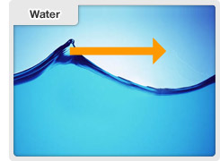

**Fig 4.6 Conductors** (signals travel along surface).

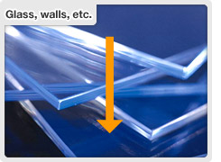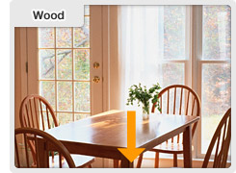

**Fig 4.7 Dielectrics** (signals pass through materials)

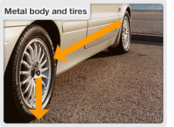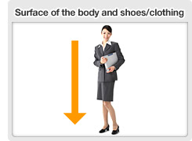

**Fig 4.8 Conductor+Dielectrics**

**CHAPTER 5**

**ADVANTAGES AND DISADVANTAGES**

* **ADVANTAGES**
* Communication by just a Simple Touch thus eliminating use of hectic arrangements of wires.
* Red Tacton provides high speed and accuracy .
* Red Tacton transceiver electrodes are covered with an insulating film, so there is no way current can flow into users body.

**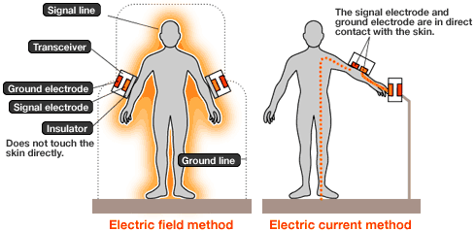**

**Fig 5.1**

* Very secure Data Transmission i.e., there is no problem of hacking since medium is our individual body.
* No need to insert smart cards, connect cables, tune frequencies, or any of the other inconveniences usually associated with today's electronic devices.
* Transmission speed does not deteriorate in congested areas where many people are communicating at the same time.
* **DISADVANTAGES**
* Very high Initial Cost.
* High Sensitivity of Receiver is required.
* Complexity in Design

**CHAPTER 6**

**POTENTIAL APPLICATIONS**

**6.1 One to one services:**

With the ability to send attribute data from personal information devices worn on the body to computers embedded in the environment, one-to-one services could be implemented that are tailored to the individual needs of the user.

* **An alarm sounds automatically to avoid accidental medicine ingestion.**

Red Tacton devices embedded medicine bottles transmit information on the medicines' attributes. If the user touches the wrong medicine, an alarm will trigger on the terminal he is carrying. The alarm sounds only if the user actually touches the medicine bottle, reducing false alarms common with passive wireless ID tags, which can trigger simply by proximity.

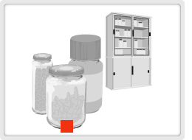

**Fig 6.1 Elemenating human error**

* **Touch advertising and receive information.**

When a consumer stands in front of an advertising panel, advertising and information matching his or her attributes is automatically displayed. By touching or standing in front of items they are interested in, consumers can get more in-depth information

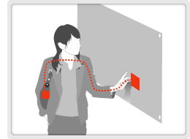

**Fig 6.2 Marketing Application**

**6.2 Intuitive operation of personal information:**

Communication is triggered by totally natural human actions and behavior, so there is no need to insert smart cards, connect cables, tune frequencies, or any of the other inconveniences usually associated with today's electronic devices.

Natural movements and actions are the trigger. There’s no "operation" any more. Just intuitive human interaction. REDTACTON transceivers embedded in two terminals can communicate not only data but also the control or configuration instructions needed to operate devices. Cable connections are eliminated. The body itself is used as transmission medium.

* **Touch a printer to print.**

Print out where you want just by touching the desired printer with one hand and a PC or digital camera with the other hand to make the link Complicated configurations are reduced by downloading device drivers "at first touch".

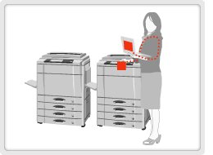

**Fig 6.3 Touch a printer**

* **Instantaneous private network transfer via personal handshake.**

By shaking hands, personal profile data can be exchanged between mobile terminals on the users. (Electronic exchange of business cards) Communication can be kept private using authentication and encryption technologies.

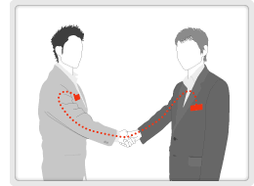

**Fig 6.4 Instant private data exchange.**

**6.3 Device personalization:**

Setup, registration, and configuration information for an individual user can all be uploaded to a device the instant the device is touched, eliminating the need for the device to be registered or configured in advance.

Digital lifestyle can be instantly personalized with just a touch. A pre-recorded configuration script can be embedded in a mobile terminal with built-in REDTACTON transceiver. When another device with REDTACTON capabilities is touched, personalization data and configuration scripts can be downloaded automatically.

* **Just touching a phone makes it your own.**

Your own phone number is allocated and billing commences. Automatic importing of personal address book and call history.

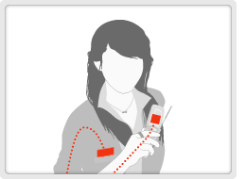

**Fig 6.5 Personalization of mobile phones.**

* **Just sitting in the seat triggers the car to load all its presets as the way you like.**

The seat position and steering wheel height adjust to match the driver just by sitting in the car. The driver's home is set as the destination in the car navigation system .The stereo plays the driver's favorite song.

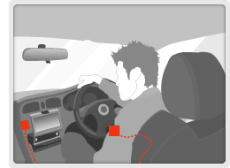

**Fig 6.6 Personalization of automobiles.**

**6.4 New behavior patterns:**

Tables, walls, floors and chairs can all act as conductors and dielectrics, turning furniture and other architectural elements into a new class of transmission medium. For example, a user could have instant access to the Internet merely by placing a laptop onto a conductive tabletop.

* **Connect to a network jus by putting laptop on a table.**

An electrically conductive sheet is embedded in the table. A network connection is initiated simply by placing a lap-top on the table. Using different sheet patterns enables segmentation of the table into subnets.

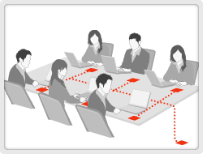

**Fig 6.7 Conferencing system**

Red Tacton can carry music or video between headsets, mobile devices, mobile phones, etc. Users can listen to music from a Red Tacton player simply by putting on a headset or holding a viewer.

* **Wireless headset.**

Red Tacton can carry music or video between headsets, mobile devices, mobile phones, etc. Users can listen to music from a Red Tacton player simply by putting on a headset or holding a viewer.

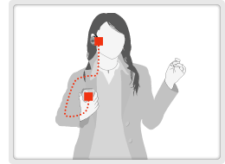

**Fig6.8 Wearable**

**6.5 Security applications:**

REDTACTON could be installed on doors, cabinets and other locations calling for secure access, such that each secure access could be initiated and authenticated with a simple touch. At the same time, all the transaction details and relevant user attributes (personal identity, security clearance, etc.) could be logged by the security system.

Automatic user authentication and login with just a touch. ID and privileges are recorded in a mobile REDTACTON device. Corresponding REDTACTON receivers are installed at security checkpoints. The system can provide authentication and record who touched the device, and when Carrying a mobile.

* **User verification and unlocking with just a touch.**

Carrying a mobile Red Tacton capable device in one's pocket, ID is verified and the door unlocked when the user holds the doorknob normally. Secure lock administration is possible by combining personal verification tools such as fingerprint ID or other biometric in the mobile terminal.

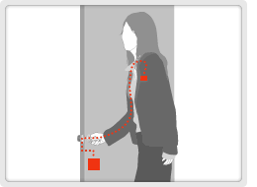

* **Automatic access log for confidential document storage.**  
  A Red Tacton receiver in a cabinet where important documents are stored enables lock administration and keeps a record of who accessed documents at what time.

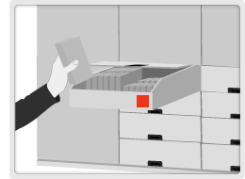

**Fig 6.9 Confidential document management**

* **Communication in new domain:**

Potential for use as communication method in outer space and under water. Potential for use as communication method with devices inside the human body

**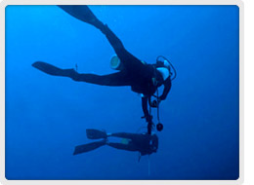**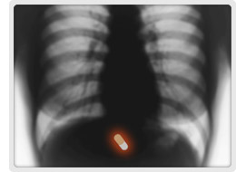

**Fig 6.10 Communication under water Fig 6.11 Communication inside**

**Human body**

**CHAPTER 7**

**COMPARISION WITH OTHER TECHNOLOGIES**

|  |  |  |  |  |  |  |  |  |
| --- | --- | --- | --- | --- | --- | --- | --- | --- |
|  |  |  | | | | |  | **RED**  **TACTON** |
|  | Evaluation criteria | Wireless  LAN | Close  Range  wireless | Wireless  Contactless  IC cards | | Passive wireless ID tag | Infrared  Standard data communi- cation |
| boxtxt_1 | Transfer speed (Can DVD-quality images be sent?) | E | P | P | P | | P | E |
| Performance deterioration during periods of congestion (Simultaneous use by many people in small spaces) | P | P | E | E | | E | E |
| Duplex data transfer (Interactive processing) | E | E | E | P | | E | E |
| boxtxt_2 | Data configuration at initiation of communications (Registration of ID profiles, etc) | E | E | P | P | | E | E |
| Tasks required at time of each communication (Adjustment of contacts and optical axis) | E | E | P | E | | P | E |
| Synchronization with user behavior (Specification of  user positioning) | P | P | E | E | | P | E |

***NOTE***: E: Excellent P: Poor

**CHAPTER 8**

**CONCLUSION**

The need for artificial body implants to communicate with each other as well as to report back to a portable device could have quite some value. In fact, according to other researchers, the most important application for body-based networking may well be for these type of communications within, rather than on the surface of, or outside, the body. Red Tacton technology is expected to dominate Bluetooth technology in the future. Red Tacton technology could put the use of cables to an end. The problem faced by the Red Tacton technology is the cost of development. This technology brings a new dimension of communication which effectively links the user to anyone he wants to communicate. Since it provides high speed communication, it can provide seamless service wherever, whenever and whoever uses it.We conclude that, when we compare Red Tacton with other technology present today it can give a better performance over others.And we can say that to connect the network with in short distances Red Tacton is best. In this technology there is no problem of hackers as our body is itself a media.

**REFERENCES**

[1]www.redtacton.com/en/info/index.html [2]www.masternewmedia.org/2003/10/19/wireless\_body\_networkingat10.htm

[3] discuss.itacumens.com/index.php?topic=12720

[4] en.wikipedia.org/wiki/Red Tacton

[5] http://www.spectrum.ieee.org/print/2596 Digit Magazine

[6] [www.Scribd.com/doc/117603u/Red](http://www.Scribd.com/doc/117603u/Red) Tacton