A SEMINAR ON RED TACTON
ABSTRACT
Technology is making many things easier; I can say that our concept is standing example for that. So far we have seen LAN, MAN, WAN, INTERNET & many more but here is new concept of “RED TACTON” which makes the human body as a communication network by name.... HAN (Human Area Network).
NTT lab from Japan is currently testing & developing this revolutionary technology .RedTacton is a new Human Area networking technology that uses the surface of the human body as a safe, high speed network transmission path. Red Tacton uses the minute electric field generated by human body as medium for transmitting the data. The chips which will be embedded in various devices contain transmitter and receiver built to send and accept data in digital format.
In this paper we will discuss about red tacton, and its working States, and Applications of red tacton various fields. And we will compare our red tacton with the other technology for data transmission. And know about human area network.

INTRODUCTION:-
RedTacton is a Human Area Networking technology, which is under development, that uses the surface of the human body as a safe, high speed network transmission path. It is completely distinct from wireless and infrared technologies as it uses the minute electric field emitted on the surface of the human body.
A transmission path is formed at the moment a part of the human body comes in contact with a RedTacton transceiver. Communication is possible using any body surfaces, such as the hands, fingers, arms, feet, face, legs or torso. RedTacton works through shoes and clothing as well. When the physical contact gets separated, the communication is ended.
Using RedTacton-enabled devices, music from a digital audio player in your pocket would pass through your clothing and shoot over your body to headphones in your ears. Instead of fiddling around with a cable to connect your digital camera to your computer, you could transfer pictures just by touching the PC while the camera is around your neck. And since data can pass from one body to another, you could also exchange electronic business cards by shaking hands, trade music files by dancing cheek to cheek, or swap phone numbers just by kissing.
We may have imagined the feature as a place crawling with antennas and emitters, due to the huge growth of wireless communications. And it is seems that the current means of transferring data might already have a very serious competitor none other than the human body.
Thus NTT labs from Japan has announced that is currently testing a revolutionary technology called “ red tacton ”,which use the electric fields generated by the human body as medium for transmitting the data . The chips which will embedded in various devices contain a transmitter and receiver built to send and accept data in digital format. The chips can take any type of file such as mp3 music file or mail and convert it in to the format that takes the form of digitals pulse that can be passed and read through a human being electric field .the chip in receiver devices reads these tiny changes and convert the file back into its original form.
Red Tacton is a new Human Area Networking (HAN) technology that uses the surface of the human body as a safe, high speed network transmission path. Red Tacton uses the minute electric field emitted on the surface of the human body. Technically, it is completely distinct from wireless and infrared .A transmission path is formed at the moment a part of the human body comes in contact with a Red Tacton transceiver. Physically separating ends the contact and thus ends communication Using Red Tacton, communication starts when terminals carried by the user or embedded in devices are linked in various combinations according to the user's Communication is possible using any body surfaces, such as the hands, fingers, arms, feet, face, legs or torso. Red Tacton works natural, physical movements.

FEATURES OF RED TACTON
RedTacton has three main functional features:
- Touch - Touching, gripping, sitting, walking, stepping and other human movements can be the triggers for unlocking or locking, starting or stopping equipment, or obtaining data.
- Broadband and Interactive - Duplex, interactive communication is possible at a maximum speed of 10Mbps. Because the transmission path is on the surface of the body, transmission speed does not deteriorate in congested areas where many people are communicating at the same time.
- Any media - In addition to the human body, various conductors and dielectrics can be used as transmission media. Conductors and dielectrics may also be used in combination.
USES AND APPLICATION OF RED TACTON
Many areas can benefit from this technology. Initially, RedTacton could target security, the medical field, and the device communication field. The medical field would benefit in many ways. For example, implanted devices could use the technology to transmit information regarding their performance to doctors, patients wearing the device could quickly and securely transmit their medical history, and medicine containers could have chips embedded in them that when touched could send an alarm to the user, if the user’s device is programmed to know that an allergy to the medicine exists. Device communication is where RedTacton would compete with Bluetooth. Since RedTacton is more secure that Bluetooth, it would excel at connecting cell phones to headsets and transmitting data from one person’s PDA to another’s. As mentioned before, RedTacton is already positioning itself to become a ‘human swipe card’ and become the ultimate security device. One potential application that will be explored in depth is gun control

Red Tacton has many applications some of them are:
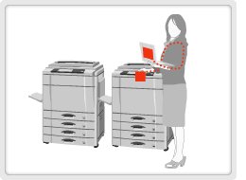
-Print out where you want just by touching the desired printer with one hand and a PC or digital camera with the other hand to make the link.
-Complicated configurations are reduced by downloading device drivers "at first touch".
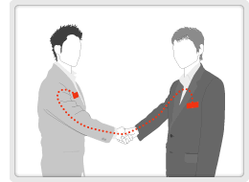
-By shaking hands, personal profile data can be exchanged between mobile terminals on the users. (Electronic exchange of business cards)
-Communication can be kept private using authentication and encryption technologies.
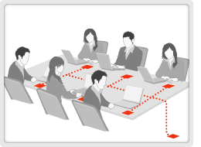
-An electrically conductive sheet is embedded in the table.
-A network connection is initiated simply by placing a lap-top on the table.
-Using different sheet patterns enables segmentation of the table into subnets.
A conductive metal sheet is placed on top of a table. Laptop computers could be connected to the Internet by simply placing them on such a table. Even different networks could be supported,
such as an enterprise LAN and Internet access, by providing separate metal sheets for each network.
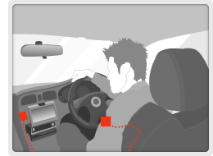

The seat position and steering wheel height adjust to match the driver just by sitting in the car. The driver's home is set as the destination in the car navigation system. The stereo plays the driver's favorite song.
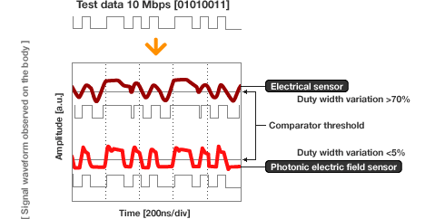
Fig: transmission of information

On the other hand, photonic electric field sensors used in RedTacton can measure stand-alone contacts without being influenced by grounds. As a result, the received waveform is not distorted, regardless of the receiver location. This makes long-distance and high-speed body surface transmission possible.

RedTacton does not require the electrode be in direct contact with the skin. High-speed communication is possible between two arbitrary points on the body.

HOW IT WORKS
Using a new super-sensitive photonic electric field sensor, RedTacton can achieve duplex communication over the human body at a maximum speed of 10 Mbps.
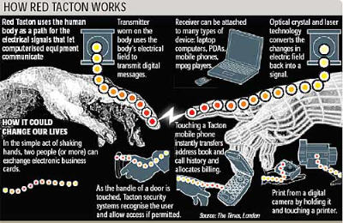
Fig: functioning

1. The RedTacton transmitter induces a weak electric field on the surface of the body.
2. The RedTacton receiver senses changes in the weak electric field on the surface of the body caused by the transmitter.
3. RedTacton relies upon the principle that the optical properties of an electro-optic crystal can vary according to the changes of a weak electric field.
4. RedTacton detects changes in the optical properties of an electro-optic crystal using a laser and converts the result to an electrical signal in a optical receiver circuit.

Note that RedTacton transceivers which integrate transmitters and receivers are also available.

When using a RedTacton device, the human body effectively becomes an Ethernet cable, so the body can use its electrical field to connect devices to networks or the internet. For example, if a person wearing a RedTacton device sat at a table with RedTacton capabilities that was connected to the Internet, the laptop would immediately be connected to the internet. While on the surface this seems similar to a wireless network connection, it is not. There is a physical connection, the person. Also, the connection is more secure and does not slow down if many people are using the same connection, as a wireless connection does.
RedTacton utilizes a point to point network, known as a piconet. The P2P network allows information to be exchanged between two transceivers without the need for a server to store or process information.
RedTacton operates on the idea that optical properties of an electro-optic crystal can vary according to the changes of a person own electric field. After contract with another RedTacton enabled device, the transmitter one wears induces an electric field on the body. Next, the transceiver on the device detects changes in the wearers electric field which was caused by the device. The devices then communicate and send data by inducing fluctuations in the electric field of the human body. Data is received using a photonic electric field sensor that combines an electro-optic crystal and a laser light to detect fluctuations in the minute electric field.
Imagine holding your digital camera in one hand and touching a printer with your other which initiates the transfer of images from your camera to your printer. In an instant you have downloaded your pictures and are ready to print them out without the need for connecting cables and intermediary devices such as a computer.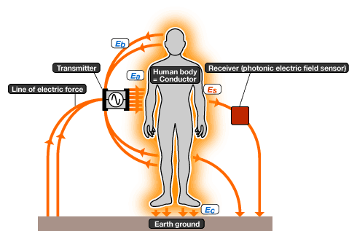

What does it need?
Each device we wish to communicate with must be equipped with a RedTacton transceiver that is able to detect the messages programmed into our own device. We are able to program our devices to exchange specific types of information by using a programmable transceiver that connects to a any computer and allows users to customize their transmission settings through a graphical user interface. Once our transmitter, that we wear, is programmed to recognize and exchange information with other devices we select, such as printers, we will be able to communicate with them easily.
In the event that we need the information we are exchanging to interact with or be processed by other applications, we will likely need a broadband connection to send that information over the internet to be processed and returned. This would be the case with our subway turn style example previously discussed.
Who does it need?
All bargaining power in the consumer market lies with the device manufacturers who would be our buyers. Our suppliers are companies such as NTT that provide this technology to the device manufacturers. Currently, we define a device as any handheld communication medium such as a cell phone or PDA. However, as this technology evolves and its popularity spreads, a device could be any piece of technology that we wish to exchange information with.
While device manufacturers may see the potential benefits of RedTacton technology, they will likely require a significant monetary fee to influence them to build this new technology into their devices. The introduction of new technologies into existing devices often requires significant design changes that can be costly and time consuming. Unless the device manufacturer stands to benefit from the design change they may reject the new technology in favor of promoting and developing the old one.
RedTacton also needs a lot of research and development. The government, military, or medical professionals might be ideally suited to help further develop the technology and find other uses for it.

COMPARISON WITH OTHER NETWORK TECHNOLOGIES
Currently, many popular technologies exist in the marketplace which provides similar functions to RedTacton technology. The first is Bluetooth. Bluetooth is also a short range frequency allowing users to transmit data within approximately a 10M range. Bluetooth, however, is unsecure. The signal can be tapped into and used by others. As mentioned previously, Zigbee, IrDA, and UWB are also potential competitors.
The focus on ubiquitous service has brought about the shortening of distances in communication. RedTacton is positioned as the last 1m solution to ultimate close-range communication. Wireless communication creates connections when signals arrive, allowing for easy connections because connectors are unnecessary. However, seen from another aspect, the arriving signals can be intercepted, so security becomes an issue. Wired communication transmits data between two connection points, so interception is difficult and security can be considered to be high. However, connectors and cables are a nuisance. Taking the above points in account, RedTacton is situated directly between wireless and wired communication.
While RedTacton may be a superior technology, adoption could be slow since Bluetooth and other radio technologies are already entrenched. Like those products, RedTacton will become more valuable as it is adopted. If there is nothing for a person’s RedTacton device to talk to, it is essentially useless. Also, initially, it will be comparatively expensive. If security applications take off, particularly in the military field, it maybe years before the technology becomes available to consumers. It does, however, have to potential to disrupt the Bluetooth market, since it is more secure and works at much higher speeds. On the medical side, however, it may create a new market. As far as security applications are concerned, it could be disruptive because it is such a secure way to communicate. Radio swipe cards are much easier to manipulate than a RedTacton human swipe card. Again, the biggest hurdle will be convincing consumers that the product is worth the premium that will be charged because it seems, on the surface, to be so similar to technologies that are already available. Explaining why it is more secure and more efficient could be a challenge. Management will need to seriously consider how it will be marketed and hire excellent marketing people to promote the product. They will also need to find partners to share in the cost of development.
The most obvious barrier to entry is that the cost and time to develop Personal Area network technology is very expensive. Second, as a new technology Personal Area networks need to gain popularity among users to help pull the technology into the marketplace instead of having it pushed upon them. Additionally, widespread marketing campaigns will need to be developed to highlight the benefits of PAN technology to facilitate its adoption. Finally, this technology will not likely be very useful until a large number of people and devices have adopted it which means a significant time investment.

CONCLUSION
• We conclude that, when we compare Red Tacton with other technology present
today it can give a better performance over others and we can say that to connect
the network with in short distances Red Tacton is best.
• In this technology there is no problem of hackers as our body is itself a media.
REFERENCES
http://en.wikipedia.org/wiki/RedTacton
www.technicalsymposium.com
www.redtacton.com/

