ABOUT BLU-RAY TECHNOLOGY

Introduction
In 1980’s a new technology emerged that brought digital sound & video into homes all over the world. It was called CD (compact disc). The CD was a very useful medium for the recording & distributing of audio & some modest data applications, demand for a new medium offering higher storage capacities rose in the 1990’s.
Now, in the next millennium, high definition video demands a new solution. History proved that a significant 5-10 x increase in storage capacity and the ability to play previous generation formats are key elements for a new format to succeed. This new format has arrived with the advent of Blu-ray Disc, the only format that offers a considerable increase in storage capacity with its 25 to 50 GB data capacity.
Explains how the Blu-ray disc works and how it was developed, and we'll see how it stacks up against some other new digital video formats on the horizon.

What is a Blu-ray Disc?
A current, single-sided, standard DVD can hold 4.7 GB (gigabytes) of information. That's about the size of an average two-hour, standard-definition movie with a few extra features. But a high-definition movie, which has a much clearer image (see How Digital Television Works), takes up about five times more bandwidth and therefore requires a disc with about five times more storage. As TV sets and movie studios make the move to high definition, consumers are going to need playback systems with a lot more storage capacity.
BD-ROM disc researcher
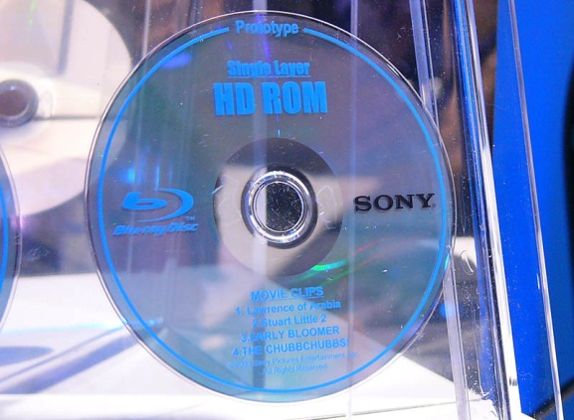
BLU-RAY disc

- A single-layer Blu-ray disc, which is roughly the same size as a DVD, can hold up to 27 GB of data -- that's more than two hours of high-definition video or about 13 hours of standard video.

The Name
The Blu-ray name is a combination of "blue," for the color of the laser that is used, and "ray," for optical ray. The "e" in "blue" was purposefully left off, according to the manufacturers, because an everyday word cannot be trademarked.
- A double-layer Blu-ray disc can store up to 54 GB, enough to hold about 4.5 hours of high-definition video or more than 20 hours of standard video. And there are even plans in the works to develop a disc with twice that amount of storage.

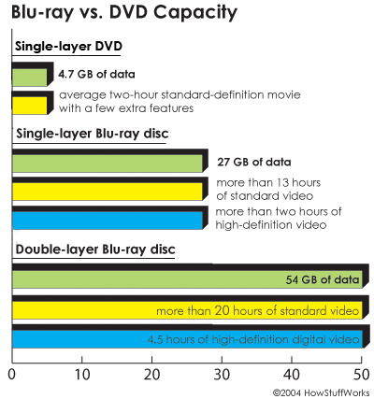

Blu-ray discs not only have more storage capacity than traditional DVDs, but they also offer a new level of interactivity. Users will be able to connect to the Internet and instantly download subtitles and other interactive movie features

Blu-ray Advantages
- record high-definition television (HDTV) without any quality loss
- instantly skip to any spot on the disc
- record one program while watching another on the disc
- create playlists
- edit or reorder programs recorded on the disc
- automatically search for an empty space on the disc to avoid recording over a program
- access the Web to download subtitles and other extra features.

How Does Blu-ray Work?
Discs store digitally encoded video and audio information in pits -- spiral grooves that run from the center of the disc to its edges. A laser reads the other side of these pits -- the bumps -- to play the movie or program that is stored on the DVD. The more data that is contained on a disc, the smaller and more closely packed the pits must be. The smaller the pits (and therefore the bumps), the more precise the reading laser must be.
Unlike current DVDs, which use a red laser to read and write data, Blu-ray uses a blue laser (which is where the format gets its name). A blue laser has a shorter wavelength (405 nanometers) than a red laser (650 nanometers). The smaller beam focuses more precisely, enabling it to read information recorded in pits that are only 0.15 microns (µm) (1 micron = 10⁻⁶ meters) long -- this is more than twice as small as the pits on a DVD. Plus, Blu-ray has reduced the track pitch from 0.74 microns to 0.32 microns. The smaller pits, smaller beam and shorter track pitch together enable a single-layer Blu-ray disc to hold more than 25 GB of information -- about five times the amount of information that can be stored on a DVD.
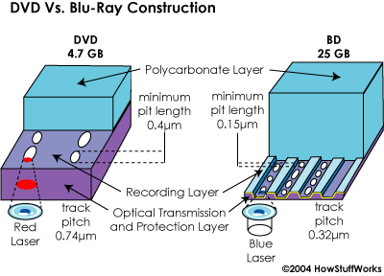
Each Blu-ray disc is about the same thickness (1.2 millimeters) as a DVD. But the two types of discs store data differently. In a DVD, the data is sandwiched between two polycarbonate layers, each 0.6-mm thick. Having a polycarbonate layer on top of the data can cause a problem called birefringence, in which the substrate layer refracts the laser light into two separate beams. If the beam is split too widely, the disc cannot be read. Also, if the DVD surface is not exactly flat, and is therefore not exactly perpendicular to the beam, it can lead to a problem known as disc tilt, in which the laser beam is distorted. All of these issues lead to a very involved manufacturing process.
In the next section, we'll see how Blu-ray overcomes these obstacles.

Building a Blu-ray

On Guard
Blu-ray discs are better armed than current DVDs. They come equipped with a secure encryption system -- a unique ID that protects against video piracy and copyright infringement.
The Blu-ray disc overcomes DVD-reading issues by placing the data on top of a 1.1-mm-thick polycarbonate layer. Having the data on top prevents birefringence and therefore prevents readability problems. And, with the recording layer sitting closer to the objective lens of the reading mechanism, the problem of disc tilt is virtually eliminated. Because the data is closer to the surface, a hard coating is placed on the outside of the disc to protect it from scratches and fingerprints.

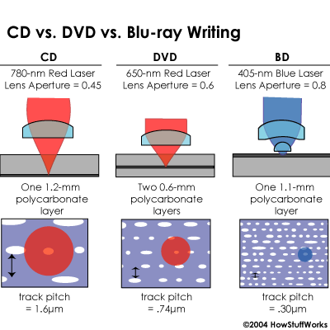
The design of the Blu-ray discs saves on manufacturing costs. Traditional DVDs are built by injection molding the two 0.6-mm discs between which the recording layer is sandwiched. The process must be done very carefully to prevent birefringence.
- The two discs are molded.
- The recording layer is added to one of the discs.
- The two discs are glued together.
Blu-ray discs only do the injection-molding process on a single 1.1-mm disc, which reduces cost. That savings balances out the cost of adding the protective layer, so the end price is no more than the price of a regular DVD.

Blu-ray has a higher data transfer rate -- 36 Mbps (megabits per second) -- than today's DVDs, which transfer at 10 Mbps. A Blu-ray disc can record 25 GB of material in just over an hour and a half.

Blu-ray vs. Other New Disc Formats
Formats
Unlike DVDs and CDs, which started with read-only formats and only later added recordable and re-writable formats, Blu-ray is initially designed in several different formats:
- BD-ROM (read-only) - for pre-recorded content
- BD-R (recordable) - for PC data storage
- BD-RW (rewritable) - for PC data storage
- BD-RE (rewritable) - for HDTV recording

Will Blu-ray replace previous DVDs? Its manufacturers hope so. In the meantime, JVC has developed a Blu-ray/DVD combo disc with an approximate 33.5-GB capacity, allowing for the release of video in both formats on a single disc. But Blu-ray is not alone in the marketplace. A few other formats are competing for a share of the DVD market.
HD-DVD
The other big player is HD-DVD, also called AOD (Advanced Optical Disc), which was developed by electronics giants Toshiba and NEC. HD-DVD was actually in the works before regular DVD, but it didn't begin real development until 2003.
The advantage to HD-DVD is that it uses the same basic format as the traditional DVD and can therefore be manufactured with the same equipment, saving on costs. The disadvantage is that it can't match the storage capacity of Blu-ray. A rewritable, single-layer HD-DVD can hold 20 GB of data; a double-layer disc can hold 30 GB (that's compared to 27 GB and 50 GB for Blu-ray). The read-only versions hold slightly less data. Also, HD-DVD doesn't offer the interactive capabilities of Blu-ray, although it will probably be less expensive than its competitor.
Other Competitors
Did You Say 500 GB?
It seems that the future holds a whole lot more than 25 to 54 GB on a single disc. According to T3: Pioneer goes beyond Blu-Ray, Pioneer is developing an optical disc that will blow away the hard disc in most of our PCs in terms storage capacity, holding 500 GB of data. How so? Pioneer's lasers are ultraviolet, which have an even shorter wavelength than the blue.
Blu-ray and HD-DVD are the two major competitors in the market, but there are other contenders, as well. Warner Bros. Pictures has developed its own system, called HD-DVD-9. This system uses a higher compression rate to put more information (about two hours of high-definition video) on a standard DVD. Taiwan has created the Forward Versatile Disc (FVD), an upgraded version of today's DVDs that allows for more data storage capacity (5.4 GB on a single-sided disc and 9.8 GB on a double-sided disc). And China has introduced the Enhanced Video Disc (EVD), another high-definition video disc.
There are also professional versions of the blue laser technology. Sony has developed XDCAM and ProData (Professional Disc for Data). The former is designed for use by broadcasters and AV studios. The latter is primarily for commercial data storage (for example, backing up servers).

When Will Blu-ray Become Available?
Blu-ray recorders are already available in Japan, where more consumers have access to HDTV than in the United States. Outside of Japan, once more TV sets come equipped with a high-definition tuner and more films and television shows are produced in high-definition (which is expected to happen by late 2005 or 2006), Blu-ray movies and TV shows on disc should become widely available. But the format is already available for home recording, professional recording and data storage.

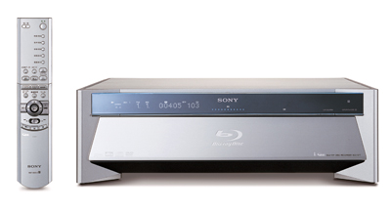
Sony Blu-ray disc player/recorder

Another important factor is cost. Just as with most new technologies, Blu-ray equipment will be pricey at first. In 2003, Sony released its first Blu-ray recorder in Japan with a price tag of around $3,000. The price is expected to drop as the format gains popularity. Blu-ray discs may also be initially more expensive than today's DVDs, but once demand grows and they can be mass-produced, manufacturers say the price will drop to within 10 percent of the price of current DVDs.
Even when the new video standard begins to replace current technologies, consumers won't have to throw away their DVDs, butthey will need to invest in a new player. The industry is planning tomarket backward-compatible drives with both blue and red lasers,which will be able to play traditional DVDs and CDs.

Some Blu-Ray movies:- Spiderman, Kingkong, 2012, Avatar, Magadheera etc.

The end

