Cryogenic Fine Grinding Technology for Rubber, Plastic and Pigment Size Reduction.
Air Products has the capability to fine grind rubber for recycling or plastics and pigments to the finest grain by using liquid nitrogen to cool the material in a grinding mill.
Air Products' Cryo-Grind® technology performs the most efficient particle size reduction for all types of rubber, plastics and pigments. By utilising the cooling power of liquid nitrogen, Cryo-Grind® can grind the toughest of materials to particle sizes below 200 micron.
Cryo-Grind for Plastics and Pigments
Air Products Cryo-Grind® systems perform three essential tasks in achieving efficient, cost effective particle size reduction of all types of plastics and pigments.
Cryogenic Grinding
Grinding tough, thermoplastic materials at cryogenic temperatures means that plastics are brittle enough to be ground to very fine particle sizes.
Temperature Control
Cryo-Grind® systems inject controlled amounts of liquid nitrogen to regulate the heat of the grinding mill and allow higher material throughputs at any time of year.
Inert Grinding
Organic materials have an increased risk of explosion when very fine particles combine. The use of nitrogen to inert the atmosphere during the grinding process minimises safety hazards associated with explosions.
Benefits
- Smaller particles
- More uniform particle size distribution
- Efficient process
- Process cooling/temperature control
- Inertness
- Trial Facilities
Who can benefit from Cryo-Grind®?
Polymer processing companies who must reduce the size of heat-sensitive raw materials or products during production or recycling.
Powder coating producers who must produce polymer powders that have consistent particle size and shape to produce uniform quality coatings on automotive, plumbing, and structural products.
Colour concentrate producers who need to produce powders of concentrated colour for use as polymer additives/colourants. These colourants must have consistent colour and controlled particle size.
Recyclers of rubber and plastic who require fine particle sizes in order to allow the material to be reformulated or reincorporated into primary products, generally via a molding process.
Producers of hot melt adhesives who need to process materials with low softening and melting temperatures onto fine particles to permit extrusion of custom shapes and sizes for glue guns.
How Does It Work?
Raw material passing along a conveyor is cooled using controlled amounts of liquid nitrogen which allows for finer grinding and increased throughputs.
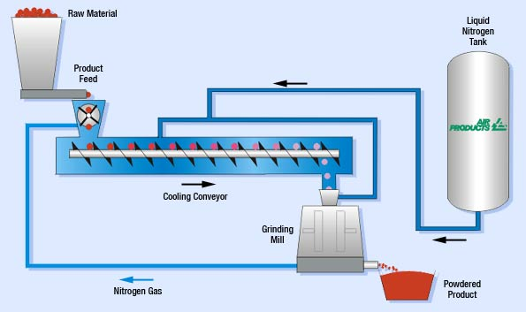
Cryo-Grind for Recycling Rubber
Air Products Cryo-Grind® systems enable rubber scrap materials to be ground into fine particles for re-use in compounding for new rubber and plastic products.
Benefits
- Can grind smaller rubber particles down to below 200 micron
- Regular particle size
- Efficient process by introducing minimum nitrogen and maximum throughput
- Improved surface morphology
Cryo-Grind Technical Support Service
Air Products provides the equipment, know-how, testing and start-up services necessary for a company to optimise its size reduction operation. We provide full-scale test services in our commercial-scale lab, along with the most extensive data and experience base in the Americas. Our offering generally includes a materials chiller, liquid nitrogen flow controls, a data acquisition system, and mill controls.
Air Products can now offer customers from across the globe a fully independent grinding test facility as well as expert consultancy services in size reduction techniques and processes.
> View our data sheet: Cryo-Grind System Cooling Conveyor (PDF, 199 K)
> View our data sheet: Cryo-Grind Size Reduction Systems for recycling rubber materials (PDF, 137 K)
> View our data sheet: Cryo-Grind Size Reduction Systems for fine grinding plastics and pigments (PDF, 137 K)
> The data sheets are in PDF format. Use this link to download the free Adobe Reader.
Study of cryogenic procedures for preparation of food for element analysis
William C. Cunningham^{, a,}
ªUS Food and Drug Administration, Center for Food Safety and Applied Nutrition, Chemical Contaminants Branch (HFS-716), 5100 Paint Branch Parkway, College Park, MD 20740, USA
Received 28 August 2006;
revised 19 July 2007;
accepted 19 July 2007.
Available online 1 August 2007.

Abstract
Two cryogenic homogenization procedures, Teflon disk milling and stainless-steel impact milling, were studied for preparing food and dietary supplements for element analysis. The functionality of the disk mill was demonstrated for a fruit/nut/oatmeal granola. Improvement over a rotary cutter blending procedure was shown for three fast-food type foods—hamburger, fried chicken, and egg/ham/cheese English muffin. The capabilities of the two procedures to process mixtures comprised of very dissimilar components were compared. The mixtures included a commercial hard candy having a chili powder coating and a 50:50 (by mass) combination of choline tablets and echinacea root capsules. Nonhomogeneities were found by calculating relative standard deviations (RSDs) for replicate analyses (n=5) and comparing them with the random uncertainties associated with the measurements. Analytical portion masses ranged between 1 g and 45 mg. Element mass fractions were determined using instrumental neutron activation analysis.
Keywords: Food analysis; Homogeneity; Cryogenic homogenization; Element analysis; Neutron activation analysis

Article Outline
1.
Introduction
2.
Materials and methods
2.1. Foods
2.2. Cryogenic apparatus and procedures
2.3. Analytical procedures
2.4. Statistical treatment and determination of nonhomogeneity
3.
Discussion of results
3.1. Demonstration of disk mill cryogenic procedure on a non-homogenized food
3.2. Homogeneity study of fast foods homogenized using conventional and disk mill cryogenic procedures
3.3. Comparison of disk mill and impact mill cryogenic procedures on two mixtures
3.4. Advantages and disadvantages of the cryogenic procedures
4. Conclusions
Acknowledgements
References

