History

A night vision device (NVD) is an optical instrument that allows images to be produced in levels of light approaching total darkness. They are most often used by the military and law enforcement agencies, but are available to civilian users. The term usually refers to a complete unit, including an image intensifier tube, a protective and generally water-resistant housing, and some type of mounting system. Many NVDs also include sacrificial lenses, IR illuminators, and telescopic lenses.
Night vision devices were first used in World War II, and came into wide use during the Vietnam War.^{[1][2]}The technology has evolved greatly since their introduction, leading to several "generations" of night vision equipment with performance increasing and price decreasing.

INTRODUCTION

The first thing you probably think of when you see the words night vision is a spy or action movie you've seen, in which someone straps on a pair of night-vision goggles to find someone else in a dark building on a moonless night. And you may have wondered "Do those things really work? Can you actually see in the dark?"
The answer is most definitely yes. With the proper night-vision equipment, you can see a person standing over 200 yards (183 m) away on a moonless, cloudy night! Night vision can work in two very different ways, depending on the technology used.
- Image enhancement - This works by collecting the tiny amounts of light, including the lower portion of the infrared light spectrum, that are present but may be imperceptible to our eyes, and amplifying it to the point that we can easily observe the image.
- Thermal imaging - This technology operates by capturing the upper portion of the infrared light spectrum, which is emitted as heat by objects instead of simply reflected as light. Hotter objects, such as warm bodies, emit more of this light than cooler objects like trees or buildings.
In this article, you will learn about the two major night-vision technologies. We'll also discuss the various types of night-vision equipment and applications. But first, let's talk about infrared light.

Infrared Light
In order to understand night vision, it is important to understand something about light. The amount of energy in a light wave is related to its wavelength: Shorter wavelengths have higher energy. Of visible light, violet has the most energy, and red has the least. Just next to the visible light spectrum is the infraredspectrum.

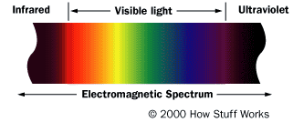
Infrared light is a small part of the light spectrum.
Infrared light can be split into three categories:
- Near-infrared (near-IR) - Closest to visible light, near-IR has wavelengths that range from 0.7 to 1.3 microns, or 700 billionths to 1,300 billionths of a meter.
- Mid-infrared (mid-IR) - Mid-IR has wavelengths ranging from 1.3 to 3 microns. Both near-IR and mid-IR are used by a variety of electronic devices, including remote controls.
- Thermal-infrared (thermal-IR) - Occupying the largest part of the infrared spectrum, thermal-IR has wavelengths ranging from 3 microns to over 30 microns.
The key difference between thermal-IR and the other two is that thermal-IR is emitted by an object instead of reflected off it. Infrared light is emitted by an object because of what is happening at the atomiclevel.

Atoms
Atoms are constantly in motion. They continuously vibrate, move and rotate. Even the atoms that make up the chairs that we sit in are moving around. Solids are actually in motion! Atoms can be in different states of excitation. In other words, they can have different energies. If we apply a lot of energy to an atom, it can leave what is called the ground-state energy level and move to an excited level. The level of excitation depends on the amount of energy applied to the atom via heat, light or electricity.
An atom consists of a nucleus (containing the protons and neutrons) and an electron cloud. Think of the electrons in this cloud as circling the nucleus in many different orbits. Although more modern views of the atom do not depict discrete orbits for the electrons, it can be useful to think of these orbits as the different energy levels of the atom. In other words, if we apply some heat to an atom, we might expect that some of the electrons in the lower energy orbitals would transition to higher energy orbitals, moving farther from the nucleus.
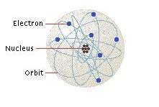
An atom has a nucleus and an electron cloud.
Once an electron moves to a higher-energy orbit, it eventually wants to return to the ground state. When it does, it releases its energy as a photon -- a particle of light. You see atoms releasing energy as photons all the time. For example, when the heating element in a toaster turns bright red, the red color is caused by atoms excited by heat, releasing red photons. An excited electron has more energy than a relaxed electron, and just as the electron absorbed some amount of energy to reach this excited level, it can release this energy to return to the ground state. This emitted energy is in the form of photons (light energy). The photon emitted has a very specific wavelength (color) that depends on the state of the electron's energy when the photon is released.
Anything that is alive uses energy, and so do many inanimate items such as engines and rockets. Energy consumption generates heat. In turn, heat causes the atoms in an object to fire off photons in the thermal-infrared spectrum. The hotter the object, the shorter the wavelength of the infrared photon it releases. An object that is very hot will even begin to emit photons in the visible spectrum, glowing red and then moving up through orange, yellow, blue and eventually white. Be sure to read How Light Bulbs Work, How Lasers Work and How Light Works for more detailed information on light and photon emission.
In night vision, thermal imaging takes advantage of this infrared emission. In the next section, we'll see just how it does this.

Thermal Imaging
Here's how thermal imaging works:
- A special lens focuses the infrared light emitted by all of the objects in view.
- The focused light is scanned by a phased array of infrared-detector elements. The detector elements create a very detailed temperature pattern called a thermogram. It only takes about one-thirtieth of a second for the detector array to obtain the temperature information to make the thermogram. This information is obtained from several thousand points in the field of view of the detector array.
- The thermogram created by the detector elements is translated into electric impulses.
- The impulses are sent to a signal-processing unit, a circuit board with a dedicated chip that translates the information from the elements into data for the display.
- The signal-processing unit sends the information to the display, where it appears as various colors depending on the intensity of the infrared emission. The combination of all the impulses from all of the elements creates the image.
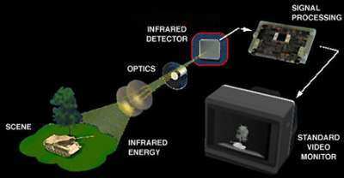
Image courtesy of Infrared, Inc.
The basic components of a thermal-imaging system
Types of Thermal Imaging Devices
Most thermal-imaging devices scan at a rate of 30 times per second. They can sense temperatures ranging from -4 degrees Fahrenheit (-20 degrees Celsius) to 3,600 F (2,000 C), and can normally detect changes in temperature of about 0.4 F (0.2 C).
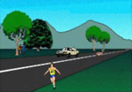  Image courtesy of Infrared, Inc.  It is quite easy to see everything during the day... | Image courtesy of Infrared, Inc.  ...but at night, you can see very little.

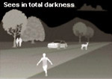
Image courtesy of Infrared, Inc.
Thermal imaging lets you see again.
There are two common types of thermal-imaging devices:
- Un-cooled - This is the most common type of thermal-imaging device. The infrared-detector elements are contained in a unit that operates at room temperature. This type of system is completely quiet, activates immediately and has the battery built right in.
- Cryogenically cooled - More expensive and more susceptible to damage from rugged use, these systems have the elements sealed inside a container that cools them to below 32 F (zero C). The advantage of such a system is the incredible resolution and sensitivity that result from cooling the elements. Cryogenically-cooled systems can "see" a difference as small as 0.2 F (0.1 C) from more than 1,000 ft (300 m) away, which is enough to tell if a person is holding a gun at that distance!
While thermal imaging is great for detecting people or working in near-absolute darkness, most night-vision equipment uses image-enhancement technology.

Image Enhancement
Image-enhancement technology is what most people think of when you talk about night vision. In fact, image-enhancement systems are normally called night-vision devices (NVDs). NVDs rely on a special tube, called an image-intensifier tube, to collect and amplify infrared and visible light.
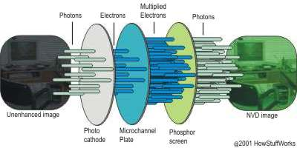
The image-intensifier tube changes photons to electrons and back again.
Here's how image enhancement works:
- A conventional lens, called the objective lens, captures ambient light and some near-infrared light.
- The gathered light is sent to the image-intensifier tube. In most NVDs, the power supply for the image-intensifier tube receives power from two N-Cell or two "AA" batteries. The tube outputs a high voltage, about 5,000 volts, to the image-tube components.
- The image-intensifier tube has a photocathode, which is used to convert the photons of light energy into electrons.
- As the electrons pass through the tube, similar electrons are released from atoms in the tube, multiplying the original number of electrons by a factor of thousands through the use of a microchannel plate (MCP) in the tube. An MCP is a tiny glass disc that has millions of microscopic holes (microchannels) in it, made using fiber-optic technology. The MCP is contained in a vacuum and has metal electrodes on either side of the disc. Each channel is about 45 times longer than it is wide, and it works as an electron multiplier.
When the electrons from the photo cathode hit the first electrode of the MCP, they are accelerated into the glass microchannels by the 5,000-V bursts being sent between the electrode pair. As electrons pass through the microchannels, they cause thousands of other electrons to be released in each channel using a process called cascaded secondary emission. Basically, the original electrons collide with the side of the channel, exciting atoms and causing other electrons to be released. These new electrons also collide with other atoms, creating a chain reaction that results in thousands of electrons leaving the channel where only a few entered. An interesting fact is that the microchannels in the MCP are created at a slight angle (about a 5-degree to 8-degree bias) to encourage electron collisions and reduce both ion and direct-light feedback from the phosphors on the output side.
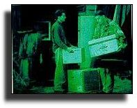
Photo courtesy of B.E. Meyers Company
Night-vision images are known for their eerie green tint.
- At the end of the image-intensifier tube, the electrons hit a screen coated with phosphors. These electrons maintain their position in relation to the channel they passed through, which provides a perfect image since the electrons stay in the same alignment as the original photons. The energy of the electrons causes the phosphors to reach an excited state and release photons. These phosphors create the green image on the screen that has come to characterize night vision.
- The green phosphor image is viewed through another lens, called the ocular lens, which allows you to magnify and focus the image. The NVD may be connected to an electronic display, such as a monitor, or the image may be viewed directly through the ocular lens.

Generations

NVDs have been around for more than 40 years. They are categorized by generation. Each substantial change in NVD technology establishes a new generation.

- Generation 0 - The original night-vision system created by the United States Army and used in World War II and the Korean War, these NVDs use active infrared. This means that a projection unit, called an IR Illuminator, is attached to the NVD. The unit projects a beam of near-infrared light, similar to the beam of a normal flashlight. Invisible to the naked eye, this beam reflects off objects and bounces back to the lens of the NVD. These systems use an anode in conjunction with the cathode to accelerate the electrons. The problem with that approach is that the acceleration of the electrons distorts the image and greatly decreases the life of the tube. Another major problem with this technology in its original military use was that it was quickly duplicated by hostile nations, which allowed enemy soldiers to use their own NVDs to see the infrared beam projected by the device.

- Generation 1 - The next generation of NVDs moved away from active infrared, usingpassive infrared instead. Once dubbed Starlight by the U.S. Army, these NVDs use ambient light provided by the moon and stars to augment the normal amounts of reflected infrared in the environment. This means that they did not require a source of projected infrared light. This also means that they do not work very well on cloudy or moonless nights. Generation-1 NVDs use the same image-intensifier tube technology as Generation 0, with both cathode and anode, so image distortion and short tube life are still a problem.

- Generation 2 - Major improvements in image-intensifier tubes resulted in Generation-2 NVDs. They offer improved resolution and performance over Generation-1 devices, and are considerably more reliable. The biggest gain in Generation 2 is the ability to see in extremely low light conditions, such as a moonless night. This increased sensitivity is due to the addition of the microchannel plate to the image-intensifier tube. Since the MCP actually increases the number of electrons instead of just accelerating the original ones, the images are significantly less distorted and brighter than earlier-generation NVDs.

- Generation 3 - Generation 3 is currently used by the U.S. military. While there are no substantial changes in the underlying technology from Generation 2, these NVDs have even better resolution and sensitivity. This is because the photo cathode is made using gallium arsenide, which is very efficient at converting photons to electrons. Additionally, the MCP is coated with an ion barrier, which dramatically increases the life of the tube.

- Generation 4 - What is generally known as Generation 4 or "filmless and gated" technology shows significant overall improvement in both low- and high-level light environments.
The removal of the ion barrier from the MCP that was added in Generation 3 technology reduces the background noise and thereby enhances the signal to noise ratio. Removing the ion film actually allows more electrons to reach the amplification stage so that the images are significantly less distorted and brighter.
The addition of an automatic gated power supply system allows the photocathode voltage to switch on and off rapidly, thereby enabling the NVD to respond to a fluctuation in lighting conditions in an instant. This capability is a critical advance in NVD systems, in that it allows the NVD user to quickly move from high-light to low-light (or from low-light to high-light) environments without any halting effects. For example, consider the ubiquitous movie scene where an agent using night vision goggles is “sightless” when someone turns on a light nearby. With the new, gated power feature, the change in lighting wouldn’t have the same impact; the improved NVD would respond immediately to the lighting change.
Many of the so-called "bargain" night-vision scopes use Generation-0 or Generation-1 technology, and may be disappointing if you expect the sensitivity of the devices used by professionals. Generation-2, Generation-3 and Generation 4 NVDs are typically expensive to purchase, but they will last if properly cared for. Also, any NVD can benefit from the use of an IR Illuminator in very dark areas where there is almost no ambient light to collect.
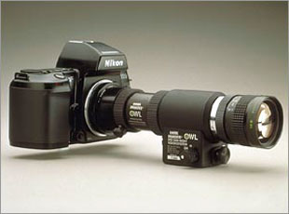
Photo courtesy of B.E. Meyers Company
NVDs come in a variety of styles, including ones that can be mounted to cameras.
A cool thing to note is that every single image-intensifier tube is put through rigorous tests to see if it meets the requirements set forth by the military. Tubes that do are classified as MILSPEC. Tubes that fail to meet military requirements in even a single category are classified as COMSPEC.

Night Vision Equipment and Applications

Night-vision equipment can be split into three broad categories:
- Scopes - Normally handheld or mounted on a weapon, scopes are monocular (one eye-piece). Since scopes are handheld, not worn like goggles, they are good for when you want to get a better look at a specific object and then return to normal viewing conditions.
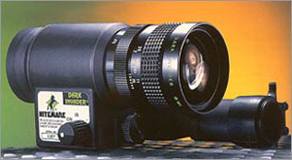
Photo courtesy of B.E. Meyers Company
DARK INVADER Multi-purpose Pocketscope
- Goggles - While goggles can be handheld, they are most often worn on the head. Goggles are binocular (two eye-pieces) and may have a single lens or stereo lens, depending on the model. Goggles are excellent for constant viewing, such as moving around in a dark building.
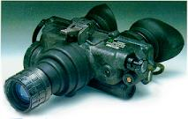
Photo courtesy of B.E. Meyers Company
DARK INVADER Night-vision Goggles 4501
- Cameras - Cameras with night-vision technology can send the image to a monitor for display or to a VCR for recording. When night-vision capability is desired in a permanent location, such as on a building or as part of the equipment in a helicopter, cameras are used. Many of the newer camcorders have night vision built right in.
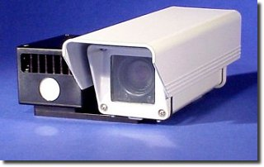
Photo courtesy of B.E. Meyers Company
Stealth 301 Series Day/Night Video Camera

Applications

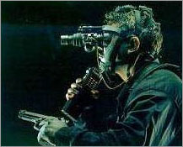
Photo courtesy of B.E. Meyers Company
This soldier is using DARK INVADER night-vision goggles.
Common applications for night vision include:
- Military
- Law enforcement
- Hunting
- Wildlife observation
- Surveillance
- Security
- Navigation
- Hidden-object detection
- Entertainment
The original purpose of night vision was to locate enemy targets at night. It is still used extensively by the military for that purpose, as well as for navigation, surveillance and targeting. Police and security often use both thermal-imaging and image-enhancement technology, particularly for surveillance. Hunters and nature enthusiasts use NVDs to maneuver through the woods at night.
Detectives and private investigators use night vision to watch people they are assigned to track. Many businesses have permanently-mounted cameras equipped with night vision to monitor the surroundings.
A really amazing ability of thermal imaging is that it reveals whether an area has been disturbed -- it can show that the ground has been dug up to bury something, even if there is no obvious sign to the naked eye. Law enforcement has used this to discover items that have been hidden by criminals, including money, drugs and bodies. Also, recent changes to areas such as walls can be seen using thermal imaging, which has provided important clues in several cases.
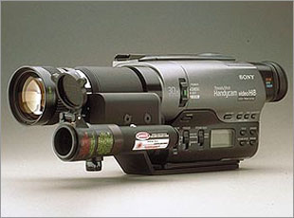
Photo courtesy of B.E. Meyers Company
Camcorders are a fast-growing segment
of the night-vision industry.
Many people are beginning to discover the unique world that can be found after darkness falls. If you're out camping or hunting a lot, chances are that night-vision devices can be useful to you -- just be sure to get the right type for your needs.

BIBLIOGRAPHY

- Websites:www.howstuffworks.com

- Journal :Electronics for u

ACKNOWLEDGEMENT

I take this opportunity to express our profound sense of gratitude and respect to all those who helped me in completing this seminar report.
I express my humble gratitude to the entire staff of ELECTRONICS DEPARTMENT who provided me with the relevant and required information to complete my report.
I would like to thank Mr. Jaspal Jindal (H.O.D.) for his guidance and concern regarding our project. Then I would like to than Mr. Mahajan , Mr. Nazim , Miss Renu Rawat for expressing their confidence in me & providing their support, help and encouragement in implementing this report.

ANUJ KALRA
(05/EL017)

INDEX

- INTRODUCTION: NIGHT VISION TECHNOLOGY

- HISTORY

- INFRARED LIGHT

- ATOM

- THERMAL IMAGING

- IMAGE ENHANCEMENT

- GENERATIONS

- NIGHT VISION EQUIPMENTS

- APPLICATIONS

- BIBLIOGRAPHY

