- home
- contact
- links
- participate!
- policy
- showcase
- sitemap
- store
- Audio
- Datasheet
- DIY
- Gadgets
- Hobby
- Lights
- Measure
- Power supply
- Radio
- Service
- Solar
- Theory
- Useful
- Various »
Find more projects

CELL PHONE JAMMER CIRCUIT
A beautiful diy gsm jammer or mobile cell phone jammer schematic diagram for use only in GSM1900 with frequency from 1930 MHz to 1990 MHz. The GSM1900 mobile phone network is used by USA, Canada and most of the countries in South America.

Mobile cellphone jammer circuit diagram
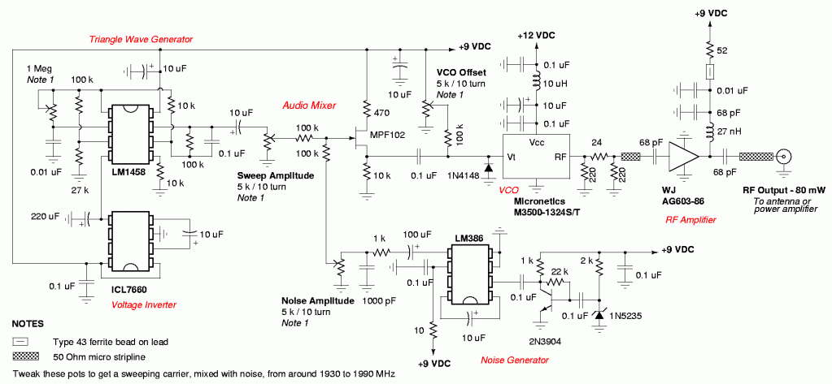
This cell phone jammer is not applicable for use in Europe, Middle East, nor Asia.
The GSM jammer circuit could block mobile phone signals which works on GSM1900 band, also called DCS. For more cell phone jammers check the related posts.
LM386 datasheet

Do you want to buy a cellphone jammer?
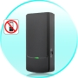Mini Wireless Cellphone Signal Jammer – $35.24
An awesome mini wireless cellphone jammer — that deceptively comes in the shape of a cellphone! Not only is it effective at shutting down GSM and 3G cellphone signals – it even eliminates older CDMA and DCS mobile phones for silence all around, all the time!
Industrial Cell Phone Jammer – $81.24
If you’re looking for a high-power, technologically advanced cellphone jamming solution – you’ve found it with the Industrial Strength Cell Phone Jammer for CDMA, GSM, DCS, and even 3G!
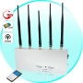5 Antenna Cell Phone Scrambler – $79.35
For absolute jamming of any cell phone signal, there is no stronger or more efficient solution than the 5 Antenna Cell Phone Jammer with Remote Control. This high quality device provides you with 10 Watts of output power and 5 powerful high gain antennas to completely block all mobile phone signals within 50 meters.
Find more projects

﻿

37 Responses to “Cell phone jammer circuit”
- Gregory Kerr
January 26, 2009 at 2:52 pm
I would like to let you know that listing to someones phone calls is a breach of privicy anso the sue of mobile phone jamming may also land you in prison or a possable death sentence.
  - Omnidon
April 23, 2009 at 8:39 pm
Death sentence huh…I seriously doubt that unless you are living 20 years ago in the USSR…are you? No the worse that can happen to you if you get caught ( the odds of that happening are slim to none unless you are STUPID and parade around waving it in your hand screaming at the top of your lungs what the hell it is…) is up to a 10,000 dollar fine from the FCC.
  - Hurricane
December 19, 2009 at 3:47 pm
You sir are very very wrong, it is against telecommunication rules in many countries but all you will get is a very large fine, it is almost impossible to get caught if you are discreet.
BTW, this does NOT listen to calls, it emits signals that make cell phones cease to work properly. A nice trick while watching a movie or waiting for a doctor.
- marius
January 26, 2009 at 9:41 pm
) Sorry …
This is not a device for listening someones phone calls, its just for blocking the cell phone signal.
The mobile phones encrypt their signal and its hard and expensive to decrypt the signal from a mobile phone.
- hell boy
January 27, 2009 at 6:51 am
mr gregory ur attitude suxx!!
u must encourage the innovative ideas not discourage it!!!
jammers r essential in exam halls,hospitals n schools.
u must do a conscious check before acting.
Best of luck dude!!!!
- jammers
February 4, 2009 at 1:13 pm
I just picked up a jammer from cellphonejammer.cn and used it in the mall….OMG, so much fun!
  - srinivas
May 25, 2009 at 11:55 am
hi dudue.dis is srinvias.am in need of cell or mobile jammers plz do send me a circiut diagram or schematics which can jam at a frequncy of 800 mhz of gsm mobiles
- ayaz
February 17, 2009 at 11:02 am
Hi
i am locking GSM FWT circuit diagram that can suport PABX,if you can help so please reply
  - vLaD
March 21, 2009 at 4:02 pm
Hi ayaz, i need jammers circuit diagram. can you help me?
sorry for my english. Here in my country , use GSM in the four bands. I dont remember the freq.
thks and regards.
vLad
- sandesh
February 23, 2009 at 6:26 am
i need description of circuit diagram,….
i also want to know that, will this circuit jam the signal in inda….
  - nauman
February 24, 2009 at 7:46 am
I am also working on a cell phone jammer.If you have succeeded in all this work;please share it with me.I will be great ful…
my e mail add is nomino_747 @ hotmail.com
- perplexed6
February 24, 2009 at 4:42 am
I needed a schematic for dual band GSM 900/1800… what are the changes i might have to make in this?
  - face_baby
October 22, 2009 at 10:28 am
I think that is 900/1800 or i’m wrong?
  - junaid
November 23, 2009 at 9:35 am
hy..plz send me circuit diagram of signal jammer…if u have on atish_khan2003@yahoo.cm………pllllllzzzzzzzzzz
- kamran
March 31, 2009 at 5:45 am
its a very amazing ckt….if any body has scematic of mobil tacker and capture of calls ckt then plz help me .. thanks
- wirelessphonejammer
May 6, 2009 at 3:06 am
almost seven years after the first report about cell phone jammer,now cell phone jammer become commen in lots of countries and it is known by more and more persons.you can find this kind of item by google just type cell phone jammer,you will find the manufacture just like wirelessphonejammer.com ,the price become lower and lower.
Though in some countries,the product is illegal,its existance prove it is needed by some persons
- Adebayo
June 22, 2009 at 11:14 am
pls,am ask to construct and design freq.wireless network multi-jammer.pls i need suitable write up on it and how to go about the design.thanks.
  - farhan
July 13, 2009 at 5:59 am
hello friend. i have info how to construct and design. this is my project in my university. here is my mail address
mfzaidi_uit[@]hotmail.com
contact me by email as soon as possible
- SectechBiz
July 15, 2009 at 11:14 am
If some one need cell phone jammers then contact us , we provide the such type of security solution in worldwide
  - pradeepak
September 1, 2009 at 5:36 pm
hi
this is pradeepak prefinal year student of ECE.i want to design cellphone jammer which can use in india as miniproject.please help it is urgent.please send me schematic.my id pradeepak1990@gmail.com
    - patrick
February 12, 2010 at 1:53 pm
hello friend. i have info how to construct and design. this is my project in my university. here is my mail address
mfzaidi_uit[@]hotmail.com
contact me by email as soon as possible
  - frank
February 25, 2010 at 1:51 am
i am intrested in purchasing a few how much how big?
thanks
- Aslan
July 25, 2009 at 5:57 am
Is this equipment meant to block a users cellphone signal when someone is trying to introduce a connection to listen onto the device being used. If so does it block major companys like verizon, at&t, t-mobile and etc. Or is it meant to block singnals coming from certain models of phone? Is so what models? i need more information about it. Cap_Com@live.com
  - Bcaseb
December 2, 2009 at 7:04 pm
@Aslan, no, GSM is a standard of the cell phone industry. If I’m reading all of this info correctly, it blocks all phones that use the GSM standard.
Ex.)
Person A does not use a GSM-type phone and his carrier does not use it, they use some older, archaic type of communication.
Person B uses a GSM-enabled phone.
most people fall under this category.
Person C has a high tech smart phone, using multiple systems to communicate.
Use this jammer and people on the 1930-1990 MHz range, or GSM, (not 100$ on this) have static/noise played on their ENCRYPTED signal frequency. This noise combines with the actual signal to make a jumbled up signal. The phone cannot decrypt the signal properly if there are bits and bytes that dont fit, aka a corrupted signal. Since the phone can’t decrypt this, it tells the user it has no signal; effectively jamming the service.
p.s. the GSM standard covers a few different frequency ranges, and the one most popular in the U.S. is the 1900-1990 MHz band. This jammer works best in the U.S. as it targets this range of frequencies.
I hope this helps. =D
- Bongo
August 24, 2009 at 10:31 am
It’s true! I tried listening to someone’s phone call and the FCC came around with a their own SWAT team and killed me. But when I got to heaven God told me how much he hates cellulars and sent me back to share jammers with the world. Who am I to say no to God?
- LOHITH
August 31, 2009 at 11:53 am
this is a woderfull circuit i need full details about this . i want compleat details of this &i want this circuit b oprated in india plz send about it i dont no at wat gsm using here
- Arsalan Haider
October 3, 2009 at 10:06 pm
hi frends
i want to make a mini mobile jammer so please help me
i am a student of Electronics please inform me what should i do ,,,,,
03333107313
here is my no please u can inform me on my cell
thank
Arsalan
- AJENDRA
October 29, 2009 at 5:59 am
hi i want this project plz help me on coolajendradabhi@gmail.com or +919510079083
- Amadi Ichebadu
November 19, 2009 at 9:24 am
pls help me i want to build a dispenser that can dispens water and ice cream and tea pls my num is +2347030278060
- sreeja
December 4, 2009 at 5:32 pm
y cant this mobile jammer ‘ll not block CDMA…what changes should we make for that in the circuit
- jena He
December 25, 2009 at 5:59 am
we supply all kinds of mobile signal booster/repeater and jammer with high quality , pls feel free to visit our website http://www.asicon.netand http://www.dzxcon.com .
Email: jena@dzxcon.com
MSN:ascjena0910@hotmail.com
Skype:jena0910
Mobile: 0086-15818561923
- fortune
December 30, 2009 at 4:00 am
Hello, This is fortune chou from Tangreat,china
if you are interested in cellphon jammers, pls contact me anytime.
looking forward to hearing from you soon.
Best regards
fortune
Shenzhen Tangreat Technology,co.,Ltd
Tel: 0086-755-33611881
Mobile: 0086-13670292315
Fax: 0086-755-82527821
Skype: tangreat0909
MSN: tangreat09@hotmail.com
- fortune
January 8, 2010 at 6:16 am
Hello, Thank you very much for your patience .
If you are interested in cell phone jammer or need more details , you can contact me anytime.www.tangreat.com
Thanks
Fortune chou
Tel: 0086-755-33611881
Mobile: 0086-13670292315
  - KASHIF
January 11, 2010 at 5:23 pm
hello sir,
sir i need cellur phone jammer circuit diagram. i live in pakistan. In pakistan the frequency use with respect i need that circuit diagram
- мaлышyля
January 10, 2010 at 10:01 pm
Так ведь без недостатков и достоинства незаметны
- jaspartap singh
February 23, 2010 at 10:51 am
hello,i want this project,i want to build this jammer.kindly send its detail to jaspratapsingh@gmail.com.is it wokable in india….
- Ris_ilient@yahoo.com
February 25, 2010 at 2:34 am
You are all under arrest! Me and The Mothers of America are gunna shut this site down! Just kidding. This is a cool site! Thanks!
receive the projects by email

related electronic projects
- Cell phone detector aka mobile bug
- Mobile phone sniffer – gsm telephone detector
- Top 10 Electronic Circuits February 2011
- Mobile Phone Travel Charger
- Mobile Scanner Circuit
recent electronic circuits
- Telephone ringtone generator circuit
- Flashing Lights Circuit
- Simple water detector circuit
- Micro-GT servo motor driver
- Top 10 Electronic Circuits June 2011
last 7 days popular posts
- Solar Charger Circuit
- Cell phone detector aka mobile bug
- TransformerLess Power Supply 12V 100mA
- Mobile Phone Travel Charger
- Sensitive Clap Switch circuit
- Long range FM transmitter
- 12V to 220V converter circuit
- Capacitor Power Supply circuit
- Clap Switch Circuit
- FM Module with USB Function
become our friend on facebook

