PREFACE
This assignment given to us is about feasibility of solar energy in Pakistan. We have tried our best together as much information as we can present in the form of completely arranged booklet
As far as its contents are concerned, it includes the necessary introduction to the topic and the basic knowledge about the scope of solar energy in Pakistan to overcome the power shortage, one of the major crises Pakistan is facing now days.
During completing this assignment it was our intention to cover all major topics regarding solar energy, its benefits, and its drawbacks.
In presenting a good deal of information concerning the topic of this assignment, every group member did different jobs in order to divide the bulk of this assignment. We collectively gathered information from the internet and various books to present the data in the complete form.
In the end, we would like to thank again all the people who helped us. We hope that our assignment will prove beneficial to our class mates as well as the others seeking information about the solar energy and its feasibility in Pakistan.

CONTENTS
- INTRODUCTION AND TYPES OF ENERGY………………………...03
- ENREGY SOURCES: SOLAR ENERGY………………………………04
- TYPES OF SOLAR ENERGY AND ITS IMPORTANCE……...……..05
- ENERGY CRISIS IN PAKISTAN………………………………………08
- POSSIBLE SOLUTIONS OF ENERGY CRISIS IN PAKISTAN AND SOLAR ENERGY AS THE SOLUTION IN PAKISTAN……..…...….09
- CLIMATE DISTRIBUTION IN PAKISTAN………………………..…10
- SUITABLE TEMPERATURE FOR SOLAER ENERGY IN PAKISTAN………………………………………………………………..11
- SCOPE OF SOLAR ENERGY IN PAKISTAN……………………...…12
- USE OF SOLAR ENERGY IN DIFFERENT CITIES OF PAKISTAN…………………………………………………………….….13
- AUTHORITIES AND SOLAR ENERGY COMPANIES IN PAKISTAN…………………………………………………………….….15
- ADVANTAGES OF SOLAR ENERGY IN PAKISTAN………….…..16
- DRAWBACKS OF SOLAR ENERGY IN PAKISTAN………..……..17
- REFFERENCES………………………………………………………..…19

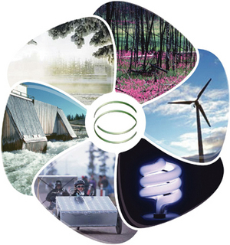
Energy:-
Energy is a scalar physical quantity that describes the amount of work that can be performed by a force, an attribute of objects and systems that is subject to a conservation law
Different forms of energy include kinetic, potential, thermal, gravitational, sound, light, elastic, and electromagnetic energy. The forms of energy are often named after a related force.
Any form of energy can be transformed into another form, but the total energy always remains the same. This principle, the conservation of energy, was first postulated in the early 19th century, and applies to any isolated system.
Types of Energy:
There are two types of energy
- Primary energy
- Secondary energy
- Primary Energy
Primary energy is energy found in nature that has not been subjected to any conversion or transformation process.
Primary energy is energy contained in raw fuels and any other forms of energy received by a system as input to the system.
The concept is used especially in energy statistics in the course of compilation of energy balances. Primary energy includes non-renewable energy and renewable energy.
- Secondary Energy
Primary energies are transformed in energy conversion processes to more convenient forms of energy, such as electrical energy, refined fuels, or synthetic fuels such as hydrogen fuel. In energy statistics these forms are called energy. Secondary energy is an energy form which has been transformed from another one. Electricity is the most common example, being transformed from such primary sources as coal, oil, natural gas, and wind.

Energy Sources:
The following are some of the energy sources
- Solar Energy
- Wind Energy
- Water Energy
- Tidal Energy
- Wave Energy
- Solid Biomass
- Bio Gas
- Geothermal Energy

Solar Energy:
Solar energy is the radiant light and heat from the Sun that has been harnessed by humans since ancient times using a range of ever-evolving technologies. Solar radiation along with secondary solar resources such as wind and wave power, hydroelectricity and biomass account for most of the available renewable energy on Earth. Only a minuscule fraction of the available solar energy is used.
Solar power provides electrical generation by means of heat engines or photovoltaic. Once converted, its uses are limited only by human ingenuity. A partial list of solar applications includes space heating and cooling through solar architecture, potable water via distillation and disinfection, day lighting, hot water, thermal energy for cooking, and high temperature process heat for industrial purposes.
Solar technologies are broadly characterized as either passive solar or active solar depending on the way they capture, convert and distribute sunlight. Active solar techniques include the use of photovoltaic panels and solar thermal collectors (with electrical or mechanical equipment) to convert sunlight into useful outputs. Passive solar techniques include orienting a building to the Sun, selecting materials with favorable thermal mass or light dispersing properties, and designing spaces that naturally circulate air.

Types of Solar System:
There are two types of solar system
- Active Solar System
- Passive Solar System
- Active Solar System
An active solar system is a system that uses a mechanical device, such as pumps or fans run by electricity in addition to solar energy, to transport air or water between a solar collector and the interior of a building for heating or cooling.
- Passive Solar System
A passive solar system is a system that distributes collected heat via direct transfer from a thermal mass rather than mechanical power. Passive systems rely on building design and materials to collect and store heat and to create natural ventilation for cooling.
Importance of Solar Energy:
The following points indicate the importance of solar energy in Pakistan:

Solar lighting

Water heating

Heating, cooling and ventilation

Electrical generation
- Solar Lighting
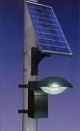
In the 20th century artificial lighting became the main source of interior illumination but day lighting techniques and hybrid solar lighting solutions are ways to reduce energy consumption. Day lighting systems collect and distribute sunlight to provide interior illumination. This passive technology directly offsets energy use by replacing artificial lighting, and indirectly offsets non-solar energy use by reducing the need for air-conditioning. Although difficult to quantify, the use of natural lighting also offers physiological and psychological benefits compared to artificial lighting. Day lighting design implies careful selection of window types, sizes and orientation; exterior shading devices may be considered as well. Individual features include saw tooth roofs, clerestory windows, light shelves, skylights and light tubes. They may be incorporated into existing structures, but are most effective when integrated into a solar design package that accounts for factors such as glare, heat flux and time-of-use. When day lighting features are properly implemented they can reduce lighting-related energy requirements by 25%.
Hybrid solar lighting is an active solar method of providing interior illumination. HSL systems collect sunlight using focusing mirrors that track the Sun and use optical fibers to transmit it inside the building to supplement conventional lighting. In single-story applications these systems are able to transmit 50% of the direct sunlight received. Solar lights that charge during the day and light up at dusk are a common sight along walkways.
Although daylight saving time is promoted as a way to use sunlight to save energy, recent research has been limited and reports contradictory results: several studies report savings, but just as many suggest no effect or even a net loss, particularly when gasoline consumption is taken into account. Electricity use is greatly affected by geography, climate and economics, making it hard to generalize from single studies.
- Water Heating
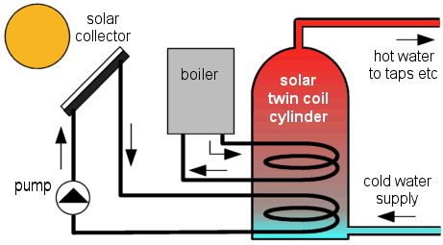
Pakistan has best condition available for water heating by solar energy. Solar hot water systems use sunlight to heat water. In low geographical latitudes (below 40 degrees) from 60 to 70% of the domestic hot water use with temperatures up to 60 °C can be provided by solar heating systems. The most common types of solar water heaters are evacuated tube collectors (44%) and glazed flat plate collectors (34%) generally used for domestic hot water; and unglazed plastic collectors (21%) used mainly to heat swimming pools.
As of 2007, the total installed capacity of solar hot water systems is approximately 154 GW. China is the world leader in their deployment with 70 GW installed as of 2006 and a long term goal of 210 GW by 2020. Israel and Cyprus are the per capita leaders in the use of solar hot water systems with over 90% of homes using them. In the United States, Canada and Australia heating swimming pools is the dominant application of solar hot water with an installed capacity of 18 GW as of 2005.
- Heating Cooling and Ventilation
In many countries, heating, ventilation and air conditioning (HVAC) systems account for 30% (4.65 EJ) of the energy used in commercial buildings and nearly 50% (10.1 EJ) of the energy used in residential buildings. Solar heating, cooling and ventilation technologies can be used to offset a portion of this energy.
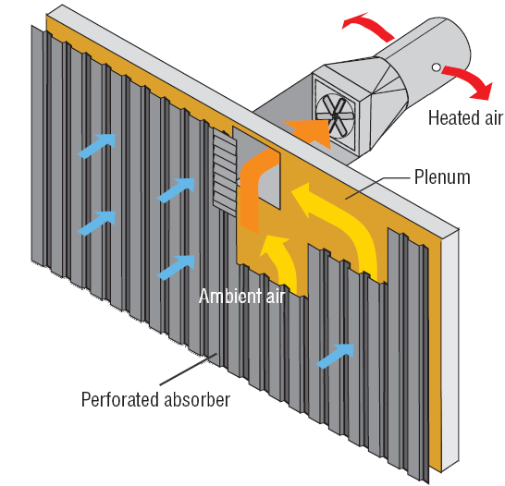
Thermal mass is any material that can be used to store heat—heat from the Sun in the case of solar energy. Common thermal mass materials include stone, cement and water. Historically they have been used in arid climates or warm temperate regions to keep buildings cool by absorbing solar energy during the day and radiating stored heat to the cooler atmosphere at night. However they can be used in cold temperate areas to maintain warmth as well. The size and placement of thermal mass depend on several factors such as climate, day lighting and shading conditions. When properly incorporated, thermal mass maintains space temperatures in a comfortable range and reduces the need for auxiliary heating and cooling equipment.
A solar chimney (or thermal chimney, in this context) is a passive solar ventilation system composed of a vertical shaft connecting the interior and exterior of a building. As the chimney warms, the air inside is heated causing an updraft that pulls air through the building. Performance can be improved by using glazing and thermal mass materials in a way that mimics greenhouses.
Deciduous trees and plants have been promoted as a means of controlling solar heating and cooling. When planted on the southern side of a building, their leaves provide shade during the summer, while the bare limbs allow light to pass during the winter. Since bare, leafless trees shade 1/3 to 1/2 of incident solar radiation, there is a balance between the benefits of summer shading and the corresponding loss of winter heating. In climates with significant heating loads, deciduous trees should not be planted on the southern side of a building because they will interfere with winter solar availability. They can, however, be used on the east and west sides to provide a degree of summer shading without appreciably affecting winter solar gain.
- Electrical Generation
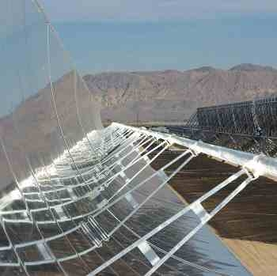
Sunlight can be converted into electricity using photovoltaic (PV), concentrating solar power (CSP), and various experimental technologies. PV has mainly been used to power small and medium-sized applications, from the calculator powered by a single solar cell to off-grid homes powered by a photovoltaic array. For large-scale generation, CSP plants like SEGS have been the norm but recently multi-megawatt PV plants are becoming common. As an intermittent power source, solar power requires a backup supply, which can partially be complemented with wind power. Local backup usually is done with batteries, while utilities normally use pumped-hydro storage. The Institute for Solar Energy Supply Technology of the Pakistan pilot-tested a combined power plant linking solar, wind, biogas and hydro storage to provide load-following power around the clock, entirely from renewable sources.
Energy crises in Pakistan:
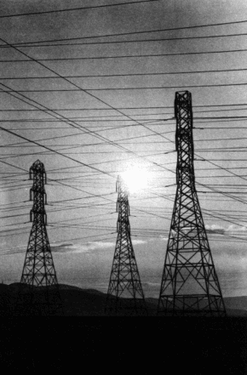
An energy crisis is any great shortfall (or price rise) in the supply of energy resources to an economy. It usually refers to the shortage of oil and additionally to electricity or other natural resources.
The crisis often has effects on the rest of the economy, with many recessions being caused by an energy crisis in some form. In particular, the production costs of electricity rise, which raises manufacturing costs.
For the consumer, the price of gasoline (petrol) and diesel for cars and other vehicles rises, leading to reduced consumer confidence and spending, higher transportation costs and general price rising.
Energy resources have depleted! Whatever resources are available are simply too expensive to buy or already acquired by countries which had planned and acted long time ago. Delayed efforts in the exploration sector have not been able to find sufficient amounts of energy resources. Nations of the world which have their own reserves are not supplying energy resources anymore; only the old contracts made decades ago are active. Airplanes, trains, cars, motorbikes, buses and trucks, all modes of transportation are coming to a standstill.
In Pakistan many industries have closed due to insufficient power supply. Price of oil has gone above the ceiling. At domestic level, alternate methods like solar, biogas and other methods are being tried for mere survival.
The above is a likely scenario of Pakistan and around the globe after 25 years. A pessimistic view, but realistic enough to think about and plan for the future. But are we doing anything about it? Let’s have a look at the current energy situation of Pakistan
Pakistan’s economy is performing at a very high note with GDP growing at an exceptional rate, touching 8.35% in 2004-05.In its history of 65 years, there has been only a few golden years where the economy grew above 7%.
Pakistan’s energy requirements are expected to double in the next few years, and our energy requirements by 2015 is likely to cross 120MTOE. By 2030, the nation’s requirement will be 7 times the current requirement reaching 361MTOE.
Pakistan’s energy requirements are fulfilled with more than 80% of energy resources through imports. On the other hand, international oil prices have not only broken all records but are touching new highs, with every news directly or indirectly affecting the black gold industry. Moreover, speculators all around the world expect oil prices to touch $350 per barrel in medium term. With concerns over Iran’s nuclear program, terrorist issues in Nigeria and high economic growth in China & India and their ever rising energy requirements, oil prices don’t see any another way but to shoot upwards.
Solution of energy crises in Pakistan:
The simplest solution to solve the energy crises is the use of renewable energy resources. This is because
- One major advantage with the use of renewable energy is that as it is renewable it is therefore sustainable and so will never run out.
- Renewable energy facilities generally require less maintenance than traditional generators.
- Their fuel being derived from natural and available resources reduces the costs of operation.
- Even more importantly, renewable energy produces little or no waste products such as carbon dioxide or other chemical pollutants, so has minimal impact on the environment.
- Renewable energy projects can also bring economic benefits to many regional areas, as most projects are located away from large urban centers and suburbs of the capital cities. These economic benefits may be from the increased use of local services as well as tourism.
Solar Energy as a Problem Solver in the Pakistan:

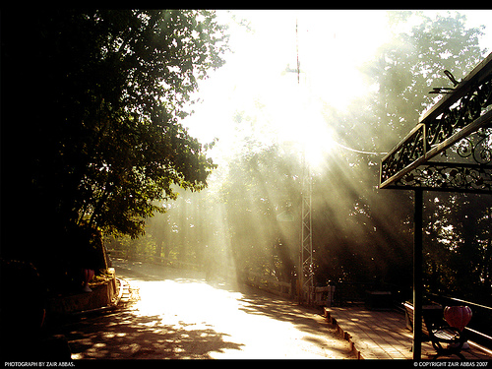
Pakistan covers 796,095 square kilometers of land between latitudes 24° and 36° north and longitudes 61° and 76° east. At present, it faces serious energy problems: 95 per cent of its electricity generation comes from hydropower, which becomes less productive during the driest, hottest months of the year and cannot keep pace with the sharp rise in energy demand.
Also, about 70 per cent of the population lives in some 50,000 villages dispersed around the country. Many of these villages are far from the main transmission lines of the national grid and, because of their relatively small populations; it is usually not economically viable to connect these villages to the grid. Solar energy, on the other hand, has excellent potential in areas of Pakistan that receive high levels of solar radiation throughout the year. Every day, for example, the country receives an average of about 19 mega joules per square meter of solar energy.
Solar energy systems have already been developed and tested, and they should now be adopted extensively as a way of supporting the economy of the country and improving the living standards of its people. Not only can solar systems meet basic needs of rural areas, but they can also reduce the pressure on conventional energy sources in urban areas, leaving more of these valuable resources for other domestic and industrial needs. Solar geysers and cookers can be installed in remote rural and suburban areas and are a safe, pollution-free alternative to gas, other electricity sources and wood. They can also replace the traditional use of wood or dried dung for domestic cooking, thereby solving significant health and environmental problems.

Wood conservation is particularly significant in rural areas, where demand for fuel wood is leading to widespread deforestation. As a result of deforestation and other ecological changes, rainfall has decreased, temperatures have risen, water-table levels have fallen, and agriculture is suffering. At the same time, women and children, in particular, are suffering the health implications of inhaling fumes from dung and other materials. The effects of the new technology are:

- reduced deforestation;
- improved environmental conditions;
- better health for many rural people;
- less rural to urban migration;
- enhanced agricultural development;
- poverty alleviation

Solar energy is most suitable for use in Pakistan due to the climate distribution in Pakistan. This is mentioned below…
Climate Distribution in Different Parts of Pakistan:
Depending on the topography, there is an extreme variation in the temperature of Pakistan. The country is essentially arid except for the southern slopes of the Himalayas and the sub-mountainous tract where the annual rainfall varies between 760 and 1270 mm. This area has humid sub-Tropical climate. In the extreme north - because of great heights - Highland climate prevails. The controlling factors of the climate are:
- The sub-Tropical location of Pakistan that tends to keep the temperature high, particularly in
summer.
- The oceanic influence of the Arabian Sea that keeps down the temperature contrast between summer and winter at the coast.
- Higher altitudes in the west and north that keep the temperature down throughout the year.
- The Monsoon winds that bring rainfall in summer.
- The Western Depression originating from the Mediterranean region and entering Pakistan from the west that brings rainfall in winter. These cyclones make a long land journey and are thus robbed of most of the moisture by the time they reach Pakistan.
- A temperature inversion layer at a low elevation of about 1,500 m in the south during the summer that does not allow the moisture-laden air to rise and condensation to take place.

Suitable Temperature for Solar Energy:
Pakistan can be divided into four broad temperature regions:
- Warm summer and mild winter: 21 - 32oC in summer and 10 to 21oC in winter.
- Hot summer and mild winter: 32o C or more in summer and 10 to 21o C in winter.
- Warm summer and cool winter: 21 - 32oC in summer and 0 - 10oC in winter.
- Mild summer and cool/cold winter: Summer temperature between 10 and 21oC and winter temperature between 0 and 10oC.

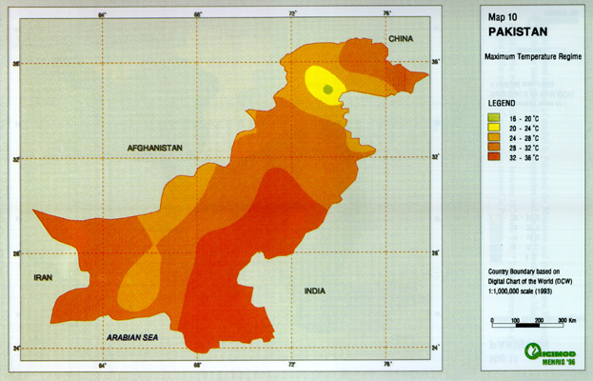

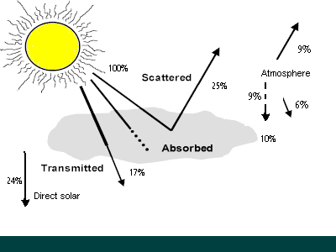
How Much Energy Does the Sun Provide? Will it Work in Pakistan?
The surface receives about 47% of the total solar energy that reaches the Earth. Only this amount is usable. Each year, the sun’s radiation provides the Earth with 174 megawatts of energy. Pakistan has an ideal climate for solar given the hot, sunny climate, long daytime hours and unstable grid power generation but cannot utilize much more energy received from the sun.

Scope of Solar Energy in Pakistan:
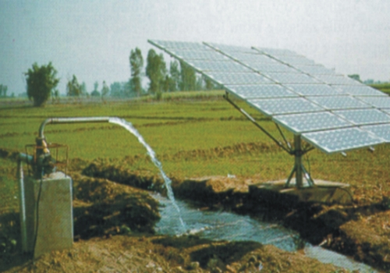
Pakistan is an exceptionally sunny country. If 0.25% of Baluchistan was covered with solar panels with an efficiency of 20%, enough electricity would be generated to cover all of Pakistani demand.
Solar energy makes much sense for Pakistan because, 70% of the population lives in 50,000 villages that are very far away from the national grid, according to a report by the Solar Energy Research Centre (SERC). Connecting these villages to the national grid would be very costly, thus giving each house a solar panel would be cost efficient and would empower people both economically and socially. In many Pakistani villages, wood and animal dung is used for cooking fuel; however, this is causing widespread deforestation.

Appreciating solar energy versatility in Pakistan:
You can use solar energy in many ways in Pakistan. In Pakistan solar power lets you do anyof the following:
- Generate electricity for general use: in Pakistan you can install a solar electric generating system that allows reducing electric bills to zero. This is one of the most popular solar application on the market today, and the growth in solar powered electrical systems is over 25% per year in Pakistan.
- Cook: in Pakistan by using the sun and vivid imagination, along with a few easy-to-build ovens and heaters, solar power can help to put dinner on the table.
- Practice passive space heating: the sun can heat your house in Pakistan by strategic use of blinds, awnings, sunrooms and the like.
- Heat water: in Pakistan you use solar energy to heat your domestic water supply or let sun-warm water heat your house by pumping it through appropriate plumbing systems. You may need no electrical pumps or moving parts other than the water itself.
- Pump water: in Pakistan you can slowly pump water into a tank when the sun is shining and then get the water back any time you want. You can also make your tank absorbs sun light and heat the water, thereby reducing the power load on your domestic water heater.
- Heat your swimming pool: you can cover your pool with the solar blanket to heat it cheaply and efficiently in Pakistan, or you can install solar hot water heating panels on your roof that can heat your pool year round.
- Add landscape lighting: you can put small inexpensive solar lights around your yard and eliminate the need for high-priced over head lighting power by the utility company. With advances in technology, these lights actually look and work better than hard-wired versions. This is the most widely assessable solar technology, and it is nearly fool proof and best operating conditions are available in Pakistan for it.
- Provide indoor lighting: you can light your porches and even rooms in your house with small, off-grid photovoltaic systems connected to a battery. During the day, the battery charges so that you have enough juice at night to do the job in Pakistan.
- Power remote dwellings: you can completely power a remote cabin, RV, or boat with solar.
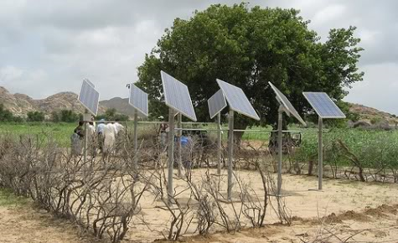
Solar Energy Usage in Different Cities of Pakistan:
The use of solar energy for the generation of electricity is not something new. Most of the countries are doing it successfully for decades and their population benefiting through the use of this free resource. But, to most of the people, it may still look like a mystery. These days, this energy is being utilized to light our homes, run fans, provide power to our fridges and microwave ovens, assist in warming our homes and swimming pools, provide power to our gardens and street lights, run our TVs and computers, and extract water from the sub-soil for irrigation purposes.
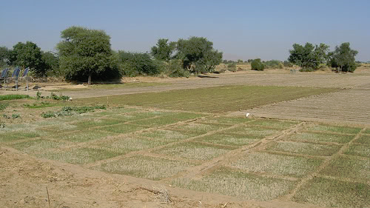
A practical example of the use of solar energy could be seen in some villages of Pakistan where each house has been provided with a solar panel sufficient to run an electric fan and two energy saving bulbs. The whole village used to be plunged in pitch dark during night. One such example is the village with the name of Narian Khorian, some 50 kilometers away from Islamabad, where 100 solar panels have been installed by a local firm, free of cost, to promote the use of solar energy among the masses. Through these panels, the residents of 100 households are enjoying light and fan facilities.

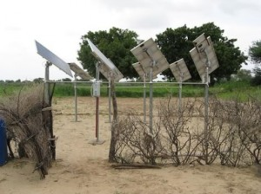
Another example seen on the newly constructed Murree Road from Rawalpindi (Faizabad) towards Murree there is side blinking red hazard lights installed at the top of each WAPDA pole. Each of these lights is being powered by a stand-alone solar system i.e. a solar panel and a battery. It is much expensive and full of hassle if solar panels were not used for this purpose and these lights were provided normal electric connections.
In the next few years it is expected that millions of households in the world will be using solar energy as the trends in USA and Japan show. In Pakistan too, the Pakistan Renewable Energy Development Agency and the Ministry of Non-Conventional Energy Sources are formulating a program to have solar energy in more than a million households in the next few years. However, the people’s initiative is essential if the program is to be successful.
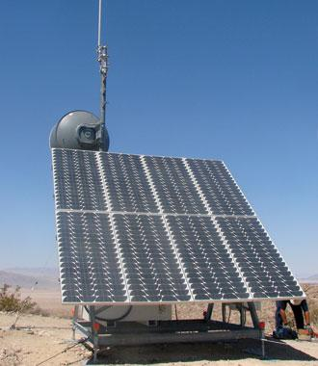
Solar Cells in Pakistan
To import huge quantity of solar cells from other countries is much more difficult task. Naturally, there would be no other option but to resort to manufacturing these cells in Pakistan. Once it has been decided in principle to manufacture solar cells in Pakistan, then look for three basic requirements i.e. raw material, trained manpower and necessary infrastructure.
The basic raw material (quartz) is available in abundance in the northern areas Pakistan. But, this raw material is useless for us as far as its purification and development to a stage where this raw material could be converted into solar cells is concerned. This equipment will have to be imported; but it would be a one-time investment. This raw material is being utilized by the local population of Northern areas for raising the walls of their houses in place of bricks as the poor know its value. Some of them take it for marble as well.
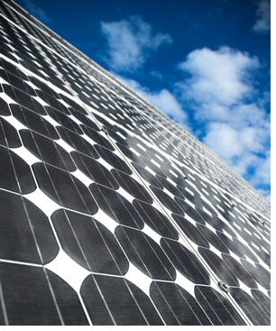
The other raw material required to manufacture solar cells is silica (sand) which is available in inexhaustible quantity in River Sindh as water these days is otherwise in less quantity in our rivers. At least we should make use of silica in the manufacture of solar cells. So, to venture into manufacturing of solar panels, both the raw materials are available.
The other requirement is that of manpower. I have no qualms in making a statement here that we have the finest and the most hard-working, skilled manpower available in country. From my personal experience, I could say with conviction that the retired personnel of the defence services who have been working on electronics and telecommunication equipment during their service careers would be the best choice for deployment on the manufacture of solar panels and cells. These people are highly skilled and disciplined and get retired at an early age. Shaheen Foundation, Islamabad maintains an up-to-date computerized record of such personnel who are just a telephone call away. The expertise of such workers is not less than any worker deployed in the western countries for such jobs. The only difference is that a European worker of such calibre gets US $ 45 per hour whereas a Pakistani worker, if he is paid $5 per hour (or even less) in his own country would be the happiest man around.

List of Solar Energy Companies in Pakistan:
- Akhter Solar Limited
- Alt-Energy Tech Inc. Pakistan (PVT) Ltd
- Clean Power (Pvt.) Ltd.
- Crest International Trading Co.
- Electro Control Industries (Pvt) Ltd
- NATIONAL ENGINEERING CORPORATION
- Socio-Engineering Consultants
- Trillium Pakistan (Pvt) Ltd
- Adaptive Technologies (Pvt) Ltd

Authorities for the promotion of solar energy:
Government of Pakistan have takes some serious steps in order of Alternate Energy and Renewable Energy Development. Government of Pakistan has made following two organizations for the development of these energy resources:
- Pakistan Council of Renewable Energy Technologies (PCRET)
- Alternative Energy Development Board (AEDB)
- Pakistan Council of Renewable Energy Technologies (PCRET):

Ministry of Science and Technology, Government of Pakistan has recently established Pakistan Council of Renewable Energy Technologies (PCRET). PCRET’s main responsibility is research and development in following fields:
- Photovoltaic (Solar Electricity)
- Solar Thermal Home Appliances (Solar Cookers, Solar Dyers, Solar Water heater, Solar desalination Plants)
- Wind
- Bio-energy (Biogas, Bio-oil and other Bio fuels)
- Geothermal
- Ocean Waves
PCRET has completed many projects in last couple of years while many others are in process. More than 200 research papers on the topic of Renewable Energy Technology have been published in national and internationally workshop conferences journals.
- Alternative Energy Development Board, Pakistan:
Alternative Energy Development Board, Pakistan was established with an ordinance on October 3, 2007.

Advantages of Solar Energy in Pakistan:
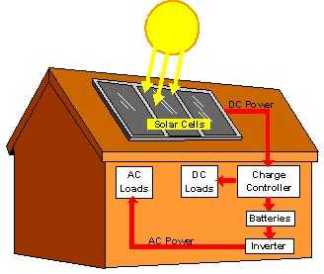
Advantages of solar energy in Pakistan are as follows:
- There is virtually an unlimited supply of solar energy for us to use and it is renewable. This means that our reliance on fossil fuels can be reduced in direct proportion by the amount of solar energy that we produce. With the constantly increasing demands on our traditional energy sources and the climbing costs related to these increases, solar is quickly becoming a necessity.
- Solar energy is an excellent alternative energy source because there is no pollution generated while it is being used so we actually reduce pollution with every watt of power generated from the sun. Even if we can’t reduce how much energy is used we should at least control where that energy comes from.
- There is no cost involved with using solar power other that the cost of manufacturing the components, purchasing and installation. After your initial investment there is no further cost associated with its use.
- Solar energy systems are flexible and expandable. This means that your first solar project can be a small one and you can expand your solar electric system to meet your needs by installing more panels. By starting with a small project you can avoid a major investment up front.
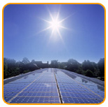
- As our use of solar energy increases, our demand on fossil fuels decreases. This will extend the time before our supply of fossil fuels (oil and natural gas etc…) expires or costs become so high only the rich can afford them.
- There is no pollution associated with the use of solar power. No smoke stacks pumping greenhouse gasses into the air means less pollution.
- A solar electric system installed in a home could potentially eliminate 18 tons of greenhouse gas emissions from the environment each year.
- Using solar energy is a silent process. No noise pollution.
- With space heating appliances using fossil fuels there is always the risk of a cracked heat exchanger, which can cause CO2 poisoning (Carbon Dioxide). This is not a problem when using solar energy.
- A great advantage of solar is for remote applications. It is the best way to supply electricity to isolated places in the world where the cost associated with installing power distribution lines makes it impractical or impossible.
- Solar energy can be used to heat water and for space heating.
- You can build your own system from collecting the parts required or purchase one of the many solar kits that are available. Using kits takes a lot of the work out of building your own system.
Disadvantages of Solar Energy in Pakistan:
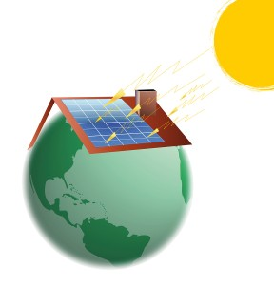
Disadvantages of solar energy in Pakistan are as follows:
- Potentially large areas of land are required for large-scale commercial solar energy projects. A self sufficient home system doesn’t have this concern.
- An unfortunate disadvantage of this renewable energy source is the upfront costs associated with installing a solar system.
- Many places in the world don’t have enough constant and intense sunshine to make commercial use of solar energy practical.
- If you live in a region where sunshine is limited it may be difficult to produce a constant supply of solar energy. This problem can be eliminated by installing a intertie system (a system connected to the grid so that extra power generated by your system can be used by the utility company and during times when your system produces less power than you require, extra energy is available from the grid)
- Can be unreliable unless you're in a very sunny climate. In the United Kingdom, solar power isn't much use for high-power applications, as you need a large area of solar panels to get a decent amount of power. However, technology has now reached the point where it can make a big difference to your home fuel bills.
- Doesn't work at night.
- Very expensive to build solar power stations, although the cost is coming down as technology improves. In the meantime, solar cells cost a great deal compared to the amount of electricity they'll produce in their lifetime.
- Sun does not shine consistently.
- Solar energy is a diffuse source. To harness it, we must concentrate it into an amount and form that we can use, such as heat and electricity.

References:
- “Solar Power Your Home For Dummies” By Rik DeGunther.
- http://www.cssforum.com.pk/css-compulsory-subjects/current-affairs/current-affairs-notes/4082-energy-crisis-pakistan.html
- http://www.darvill.clara.net/altenerg/solar.html
- http://www.rural-electrification.com/cms/upload/pdf/Lis-solar-companies-Pakistan040407.pdf
- http://pakistaniat.com/2009/02/17/utilizing-solar-energy-in-pakistan//4082-energy-crisis-pakistan.html

