INSTRUMENTATION & CONTROL ENGINEERING DEPARTMENT
SARVAJANIK COLLEGE OF ENGG. & Technology
SURAT 395001
2010-2011

A PROJECT PRELIMINARY REPORT ON FIBRE OPTICS
COMMUNICATION
GUIDE:
PR. VANDANA PATEL
PR. NAND KISHORE JOSHI
PREPARED BY:
SAURABH DWIVEDI

ABSTRACT
FIBRE-OPTICS COMMUNICATION
Most reference materials that discuss the historical perspective mention about Indian smoke signals. None of these primitive systems was secure due to the spreading of the unguided light. Ideally, a communication system should be secure and should not require installation of a cumbersome physical media. Fiber optics satisfied these desires, and as early as 1958, fiber-optic equipment was being focused for use in the factory. The fiber-optic cable is an important element in the fiber-optic link. Today, in comparison to the early 1970s, the performance of fiber-optic cable in terms of bandwidth and attenuation is far superior to any electrical cable of similar cost. Some consider it a problem of fiber optics that the electronics of the fiber-optic transceivers are unreliable. This is a false, in that the electronics have the same life as any of the other electronic components used in a network. The need for sharing components or modules is the same for fiber optics as for any other critical factory-level electronics. Optical fiber is used as glass or plastic, to contain and guide light wave.
The fiber cable does not transmit electrical current, so it cannot cause ground loops. Therefore ground differentials caused by lightning-induced transients do not affect the communication cable. This characteristic is quite an advantage because lightning strikes are a common phenomenon. A typical fiber-optic cable can allow up to 200 million bits per second (MBS), while a high-quality coaxial cable is required to achieve the same data rate, but can cover only shorter distances. The reduction in the number of repeaters is a prime reason for the telephone companies increasing use of fiber optics. Many control applications require the operator to perform normal duties in the vicinity of high voltages. The use of fiber allows isolation of the high voltage from the operators. An advantage of fiber-optics is that the light signal used for data communication cannot develop a spark above the ignition point, which could cause ignition in hazardous environments.
The fiber-optic cable is susceptible to noise and it does not generate electromagnetic interference. It is very simple to install because of light and small size and is suitable for rugged environments i.e. it can survive high temperatures and other extreme environments.

INDEX
1 Optical Fibers in Communication:- 4
  - Introduction 4
  - Fundamentals of fibers 4
  - Constructions of fibers 5
  - Classification of fibers 6
- Components of Optical Fiber Communication:- 8
  - Transmitters 8
  - Fibers 8
  - Receivers 8
  - Amplifiers 9
  - Wavelength-division multiplexing 9
  - Dispersion 9
  - Regeneration 10
  - Modes and propagation of light 10
- Principle of operation:- 12
  - Index of Refraction 12
  - Snell’s law 12
  - Critical angle 13
  - Total Internal Reflection 13
  - Acceptance Cone 14
- Advantages over conventional cables:- 15
- Limitations of optical fibers:- 16
- Applications:- 17

1 OPTICAL FIBERS IN COMMUNICATION
1.1 Introduction
Optical fibers are one of the world’s most influential scientific developments from the latter half of the 20th century. Normally we are unaware that we are using them, although many of us do frequently. The majority of telephone calls and internet traffic at some stage in their journey will be transmitted along an optical fiber. Why has the development of fibers been given so much attention by the scientific community when we have alternatives? The main reason is bandwidth – fibers can carry an extremely large amount of information. More indirectly, many of the systems that we either rely on or enjoy in everyday life such as banks, television and newspapers as are themselves dependent on communication systems that are dependent on optical fibers.
Fiber-optic communication is a method of transmitting information from one place to another by sending pulses of light through an optical fiber. The light forms an electromagnetic carrier wave that is modulated to carry information.
An optical fiber is a glass or plastic fiber that carries light along its length. Optical fibers are widely used in fiber optic communications, which permits transmission over longer distances and at higher bandwidths because light has higher frequency than any other form of radio signal. Light is kept in the core of the optical fiber by total internal reflection. Fibers are used instead of metal wires because signals travel along them with less loss, and they are also immune to electromagnetic interference.
1.2 Fundamentals of Fibers

The fundamental principle that makes optical fibers possible is total internal reflection. This is described using the ray model of light as shown in figure 1.
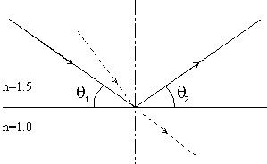

Figure 1 - Total Internal Reflection
From Snell’s Law we find that refraction (as shown by the dashed line) can only occur when the angle theta1 is large enough. This implies that as the angle is reduced, there must be a point when the light ray is reflected, where theta1 = theta2.
The angle where this happens is known as the critical angle and is:
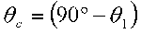
1.3 CONSTRUCTION OF FIBERS
In fibers, there are two significant sections – the core and the cladding. The core is part where the light rays travel and the cladding is a similar material of slightly lower refractive index to cause total internal reflection. Usually both sections are fabricated from silica (glass). The light within the fiber is then continuously totally internally reflected along the waveguide.

Figure 2: Structure of Fiber
When light enters the fiber we must also consider refraction at the interface of the air and the fiber core. The difference in refractive index causes refraction of the ray as it enters the fiber, allowing rays to enter the fiber at an angle greater than the angle allowed within the fiber as shown in the figure 3.

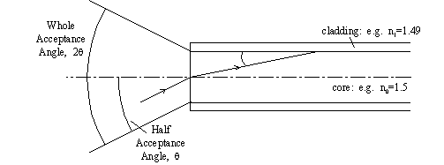

Figure 3 - Acceptance Angle

1.4 CLASSIFICATION OF OPTICAL FIBeRS:-
Optical fibers are classified into three types based on the material used, number of modes and refractive index.
1.4.1. Based on the materials used:-
- Glass fibers:
They have a glass core and glass cladding. The glass used in the fiber is ultra pure, ultra transparent silicon dioxide (SiO2) or fused quartz. Impurities are purposely added to pure glass to achieve the desired refractive index.
b. Plastic clad silica:
This fiber has a glass core and plastic cladding. This performance though not as good as all glass fibers, is quite respectable.
- Plastic fibers:
They have a plastic core and plastic cladding. These fibers are attractive in applications where high bandwidth and low loss are not a concern.

1.4.2. Based on the number of modes:-
a. Single Mode fiber:
When a fiber wave-guide can support only the HE11 mode, it is referred to as a single mode wave-guide. In a step index structure this occurs when the wave-guide is operating at v<2.4 where v is dimensionless number which relates the propagating in the cladding. These single mode fibers have small size and low dopant level (typically 0.3% to 0.4% index elevation over the lading index.)
In high silica fibers the wave-guide and the material dispersion are often of opposite signs. This fact can be used conveniently to achieve a single mode fiber of extremely large bandwidth. Reduced dopant level results in lower attenuation than in multimode fibers. A single mode wave guide with its large and fully definable bandwidth characteristics is an obvious candidate for long distance, high capacity transmission applications.
- Multimode fiber:

It is a fiber in which more than one mode is propagating at the system operating wavelength. Multimode fiber system does not have the information carrying capacity of single mode fibers. However they offer several advantages for specific systems. The larger core diameters result in easier splicing of fibers. Given the larger cores, higher numerical apertures, and typically shorter link distances, multimode systems can use less expensive light sources such as LED s. Multimode fibers have numerical apertures that typically range from 0.2 to 0.29 and have core size that range from 35 to100 micro-meters.

1.4.3. Based on refractive index:-
a. Step index fiber:
The step index (SI) fiber consists of a central core whose refractive index is n1, surrounded by a lading whose refractive index is n2, lower than that of core. Because of an abrupt index change at the core cladding interface such fibers are called step index fibers.
b. Graded index fibers:
The refractive index of the core in graded index fiber is not constant, but decreases gradually from its maximum value n1 to its minimum value n2 at the core-cladding interface. The ray velocity changes along the path because of variations in the refractive index. The ray propagating along the fiber axis takes the shortest path but travels most slowly, as the index is largest along this path in medium of lower refractive index where they travel faster. It is therefore possible for all rays to arrive together at the fiber output by a suitable choice of refractive index profile.

2 COMPONENTS OF OPTICAL FIBER COMMUNICATION:
2.1 Transmitters: -
Fiber optic transmitters are devices that include an LED or laser source, and signal conditioning electronics, to inject a signal into fiber. The modulated light may be turned on or off, or may be linearly varied in intensity between two predetermined levels.

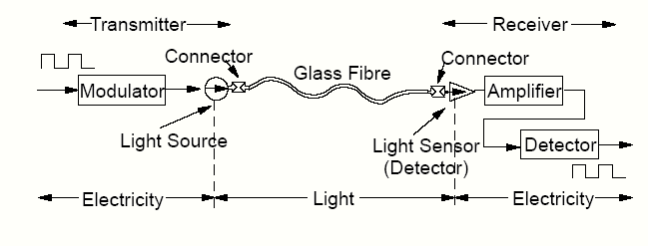
Figure:-The basic components of an optical fiber communication
The transmitter is physically close to the optical fiber and may even have a lens to focus the light into the fiber. Lasers have more power than LEDs, but vary more with changes in temperature and are more expensive. The most common wavelengths of light signals are 850 nm, 1,300 nm, and 1,550 nm

2.2 Fiber:-
It is the medium to guide the light form the transmitter to the receiver.
2.3 Receivers:-
Fiber optic receivers are instruments that convert light into electrical signals. They contain a photodiode semiconductor, signal conditioning circuitry, and an amplifier at the receiver end. Several types of photodiodes include p-n photodiodes, a p-i-n photodiodes, and avalanche photodiodes. Metal-semiconductor-metal (MSM) photo detectors are also used due to their suitability for circuit integration in regenerators and wavelength-division multiplexers.

2.4 Amplifiers
The transmission distance of a fiber-optic communication system has traditionally been limited by fiber attenuation and by fiber distortion. By using opto-electronic repeaters, these problems have been eliminated. These repeaters convert the signal into an electrical signal, and then use a transmitter to send the signal again at a higher intensity than it was before. Because of the high complexity with modern wavelength-division multiplexed signals (including the fact that they had to be installed about once every 20 km), the cost of these repeaters is very high.
An alternative approach is to use an optical amplifier, which amplifies the optical signal directly without having to convert the signal into the electrical domain. It is made by doping a length of fiber with the rare-earth mineral erbium, and pumping it with light from a laser with a shorter wavelength than the communications signal (typically 980 nm). Amplifiers have largely replaced repeaters in new installations.
2.5 Wavelength-division multiplexing
Wavelength-division multiplexing (WDM) is the practice of multiplying the available capacity of an optical fiber by adding new channels, each channel on a new wavelength of light. This requires a wavelength division multiplexer in the transmitting equipment and a demultiplexer (essentially a spectrometer) in the receiving equipment. Arrayed waveguide gratings are commonly used for multiplexing and demultiplexing in WDM. Using WDM technology now commercially available, the bandwidth of a fiber can be divided into as many as 160 channels to support a combined bit rate into the range of terabits per second.

2.6 Dispersion
For modern glass optical fiber, the maximum transmission distance is limited not by direct material absorption but by several types of dispersion, or spreading of optical pulses as they travel along the fiber. Dispersion in optical fibers is caused by a variety of factors. Intermodal dispersion, caused by the different axial speeds of different transverse modes, limits the performance of multi-mode fiber. Because single-mode fiber supports only one transverse mode, intermodal dispersion is eliminated.
In single-mode fiber performance is primarily limited by chromatic dispersion (also called group velocity dispersion), which occurs because the index of the glass varies slightly depending on the wavelength of the light, and light from real optical transmitters necessarily has nonzero spectral width (due to modulation). Polarization mode dispersion, another source of limitation, occurs because although the single-mode fiber can sustain only one transverse mode, it can carry this mode with two different polarizations, and slight imperfections or distortions in a fiber can alter the propagation velocities for the two polarizations. This phenomenon is called fiber birefringence and can be counteracted by polarization-maintaining optical fiber. Dispersion limits the bandwidth of the fiber because the spreading optical pulse limits the rate that pulses can follow one another on the fiber and still be distinguishable at the receiver.
Some dispersion, notably chromatic dispersion, can be removed by a 'dispersion compensator'. This works by using a specially prepared length of fiber that has the opposite dispersion to that induced by the transmission fiber, and this sharpens the pulse so that it can be correctly decoded by the electronics.

2.7 Regeneration
When a communications link must span a larger distance than existing fiber-optic technology is capable of, the signal must be regenerated at intermediate points in the link by repeaters. Repeaters add substantial cost to a communication system, and so system designers attempt to minimize their use.
Recent advances in fiber and optical communications technology have reduced signal degradation so far that regeneration of the optical signal is only needed over distances of hundreds of kilometers. This has greatly reduced the cost of optical networking, particularly over undersea spans where the cost and reliability of repeaters is one of the key factors determining the performance of the whole cable system. The main advances contributing to these performance improvements are dispersion management, which seeks to balance the effects of dispersion against non-linearity; which use nonlinear effects in the fiber to enable dispersion-free propagation over long distances.

2.8 Modes and PROPAGATION OF LIGHT IN FIBERS
Also crucial to understanding fibers is the principle of modes. A more in-depth analysis of the propagation of light along an optical fiber requires the light to be treated as an electromagnetic wave (rather than as a ray).

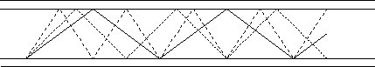
Figure 4 – Modes
The solid line is the lowest order mode shown on figure 4. It is clear that according to the ray model the lowest order mode will travel down a given length of fiber quicker than the others. The electromagnetic field model predicts the opposite – that the highest order mode will travel quicker. However, the overall effect is still the same – if a signal is sent down the fiber as several modes then as it travels along the fiber the pulse will spread out, this can lead to the pulses merging and becoming indistinguishable.
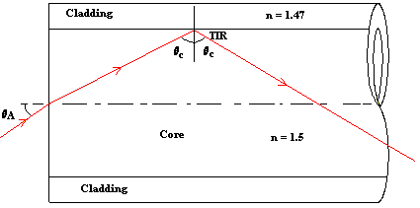
Figure 5: Propagation of light in fibers

The propagation of light is as shown in figure 5. When light ray enters the core with an angle strikes the surface of cladding whose refractive index is less than that of core. As the incidence angle on surface of the cladding is greater than or equal to critical angle total internal reflection takes place. Hence the ray is reflected back into the core in the forward direction. This process continues until it reaches other end of the cable.

3 PRINCIPLE OF OPTICAL TRANSMISION

3.1 Index of refraction:-
This is the measuring speed of light in respective medium. It is calculated by dividing speed of light in vacuum to the speed of light in material. The RI for vacuum is 1, for the cladding material of optical fiber it is 1.46, the core value of RI is 1.48(core RI must be more than cladding material RI for transmission) it means signal will travel around 200 million meters per second. it will travel 12000 km in only 60 seconds. other delay in communication will be due to communication equipment switching and decoding, encoding the voice of the fiber.
3.2 Snell's Law:-

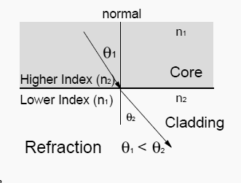

In order to understand ray propagation in a fiber. We need one more law from high school physics. This is Snell' law. n1 sin Ө1 = n2 sin Ө2
Where n denotes the refractive index of the material. Ө1/ Ө2 are angles in Ө1/ Ө2 respective medium. Higher Refractive Index means denser medium. 1) When light enters in lighter medium from denser it inclines towards normal. 2) When light enters in denser medium from lighter it inclines away to normal.

3.3 Critical Angle:-
If we consider we notice above that as the angle Ө1 becomes larger and larger so does the angle Ө2. Because of the refraction effect Ө2.becomes larger more quickly than Ө1 .At some point Ө2 will reach 90° while Ө1 is still well less than that. This is called the “critical angle”. When Ө1is increased further then refraction ceases and the light starts to be reflected rather than refracted. Thus light is perfectly reflected at an interface between two materials of different refractive index if:
1. The light is incident on the interface from the side of higher refractive index.
2. The angle is greater than a specific value called the “critical angle”. Glass refractive index is 1.50 (critical angle is 41.8); Diamond critical angle is 24.4 degree.

3.4Total Internal reflection (TIR):-
When light traveling in a dense medium hits a boundary at a steep angle (larger than the "critical angle “for the boundary), the light will be completely reflected. This phenomenon is called total internal reflection. This effect is used in optical fibers to confine light in the core. Light travels along the fiber bouncing back and forth off of the boundary; because the light must strike the boundary with an angle greater than the critical angle, only light that enters the fiber within a certain range of angles can travel down the fiber without leaking out. Total internal. Reflection occurs when light enters from higher refractive index to lower refractive index material, i.e. from glass to air total internal reflection is possible but it is not possible in air to glass.

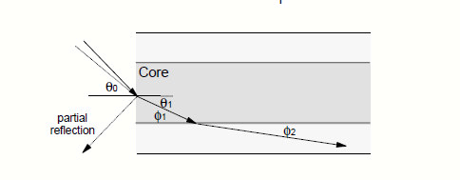
Figure-1 (optical rays leaks out from core i.e. is loss)

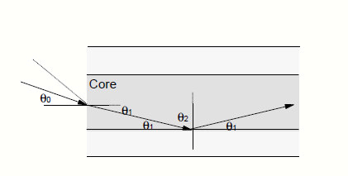
Figure-2 (Optical rays reflected back due to TIR) Fig-2

If we now consider above Figures we can see the effect of the critical angle within the fiber. In Figure 2 we see that for rays where angle Ө1 is less than a Critical value then the ray will propagate along the fiber and will be “bound” within the fiber. In Figure 1 we see that where the angle Ө1 is greater than the critical value the ray is refracted into the cladding and will ultimately be lost outside the fiber. This is loss.
3.5 Acceptance Cone:-
When we consider rays entering the fiber from the outside (into the end face of the Fiber) we see that there is a further complication. The refractive index difference between the fiber core and the air will cause any arriving ray to be refracted. This means that there is a maximum angle for a ray arriving at the fiber end face at which the ray will propagate. Rays arriving at an angle less than this angle will propagate but rays arriving at a greater angle will not. This angle is not a “critical angle” as that term is reserved for the case where light arrives from a material of higher RI to one of lower RI. (In this case, the critical angle is the angle within the fiber.) Thus there is a “cone of acceptance” at the end face of a fiber. Rays arriving within the cone will propagate and ones arriving outside of it will not. The size of acceptance cone is function of difference of RI of core and cladding.

4 ADVANTAGEs over conventional cables
The choice between optical fiber and electrical (or copper) transmission for a particular system is made based on a number of trades-offs. Optical fiber is generally chosen for systems requiring higher bandwidth or spanning longer distances than electrical cabling can accommodate. The main benefits of fiber are its exceptionally low loss, allowing long distances between amplifiers or repeaters; and its inherently high data-carrying capacity, such that thousands of electrical links would be required to replace a single high bandwidth fiber. Another benefit of fiber is that even when run alongside each other for long distances, fiber cables experience effectively no crosstalk, in contrast to some types of electrical transmission lines.
In short distance and relatively low bandwidth applications, electrical transmission is often preferred because of its
- Lower material cost, where large quantities are not required.
- Lower cost of transmitters and receivers.
- Ease of splicing.
- Capability to carry electrical power as well as signals.
- Ease of operating transducers in linear mode.

Wide Bandwidth:

Optical fibers offer greater bandwidth due to the use of light as carrier. The frequency range used for glass fiber communication extends from 2*e14Hz to 4*e14Hz. Hence optical fibers are suitable for high speed, large capacity telecommunication lines.

Low Loss:

In a coaxial cable attenuation increases with frequency. The higher the frequency of information signals the greater the loss, whereas in an optical fiber the attenuation is independent of frequency. They offer a loss of0.2 dBm/km, allowing repeater separation up to 50Km or more.

Freedom from electromagnetic interference:

Optical fibers are not affected by interference originating from power cables, railways and radio waves. They do not limit unwanted radiation and no cross talk between fibers exists. These fibers make an ideal transmission medium when EMI (Electro Magnetic Immunity) is increased.

Non conductivity:

Optical fibers are non-conductive and are not effective by strong electromagnetic interference such as lighting. These are usable in explosive environment.

Small diameters and less weight:

Even multi fiber optical cables have a small diameter and are light weight, and flexible optical fiber cables permit effective utilization of speech and can also be applicable to long distance use are easier to handle and install than conventional cables.

Security:

Fiber optic is a highly source transmission medium. It does not radiate energy that can be received by a nearby antenna, and it is extremely difficult to tap a fiber and virtually impossible to make the tap undetected.

Safety:

Fiber is a dielectric and does not carry electricity. It presents no sparks or fire hazards. It does not cause explosions, which occur due to faulty copper cable.

5 LIMITATIONS OF OPTICAL FIBER:

1. The terminating equipment is still costly as compared to copper wire.

2. Delicate so has to be handled carefully.

3. Communication is not totally in optical domain, so repeated electric to optical to electrical conversion is needed.

4. Optical amplifiers, splitters, MUX-DEMUX are still in development stages.

5. Tapping is not possible. Specialized equipment is needed to tap a fiber.

6. Optical fiber splicing is a specialized technique and needs expertly trained manpower.

7. The splicing and testing equipments are very expensive as compared to copper equipments.

8. Bending Cables

9. Gamma Radiation

10. Electrical Fields

6 APPLICATIONS:-

- Military applications
- Mobile applications
- Telecommunications
- Satellite communications
- Under sea transmission cable
- Internet & Broadband applications
- Computer applications
- Electrical power companies
- Optical sensor system
- Local area networks
- Electronic media
- Public network applications
- Civil application
- Consumer application
- Industrial application

