SAINT LOUIS UNIVERSITY
SCHOOL OF ENGINEERING AND ARCHITECTURE
DEPARTMENT OF ARCHITECTURE

AR 414B-INTERIOR DESIGN
RSW #: PR- 02
“ANTHROPOMETRICS, PROXEMICS, AND ERGONOMETRICS IN INTERIOR DESIGN”

D. ISSUED: 27 JUNE 2011
D. DUE: 28 JUNE 2011
D. SUB: 28 JUNE 2011

REFERENCES:
http://ezinearticles.com/?Designing-For-Life---Architecture-and-Design-Psychology&id=891719
http://www.interiordezine.com/
http://designobserver.wordpress.com/2010/01/28/proxemics-personal-space-and-territory/

ARCHT. ED B. LLEDO MENCIAS, NOVELITA M.
INSTRUCTOR STUDENT
PROXEMICS
- Proxemics the study of cultural differences in personal boundaries and space requirements. Proxemics is intimately connected to design psychology and the placement of physical dividers such as doors and walls. In offices and homes alike, a social order is established by proximity. The offices that are the most distant from the waiting room and closest to the boss are for the most important staff members. Likewise, master bedrooms are usually the most distant from shared spaces such as entryways and living rooms. The rooms closest to the kitchen, family room and gathering areas are for those lowest on the totem pole, usually the children.
- Proxemics also has much to do with issues of privacy. Those who have important activities and conversations to engage in need to have their space. When material dividers aren't available, visual and auditory clues can serve to define boundaries. Signs, frosted glass, bells and intercoms can serve to separate places where others are welcome and places where they must have permission to enter.
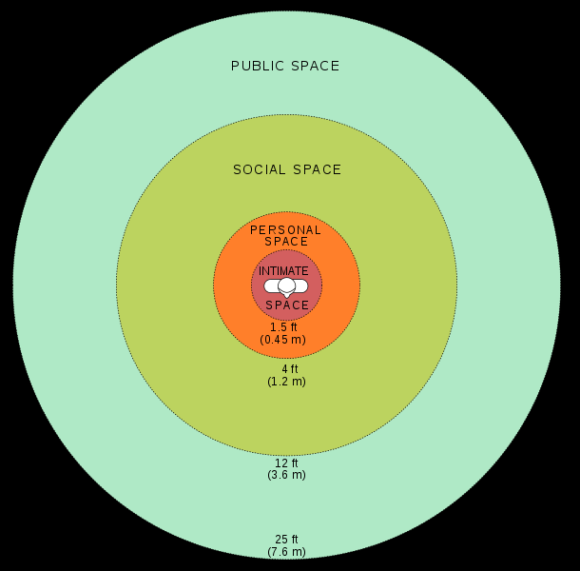
The idea that body spacing and posture acting as unintentional reactions to sensory fluctuations or shifts is intriguing from a design standpoint. According to Edward T. Hall, the man who coined the term “proxemics,” social distance between people is reliably correlated with physical distance, as are intimate and personal distance, according to the following delineations:
- Intimate distance for embracing, touching or whispering ranges anywhere between 6 to 18 inches or even closer.
- Personal distance for interactions among good friends or family memebers ranges anywhere from 1.5 feet to 4 feet.
- Social distance for interactions among acquaintances ranges anywhere from 4 to 12 feet.
- Public distance used for public speaking ranges anywhere from 12 to 25 feet.

ERGONOMICS
- Ergonomics is the science of the relationship between man and machinery and the equipment human beings use, and the working environment. Having something that is called ergonomic means that the item has been designed to maximize productivity by minimizing effort and discomfort.
The diagrams on the following page describe the basic and average sizes (based on 90 percentile) of human beings performing various functions and movements.
These are here as a tool for interior designers to aid working out how high or how far an average male or female may reach in relative comfort.
These are factors that need to be considered when designing joinery or cabinetry, furniture, planning circulation spaces, work spaces, accessible spaces and to generally make the user comfortable in their interior environment.
Please note that all these measurements are in millimeters and are based on the authors experience and common industry standards.

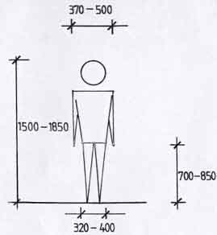 | 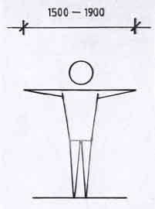
Diagram 1 depicts the average heights and  widths of various parts of the body face on.  Use this in relation to joinery and space  planning. | Diagram 2 depicts the average maximum distance of outstretched arms. This may be used when planning a small bathroom and the distance need for drying ones self.

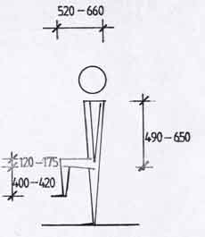 | 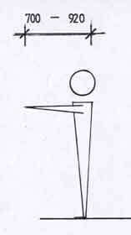
Diagram 3 depicts the various heights and  lengths of parts of the body with the legs bent as for sitting or climbing. Relate this to chairs and tables.. | Diagram 4 depicts the reach of forward outstretched arms. Reference to this is important with cupboards and shelves over benches and to windows behind furniture.

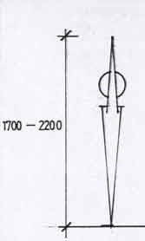 | 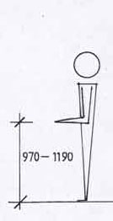
Diagram 5 depicts the maximum reach (flat footed) straight up. This can be referred to for the maximum height of close shelves or cupboards while also considering the angle. | Diagram 6 depicts the height of the forearm when standing and bent at right angles. This is useful for determining the heights of work surfaces.

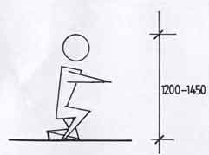 | 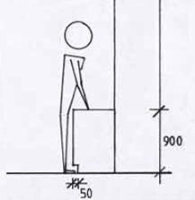
Diagram 7 depicts the height of a person when kneeling or crouching down. You can determine minimum heights of shelving or basic reach. | Diagram 8 depicts the height of a medium use workbench. It also shows space allocated for the front of the foot to fit under the bench.

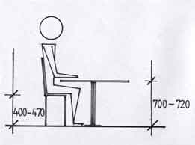 | 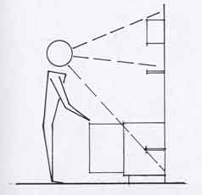
Diagram 9 depicts a person sitting at a table. The height of the chair and table are shown in relation to the body. | Diagrams 10 and 11 depict heights and widths of shelves showing the reach required and also the eye line.

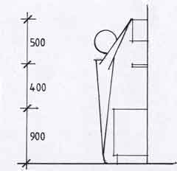 | 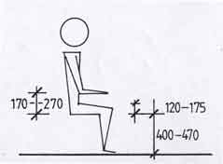
 | Diagram 12 depicts a person in sitting position showing the base of the bent forearm to the seat height for armrests, the thickness of the thigh and the height from the base of the thigh to the floor for clearance under tables.

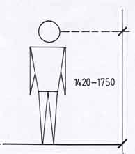 | 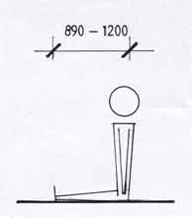
Diagram 13 shows where the eyes height in relation to the floor. Use this to determine placing of items such as switching or signage. | Diagram 14 depicts the length of the legs and body combined when sitting on the floor or bed. Use this to help determine leg room.

According to Story et al, these spaces should encompass:

- Equitable use: The design is useful and marketable to people with diverse abilities.
- Flexibility in use: The design accommodates a wide range of individual preferences and abilities.
- Simple and intuitive use: Use of the design is easy to understand, regardless of the user’s experience, knowledge, language skills, or current concentration level.
- Perceptible information: The design communicates necessary information effectively to the user, regardless of ambient conditions or the user’s sensory abilities.
- Tolerance for error: The design minimizes hazards and the adverse consequences of accidental or unintended actions.
- Low physical effort: The design can be used efficiently and comfortably, and with a minimum of fatigue.
- Size and space for approach and use: Appropriate size and space is provided for approach, reach, manipulation, and use, regardless of the user’s body size, posture, or mobility.

It is not difficult to see how living spaces which strive to embody these qualities would not only be easier to use, but would most likely increase home productivity. Imagine, for example, a living room which utilized thoughtfully-designed lighting fixtures, placed such that they illuminate adequately the areas of interest within the room. Chairs, tables, and footstools would be easy to relocate, thereby making the space amenable to a wider range of uses, while each furniture piece would be able to accommodate persons of every size and ability.

