ERGONOMICS & AESTHETIC TOOL DESIGN OF PORTABLE DRILLING MACHINE
How can one reduce the risk for work-related musculoskeletal disorders (WMSDs) resulting from the use of hand tools?
Tool design (weight, shape, fit to the user and the task), workstation design (size, shape and layout), and the way tasks are scheduled are all key factors in making hand tool use safe and risk-free. Since, none of those three areas is more important then the other, an effective prevention strategy must address all of them simultaneously.
What are the major ergonomic concerns of a hand tool design?
Weight of the tool
Ideally, a worker should be able to operate a tool with one hand. Therefore the weight of the tool, especially for repetitive use, should not exceed 1 kg (2.2 lb.). It is also important that the centre of gravity be aligned with the centre of the gripping hand.
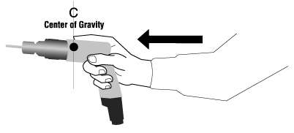
Figure 1
In other words, tools should feel "easy" to hold either in an upright position or in the position it will be used (ie. pointing down). For example, drills that are "front-heavy" will require effort (especially in the wrist and forearm) to hold in a usable position and should be avoided. The exception to this principle is a power hand tool, such as a grinder, that has to be heavy in order to reduce the force that the worker has to exert while using it. Tools heavier than 1 kg or poorly balanced tools should be supported by counter-balancers.
Power
Where possible, power tools should replace hand tools which normally require the exertion of frequent and repetitive force to do the job, because the greater the force exerted with a hand tool, and the more the hand has to twist to use it, then the greater the risk for WMSDs.
Handles
With the exception of tools for precision work (e.g., watchmaking, microsurgery, carving), the handles and grips of hand tools should be designed for a power grip. The belief that smaller tools should have smaller handles while larger tools have larger ones is debatable.
Handle shape
Tools with "bent" or angled handles or tools with pistol-grips are beneficial where the force is exerted in a straight line in the same direction as the straightened forearm and wrist, especially when the force must be applied horizontally (see Figures 2, 3, 4).
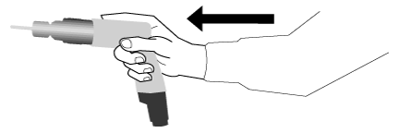
Figure 2
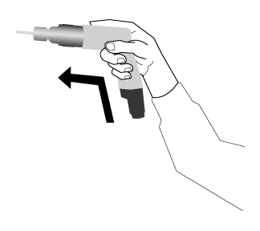
Figure 3
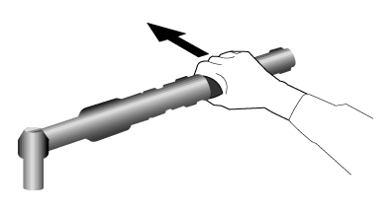
Figure 4
Tools with straight handles are for tasks where the force is exerted perpendicular to the straightened forearm and wrist, for instance, when the force must be applied vertically.
Shaped tools such as bent-handle tools are effective where most of the tasks are done in the same plane and height as the arm and hand, and when only one or two other tools are used (see Figure 5).
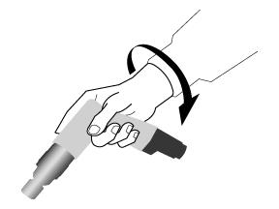
Figure 5
Knowing the tasks and the layout of the workplace where they will be used is vital for selecting the right tools for any given job. Select tools that do NOT require wrist flexion, extension or deviation. In other words, select tools that allow you to keep the wrist straight or in a neutral position.
The crucial ergonomic principle in tool use and design -- bend the tool, not the wrists -- however correct and valuable does not always prevent discomfort and injuries when bent-handle tools are used indiscriminately, regardless of the layout of the work situation.
Diameter
Handles should be cylindrical or oval in cross section, with a diameter of between 30 mm and 45 mm. For precision work the recommended diameter for handles is between 5 mm and 12 mm. For a greater torque large screwdrivers should have a handle diameter up to 50-60 mm.
Length
A handle that is too short can cause unnecessary compression in the middle of the palm. It should extend across the entire breadth of the palm. Tool handles longer than 100 mm (preferably 115-120 mm) will reduce the negative effects of any compression exerted. Rounded handles will minimize palm compression on the palm still further. Keep in mind that the use of gloves requires longer tool handles.
Separation between handles
Crushing, gripping or cutting tools such as pliers or tongs are equipped with two handles. The recommended distance separating handle is between 50 mm and 65 mm. Such a range will fit both male and female users. Tools with larger or smaller spans will reduce one's maximum grip strength and may contribute to the onset of carpal tunnel syndrome.
Power tool triggers
Frequent movements of the index finger while operating the trigger of power tools (such as a power drill) poses a considerable risk for both "trigger finger" and "trigger thumb" (tendonitis in the index finger and/or thumb). A longer trigger which allows the use of two or three fingers to activate them reduces discomfort and minimizes the risk for injury. The recommended minimum length of the trigger is 50 mm.
Materials and texture of handles
To ensure a good grip on a handle, sufficient friction must exist between the hand and the handle. This is particularly important where a considerable force must be applied with a sweaty hand. Hand tools should be made of non-slip, non-conductive and compressible materials. For example, textured rubber handles provide a good grip, reduce the effort needed to use the tool effectively, and prevent the tool from slipping out of the hand. Glossy coatings and highly polished handles should be avoided. The electrical and heat insulation properties of the handles are important for power hand tools. Handles made of plastics or compound rubber are recommended. Sharp edges and contours can be covered with cushioned tape to minimize lacerations.
Vibration
The only effective way to reduce vibration in power tools is at the design stage. This fact makes tool selection most critical. The common practices of covering handles of vibrating tools with a layer of viscoelastic material or of using anti-vibration gloves made of similar material are of dubious value. These "anti-vibration" materials will dampen vibration above certain frequencies that are characteristic for the kind of material, but most of the vibration energy in a handle of a power tool is below those frequencies.
What should one remember when selecting and using hand tools?
When selecting and using a hand tool it is important:
- to "bend" the tool, not the wrist; use tools with angled or "bent" handles, when appropriate)
- to avoid high contact forces and static loading (see Hand Tool Ergonomics - Health Hazards)
- to reduce excessive gripping force or pressure
- to avoid extreme and awkward joint positions
- to avoid twisting hand and wrist motion by using power tools rather than hand tools.
- to avoid repetitive finger movements, or at least reduce their number
- to avoid or limit vibration
- to minimize the amount of force needed to activate trigger devices on power tools.
How does hand tool maintenance reduce the risk for injuries?
The condition of tools is an important factor. Blunt or dull tools such as scissors, cutters, saws, screwdriver tips, in fact any tools in a poor state of repair, not only compromise safety but also increase (sometimes by a factor of ten) the effort needed to use them. Tools in poor condition should be discarded (with the exception of those few that can be restored to optimum condition, for example, a wood chisel or wood saw) and replaced with new ones.

