Visveswaraya Technological University, Belgaum



A Seminar Report

On

**“ULTRASONIC MOTORS”**

**A Seminar report submitted in partial fulfillment of requirements of 8th semester 2010-2011**

*Submitted by:*

**PRAVEEN KUMAR KOMMU**

**(3GN03EE019)**

*Under the Esteemed guidance of:*

**Prof. R. DEVASARAN**



DEPARTMENT OF ELECTRICAL AND ELECTRONICS ENGINEERING

**GURU NANAK DEV ENGINEERING COLLEGE**

**BIDAR-585403**

**KARNATAKA**

**VisVeswaraya Techonological University, Belgaum**

**BIDAR**



**Department of**

**ELECTRICAL AND ELECTRONICS ENGINEERING**

**CERTIFICATE**

This is to certify that the seminar ***“ULTRASONIC MOTORS”*** is a bonafide work carried out by ***PRAVEEN KUMAR KOMMU (3GN03EE019)*** in partial fulfillment for the award of bachelor of Engineering in *electrical and Electronics Engineering* from the Visveswaraya Technological University, Belgaum during the year 2010-2011. It is certified that seminar report satisfies the academic requirements of seminar work described for the bachelor of engineering degree.

**……………. …………………….. ……………………..**

**Prof: R. Devasaran Prof: M.N. Singh Prof: R. Devasaran**

**( Seminar Guide) (Seminar Co-ordinator) ( Head Of Dept.)**

**ACKNOWLEDGEMENT**

I am grateful to **Dr. V.D Mytri Principal,** GNDEC, Bidarfor providing all the required facilities for the completion of our Seminar.

I express my sincere gratitude to Head of the department **Prof. R. DEVASARAN** of Information Science and Engineering department, GNDEC, Bidar for his encouragement, moral support, for providing all the required facilities in the department and for the smooth functioning of the Seminar.

I am also grateful and express my sincere thanks to my Seminar guide **Prof: R. DEVASARAN** Information Science and Engineering department, for helping in understanding the conceptand for her time to time valuable constant guidance, advice and invaluable suggestions. Without the full support and cheerful encouragement of my guide, this seminar would be a dream.

I express my gratitude and sincere thanks to Seminar coordinator **Prof. M.N. SINGH** for his valuable guidance during the course of this seminar and continuous suggestions to make my seminar successful.

Last but not the least, I would like to thank the **Teaching & Non-Teaching Staff** Information Science and Engineering department, I would like to thank one and all who have helped me during the course of this Seminar.

***K. PRAVEEN KUMAR***

**CONTENT**

1. **ABSTRACT**
2. **INTRODUCTION**
3. **USM PROTOTYPES**

**1. Linear ultrasonic motors**

**I) DOF planar pin-type actuator**

**II)**[**Bi-directional linear standing wave USM**](http://155.69.254.10/users/risc/Pub/Conf/99-c-aim-usm.pdf)

**2.**[**Rotary ultrasonic motor**](http://155.69.254.10/users/risc/Pub/Thesis/00-me-lim-usm.pdf)

**3. Spherical ultrasonic motor**

### 4) ULTRASONIC MOTOR DRIVING PRINCIPLE

**5) DESIGN & MODELLING OF USMs**

**1. Equivalent Circuit**

**2. Vibration Analysis**

**3. Contact Mechanism**

**6) ANALYSIS OF PIEZOELECTRIC MOTORS**

**1. Self-induced oscillating drive circuit**

**2. Research diagram**

**7) RESULTS OF SAMPLE ULTRASONIC MOTOR**

**1) The 3D Model Analysis for the Stator**.

**2) Simulation**

**8)** **ADVANTAGES OF USM’S OVER ELECTROMAGNETIC MOTOR**

**1. Little influence by magnetic field:**

#### 2. Low speed, high torque characteristics, compact size and quiet operation:

#### 3. Compact-sized actuators:

**9) APPLICATIONS**

**11) CONCLUSION**

**1) ABSTRACT**

Ultrasonic rotary motors have the potential to meet this NASA need and they are developed as actuators for miniature telerobotic applications. These motors are being adapted for operation at the harsh space environments that include cryogenic temperatures and vacuum and analytical tools for the design of efficient motors are being developed. A hybrid analytical model was developed to address a complete ultrasonic motor as a system. Included in this model is the influence of the rotor dynamics, which was determined experimentally to be important to the motor performance. The analysis employs a 3D finite element model to express the dynamic characteristics of the stator with piezoelectric elements and the rotor. The details of the stator including the teeth, piezoelectric ceramic, geometry, bonding layer, etc. are included to support practical USM designs. A brush model is used for the interface layer and Coulomb's law for the friction between the stator and the rotor. The theoretical predictions were corroborated experimentally for the motor. In parallel, efforts have been made to determine the thermal and vacuum performance of these motors. To explore telerobotic applications for USMs a robotic arm was constructed with such motors.

**2) INTRODUCTION**

**What is an ultrasonic motor**

An ultrasonic motor is driven by the vibration of piezoelectric elements, and produces force for rotation or horizontal movement by harnessing the elements ultrasonic resonant of over 20 KHz.An ultrasonic motor is a type of electric motor formed from the ultrasonic vibration of a component, the stator, placed against another, the rotor or slider depending on the scheme of operation (rotation or linear translation). Ultrasonic motors differ from piezoelectric actuators in several ways, though both typically use some form of piezoelectric material, and most often lead zirconate titanate and occasionally lithium niobate or other single-crystal materials. The most obvious difference is the use of resonance to amplify the vibration of the stator in contact with the rotor in ultrasonic motors. Ultrasonic motors also offer arbitrarily large rotation or sliding distances, while piezoelectric actuators are limited by the static strain that may well be induced in the piezoelectric element.

Piezoelectric ultrasonic motors are a new type of actuator.They are characterized by high torque at low rotational speed,simple mechanical design and good controllability. They alsoprovide a high holding torque even if no power is applied. Comparedto electromagnetic actuators the torque per volume ratio ofpiezoelectric ultrasonic motors can be higher by an order ofmagnitude.

The ultrasonic motor is characterized by a “low speed and high torque”, contrary to the “high speed and low torque” of the electromagnetic motors. Two categories of ultrasonic motors are developed at our laboratory: the standing wave type and the traveling wave type.

The standing wave type is sometimes referred to as a vibratory-coupler type, where a vibratory piece is connected to a piezoelectric driver and the tip portion generates flat-elliptical movement. Attached to a rotor or a slider, the vibratory piece provides intermittent rotational torque or thrust. The travelling-wave type combines two standing waves with a 90¡-phase difference both in time and space. By means of the traveling elastic wave induced by the thin piezoelectric ring, a ring-type slider in contact with the surface of the elastic body can be driven.

**3) USM Prototypes**

**1. Linear ultrasonic motors**

**I) DOF planar pin-type actuator**

The objective of this project is to design and develop a piezoelectric actuator based on the fundamental operating mechanism of ultrasonic motors. Two pin-type prototypes with piezoelectric bimorph plate and a contact pin for generating driving force in the X-Y direction were designed and fabricated. A test rig was also constructed for the evaluation of the two prototypes and basic characteristics of the actuators were investigated. The working principle of the actuator was verified and proven during the experiment. Basically, the optimal driving speed of an actuator is dependent on the driving frequency, the input voltage, the contact surface and the friction coefficient between the stator and motor. An analytical study of the prototypes has been carried out by means of finite element analysis utilizing ANSYS5.4. With comparison to the experimental results, it was proven that the optimal driving condition occurred at the specific resonant mode depending on the pin vibration. Maximum unloaded driving speed was obtained to be approximately 0.68 cm/s at a frequency of 14.8 kHz and the optimum input voltage was found to be approximately 70 Vp-p.

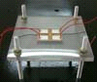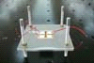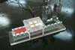

**II)**[**Bi-directional linear standing wave USM**](http://155.69.254.10/users/risc/Pub/Conf/99-c-aim-usm.pdf)

A standing wave bi-directional linear ultrasonic motor has been fabricated. This linear USM has very simple structure and can be easily mounted onto any commercially available linear guide. A high precision positioning x-y table was built by mounting these individual movable linear guides together. The basic parameters of our linear USM are: moving range 220mm(variable depending on the linear guide), no-load speed 80mms/s, ratings 23mm/s at 300gf, stall force 700gf, starting thrust 500gf, resolution<50nm, response time of 12ms from stationary status to constant velocity(80mm/s) with a initial mass of 260g.

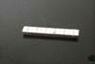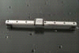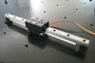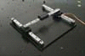

**2.**[**Rotary ultrasonic motor**](http://155.69.254.10/users/risc/Pub/Thesis/00-me-lim-usm.pdf)

  The characteristics of the rotary disc type motor will be investigated and theoretical model will be formed to relate the important components on the power of the motor. The scope includes designing different motor with various dimensions, form ulation of the analytical model, experimental testing and ultimately, setting a standard for practical application of this particular type of USM. This project will lay the foundation of the characteristics and performance of the rotary disc type USMs for future application.

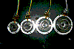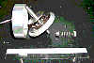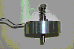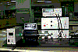

**3. Spherical ultrasonic motor**

Presently a new type of spherical USM is under investigation. This particular USM consists of a thin square plate, 30x30mm in area. It can rotate in more than 4 individual directions. Now we are trying to compile rotation in any dirction by using a computer to control the 4 individual directions properly.

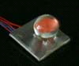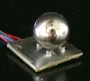

### 4) Ultrasonic micromotor drive principle

Fig.1 shows an exploded view of a typical traveling wave ultrasonic motor, is discussed

in this paper.



Fig. 1; An exploded view of a typical traveling wave ultrasonic motor

It consists of two basic parts: the statically part vibration (stator vibration) with a

frequency in the ultrasonic range, and the driven part (rotor) by the stator effect via

frictional forces. Stator is composed of an elastic body and a thin piezoceramic ring. The

pizoceramic ring is bonded under the elastic body. It has the function of exciting traveling bending waves and is shown in Fig. 2.

The piezoceramic ring is divided into two halves: phase A and phase B. These two

phases are separated by sensor and ground parts which are a quarter and three quarters of a wavelength, respectively. Each phase (A or B) includes n segments. Each segment is a half wavelength and polarized adversely regarding the adjacent one. Phase A and phase B are a quarter of the wavelength out of phase, spatially. The phases are excited by two sinusoidal voltages which are temporally 900 out of phase [18]. Therefore, a traveling wave is generated and the particles of the stator surface move elliptically [19]. The sensor part is used for measuring the amplitude and the phase of the traveling wave to control the excitation of the piezoceramic ring.

The rotor is pressed against the stator by means of a disk spring, and a thin contact layer is bonded to the rotor in the contact region [20]. Therefore, the vibration of the stator with high frequency and small amplitude is transformed into the macroscopic rotary motion of the rotor by friction.



Fig. 2: The piezoceramic ring of the experimental ultrasonic motor.

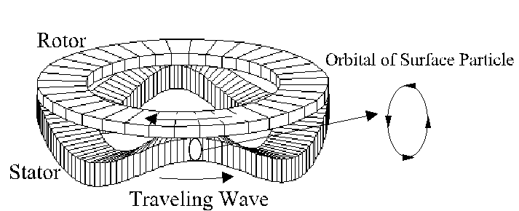

Figure 1. Principle of Operation of a Rotary Traveling Wave Motor.

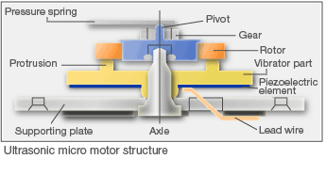

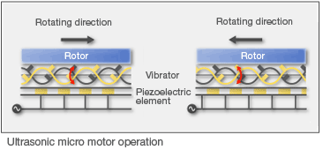

Many ultrasonic motors employ the traveling wave method where the driving source is a unidirectional wave. Using this method, it is easy to switch the rotation direction, but the driving circuit is complicated and generally requires a high start up voltage.

To address this challenge, SII's ultrasonic motors employ the standing wave method in which the driving source is an up-and-down wave. Traditionally, this method was difficult to use for a driving source.

We addressed this by incorporating an elastic material vibrator attached to the piezoelectric elements with an equally-spaced electrode pattern. With this structure, the vibrator protrusions at the electron pattern borders convert the minute vibration into rotor rotation.

**5) Design & Modeling of USMs**

**1. Equivalent Circuit**

It is often useful to represent a problem in mechanics by an equivalent circuit. The basic idea of the circuit is to determine the static and dynamic behavior in force and velocity transmission of a system where friction plays an essential role. The equivalent circuit expression for a piezoelectric vibrator is very convenient for understanding its operating characteristics and for applying it in practice. Shown in Fig. 1 is an equivalent circuit representing free vibration of a stator with no loads and includes two resistors which symbolizes losses. Cm and Lm is the piezoceramic equivalent capacitance and inductance and capacitance, Cd is due to the element’s dielectric properties called the “blocking capacitance”. r0 is the internal resistance of the motor.

There are two power transformation involved in the running of a USM: 1) electric energy is transformed into mechanical vibrational energy of the stator by converse piezoelectric effect; 2)vibrational energy of the stator is transformed into continous moving energy of the rotor(or moving part) due to frictional interaction between the stator and the rotor(or moving parts). Correspondingly, modeling a USM normally includes two aspects: 1) piezoelectric vibration analysis for the stator which is a piezoceramic-metal composite structure; 2) the frictional actuation mechanism between the the vibrator and the rotor.

**2. Vibration Analysis**

An uniformizing method for the vibration analysis of metal-piezoceramic composite thin plates has been proposed. Using this method, piezoelectric composite thin plates with different shapes can be uniformized into equivalent uniform single-layer thin plates which have the same vibrational characteristics as the original piezoelectric composite thin plates. Hence the vibrational characteristics of metal-piezoceramic composite thin plates can be obtained through calculating the natural frequencies and the vibration modes of the equivalent uniform single-layer thin plates using single-layer thin plate theory. Furthermore mid-plane of piezoelectric composite thin plate can also be obtained, which is significant when designing thin plate type USMs.

**3. Contact Mechanism**

In the existing study on the friction actuation mechanism of USMs, the dynamic normal contact between the stator and the rotor in the ultrasonic range has not been taken into consideration. In fact this is a vital factor which causes the reduction of the coefficient of friction between the stator and rotor when the motor is in motion. In our research we take a traveling wave USM as an example and model the normal ultrasonic dynamic contact of the stator and rotor using elastic Hertzian contact theory. Result shows that the rotor is levitated in normal direction by the ultrasonic dynamic contact of the stator. Concurrently, the real area of contact of the stator and rotor decreases. Under the assumption that friction force is proportional to real area of contact, frictional coefficient of stator/rotor decreases under ultrasonic dynamic contact. Our contact model can give good explanation for the phenomena of reduction in the coefficient of friction when a USM is in operation. The normal contact model we have established has great significance in understanding real contact condition of stator/rotor in a USM and also building accurate friction driving model. In order to validate the normal dynamic contact model, we also tested the normal levitation of rotor. Tested results gave good agreement with the theoretical model.

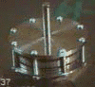 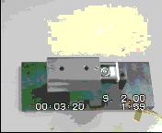 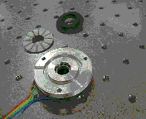

Rotary USM  Micro linear USM  Rotary USM   
 Animation Video/v-usm-linear.mpg, Video/v-usm-rotary.mpg,

**6) ANALYSIS OF PIEZOELECTRIC MOTORS**

The analysis of the nonlinear, coupled rotor-stator dynamic model discussed above has demonstrated the potential to predicting motor steady state and transient performance as a function of critical design parameters such as interface normal force, tooth height, and stator radial cross section. A finite element algorithm was incorporated into the analysis and a MATLAB code was developed to determine the modal characteristics of the stator. The model accounts for the shape of the stator, the piezoelectric poling pattern, and the teeth parameters. Once the details of the stators are selected the modal response is determined and is presented on the computer monitor, as shown for example in Figure 2, where the mode (m, n) = (4, 0) is presented. An electronic speckle pattern interferometry was used to corroborate the predicted modal response and the agreement seems to be very good as can be seen in Figure 3 on the left.

Using MATLAB we developed an animation tool to view the operation of USMs on the computer display. The tool allows to show the rotation of the rotor while a flexural wave is traveling on the stator (Figure 4).

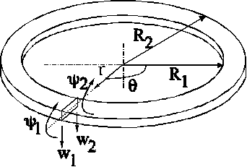

Figure 2: An annular finite element

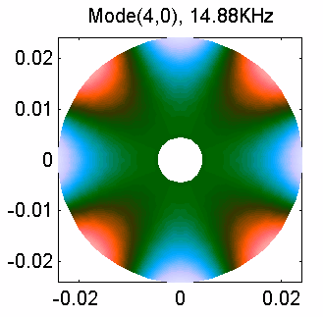

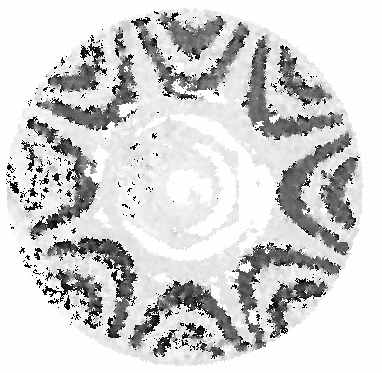

3: Modal response and resonance frequency (left) and experimental verification (right).

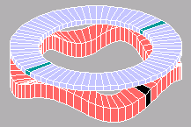

Figure 4: Animation tool for viewing the operation of USM. The stator is shown with traveling wave and the rotor is rotating above the stator.

Using this analytical model that employs finite element analysis, motors were constructed. The predicted resonance and measured resonance frequency for a 1.71-in diameter steel stator are represented in Table 1. The results that are presented in this table are showing an excellent agreement between the calculated and measured data. To examine the effect of vacuum and low temperatures, a 1.1 inch USM was also tested in a cryo-vac chamber that was constructed using a SATEC system and the torque speed was measured as shown in Figure 7. The motor that was servo-controlled showed a remarkable stable performance down to about -48oC and vacuum at the level of 2x10-2 Torr. This result is very encouraging and more work will be done in the future to determine the requirements for operation of USMs at Mars simulated conditions.

**TABLE** 1. The measured and calculated resonance frequencies of a USM’s stator

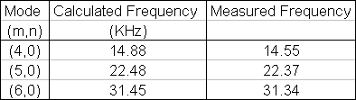

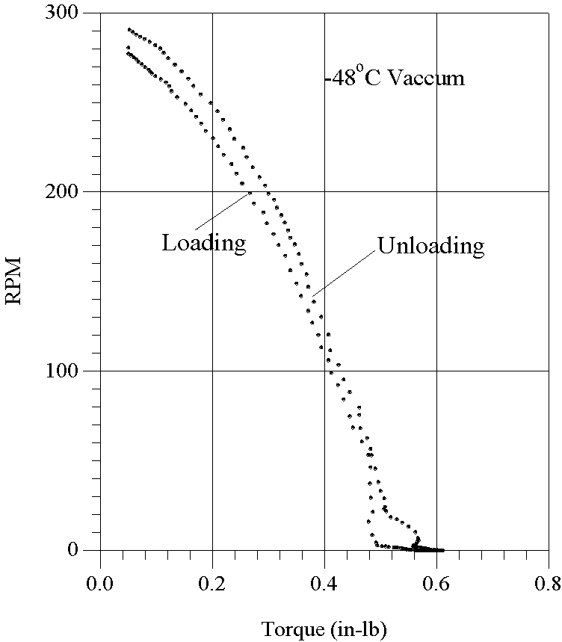

 Figure 7. Measured torque-speed curve for a 1.1-inch diameter USM at -48o C and 2x10-2 Torr.

**1) Self-induced oscillating drive circuit**

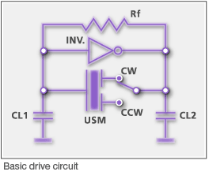

SII's ultrasonic micromotorss drive circuit also has its own unique features. For example, using the motor's piezoelectric element as part of a self-oscillating circuit enabled the design of a simple and scalable drive circuit.

This drive circuit design also achieved a lower start up voltage (1.5V - 3V), an important requirement wristwatches with thin small battery cells.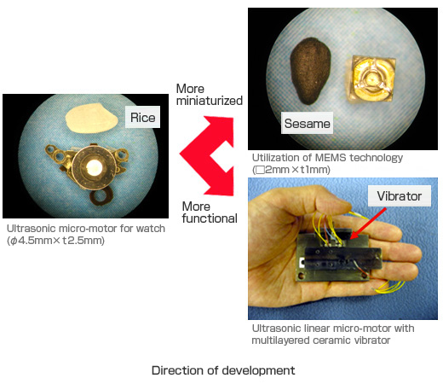

The ultrasonic motor is characterized by a "low speed and high torque", contrary to the "high speed and low torque" of the electromagnetic motors. Two categories of ultrasonic motors are developed at our laboratory: the standing wave type and the travelling wave type.

The standing wave type is sometimes referred to as a vibratory-coupler type, where a vibratory piece is connected to a piezoelectric driver and the tip portion generates flat-elliptical movement. Attached to a rotor or a slider, the vibratory piece provides intermittent rotational torque or thrust. The travelling-wave type combines two standing waves with a 90¡-phase difference both in time and space. By means of the travelling elastic wave induced by the thin piezoelectric ring, a ring-type slider in contact with the surface of the elastic body can be driven.

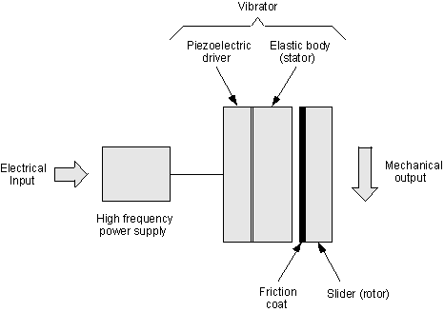

General diagram of an ultrasonic motor

To describe in a satisfactory way the behavior of the ultrasonic motor, an analytical model has to be built with a particular stress on the modeling of the zone of contact between stator and rotor. At the same time, it is necessary for the analytical model to meet with the complexity of operational applications and control techniques.

Thus, a first project is carried out at the laboratory to establish various control algorithms in order to bring under control the speed travelling wave ultrasonic motor. The research will be dedicated to the development of control algorithms and given that the travelling wave ultrasonic motor has a strong non-linearity due to the phenomena occurring in the zone of contact, it is also necessary to study new algorithms of observation applicable to strongly non-linear systems.

The current research can be described by the following diagram. The project based on the linear motors is more centered on the modeling aspect than on the control but both studies have the same goal: the performance optimization of the motor to obtain a better efficiency.

Some prototypes have been developed at the laboratory and are subject to tests and measurements. The electronics necessary to control them is also developed within the laboratory and has already given some results.

|  |  |  |
| --- | --- | --- |
| http://laiwww.epfl.ch/research/piezo/piezoelectric-small.jpg*Linear piezoelectric actuator* | The development and the study of both linear and rotational ultrasonic motors open new ways to the future for more applications in the medical micro-surgery or for miniature space robotics. Indeed, the ongoing miniaturization of systems and drives confines the electromagnetic motors to their limits and thus opens the way to the ultrasonic motors in the industrial world. | http://laiwww.epfl.ch/research/piezo/shinsei-small.jpg *Shinsei ultrasonic motor* |

**7) RESULTS OF SAMPLE ULTRASONIC MOTOR**

**1) The 3D Model Analysis for the Stator**.



This 3D finite element model enables the simulation of complex structures and to obtain more accurate results

than other approaches e.g. analytical models or annual finite element models. However, the computational process is time consuming and far from being practical when using a personal computers or workstations to determine the full model of the stator with finer meshes. Using the symmetry of the stator structure, a fraction of the stator mesh is needed combined with set proper boundary conditions allows significant reduction in computation time. In order to obtain high symmetry, 10 electrodes (polarized alternately) are assumed to be uniformly distributed on the circumference. Figure 4 shows the resonance frequency and the model shape obtained by meshing 1/10 of the stator, which is equal to 1/2 wavelength of the 5-wavelength mode. The volume is chosen with a total of 2340 mesh elements and total number of degree of freedom is 11000. Using a Sun workstation and an ANSYS program with these conditions the calculation time lasted 360 seconds. The computed resonance frequency of 47.208 kHz was found very close to the measured value of 47.29 kHz.

**2) SIMULATION**



(a) At the outer diameter of the teeth (b) At inner diameter of the teeth

Distribution of the displacements on the top surface of the teeth, Ux is in radial direction, Uy in circumference direction, and Uz is in axis direction.

The 3D model provides detailed displacement distribution of the mode on the tips of the teeth. The tip motion of the traveling wave is obtained by adding two vibration models separated by1/4 wavelength in space and 90 out of phase in time. As shown in the Figure 5, the radial displacements of the tips are comparable with the circumferential. The results also show that both normal and circumferential displacements at the inner diameter of the teeth are significantly less than those at the outer diameter. The ratio of the normal displacement over the circumferential is greatly changed as well. All these phenomena are important for motor design.

A comparison of the calculated input impedance to the measured is a common, convenient mean to evaluate the accuracy of the model. Although we can directly calculate the impedance curve by the FE package, but it requires full meshed model and long computing time. An alternative approach, the equivalent circuit, is used to get the curve.

The response of the stator at the frequency around the resonance can be presented by an equivalent circuit. The 3D finite element model was formulated for one terminal case, i.e. all the positively or negatively polarized areas are connected. In this case, the equivalent circuit is presented in Figures 6(a) and (b), where for this circuit there are two resonance frequencies. One is the series resonance Fs, which is equal to the resonance we computed by the 3D finite element model. The other is known as parallel resonance Fp. The Fp is computed in the same way as Fs in the 3D finite element model but without setting Ve to zero. At low frequency, the input impedance is a capacitance *C*t given by

*C*t = *C*0 + *C*et

where *C*0 and *C*et are the clumped and motion capacitance in the equivalent circuit of Figure 6(b) respectively.

Generally, the capacitance *C*t can also be computed by the finite element model. The three parameters in Figure 6

(b) can be determined using the Electro-mechanical circuit. The stator actually has two electric input terminals; each is connected to partial electrodes. To obtain the equivalent circuit for the partial electrodes, the circuit in Figure 6(a) is redrawed as 6(c) to represent the case of two terminals. When the two terminals are connected in parallel,

Ce1 =Ce (n/m)2

Le1 =Le(m/n)2

the same as 5(a). When the voltage is applied to one terminal and another is shorted, Figure 6(c) becomes 6(d). We have

Considering the parameter values of the motor used for the simulation the steady and transitory state motor is simulated. For the first test, the optimal parametersof the excitation voltages frequency have been tracked and evaluated to 46.65 kHz as frequency, 570 volt as excitation voltages amplitude and the shift between the two excitations π/2 rd. In the second test the simulation parameters are the same except that the excitation voltages amplitude was 595 Volts. The work carried out in was investigated only the torque range located between -3Nm and 3Nm, because it was to be used in a speed control and the optimization of the performance of the drive system because generally, in this torque range the analytical values of the precedent model are close to measured values, for a torque between 0 and 3 Nm.

The values of speed-torque, was represented By comparing the results obtained with the data of the manufacturer [21-22]. We can say that implementation [9] performed, on the software Matlab/Simulink, of refined model reflects the true behavior of the motor. The simulation results compared with experimental measurements are presented in Fig. 6.

represent the points of measurements of the manufacturer, and the solid lines the interpolation ensured by the points extracted from the simulation results. This shift between the measured values and the analytical curve is due to the effect of the temperature of ceramics following friction stator/rotor.





**8) Advantages of ultrasonic motor over electromagnetic motor:**

**1. Little influence by magnetic field:**

The greatest advantage of ultrasonic motor is that it is neither affected by nor creates a magnetic field. Regular motors which utilize electromagnetic induction will not perform normally when subjected to strong external magnetic fields. Since a fluctuation in the magnetic field will always create an electric field (following the principle of electromagnetic induction), one might think that ultrasonic motors will b affected as well. In practice, however, the effects are negligible. For example, consider a fluctuation in the flux density by, say, 1T (which is a considerable amount), at a frequency of 50 Hz , will create an electric field of 100 volts per meter. This magnitude is below the field strength in the piezoelectric ceramic and hence can be ignored.

#### 2. Low speed, high torque characteristics, compact size and quiet operation:

Ultrasonic motors can be made very compact in size. The motor generates high torques at low speeds and no reduction gears are needed unlike the electromagnetic motors. The motor is also very quiet, since its drive is created by ultrasonic vibrations that are inaudible to humans.

#### 3. Compact-sized actuators:

The ultrasonic motor’s small size and large torque are utilized in several applications. The ultrasonic motors hollow structure is necessary for an application in several fields such a robotics etc where it would be very difficult to design a device with an electromagnetic motor and satisfy the required specifications.

Their main advantages over the conventional electromagnetic devices are:

4. Different velocities without gear-mechanisms,

5. High positioning accuracy due to the friction drive,

6. High holding torque (braking force without energy supply) [4],

7. Simplicity and flexibility in structural design [4 -5],

8. No magnetic noise [6],

9. High out put torque at low speed[7],

10. High force density,

**9) APPLICATIONS**

**Ultrasonic micromotor**

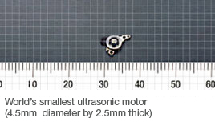

A wristwatch is essentially a high density micro mechanism that includes a power supply, oscillator, control and drive circuits, micromotor, micro transfer mechanism, micro sensor and display elements.

The key technology behind this micro mechanism is the micro motor. SII successfully launched mass production of the world's smallest ultrasonic motor (4.5mm diameter by 2.5mm thick), and incorporated it in wristwatches as the actuator for the fully-automatic calendar. Highly evaluated for its small size, low voltage operation using a simple drive circuit, and application in wristwatches, the ultrasonic micromotor received the Aoki Award from the Horological Institute of Japan, the Technology Award from the Japan Society for Precision Engineering, and the Japan Society for the Promotion of Machine Industry Prize.  
We have also developed many types of ultrasonic micro-motors, with a focus on downsizing.

The technology has been applied to photographic lenses by a variety of companies under different names:

* Canon – **USM**, UltraSonic Motor
* [Minolta](http://en.wikipedia.org/wiki/Minolta), Sony – **SSM**, SuperSonic Motor
* Nikon – **SWM**, Silent Wave Motor
* [Olympus](http://en.wikipedia.org/wiki/Olympus_Corporation) – **SWD**, Supersonic Wave Drive
* [Panasonic](http://en.wikipedia.org/wiki/Panasonic) – **XSM**, Extra Silent Motor
* [Pentax](http://en.wikipedia.org/wiki/Pentax) – **SDM**, Silent Drive Motor
* [Sigma](http://en.wikipedia.org/wiki/Sigma_Corporation) – **HSM**, Hyper Sonic Motor
* [Tamron](http://en.wikipedia.org/wiki/Tamron) - **USD**, Ultrasonic Silent Drive

**10. FUTURE OF USM’S**

[Piezoelectric Materials Will Power Future Nanoscale Devices](http://news.softpedia.com/news/Piezoelectric-Materials-Will-Power-Future-Nanoscale-Devices-117712.shtml)

One of the most daring dreams that scientists have is to create a world that is completely self-sustaining, and which is not reliant on exterior sources of power for it to operate. This means that everything requiring electricity will have to reach a high-level of conservation abilities,

|  |  |
| --- | --- |
|  |  |

**Image comment:** A small piezoelectric motor. In the future, these devices may also exist at the nanoscale, powering others all around us

[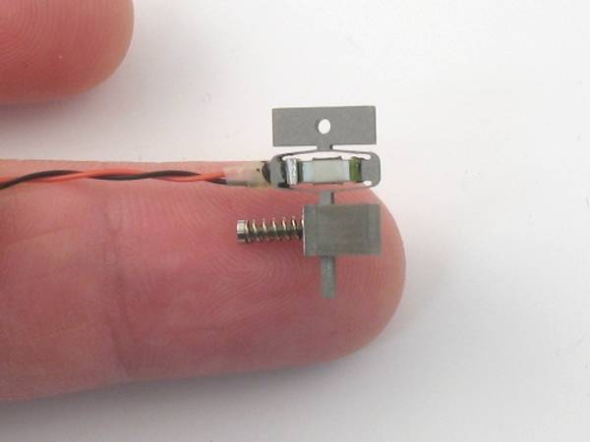](http://i1-news.softpedia-static.com/images/news2/Piezoelectric-Materials-Will-Power-Future-Nanoscale-Devices-2.jpg)

**11. Conclusion**

The main contribution of the work presented in this paper consists in description

development rotary traveling wave ultrasonic motor as structure, principle function and

application form in according to its working characteristics.

As technical example of ultrasonic motor, Daimler-Benz AWM90-X motor is presented,

using the measurements values obtained from the manufacturer data and it simulation

implemented that we have developed.

After 25 years of active search and nowadays piezoelectric rotary motors have

considerable advantages and represent a truth concurrent for conventional electromagnetic

motors.

For the new needs of applications domains, several types of piezoelectric ultrasonic

motors have been suggested and designed and developed, to be used as standard as

efficient, particularly the rotary traveling wave ones which are now commercially available

and applied as auto-focus cameras, in robotics, in medical domain and in aerospace.