Heat Transfer Equipment
- Includes not only simple concentric pipe exchangers but encompasses complex surface exchangers with thousands of square meters heating area.
Examples of Heat Transfer Equipments
- Heat Exchangers
- Condensers
- Evaporators
- Furnaces

- Heat Exchangers
- a device built for efficient heat transfer from one medium to another
- are widely used in space heating, refrigeration, air conditioning, power plants, chemical plants, petrochemical plants, petroleum refineries, natural gas processing and sewage treatment
- the shell-and-tube exchanger is the most commonly used type in the process industry, accounting at least 60 percent of all heat exchangers in use today
Basic Theory of Heat Transfer in Exchangers
- Heat can be transferred from a source to a receiver by conduction, convection, or radiation. In many cases, the exchange occurs by a combination of two or three of these mechanisms.
- STEADY STATE – when the rate of heat transfer remains constant and is unaffected by time (most industrial operations except startup, cool down, and surge operations)
- UNSTEADY STATE – when the rate of heat transfer at any point varies with time. (Batch processes, cooling and heating of materials, certain types of regeneration, curing or activation process.)
Alternative Approach to Heat Exchanger Performance
- Involves the concepts of heat exchanger effectiveness E and number of transfer units NTU.
Determination of Pressure Drop in Heat Exchangers
- Increased in fluid velocities result in larger heat-transfer coefficients and thus less required heat-transfer area and lower heat exchanger costs for a given rate of heat transfer. On the other hand, increased fluid velocities lead to increased pressure drop through the exchanger, which can result in higher operating costs.
- Major source of pressure drop in a heat exchanger is friction through either the shell or the tubes of the exchanger (sudden expansion, contraction, or reversal in the direction of flow of the fluids).
Tube-Side Pressure Drop
- The pressure drop on the tube side of a heat exchanger may be expressed as
$$∆p_{i}=\frac{2β_{i}f_{i}G_{i}^{2}{Ln}_{p}}{ρ_{i}D_{i}Φ_{i}}$$
- Where:
i - inside diameter
$n_{p}$- recognizes if more than one tube pass is involved with a length of L.
$f_{i}$ – fanning friction factor for isothermal flow; fully developed turbulent flow in a smooth pipe:
$f_{i}=0.079{Re}^{-0.25}$ for Re ≤ 2100 ;
$f_{i}=0.046{Re}^{-0.2}$ for Re > 2100
${ Φ}_{i}$- correction factor for nonisothermal flow
$Φ_{i}$ =1.1(${μ_{i}/μ_{w})}^{0.25}$ for Re < 2100
${ Φ}_{i}$ =1.02(${μ_{i}/μ_{w})}^{0.14}$ for Re > 2100
$μ_{i}$ - viscosity at the arithmetic-average bulk temperature of the fluid
$μ_{w}$- Viscosity of the fluid at the average temperature of the inside-tube wall surface
$β_{i}$ - added friction due to sudden contraction, expansion and reversal of flow direction;
$β_{i}=1+\frac{F_{e}+F_{c}+F_{r}}{2f_{i}G_{i}^{2}L/\left(ρ_{i}^{2}D_{i}Φ_{i}\right)}$ or
${ β}_{i}=1+\frac{0.51K_{1}n_{p}{ΔT}_{f,i}{\left({μ_{i}}/{μ_{w}}\right)}^{0.28}}{\left(T_{i,in}-T_{i,out}\right){Pr}_{i}^{2/3}}$ (if the flow is highly turbulent)
Where ${ΔT}_{f,i}$ is the temperature difference across the film inside the tube.

Shell-Side Pressure Drop
- For the case of flow directly across tubes, either in-line or staggered, the based on outside diameter of the tubes at the bulk temperature of the fluid the equation is:
$$∆p_{0}=\frac{2B_{0}f^{'}N_{tr}G_{s}^{2}}{ρ_{0}}$$
- Where:
$∆p_{0}$- pressure drop due to friction based on the outside diameter of the tubes at the bulk temperature of the fluid
$B_{0}$- is a correction factor to account for friction due to reversal in the direction of flow, recrossing of tubes, and variation in the cross section.
f’ - is a modified friction factor for shell-side flow
${ N}_{tr}$- number of tube rows over which the shell fluid flows

- For normal case where the external Reynolds number is between 2000 and 40, 000, the friction factor may be represented as
$$f^{'}=b_{o}{\left(\frac{D_{o}G_{s}}{μ_{o}}\right)}^{-0.15}$$
$b_{o}$- has been approximated by Grimson’s for in-line tubes as
$b_{o}=0.044+\frac{0.08x_{L}}{{\left(x_{T}-1\right)}^{\left(0.43-1.13/x_{L}\right)}}$ or $b_{o}=0.23+\frac{0.11}{{\left(x_{T}-1\right)}^{1.08}}$
- Where:
$x_{T}$- is the dimensionless ratio of pitch (the centre-centre distance of adjoining tubes) transverse to flow to the outside tube diameter
$x_{L}$ - is the dimensionless ratio of pitch parallel to flow to the outside tube diameter
  - Best results are obtained if is between 1.5 and 4.0. For design purposes the range can be extended down to 1.25.
  - A larger tube pitch leads to a larger overall shell diameter which leads to a more expensive heat exchanger

TYPES OF HEAT EXCHANGERS:
1. DOUBLE-PIPE AND MULTIPLE DOUBLE-PIPE EXCHANGERS
- one pipe inside another larger pipe
- simplest device for exchanging heat b/w two fluids, consisting of a “tube inside a tube” with a suitable inlet and outlet connections for both fluids
- generally operated in a counter current mode
*Fins- are added to the outside surface of the inner tube, when the required heat transfer is small or high pressures exist for both fluid streams
Determination of the heat transfer surface area:
Q = UA ΔT_{lm},
where:
Q = rate of heat transfer between the two fluids in the heat exchanger in Btu/hr,
U = overall heat transfer coefficient in BTU/hr-ft²-ºF,
A = heat transfer surface area in ft², and
ΔT_{lm} = log mean temperature difference in ºF, calculated from the inlet and outlet temperatures of both fluids
2. SHELL AND TUBE HEAT EXCHANGER
- because of its robust feature due to their shape are typically used for high pressure applications (pressures greater than 30 bar and temp. greater than 260°C)
- One set of these tubes contains the fluid that must be either heated or cooled. The second fluid runs over the tubes that are being heated or cooled so that it can either provide the heat or absorb the heat required.
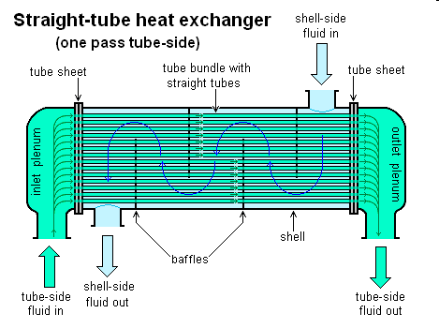
- A set of tubes is called the tube bundle and can be made up of several types of tubes: plain, longitudinally finned, etc.

A. TUBE LAYOUT
Square Pitch pattern– has the advantage of easier external cleaning. Employed where high fouling is experienced and cleaning is more regular.
Triangular Pitch pattern– often preferred because it permits the use of more tubes and hence results in more surface area in a given shell diameter. Employed to give greater heat transfer as they force the fluid to flow in a more turbulent fashion around the piping.
- Tube Pitch PT - the shortest center-to-center distance between adjacent tubes in either arrangement. Maintained between 1.25 to 1.50 times the tube diameter.
- Tube Clearance PD – shortest distance between any two tubes. Not be less than ¼ of the tube diameter with a minimum clearance of no less than 0.0048 m.
B. TUBE LENGTH
- Standard length of tubes is normally 2.44, 3.66 or 4.88 m.
C. TUBE DIAMETER
- A tube diameter of 0.019- or 0.0254m OD is the most common, but outside diameters up to 0.038 m are used in many industrial installations.
D. TUBE WALL THICKNESS
- Normal thickness:
for average wall tubes -±10 percent
for minimum wall tubes -+22 percent
E. SHELL DIAMETER & THICKNESS
- For normal pipe sizes shell diameter is up to 0.710m
- In general, a shell thickness of 0.0095 m is used for shell diameters b/w 0.305 and 0.710 m unless the shell fluids are extremely corrosive or the operating pressure on the shell side exceeds 2200 kPa.
F. BAFFLE
- The function of the baffle in a shell-and-tube heat exchanger is to direct the flow across the tube bundle as well as to support the tubes from sagging and possible vibration.
- Should not be spaced closer than 1/5 of the inner shell diameter, having baffles spaced too closely causes a greater pressure drop because of flow redirection. Consequently having the baffles spaced too far apart means that there may be cooler spots in the corners between baffles. It is also important to ensure the baffles are spaced close enough that the tubes do not sag.
- The most common type of baffle used in shell-and-tube heat exchangers is the segmental baffle.
3. SCRAPED-SURFACE EXCHANGERS
- Used in heat transfer from highly viscous or crystallization systems where fouling of the system is a problem.
- A heat exchanger in which a rotating blade periodically moves over the surface, scraping off the dried or crystallized product and allowing the latter to exit as a solid from the bottom of the exchanger.
- The blade action creates shearing of the dried product immediately adjacent to the wall, resulting in locally high-heat transfer rates.
- This exchanger should be considered only when the liquid viscosity exceeds 1 Pa-s or where there is heavy fouling or deposition.
4. PLATE EXCHANGERS
- Plate heat exchangers consist of thin plates joined together, with a small amount of space between each plate, typically maintained by a small rubber gasket.
- The surface area is large, and the corners of each rectangular plate feature an opening through which fluid can flow between plates, extracting heat from the plates as it flows.
- The fluid channels themselves alternate hot and cold fluids, meaning that heat exchangers can effectively cool as well as heat fluid—they are often used in refrigeration applications. Because plate heat exchangers have such a large surface area, they are often more effective than shell and tube heat exchangers.

Types of Plate Exchangers
- GASKETED PLATE EXCHANGER
- The plate-and-frame or gasketed plate heat exchanger (PHE) consists of a number of thin rectangular metal plates sealed around the edges by gaskets and held together in a frame
- WELDED PLATE EXCHANGER
- Plates welded together to increase pressure and temperature limits
Gasketed and Welded PHE
- used when a compact, flexible, liquid heat exchange system is required that encounters up to 250°C and` pressures up to 2.5 MPa.
- PHE with welded joints may be used with toxic and highly inflammable liquids, but such units can experience difficult maintenance problems.
Gasketed plate-and-frame Heat Exchanger

Welded Plate Heat Exchanger

5. SPIRAL PLATE AND TUBE EXCHANGERS
- Spiral plate exchangers are suitable for small capacity service with viscous, fouling, and corrosive fluids
- To use a spiral of adjacent tubes, overcomes the pressure limitations of plate exchangers
- The overall heat-transfer coefficients for spiral tube exchangers generally are somewhat higher than conventional exchangers because of the increase turbulence created by the centrifugal configurations of the tubes.
- is extremely compact and can handle a variety of fluids, but capacities are limited
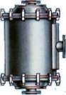
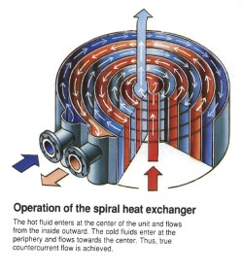

6. COMPACT EXCHANGERS
- Area density greater than 700m²/m³ for gas greater than 300m²/m³ when operating in liquid or two-phase streams.
- Highly efficient
- Reduce volume, weight and cost
- One of the most widely used compact heat exchanger is the Plate-Fin Heat Exchanger.
- fabricated by stacking alternate layers of corrugated, high-uniformity die-formed metallic sheets(fins) between flat separator plates to form individual flow passages.
PLATE-FIN EXCHANGERS
- are about 9 times as compact as conventional shell-and-tube heat exchangers while providing the same surface area, weigh less than conventional heat exchangers
- withstand design pressure up to 6 MPa for temperatures between -270 and 800°C.
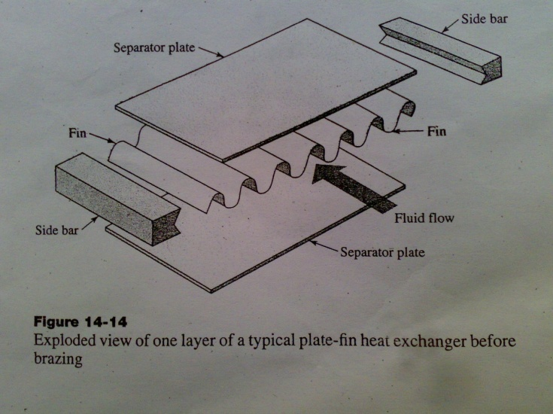

- The overall UA product for a plate-fin exchanger can be related to the individual hA product values for the hot and cold streams by:
- where h = individual heat transfer coefficient and
- A_{h} and A_{c} = the effective heat transfer areas for the hot and cold streams
- Colburn correlation is generally used to express the heat-transfer coefficients for single phase flow in the form of
h=j_{t}C_{P}GPr^{-2/3}
- Pressure drop relations for single-phase flow in plate-fin heat exchangers
7. ADIABATIC WHEEL HEAT EXCHANGERS
- uses an intermediate fluid or solid store to hold heat, which is then moved to the other side of the heat exchanger to be released
- Two examples of this are adiabatic wheels, which consist of a large wheel with fine threads rotating through the hot and cold fluids, and fluid heat exchangers.
8. FLUID HEAT EXCHANGERS
- This is a heat exchanger with a gas passing upwards through a shower of fluid (often water), and the fluid is then taken elsewhere before being cooled. This is commonly used for cooling gases whilst also removing certain impurities, thus solving two problems at once.
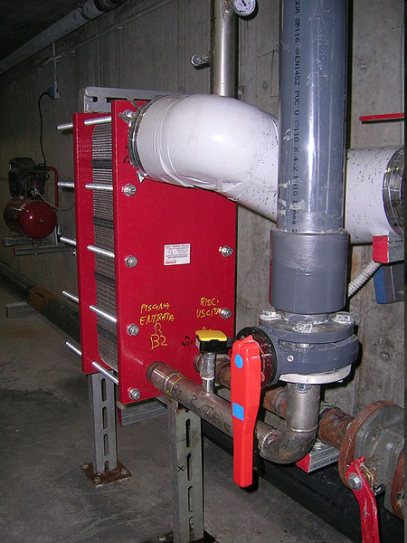

An interchangeable plate heat exchanger applied to the system of a swimming pool.

9. Gas-to-Gas Exchangers
- A major application of this type of exchanger is seen in the recovery of energy from combustion gases to preheat furnace air.
- In the plain tube gas-togas heat exchanger, the hot gas flows past the tubes in the tube bank in either a single-pass (cross-flow) or a multipass configuration. The normal maximum operating temperature for such units is 250°C
- Another type of gas-to-gas exchanger establishes a convection bank with polished, dimple-ribbed stainless-steel tubes. In a typical unit, the flat-sided tubes are mounted horizontally and sealed with an elastomer to perforated end plates that are formed into a flange plate and an enclosure. The units are compact and lightweight and can be used to recover heat from exhaust gases up to 250°C.
10. Air-Cooled Exchangers
- this type of exchanger is sometimes referred to as a fin-fan unit because the tubes have external fins and fans are employed to force or draw air through the tube banks in a cross-flow arrangement.The latter arrangement makes these units less efficient than a countercurrent exchanger.
- The penalty for cross-flow often can be decreased through the use of multiple tube-side passes.
- The use of fins is required to increase the overall heat-transfer coefficient. The extra investment in fines tubing is partially compensated for by the fact that no shell is required and no cooling water (including pumps and associated piping) is necessary. Shell-side fouling generally is not a problem, tube cleaning is relatively easy.

Optimum Design of Heat Exchangers
- Involves initial conditions in which the following variables are known:
- Process-fluid rate of flow
- Allowed temperature change of process fluid
- Inlet temperature of utility fluid(for cooling or heating)
- The engineer must prepare a design for the optimum exchanger that will meet the required process conditions. The following results must be determined:
- Heat-transfer area
- Exit temperature and flow rate of utility fluid
- Number, length, diameter, and arrangement of tubes
- Pressure drops for the hot and cold fluids

- Condensers
- a wide range of equipment is used to meet the condensation requirements of industrial processes.
- Condensing equipment can be classified into four generic types, namely, tubular, plate-type, air-cooled, and direct contact. In the process industry, tubular condensers are normally conventional shell-and-tube types with condensation either inside the tube or in the shell depending on the process requirements, particularly with respect to fouling tendencies.
- The plate type includes both plate-and-frame exchangers and plate-fin exchangers.
- Condensation in the air-cooled condensers occurs within the tubes while in the direct-contact condensers the coolant is brought in direct contact with the condensing vapour, eliminating the need for a heat-transfer surface as in the other generic types.

- Evaporators
- Heat exchangers used for concentration and crystallization. Those designed for vapour production are designated as vapour generators.
- There are many types of evaporators including film, in-tube boiling, shell-side boiling, flash, and direct-contact types. Selection of the most suitable type is very dependent on the properties of the evaporating liquid.

