HEAT EXCHANGER
A heat exchanger is a piece of equipment built for efficient heat transfer from one medium to another. The media may be separated by a solid wall, so that they never mix, or they may be in direct contact.^{[1]} They are widely used in space heating, refrigeration, air conditioning, power plants, chemical plants, petrochemical plants, petroleum refineries, natural gas processing, and sewage treatment. The classic example of a heat exchanger is found in an internal combustion engine in which a circulating fluid known as engine coolant flows through radiator coils and air flows past the coils, which cools the coolant and heats the incoming air.
FLOW ARRANGEMENT
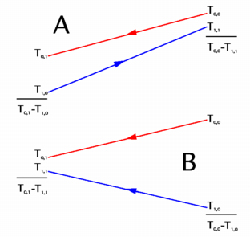
Keterangan :
- A : Countercurrent flow
- B : Parallel flow
There are two primary classifications of heat exchangers according to their flow arrangement. In parallel-flow heat exchangers, the two fluids enter the exchanger at the same end, and travel in parallel to one another to the other side. In counter-flow heat exchangers the fluids enter the exchanger from opposite ends. The counter current design is most efficient, in that it can transfer the most heat from the heat (transfer) medium. See countercurrent exchange. In a cross-flow heat exchanger, the fluids travel roughly perpendicular to one another through the exchanger.
For efficiency, heat exchangers are designed to maximize the surface area of the wall between the two fluids, while minimizing resistance to fluid flow through the exchanger. The exchanger's performance can also be affected by the addition of fins or corrugations in one or both directions, which increase surface area and may channel fluid flow or induce turbulence.
The driving temperature across the heat transfer surface varies with position, but an appropriate mean temperature can be defined. In most simple systems this is the "log mean temperature difference" (LMTD). Sometimes direct knowledge of the LMTD is not available and the NTU method is used.
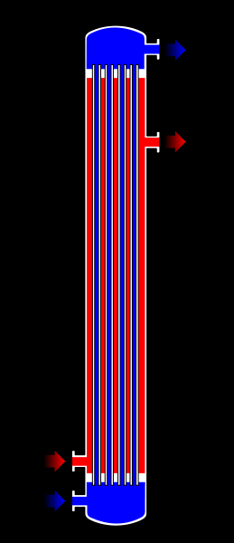
Gbr 1. Shell and Tube Single Pass
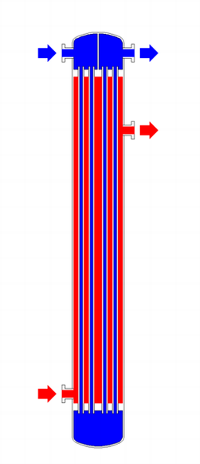
Gbr 2.Shell And Tube, 2 Pass 2 Side.
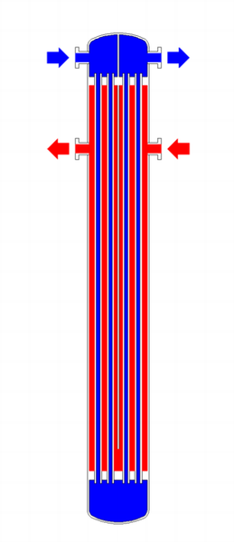
Gbr 3. Shell and Tube, 2-pass shell side, 2-pass tube side
TYPES OF HEAT EXCHANGER
- Shell and Tube Heat Exchanger
Shell and tube heat exchangers consist of a series of tubes. One set of these tubes contains the fluid that must be either heated or cooled. The second fluid runs over the tubes that are being heated or cooled so that it can either provide the heat or absorb the heat required. A set of tubes is called the tube bundle and can be made up of several types of tubes: plain, longitudinally finned, etc. Shell and tube heat exchangers are typically used for high-pressure applications (with pressures greater than 30 bar and temperatures greater than 260 °C). This is because the shell and tube heat exchangers are robust due to their shape.
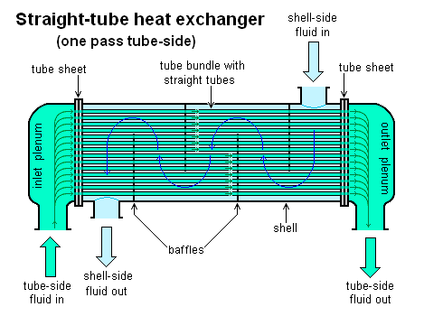
There are several thermal design features that are to be taken into account when designing the tubes in the shell and tube heat exchangers. These include:
Tube diameter: Using a small tube diameter makes the heat exchanger both economical and compact. However, it is more likely for the heat exchanger to foul up faster and the small size makes mechanical cleaning of the fouling difficult. To prevail over the fouling and cleaning problems, larger tube diameters can be used. Thus to determine the tube diameter, the available space, cost and the fouling nature of the fluids must be considered.
Tube thickness: The thickness of the wall of the tubes is usually determined to ensure:
  - There is enough room for corrosion
  - That flow-induced vibration has resistance
  - Axial strength
  - Availability of spare parts
  - Hoop strength (to withstand internal tube pressure)
  - Buckling strength (to withstand overpressure in the shell)
Tube length: heat exchangers are usually cheaper when they have a smaller shell diameter and a long tube length. Thus, typically there is an aim to make the heat exchanger as long as physically possible whilst not exceeding production capabilities. However, there are many limitations for this, including the space available at the site where it is going to be used and the need to ensure that there are tubes available in lengths that are twice the required length (so that the tubes can be withdrawn and replaced). Also, it has to be remembered that long, thin tubes are difficult to take out and replace.
Tube pitch: when designing the tubes, it is practical to ensure that the tube pitch (i.e., the centre-centre distance of adjoining tubes) is not less than 1.25 times the tubes' outside diameter. A larger tube pitch leads to a larger overall shell diameter which leads to a more expensive heat exchanger.
Tube corrugation: this type of tubes, mainly used for the inner tubes, increases the turbulence of the fluids and the effect is very important in the heat transfer giving a better performance.
Tube Layout: refers to how tubes are positioned within the shell. There are four main types of tube layout, which are, triangular (30°), rotated triangular (60°), square (90°) and rotated square (45°). The triangular patterns are employed to give greater heat transfer as they force the fluid to flow in a more turbulent fashion around the piping. Square patterns are employed where high fouling is experienced and cleaning is more regular.
Baffle Design: baffles are used in shell and tube heat exchangers to direct fluid across the tube bundle. They run perpendicularly to the shell and hold the bundle, preventing the tubes from sagging over a long length. They can also prevent the tubes from vibrating. The most common type of baffle is the segmental baffle. The semicircular segmental baffles are oriented at 180 degrees to the adjacent baffles forcing the fluid to flow upward and downwards between the tube bundle. Baffle spacing is of large thermodynamic concern when designing shell and tube heat exchangers. Baffles must be spaced with consideration for the conversion of pressure drop and heat transfer. For thermo economic optimization it is suggested that the baffles be spaced no closer than 20% of the shell’s inner diameter. Having baffles spaced too closely causes a greater pressure drop because of flow redirection. Consequently having the baffles spaced too far apart means that there may be cooler spots in the corners between baffles. It is also important to ensure the baffles are spaced close enough that the tubes do not sag. The other main type of baffle is the disc and donut baffle which consists of two concentric baffles, the outer wider baffle looks like a donut, whilst the inner baffle is shaped as a disk. This type of baffle forces the fluid to pass around each side of the disk then through the donut baffle generating a different type of fluid flow.
PLATE HEAT EXCHANGER
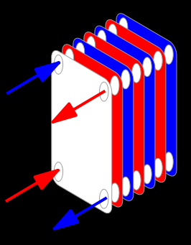
Another type of heat exchanger is the plate heat exchanger. One is composed of multiple, thin, slightly separated plates that have very large surface areas and fluid flow passages for heat transfer. This stacked-plate arrangement can be more effective, in a given space, than the shell and tube heat exchanger. Advances in gasket and brazing technology have made the plate-type heat exchanger increasingly practical. In HVAC applications, large heat exchangers of this type are called plate-and-frame; when used in open loops, these heat exchangers are normally of the gasket type to allow periodic disassembly, cleaning, and inspection. There are many types of permanently bonded plate heat exchangers, such as dip-brazed and vacuum-brazed plate varieties, and they are often specified for closed-loop applications such as refrigeration. Plate heat exchangers also differ in the types of plates that are used, and in the configurations of those plates. Some plates may be stamped with "chevron" or other patterns, where others may have machined fins and/or grooves.

ADIABATIC WHEEL HEAT EXCHANGER
A third type of heat exchanger uses an intermediate fluid or solid store to hold heat, which is then moved to the other side of the heat exchanger to be released. Two examples of this are adiabatic wheels, which consist of a large wheel with fine threads rotating through the hot and cold fluids, and fluid heat exchangers.
PLATE FIN HEAT EXCHANGER
This type of heat exchanger uses "sandwiched" passages containing fins to increase the effectivity of the unit. The designs include crossflow and counterflow coupled with various fin configurations such as straight fins, offset fins and wavy fins.

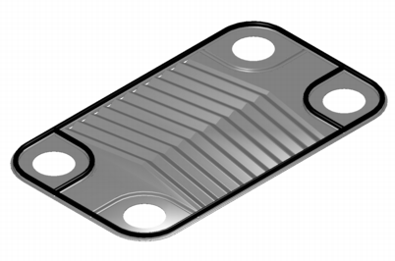
gbr 1. Plate fin heat exchanger

Plate and fin heat exchangers are usually made of aluminium alloys which provide higher heat transfer efficiency. The material enables the system to operate at a lower temperature and reduce the weight of the equipment. Plate and fin heat exchangers are mostly used for low temperature services such as natural gas, helium and oxygen liquefaction plants, air separation plants and transport industries such as motor and aircraft engines.
Advantages of plate and fin heat exchangers:
- High heat transfer efficiency especially in gas treatment
- Larger heat transfer area
- Approximately 5 times lighter in weight than that of shell and tube heat exchanger.
- Able to withstand high pressure
Disadvantages of plate and fin heat exchangers:
- Might cause clogging as the pathways are very narrow
- Difficult to clean the pathways
- Aluminum alloys are susceptible to Mercury Liquid Embrittlement Failure
PILLOW PLATE HEAT EXCHANGER
A pillow plate exchanger is commonly used in the dairy industry for cooling milk in large direct-expansion stainless steel bulk tanks. The pillow plate allows for cooling across nearly the entire surface area of the tank, without gaps that would occur between pipes welded to the exterior of the tank.
The pillow plate is constructed using a thin sheet of metal spot-welded to the surface of another thicker sheet of metal. The thin plate is welded in a regular pattern of dots or with a serpentine pattern of weld lines. After welding the enclosed space is pressurized with sufficient force to cause the thin metal to bulge out around the welds, providing a space for heat exchanger liquids to flow, and creating a characteristic appearance of a swelled pillow formed out of metal.
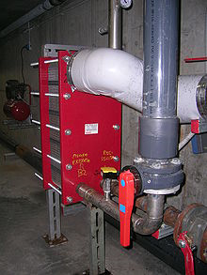
Gbr 1. Heat exchanger applied for swimming pool
FLUID HEAT EXCHANGER
This is a heat exchanger with a gas passing upwards through a shower of fluid (often water), and the fluid is then taken elsewhere before being cooled. This is commonly used for cooling gases whilst also removing certain impurities, thus solving two problems at once. It is widely used in espresso machines as an energy-saving method of cooling super-heated water to be used in the extraction of espresso.
WASTE HEAT RECOVERY UNIT
A Waste Heat Recovery Unit (WHRU) is a heat exchanger that recovers heat from a hot gas stream while transferring it to a working medium, typically water or oils. The hot gas stream can be the exhaust gas from a gas turbine or a diesel engine or a waste gas from industry or refinery.

DYNAMIC SCRAPED SURFACE HEAT EXCHANGER
Another type of heat exchanger is called "(dynamic) scraped surface heat exchanger". This is mainly used for heating or cooling with high-viscosity products, crystallization processes, evaporation and high-fouling applications. Long running times are achieved due to the continuous scraping of the surface, thus avoiding fouling and achieving a sustainable heat transfer rate during the process.
The formula used for this will be Q=A*U*LMTD, whereby Q= amount of heat transferred; U= heat transfer coefficient; A=Heat Transfer Area; LMTD = Log mean temperature differential.^{[3]}
PHASE-CHANGE HEAT EXCHANGER
In addition to heating up or cooling down fluids in just a single phase, heat exchangers can be used either to heat a liquid to evaporate (or boil) it or used as condensers to cool a vapor and condense it to a liquid. In chemical plants and refineries, reboilers used to heat incoming feed for distillation towers are often heat exchangers.^{[4][5]}
Distillation set-ups typically use condensers to condense distillate vapors back into liquid.
Power plants which have steam-driven turbines commonly use heat exchangers to boil water into steam. Heat exchangers or similar units for producing steam from water are often called boilers or steam generators.
In the nuclear power plants called pressurized water reactors, special large heat exchangers which pass heat from the primary (reactor plant) system to the secondary (steam plant) system, producing steam from water in the process, are called steam generators. All fossil-fueled and nuclear power plants using steam-driven turbines have surface condensers to convert the exhaust steam from the turbines into condensate (water) for re-use.^{[6][7]}
To conserve energy and cooling capacity in chemical and other plants, regenerative heat exchangers can be used to transfer heat from one stream that needs to be cooled to another stream that needs to be heated, such as distillate cooling and reboiler feed pre-heating.
This term can also refer to heat exchangers that contain a material within their structure that has a change of phase. This is usually a solid to liquid phase due to the small volume difference between these states. This change of phase effectively acts as a buffer because it occurs at a constant temperature but still allows for the heat exchanger to accept additional heat. One example where this has been investigated is for use in high power aircraft electronics.
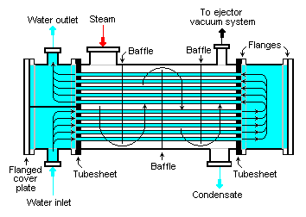
Gbr 1. Typical Water cooled surface condenser

Materials for Heat Exchanger Tubes

Introduction
Heat exchangers take heat from one fluid and pass it to a second. The fire-tube array of a steam engine is a heat exchanger, taking heat from the hot combustion gases of the firebox and transmitting it to the water in the boiler. The network of finned tubes in an air conditioner is a heat exchanger, taking heat from the air of the room and dumping it into the working fluid of the conditioner. The radiator in a car performs a similar function. A key element in all heat exchangers is the tube wall or membrane which separates the two fluids. It is required to transmit heat and there is frequently a large pressure difference across it.
What are the best materials for making heat exchangers? Or, more specifically, what are the best materials for a conduction-limited exchanger, with substantial pressure difference between the two fluids?
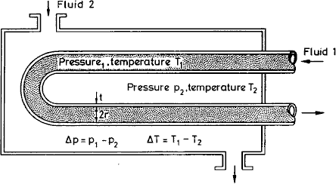

Figure 1 Schematic of a heat exchanger

Design Requirements
FUNCTION | Heat Exchanger
OBJECTIVE | Maximise heat flow per unit area, or per unit weight
CONSTRAINTS | (a) Support pressure difference Dp  (b) Withstand chloride ions  (c) Operating temperature up to 150°C  (d) Low Cost

Table 1
The Model
First, a little background on heat flow. Heat transfer from one fluid, through a membrane to a second fluid, involves convective transfer from fluid 1 into the tube wall, conduction through the wall, and convection again to transfer it into fluid 2. The heat flux q into the tube wall by convection (in units of W/m²) is described by the heat transfer equation:
(1)
in which h1 is the heat transfer coefficient and DT1 is the temperature drop across the surface from fluid 1 into the wall. Conduction is described by the conduction (or Fourier) equation
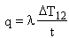(2)
where l is the thermal conductivity of the wall (thickness t) and D T12 is the temperature difference across it.
It is helpful to think of the thermal resistance at surface 1 as 1/h1; that of surface 2 is 1/h2; and that of the wall itself is t/l. Then continuity of heat flux requires that the total resistance 1/U is
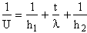(3)
where U is called the 'total heat transfer coefficient '. The heat flux from fluid 1 to fluid 2 is then given by
(4)
where DT is the difference in temperature between the two working fluids. When one of the fluids is a gas, as in an air conditioner, heat transfer at the tube surface contributes most of the resistance; then fins are used to increase the surface area across which heat can be transferred. But when both working fluids are liquid, convective heat transfer is rapid and conduction through the wall dominates the thermal resistance. In this case simple tube elements are used, with their wall as thin as possible to maximise l/t. We will consider the second case: conduction limited heat transfer. Then 1/h1 and 1/h2 are negligible when compared with t/l, and the heat transfer equation becomes
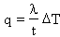(5)
Consider, now, a heat exchanger with many tubes, each of radius r and wall thickness t with a pressure difference Dp between the inside and outside. Our aim is to select a material to maximise the total heat flow, while safely carrying the pressure difference Dp. The total heat flow is
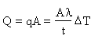(6)
where A is the total surface area of tubing.
This is the objective function. The constraint is that the wall thickness must be sufficient to support the pressure difference Dp. This requires that the stress in the wall remain below the elastic limit (yield strength) sel (times a safety factor, which need not be included in this analysis):
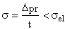(7)
Eliminating t between the last two equations gives
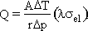(8)
The heat flow per unit area of tube wall, Q/A, is maximised by maximising the performance index:
(9)
Four further considerations enter the selection. It is essential to choose a material that withstands corrosion in the working fluids, which we take here to be water containing chloride ions (sea water). Cost will naturally be of concern. The maximum service temperature must be adequate and the material should be available as drawn tube.

The Selection
A preliminary selection using the Generic filter is shown in Figures 2-4. The first chart is of elastic limit versus thermal conductivity, to allow us to maximise the value of M1. The second stage shows maximum service temperature plotted as a bar-chart against resistance to sea-water, selecting materials with high temperature resistance and high resistance to corrosion in sea-water. The last stage shows a bar chart of material cost against available forms, selecting cheap materials that are available as sheet or tube.
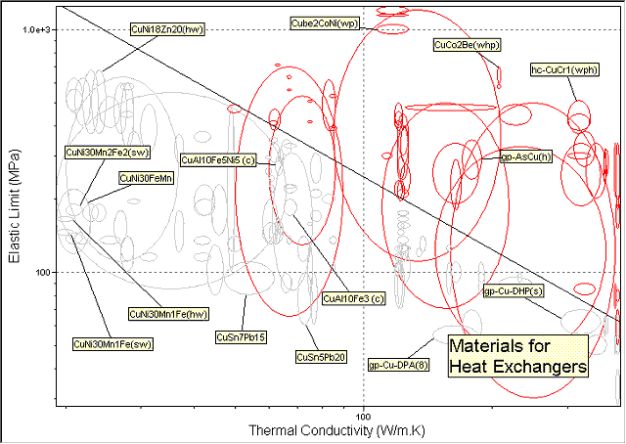

Figure 2 A Chart of Elastic Limit versus Thermal Conductivity
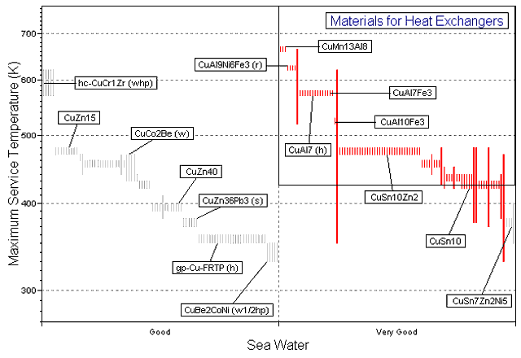

Figure 3 A Bar-chart of Maximum Service Temperature versus Resistance to Sea-Water Corrosion
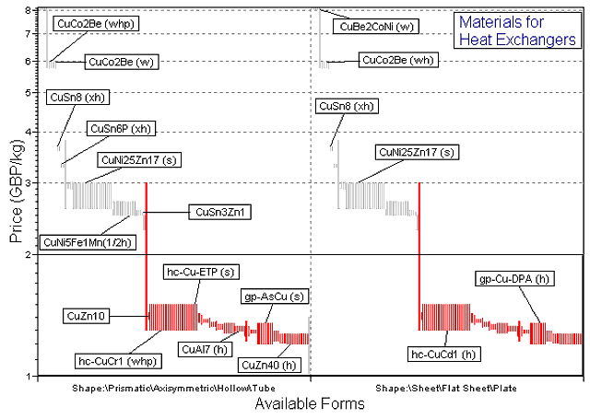

Figure 4 Material Cost against Available Forms
The results of this selection are shown in Results Table 1, and they suggest that it may be worth transferring the selection criteria to the coppers database to refine the search for a suitable material.

Results
Material (ranked by M₁) | Comment
High Conductivity Coppers | Have the best performance index, but relatively poor corrosion resistance
Brasses | Again, relatively poor corrosion resistance
Wrought Martensitic Stainless Steel | A good choice, but steel is more dense than copper
Aluminium Bronzes | An economical and practical choice

Table 1 The Results of the Selection using the Generic Filter

Material (ranked by M₁) | Comment
90/10 Aluminium bronze, cold wkd (wrought) | The aluminium bronzes are cheap
92/8 Aluminium bronze, hard (wrought)
93/7 Aluminium bronze, hard (wrought)
95/5 Aluminium bronze, 1/2 hard (wrought)
95/5 Aluminium bronze, hard (wrought)
Nickel iron aluminium bronze, as extruded (wrought) | The Nickel iron aluminium bronzes are more corrosion resistant
Nickel iron aluminium bronze, hot wkd (wrought)

Table 2 The Results of the Selection by expanding the coppers branch

PostScript
Conduction may limit heat flow in theory, but unspeakable things go on inside heat exchangers. Sea water—often one of the working fluids—seethes with biofouling organisms which attach themselves to tube walls and thrive, creating a layer of high thermal resistance and impeding fluid flow, like barnacles on a boat. Some materials are more resistant to biofouling than others; copper-nickel alloys are particularly good, probably because the organisms dislike copper salts, even in very low concentrations. Otherwise the problem must be tackled by adding chemical inhibitors to the fluids, or by scraping—the traditional winter pass-time of boat owners.
It is sometimes important to minimise the weight of heat exchangers. Repeating the calculation to seek materials for the lightest heat exchanger gives, instead of M, the index:
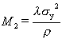(10)
where r is the density of the materials from which the tubes are made. This is quite a different index—the strength varies to the power 2 because the weight depends on the wall thickness, and from Eqn 7 we know that wall thickness varies as 1/strength.
Of course, all copper alloys have roughly the same density, so there is little point applying this index within the coppers in the database—but if copper alloys were c

