circuit breaker is an equipment, which can make or break a circuit manually or automatically under all conditions i.e. no load, full load and short circuit conditions.
OPERATING PRINCIPLE
It consists of fixed and moving contacts which remain closed under normal condition, when fault occur the trip coil are energized and the moving contacts are pulled apart. When contacts get separated an arc will be struck between the contacts, which will not only delay current interruption process but also generate enormous heat, which may cause damage to the system or to the circuit breaker itself. So the main problem with circuit breaker is to extinguish the arc within the shortest possible time.
ARC PHENOMENON
When fault occurs current flow through contacts before they are being separated. At the instant when contact separates, the contact area decreases and the large fault current cause increased current density and hence rise in temperature occur due to which the surrounding air or oil get ionised. They acts as conductor and an arc is struck between them. The potential difference between contacts is sufficient to maintain the arc. The arc provides a low resistance path and current flows till the arc persists.
The current flow depends on the arc resistance. As the resistance increases current flow between the contacts decreases. Arc resistance depends on:
(a) Degree of ionisation – arc resistance increases with decrease in number of ionised particles.
(b) Length of arc – arc resistance increases with length of the arc i.e. separation of contacts.
(c) Cross-section of arc – arc resistance increases with decrease in the area of x-section of the arc.
FACTORS RESPONSIBLE FOR MAINTENANCE OF ARC
(a) Potential difference between contacts – if contacts have small separation the potential difference between them is sufficient to maintain to maintain the arc. So in order to extinguish the arc the separation can be increased to such a distance that the potential difference becomes inadequate to maintain the arc.
(b) Ionised particles between contacts – the ionised particles between the contacts tend to maintain the arc. If the arc path can be deionised by cooling or removing the ionized particles arc extinction can be facilitated.

A circuit breaker is an automatically operated electrical switch designed to protect an electrical circuit from damage caused by overload or short circuit. Its basic function is to detect a fault condition and, by interrupting continuity, to immediately discontinue electrical flow. Unlike a fuse, which operates once and then has to be replaced, a circuit breaker can be reset (either manually or automatically) to resume normal operation. Circuit breakers are made in varying sizes, from small devices that protect an individual household appliance up to large switchgear designed to protect high voltage circuits feeding an entire city.

Contents
[hide]
- 1 Origins
- 2 Operation
- 3 Arc interruption
- 4 Short-circuit current
- 5 Standard current ratings
- 6 Types of circuit breakers
  - 6.1 Low voltage circuit breakers
  - 6.2 Magnetic circuit breakers
  - 6.3 Thermal magnetic circuit breakers
  - 6.4 Common trip breakers
  - 6.5 Medium-voltage circuit breakers
  - 6.6 High-voltage circuit breakers
  - 6.7 Sulfur hexafluoride (SF₆) high-voltage circuit-breakers
- 7 Other breakers
- 8 See also
- 9 References
- 10 External links

[edit] Origins
Inspired by the works of American scientist Joseph Henry and English scientist Michael Faraday, the circuit breaker was invented in 1836 by an American, Charles Grafton Page.^{[1]}
An early form of circuit breaker was described by Thomas Alva Edison in an 1879 patent application, although his commercial power distribution system used fuses.^{[2]} Its purpose was to protect lighting circuit wiring from accidental short-circuits and overloads. A modern miniature circuit breaker similar to the ones now in use was patented by Brown, Boveri & Cie in 1924. Hugo Stotz, an engineer who had sold his company, Stotz-Kontakt, to BBC, was credited as the inventor on DRP (Deutsches Reichspatent) 458329.^{[3]} Stotz's invention was the forerunner of the modern thermal-magnetic breaker commonly used in household load centers to this day.

[edit] Operation
All circuit breakers have common features in their operation, although details vary substantially depending on the voltage class, current rating and type of the circuit breaker.
The circuit breaker must detect a fault condition; in low-voltage circuit breakers this is usually done within the breaker enclosure. Circuit breakers for large currents or high voltages are usually arranged with pilot devices to sense a fault current and to operate the trip opening mechanism. The trip solenoid that releases the latch is usually energized by a separate battery, although some high-voltage circuit breakers are self-contained with current transformers, protection relays, and an internal control power source.
Once a fault is detected, contacts within the circuit breaker must open to interrupt the circuit; some mechanically-stored energy (using something such as springs or compressed air) contained within the breaker is used to separate the contacts, although some of the energy required may be obtained from the fault current itself. Small circuit breakers may be manually operated; larger units have solenoids to trip the mechanism, and electric motors to restore energy to the springs.
The circuit breaker contacts must carry the load current without excessive heating, and must also withstand the heat of the arc produced when interrupting (opening) the circuit. Contacts are made of copper or copper alloys, silver alloys, and other highly conductive materials. Service life of the contacts is limited by the erosion of contact material due to arcing while interrupting the current. Miniature and molded case circuit breakers are usually discarded when the contacts have worn, but power circuit breakers and high-voltage circuit breakers have replaceable contacts.
When a current is interrupted, an arc is generated. This arc must be contained, cooled, and extinguished in a controlled way, so that the gap between the contacts can again withstand the voltage in the circuit. Different circuit breakers use vacuum, air, insulating gas, or oil as the medium in which the arc forms. Different techniques are used to extinguish the arc including:
- Lengthening / deflection of the arc
- Intensive cooling (in jet chambers)
- Division into partial arcs
- Zero point quenching (Contacts open at the zero current time crossing of the AC waveform, effectively breaking no load current at the time of opening. The zero crossing occurs at twice the line frequency i.e. 100 times per second for 50 Hz and 120 times per second for 60 Hz AC)
- Connecting capacitors in parallel with contacts in DC circuits
Finally, once the fault condition has been cleared, the contacts must again be closed to restore power to the interrupted circuit.

[edit] Arc interruption
Miniature low-voltage circuit breakers use air alone to extinguish the arc. Larger ratings will have metal plates or non-metallic arc chutes to divide and cool the arc. Magnetic blowout coils or permanent magnets deflect the arc into the arc chute.
In larger ratings, oil circuit breakers rely upon vaporization of some of the oil to blast a jet of oil through the arc.^{[4]}
Gas (usually sulfur hexafluoride) circuit breakers sometimes stretch the arc using a magnetic field, and then rely upon the dielectric strength of the sulfur hexafluoride (SF₆) to quench the stretched arc.
Vacuum circuit breakers have minimal arcing (as there is nothing to ionize other than the contact material), so the arc quenches when it is stretched a very small amount (<2–3 mm). Vacuum circuit breakers are frequently used in modern medium-voltage switchgear to 35,000 volts.
Air circuit breakers may use compressed air to blow out the arc, or alternatively, the contacts are rapidly swung into a small sealed chamber, the escaping of the displaced air thus blowing out the arc.
Circuit breakers are usually able to terminate all current very quickly: typically the arc is extinguished between 30 ms and 150 ms after the mechanism has been tripped, depending upon age and construction of the device.

[edit] Short-circuit current
Circuit breakers are rated both by the normal current that they are expected to carry, and the maximum short-circuit current that they can safely interrupt.
Under short-circuit conditions, a current many times greater than normal can exist (see maximum prospective short circuit current). When electrical contacts open to interrupt a large current, there is a tendency for an arc to form between the opened contacts, which would allow the current to continue. This condition can create conductive ionized gases and molten or vaporized metal which can cause further continuation of the arc, or creation of additional short circuits, potentially resulting in the explosion of the circuit breaker and the equipment that it is installed in. Therefore, circuit breakers must incorporate various features to divide and extinguish the arc.
In air-insulated and miniature breakers an arc chute structure consisting (often) of metal plates or ceramic ridges cools the arc, and magnetic blowout coils deflect the arc into the arc chute. Larger circuit breakers such as those used in electrical power distribution may use vacuum, an inert gas such as sulphur hexafluoride or have contacts immersed in oil to suppress the arc.
The maximum short-circuit current that a breaker can interrupt is determined by testing. Application of a breaker in a circuit with a prospective short-circuit current higher than the breaker's interrupting capacity rating may result in failure of the breaker to safely interrupt a fault. In a worst-case scenario the breaker may successfully interrupt the fault, only to explode when reset.
Miniature circuit breakers used to protect control circuits or small appliances may not have sufficient interrupting capacity to use at a panelboard; these circuit breakers are called "supplemental circuit protectors" to distinguish them from distribution-type circuit breakers.

[edit] Standard current ratings
International Standard IEC 60898-1 and European Standard EN 60898-1 define the rated current I_{n} of a circuit breaker for low voltage distribution applications as the maximum current that the breaker is designed to carry continuously (at an ambient air temperature of 30 °C). The commonly-available preferred values for the rated current are 6 A, 10 A, 13 A, 16 A, 20 A, 25 A, 32 A, 40 A, 50 A, 63 A, 80 A, 100 A^{[5]}, and 125A (Renard series, slightly modified to include current limit of British BS 1363 sockets). The circuit breaker is labeled with the rated current in amperes, but without the unit symbol "A". Instead, the ampere figure is preceded by a letter "B", "C" or "D" that indicates the instantaneous tripping current, that is the minimum value of current that causes the circuit-breaker to trip without intentional time delay (i.e., in less than 100 ms), expressed in terms of I_{n}:
Type | Instantaneous tripping current
B | above 3 I_{n} up to and including 5 I_{n}
C | above 5 I_{n} up to and including 10 I_{n}
D | above 10 I_{n} up to and including 20 I_{n}
K | above 8 I_{n} up to and including 12 I_{n}  For the protection of loads that cause frequent short duration (approximately 400 ms to 2 s) current peaks in normal operation.
Z | above 2 I_{n} up to and including 3 I_{n} for periods in the order of tens of seconds.  For the protection of loads such as semiconductor devices or measuring circuits using current transformers.
In the United States, Underwriters Laboratories (UL) certifies equipment ratings, called Series Ratings (or “integrated equipment ratings”), using a two-tier rating. For example, a 22/10 rating. This rating means that the meter pack has a 22 kAIC tenant breaker, feeding a 10 kAIC loadcenter with 10 kAIC branches, where kAIC stands for “Thousand Ampere Interrupting Capacity.” Common meter pack ratings are 22/10, 42/10 and 100/10.^{[6]}

[edit] Types of circuit breakers

Front panel of a 1250 A air circuit breaker manufactured by ABB. This low voltage power circuit breaker can be withdrawn from its housing for servicing. Trip characteristics are configurable via DIP switches on the front panel.
Many different classifications of circuit breakers can be made, based on their features such as voltage class, construction type, interrupting type, and structural features.

[edit] Low voltage circuit breakers
Low voltage (less than 1000 V_{AC}) types are common in domestic, commercial and industrial application, and include:
- MCB (Miniature Circuit Breaker)—rated current not more than 100 A. Trip characteristics normally not adjustable. Thermal or thermal-magnetic operation. Breakers illustrated above are in this category.
- MCCB (Molded Case Circuit Breaker)—rated current up to 2500 A. Thermal or thermal-magnetic operation. Trip current may be adjustable in larger ratings.
- Low voltage power circuit breakers can be mounted in multi-tiers in low-voltage switchboards or switchgear cabinets.
The characteristics of Low Voltage circuit breakers are given by international standards such as IEC 947. These circuit breakers are often installed in draw-out enclosures that allow removal and interchange without dismantling the switchgear.
Large low-voltage molded case and power circuit breakers may have electrical motor operators, allowing them to be tripped (opened) and closed under remote control. These may form part of an automatic transfer switch system for standby power.
Low-voltage circuit breakers are also made for direct-current (DC) applications, for example DC supplied for subway lines. Special breakers are required for direct current because the arc does not have a natural tendency to go out on each half cycle as for alternating current. A direct current circuit breaker will have blow-out coils which generate a magnetic field that rapidly stretches the arc when interrupting direct current.
Small circuit breakers are either installed directly in equipment, or are arranged in a breaker panel.

Photo of inside of a circuit breaker
The 10 ampere DIN rail-mounted thermal-magnetic miniature circuit breaker is the most common style in modern domestic consumer units and commercial electrical distribution boards throughout Europe. The design includes the following components:
- Actuator lever - used to manually trip and reset the circuit breaker. Also indicates the status of the circuit breaker (On or Off/tripped). Most breakers are designed so they can still trip even if the lever is held or locked in the "on" position. This is sometimes referred to as "free trip" or "positive trip" operation.
- Actuator mechanism - forces the contacts together or apart.
- Contacts - Allow current when touching and break the current when moved apart.
- Terminals
- Bimetallic strip.
- Calibration screw - allows the manufacturer to precisely adjust the trip current of the device after assembly.
- Solenoid
- Arc divider/extinguisher

[edit] Magnetic circuit breakers
Magnetic circuit breakers use a solenoid (electromagnet) whose pulling force increases with the current. Certain designs utilize electromagnetic forces in addition to those of the solenoid. The circuit breaker contacts are held closed by a latch. As the current in the solenoid increases beyond the rating of the circuit breaker, the solenoid's pull releases the latch which then allows the contacts to open by spring action. Some types of magnetic breakers incorporate a hydraulic time delay feature using a viscous fluid. The core is restrained by a spring until the current exceeds the breaker rating. During an overload, the speed of the solenoid motion is restricted by the fluid. The delay permits brief current surges beyond normal running current for motor starting, energizing equipment, etc. Short circuit currents provide sufficient solenoid force to release the latch regardless of core position thus bypassing the delay feature. Ambient temperature affects the time delay but does not affect the current rating of a magnetic breaker

[edit] Thermal magnetic circuit breakers
Thermal magnetic circuit breakers, which are the type found in most distribution boards, incorporate both techniques with the electromagnet responding instantaneously to large surges in current (short circuits) and the bimetallic strip responding to less extreme but longer-term over-current conditions. The thermal portion of the circuit breaker provides an "inverse time" response feature which provides faster or slower response for larger or smaller over currents respectively.

[edit] Common trip breakers

Three pole common trip breaker for supplying a three-phase device. This breaker has a 2 A rating
When supplying a branch circuit with more than one live conductor, each live conductor must be protected by a breaker pole. To ensure that all live conductors are interrupted when any pole trips, a "common trip" breaker must be used. These may either contain two or three tripping mechanisms within one case, or for small breakers, may externally tie the poles together via their operating handles. Two pole common trip breakers are common on 120/240 volt systems where 240 volt loads (including major appliances or further distribution boards) span the two live wires. Three-pole common trip breakers are typically used to supply three-phase electric power to large motors or further distribution boards.
Two and four pole breakers are used when there is a need to disconnect the neutral wire, to be sure that no current can flow back through the neutral wire from other loads connected to the same network when people need to touch the wires for maintenance. Separate circuit breakers must never be used for disconnecting live and neutral, because if the neutral gets disconnected while the live conductor stays connected, a dangerous condition arises: the circuit will appear de-energized (appliances will not work), but wires will stay live and RCDs will not trip if someone touches the live wire (because RCDs need power to trip). This is why only common trip breakers must be used when switching of the neutral wire is needed

[edit] Medium-voltage circuit breakers
Medium-voltage circuit breakers rated between 1 and 72 kV may be assembled into metal-enclosed switchgear line ups for indoor use, or may be individual components installed outdoors in a substation. Air-break circuit breakers replaced oil-filled units for indoor applications, but are now themselves being replaced by vacuum circuit breakers (up to about 35 kV). Like the high voltage circuit breakers described below, these are also operated by current sensing protective relays operated through current transformers. The characteristics of MV breakers are given by international standards such as IEC 62271. Medium-voltage circuit breakers nearly always use separate current sensors and protective relays, instead of relying on built-in thermal or magnetic overcurrent sensors.
Medium-voltage circuit breakers can be classified by the medium used to extinguish the arc:
- Vacuum circuit breakers—With rated current up to 3000 A, these breakers interrupt the current by creating and extinguishing the arc in a vacuum container. These are generally applied for voltages up to about 35,000 V,^{[7]} which corresponds roughly to the medium-voltage range of power systems. Vacuum circuit breakers tend to have longer life expectancies between overhaul than do air circuit breakers.
- Air circuit breakers—Rated current up to 10,000 A. Trip characteristics are often fully adjustable including configurable trip thresholds and delays. Usually electronically controlled, though some models are microprocessor controlled via an integral electronic trip unit. Often used for main power distribution in large industrial plant, where the breakers are arranged in draw-out enclosures for ease of maintenance.
- SF₆ circuit breakers extinguish the arc in a chamber filled with sulfur hexafluoride gas.
Medium-voltage circuit breakers may be connected into the circuit by bolted connections to bus bars or wires, especially in outdoor switchyards. Medium-voltage circuit breakers in switchgear line-ups are often built with draw-out construction, allowing the breaker to be removed without disturbing the power circuit connections, using a motor-operated or hand-cranked mechanism to separate the breaker from its enclosure.

[edit] High-voltage circuit breakers
Main article: High-voltage switchgear

Russian 110 kV oil circuit breaker

115 kV bulk oil circuit breaker

400 kV SF₆ live tank circuit breakers
Electrical power transmission networks are protected and controlled by high-voltage breakers. The definition of high voltage varies but in power transmission work is usually thought to be 72.5 kV or higher, according to a recent definition by the International Electrotechnical Commission (IEC). High-voltage breakers are nearly always solenoid-operated, with current sensing protective relays operated through current transformers. In substations the protective relay scheme can be complex, protecting equipment and buses from various types of overload or ground/earth fault.
High-voltage breakers are broadly classified by the medium used to extinguish the arc.
- Bulk oil
- Minimum oil
- Air blast
- Vacuum
- SF₆
Some of the manufacturers are ABB, GE (General Electric) , Tavrida Electric, Alstom, Mitsubishi Electric, Pennsylvania Breaker, Siemens, Toshiba, Končar HVS, BHEL, CGL, Square D (Schneider Electric).
Due to environmental and cost concerns over insulating oil spills, most new breakers use SF₆ gas to quench the arc.
Circuit breakers can be classified as live tank, where the enclosure that contains the breaking mechanism is at line potential, or dead tank with the enclosure at earth potential. High-voltage AC circuit breakers are routinely available with ratings up to 765 kV. 1200kV breakers were launched by Siemens in November 2011.^{[8]}
High-voltage circuit breakers used on transmission systems may be arranged to allow a single pole of a three-phase line to trip, instead of tripping all three poles; for some classes of faults this improves the system stability and availability.

[edit] Sulfur hexafluoride (SF₆) high-voltage circuit-breakers
Main article: Sulfur hexafluoride circuit breaker
A sulfur hexafluoride circuit breaker uses contacts surrounded by sulfur hexafluoride gas to quench the arc. They are most often used for transmission-level voltages and may be incorporated into compact gas-insulated switchgear. In cold climates, supplemental heating or de-rating of the circuit breakers may be required due to liquefaction of the SF₆ gas.

[edit] Other breakers
The following types are described in separate articles.
- Breakers for protections against earth faults too small to trip an over-current device:
  - Residual-current device (RCD, formerly known as a residual current circuit breaker) — detects current imbalance, but does not provide over-current protection.
  - Residual current breaker with over-current protection (RCBO) — combines the functions of an RCD and an MCB in one package. In the United States and Canada, panel-mounted devices that combine ground (earth) fault detection and over-current protection are called Ground Fault Interrupter (GFI) breakers; a wall mounted outlet device or separately enclosed plug-in device providing ground fault detection and interruption only (no overload protection) is called a Ground Fault Circuit Interrupter (GFCI).
  - Earth leakage circuit breaker (ELCB) — This detects earth current directly rather than detecting imbalance. They are no longer seen in new installations for various reasons.
- Autorecloser — A type of circuit breaker which closes again after a delay. These are used on overhead power distribution systems, to prevent short duration faults from causing sustained outages.
- Polyswitch (polyfuse) — A small device commonly described as an automatically resetting fuse rather than a circuit breaker.

[edit] See also
Electronics portal
- Power system protection
- Residual current device
- Earth leakage circuit breaker
- Earthing system
- Domestic AC power plugs and sockets
- Arc-fault circuit interrupter
- Insulation monitoring device
- Circuit Total Limitation (CTL)
- Network protector
- Circuit breaker panel
- Remote racking system

[edit] References
  - ^ The Making of America. BiblioBazaar, LLC. http://books.google.com/books?id=Z3JN-3bdkrkC&pg=PA1&lpg=PA1&dq=The+Making+of+America+Author%09W+J+Mcgee#v=onepage&q=Charles%20Grafton%20Page%20circuit%20breaker&f=false.
  - ^ Robert Friedel and Paul Israel, Edison's Electric Light: Biography of an Invention, Rutgers University Press, New Brunswick New Jersey USA,1986 ISBN 0-8135-1118-6 pp.65-66
  - ^ "1920-1929 Stotz miniature circuit breaker and domestic appliances", ABB, 2006-01-09, accessed 4 July 2011
  - ^ B. M. Weedy, Electric Power Systems Second Edition, John Wiley and Sons, London, 1972, ISBN 0-471-92445-8 pp. 428-430
  - ^ http://bonle.en.alibaba.com/product/50348671/51680889/Switch/MCB___MCCB.html
  - ^ http://www.claytonengineering.com/training/myweb6/Module11/Output/ImportantConcepts.html
  - ^ Few manufacturers offer now a single-bottle vacuum breaker rated up to 72.5 kV and even 145 kV. See http://www3.interscience.wiley.com/journal/113307491/abstract?CRETRY=1&SRETRY=0 Electrical Engineering in Japan, vol 157 issue 4 pages 13-23
  - ^ "Siemens launches world's first 1200kV SF6 Circuit Breaker". http://www.indiainfoline.com/Markets/News/Siemens-launches-worlds-first-1200-kV-SF6-Circuit-Breaker/5286275764. Retrieved 14 November 2011.
- BS EN 60898-1. Electrical accessories — Circuit breakers for over-current protection for household and similar installations. British Standards Institution, 2003.

Circuit Breaker Types
A circuit breaker is a device that defends an electrical circuit from the damage caused by an overload or a short circuit. To know more about circuit breakers and circuit breaker types, read on...

Circuit breakers have an in-built fixed electric current load capacity which when breached causes automatic circuit shutdown. It basically detects the fault condition like a short circuit or overload in the circuit, interrupts the continuity, and immediately stops the current flow. This safety feature makes circuit breaker installation an essential part in an electrical circuit. Overloading in an electrical circuit occurs when the wires are forced to carry and conduct an electric charge more than their capacity. This causes the wires to heat up and results in insulation breakdown and an electrical fire. Short circuit occurs when two points in the circuit having different potential difference accidentally come in contact. This causes unwanted current flow from one node to another which may result in excessive heating, circuit damage, explosion or even fire. Therefore, circuit breakers are used to protect the circuit from unwanted consequences of wire overloading and accidental short circuiting.
Circuit Breaking Mechanism
Generally, a circuit breaker panel consists of a switch and a moving, conductive contact plate which moves with the switch. When the switch is on an 'on' position, the contact plate touches a stationary plate which is connected to the circuit so that the electric current can flow. But when the switch is on the 'off' position, due to overloading or short circuit, the contact plate moves away from the stationary plate and the circuit gets opened and the electric current ceases to flow. Though most circuit breakers have common features in their operation, the mechanism may vary substantially as per the voltage class, current rating, and type of the circuit breaker. In low voltage circuit breakers, when a fault condition is detected, it is rectified within the breaker enclosure, whereas in circuit breakers for large currents or high voltages, special pilot devices like relays are arranged to sense the fault current and rectify it by employing a circuit breaker trip opening mechanism.
Types of Circuit Breakers
Circuit breaker types can be classified according to their characteristics like voltage class, construction type, interrupting type, and structural features.
- Low Voltage Circuit Breakers: These breakers are made for direct current (DC) applications and are commonly used in domestic, commercial, and industrial fields. They can be installed in multi-tiers in LV switchboards or switchgear cabinets. Low voltage circuit breakers are usually placed in draw-out enclosures that permit removal and interchange without dismantling the switchgear. Miniature circuit breakers (MCB) and molded case circuit breakers (MCCB) are some common types of low voltage circuit breakers.
- Medium Voltage Circuit Breakers: These breakers can be assembled into metal enclosed switchgear line ups for indoor applications, or as individual components for outdoor applications like substations. Medium voltage circuit breakers use discrete current sensors and protection relays, and can be attached into the circuit by bolted connections to bus bars or wires. Vacuum circuit breakers, air circuit breakers and SF6 circuit breakers are some examples of medium voltage circuit breakers.
- High Voltage Circuit Breakers: These breakers help in protecting and controlling electrical power transmission networks. They are solenoid operated and are employed with current sensing protective relays that function through current transformers.
- Magnetic Circuit Breakers: These breakers use a three dimensional electromagnetic coil whose pulling force increases with the current. The circuit breaker contacts are held closed by a latch so that when the current in the coil goes beyond the rating of the circuit breaker, the coil's pull releases the latch which allows the contacts to open with a spring action.
- Thermal Circuit Breakers: These breakers employ heat to break the circuit current flow and consist of a bimetallic strip, made of two types of materials welded together. At high heat levels, this strip bends at an angle that pulls the circuit breaker's lever down and breaks the connection between the circuit breaker's contact plate and the stationary contact plate.
Rated circuit breakers, common trip breakers, Earth leakage circuit breakers are some more circuit breaker types. One of the most important difference between circuit breakers and fuses is that circuit breakers can be reset either manually or automatically to resume normal operation, whereas fuses once used, have to be replaced. Circuit breakers come in different sizes, varying from a small device that protects a single household appliance to a large switchgear manufactured to defend high voltage circuits feeding an entire city.

Description
Figure H24 shows schematically the main parts of a LV circuit-breaker and its four essential functions:
- The circuit-breaking components, comprising the fixed and moving contacts and the arc-dividing chamber
- The latching mechanism which becomes unlatched by the tripping device on detection of abnormal current conditions
This mechanism is also linked to the operation handle of the breaker.
- A trip-mechanism actuating device:
- Either: a thermal-magnetic device, in which a thermally-operated bi-metal strip detects an overload condition, while an electromagnetic
striker pin operates at current levels reached in short-circuit conditions, or
- An electronic relay operated from current transformers, one of which is installed on each phase
- A space allocated to the several types of terminal currently used for the main power circuit conductors

the amount of amperes (amps) being sent through the electrical wiring. Circuit breakers come in a variety of sizes. For instance, 10, 15 and 20 amp breakers are used for most power and lighting needs in the typical home. Some appliances and specialty items (washers, dryers, freezers, whirlpools, etc.) will require a larger circuit breaker to handle the electrical load required to run that appliance.
If a power surge occurs in the electrical wiring, the breaker will trip. This means that a breaker that was in the "on" position will flip to the "off" position and shut down the electrical power leading from that breaker. Essentially, a circuit breaker is a safety device. When a circuit breaker is tripped, it may prevent a fire from starting on an overloaded circuit; it can also prevent the destruction of the device that is drawing the electricity.
Electricity can be regarded as the next essential to food, air and water. Right from a bulb, till the washing machine, every house requires this source of energy. In case you were unaware, your house gets electricity that is delivered by a power distribution grid, which also does the same for all other houses. The electricity is delivered with the help of large wires. So the electricity flows through your house in a large circuit, which is again made up of smaller circuits. Now one end of the circuit is connected to the power grid; it is known as the hot wire, while, the other end is grounded; known as the neutral wire. Due to these two connections, a potential difference is created across the circuit, and when this circuit is closed, electricity starts flowing.
Some Basic Facts
In the United States, the standard voltage at which electricity is delivered is 120 and 240 volts. However, with different electrical appliances, the resistance differs thus, the current. As you must be familiar with Ohm's law, it stated that a current through a conductor between two points, is directly proportional to the potential difference across the two points, and inversely proportional to the resistance between them. In formula, it is I = V/R (where I = current, V = potential difference, and R = resistance). That is, the current differs when it flows between devices of different resistance.
For instance, in your house, a light bulb acts as the resistance for the current in the circuit. Now for the electricity to flow, it must work to mover further, and this work occurs in the form of heat after the filament of the bulb glows. So it is the resistance of the appliance that decides the amount of charge flowing through a circuit. That is why, every electrical appliance is designed in such a way that it operates on electricity at a safe level. Heavy current can risk the wires of not only the appliance to damage, but that of the whole building to catch a fire.
In certain circumstances, it may happen that the hot wire and the neutral wire get fused together. And this means that the hot wire is directly connected to the ground, with minimal resistance. This is known as a short-circuit, which causes a huge amount of charge to flow through the wire, risking overheating, damage to the circuit, explosion and fire. And this is where the job of a circuit breaker comes into play.
Working Mechanism of A Circuit Breaker
The work of the circuit breaker, as the name suggests, is to break the circuit and keep the electricity from flowing any further. When a short-circuit occurs, this safety appliance automatically turns itself from an 'ON' mode to 'OFF' mode. And this cuts the current from the power source to the appliance. In this way, it can prevent the appliance from getting damaged, and a fire from breaking out in the house.
This device consists of a few simple components which may include:
- A moving, conductive contact plate
- A stationary conducting plate
- A switch
- Electromagnet
- Bimetallic strip
The contact plate is made to contact the stationary plate, which is connected to the rest of the circuit. Now a circuit breaker may use an electromagnet to work, or a bimetallic strip. In some cases, both of these are used.
Electromagnet
If the circuit uses an electromagnet, then it works on the principle of electromagnetism. The magnitude of magnetism of the electromagnet increases with that of the electricity. And the magnet has predetermined value. Now during a power surge, when the current load exceeds this value, the magnetism becomes so powerful that it forcefully pulls down the metal lever. This in turn breaks the connection between the conductive contact plate and the stationary plate thus, breaking the circuit and ceasing the current.
Bimetallic Strip
Coming to the next section, when the appliance makes use of bimetallic strip, it is the principle of heat that is used. The strip consists of strips of two different metals which are welded together. These metals are supposed to expand as a response to heat, but at varying rates. So when a short-circuit occurs, due to the heavy current, a dangerously high amount of heat gets generated. And due to this heat, the strip bends at such a level that is enough to bring down the lever of the circuit breaker. And eventually this moves the contact plate away from the stationary plate, thus cutting the electricity.
And this is how a circuit breaker works to ensure optimal functioning of electricity in your house. But to understand the working better, practical knowledge is a must. So seek help from a professional electrician in your neighborhood, and learn more. But do not try any trick at home if you are not a professional!

Circuit Breaker Testing
The procedure of circuit breaker testing is easy to understand and implement. If one learns how to test a circuit breaker, it would save time, money and help him in protecting the electrical appliances in the house.

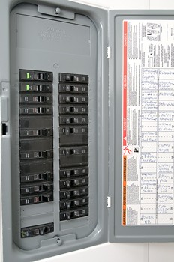
Circuit breakers are switches that operate automatically and prevent any kind of damage to an electrical circuit resulting from a short circuit. The main function of a circuit breaker is to discontinue the electrical flow if it detects any problem or fault in the electrical circuit.
Circuit Breaker Testing
A circuit breaker can be tested with the help of a voltage tester at home. The voltage tester does the work of indicating whether the circuit breaker is getting the electrical supply. One can purchase a voltage tester at any nearby electrical store.
How to Test a Circuit Breaker?
The first step in the process of testing a circuit breaker is to open the electrical box which contains the circuit breaker panel with black switches. These switches are the circuit breakers which correspond to the different parts of the house. The switches are labeled with the parts of the house to which they are connected to. Before actually testing the circuit breaker, all the home appliances should be turned off and then unplugged. It helps prevent a short circuit which might result from an increase in the voltage.
The next step is to check the circuit breaker in question. If the circuit breaker is in the 'off' position, then it said to be working properly. The circuit should then be turned on. It should be checked whether the circuit goes back to the 'off' position. If it does, then there is a problem in the wiring and it should be addressed by a professional electrician.
The multimeter is used to check whether the circuit breaker is working or not. It should be set to the position called 'Volts AC'. One should use two prongs, the first one to touch the terminal screw and the other one for the ground screw. The multimeter indications should be checked thereafter. If the indicator doesn't show anything, then it becomes clear that no current is flowing through the circuit breaker. The next thing one needs to do is the replacement of circuit breaker.
Circuit Breaker Replacement
A superior quality model of circuit breaker should be used for replacement. The circuit breaker panel screws should be removed and the color of the wires should be noted down. It helps in connecting the wires later without confusion. One should start with the white wires followed by the colored ones. The nuts that hold the wires should be unscrewed in order to remove them. Once all the nuts are unscrewed, the circuit breaker panel should be removed gently. The new circuit breaker should to be fitted in the same position where the older one was placed. The screws should be fitted in the same manner as the older ones were removed. This completes the procedure of circuit breaker replacement.
The above article provides information regarding the process of circuit breaker testing, something which is an important aspect of electrical safety. A circuit breaker is an important device that helps in protecting the electrical appliances at home from voltage spikes. One should thus, learn how to test a circuit breaker for the safety of his own property.
Circuit Breaker Installation
Circuit breaker is used to break the circuit continuity to protect it from voltage spike. To know more about circuit breaker installation, read on...
The circuit breakers are used to protect the circuitry from accidental short circuits and overloading of the circuit. Circuit breakers have a predefined electric load capacity. If this capacity is violated, the circuit breaker breaks the continuity of the circuit. Circuit breakers are used for protecting the electrical appliances from accidental short circuits and prevention from damage when power surges occur. Sometimes, lightening can cause damage to an appliance. The circuit breaker can become worn out due to some reason. In such a case, you need to install a new circuit breaker. It is advisable, if you are unaware of electric wiring, to get the circuit breaker installation done from a professional.
How to Install a Circuit Breaker
A circuit breaker is necessary to ensure the safe working of the electric appliances. Before installing circuit breaker, it is necessary to check the circuit breaker panel, to check whether it is damaged or it is tripped off. To ensure that the circuit breaker is really damaged is an important step. The following steps are to be followed for circuit breaker installation.
Step 1
The foremost step before you install the circuit breaker, is to wear a pair of rubber shoes. If rubber shoes are not available, get a rubber mat and stand on this mat while you are working for circuit breaker installation. Ensure that there are no water puddles near the place where you are working to install the circuit breaker.
Step 2
The next important step of circuit breaker installation is to turn off the main switch. There are some important things you need to collect before circuit breaker installation. They are as follows:
* Screwdriver
* New circuit breaker
* Voltmeter
Step 3
Make sure that you turn off the circuit breaker that you want to replace. With the help of a screwdriver, take off the metal panel in which the circuit breaker is housed. You need to use the screwdriver to do this.
Step 4
The circuit breaker is checked with a voltmeter. After testing the circuit breaker, if it does not indicate any reading, it means that you need a circuit breaker replacement.
Step 5
With the help of screwdriver remove the wires and terminals of the old circuit breaker. When you take out the wires, remember the connections of the wire. Carefully take out the old circuit breaker.
Step 5
The next step of circuit breaker installation is to ensure that the switch of the new circuit breaker is turned off. Attach the wires of the new circuit breaker according to the old circuit breaker.
Step 6
After you connect the wires in the correct position, check with the voltmeter the voltage across the circuit breaker. Replace the metal panel on the new circuit breaker.
Step7
The last step of circuit breaker installation is to turn on the main switch. This ends the process of installation of circuit breaker.

The installation of circuit breaker is to be done taking into consideration the electrical safety. It is necessary to know some safety tips before you troubleshoot the old circuit breaker or install a new circuit breaker. If you are wearing any jewelry, remove it before you install the circuit breaker. Many a time, a device gets damaged due to short circuit and you have to change the circuit breaker. In this case, the device which is damaged must be unplugged before you install the circuit breaker. This is how the circuit breaker installation is done. Next time when you change the circuit breaker, be careful and follow all rules of electrical safety.
Circuit Breaker Replacement
A main circuit breaker protects the electrical fixtures and connections from overloading and short circuiting damages. What if the circuit breaker itself is not working properly? Here are some instructions for circuit breaker replacement.

For any household electrical safety, a circuit breaker plays an important role by protecting the fixtures from damages caused due to overloading or short circuiting. Circuit breakers are also commonly referred to as fuses. In case of high current levels in any of the electrical wiring, the circuit breaker immediately cuts off the electric flow, so as to prevent further damages to the systems. The normal power supply can be restored after fixation of the problem. Let's take a look at the instructions for circuit breaker replacement.
Instructions for Circuit Breaker Replacement
While discussing the circuit breaker fuse replacement, the first step is to diagnose the problem. By doing so, you can determine whether the circuit breaker really needs replacement or not. Many people opt for circuit breaker replacement prior to examining it carefully, stating that it trips off very often. In such a case, it may not be the circuit breaker that is creating the problem, the main defect can be in the electricity supply. This article focuses on examining and replacing a circuit breaker that is installed correctly.
Diagnosing Circuit Breaker Defect
In order to diagnose circuit breaker malfunction, turn off the main power supply, unplug the home appliances connected to the circuit breaker and also, switch off the lights. Check whether the circuit breaker works after disconnecting the devices. In case the circuit breaker resets, turn on the lights and connect the appliances one-by-one. This way, you can determine the actual malfunctioning. If such is not the case, press the rest button and try switching the circuit breaker on and off alternately. The circuit breaker is of inferior quality or loosely connected, if it trips suddenly.
Replacing Circuit Breaker
After examining the defects of the circuit breaker, you can proceed with the replacement steps. For replacing a circuit breaker, purchase a superior quality model from the local hardware store. Remove the panel cover by loosening the screws fastened to it. Note the wires and their colors before you start connecting them. Also, make sure you remember the wires that are connected on the sides of the breaker.
The next step is dealing with the wires, including the white and the colored ones. To prevent confusion or faulty connections, handle one wire at a time. You can start with the white wire first; unscrew the nut that holds the white wire and fasten a wire nut at the tip. Continue the same procedure for the other colored wires. Once you are done with preparation of the wires, remove the old circuit breaker by pulling it gently.
Position the new circuit breaker panel in place of the old one. Make the wire connections in the same way as that of the previous ones with reference to the colors. Tighten the necessary nuts and screws to secure the wires properly. Remount the panel cover by securing the nuts. This is how circuit breaker replacement is done.
Switch on the circuit breaker to check whether the circuit breaker is functioning or not. You can turn on the lights to ensure them working. Follow these instructions for any type of circuit breakers replacement. Nevertheless, if there is no light after switching them on, then you need to call a professional electrician.
There are several type of circuit breakers now a day we are using these are as follows:
1. M.C.B. (Miniature circuit Breaker)
Rating : 1, 2, 4, 6, 10, 16, 20, 25, 32, 63 Amperes
2. M.C.C.B. (Miniature current circuit Breaker)
Rating : 10, 16, 20, 25, 32, 63, 100, 200, 250, 400 Amperes.
3. A.C.B. (Air Circuit Breaker)
Rating : 400, 800, 1000, 1200, 1500, 1800, 2000 Amperes.
4. A. B. Switch (Air Breaker)
used in High tension line.
5. SF6 Breaker (Contact break in the Sf6 medium)
used in High tension line.

What Do Electrical Arcs Have To Do With Circuit Breakers?
If you’ve ever seen a welder working on a building, you know a little bit about the power of an electric arc. Put simply, it’s a stream of electrons passing through space from one material to another. This stream of electrons can be very strong, strong enough to melt metal or, in the wrong circumstances, start fires.
So how does this apply to circuit breakers? Basically, circuit breakers are just switches. If everything’s working, the switch is closed, and electricity flows across the breaker into your home. If something happens to overload the circuit, however, a device in the breaker flips the switch open so that no more electricity can cross. That’s when arcs become important. If enough electricity was going through the breaker when it opened, there’s a chance that even after the contacts of the switch separate electrons could continue to pass between them, creating an arc that will continue to supply too much electricity to the circuit and become a separate hazard to anyone who tries to use the circuit breaker panel to turn off power. Because of this, most circuit breakers are equipped with special devices that are designed to “blow out” or dispel an arc before it can cause problems. It’s important to learn about these devices and make sure you pick breakers that suit your power needs.

Circuit Breaker Trio
There are three common types of circuit breakers. The basic parts of a circuit breaker are the switch and a moving, conductive contact plate that moves the switch when electricity comes into contact with it. In the circuit box the contact plate is connected to a stationary plate that allows electricity to flow; but if the circuit is overloaded the contact plate will force the switch to flip and break the electrical flow.
A magnetic circuit breaker uses electromagnetism to break the circuit. The electromagnet on this circuit breaker gets stronger with the flow of electricity. When the electrical load exceeds the prescribed currency the electromagnet will be powerful enough to force the circuit breaker lever down and move the contact plate which flips the switch.
Another kind of circuit breaker is the thermal circuit breaker which uses heat to break the circuit. With a bimetallic strip (two types of metal; one on each side) this circuit breaker responds to the extreme heat of the electrical current. Each type of metal expands differently to bend the strip. When the electricity is too strong then the strip is bent at an angle which will turn over the contact plate and break the circuit.
The third type of circuit breaker combines electromagnetism and heat. This device has an electromagnet that protects against sudden surges in the electrical load and a bimetallic strip that protects against prolonged electrical overload and overheating.
When purchasing circuit breakers for your home you will need to discuss your options with your electrician and select the best type of circuit breaker for your needs. You can find a large selection of circuit breakers by visiting http://www.relectric.com

Ground Fault Interrupter Circuit Breakers
Basic circuit breakers will detect a circuit overload and automatically “trip” or shut off in order to protect the electrical system. Ground fault interrupter (GFI) circuit breakers go one step further to detect problems due to electricity being "grounded" by something that's not part of the electrical system. They're used in places that are exposed to water; for instance, they're what prevent you from getting electrocuted even if you get a hairdryer wet.
A typical circuit breaker has a 15 amp rating and is used to handle lighting, and other electrical outlets in the home. Some rooms may require more than one 15 amp rating resulting in multiple breakers. A GFI circuit breaker is used in wet areas such as bathrooms, kitchens, laundry rooms, garages, outside, etc. The GFI breaker is required unless GFI protection is already installed at the outlet locations.
If you are not sure that you have the GFI protection in your home because you live in an older home that may not be “up-to-code” then you can have an electrician inspect your circuit breaker panel and electrical wiring to make sure you have this important protection.

High Voltage Circuit Breakers: Oil Circuit Breakers
Oil circuit breakers are high-voltage circuit breakers that have their contacts immersed in oil. The smaller oil circuit breakers have their poles in one tank of oil; several breakers share one tank. The larger high-voltage industrial circuit breakers require a tank of oil for each pole The oil tanks are sealed around the oil circuit breakers and electrical connections are made through porcelain bushings. Oil circuit breakers work by using oil to quench an electrical arc; the oil causes current interruption when needed. The oil cools the large arcs of electricity so that the circuits do not overheat.
The main disadvantages of oil circuit breakers is the fact that the oil can be flammable and it may be hard to keep the oil fresh and in good condition (requires changing and purifying the oil). If you use oil circuit breakers, make sure that you know how to maintain them correctly. Always do your research and select the type of circuit breaker that will best fits your needs.
Different types of circuit breakers including oil circuit breaker brands can be found by visiting an electrical equipment company like http://www.relectric.com

How Many Circuit Breakers?
The circuit breaker panel in your home contains separate circuits for various areas in your home. Each circuit can handle a certain power load. If this load is exceeded because something is drawing too much power (a stripped wire, for instance, or even just running too many appliances at once) the circuit breaker will interrupt that particular circuit. So if you only lose power in one or two rooms of your house, you should check the breaker panel before you call the power company. Because of the growing popularity of electrical appliances and “toys” like home entertainments systems, big television sets, and computers, many experts will agree that you should plan for your power use to grow, and install more circuit breakers rather than fewer.
When building a new home you should make sure that you meet with your electrician to specify how many circuits to set up throughout the house. There are codes and regulations that the electrician must follow, so you can't ask them to wire your house in a way that would be unsafe. It is wise to request a minimum of a 200 amp circuit panel with 40 circuit breakers. Now 40 may sound like too many and you may not use them all right away, but if you purchase new equipment or decide to add on to the house, you will have your circuit breakers all ready wired and all you have to do is tie them into the main system.
Installing enough the circuits during construction will save a lot of work later. Adding a circuit to an existing house requires running more wire through the walls. If the circuit box is already wired for more breakers it is simple to connect the additional circuit breakers in the home.

How to Add a New Circuit Breaker
If your home does not have enough circuit breakers to handle the electrical load of the household then you may have to add additional circuit breakers. An overloaded circuit can trip off often or may even become an overheated circuit breaker. In order to relieve some of the pressure you can install an additional circuit breaker in the circuit panel.
Before adding a new circuit breaker you will need to make sure that you have enough amps to handle the extra load and check building codes to see if you need to get a permit first. Once you have covered all the bases then you are ready to add a new circuit breaker.
If you aren't a certified electrician, you should have one come and do the work for you. If you know the proper procedures, you can proceed with the new circuit breaker installation process.
First, turn off the power to the main breaker and make sure there are no live wires in the circuit panel.
Now, remove the panel cover and the knockouts so that you have space for the new circuit breaker. Next, using insulated tools install the proper cable connector allowing enough free cable to snake around the breaker box.
Using an insulated cable stripper proceed to strip the outer insulation of the cable wires and feed them into the correct locations. Connect the ground wire by running it to the ground bus wire.
A single-pole breaker (120-volt circuit) will have the white wire connected to the neutral bus bar and the black wire connected to the breaker. Once the wires are connected then you will install the circuit breaker and push it into place.
The last step is to test the circuit to make sure it works properly. If it does not work then you connected the wires wrong or there is something wrong with the new circuit breaker.
To purchase electrical circuit breakers you can visit an electric distributor such as www.relectric.com for a wide variety of circuit breakers and other electrical devices and equipment.

How to Locate the Main Electrical Circuit Breaker
The “main circuit breaker” is usually located at the top of the circuit breaker panel, and it looks like two connected circuit breaker switches. It's important to know where this power box is located in case of an emergency or natural disaster. In many cases you will need to turn off the power to your home if you have an emergency such as a flood, hurricane or earthquake. If the power lines to your house are damaged or exposed, they can be extremely dangerous.
The main circuit breaker, often called the “Double Pole Service Disconnect” supplies power to the home. It will turn on or off all of the power to the entire house at once. The electrical power to a home comes directly from the electrical company’s power line through the electric meter to your main circuit box.
Educate your family on the location of the main breaker box that powers your household. Make sure they know how to disconnect power in an emergency. This information may help prevent disaster, injury or even save a life.

Is Recycled or Refurbished Acceptable?
The growing awareness of the importance of reusing and recycling material and equipment have opened up new doors for all kinds of products. Some electrical equipment and devices can be safely recycled and/or refurbished for reuse.
If you live in an older home it may be impossible to find the right brand and model of circuit breaker to match the other circuit breakers in the breaker box. This can making changing a circuit breaker next to impossible. If this is the case then a refurbished circuit breaker may be your only choice. There are companies that sell refurbished, obsolete circuit breakers and other electrical devices. These companies will certify the refurbished equipment by testing the functionality of the parts and repairing any problems.
Purchasing refurbished parts can be done safely by doing some research first. You should always purchase recycled parts from a reputable company. Research the company by searching the Internet, getting references from friends or consulting an electrician. Check the Better Business Bureau in order to make sure the company’s record is clean.
Once you have found a reputable company then you should be able to safely purchase a workable part to use in your home. For new, refurbished and obsolete circuit breakers and electrical parts you can visit www.relectric.com .

New Arc Fault Breakers
Traditional circuit breakers are designed to switch off when there is a circuit overload. This feature is supposed to help prevent wires from overheating because the power is cut when the electrical circuit breaker trips, but electrical fires are still a risk with traditional circuit breakers. In fact, while these breakers are designed to protect the wire behind the walls and the outlets, they do not have fire protection or fire stopping features. Fire producing arcs of electricity can occur in the wall before traditional breakers have time to react.
Because of electrical fire danger and the reality of electrical fires in homes it may be worth the investment to purchase new arc fault breakers for your house. The added protection not only gives you “peace of mind”, but it may also save you thousands of dollars in fire damage. Staying up-to-date on new circuit breaker information is extremely helpful for homeowners.
The new arc fault circuit breaker functions similarly to a traditional circuit breaker but it has small filters and detection devices that sense an intense arc just as it is about to spark. If that was only true with relationship troubles. When arcing conditions are present then the breaker will flip instantly. The new arc fault breakers are readily available at most electrical supply stores. You can find them online at www.relectric.com.

What are Circuit Breakers?
Circuit breakers are electrical devices used to automatically “break” an electrical circuit when it becomes overloaded. This safety mechanism can save a home or building from having a major electrical disaster.
When electrical wires are forced to carry an electrical current that is over their set capacity, the circuit breaker flips off the electricity. If you have an older electrical system, an electrical short may blow a fuse, which is a little different than a circuit breaker.
A blown fuse has to be replaced, but a flipped circuit breaker can usually be reset. If the circuit breaker continues to kick off the electricity when reset then the situation may be more serious than just an accidental short circuit from a power surge or electrical overload. In this situation the wiring to the circuit should be inspected and tested by a professional either an electrician or someone from an electrical equipment company. In some cases, however, you may just be trying to use too much power at once. Having many appliances on at one time can overload a circuit.

Oil Circuit Breakers (OCBs)

The oil in OCBs serves two purposes. It insulates between the phases and between the phases and the ground, and it provides the medium for the extinguishing of the arc. When electric arc is drawn under oil, the arc vaporizes the oil and creates a large bubble that surrounds the arc. The gas inside the bubble is around 80% hydrogen, which impairs ionization. The decomposition of oil into gas requires energy that comes from the heat generated by the arc. The oil surrounding the bubble conducts the heat away from the arc and thus also contributes to deionization of the arc.

Main disadvantage of the oil circuit breakers is the flammability of the oil, and the maintenance necessary to keep the oil in good condition (i.e. changing and purifying the oil)

Figure 9 A Bubble of Hydrogen Surrounding an Arc Drawn Under Oil

Bulk Oil Circuit Breakers

Bulk oil circuit breakers are enclosed in metal-grounded weatherproof tanks that are referred to as dead tanks. The original design of bulk OCBs was very simple and inexpensive. Example of such a breaker, called plain break oil circuit breaker, is in Figure 10.

Figure 10 Plain Break Oil Circuit Breaker

The arc was drawn directly inside of the container tank without any additional arc extinguishing but the one provided by the gas bubble surrounding the arc. Plain break breakers were superceded by arc controlled oil breakers. The arc controlled oil breakers have an arc control device surrounding the breaker contacts. The purpose of the arc control devices is to improve operating capacity, speed up the extinction of arc, and decrease pressure on the tank. The arc control devices can be classified into two groups: cross-blast and axial blast interrupters.

Figure 11 Schematic Illustration of Cross Blast (a) and Axial Blast (b) Interrupters for
Oil Breakers

In cross blast interrupters, the arc is drawn in front of several lateral vents (Figure 11). The gas formed by the arc causes high pressure inside the arc control device. The arc is forced to bow into the lateral vents in the pot, which increases the length of the arc and shortens the interruption time. The axial blast interrupters use similar principle as the cross blast interrupters. However, the axial design has a better dispersion of the gas from the interrupter.

Figure 12 illustrates a typical 69 kV breaker of 2500 MVA breaking capacity. All three phases are installed in the same tank. The tank is made of steel and is grounded. This type of breaker arrangement is called the dead tank construction. The moving contact of each phase of the circuit breaker is mounted on a lift rod of insulating material. There are two breaks per phase during the breaker opening. The arc control pots are fitted over the fixed contacts. Resistors parallel to the breaker contacts may be installed alongside the arc control pots. It is customary and convenient for this type of breakers to mount current transformers in the breaker bushings.

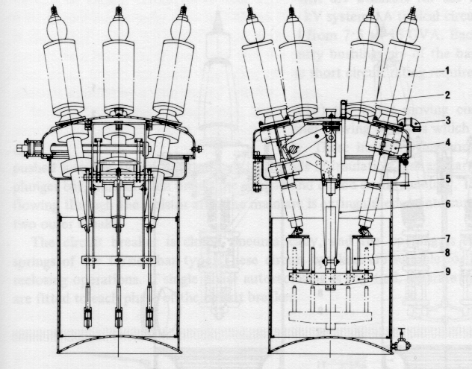
Figure 12 Dead Tank Oil Circuit Breaker (Allis Chalmers Ltd.)
1 bushing 6 plunger guide
2 oil level indicator 7 arc control device
3 vent 8 resistor
4 current transformer 9 plunger bar
5 dashpot

At voltages higher than 115 kV, it is customary to use separate tanks for each phase. The practical limit for the bulk oil breakers is 275 kV. Figure 13 shows 220 kV one phase dead tank circuit breaker.
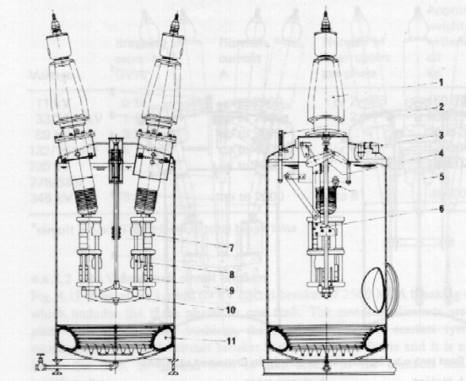

Figure 13 Single Phase Dead Tank Oil Circuit Breaker (Allis Chalmers)

1 bushing 7 arc control unit
2 oil level indicator 8 parallel contact
3 vent 9 resistor
4 linear linkage 10 plunger bar
5 dashpot 11 impulse cushion
6 guide block

The oil circuit breakers are usually installed on concrete foundations at the ground level. During interruption of heavy fault currents the breakers tend to move. To minimize the damage to the breakers, breakers with very high interrupting capacity have an impulse cushion is provided at the bottom of the breakers. The cushion is filled with an inert gas, for example nitrogen.

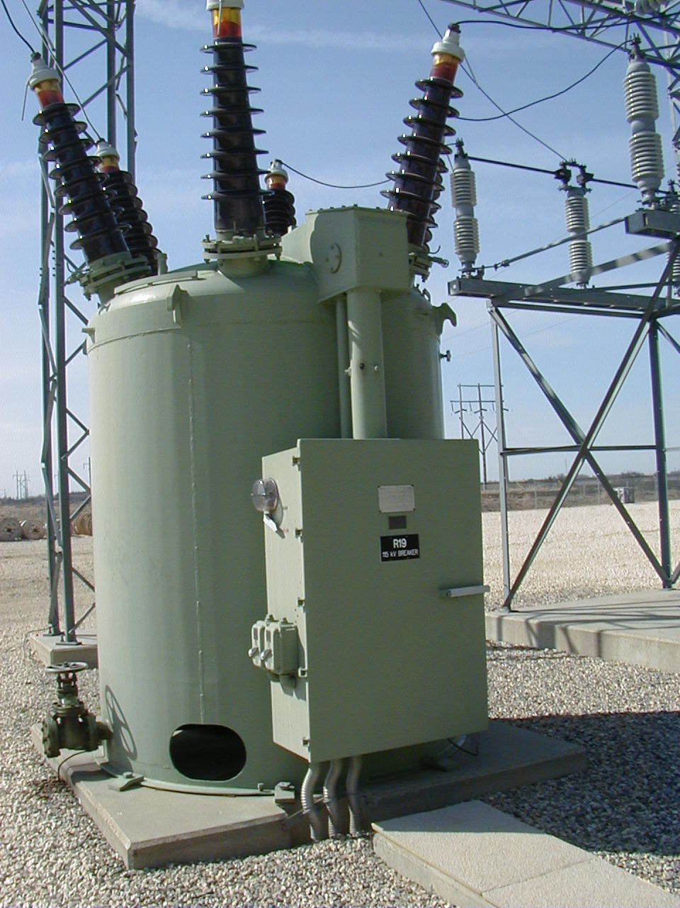

Figure: 66kV Oil Circuit Breaker, Manitoba Hydro

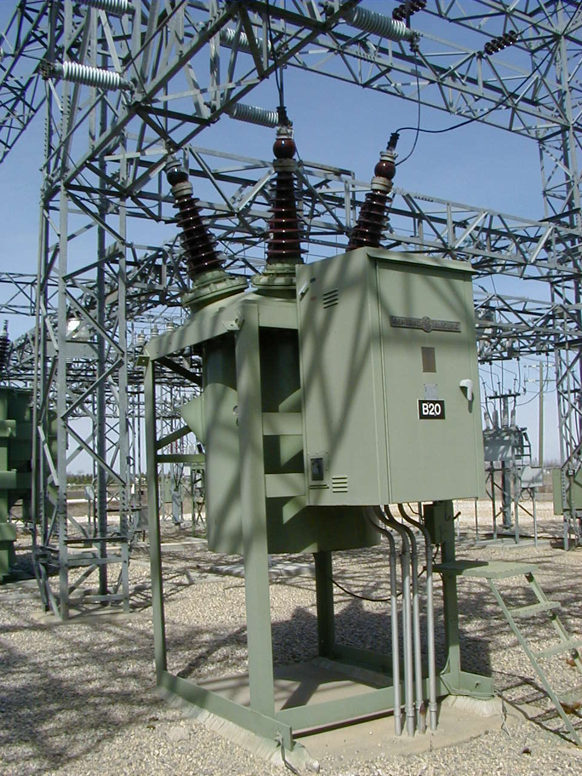

Minimum Oil Breakers

In the bulk oil breakers, the oil serves as both arcs extinguishing medium and main insulation. The minimum oil breakers were developed to reduce the oil volume only to amount needed for extinguishing of the arc – about 10% of the bulk- oil amount. The arc control for the minimum oil breakers is based on the same principle as the arc control devices of the bulk oil breakers. To improve breaker performance, oil is injected into the arc.

The interrupter containers of the minimum oil breakers are made of insulating material and are insulated from the ground. This is usually referred to as live tank construction. For high voltages (above 132 kV), the interrupters are arranged in series. It is essential to ensure that each interrupter carries its share of the duty. Care must be taken that all breaks occur simultaneously, and that the restriking voltage is divided equally across the breaks during the interrupting process. The natural voltage division depends on stray capacitances between the contacts and to the ground, and therefore is in very uneven. This is corrected by connecting capacitances or resistors in parallel with the interrupting heads.
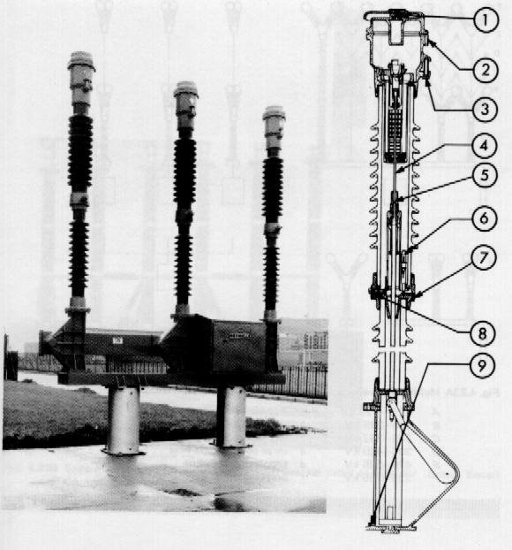
(a) (b)
VACUUM CIRCUIT BREAKER
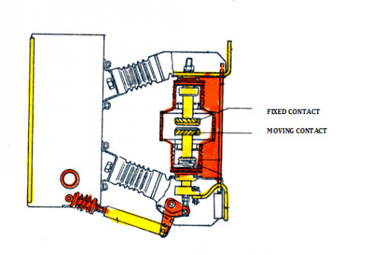
Vacuum circuit breakers are circuit breakers which are used to protect medium and high voltage circuits from dangerous electrical situations. In a vacuum circuit breaker, two electrical contacts are enclosed in a vacuum. One of the contacts is fixed, and one of the contacts is movable. When the circuit breaker detects a dangerous situation, the movable contact pulls away from the fixed contact, interrupting the current. Because the contacts are in a vacuum, arcing between

Comparison Between Vacuum and SF6 Circuit Breaker
25,541 views
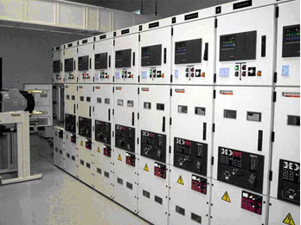
What CB to use? Vacuum or SF6 circuit breaker?
Until recently oil circuit breakers were used in large numbers for Medium voltage Distribution system in many medium voltage switchgears. There are number of disadvantages of using oil as quenching media in circuit breakers. Flammability and high maintenance cost are two such disadvantages! Manufacturers and Users were forced to search for different medium of quenching. Air blast and Magnetic air circuit breakers were developed but could not sustain in the market due to other disadvantages associated with such circuit breakers. These new types of breakers are bulky and cumbersome. Further research were done and simultaneously two types of breakers were developed with SF6 as quenching media in one type and Vacuum as quenching media in the other. These two new types of breakgasers will ultimately replace the other previous types completely shortly. There are a few disadvantages in this type of breakers also. One major problem is that the user of the breakers are biased in favour of old fashioned oil circuit breakers and many of the users always have a step motherly attitude to the new generations of the breakers. However in due course of time this attitude will disappear and the new type of breakers will get its acceptance among the users and ultimately they will completely replace the oil circuit breakers. An attempt is made to make a comparison between the SF6 type and vacuum type circuit breakers with a view to find out as to which of the two types is superior to the other. We will now study in detail each type separately before we compare them directly.

Vacuum Circuit Breaker
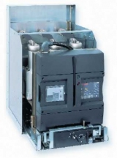
Evolis MV Circuit Breaker
In a Vacuum circuit breaker, vacuum interrupters are used for breaking and making load and fault currents. When the contacts in vacuum interrupter separate, the current to be interrupted initiates a metal vapour arc discharge and flows through the plasma until the next current zero. The arc is then extinguished and the conductive metal vapour condenses on the metal surfaces within a matter of micro seconds. As a result the dielectric strength in the breaker builds up very rapidly.
The properties of a vacuum interrupter depend largely on the material and form of the contacts. Over the period of their development, various types of contact material have been used. At the moment it is accepted that an oxygen free copper chromium alloy is the best material for High voltage circuit breaker. In this alloy , chromium is distributed through copper in the form of fine grains. This material combines good arc extinguishing characteristic with a reduced tendency to contact welding and low chopping current when switching inductive current. The use of this special material is that the current chopping is limited to 4 to 5 Amps.
At current under 10KA, the Vacuum arc burns as a diffuse discharge. At high values of current the arc changes to a constricted form with an anode spot. A constricted arc that remain on one spot for too long can thermically over stress the contacts to such a degree that the deionization of the contact zone at current zero can no longer be guaranteed . To overcome this problem the arc root must be made to move over the contact surface. In order to achieve this, contacts are so shaped that the current flow through them results in a magnetic field being established which is at right angles to the arc axis. This radial field causes the arc root to rotate rapidly around the contact resulting in a uniform distribution of the heat over its surface. Contacts of this type are called radial magnetic field electrodes and they are used in the majority of circuit breakers for medium voltage application.
A new design has come in Vacuum interrupter, in which switching over the arc from diffusion to constricted state by subjecting the arc to an axial magnetic field. Such a field can be provided by leading the arc current through a coil suitably arranged outside the vacuum chamber. Alternatively the field can be provided by designing the contact to give the required contact path. Such contacts are called axial magnetic field electrodes. This principle has advantages when the short circuit current is in excess of 31.5 KA.

SF6 Gas Circuit Breaker
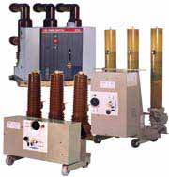
SF6 circuit breakers
In an SF6 circuit-breaker, the current continues to flow after contact separation through the arc whose plasma consists of ionized SF6 gas. For, as long as it is burning, the arc is subjected to a constant flow of gas which extracts heat from it. The arc is extinguished at a current zero, when the heat is extracted by the falling current. The continuing flow of gas finally de-ionises the contact gap and establishes the dielectric strength required to prevent a re-strike.
The direction of the gas flow, i.e., whether it is parallel to or across the axis of the arc, has a decisive influence on the efficiency of the arc interruption process. Research has shown that an axial flow of gas creates a turbulence which causes an intensive and continuous interaction between the gas and the plasma as the current approaches zero. Cross-gas-flow cooling of the arc is generally achieved in practice by making the arc move in the stationary gas. This interruption process can however, lead to arc instability and resulting great fluctuations in the interrupting capability of the circuit breaker.
In order to achieve a flow of gas axially to the arc a pressure differential must be created along the arc. The first generation of the SF6 circuit breakers used the two-pressure principle of the air-blast circuit-breaker. Here a certain quantity of gas was kept stored at a high pressure and released into the arcing chamber. At the moment high pressure gas and the associated compressor was eliminated by the second generation design. Here the pressure differential was created by a piston attached to the moving contacts which compresses the gas in a small cylinder as the contact opens. A disadvantage is that this puffer system requires a relatively powerful operating mechanism.
Neither of the two types of circuit breakers described was able to compete with the oil circuit breakers price wise. A major cost component of the puffer circuit-breaker is the operating mechanism; consequently developments followed which were aimed at reducing or eliminating this additional cost factor. These developments concentrated on employing the arc energy itself to create directly the pressure-differential needed. This research led to the development of the self-pressuring circuit-breaker in which the over – pressure is created by using the arc energy to heat the gas under controlled conditions. During the initial stages of development, an auxiliary piston was included in the interrupting mechanism, in order to ensure the satisfactory breaking of small currents. Subsequent improvements in this technology have eliminated this requirement and in the latest designs the operating mechanism must only provide the energy needed to move the contacts.
Parallel to the development of the self-pressuring design, other work resulted in the rotating – arc SF6 gas circuit breaker. In this design the arc is caused to move through, in effect the stationery gas. The relative movement between the arc and the gas is no longer axial but radial, i.e., it is a cross-flow mechanism. The operating energy required by circuit breakers of this design is also minimal.
Table 1. Characteristics of the SF6 and vacuum current interrupting technologies.
 | SF6 Circuit Breakers |  | Vacuum Circuit Breakers
Criteria | Puffer Circuit Breaker | Self-pressuring circuit-breaker | Contact material-Chrome-Copper
Operating energy requirements | Operating Energy requirements are high, because the mechanism must supply the energy needed to compress the gas. | Operating Energy requirements are low, because the mechanism must move only relatively small masses at moderate speed, over short distances. The mechanism does not have to provide the energy to create the gas flow | Operating energy requirements are low, because the mechanism must move only relatively small masses at moderate speed, over very short distances.
Arc Energy | Because of the high conductivity of the arc in the SF6 gas, the arc energy is low. (arc voltage is between 150 and 200V.) |  | Because of the very low voltage across the metal vapour arc, energy is very low. (Arc voltage is between 50 and 100V.)
Contact Erosion | Due to the low energy the contact erosion is small. |  | Due to the very low arc energy, the rapid movement of the arc root over the contact and to the fact that most of the metal vapour re-condenses on the contact, contact erosion is extremely small.
Arc extinguishing media | The gaseous medium SF6 possesses excellent dielectric and arc quenching properties. After arc extinction, the dissociated gas molecules recombine almost completely to reform SF6. This means that practically no loss/consumption of the quenching medium occurs. The gas pressure can be very simply and permanently supervised. This function is not needed where the interrupters are sealed for life. |  | No additional extinguishing medium is required. A vacuum at a pressure of 10-7 bar or less is an almost ideal extinguishing medium. The interrupters are ‘sealed for life’ so that supervision of the vacuum is not required.
Switching behavior in relation to current chopping | The pressure build-up and therefore the flow of gas is independent of the value of the current. Large or small currents are cooled with the same intensity. Only small values of high frequency, transient currents, if any, will be interrupted. The de-ionization of the contact gap proceeds very rapidly, due to the electro-negative characteristic of the SF6 gas and the arc products. | The pressure build-up and therefore the flow of gas is dependent upon the value of the current to be interrupted. Large currents are cooled intensely, small currents gently. High frequency transient currents will not, in general, be interrupted. The de-ionization of the contact gap proceeds very rapidly due to the electro-negative characteristic of the SF6 gas and the products. | No flow of an ‘extinguishing’ medium needed to extinguish the vacuum arc. An extremely rapid de-ionization of the contact gap, ensures the interruption of all currents whether large or small. High frequency transient currents can be interrupted. The value of the chopped current is determined by the type of contact material used. The presence of chrome in the contact alloy with vacuum also.
No. of short-circuit operation | 10—50 | 10—50 | 30—100
No. full load operation | 5000—10000 | 5000—10000 | 10000—20000
No. of mechanical operation | 5000—20000 | 5000—20000 | 10000—30000

Comparison of the SF6 And Vacuum Technologies
The most important characteristics of the SF6 gas and vacuum-circuit breakers, i.e., of SF6 gas and vacuum as arc-extinguishing media are summarized in Table-1.
In the case of the SF6 circuit-breaker, interrupters which have reached the limiting number of operations can be overhauled and restored to ‘as new’ condition. However, practical experience has shown that under normal service conditions the SF6 interrupter never requires servicing throughout its lifetime. For this reason, some manufacturers no longer provide facilities for the user to overhaul the circuit-breaker, but have adopted a ‘sealed for life’ design as for the vacuum-circuit breaker.
The operating mechanisms of all types of circuit-breakers require servicing, some more frequently than others depending mainly on the amount of energy they have to provide. For the vacuum-circuit breaker the service interval lies between 10,000 and 20,000 operations. For the SF6 designs the value varies between 5,000 and 20,000 whereby, the lower value applies to the puffer circuit-breaker for whose operation, the mechanism must deliver much more energy.
The actual maintenance requirements of the circuit-breaker depend upon its service duty, i.e. on the number of operations over a given period of time and the value of current interrupted. Based on the number of operations given in the previous section, it is obvious that SF6 and vacuum circuit-breakers used in public supply and /or industrial distribution systems will, under normal circumstances, never reach the limits of their summated breaking current value. Therefore, the need for the repair or replacement of an interrupter will be a rare exception and in this sense these circuit-breakers can be considered maintenance-free. Service or maintenance requirements are therefore restricted to routine cleaning of external surfaces and the checking and lubrication of the mechanism, including the trip-linkages and auxiliary switches. In applications which require a very high number of circuit-breaker operations e.g. for arc furnace duty or frequently over the SF6 design, due to its higher summated-breaking current capability. In such cases it is to be recommended that the estimation of circuit-breaker maintenance costs be given some consideration and that these be included in the evaluation along with the initial, capital costs.

Reliability
In practice, an aspect of the utmost importance in the choice of a circuit-breaker is reliability.
The reliability of a piece of equipment is defined by its mean time to failure (MTF), i.e. the average interval of time between failures. Today, the SF6 and vacuum circuit-breakers made use of the same operating mechanisms, so in this regard they can be considered identical.
However, in relation to their interrupters the two circuit breakers exhibit a marked difference. The number of moving parts is higher for the SF6 circuit-breaker than that for the vacuum unit. However, a reliability comparison of the two technologies on the basis of an analysis of the number of components are completely different in regards design, material and function due to the different media. Reliability is dependent upon far too many factors, amongst others, dimensioning, design, base material, manufacturing methods, testing and quality control procedures, that it can be so simply analyzed.
In the meantime, sufficient service experience is available for both types of circuit-breakers to allow a valid practical comparison to be made. A review of the available data on failure rates confirms that there is no discernible difference in reliability between the two circuit-breaker types. More over, the data shows that both technologies exhibit a very high degree of reliability under normal and abnormal conditions.

Switching of fault currents
Today, all circuit-breakers from reputable manufacturers are designed and type-tested in conformance with recognized national or international standards (IEC56). This provides the assurance that these circuit-breakers will reliably interrupt all fault currents up to their maximum rating. Further, both types of circuit-breakers are basically capable of interrupting currents with high DC components; such currents can arise when short circuits occur close to a generator. Corresponding tests have indeed shown that individual circuit-breakers of both types are in fact, capable of interrupting fault currents with missing current zeros i.e. having a DC component greater than 100 per cent. Where such application is envisaged, it is always to be recommended that the manufacturer be contacted and given the information needed for a professional opinion.
As regards the recovery voltage which appears after the interruption of a fault current the vacuum-circuit breaker can, in general, handle voltages with RRV values of up to 5KV. SF6 circuit-breakers are more limited, the values being in the range from 1 to 2 KV. In individual applications, e.g. in installations with current limiting chokes or reactors, etc., With SF6 circuit-breakers it may be advisable or necessary to take steps to reduce that rate of rise of the transient recovery voltage.

Switching small inductive currents
The term, small inductive currents is here defined as those small values of almost pure inductive currents, such as occur with unloaded transformers, motor during the starting phase or running unloaded and reactor coils. When considering the behavior of a circuit-breaker interrupting such currents, it is necessary to distinguish between high frequency and medium frequency transient phenomena.
Medium frequency transients arise from, amongst other causes, the interruption of a current before it reaches its natural zero. All circuit-breakers can, when switching currents of the order of a few hundred amperes and, due to instability in the arc, chop the current immediately prior to a current zero.
This phenomenon is termed real current chopping. When it occurs, the energy stored in the load side inductances oscillates through the system line to earth capacitances (winding and cable capacitances) and causes an increase in the voltage. This amplitude of the resulting over voltage is a function of the value of the current chopped. The smaller the chopped current, the lower the value of the over voltage.
In addition to the type of circuit – breaker, the system parameters at the point of installation are factors which determine the height of the chopping current, in particular the system capacitance parallel to the circuit breaker is of importance. The chopping current of SF6 circuit-breakers is essentially determined by the type of circuit-breaker. The value of chopping current varies from 0.5A to 15A, whereby the behavior of the self – pressuring circuit-breaker is particularly good, its chopping current being less than 3A.This ‘soft’
Switching feature is attributable to the particular characteristics of the interrupting mechanism of the self-pressuring design and to the properties of the SF6 gas itself.
In the early years of the development of the vacuum circuit-breaker the switching of small inductive currents posed a major problem, largely due to the contact material in use at that time. The introduction of the chrome copper contacts brought a reduction of the chopping current to between 2 to 5A.The possibility of impermissible over voltages arising due to current chopping has been reduced to a negligible level.
High frequency transients arise due to pre- or re-striking of the arc across the open contact gap. If, during an opening operation, the rising voltage across the opening contacts, exceed the dielectric strength of the contact gap , a re-strike occurs. The high-frequency transient current arising from such a re-strike can create high frequency current zeros causing the circuit-breaker to, interrupt again. This process can cause a further rise in voltage and further re-strikes. Such an occurrence is termed as multiple restriking.
With circuit- breakers that can interrupt high frequency transient currents, re-striking can give rise to the phenomenon of virtual current chopping. Such an occurrence is possible when a re-strike in the first-phase-to-clear, induces high frequency transients in the other two phases, which are still carrying service frequency currents. The superimposition of this high frequency oscillation on the load current can cause an apparent current zero and an interruption by the circuit-breaker, although the value of load current may be quite high. This phenomenon is called virtual current chopping and can result in a circuit breaker ‘chopping’ very much higher values of current than it would under normal conditions. The results of virtual current chopping are over-voltages of very high values.
This phenomenon is termed real current chopping. When it occurs, the energy Stored in the load side inductances oscillates through the system line to earth capacitances (winding and cable capacitances) and causes an increase in the voltage. This amplitude of the resulting over voltage is a function of the value of the current chopped. The smaller the chopped current, the lower the value of the over voltage.
In addition to the type of circuit – breaker, the system parameters at the point of installation are factors which determine the height of the chopping current, in particular the system capacitance parallel to the circuit breaker is of importance. The chopping current of SF6 circuit-breakers is essentially determined by the type of circuit-breaker. The value of chopping current varies from 0.5A to 15A, whereby the behaviour of the self – pressuring circuit-breaker is particularly good, its chopping current being less than 3A.This ‘soft’ Switching feature is attributable to the particular characteristics of the interrupting mechanism of the self-pressuring design and to the properties of the SF6 gas itself.
In the early years of the development of the vacuum circuit-breaker the switching of small inductive currents posed a major problem, largely due to the contact material in use at that time. The introduction of the chrome copper contacts brought a reduction of the chopping current to between 2 to 5A.The possibility of impermissible over voltages arising due to current chopping has been reduced to a negligible level.
High frequency transients arise due to pre- or re-striking of the arc across the open contact gap. If, during an opening operation, the rising voltage across the opening contacts exceeds the dielectric strength of the contact gap, a re-strike occurs. The high-frequency transient current arising from such a re-strike can create high frequency current zeros causing the circuit-breaker to, interrupt again. This process can cause a further rise in voltage and further re-strikes. Such an occurrence is termed as multiple re-striking.
With circuit- breakers that can interrupt high frequency transient currents, re-striking can give rise to the phenomenon of virtual current chopping. Such an occurrence is possible when a re-strike in the first-phase-to-clear, induces high frequency transients in the other two phases, which are still carrying service frequency currents. The superimposition of this high frequency oscillation on the load current can cause an apparent current zero and an interruption by the circuit-breaker, although the value of load current may be quite high. This phenomenon is called virtual current chopping and can result in a circuit breaker ‘chopping’ very much higher values of current than it would under normal conditions. The results of virtual current chopping are over-voltages of very high values
Table2. Comparison of the SF6 And Vacuum Technologies In Relation To Operational Aspects
Criteria | SF6 Breaker | Vacuum Circuit Breaker
Summated current cumulative | 10-50 times rated short circuit current | 30-100 times rated short circuit current
Breaking current capacity of interrupter | 5000-10000 times | 10000-20000 times
Mechanical operating life | 5000-20000 C-O operations | 10000-30000 C-O operations
No operation before maintenance | 5000-20000 C-O operations | 10000-30000 C-O operations
Time interval between servicing Mechanism | 5-10 years | 5-10 years
Outlay for maintenance | Labour cost High, Material cost Low | Labour cost Low, Material cost High
Reliability | High | High
Dielectric withstand strength of the contact gap | High | Very high
Very extensive testing has shown that, because of its special characteristics the SF6 self-pressuring circuit-breaker possesses considerable advantages in handling high frequency transient phenomena, in comparison with both the puffer type SF6 and the vacuum circuit breakers. The past few years have seen a thorough investigation of the characteristics of vacuum circuit breakers in relation to phenomena such as multiple re-striking and virtual current chopping. These investigations have shown that the vacuum circuit-breaker can indeed cause more intense re-striking and hence more acute over voltages than other types. However, these arise only in quite special switching duties such as the tripping of motors during starting and even then only with a very low statistical probability. The over-voltages which are created in such cases can be reduced to safe levels by the use of metal oxide surge diverters.
Table3. Comparison of the SF6 And Vacuum Switching Technologies In Relation To Switching Applications
Criteria | SF6 Circuit Breaker | Vacuum Circuit Breaker
Switching of Short circuit current with High DC component | Well suited | Well suited
Switching of Short circuit current with High RRV | Well suited under certain conditions (RRV>1-2 kV per Milli seconds | Very well suited
Switching of transformers | Well suited. | Well suited
Switching of reactors | Well suited | Well suited. Steps to be taken when current <600A. to avoid over voltage due to current chopping
Switching of capacitors | Well suited. Re-strike free | Well suited. Re-strike free
Switching of capacitors back to back | Suited. In some cases current limiting reactors required to limit inrush current | Suited. In some cases current limiting reactors required to limit inrush current
Switching of arc furnace | Suitable for limited operation | Well suited. Steps to be taken to limit over voltage.

