Types of Power Plant:

Solar Power Plant
Wind Power Plant
Hydro Power Plant
Nuclear Power Plant
Thermal Power Plant
Power Plant

HYDRO ELECTRIC POWER PLANT

Different factors to be considered while selecting the site of a hydro power plant
Site investigations are to be carried out in mainly two stages:
- Preliminary Investigation
To provide sufficient information for finding out the practicability of the proposed scheme and to choose between alternative schemes.
- Final Investigation
Includes the detailed exploration of the recommended site so as to establish the complete suitability and to enable the final design.
The preliminary and final investigation mainly include,

Hydrological Investigations:
- Water availability
- Water storage
- Water head
- Ground water data

- Topographical Investigations
Mapping of catchment area and mapping of the area where dam, conduit and power station are proposed.

- Geological Investigations
Geological investigations of reservoir area
Geological investigations of dam site

- Consideration of water pollution effects

- Sedimentation effects
Classification of Hydro Power Plant
The hydro power plants are generally classified according to a) Availability of head b) according to the nature of load c) according to the quantity of water available for generation
a) Classification according to availability of head:
- Low head power plant: Head of water available is below 30m
- Medium head power plant : Head of water available is between 30 to 100m
- High head plant : Head of water available is more than 100m
b) Classification according to nature of load (demand):
- Base load plant: Plant designed for average load of the demand curve
- Peak load plant: Plant designed for peak load of the demand curve
c) Classification according to quantity of water available:
- Run-off river plant without pondage:
- It does not store the water and uses water as it comes.
- Utility of this plant is very less as compared to others due to non- uniformity of and lack of assurance for continuous constant supply.
- Run-off river plant with pondage:
- A pond is incorporated in the plant.
- The pond stores water during off peak hours and uses during peak hours.
- When providing pondage tail race conditions should be such that floods do not raise tail-race water level thus reducing the head on the plant and impairing its effectiveness.
- This type of plant is comparatively more reliable and its generating capacity is less dependent on available rate of flow of water.
- Storage type plants:
- A storage plant is that which has a reservoir of such size as to permit carrying over storage from wet season to the next dry season.
- Water is stored behind the dam and is available to the plant with control as required.
- Such a plant has better capacity and can be used efficiently throughout the year. Majority of the hydroelectric plants are of this type.

- Pump storage plants:
- A pumped-storage plant has two reservoirs:
- Upper reservoir - Like a conventional hydropower plant, a dam creates a reservoir. The water in this reservoir flows through the hydropower plant to create electricity.
- Lower reservoir - Water exiting the hydropower plant flows into a lower reservoir rather than re-entering the river and flowing downstream.
- Using a reversible turbine, the plant can pump water back to the upper reservoir. This is done in off-peak hours. Essentially, the second reservoir refills the upper reservoir. By pumping water back to the upper reservoir, the plant has more water to generate electricity during periods of peak consumption
- Low-cost off-peak electric power is used to run the pumps. During periods of high electrical demand, the stored water is released through turbines. Although the losses of the pumping process makes the plant a net consumer of energy overall, the system increases revenue, by selling more electricity during periods of peak demand, when electricity prices are highest.
d) Classification based on installed capacity:
Micro: up to 100 KW
Mini: 101KW to 2 MW
Small: 2 MW to 25 MW
Mega: Hydro projects with installed capacity >= 500 MW

General arrangement and functions of components of storage type hydro power plant:
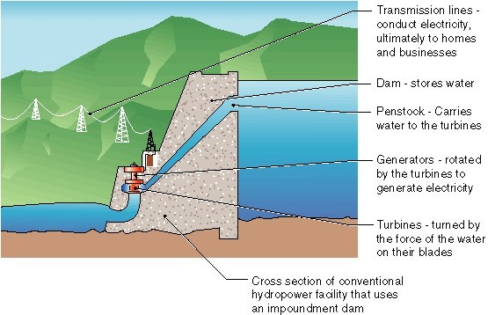
- Dam: A dam is built to trap water and to increase the head, usually in a valley where there is an existing lake. An artificial storage reservoir is formed by constructing a dam across a river.
- Reservoir: The area behind the dam where water is stored is called the reservoir.
- Intake and control gate: These are the gates built on the inside of the dam. The water from reservoir is released and controlled through these gates.
The intake the head works which are the structures at the intake of conduits, tunnels or flumes. These structures include blooms, screens or trash - racks, sluices to divert and prevent entry of debris and ice in to the turbines. Booms prevent the ice and floating logs from going in to the intake by diverting them to a bypass chute. Screens or trash-racks are fitted directly at the intake to prevent the debris from going in to the take. Debris cleaning devices should also be fitted on the trash-racks. Intake structures can be classified in to high pressure intakes used in case of large storage reservoirs and low pressure intakes used in case of small ponds.
Control gates arrangement is provided with Spillways. Spillway is constructed to act as a safety valve. It discharges the overflow water to the downstream side when the reservoir is full. These are generally constructed of concrete and provided with water discharge opening, shut off by metal control gates. By changing the degree to which the gates are opened, the discharge of the head water to the tail race can be regulated in order to maintain water level in reservoir.
- Penstock: The penstock is a long pipe that carries the water towards the turbines. They are generally equipped with head gates at the inlet which can be closed during the repair of the penstocks. An air inlet valve downstream from the gate is provided to prevent collapse of pipe immediately after the head gate is closed.
- Surge tank: Due to motion, water possesses some momentum. This momentum is destroyed, if the Flowing water is suddenly brought to rest, by closing the Valve. A very high pressure is developed on valve. This high pressure is followed by a series of pressure vibrations, resulting noise in pipe. This noise is known as "Knocking".
The sudden rise in Pressure has the effect of Hammering Action on the walls of pipe, known as Water Hammer. This Water Hammer can burst the pipe In Hydro Electric Power Plant, the requirement of Water goes on changing, that's why it is essential to increase or decrease the discharge flowing through the pipe line.
To overcome this problem, a Storage Reservoir is made in order to store Water when the Valve is suddenly closed, or to discharge water when increased discharged is required. Such a Storage Reservoir is known as "Surge Tank”.
- Power House:
- Sub Structure: That part which extends from the top of the draft tube to the soil or rock. Its purpose is to house the passage for the water coming out of the turbine.
- Intermediate Structure: It is that part of power plant which extends from the top of the draft tube to top of the generator foundation.
- Super structure: A building for housing all operating equipments. The part of the power house above the generator floor right up to the roof. It provides an over head travelling crane for handling heavy machine parts.
- Prime movers: Converts kinetic energy of water in to mechanical energy to produce electricity. The prime movers which are in common use are Pelton turbine, Francis turbine, Kaplan turbine and propeller turbines.
- Draft Tube: It is a diverging discharge passage connecting the running with tail race.

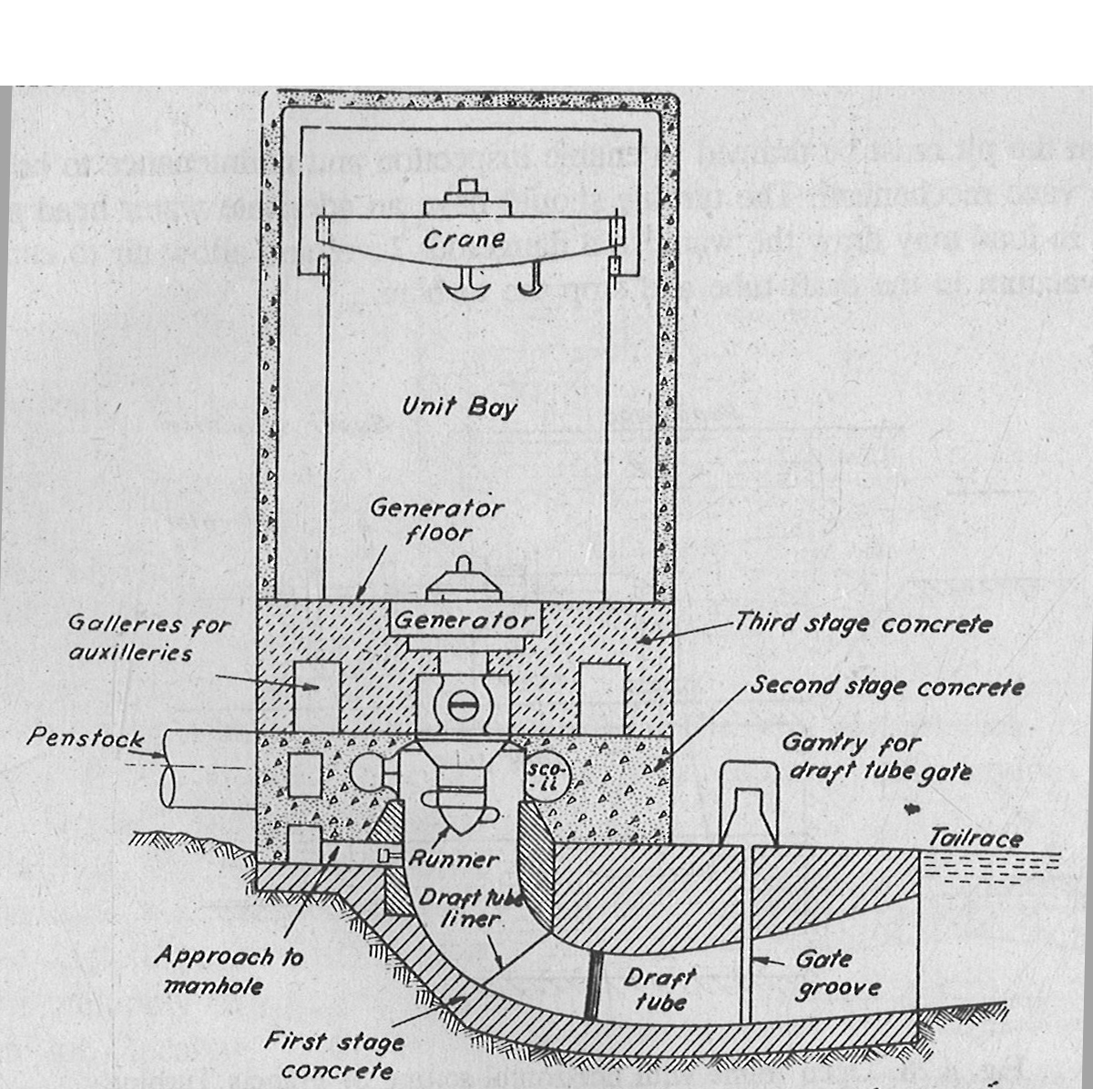

Section of a Hydro Power station showing sub-structure

Advantages and disadvantages of hydro-electric power
Advantages:
- Dams are designed to last many decades and so can contribute to the generation of electricity for many years / decades. .
- If electricity is not needed, the sluice gates can be shut, stopping electricity generation. The water can be saved for use another time when electricity demand is high. The buildup of water in the lake means that energy can be stored until needed, when the water is released to produce electricity.
- The lake that forms behind the dam can be used for water sports and leisure / pleasure activities. Often large dams become tourist attractions in their own right.
- The lake's water can be used for irrigation purposes.
- Hydropower is a fueled by water, so it's a clean fuel source. Hydropower doesn't pollute the air like power plants that burn fossil fuels, such as coal, oil or natural gas.
- Hydropower relies on the water cycle, which is driven by the sun, thus it's a renewable power source so long as the rain keeps falling on the dam catchment area.
- Hydropower is generally available as needed; engineers can control the flow of water through the turbines to produce electricity on demand.
- Hydropower is not only a cleaner source of energy than oil but is it more cost effective as well. The most efficient coal burning plants are only able to convert around 50 percent of their energy into electricity, whereas modern day hydro power turbines convert up to 90 percent of their energy into electricity.
- Hydropower plants provide benefits in addition to clean electricity. Hydro power plants create reservoirs that offer a variety of recreational opportunities, notably fishing, swimming, and boating. Most hydro power installations are required to provide some public access to the reservoir to allow the public to take advantage of these opportunities. Other benefits may include water supply and flood control.

Disadvantages:
- Dams are extremely expensive to build and must be built to a very high standard.
- The high cost of dam construction means that they must operate for many decades to become profitable.
- The flooding of large areas of land means that the natural environment is destroyed.
- People living in villages and towns that are in the valley to be flooded, must move out. This means that they lose their farms and businesses. In some countries, people are forcibly removed so that hydro-power schemes can go ahead.
- The building of large dams can cause serious geological damage.
- Dams built blocking the progress of a river in one country usually means that the water supply from the same river in the following country is out of their control. This can lead to serious problems between neighboring countries.
- Building a large dam alters the natural water table level. For example, the building of the Aswan Dam in Egypt has altered the level of the water table. This is slowly leading to damage of many of its ancient monuments as salts and destructive minerals are deposited in the stone work from 'rising damp' caused by the changing water table level.
- Hydro power dams can damage the surrounding environment and alter the quality of the water by creating low dissolved oxygen levels, which impacts fish and the surrounding ecosystems. They also take up a great deal of space and can impose on animal, plant, and even human environments.
- Hydro power can impact water quality and flow. Hydro power plants can cause low dissolved oxygen levels in the water, a problem that is harmful to riparian (riverbank) habitats and is addressed using various aeration techniques, which oxygenate the water. Maintaining minimum flows of water downstream of a hydro power installation is also critical for the survival of riparian habitats.
- Hydro power plants can be impacted by drought. When water is not available, the hydro power plants can't produce electricity.
- New hydro power facilities impact the local environment and may compete with other uses for the land. Those alternative uses may be more highly valued than electricity generation. Humans, flora, and fauna may lose their natural habitat. Local cultures and historical sites may be flooded. Some older hydro power facilities may have historic value, so renovations of these facilities must also be sensitive to such preservation concerns and to impacts on plant and animal life.
Hydro Electric Power Plant of Sardar Sarovar
There are two power houses for the Sardar Sarovar Project (SSP).
  - 1200 MW River Bed Power House and
  - 250 MW Canal Head Power House.
Power benefits are shared among Madhya Pradesh, Maharashtra and Gujarat in the ratio of 57:27:16 respectively.

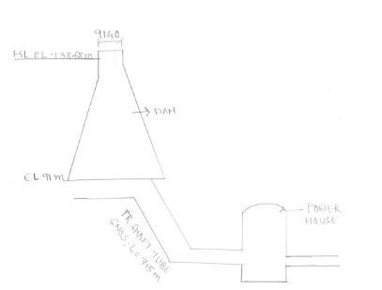

General Arrangement of the Power Plant

i) River Bed Power House (RBPH)
The RBPH is an underground power house stationed on the right bank of the river located about 165 meters downstream of the dam. It has six number of Francis type reversible turbine generators each of 200 MW installed capacity.
These units can operate at minimum reservoir water level of 110.64 meters. These six units have been commissioned in a phase manner during Feb-05 to June-06. The energy produced up to May'2010 is 13746.620 MUs. The generation of energy depends upon inflow of water from upstream projects and need of water for irrigation in Gujarat.
ii) Canal Head Power House (CHPH)
The CHPH is a surface power station in a saddle dam on right bank of the reservoir having total installed capacity of 250 MW (5 x 50 MW). These five units have been commissioned in a phased manner during Aug-04 to Dec-04. These units can be operated with minimum reservoir water level of 110.18 meters. The energy produced up to May'2010 is 1798.395 MUs.
The energy generated from both the power houses is to be evacuated through 400 KV level through interconnecting transformers at GIS, situated in RBPH switch yard. The 400 KV Switchyard is indoor type having Gas Insulated Switch Gear and Bus bars. The energy is transmitted to party states i.e. Gujarat, Maharashtra and Madhya Pradesh in the proportion of 16:27:57 respectively through 400 KV double circuit transmission lines, namely SSP-Kasor, SSP-Asoj, SSP-Dhule and SSP-Nagda respectively.
The operation and maintenance of SSP power complex and transmission lines is being done by Gujarat State Electricity Company Limited (GSECL).

