|  |
| --- |
| UNIVERSITY OF MAINE |
| PRELIMINARY PROGRESS REPORT |
| First Revision |

|  |
| --- |
| 6/30/2008 |

PRELIMINARY PROGRESS REPORT

# Objective

Optimal design, construction and development of intelligent machines with the capability to interact with their surroundings

* Entertainment companies and research facilities are the intended primary customers for the humanoid robot
* Research facilities interested in alternatives to locomotion are the intended primary customers for the 4-legged robot
* Health centers are intended primary customer for the two articulated arms

# Background

The following criteria was chosen for the design of the intelligent machines

* Modular to facilitate modification of the design in the prototyping stage and to minimize the number of supply parts needed
* Easy to assemble to minimize the prototyping stage
* Facilitate manufacturing by using off-the-shelf components

These criteria should not compromise the integrity of the structure of the robot.

The following constraints were chosen for the design

* The primary function of the humanoid robot is to walk and be able to get up.
* The primary function of the four legged robot is to walk in different terrains.
* The primary function of the 2 articulated arms is to assist surgeon in the performance of suturing routines

In order for the robot to be able to interact with its surroundings, the number of transducers and corresponding data implemented need to be at a minimum. These transducers, that mimic its human counterparts, should provide information on demand so the robot control unit can adjust the robot behavior to the existing conditions.

The following architecture is suggested for the design

# Component Requirements

The following requirements are suggested for this design and are not intended as a general rule.

The robot control unit must comply with the following:

1. Servo Control and Position Monitoring
2. Process transducer and servo inputs
3. Have the capability of expansion with minimal modification to the design, at least 25% for transducer inputs and servo motors

The servo unit must comply with the following:

1. Provide the highest High Toque vs. Price ratio
2. Have a range of at least 180 degrees preferably 300 degrees
3. Desirable – Self-Protection against overloading and overheating

The transducer selection criteria are the following:

1. Accuracy of its measurement
2. Price

For the intelligent machines to interact with the surroundings transducers are needed, for the following functions:

1. Vision to recognize colors and shapes
2. Equilibrium due to uneven surfaces
3. Object detection

To process the information from the different transducers the following requirements have to be met for the data processing component. In other words, this unit should transform data into information that the robot control unit can use:

1. Provide the information on demand in a timely manner
2. Have the capability of expansion with minimal modification to the design, at least 25% for transducer inputs and servo motors
3. Easy to use programming interface
4. Desirable - Simultaneously processing of information from different transducers
5. Desirable - Digital Signal Processing Capabilities

# Consideration of Alternatives (Hardware)

# Transducers

The requirements for the transducers are the following:

1. Easy integration of the data to the system
2. Cost
3. Size
4. Availability

The transducers that will be considered for the designed fall in these categories:

* Touch
* Mechanical Switch
* Optical Sensor
* Pressure sensor
* Object Detection
* Infrared Light Proximity Sensor
* Ultrasound Sensor
* Bumper Switch
* Sound Input and Output
* Navigation
* Line Tracing
* Odometry
* Compass
* Distance Measurement
* Position Referencing
* Tilt and Gravity
* Accelerometer
* Gyroscope
* Vision
* Multi-Cell Light Sensor
* Video Vision System
* Other

Vision – Camera

# Servo Motors

Three main options were consider

## Servos and Pulse Width Modulation

The motor shaft of a servo is positioned by using pulse width modulation (PWM). In this system, the servo responds to the duration of a steady stream of digital pulses. Specifically, the control board responds to a digital signal whose pulses vary from about 1ms to about 2ms .These pulses are sent some 50 times per second. The exact length of the pulse, in fractions of a millisecond, determines the position of the servo.



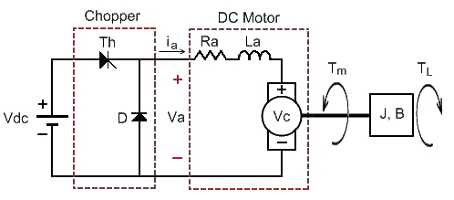

## Dynamixel control

It has been seen that the Robotis servo (dynamixel) can receive a desired angular position and a desired angular velocity as input. When the servo receives the desired angular velocity, it converts into the necessary average voltage consumption and then into the correspondent PWM signal. This procedure enables the output angular velocity to be equal to the desired one when working without external load. The next figure provides a possible block diagram control of the servos.

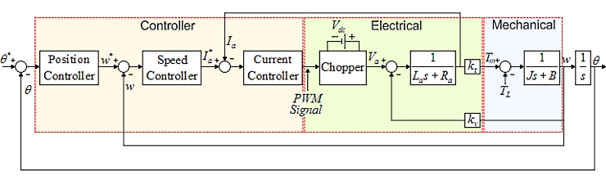

http://humanoids.dem.ist.utl.pt/index.html

# Stepper Motors

Stepper motors are in fact, DC motors with a twist. Instead of being powered by a continuous flow of current, as with regular DC motors, they are driven by pulses of electricity. Each pulse drives the shaft of the motor a little bit.

Since they are more expensive than the servo motors and Dynamixel actuators they were not considered in the design.

# Servo Comparison

A comparison of 4 different servo offerings was performed to find the best benefit vs. price ratio.

|  |  |  |  |  |  |  |
| --- | --- | --- | --- | --- | --- | --- |
| **BRAND** | **PART NUMBER** | **DESCRIPTION** | **CONTROL** | **TORQUE Oz-in** | **Price USD** | **Ratio Torque/Price** |
| FUTABA | FUTRS403PR | Hi-Torque Robot Servo MG Digital Fut J | PWM | 196.0 | $ 119.99 | 1.633 |
| JP | JRPS8711 | DS8711 Ultra Torque Servo | PWM | 403.0 | $ 139.99 | 2.879 |
| JP | JRPSR8801 | SR8801 Digital Ultra Torque Robot Servo | PWM | 395.8 | $ 124.99 | 3.167 |
| HiTec | R291-HSR-5990TG | Titanium Servo | PWM | 417.0 | $ 128.00 | 3.258 |
| Robotis | RX-64 | RX_64 Servo | Robotis Protocol | 1003.0 | $ 285.00 | 3.519 |

Using this comparison, the Robotis Dynamixel has the best benefit for price. Additional benefits that this actuator offers is that it has the best range 300 degrees compared to Futaba’s servo 180 degrees and HiTec’s servo 90 degrees, and that it provide protection from overload and overheating (4 servos have been burn so far from overloading and overheating).

# Data Processing Component

Currently no data processing component has been chosen. Two main options are being explored, microcontrollers and FPGA. In the meantime, this function will be assigned to the computer.

# Consideration of Alternatives (Software)

In the context of control for robotic systems, tasks can be classified as synchronous (or periodic) and asynchronous (or aperiodic). A reliable internal mechanism to provide a timing base for synchronous events is needed. The asynchronous events occurring during the normal activities are dealt with in the spare time between the synchronous events.

The host machine is usually supervised by a general purpose operating system with graphical interfaces, allowing a simple and direct interaction with the user in the design and development phases. No real-time requirements are necessary. The user prepares his tasks off-line, sets the target execution, and, at the end, analyzes the obtained data.

# Robotis Communication

The architecture of the Robotis system is distributed, that is the controller elements are not all central in location but are throughout the system with each component sub-system controlled by one controller (Dynamixel). The entire system of controllers is connected by networks for communication and monitoring (The dynamixel can send its actual position, speed, temperature and load). The dynamixel controllers use protocol for communication. Input sensors and servo modules form components parts of the Robotis system. The main processor receives information from input modules and sends information to the servo modules.

# Robot Control Unit Communication

In the meantime this activity is being done using the USBDyamixel TTL port. Options like wireless communication and/or portable robot control units are being explored.

# Matlab and Simulink

Simulink and Matlab are tools widely used in research and design of control systems. Matlab and Simulink are used to develop mathematical models that capture some important characteristics of a system under study. These models, often in the form of time-dependent ordinary differential equations, are then solved numerically in a computer simulation. Simulations are then used to analyze the mechanism.

In Simulink it is possible to include event-driven process logic using the Stateflow tool. A Stateflow diagram is composed by blocks representing states, and the simulator passes from one to another when some specified event happens. These events are associated with oriented edges linking the state blocks and labels specifying conditions and , possibly, actions. A Stateflow diagram included in a Simulink diagram can implement conditions and constraints on the execution of the overall simulation.

# Motion Requirements

The motion analysis platform should be able to enable the following actions:

* Simulation
* Prototyping new robots
* 3D Visualization
* Forward Kinematics
* Inverse Kinematics
* Fast Collision Checking (Oriented Boundary Boxes)
* Online robot information via USB Dynamixel
* Motion Planning, Point to Point with Speed Control

# Robot Architecture

The following architecture was selected for the three robots

# Humanoid Robot

# Spider

# Articulated Arm

# Task Assignment

### Team

|  |  |
| --- | --- |
| **Name** | **Status** |
| Xibei Ding | Full Time |
| Remi Jaouen | Temporary (Probably leaving July 15th) |
| Mark Liimakka | Full Time (Leaving on July 3rd) |
| Ronnie Oliver | Full Time |
| Scott Prince | Full Time |
| Raul Urbina | Full Time |
| Haojie Wang (Rockie) | Temporary (Left on June 25th) |

### Activities assignment

|  |  |
| --- | --- |
| **Name** | **Status** |
| Xibei Ding | * Design of the intelligent machines using Solid Works * Manufacturing of the prototyping machine * CNC programming and manufacturing of components |
| Remi Jaouen | * Design of the intelligent machines using Solid Works * Stress simulation of main components using Cosmos * Manufacturing of the prototyping machine * CNC and Lathe manufacturing of components |
| Mark Liimakka | * Articulated Hand design optimization * Microcontroller programming for hand control * CNC and Lathe manufacturing of components * Galil and IMS Controllers |
| Ronnie Oliver | * Vision system design, programming and construction * Manufacturing and design advisor |
| Scott Prince | * Motion simulation using Mathworks Simulynk * Motion planning * C# motion programming to servos * Matlab motion routines |
| Raul Urbina | * Supervising * Inverse Kinematics and Matlab motion routines * CNC and Lathe manufacturing of components |
| Haojie Wang (Rockie) | * Robot interaction using Matlab * Microcontroller communication with computer for transducer integration using Parallax |

# Development

## Manufacturing

The manufacturing of the main components was divided in three main areas:

* Off the shelf components
* Simple geometry
* Complex geometry

Special steps were taken to minimize the weight of the humanoid and 4-legged robots. Three main characteristics were taken into account when choosing the materials to be used:

* Light weight
* Tensile strength
* Machinability

The materials considered were:

|  |  |  |  |
| --- | --- | --- | --- |
| **Material** | **Specific Gravity** | **Tensile Strength** | **Machinability** |
| Aluminum 6061 | 2.7 | 40,000 psi | Very Good |
| MDS filled Nylon 6/6 | 1.15 | 12,000 psi | Very Good |
| ABS 400 (Stratasys) | 1.05 | 3,200 psi | Good |

The following criteria were used for the design, when applicable:

|  |  |  |  |
| --- | --- | --- | --- |
| **Material of choice** | **Simple Geometry** | **Complex Geometry** | **Strength Critical** |
| Nylon | Yes | No | No |
| ABS 400 | No | Yes | No |
| Nylon/Aluminum  (dependent on shape availability) | Yes | No | Yes |
| Aluminum | No | Yes | Yes |

Efforts were made to keep the design as simple, modular and functional as possible. As a result, for the three distinct designs only three types of pieces are going to be manufactures outside of our facilities.

The main part list for the Robots is as follows:

**HUMANOID**

|  |  |  |  |  |
| --- | --- | --- | --- | --- |
| **Part Number** | **Description** | **Material** | **Supplier/OEM** | **Qty** |
| S/N | Hollow Head | ABS 400 | Stratasys | 1 |
| RX-64 | RX-64 Servo | Off-The-Shelf | Robotis | 24 |
| OF-64B | Bracket | Off-The-Shelf | Robotis | 6 |
| OF-64S | Bracket | Off-The-Shelf | Robotis | 12 |
| OF-64H | Bracket | Off-The-Shelf | Robotis | 4 |
| CM-2 | CM-2 Controller | Off-The-Shelf | Robotis | 1 |
| RC-V96-8AA-HI01 | 9.6V 2300mAh Square Futaba NT8S600B Transmiter Battery Pack | Off-The-Shelf | All-battery | 4 |
| AnyVolt3 | Tenergy Universal DC-DC Converter and Voltage Stablizer | Off-The-Shelf | All-battery | 1 |
| S/N | Limb Extension Lower Arm | MDS Filled Nylon 6/6 | McMaster | 2 |
| S/N | Limb Extension Upper Arm | MDS Filled Nylon 6/6 | McMaster | 2 |
| S/N | Limb Extension Lower Leg | MDS Filled Nylon 6/6 | McMaster | 2 |
| S/N | Limb Extension Upper Leg | ABS 400 | Stratasys | 2 |
| S/N | Foot | ABS 400 | Stratasys | 2 |
| S/N | Hand | ABS 400 | Stratasys | 2 |
| S/N | Spine | MDS Filled Nylon 6/6 | McMaster | 1 |
| S/N | Body Case | ABS 400 | Stratasys | 1 |
| S/N | CM-2 Case | ABS 400 | Stratasys | 1 |
| S/N | Waist Case | Aluminum | McMaster | 1 |
| S/N | Bracket OF-H2 | Aluminum | OutSourced | 11 |
| S/N | Bracket OF-H3 | Aluminum | Outsourced | 5 |
| 8444-060100 | Cable 4 wires | Off-The-Shelf | Mouser Electronics | 6 m. |
| TBD | Main Controller | Off-The-Shelf |  | 1 |
| TBD | Gyro Package | Off-The-Shelf |  | 1 |

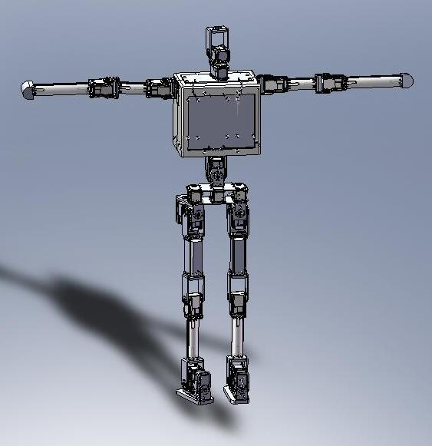

**4-LEGGED ROBOT**

|  |  |  |  |  |
| --- | --- | --- | --- | --- |
| **Part Number** | **Description** | **Material** | **Supplier/OEM** | **Qty** |
| S/N | Main Body | ABS 400 | Stratasys | 1 |
| RX-64 | RX-64 Servo | Off-The-Shelf | Robotis | 12 |
| OF-64S | Bracket | Off-The-Shelf | Robotis | 8 |
| OF-64H | Bracket | Off-The-Shelf | Robotis | 8 |
| CM-2 | CM-2 Controller | Off-The-Shelf | Robotis | 1 |
| RC-V96-8AA-HI01 | 9.6V 2300mAh Square Futaba NT8S600B Transmiter Battery Pack | Off-The-Shelf | All-battery | 2 |
| AnyVolt3 | Tenergy Universal DC-DC Converter and Voltage Stablizer | Off-The-Shelf | All-battery | 1 |
| S/N | Limb Extension Lower Arm | MDS Filled Nylon 6/6 | McMaster | 4 |
| S/N | Limb Extension Middle Arm | MDS Filled Nylon 6/6 | McMaster | 4 |
| S/N | Limb Extension Upper Arm | MDS Filled Nylon 6/6 | McMaster | 4 |
| S/N | DC-DC Converter Case | ABS 400 | Stratasys | 1 |
| S/N | Foot | ABS 400 | Stratasys | 4 |
| S/N | CM-2 Case | ABS 400 | Stratasys | 1 |
| S/N | Bracket OF-H2 | Aluminum | OutSourced | 8 |
| TBD | Main Controller | Off-The-Shelf |  | 1 |
| TBD | Gyro Package | Off-The-Shelf |  | 1 |

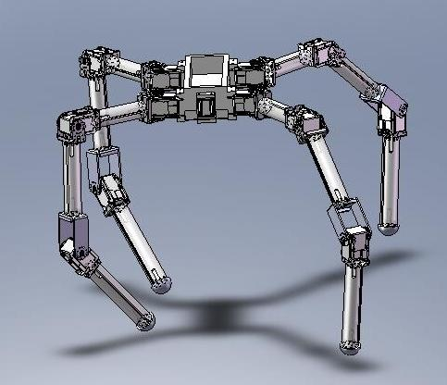

**2 ROBOTIC ARMS**

|  |  |  |  |  |
| --- | --- | --- | --- | --- |
| **Part Number** | **Description** | **Material** | **Supplier/OEM** | **Qty** |
| S/N | Main Body | Aluminum | McMaster | 2 |
| RX-64 | RX-64 Servo | Off-The-Shelf | Robotis | 6 |
| RX-28 | RX-28 Servo | Off-The-Shelf | Robotis | 4 |
| OF-64S | Bracket | Off-The-Shelf | Robotis | 4 |
| OF-64H | Bracket | Off-The-Shelf | Robotis | 2 |
| OF-28S | Bracket | Off-The-Shelf | Robotis | 2 |
| OF-28H | Bracket | Off-The-Shelf | Robotis | 2 |
| CM-2 | CM-2 Controller | Off-The-Shelf | Robotis | 1 |
| RC-V96-8AA-HI01 | 9.6V 2300mAh Square Futaba NT8S600B Transmiter Battery Pack | Off-The-Shelf | All-battery | 1 |
| AnyVolt3 | Tenergy Universal DC-DC Converter and Voltage Stablizer | Off-The-Shelf | All-battery | 1 |
| S/N | Main Shaft | MDS Filled Nylon 6/6 | McMaster | 2 |
| S/N | Limb Extension Upper Arm | MDS Filled Nylon 6/6 | McMaster | 2 |
| S/N | Limb Extension Lower Arm | MDS Filled Nylon 6/6 | McMaster | 2 |
| S/N | DC-DC Converter Case | ABS 400 | Stratasys | 1 |
| S/N | CM-2 Case | ABS 400 | Stratasys | 1 |
| UCF206-20 | Flanged Bearing | Off-The-Shelf | McMaster | 4 |
| S/N | Servo Case | ABS 400 | Stratasys | 2 |
| S/N | Bracket OF-H2 | Aluminum | OutSourced | 4 |
| TBD | Gripper | Off-The-Shelf |  | 2 |
| TBD | Flexible Coupling | Off-The-Shelf |  | 2 |

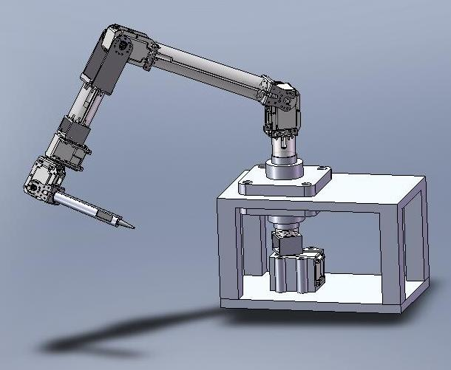

### ACTIVITIES DESCRIPTION

The following description is general for the three designs. Any difference will be highlighted or noted.

#### DESIGN PLANNING

Familiar platforms that had been used in the lab were decided on for the design. The Robotis-Dynamixel platform was used as the actuators, taking into account that they provided the best toque vs. price.

#### SOLID WORKS MODELS

Due to the familiarity with the platform Solid Works was chosen to aid in the design development.

This suite also was use to create the manufacturing drawing for the outsourced items. Also, Solid Work files were used to machine prototype some items.

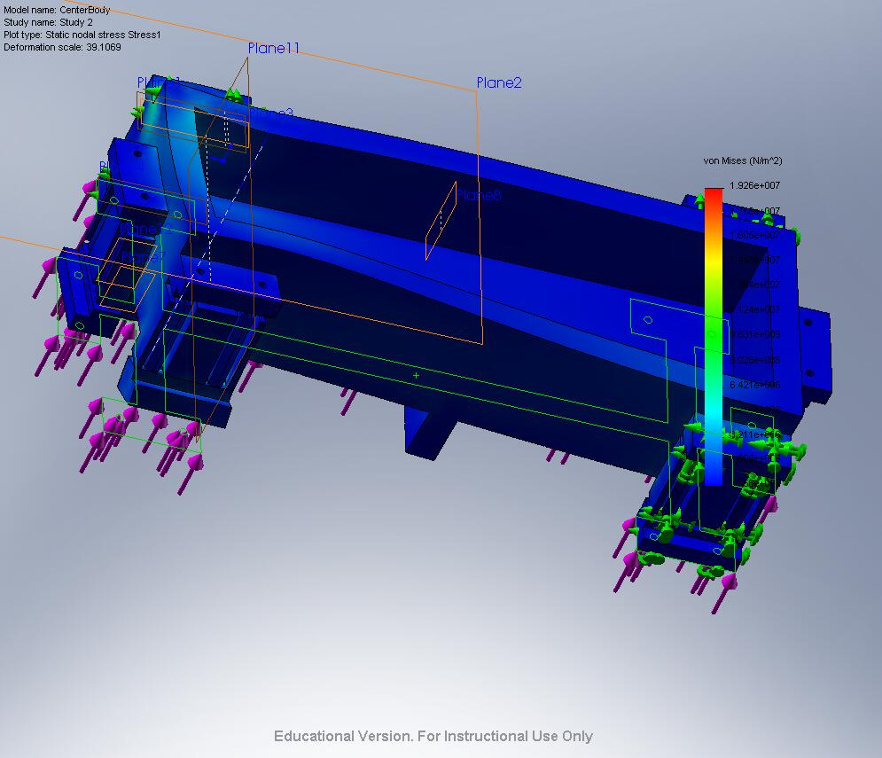

The Cosmos suite of Solid Works was used to simulate main components standing forces. This was done to ensure the structure integrity of the intelligent machines.

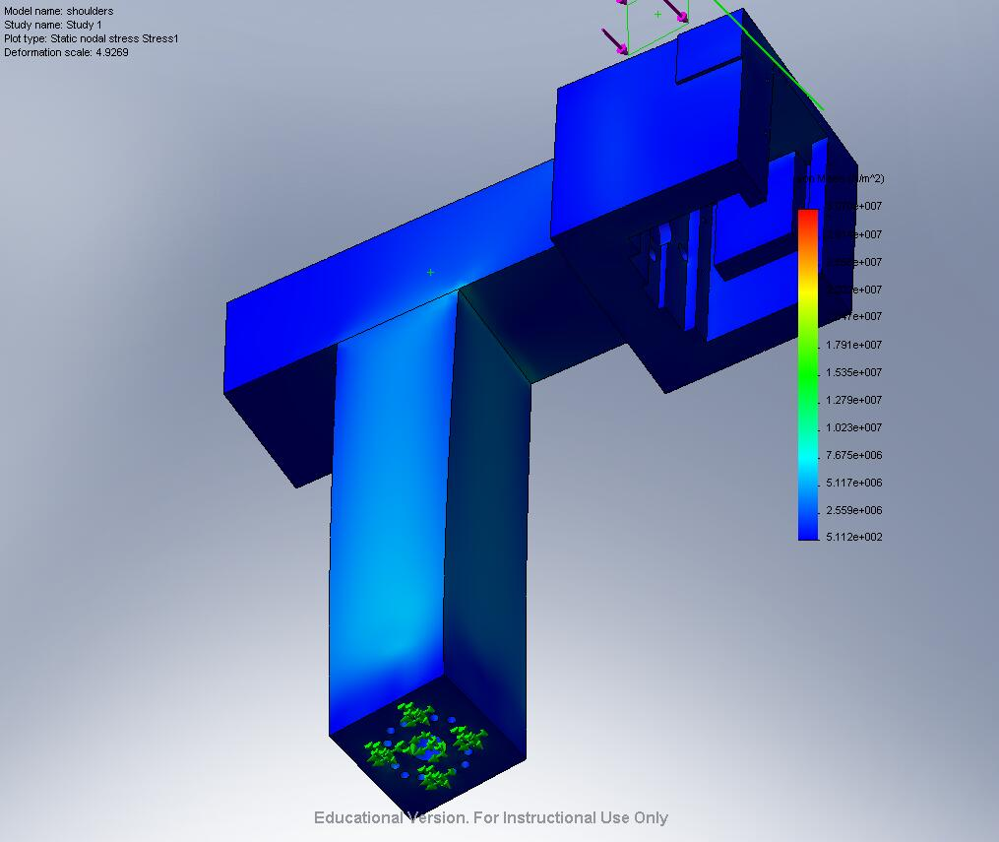

#### MANUFACTURING PLANNING

During this stage, the materials that were to be used and the methods to manufacture were decided on. During the manufacturing of the extensions a decision was made to change the material being used to MDS filled nylon and modify some parts in an effort to reduce the manufacturing time and the number of parts on the assembly.

#### TOOLS PURCHASING

During the manufacturing some tools have been purchased:

* Milling bits
* Drilling bits
* Taping bits
* De-burring tool set

#### RAW & ESSENTIAL MATERIAL PURCHASING

The status is the following:

|  |  |  |  |  |
| --- | --- | --- | --- | --- |
| **HUMANOID** | | | | |
| **Part Number** | **Description** | **Status** | **Supplier** | **Qty** |
| S/N | Limb Extension Lower Arm | Received | McMaster | 2 |
| S/N | Limb Extension Upper Arm | Received | McMaster | 2 |
| S/N | Limb Extension Lower Leg | Received | McMaster | 2 |
| S/N | Spine | To be ordered | McMaster | 1 |
| S/N | Waist Case | To be ordered | McMaster | 1 |

|  |  |  |  |  |
| --- | --- | --- | --- | --- |
| **4 LEGGED-ROBOT** | | | | |
| **Part Number** | **Description** | **Material** | **Supplier/OEM** | **Qty** |
| S/N | Limb Extension Lower Arm | Received | McMaster | 4 |
| S/N | Limb Extension Middle Arm | Received | McMaster | 4 |
| S/N | Limb Extension Upper Arm | Received | McMaster | 4 |

|  |  |  |  |  |
| --- | --- | --- | --- | --- |
| **2 ARTICULATED ARMS** | | | | |
| **Part Number** | **Description** | **Status** | **Supplier/OEM** | **Qty** |
| S/N | Main Body | To be Ordered | McMaster | 2 |
| S/N | Main Shaft | Received | McMaster | 2 |
| S/N | Limb Extension Upper Arm | Received | McMaster | 2 |
| S/N | Limb Extension Lower Arm | Received | McMaster | 2 |

#### PURCHASING OF OUTSOURCED ITEMS

Four suppliers were contacted for the manufacturing of three types of pieces. Only one provider has shown interest on manufacturing the parts.

As for today, the final quote is pending by the supplier to place the purchase order.

#### PURCHASING OF OFF-THE-SHELF ITEMS

The status of the purchasing of the off-the-shelf-items is the following:

|  |  |  |  |  |
| --- | --- | --- | --- | --- |
| **HUMANOID** | | | | |
| **Part Number** | **Description** | **Status** | **Supplier** | **Qty** |
| RX-64 | RX-64 Servo | Half have been received. The other half is still pending to be received | Robotis / Road Narrow Robotics | 24 |
| OF-64B | Bracket | Half have been received. The other half is still pending to be received | Robotis / Road Narrow Robotics | 6 |
| OF-64S | Bracket | Half have been received. The other half is still pending to be received | Robotis / Road Narrow Robotics | 12 |
| OF-64H | Bracket | Half have been received. The other half is still pending to be received | Robotis / Road Narrow Robotics | 4 |
| CM-2 | CM-2 Controller | Ordered. Still hasn’t been received | Robotis / Road Narrow Robotics | 1 |
| RC-V96-8AA-HI01 | 9.6V 2300mAh Square Futaba NT8S600B Transmiter Battery Pack | Ordered. Still hasn’t been received | All-battery | 4 |
| AnyVolt3 | Tenergy Universal DC-DC Converter and Voltage Stablizer | Ordered. Still hasn’t been received | All-battery | 1 |
| 8444-060100 | Cable 4 wires | Received | Mouser Electronics | 6 m. |
| TBD | Main Controller | Hasn’t been defined |  | 1 |
| TBD | Gyro Package | The order hasn’t been placed | HUV Robotics | 1 |

|  |  |  |  |  |
| --- | --- | --- | --- | --- |
| **4 LEGGED-ROBOT** | | | | |
| **Part Number** | **Description** | **Status** | **Supplier/OEM** | **Qty** |
| RX-64 | RX-64 Servo | Received | Robotis / Road Narrow Robotics | 12 |
| OF-64S | Bracket | Received | Robotis / Road Narrow Robotics | 8 |
| OF-64H | Bracket | Received | Robotis / Road Narrow Robotics | 8 |
| CM-2 | CM-2 Controller | Received | Robotis / Road Narrow Robotics | 1 |
| RC-V96-8AA-HI01 | 9.6V 2300mAh Square Futaba NT8S600B Transmiter Battery Pack | Ordered. Still hasn’t been received | All-battery | 2 |
| AnyVolt3 | Tenergy Universal DC-DC Converter and Voltage Stablizer | Ordered. Still hasn’t been received | All-battery | 1 |
| TBD | Main Controller | Hasn’t been defined |  | 1 |
| TBD | Gyro Package | The order hasn’t been placed | HUV Robotics | 1 |

|  |  |  |  |  |
| --- | --- | --- | --- | --- |
| **2 ARTICULATED ARMS** | | | | |
| **Part Number** | **Description** | **Material** | **Supplier/OEM** | **Qty** |
| RX-64 | RX-64 Servo | Ordered. Still hasn’t been received | Robotis / Road Narrow Robotics | 6 |
| RX-28 | RX-28 Servo | Half have been received. The other half is still pending to be received | Robotis / Road Narrow Robotics | 4 |
| OF-64S | Bracket | Ordered. Still hasn’t been received | Robotis / Road Narrow Robotics | 4 |
| OF-64H | Bracket | Ordered. Still hasn’t been received | Robotis / Road Narrow Robotics | 2 |
| OF-28S | Bracket | Ordered. Still hasn’t been received | Robotis / Road Narrow Robotics | 2 |
| OF-28H | Bracket | Ordered. Still hasn’t been received | Robotis / Road Narrow Robotics | 2 |
| CM-2 | CM-2 Controller | Ordered. Still hasn’t been received | Robotis / Road Narrow Robotics | 1 |
| RC-V96-8AA-HI01 | 9.6V 2300mAh Square Futaba NT8S600B Transmiter Battery Pack | Ordered. Still hasn’t been received | All-battery | 1 |
| AnyVolt3 | Tenergy Universal DC-DC Converter and Voltage Stablizer | Ordered. Still hasn’t been received | All-battery | 1 |
| UCF206-20 | Flanged Bearing | Received | McMaster | 4 |
| TBD | Gripper | Hasn’t been defined |  | 2 |
| TBD | Flexible Coupling | The order hasn’t been placed | McMaster | 2 |

#### CNC, MILLS & LATHE MANUFACTURING

The planning for 85% of the components, to be produced in this way, had been done. The manufacturing will continue, as soon as access to the Crosby machine shop is available.

#### PROTOTYPING MANUFACTURING

Prototyping manufacturing has been done for the main components of the 4 legged-robot.

The prototyping manufacturing of components for the humanoid robot will start as soon as the 4 legged-robot components are finished.

For the 2 articulated arms, there are no main components to be manufactured using the prototyping machine.

#### FORWARD & INVERSE KINEMATICS

The forward kinematics calculations for the humanoid will be calculated using the Denavit Hartengberg calculation. Jacobian numerical techniques will be used for the inverse kinematics.

The forward and inverse kinematics for the 4 legged-robot had been calculated and tested.

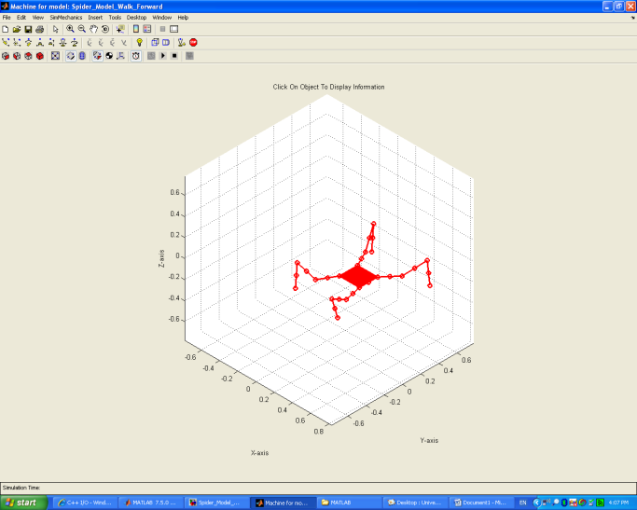

The forward kinematics for the 2 articulated arms had been calculated. Currently the inverse kinematics had been calculated, but yet to be validated.

#### MOTION SIMULATION

For the motion simulation, Matlab and Simulink were chosen, because of the familiarity that we had with the program and the graphics. Currently it has been tested only for the 4 legged-robot.

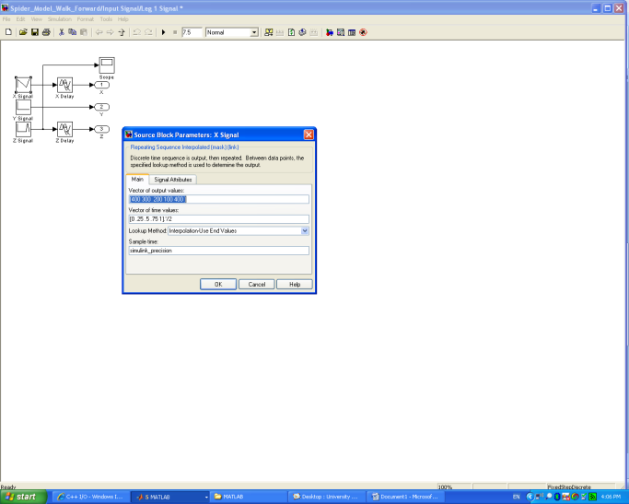

The process being used is the following:

* Leg movement definition using Matlab function called by Simulink
* Link angle calculation using Matlab function called by Simulink (from inverse kinematics)
* Static stability check with polygons using Matlab function and plots
* Velocity calculation using Simulink
* Simulink exports the position and velocity data to Excel
* C# program reads position and velocity data from Excel
* C# program sends position and velocity data to servos via USB Dynamixel port using the SyncWrite command

Using the motion platform, two designs of experiments (DOE) calculations were performed to optimize the link size of the legs. The results were already included in the 4 legged-robot.

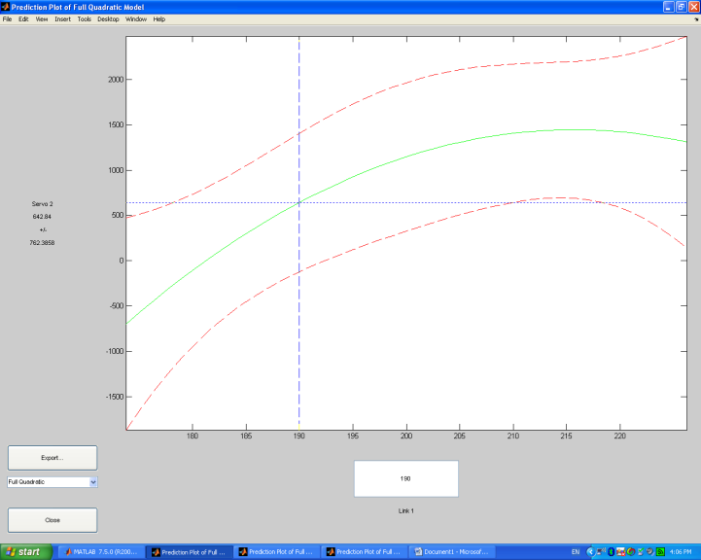

#### TRANSDUCER INTEGRATION

Currently no transducer integration has been done

#### CONTROL PROGRAMMING

Walking and turning routines had been tested for the small 4 legged-robot using the motion simulation. The results have been encouraging since very stable and fluid movements have been accomplished.

Currently no control programming has been done for the humanoid and the articulated arm.

#### ASSEMBLY

Currently no assembly has been done.

#### TESTING

Currently no testing has been done.

#### TROUBLESHOOTING

Currently no troubleshooting has been done.

### ADVANCE TO DATE

HUMANOID

Considering 16 Activities to evaluate the advance the calculation is the following:

|  |  |  |
| --- | --- | --- |
| **ADVANCE** | **NO. OF ACTIVITIES** | **WEIGHTED ADVANCE** |
| 100% | 0 | 0 |
| 75% | 6 | 4.5 |
| 50% | 0 | 0 |
| 25% | 2 | 0.5 |
| 0% | 8 | 0 |
|  |  |  |
|  | TOTAL WEIGHTED ADVANCE | 5 |
|  | PERCENTAGE OF ADVANCE | 31.25% |

4 LEGGED ROBOT

Considering 16 Activities to evaluate the advance the calculation is the following:

|  |  |  |
| --- | --- | --- |
| **ADVANCE** | **NO. OF ACTIVITIES** | **WEIGHTED ADVANCE** |
| 100% | 2 | 2 |
| 75% | 5 | 3.75 |
| 50% | 2 | 1 |
| 25% | 3 | 0.75 |
| 0% | 4 | 0 |
|  |  |  |
|  | TOTAL WEIGHTED ADVANCE | 7.5 |
|  | PERCENTAGE OF ADVANCE | 46.88% |

2 ARTICULATED ARMS

Considering 16 Activities to evaluate the advance the calculation is the following:

|  |  |  |
| --- | --- | --- |
| **ADVANCE** | **NO. OF ACTIVITIES** | **WEIGHTED ADVANCE** |
| 100% | 1 | 1 |
| 75% | 5 | 3.75 |
| 50% | 0 | 0 |
| 25% | 5 | 1.25 |
| 0% | 5 | 0 |
|  |  |  |
|  | TOTAL WEIGHTED ADVANCE | 6 |
|  | PERCENTAGE OF ADVANCE | 37.50% |

# Test and Evaluation

Pending

# Proposed Future Work

### Humanoid

Proposed future work on the humanoid robot

* Design optimization
* Motion repertoire expansion
* Human-machine interaction
* Learn lessons for full-size humanoid

### 4-Legged Robot

Proposed future work on the 4-legged robot

* Design optimization
* Motion optimization
* Motion repertoire expansion
* Human-machine interaction
* Increase autonomy, using feedback control
* Weather-proof design (IP54)
* Expand into surveillance capabilities

### Articulated Arms

Proposed future work on the articulated arms

* Design optimization
* Increase functionality for surgical support
* Human-machine interaction using control unit (PC)
* Increase number of actuators (gripper, clamp, etc) for surgical purposes

# References

B. Siciliano, A. de Luca, C. Melchiorri, G. Casalino, *Advances in Control of Articulated and Mobile Robots*, Springer-Verlag 2004

Saeed B. Niku, *Introduction to Robotics Analysis, Systems, Applications*, Prentice Hall 2001

John F. Gardner, *Simulations of Machines using Matlab and Simulink*, Wadsworth Group, 2001

Pablo Gonzalez de Santos, Elena Garcia, Joaquin Estremera, *Quadrupedal Locomotion An Introduction to the Control of Four-Legged Robots*, Springer 2006

Gordon McComb, Myke Predko, *Robot Builder’s Bonanza*, Third Edition, McGraw-Hill, 2006

## GLOSSARY

**Protocol**   
A set of formal rules describing how to transmit data, especially across a [network](http://dictionary.reference.com/browse/network). Low level protocols define the electrical and physical standards to be observed, bit- and byte-ordering and the transmission and [error detection and correction](http://dictionary.reference.com/browse/error%20detection%20and%20correction) of the bit stream. High level protocols deal with the data formatting, including the [syntax](http://dictionary.reference.com/browse/syntax) of messages, the terminal to computer dialogue, [character sets](http://dictionary.reference.com/browse/character%20sets), sequencing of messages etc.

**Servo**

Servomotor

**Dynamixel**

A Robotis actuator controlled by digital packet communication (protocol communication).

**Transducer**

A device that receives a signal in the form of one type of energy and converts it to a signal in another form

## ANNEX

# SERVO PRICING

**FUTRS403PR Hi-Torque Robot Servo MG Digital Fut J**

SPECS: Speed: .13 sec/60° @ 6V

Torque: 196 oz-in @ 6V

(13.8 kg-cm @ 6V)

Weight: 2.22oz (63g)

Length: 1.57" (40mm)

Width: .8" (20mm)

Height: 1.5" (38mm)

Communication: Pulse Width Modulation (PWM)

Operation range: 180°

Pulse cycle: 14.25ms

Pulse width: 920-2120us

$119.99

<http://www.hobbiesr.com/fut/fut-253/futrs403pr.htm>

**JRPS8711      DS8711 ULTRA TORQUE SERVO**

Type: Digital Ultra Torque   
Torque: 347 oz/in @ 4.8V, 403 oz/in @ 6V   
Speed: .19 sec/60° @ 4.8V, .15 sec/60° @ 6V   
Dimensions (WxLxH): .82" x 1.58" x 1.56"   
Weight: 2.36 oz   
Gears: Metal alloy

$139.99

<http://www.hobbiesr.com/jrp/jrp-253/jrps8711.htm>

**JRPSR8801      SR8801 Digital Ultra Torque Robot Servo**

Type: Digital Ultra-Torque   
Torque: 395.8 oz/in   
Speed: 0.14s/60deg   
Dimensions (WxLxH): .83 x 1.59 x 1.41   
Weight: 2.3 oz   
Voltage: 7.4 (data)

$124.99

<http://www.hobbiesr.com/jrp/jrp-253/jrpsr8801.htm>

|  |  |
| --- | --- |
| Part Number: | R291-HSR-5990TG |
| Price: | $128.00 |
| Weight: | 0.16 lbs |

The Titanium servo has a Hitech/JR connector which mates directly with a 0.1" 3-pin header. The servo accepts Hitec servo horns, and additional metal horns are available in various shapes.

|  |  |  |  |  |  |
| --- | --- | --- | --- | --- | --- |
| **Specifications** | | | | | |
| **Voltage** | **Operating Speed** | **Output Torque** | **Weight** | **Dimensions** |  |
| 6V | 0.17sec/60 degrees | 24 kg.cm (333 oz.in) | 68.0g (2.39oz) | 1.57" x 0.78" x 1.45" 40.00 x 20.00 x 37.00 mm |  |
| 7.4V | 0.14sec/60 degrees | 30 kg.cm (417 oz.in) |  |

<http://www.acroname.com/robotics/parts/R291-HSR-5990TG.html>