ELECTRICAL DISTRIBUTION

INTRODUCTION
As a Construction Electrician second class, you may have to supervise the installation, maintenance, and repair of overhead primary and secondary power distribution systems. This chapter will provide the necessary information to enable you to calculate electrical loads and perform fundamental tasks in the selection, by size and type, of distribution equipment. When you perform the above-mentioned tasks, remember, your primary goal should be the safety of your troops.
A power distribution system includes all parts of an electrical system between the power source and the customer’s service entrance. The power source may be either a local generating plant or a high-voltage transmission line feeding a substation that reduces the high voltage to a voltage suitable for local distribution. At most advance bases, the source of power will be generators connected directly to the load.
DISTRIBUTION SYSTEMS CONFIGURATION
The configurations of four distribution systems are defined in the following paragraphs. These four distribution systems — radial, loop (ring), network, and primary selective — are briefly described. For additional information, review the Electric Power Distribution Systems Operations, NAVFAC MO-201.
RADIAL DISTRIBUTION SYSTEM
A representative schematic of a radial distribution system is shown in figure 4-1. You should note that the independent feeders branch out to several distribution centers without intermediate connections between feeders.
The most frequently used system is the radial distribution system because it is the simplest and least expensive system to build. Operation and expansion are simple. It is not as reliable as most systems unless quality components are used. The fault or loss of a cable, primary supply, or transformer will result in an outage on all loads served by the feeder. Furthermore, electrical service is interrupted when any piece of service equipment must be de-energized to perform routine maintenance and service.
Service on this type of feeder can be improved by installing automatic circuit breakers that will reclose the service at predetermined intervals. If the fault continues after a predetermined number of closures, the breaker will lock out until the fault is cleared and service is restored by hand reset.
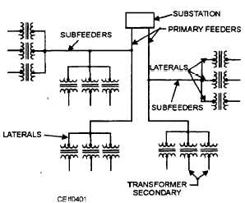

Figure 4-1.—Radial distribution system.

LOOP/RING DISTRIBUTION SYSTEM
The loop, or ring, system of distribution starts at the substation and is connected to or encircles an area serving one or more distribution transformers or load centers. The conductor of the system returns to the same substation.
The loop system (fig. 4-2) is more expensive to build than the radial type, but it is more reliable. It may be justified in an area where continuity of service is of considerable importance, for example, a medical center.
In the loop system, circuit breakers sectionalize the loop on both sides of each distribution transformer connected to the loop. The two primary feeder breakers and the sectionalizing breakers associated with the loop feeder are ordinarily controlled by pilot wire relaying or directional overcurrent relays. Pilot wire relaying is used when there are too many secondary substations to obtain selective timing with directional over current relays
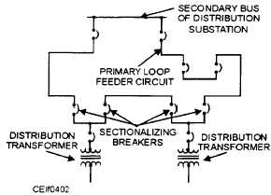

Figure 4-2.—Loop, or ring, distribution system.

A fault in the primary loop is cleared by the breakers in the loop nearest the fault, and power is supplied the other way around the loop without interruption to most of the connected loads. Because the load points can be supplied from two or more directions, it is possible to remove any section of the loop from service for maintenance without causing an outage at other load points. If a fault occurs in a section adjacent to the distribution substation, the entire load may have to be fed from one side of the loop until repairs are made. Sufficient conductor capacity must be provided in the loop to permit operation without excessive voltage drop or overheating of the feeder when either side of the loop is out of service. If a fault occurs in the distribution transformer, it is cleared by the breaker in the primary leads; and the loop remains intact.

NETWORK DISTRIBUTION SYSTEM

The network and radial systems differ with respect to the transformer secondaries. In a network system (fig. 4-3) transformer secondaries are paralleled; in a radial system, they are not.
The network is the most flexible type of primary system; it provides the best service reliability to the distribution transformers or load center, particularly when the system is supplied from two or more distribution substations. Power can flow from any substation to any distribution transformer or load center in the network system. The network system is more flexible with regard to load growth than the radial or loop system and is adaptable to any rate of load growth. Service readily can be extended to additional points of usage with relatively small amounts of new construction. The network system, however, requires large quantities of equipment and extensive relaying; therefore, it is more expensive than the radial system. From the standpoint of economy, the network system is suitable only in heavy-load-density areas where the load center units range from 1,000 to 4,000 kilovoltamperes (kVA)
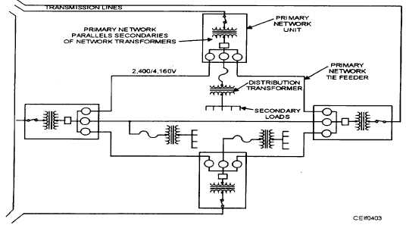

Figure 4-3.—Network distribution system

