**REGULATED POWER SUPPLY**

###### DESCRIPTION

A variable regulated power supply, also called a variable bench power supply, is one where you can continuously adjust the output voltage to your requirements. Varying the output of the power supply is the recommended way to test a project after having double checked parts placement against circuit drawings and the parts placement guide.

This type of regulation is ideal for having a simple variable bench power supply. Actually this is quite important because one of the first projects a hobbyist should undertake is the construction of a variable regulated power supply. While a dedicated supply is quite handy e.g. 5V or 12V, it's much handier to have a variable supply on hand, especially for testing.

Most digital logic circuits and processors need a 5 volt power supply. To use these parts we need to build a regulated 5 volt source. Usually you start with an unregulated power supply ranging from 9 volts to 24 volts DC (A 12 volt power supply is included with the [Beginner Kit](http://www.iguanalabs.com/1stled.htm) and the [Microcontroller Beginner Kit](http://www.iguanalabs.com/mbkit.htm).). To make a 5 volt power supply, we use a LM7805 voltage regulator IC (Integrated Circuit). The IC is shown below. 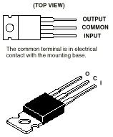

Any invention of latest technology cannot be activated without the source of power. So in this fast moving world we deliberately need a proper power source which will be apt for a particular requirement. All the electronic components starting from diode to ics only work with a DC supply ranging from 5V to 12V.We are utilizing for the same, the cheapest and commonly available energy source of 230V-50Hz and stepping down, rectifying, filtering and regulating the voltage.

**Transformer:**

A bridge rectifier coupled with a step down transformer is used for our design. The voltage rating of transformer used is 0-12V and the current rating is

500mA. When AC voltage of 230V is applied across the primary winding an output AC voltage of 12V is obtained. One alteration of input causes the top of transformer to be positive and the bottom negative. The next alteration will temporarily cause the reverse.

**Rectifier:**

In the power supply unit, rectification is normally achieved using a solid state diode. Diode has the property that will let the electron flow easily at one direction at proper biasing condition. Bridge rectifiers of 4 diodes are used to achieve full wave rectification. Two diodes will conduct during the negative cycle and the other two will conduct during the positive half cycle.

**Filtering unit:**

Filter circuit which is usually a capacitor acts as a surge arrester always follows the rectifier unit. This capacitor is also called as a decoupling capacitor or a bypass capacitor, is used not only to short the ripple with frequency to ground but also leave the frequency of the DC to appear at the output.

**Regulators:**

The voltage regulators play an important role in any power supply unit. The primary purpose of a regulator is to aid the rectifier and filter circuit in providing a constant DC voltage to the device. Power supplies without regulators haveinherent problem of changing DC voltage values due to variations in the load or due to fluctuations in the AC line voltage. With a regulator connected to DC output, the voltage can be maintained within a close tolerant region of the desired output. IC 7805 and 7812 regulators are used in this project for providing a DC voltage of +5V and +12V respectively.

**LM78XX**

**General Description:**

The LM78XX series of three terminal regulators is available with several fixed output voltages making them useful in a wide range of applications. One of these is local on card regulation, eliminating the distribution problems associated with single point regulation. The voltages available allow these regulators to be used in logic systems, instrumentation, HiFi, and other solid state electronic equipment. Although designed primarily as fixed voltage regulators these devices can be used with external components to obtain adjustable voltages and currents.

The LM78XX series is available in an aluminum TO-3 package which will allow over 1.0A load current if adequate .

Heat sinking is provided. Current limiting is included to limit the peak output current to a safe value. Safe area protection for the output transistor is provided to limit internal power dissipation. If internal power dissipation becomes too high for the heat sinking provided, the thermal shutdown circuit takes cover preventing the IC from overheating. Considerable effort was expanded to make the LM78XX series of regulators easy to use and minimize the number of external components. It is not necessary to bypass the output,although this does improve transient response. Input bypassing is needed only if the regulator is located far from the filter capacitor of the power supply.For output voltage other than 5V, 12V and 15V the LM117 Series provides an output voltage range from 1.2V to 57V.

**CIRCUIT FEATURES**

* Brief description of operation: Gives out well regulated +5V output, output current capability of 100 mA
* Circuit protection: Built-in overheating protection shuts down output when regulator IC gets too hot
* Circuit complexity: Very simple and easy to build
* Circuit performance: Very stable +5V output voltage, reliable operation
* Availability of components: Easy to get, uses only very common basic components
* Design testing: Based on datasheet example circuit, I have used this circuit successfully as part of many electronics projects
* Applications: Part of electronics devices, small laboratory power supply
* Power supply voltage: Unregulated DC 8-18V power supply
* Power supply current: Needed output current + 5 mA
* Component costs: Few dollars for the electronics components + the input transformer cost
* 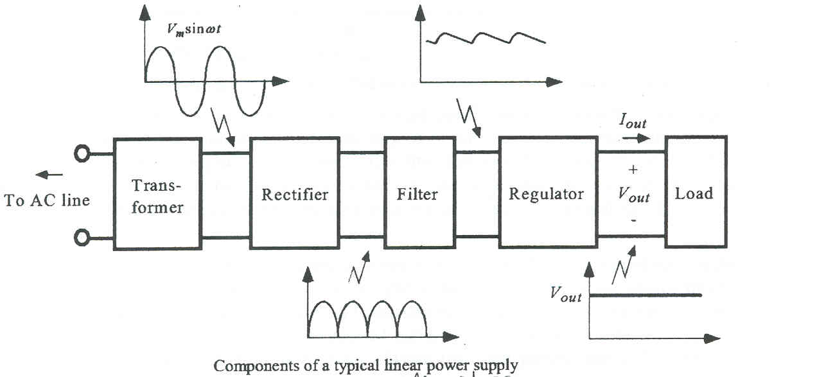**BLOCK DIAGRAM**

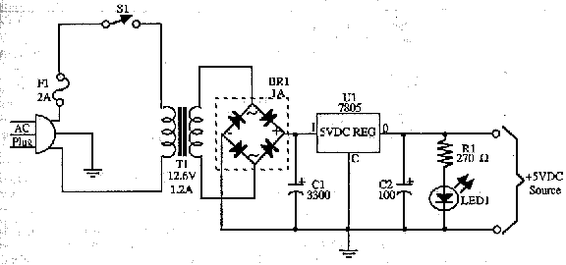**CIRCUIT DIAGRAM**

**BASIC POWER SUPPLY CIRCUIT**

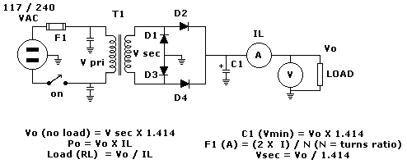

Above is the circuit of a basic **unregulated** dc power supply. A bridge rectifier D1 to D4 rectifies the ac from the transformer secondary, which may also be a block rectifier such as WO4 or even four individual diodes such as 1N4004 types. (See later re rectifier ratings).

The principal advantage of a bridge rectifier is you do not need a centre tap on the secondary of the transformer. A further but significant advantage is that the ripple frequency at the output is twice the line frequency (i.e. 50 Hz or 60 Hz) and makes filtering somewhat easier.

As a design example consider we wanted a small unregulated bench supply for our projects. Here we will go for a voltage of about 12 - 13V at a maximum output current (IL) of 500ma (0.5A). Maximum ripple will be 2.5% and load regulation is 5%.

Now the RMS secondary voltage (primary is whatever is consistent with your area) for our power transformer T1 must be our desired output Vo PLUS the voltage drops across D2 and D4 ( 2 * 0.7V) divided by 1.414.

This means that Vsec = [13V + 1.4V] / 1.414 which equals about 10.2V. Depending on the VA rating of your transformer, the secondary voltage will vary considerably in accordancewith the applied load. The secondary voltage on a transformer advertised as say 20VA will be much greater if the secondary is only lightly loaded.

If we accept the 2.5% ripple as adequate for our purposes then at 13V this becomes 13 * 0.025 = 0.325 Vrms. The peak to peak value is 2.828 times this value. Vrip = 0.325V X 2.828 = 0.92 V and this value is required to calculate the value of C1. Also required for this calculation is the time interval for charging pulses. If you are on a 60Hz system it it 1/ (2 * 60 ) = 0.008333 which is 8.33 milliseconds. For a 50Hz system it is 0.01 sec or 10 milliseconds.

Remember the tolerance of the type of capacitor used here is very loose. The important thing to be aware of is the voltage rating should be at least 13V X 1.414 or 18.33. Here you would use at least the standard 25V or higher (absolutely not 16V).With our rectifier diodes or bridge they should have a PIV rating of 2.828 times the Vsec or at least 29V. Don't search for this rating because it doesn't exist. Use the next highest standard or even higher. The current rating should be at least **twice** the load current maximum i.e. 2 X 0.5A or 1A. A good type to use would be 1N4004, 1N4006 or 1N4008 types.