GOOGLE DRIVERLESS CAR

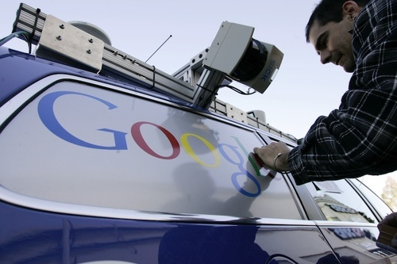

ABSTRACT:-
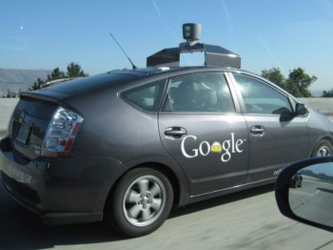

From the invention of the car there is a great relation between human and car. Because by the invention of the car the automobile industry was established, by this car the traveling time from one place to another place is reduced. The car brings royalty from the invention. As cars are coming on roads at that time there are so many accidents are occurring due to lack of driving knowledge & drink driving and soon, In that view only the Google took a great project, i.e. Google Driverless Car in these the Google puts the technology in the car, that technology was Artificial Intelligence with Google map view. The input video camera was fixed beside the front mirror inside the car, A LIDAR sensor was fixed on the top of the vehicle, RADAR sensor on the front of the vehicle and a position sensor attached to one of the rear wheels that helps locate the cars position on the map, The Computer, Router, Switch, Fan, Inverter, rear Monitor, Topcon, Velodyne, Applanix and Battery are kept inside the car.
These all components are connected to computer’s CPU and the monitor is fixed on beside of the driver seat, these we can observe in that monitor and can operate all the operations.

INTRODUCTION:-
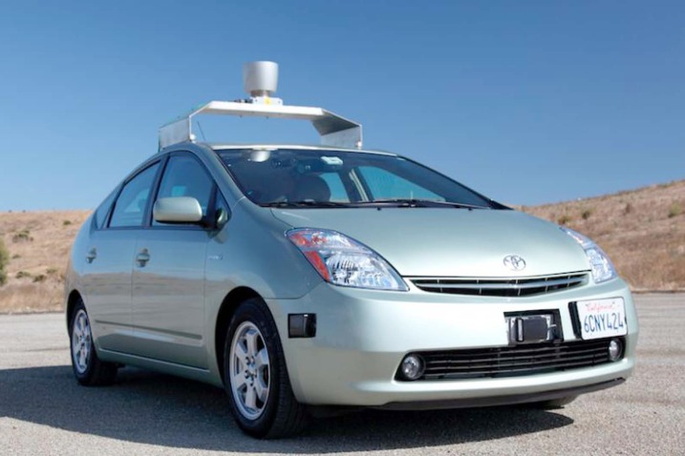
The system combines information gathered from Google street view with artificial intelligence software that combines input from video camera inside the car, a LIDAR sensor on the top of the vehicle, RADAR sensors on the front of the vehicle and a position sensor attached to one of the rear wheel that helps to locate the car position on the map. At the same time some hardware components are used in the car these are APPIANIX PCS, VELODYNE, SWITCH,TOPCON, REAR MONITOR, COMPUTER, ROUTER, FAN, INVERTER and BATTERY along with some software program is installed in it. By all the components combined together to operate the car without the DRIVER. i.e., the car drives itself only.
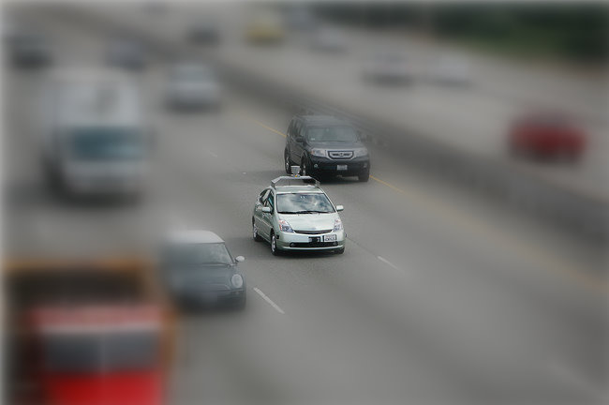

History:-
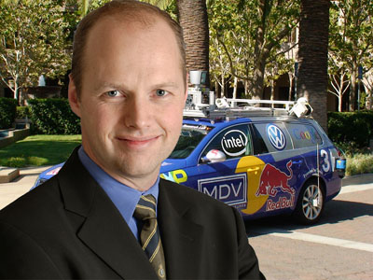
The Sebastian Thrun was invented the Google driverless car. He was director of the Stanford Artificial Intelligence laboratory. Sebastian friends were killed in car accident, so that he decided there should not be any accidents on the road by car. By that decision only the Google Driverless car was invented.
”Our goal is to help prevent traffic accidents, free up people’s time and reduce carbon emission by fundamentally changing car use”-Sebastian Thrun
The Google Driverless car was tested in the year 2010; Google has tested several vehicles equipped with the system, driving 1,609 kilometers (1,000 mi) without any human intervention, in addition to 225,308 kilometers (140,000 mi) with occasional human intervention. Google expects that the increased accuracy of its automated driving system could help reduce the number of traffic-related injuries and deaths, while using energy and space on roadways more efficiently. It was introduced in oct-2010 and it becomes legal in Nevada at June 2011, August 2012- Accident.
The project team has equipped a test fleet of at least eight vehicles, consisting of six Toyota Prius, an Audi TT, and a Lexus RX450h, each accompanied in the driver's seat by one of a dozen drivers with unblemished driving records and in the passenger seat by one of Google's engineers. The car has traversed San Francisco's Lombard Street, famed for its steep hairpin turns and through city traffic. The vehicles have driven over the Golden Gate Bridge and on the Pacific Coast Highway, and have circled Lake Tahoe. The system drives at the speed limit it has stored on its maps and maintains its distance from other vehicles using its system of sensors. The system provides an override that allows a human driver to take control of the car by stepping on the brake or turning the wheel, similar to cruise control systems already in cars.
LIDAR SENSOR:-
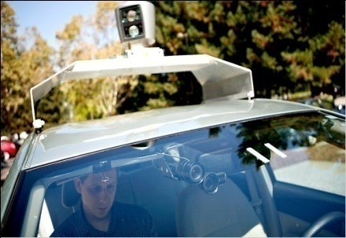

The LIDAR (Light detection and Ranging) sensor is a scanner. It will rotate in the circle. It is fixed on the top of the car. In the scanner contains the 64 lasers that are send surroundings of the car through the air. These the laser is hits objects around the car and again comes back to it. By these known How far that objects are from the car and also it calculates the time to reach that object. These are can see in monitor in a 3D object with the map. The monitor is fixed in front seat. “The heart of the system generates a detailed 3D map of environment (velodyne 64- beam laser). The map accessed from the GPRS connection .

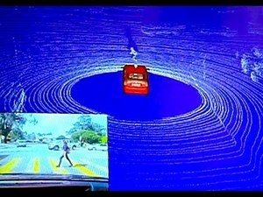
For example , that a person was crossing the road, the LIDAR sensor will reorganized by sending the lasers in to the air as waves and waves are disturbed these it identify as some object was crossing and by these the car will be slow down.
RADAR SENSOR:-
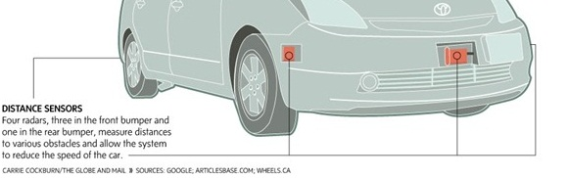
The three RADAR sensors were fixed in front of the bumper and one in the rear bumper. These will measures the distance to various obstacles and allow the system to reduce the speed of the car. The back side of sensor will locates the position of the car on the map.

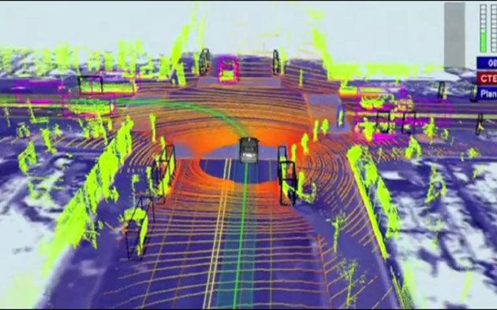

For example, when the car was travelling on the road then RADAR sensor was projected on road from front and back side of the car.

VIDEO CAMERA:-
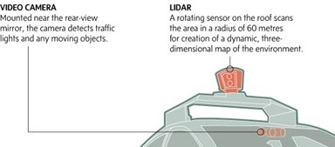
The video camera was fixed near the rear view mirror. That will detect traffic lights and any moving objects front of the car. For example if any vehicle or traffic detected then the car will be slow down automatically, these all will be done by the artificial intelligence software only.
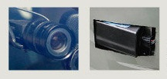
By that the computer will recognize moving obstacles like pedestrians and bicyclists.
POSTION ESTIMATOR:-
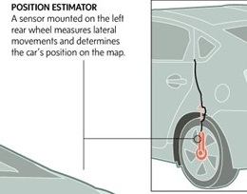
A sensor mounted on the left rear wheel. By these sensor only measures small movements made by the car and helps to accurately locate its position on the map. The position of the car can be seen on the monitor.

Advantages:-
*No accidents occurred by these car.
*Time will be saved in the traffic.
* In night time the car its can drive.
*The car itself park at the parking area.
*No license will be needed for driver because it is self driver.
Disadvantages:-
* The cost of car is high.
*By coming Google driverless car into the market so many taxi drivers can lose their jobs.
Conclusion:-
It is so useful for the humans when driving the car. By the Google driverless car can avoid the accidents on the roads and can reduce the traffic time at the traffic signals, can prevent the drinking driving on the roads. The car itself can driver at night times also. At the same time so many taxi drivers can lose their jobs.

