ABSTRACT :
From the invention of the car there is a great relation between human and car. Because by the invention of the car the automobile industry was established, by this car the traveling time from one place to another place is reduced. The car brings royalty from the invention. As cars are coming on roads at that time there are so many accidents are occurring due to lack of driving knowledge & drink driving and soon, In that view only the Google took a great project, i.e. Google Driverless Car in these the Google puts the technology in the car, that technology was Artificial Intelligence with Google map view. The input video camera was fixed beside the front mirror inside the car, A LIDAR sensor was fixed on the top of the vehicle, RADAR sensor on the front of the vehicle and a position sensor attached to one of the rear wheels that helps locate the cars position on the map, The Computer, Router, Switch, Fan, Inverter, rear Monitor, Topcon, Velodyne, Applanix and Battery are kept inside the car.
These all components are connected to computer’s CPU and the monitor is fixed on beside of the driver seat, these we can observe in that monitor and can operate all the operations.

INTRODUCTION :
The Google driverless car is a project by Google that involves developing technology for autonomous cars. The software powering Google's cars is called Google Chauffeur. Lettering on the side of each car identifies it as a "self-driving car". The project is currently being led by Google engineer Sebastian Thrun, director of the Stanford Artificial Intelligence Laboratory and co-inventor of Google Street View. Thrun's team at Stanford created the robotic vehicle Stanley which won the 2005 DARPA Grand Challenge and its US$2 million prize from the United States Department of Defense.The team developing the system consisted of 15 engineers working for Google, including Chris Urmson, Mike Montemerlo, and Anthony Levandowski who had worked on the Darpa challenge. The system combines information gathered from Google street view with artificial intelligence software that combines input from video camera inside the car, a LIDAR sensor on the top of the vehicle, RADAR sensors on the front of the vehicle and a position sensor attached to one of the rear wheel that helps to locate the car position on the map. At the same time some hardware components are used in the car these are APPIANIX PCS, VELODYNE, SWITCH,TOPCON, REAR MONITOR, COMPUTER, ROUTER, FAN, INVERTER and BATTERY along with some software program is installed in it. By all the components combined together to operate the car without the DRIVER. i.e., the car drives itself only.
HISTORY :
The Sebastian Thrun invented the Google driverless car. He was director of the Stanford Artificial Intelligence laboratory. Sebastian friends were killed in car accident, so that he decided there should not be any accidents on the road by car. By that decision only the Google Driverless car was invented.
”Our goal is to help prevent traffic accidents, free up people’s time and reduce carbon emission by fundamentally changing car use”-Sebastian Thrun The Google Driverless car was tested in the year 2010; Google has tested several vehicles equipped with the system, driving 1,609 kilometers (1,000 mi) without any human intervention, in addition to 225,308 kilometers (140,000 mi) with occasional human intervention. Google expects that the increased accuracy of its automated driving system could help reduce the number of traffic-related injuries and deaths, while using energy and space on roadways more efficiently. It was introduced in oct-2010 and it becomes legal in Nevada at June 2011, August 2012- Accident.
The project team has equipped a test fleet of at least eight vehicles, consisting of six Toyota Prius, an Audi TT, and a Lexus RX450h, each accompanied in the driver's seat by one of a dozen drivers with unblemished driving records and in the passenger seat by one of Google's engineers. The car has traversed San Francisco The project team has equipped a test fleet of at least eight vehicles, consisting of six Toyota Prius, an Audi TT, and a Lexus RX450h, each accompanied in the driver's seat by one of a dozen drivers with unblemished driving records and in the passenger seat by one of Google's engineers. The car has traversed San Francisco's Lombard Street, famed for its steep hairpin turns and through city traffic. The vehicles have driven over the Golden Gate Bridge and on the Pacific Coast Highway, and have circled Lake Tahoe. The system drives at the speed limit it has stored on its maps and maintains its distance from other vehicles using its system of sensors. The system provides an override that allows a human driver to take control of the car by stepping on the brake or turning the wheel, similar to cruise control systems already in cars.

OBJECTIVES :
- POSITION.
- REACH THE DESTINATION.
- CHOOSE THE SHORTEST PATH.
- AVOID OBSTACLES.
- FOLLOW THE TRAFFIC RULES.
- BREAKS.
- TURNING.

COMPONENTS :
Integrates Google Maps with various hardware sensors and artificial intelligence software.

HARDWARE SENSORS :
LIDAR :
The LIDAR (Light detection and Ranging) sensor is a scanner. It will rotate in the circle. It is fixed on the top of the car. In the scanner contains the 64 lasers that are send surroundings of the car through the air. These the laser is hits objects around the car and again comes back to it. By these known How far that objects are from the car and also it calculates the time to reach that object. These are can see in monitor in a 3D object with the map. The monitor is fixed in front seat. “The heart of the system generates a detailed 3D map of environment (velodyne 64- beam laser). The map accessed from the GPRS connection . For example , that a person was crossing the road, the LIDAR sensor will reorganized by sending the lasers in to the air as waves and waves are disturbed these it identify as some object was crossing and by these the car will be slow down.
LIDAR :
The three RADAR sensors were fixed in front of the bumper and one in the rear bumper. These will measures the distance to various obstacles and allow the system to reduce the speed of the car. The back side of sensor will locates the position of the car on the map.

The video camera was fixed near the rear view mirror. That will detect traffic lights and any moving objects front of the car. For example if any vehicle or traffic detected then the car will be slow down automatically, these all will be done by the artificial intelligence software only. For example, when the car was travelling on the road then RADAR sensor was projected on road from front and back side of the car. By that the computer will recognize moving obstacles like pedestrians and bicyclists

POSITION ESTIMATOR :
A sensor mounted on the left rear wheel. By these sensor only measures small movements made by the car and helps to accurately locate its position on the map. The position of the car can be seen on the monitor.
DISTANCE SENSOR :
Allow the car to see far enough to detect nearby or upcoming cars or obstacles.

GOOGLE MAPS :
Google Maps is a Web-based service that provides detailed information about geographical regions and sites around the world. In addition to conventional road maps, Google Maps offers aerial and satellite views of many places. In some cities, Google Maps offers street views comprising photographs taken from vehicles.
Google Maps offers several services as part of the larger Web application, as follows.
- A route planner offers directions for drivers, bikers, walkers, and users of public transportation who want to take a trip from one specific location to another.
- The Google Maps application program interface (API) makes it possible for Web siteadministrators to embed Google Maps into a proprietary site such as a real estate guide or community service page.
- Google Maps for Mobile offers a location service for motorists that utilizes the Global Positioning System (GPS) location of the mobile device (if available) along with data fromwireless and cellular networks.
- Google Street View enables users to view and navigate through horizontal and vertical panoramic street level images of various cities around the world.
- Supplemental services offer images of the moon, Mars, and the heavens for hobby astronomers.

It interacts with the GPS and acts like a database.
- Speed limits.
- Upcoming directions.
- Traffic report.
- Nearby collision.
- Directions.

ARTIFICIAL INTELLIGENCE :
Google Maps and the hardware sensors data are sent to the Al
Al then determines :
1. how fast to accelerate.
2. when to slow down/stop.
3. when to steer the wheel.
The agent’s goal is to take the passenger to its desired destination safely and legally.

WORKING :
- The “driver” sets a destination. The car’s software calculates a route and starts the car on its way.
- A rotating, roof-mounted LIDAR (Light Detection and Ranging - a technology similar toradar) sensor monitors a 60-meter range around the car and creates a dynamic 3-D mapof the car’s current environment.
- A sensor on the left rear wheel monitors sideways movement to detect the car’s position relative to the 3-D map.
- Radar systems in the front and rear bumpers calculate distances to obstacles.
- Artificial intelligence (AI) software in the car is connected to all the sensors and has input from Google Street View and video cameras inside the car.
- The AI simulates human perceptual and decision-making processes and controls actions in driver-control systems such as steering and brakes.
- The car’s software consults Google Maps for advance notice of things like landmarks and traffic signs and lights.
- An override function is available to allow a human to take control of the vehicle.
Proponents of systems based on driverless cars say they would eliminate accidents caused by driver error, which is currently the cause of almost all traffic accidents. Furthermore, the greater precision of an automatic system could improve traffic flow, dramatically increase highway capacity and reduce or eliminate traffic jams. Finally, the systems would allow commuters to do other things while traveling, such as working, reading or sleeping.

Once a secret project, Google's autonomous vehicles are now out in the open, quite literally, with the company test-driving them on public roads and, on one occasion, even inviting people to ride inside one of the robot cars as it raced around a closed course.
Google's fleet of robotic Toyota Priuses has now logged more than 190,000 miles (about 300,000 kilometers), driving in city traffic, busy highways, and mountainous roads with only occasional human intervention. The project is still far from becoming commercially viable, but Google has set up a demonstration system on its campus, using driverless golf carts, which points to how the technology could change transportation even in the near future.
Stanford University professor Sebastian Thrun, who guides the project, and Google engineer Chris Urmson discussed these and other details in a keynote speech at the IEEE International Conference on Intelligent Robots and Systems in San Francisco last month.
Thrun and Urmson explained how the car works and showed videos of the road tests, including footage of what the on-board computer "sees" [image below] and how it detects other vehicles, pedestrians, and traffic lights.

Urmson, who is the tech lead for the project, said that the "heart of our system" is a laser range finder mounted on the roof of the car. The device, a Velodyne 64-beam laser, generates a detailed 3D map of the environment. The car then combines the laser measurements with high-resolution maps of the world, producing different types of data models that allow it to drive itself while avoiding obstacles and respecting traffic laws.
The vehicle also carries other sensors, which include: four radars, mounted on the front and rear bumpers, that allow the car to "see" far enough to be able to deal with fast traffic on freeways; a camera, positioned near the rear-view mirror, that detects traffic lights; and a GPS, inertial measurement unit, and wheel encoder, that determine the vehicle's location and keep track of its movements.
Here's a slide showing the different subsystems (the camera is not shown):

Two things seem particularly interesting about Google's approach. First, it relies on very detailed maps of the roads and terrain, something that Urmson said is essential to determine accurately where the car is. Using GPS-based techniques alone, he said, the location could be off by several meters.
The second thing is that, before sending the self-driving car on a road test, Google engineers drive along the route one or more times to gather data about the environment. When it's the autonomous vehicle's turn to drive itself, it compares the data it is acquiring to the previously recorded data, an approach that is useful to differentiate pedestrians from stationary objects like poles and mailboxes.
The video above shows the results. At one point you can see the car stopping at an intersection. After the light turns green, the car starts a left turn, but there are pedestrians crossing. No problem: It yields to the pedestrians, and even to a guy who decides to cross at the last minute.
Sometimes, however, the car has to be more "aggressive." When going through a four-way intersection, for example, it yields to other vehicles based on road rules; but if other cars don't reciprocate, it advances a bit to show to the other drivers its intention. Without programming that kind of behavior, Urmson said, it would be impossible for the robot car to drive in the real world.
Clearly, the Google engineers are having a lot of fun (fast forward to 13:00 to see Urmson smiling broadly as the car speeds through Google's parking lot, the tires squealing at every turn).
But the project has a serious side. Thrun and his Google colleagues, including co-founders Larry Page and Sergey Brin, are convinced that smarter vehicles could help make transportation safer and more efficient: Cars would drive closer to each other, making better use of the 80 percent to 90 percent of empty space on roads, and also form speedy convoys on freeways.
They would react faster than humans to avoid accidents, potentially saving thousands of lives. Making vehicles smarter will require lots of computing power and data, and that's why it makes sense for Google to back the project, Thrun said in his keynote.
Urmson described another scenario they envision: Vehicles would become a shared resource, a service that people would use when needed. You'd just tap on your smartphone, and an autonomous car would show up where you are, ready to drive you anywhere. You'd just sit and relax or do work.
He said they put together a video showing a concept called Caddy Beta that demonstrates the idea of shared vehicles -- in this case, a fleet of autonomous golf carts. He said the golf carts are much simpler than the Priuses in terms of on-board sensors and computers. In fact, the carts communicate with sensors in the environment to determined their location and "see" the incoming traffic. "This is one way we see in the future this technology can . . . actually make transportation better, make it more efficient," Urmson said.

SPECIAL FEATURES :
TRAFFIC LIGHT ASSISTANCE :
A device known as actinometer is used to detect the intensity of radiations.
Now comes the real game :
If red or yellow colour the device stops the car
If green the device asks the car to move.
Before taking a ride in Audi's impressive Piloted Driving A7, we took a short spin up and down the Las Vegas strip to check out a smaller, but intriguing piece of Audi driver assistance technology called Traffic Light Assist that promises to help drivers make every green light.

Using both live and predictive data beamed into the vehicle's navigation unit via onboard wifi, TLA doesn't need a single camera to tell you when the light is going to change. Local data sources provide information about traffic light patters, and the in car system uses that data and the motion of the car to predict exactly how long it'll be until the green light goes red.

In practice, the system shows a traffic light icon in the central display (a head-up display would be a nice option), along with a countdown timer that reads the number of seconds before a light changes from red to green. Additionally, the system corrects (nearly instantly in our demo) for changing lanes and resultant changing signals; changing a straight-through traffic lane to a left-turn lane and signal, for instance.

What's more, the stop/start system is integrated with the new software, as well, restarting the engine with a few seconds to go before the light in front of you changes to green. Pretty slick.

Audi set up a trial of the system in a A6 sedan around the Las Vegas Strip, and it worked pretty flawlessly for us. The only time it was tripped up was when we pulled off into a casino driveway to change drivers; here the navigation system still placed us on the neighboring road. Of course, this is an issue that crops up with navigation systems themselves, too, not specific to Traffic Light Assist.

Audi has been testing the new technology in Ingolstadt and Berlin in Germany, as well as in Verona, Italy, in addition to the test it set up in Vegas for the purposes of CES. The good news is that, even in this beta form, the implementation of the software was as simple as patching in to the existing A6 CPU. Implementation of Traffic Light Assist on a consumer level would have more to do with getting the proper streams of traffic signal data from cities across the world rather than a problem with installing it in each car. They're working on it.

PARKING ASSISTANCE :
Technology[edit]
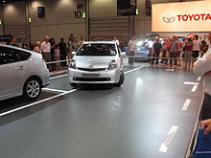
Demonstration of the parallel parking system on a Toyota Prius.
The IPAS/APGS use computer processors which are tied to the vehicle's (sonar warning system) feature, backup camera, and two additional forward sensors on the front side fenders. The sonar park sensors, known as "Intuitive Parking Assist" or "Lexus Park Assist", includes multiple sensors on the forward and rear bumpers which detect obstacles, allowing the vehicle to sound warnings and calculate optimum steering angles during regular parking.[5] These sensors plus the two additional parking sensors are tied to a central computer processor, which in turn is integrated with the backup camera system to provide the driver parking information.[6]
When the sonar park sensors feature is used, the processor(s) calculate steering angle data which are displayed on the navigation/camera touchscreen along with obstacle information. The Intelligent Parking Assist System expands on this capability and is accessible when the vehicle is shifted to reverse (which automatically activates the backup camera). When in reverse, the backup camera screen features parking buttons which can be used to activate automated parking procedures. When the Intelligent Parking Assist System is activated, the central processor calculates the optimum parallel or reverse park steering angles and then interfaces with the Electric Power Steering systems of the vehicle to guide the car into the parking spot.[6]
Functions[edit]
Newer versions of the system allow parallel or reverse parking.[7] When parallel parking with the system, drivers first pull up alongside the parking space. They move forward until the vehicle's rear bumper passes the rear wheel of the car parked in front of the open space. Then, shifting to reverse automatically activates the backup camera system, and the car's rear view appears on dash navigation/camera display.[7] The driver's selection of the parallel park guidance button on the navigation/camera touchscreen causes a grid to appear (with green or red lines, a flag symbol representing the corner of the parking spot, and adjustment arrows).[8]
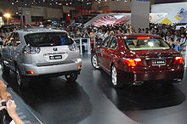
Demonstration of the automatic parking system on a Lexus LS.
The driver is responsible for checking to see if the representative box on the screen correctly identifies the parking space; if the space is large enough to park, the box will be green in color; if the box is incorrectly placed, or lined in red, using the arrow buttons moves the box until it turns green.[8] Once the parking space is correctly identified, the driver presses OK and take his/her hands off the steering wheel, while keeping the foot on the brake pedal. When the driver slowly releases the brake, while keeping the foot on the brake pedal, the car will then begin to back up and steer itself into the parking space.[7]
The reverse parking procedure is virtually identical to the parallel parking procedure.[7] The driver approaches the parking space, moving forward and turning, positioning the car in place for backing into the reverse parking spot. The vehicle rear has to be facing the reverse parking spot, allowing the backup camera to 'see' the parking area. Shifting to reverse automatically activates the backup camera system, and the driver selects the reverse park guidance button on the navigation/camera touchscreen (the grid appears with green or red lines, a flag symbol representing the corner of the parking spot, and adjustment arrows; reverse parking adds rotation selection).[7] After checking the parking space and engaging the reverse park procedure, the same exact parking process occurs as the car reverse parks into the spot.
The system is set up so that at any time the steering wheel is touched or the brake firmly pressed, the automatic parking will disengage.[7] The vehicle also cannot exceed a set speed, or the system will deactivate.[7] When the car's computer voice issues the statement "The guidance is finished", the system has finished parking the car. The driver can then shift to drive and make adjustments in the space iParking sonar uses ultrasonic (usually) or electromagnetic sensors in the back and sometimes front of the car to judge how close you are to objects nearby. Sometimes the sensors are part of the blind spot detection and cross traffic alert (see below) systems. They work like sonar in a U-boat movie: the sensor sounds a ping when it first senses an obstacle and the pings get more frequent, becoming a solid tone at about a foot away. You can have parking sonar (also park distance control, park assist, or Parktronic) without blind spot detection.f necessary.
An automated parking system that requires the driver to do nothing more than just sit back and watch the car steer itself into the best suited parking position

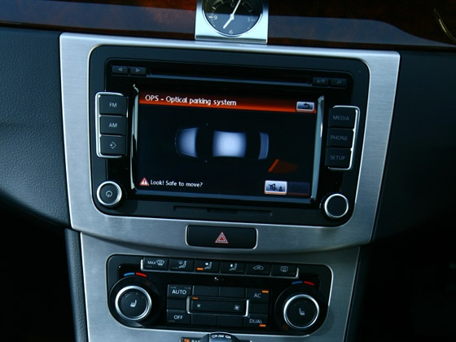

Park Assist System though a recent phenomenon in India, is expected to soon become a standard feature in most upper segment compact sedans and SUV’s. The systems is basically aided by three critical components, which are the ultrasonic sensors, a rear view camera and an Intelligent Parking System that ultimately gauges and decides the angle of steering and movement to put your car in the right slot.

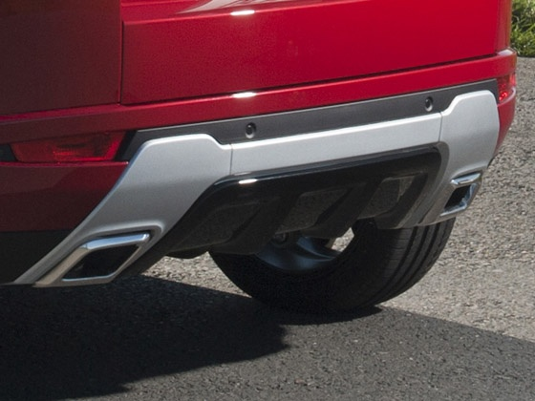

Parking Sensors The first step in achieving the Park Assist function, automobiles using this function come with ultrasonic sensors that are fitted in the front, side and (sometimes) the rear of the vehicle. These ultrasonic sensors gauge the exact length and breadth of a parking slot as you drive past a parking zone, and informs you when you have passed a suitable parking space that is wide and long enough to fit the dimensions of your car.

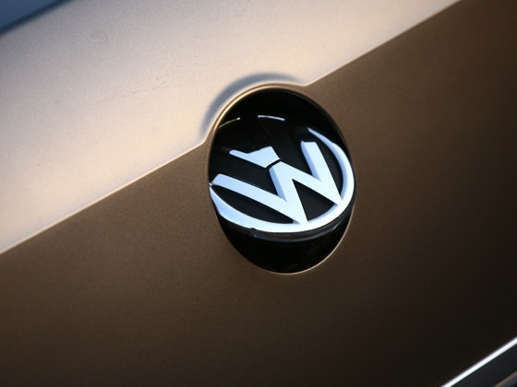

Backup Camera Once the car has found a suitable parking slot, all the driver is required is move forward and then bring the vehicle to a standstill. He then has to switch to reverse gear, and just let go of the steering wheel. The system will then take over the wheel and begin to self maneuver the car using its rear view camera to adjust the track overlay, which you can observe on the screen fitted on your cars entertainment console area.

Intelligent Park Assist System A combination of the cars sensors and the back up camera allows the onboard computer to adjust the angle of traction and speed depending on the proximity of nearby vehicles, so as to maneuver your vehicle perfectly in order to make it fit into the limited parking space available. One the car has been brought into position, the Intelligent Park Assist System will inform the driver that the parking operation has been executed successfully, and that you are free to take over control or kill the engine and simply walk out.

SPEED CONTROL :
Cruise control is a system that automatically controls the speed of an automobile. The driver sets the speed and the system takes over the throttle of the car to maintain the speed. The system thereby improves driver comfort in steady traffic conditions. In congested traffic conditions, where speeds vary widely, these systems are no longer effective. Most cruise control systems do not allow the use of cruise control below a certain speed.
In modern designs, the cruise control may need to be turned on before use — in some designs it is always "on" but not always enabled (not very common), others have a separate "on/off" switch, while still others just have an "on" switch that must be pressed after the vehicle has been started. Most designs have buttons for "set", "resume", "accelerate", and "coast" functions. Some also have a "cancel" button. Alternatively, depressing the brake or clutch pedal will disable the system so the driver can change the speed without resistance from the system. The system is operated with controls easily within the driver's reach, usually with two or more buttons on the steering wheel spokes or on the edge of the hub like those on Honda vehicles, on the turn signal stalk like in many older General Motors vehicles or on a dedicated stalk like those found in some Toyota, Mercedes-Benz and Lexus vehicles. Earlier designs used a dial to set speed choice.
The driver must bring the vehicle up to speed manually and use a button to set the cruise control to the current speed. The cruise control takes its speed signal from a rotating driveshaft, speedometer cable, wheel speed sensor from the engine's RPM, or from internal speed pulses produced electronically by the vehicle. Most systems do not allow the use of the cruise control below a certain speed (normally around 40 km/h (25 mph)). The vehicle will maintain the desired speed by pulling the throttle cable with a solenoid, a vacuum driven servomechanism, or by using the electronic systems built into the vehicle (fully electronic) if it uses a 'drive-by-wire' system.
All cruise control systems must be capable of being turned off both explicitly and automatically when the driver depresses the brake, and often also the clutch. Cruise control often includes a memory feature to resume the set speed after braking, and a coast feature to reduce the set speed without braking. When the cruise control is engaged, the throttle can still be used to accelerate the car, but once the pedal is released the car will then slow down until it reaches the previously set speed.
On the latest vehicles fitted with electronic throttle control, cruise control can be easily integrated into the vehicle's engine management system. Modern "adaptive" systems (see below) include the ability to automatically reduce speed when the distance to a car in front, or the speed limit, decreases. This is an advantage for those driving in unfamiliar areas.
The cruise control systems of some vehicles incorporate a "speed limiter" function, which will not allow the vehicle to accelerate beyond a pre-set maximum; this can usually be overridden by fully depressing the accelerator pedal. (Most systems will prevent the vehicle accelerating beyond the chosen speed, but will not apply the brakes in the event of overspeeding downhill.)
On vehicles with a manual transmission, cruise control is less flexible because the act of depressing the clutch pedal and shifting gears usually disengages the cruise control. The "resume" feature has to be used each time after selecting the new gear and releasing the clutch. Therefore cruise control is of most benefit at motorway/highway speeds when top gear is used virtually all the time.

LANE WARNING DEPARTURE SYSTEM :

Lane warning/keeping systems are based on:
- Video sensors in the visual domain (mounted behind the windshield, typically integrated beside the rear mirror)
- Laser sensors (mounted on the front of the vehicle)
- Infrared sensors (mounted either behind the windshield or under the vehicle)[2]

There are two main types of systems:
- Systems which warn the driver (lane departure warning, LDW) if the vehicle is leaving its lane (visual, audible, and/or vibration warnings)
- Systems which warn the driver and, if no action is taken, automatically take steps to ensure the vehicle stays in its lane (lane keeping system, LKS)
The first production lane departure warning system in Europe was developed by the United States company Iteris for Mercedes Actros commercial trucks. The system debuted in 2000, and is now available on most trucks sold in Europe.[citation needed]
In 2002, the Iteris system became available on Freightliner Trucks' North American vehicles. In both these systems, the driver is warned of unintentional lane departures by an audible rumble strip sound generated on the side of the vehicle drifting out of the lane. No warnings are generated if, before crossing the lane, an active turn signal is given by the driver.[citation needed] In road-transport terminology, a lane departure warning system is a mechanism designed to warn a driver when the vehicle begins to move out of its lane (unless a turn signal is on in that direction) on freeways and arterial roads. These systems are designed to minimize accidents by addressing the main causes of collisions: driver error, distractions and drowsiness. In 2009 the U.S. National Highway Traffic Safety Administration (NHTSA) began studying whether to mandate lane departure warning systems and frontal collision warning systems on automobiles.[1]

What is lane departure warning, and how does it work?
- By Bill Howard on September 3, 2013 at 9:52 am11 Comments
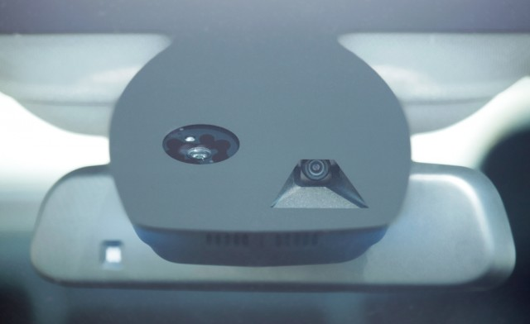
dollars. It could save you thousands in crash repairs. The camera plus processing software watch how close you are to road surface markings. It alerts you when you’re about to drift across, but only if your turn signal isn’t on. Lane departure warning has emerged as a key tool for driver safety. The technology has evolved over the last few years to lane keep assist where the car automatically corrects course if it reaches the lane markings, and now a higher level of lane keep assist that automatically keeps the car centered on the road. The corrections are subtle and the driver can always override the car and turn the wheel manually.
Lane departure warning is part of the so-called circle of safety: adaptive cruise control pacing you against the car in front, lane departure warning or lane keep assist watching ahead and to the side, blind spot detection watching for cars coming up in adjacent lanes, and rear parking sonar and a camera behind (sometimes on all four sides) watching behind when you’re backing up. Lane departure warning/lane keep assist is so good now, the best systems could keep you centered for miles and miles. It’s really a self-driving car at that point. All of them cut out after a few seconds if they detect no hands on the steering wheel.
ght.

Less often, the lane departure warning technology is a set of laser or infrared sensors. Occasionally, the automaker uses a rear-facing camera to watch the lane markings behind the car, as on the Nissan Altima. That seems counterintuitive and possibly slower in adapting to a curved road ahead. Not so, say autom
Ads by Google

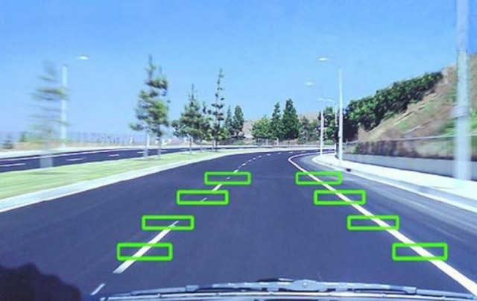
How it works: windshield camera tracks lane markings
The most common LDW system is a camera mounted high up in the windshield (photo above), often as part of the rear view mirror mounting block. It captures a moving view of the road ahead. The digitized image is parsed for straight or dashed lines — the lane markings. As the driver, you’re supposed to center the car between the two lines. As the car deviates and approaches or reaches the lane marking, the driver gets a warning: a visual alert plus either an audible tone, a vibration in the steering wheel, or a vibration in the seat. If the turn signal is on, the car assumes the driver is intentionally crossing over the lane, and there’s no alert. That’s lane departure warning.
Then there’s lane keep assist. When the car reaches the lane marking, the car nudges itself away from the marker, sort of like bouncing off the walls in Pac-Man. Sometimes the steering change is effected by braking the opposite front wheel and the car pivots back into the lane. The car can also move you back by turning the steering wheel. In either case, the driver can easily overcome the car’s intentions by turning the wheel. It doesn’t require superhuman efforts. If you read a story about a car that fought the driver for control of the wheel, it’s either urban legend and untrue, or someone pretty clever has developed an amazing hack (hasn’t happened yet) and we’re in bigger trouble than we thou

DARPA URBAN CHALLENGE :

What is the Urban Challenge?
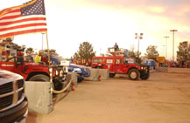
The DARPA Urban Challenge is an autonomous vehicle research and development program with the goal of developing technology that will keep warfighters off the battlefield and out of harm’s way. The Urban Challenge features autonomous ground vehicles maneuvering in a mock city environment, executing simulated military supply missions while merging into moving traffic, navigating traffic circles, negotiating busy intersections, and avoiding obstacles. The program is conducted as a series of qualification steps leading to a competitive final event, scheduled to take place on November 3, 2007, in Victorville, California. DARPA is offering $2M for the fastest qualifying vehicle, and $1M and $500,000 for second and third place. This program is an outgrowth of two previous DARPA Grand Challenge autonomous vehicle competitions. The first Grand Challenge event was held in March 2004 and featured a 142-mile desert course. Fifteen autonomous ground vehicles attempted the course and no vehicle finished. In the 2005 Grand Challenge, four autonomous vehicles successfully completed a 132-mile desert route under the required 10-hour limit, and DARPA awarded a $2 million prize to “Stanley” from Stanford University.

History and background[edit]
See also: History of driverless cars
Fully autonomous vehicles have been an international pursuit for many years, from endeavors in Japan (starting in 1977), Germany (Ernst Dickmanns and VaMP), Italy (the ARGO Project), the European Union (EUREKA Prometheus Project), the United States of America, and other countries.
The Grand Challenge was the first long distance competition for driverless cars in the world; other research efforts in the field of Driverless cars take a more traditional commercial or academic approach. The U.S. Congress authorized DARPA to offer prize money ($1 million) for the first Grand Challenge to facilitate robotic development, with the ultimate goal of making one-third of ground military forces autonomous by 2015. Following the 2004 event, Dr. Tony Tether, the director of DARPA, announced that the prize money had been increased to $2 million for the next event, which was claimed on October 9, 2005. The first, second and third places in the 2007 Urban Challenge received $2 million, $1 million, and $500,000, respectively.
The competition was open to teams and organizations from around the world, as long as there were at least one U.S. citizen on the roster. Teams have participated from high schools, universities, businesses and other organizations. More than 100 teams registered in the first year, bringing a wide variety of technological skills to the race. In the second year, 195 teams from 36 U.S. states and 4 foreign countries entered the race.
Road testing
The project team has equipped a test group of at least ten cars, consisting of six Toyota Prius, an Audi TT, and three Lexus RX450h each accompanied in the driver's seat by one of a dozen drivers with unblemished driving records and in the passenger seat by one of Google's engineers. The car has traversed San Francisco's Lombard Street, famed for its steep hairpin turns and through city traffic. The vehicles have driven over the Golden Gate Bridge and around Lake Tahoe. The system drives at the speed limit it has stored on its maps and maintains its distance from other vehicles using its system of sensors. The system provides an override that allows a human driver to take control of the car by stepping on the brake or turning the wheel, similar to cruise control systems already found in many cars today.
On March 28, 2012, Google posted a YouTube video showing Steve Mahan, a Morgan Hill California resident, being taken on a ride in its self-driving Toyota Prius. In the video, Mahan states "Ninety-five percent of my vision is gone, I'm well past legally blind". In the description of the YouTube video, it is noted that the carefully programmed route takes him from his home to a drive-through restaurant, then to the dry cleaning shop, and finally back home.
In August 2012, the team announced that they have completed over 300,000 autonomous-driving miles (500 000 km) accident-free, typically have about a dozen cars on the road at any given time, and are starting to test them with single drivers instead of in pairs. Four U.S. states have passed laws permitting autonomous cars as of December 2013: Nevada, Florida, California, and Michigan. A law proposed in Texas would establish criteria for allowing "autonomous motor vehicles".

Incidents
In August 2011, a human-controlled Google driverless car was involved in a crash near Google headquarters in Mountain View, CA. Google has stated that the car was being driven manually at the time of the accident. A previous incident involved a Google driverless car being rear-ended while stopped at a traffic light. Google says that neither of these incidents were the fault of Google's car but the fault of other humans operating the car.
Advantages:-
*No accidents occurred by these car.
*Time will be saved in the traffic.
* In night time the car its can drive.
*The car itself park at the parking area.
*No license will be needed for driver because it is self driver.
Disadvantages:-
* The cost of car is high.
*By coming Google driverless car into the market so many taxi drivers can lose their jobs.
Conclusion:-
It is so useful for the humans when driving the car. By the Google driverless car can avoid the accidents on the roads and can reduce the traffic time at the traffic signals, can prevent the drinking driving on the roads. The car itself can driver at night times also. At the same time so many taxi drivers can lose their jobs.

‘

