STUDIES ON CHARACTERIZATION OF CACO₃ PRECIPITATION
IN BACTERIAL CEMENT MORTAR

M V Seshagiri Rao¹, V Srinivasa Reddy², Ch Sasikala³

¹Department of Civil Engineering, JNTUH College of Engineering, Hyderabad-85
²Department of Civil Engineering, GRIET, Hyderabad-90
³Centre for Environment, JNTU, Hyderabad-85

ABSTRACT: Cement mortar durability is the function of its internal pore structure and distribution, porosity and its permeation properties. Research has shown that some specific bacterial species isolated from soil can tolerate harsh and challenging alkaline environment and can be used in remediating cracks in cement mortar structures. This state-of-the-art microbial based crack healing mechanism is one such phenomenon on which studies were carried out to investigate the role of calcite mineral precipitation in improvement of durability in bacteria integrated cement mortar. The primary goal of this study is to explore the potential of biomineralization, in particular, microbial calcium carbonate deposition in cement mortar, to develop sustainable construction materials. The idea has lead to the conception of energy efficient and sustainable construction material called ‘Bacterial Cement mortar’. This paper primarily focuses on the studies related to the characterization of bacteria produced calcium carbonate crystals using various nanocharacterization techniques such as Scanning Electron Microscope (SEM), X-ray diffraction (XRD), and Thermo gravimetric analysis (TGA) to validate that cracks/pores were sealed up by calcite crystals grown due to complex metabolic mechanism of nitrogen cycle by Bacillus subtilis JC3.
Keywords: bacterial cement mortar, Bacillus subtilis, Scanning Electron microscope (SEM), X-ray diffraction (XRD), Thermo gravimetric analysis (TGA).

INTRODUCTION

Cement mortar is a quasi brittle material which is susceptible to cracking. Maintenance of cement mortar structures is costly and labor intensive. Furthermore, delay between the initiation of damage and repair often increases the severity of damage. Thus research has been undertaken worldwide to develop a smart sustainable infrastructure material in
which cracks are healed at their occurrence. Recent developments related to this self healing phenomenon include application of adhesive filled glass fibers in cement mortar, use of fly ash in cement mortar that can heal shrinkage cracks, rewetting of cement mortar to recover freeze-thaw damage etc. Self-healing of cracks will increase service life and reduce life cycle cost and energy consumption. The application of cement mortar is rapidly increasing worldwide and therefore the development of sustainable cement mortar is urgently needed for environmental reasons. Mechanisms that would contribute to a longer service life of cement mortar structures would make the material not only more durable but also more sustainable are required. One such mechanism that receives increasing attention in recent years is the ability for self-repair, i.e. the autonomous healing of cracks in cement mortar. In this study we investigated the potential of bacteria to act as self-healing agent in cement mortar, i.e. their ability to repair occurring cracks. A specific group of alkali-resistant spore-forming bacteria related to the genus Bacillus was selected for this purpose. Bacteria promote calcium carbonate precipitation in the form of calcite crystals due to its metabolic reactions. The formation of calcite (CaCO₃) by process of bio-mineralization can be analyzed using various characterization techniques/methods. The micro-structural observations could improve the understanding of the mechanism of self-healing phenomenon by calcifying bacteria. Microbial calcite precipitation was visualized by SEM, quantified by X-Ray Powder Diffraction (XRD) analysis and confirmed by TG/DTG Analysis.

BIOMIMETICS-BASED SUSTAINABLE CONSTRUCTION MATERIAL

Biomimetics is a field of science that studies biological processes for effectively using them in the development of innovative engineering materials and systems. This paper discusses about biomimetics in civil engineering and its application for the development of sustainable materials in the construction industry. This paper also discusses a new type of alkaliphilic aerobic microorganism belonging to Bacillus species, which when added to cement mortar, has shown to increase the strength of the cement mortar. This is due to growth of filler material within the pores of the cement–sand matrix. Thus, there is ample scope for development of biomimetics-based sustainable construction materials. Biomimetic approaches have considerable potential in the development of new high-performance materials with low environmental impact. Biomimicry innovation methods can help us to create products and processes that are sustainable, perform well, save energy, reduce materials cost, and redefine and eliminate waste and subsequent environmental degradation. In the present scenario in a country like India, where infrastructure development is one of the deciding factors for economical and social development, the production process, use of resources and means of efficient disposal of waste should be looked up critically. Cement production is a highly energy-intensive process. Energy consumption by the cement industry is estimated at about 2% of the global primary energy consumption, or almost 5% of the total global industrial energy consumption. Due to the dominant use of carbon intensive fuel, e.g. coal, in clinker-making, the cement industry is also a major emitter of CO₂. By increasing the strength of the cement mortar by using microorganisms will result in structural member of reduced dimensions and will also help to produce relatively leaner cement mortar mix. Hence there is considerable reduction in the usage of cement. This will lead to reduction of CO₂ emission and result in a green environment. Biomimetics-based construction materials can be thought of as less energy-consuming materials to improve the strength of cement mortar which will have low environmental impact and help reduce the carbon footprint of the cement industry. The general ideas of biomimetics which can be used for cement mortar are bio-deposition and biomineralization, which are the natural biological processes of certain species of microorganisms such as bacteria. Though cement mortar is quite strong mechanically, it suffers from several drawbacks such as low tensile strength, permeability to liquids and gases, the consequence of which are corrosion of reinforcement, susceptibility to chemical attack and low durability. Cracking of cement mortar is a common phenomenon. There are a large number of products available commercially for repairing cement mortar: structural epoxy, resins, epoxy mortar and other synthetic mixtures. Currently, these types of synthetic filler agents are extensively used in cement mortar crack repair. Because cracks in cement mortar structures continue
over time, the remedy should be applied repeatedly as and when the crack limit is exceeded. Moreover, several of these products are inorganic coatings. The air-polluting effect of these compounds during manufacturing and coating has led to the development of new formulations such as organic coating materials. Due to the above limitations, the use of biomimetics as an alternative for improvement of strength and durability was studied. The idea is to use microorganisms for bio-deposition of available minerals inside the cement mortar. It is a widespread, complex phenomenon by which organisms form minerals, occurring in various geothermal systems. Bacillus species are able to precipitate calcium carbonate (CaCO₃) in a calcium-rich environment. The CaCO₃ so produced can improve the strength and reduces porosity, hence both the strength and durability of cement mortar is increased.

CHARACTERIZATION OF CACO₃ PRECIPITATION

- Optimum bacterial cell concentration for CaCO₃ Precipitation
This investigation was carried out primarily to understand the effect of bacterial cell concentration on the quantity of calcium carbonate precipitation. The appropriate bacterial cell concentration for maximum calcium carbonate precipitation can be established by determining the 28 day compressive strengths of various cement-mortar specimens induced with different bacterial cell concentrations. The sample whose 28 day compressive strength was highest determines the optimum cell concentration for high amount of crystalline calcite precipitation. Different cell concentrations were derived from the bacterial growth culture by serial dilution method. Standard Cement-mortar cubes incorporated with soil bacteria Bacillus subtilis JC3 of different cell concentrations were cast, cured for 28 days and tested for the compressive strength. The maximum percentage increase is found to be 17.88 % for 10⁵ bacterial cells induced specimens. This improvement in compressive strength was mainly due to metabolic deposition of CaCO₃ in the voids /or pores within cement–sand matrix modifying the pore structure of bacteria induced cement mortar specimens. During bacterial growth, the calcium precipitation process occurs continuously, clogging the internal pores with calcium precipitate. The gradual reduction of compressive strength of cement mortar cube specimens induced with bacterial cell concentrations more than 10⁵ cells per ml of mixing water is attributed to the disruption of cement-mortar matrix integrity by the presence of organic matter (biomass) above the permissible limits as specified by IS 456. Therefore, Bacillus subtilis JC3 cell concentration of 10⁵ cells/ml of mixing water generates the greatest reduction in porosity by precipitating calcite crystals optimally. Reduction in pores due to such material precipitation (calcium carbonate) will eventually increase the cement mortar strength.

FIG 1: Compressive Strengths at various Bacteria Cell Concentrations

FIG 2: Percentage Increase of Compressive Strengths at various
Bacteria Cell Concentrations
- Scanning Electron Microscope (SEM) Analysis

The test is to confirm the presence of bacteria precipitated calcite by generating high resolution images of bacteria induced cement mortar samples and shows spatial variations in chemical compositions. Scanning Electron Microscope (SEM) analysis is made on the samples of 28 day old bacterial cement mortar specimens and control mortar specimens (without bacteria). Broken pieces of 28 day old cement mortar cubes from the compression test were examined under a SEM Hitachi- S520 using accelerating voltages ranging from 1to 30 KV in the research centre at CSIR- Indian Institute of Chemical Technology. Fig 3 (a) and (b) shows SEM scanning images of control cement mortar sample and bacteria induced cement mortar sample. Improvement in pore structure of cement-sand mortar samples treated with Bacillus subtilis JC3 of 10⁵ cell concentration per ml can be observed in a magnified view (2500x) of SEM micrograph as shown in Fig 3 (b). The difference between these two scanning electron micrographs shows that the in case of sample from bacteria induced cement mortar, formation of dense CaCO₃ precipitation spreading over the pores present inside, with rod-shaped impressions housed by Bacillus subtilis JC3 can be observed. The morphology of the newly formed crystals of rhombohedra shape suggests that the mineral may be CaCO₃ and its formation could be the result of the metabolic conversion of the nutrients by Bacillus subtilis JC3. SEM examination shows that in a mortar made with a 10⁵/ml cell concentration, the pores are almost completely filled with narrow strands of filler (calcite) and modification of pore size distribution is noticed. In case of control sample no filler material was observed.

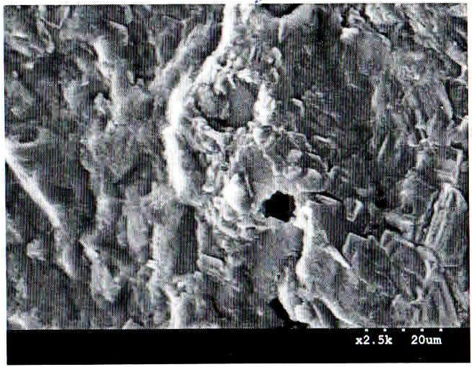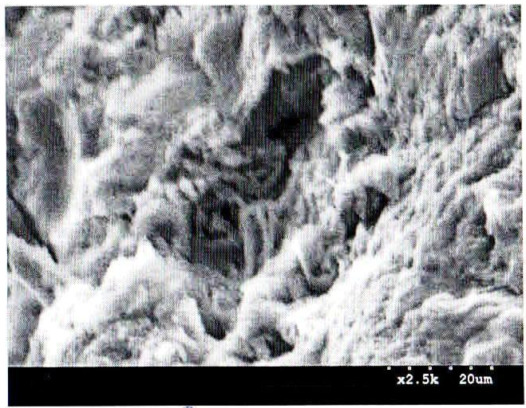

FIG 3 (a) Cell Concentration –Nil (b) Cell Concentration – 10⁵/ml
(Control Specimen) (Optimum)

- X-ray Diffraction (XRD) Analysis

X-Ray Powder Diffraction is a physico-chemical analysis method commonly used to determine the reticular plane distance and for the identification of crystalline compounds by their diffraction pattern. To identify the presence of CaCO₃ precipitation in bacteria induced samples, X-ray diffraction (XRD) analysis was conducted. This test characterizes the crystalline materials present in the given sample. The sample material should be grounded sufficiently fine so that it will pass through a 40 μm sieve. The quantity required is less than 10 gm which should be placed in the sample holder. The XRD Pattern was obtained by scanning from 2 to 80º 2θ using a vertical x-ray diffractometer. Powder diffraction patterns are typically plotted as the intensity of the diffracted X-rays vs. the angle 2θ. By measuring the 2θ values for each diffraction peak, we can calculate the d-spacing (the distance between the diffracting planes) for each diffraction peak. The data analysis software has a program for automatically calculating the d-spacings (reticular plane distance) for all of the peaks in the diffraction pattern. The constituents of the sample were identified by comparing d values of each diffraction peak against the mineral XRD database (standard JCPDS files) established by the Joint Committee on Powder Diffraction Standards (JCPDS)-International Centre for Diffraction Data (ICDD). Fig 4 depicts the profiles of XRD spectra of control and bacteria incorporated cement mortar samples. From the XRD spectrums for control mortar sample and the bacterial incorporated mortar sample, the principal calcite peaks can be observed at 26.82º. In the intensity mapping of the characteristic peaks of calcite, it is found that the higher calcite intensity peaks with reference to International Crystal Diffraction Database (ICDD) were formed for the bacterial incorporated specimen. This is an indication of presence of high percentage of calcite mineral in the bacteria incorporated specimen, which could be attributed to an formation of CaCO₃ due to microbial activities of bacteria Bacillus subtilis JC3. This high amount of calcite precipitation, thus results in significant higher compressive strength than the control mortar samples. In the XRD pattern Fig 4, for control cement mortar sample, the characteristic diffraction peak (100% intensity) occurred, at 2θ= 18.25º with reticular plane distance (d) value 3.342 (for quartz ) which indicates presence of the relatively high amount of quartz mineral when compared to other minerals present in the sample. It can also be noted that the presence of calcite in control mortar sample is due to formation of hydrated C-S-H gel. In case of bacteria incorporated sample XRD spectra Fig 4, the characteristic diffraction peak (100% intensity) occurred at 2θ= 26.82º with d value 3.035 (for Calcite) which confirms the presence of relatively high amount of calcite crystals when compared to other minerals present in the sample. This can be attributed to the copious deposition of CaCO₃ in bacteria induced samples by Bacillus subtilis JC3 during its microbial activity. So the presence of CaCO₃ was substantiated using X-Ray Diffraction (XRD) analysis.

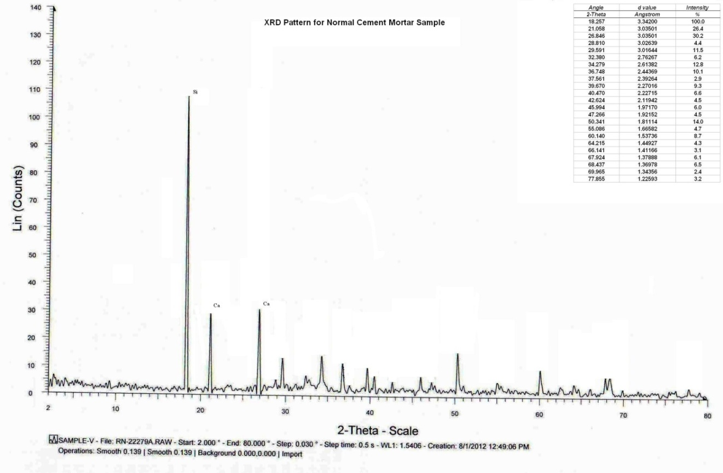
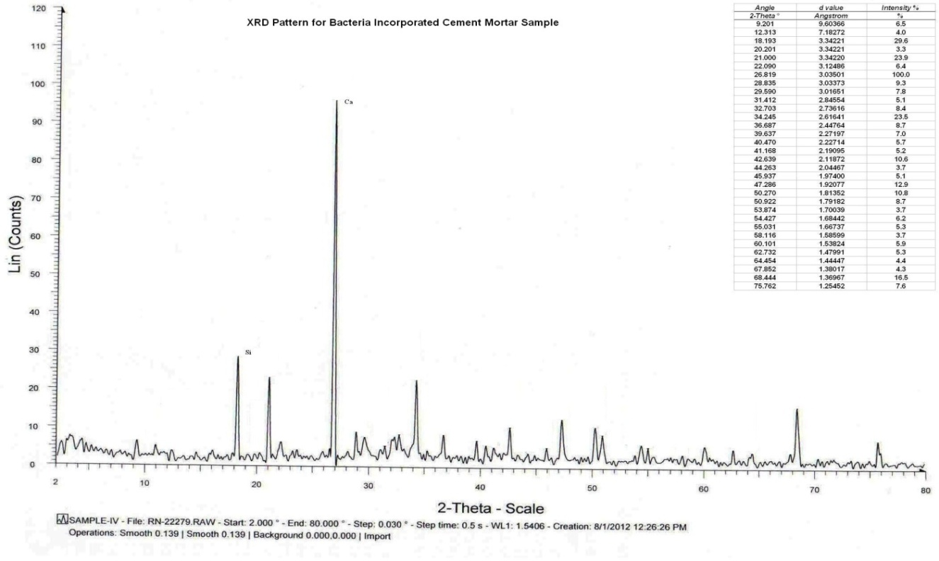

FIG 4: Diffractogram of bacteria incorporated mortar and cement mortar specimen shows the abundant presence of calcite (CaCO₃) precipitation
- Thermogravimetric (TG) Analysis

Thermogravimetric Analysis (TGA) is a technique to characterize materials by measuring the sample’s weight as it is heated or cooled in a furnace. This analysis is conducted to confirm the presence of calcite (CaCO₃) in bacteria induced samples by studying the properties of sample as they change with temperature.

FIG 5: TGA Results for cement mortar specimens with and without bacteria showing weight loss and Change in weight loss per ºC

Through performance of the TGA analysis, the presence of CaCO₃ in the repair material is determined. The descending TGA thermal curve indicates a weight loss occurred. When CaCO₃ crystals are present in the repair material, they will decompose into CaO and CO₂ upon heating (CaCO₃ → CaO + CO₂). When TGA analysis is performed on powdered bacteria incorporated cement mortar sample, extreme loss of weight is observed at temperature range of 500–700°C. This is ascribed to CaCO₃ decomposition around that temperature interval. These results provide evidence that particularly in the case of bacteria incorporated specimens; amount of CaCO₃ crystals present is high due to biomineralization by Bacillus subtilis JC3. So it can be inferred that the behavior of both control specimens and bacteria incorporated specimens are identical when subjected to elevated temperatures. So these results provide evidence that the effect of bacteria on the properties of cementitious materials is neutralized at temperatures higher than 500°C.

- Bacteria Viability Test

A piece of bacterial cement mortar of 365 days age was inoculated in nutrients broth and kept in orbital shaker for 24 hrs. After 24h incubation, a loop full of culture is taken from the broth and streaked on agar plate. Once colonies are formed their morphological characteristics and microscopic observations match with Bacillus subtilis JC3. This confirms the presence of Bacillus subtilis JC3 even after 365 days in cement mortar. Photo contrast pictures in Fig 6 shows that bacteria are still viable in cement mortar.

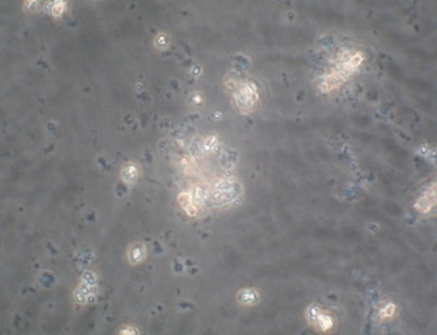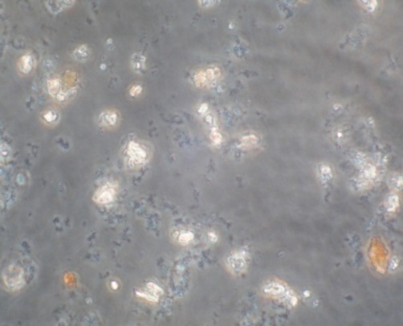

FIG 6: Phase contrast microscopic pictures identify microorganisms and white calcium carbonate crystals formation

SUMMARY AND CONCLUDING REMARKS

Studies shows that bacterial calcium carbonate (CaCO₃) precipitation which occurs as a byproduct of common metabolic processes of Bacillus subtilis JC3 can be used to improve the strength of cement mortar specimens. It was predicted that the increase in strength could be due to the refinement of pore structure through the formation of calcite in the pores of cement mortar specimens and is substantiated with relevant characterization studies. The morphology and chemical constituents of the bacteria were analyzed with SEM and XRD. The growth of dense calcite fillers are visualized by scanning electron microscopy (SEM) analysis. Further the precipitation of calcite was quantified by x-ray diffraction (XRD) analysis and confirmed by TG analysis. Microstructure analysis on bacteria incorporated cement mortar specimens using SEM, XRD and TG Analyses confirmed that calcite was present in the form of calcium carbonate. The spores of Bacillus subtilis JC3 are found to survive even after 365 days. Thus, it is evident that the minerals produced by the process of biomineralization, which is a normal biological process in certain types of micro-organism can be used both as a binder and pore filler in the process of improving the strength of cement mortar. There is scope and need for examining biological processes that have influenced materials science on biodeposition and biomineralization treatment such as microbial precipitation towards evolving a new methodology/ technology for production of new sustainable construction materials with improved structural strength and durability. Using the new materials developed, it is possible to construct structures, which will be ‘green’ and ‘sustainable’, requiring optimum resources and energy.

REFERENCES

Ivanov, V and Chu, J, 2008, “Applications of microorganisms to geotechnical engineering for bioclogging and biocementation of soil in situ”, Reviews in Environmental Science and Biotechnology, Vol. 7, 139-153.
Muynck W. De, Debrouwer D., Belie N. De and Verstraete W., “Bacterial carbonate precipitation improves the durability of cementitious materials”, Cem. Concr. Res., 2008, 38, 1005–1014.
Park, Sung-Jin, Park, Yu-Mi, Chun, Woo-Young, Kim, Wha-Jung and Ghim, Sa-Youl, “Calcite-forming bacteria for compressive strength improvement in mortar”, J. Microbiol. Biotechnol., 2010, (4), 782–788.
Ramakrishnan S. K., Panchalan R. K. and Bang S. S., “Improvement of cement mortar durability by bacterial mineral precipitation” in Proceedings of 11th International Conference on Fracture, Turin, Italy, 2005.
Stocks-Fischer S, Galinat J K and Bang S S, “Microbiological precipitation of CaCO₃”, Soil Biol. Biochem., 1999, 31(11), 1563– 1571.

