INTRODUCTION
Damage from a short circuit is a constant threat to any electric power system. Insulation damaged by aging an accident or lightning strike can unloose immense fault currents practically the only limit on their size being the impedance of the system between their location and power sources. At their worst, faults can exceed the largest current expected under normal load – the nominal current by a factor of 100 producing mechanical and thermal stresses in proportion to the square of the current’s value.
All power system components must be designed to withstand short circuit stresses for certain period determined by time needed for circuit breakers to activate (20-300 ms). The higher the fault currents anticipated the higher will be the equipment and also the maintenance cost. So there obviously is a big demand for devices that under normal operating conditions have negligible influence on power system but in case of fault will limit the prospective fault current. A device of this kind is called fault current limiter.
According to the accumulated intelligence of many utility experts, an ideal fault current limit would:
- Have zero impedance throughout normal operation
- Provide sufficiently large impedance under fault conditions
- Provide rapid detection and initiation of limiting action within less than one cycle or 16ms.

- Provide immediate (half cycle or 8ms) recovery of normal operation after clearing of a fault.
- Be capable of addressing tow faults within a period of 15 seconds.
Ideal limiters would also have to be compact, light weight inexpensive, fully automatic, and highly reliable besides having long life.
In the past, the customary means of limiting fault current have included artificially raising impedance in the system with air-coil rectors or with high stray impedance of transformers and generators or splitting power-grids artificially to lower the number of power sources that could feed a fault current. Nut such measures are inconsistent with today’s demand for higher power quality, which implies increased voltage stiffness and strongly interconnected grids with low impedance.
What is need is a device that normally would hardly affect a power system bit during a fault would hold surge current close to nominal value that is a fault current limiter. Until recently most fault current limiter concepts depend on mechanical means, on the detuning of L_C resonance circuit or use of strongly non-linear materials other than High Temperature super conditions (HTS). None is without drawbacks.

TRADITIONAL WAY OF FIXING FAULT CURRENT LIMITERS

Device Advantages Disadvantages

Circuit Breaker Proven Needs zero current to break
Reliable Performances limited to 100000A
Has limited life time
High-impedance widely used Breeds inefficiency in system
(high losses)
Fuse simple Breaks too soon (have too
low a with-standable fault current) -
Must be replaced by hand
Air-core reactor proven Entails large voltage drops
Traditional Causes substantial power
Loss during normal operation
System proven Reduce system reliability
Reconfiguration preferred for reduces operating flexibility
(bus-splitting) fast-growing areas Incurs high
cost of adding line. Adds cost
opening circuit breakers

Before examining super conducting fault current limiters some characteristics f non-linear material deserve a closer clock.

Super conductors because of their sharp transition from zero resistance at normal currents to finite resistance at higher current densities are tailor made for use in fault current limiters. Equipped with proper power controlled electronics, a super conducting limiter can rapidly detect a surge and taken and can also immediately recover to normal operation after a fault is cleared.
Superconductors lose their electrical resistance below certain critical values of temperature, magnetic field and current density. A simplified phase diagram of a super conductor defines three regions.
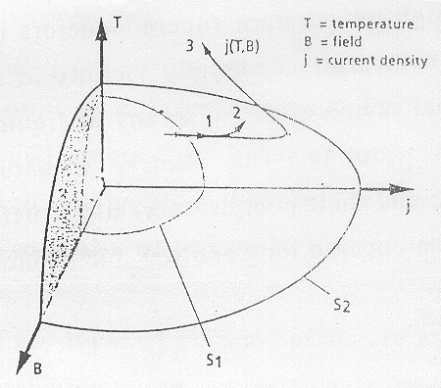

In the innermost, where values for temperature, field, and current density are low enough, the material is in its true superconducting state and has zero resistance. In a region surrounding that area, resistively rises steeply as values for three variables so higher. Outside that area, receptivity is in essence independent of field and current density as with ordinary conductors.
Until the discovery of high temperature superconductors in 1986, the only material known to super conduct had to be cooled to below 23K (-250⁰C). The cost of cooling such low temperature superconductor which is mostly metals, alloys and inter-metallic, makes their use in many possible applications commercially impractical. The high temperature superconductors have a critical temperature in the comparatively balmily vicinity of 100 K and can be maintained at that temperature by means of liquid nitrogen (as opposed to helium) cooling. The relative immaturity of HTS materials processing and their complex ceramic structures render it difficult to draw them out into long and flexible conductors.

MATERIAL ISSUES
Low-temperature superconducting (LTS) wire has been available for several decades. Its ac losses have been reduced by the development of multi filament wire. The diameter of the filament is of the order of 0.1µm and they are decouples by a highly resistive, normal conducting matrix which also serves as thermal stabilization. Since any magnetic field interacts only with the very thin and decoupled filaments, the ac losses in the materials are tolerable even at extremely low temperatures (for LTS application, usually 4.2 K, boiling point of liquid helium).
Kept this cold, the specific heat of LTS is very low, but the current carrying capacity is very high (greater than 10⁵ ACm²). Consequently any conceivable SCFCL based on LTS would exceed its critical temperature within several hundred microseconds of a fault. By the same token the material is prone to hot spots, which some tiny disturbance can trigger even at sub critical current values.
Because of such properties LTS material is predestined for the fast heating resistor design. A fast homogenous transmission into the normal conducting state is supported by excellent thermal conductivity which together with the low specific heat, leads to rapid propagation of hot spots.
While there is only one large program left in the low temperature type of SCFL, more than 10 major projects are under way worldwide on high temperature type of device. The main reason in the lower HTS cooling cost.

Essentially just three types of HTS materials are available; all made from bismuth (BSCCO) or yttrium-cuprate (YBCO) compound. They are silver sheathed wire (based on Bi 2223), thin films (based on YBCO) and bulk material (based on Bi 2212, Bi 2223 or YBCO). Usable in varying degrees either resistive or shielded core SCFLs, these materials are very poor at conducting heat, unlike the LTS. In other words, hot spots don’t propagate fast in the HTS so that electrical stabilization becomes a major concern.
The HTS materials with the highest critical current are YBCO films. They are typically, 1µm thick and have a current criticality threshold at 77K or up to 2000KA cm⁻². But it is very difficult produce YBCO films that are either long or extensive. Nevertheless, several groups are developing limiters based on these materials. Because of their high critical current and the need to conserve material, any economically justifiable design will perforce be of fast heating type. The huge electric field-current density product in a fault will heat the HTS to the point of normal resistance setting in within a few hundred microseconds.
SCFLs may be categorized as resistive or shield core.

RESISTIVE LIMITERS
In the resistive SCFCL, the super conductor is directly connected in series with the line to be protected. To keep it superconducting, it is usually immersed in a coolant that is chilled by a refrigerator. Current leads are designed to transfer as little heat as possible from the outside to the coolant.
In normal operation, the current and its magnetic field can vary but temperature is held constant. The cross section of super conductor is such as to let it stay below critical current density, since its receptivity is zero in this regime; the impedance of the SCFCL is negligible and does not interfere with the network. All the same the superconductor’s impedance is truly zero only for dc currents. The more common as applications are affected by two factors. First, the finite length of the conductor produces a finite reactance which however can be kept low by special conductor architecture. Second a superconductor is not loss free in ac operation, the magnetic as field generated by the current produces so called ac losses basically, just eddy current losses. These are heavily influenced by the geometry of the conductor and can be reduced by decreasing the conductor dimension transverse to direction of local magnetic field. They barely contribute to total SCFCL impedance but dissipate energy in superconductor, thus raising cooling costs.

In case of a fault the inrush of current and magnetic field take the super conductor into the transition region, between zero resistance and normal receptivity. The fast rising resistance limits the fault current to a value some where between the nominal current and what ever fault current otherwise would ensure. After some time, perhaps a tenth of seconds, a breaker will interrupt the current.
The behavior of resistic fault current limiter is largely determined by the length of the superconductor and the type of material used for it.

SUPERCONDUCTORS AS VARIABLE RESISTORS AND SWITCHES
Several anisotropic high temperature superconductor show critical current densities which are strongly dependent on direction of an applied external magnetic field. The resistance of a sample can change by several orders of magnitude by applying a magnetic field.
The current carrying capability of both low temperature and high temperature super conductors decreases with the application of a magnetic field. Some anisotropic high temperature superconductors in particular the bismuth and thallium based super conductors show a resistance that is highly dependent on the amplitude and direction of applied field.[1,2]

Resistance Field Dependence Of HTS Wire
Anisotropic HTS materials show a dependence of the critical current density and therefore the resistivity, on the direction of applied magnetic field. However, if the magnetic field is perpendicular to the ab plane, a steep exponential reduction with field in the critical current density is observed.
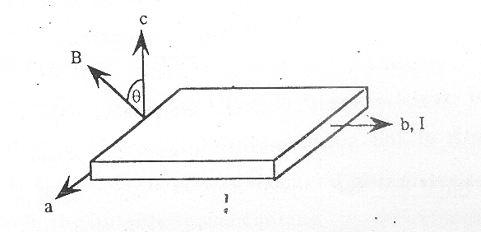

By rotating a HTS wire sample along a-axis in a constant magnetic field, the voltage varies as a function of angle θ as shown in figure below.
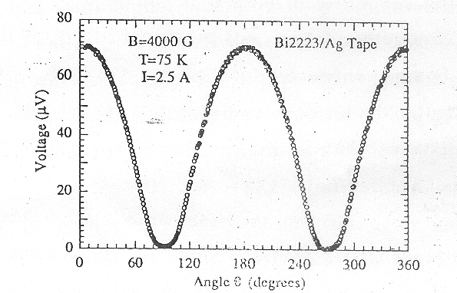
Voltage drop in a BSCCO sample as a function of external magnetic field angle.
The measured voltage drop is directly proportional to the resistance of the samples because the current is constant. The resistance of the samples shows, to the first approximation a sinusoidal dependence on angleθ, which is formed by the c axis and the direction of external field. The sample resistivity is the highest, when the field is parallel to the c axis (θ = 0).
While the voltage drop and resistance values of the samples shown in figure above (measurements made at 75k. Test sample was 1 cm long BSCCO tape with a silver sheath) are rather modest, larger values can be achieved with longer sample length. The V-1 characteristics of thallium based short sample is shown in figure below for a field of variable strength parallel to the c-axis.[3].

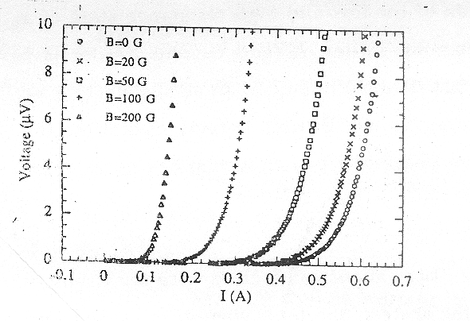
The sample, which is commercially available is 10cm long and is formed in a meander line fashion. The super conduction is T122122 an Lanthanium Aluminates substrate. The figure clearly shows that, with increasing magnetic field, the critical current of sample decreases. While sample can carry a current of 0.4A in superconducting state with no background field, the current capability is reduced to 0.1A with an applied external field of 200 Gausses. The resistance of the sample in flux flow state is limited by the resistivity of the sheath or substrate material. The resistivity of sheath or substrate should be high to achieve a large resistance ratio between the resistive and the superconducting state.
Use of field dependent resister in the form of a variable resistor and switch can be used for fault current limiters.
A natural application of the low and high resistance state of a HTS wire is as a fault current limiter. A fault current limiter is a device that reduces current in short circuit in an ac system to a determined allowable lower value. During normal operation the HTS wire, installed in each phase of a power system has no external field applied.
The resistance values of the super conducting were is extremely low. If a fault occurs in the system, the fault current is sensed and background field for the HTS wire is turned on, which results in a resistance increase in the circuit and in a reduction of the fault current. A simplified in diagram of a fault cannot limiter is given below.
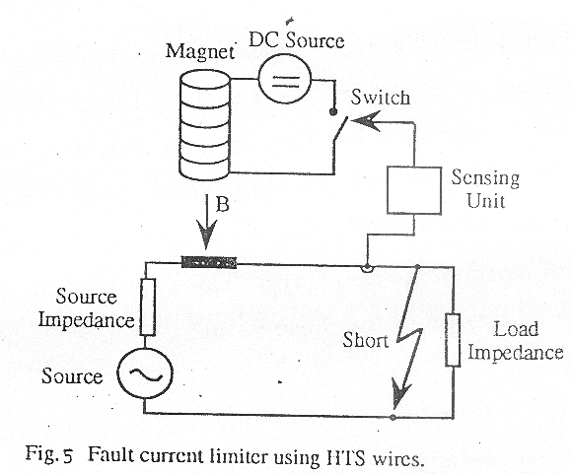
Included in the figure is a current sensing unit which measures the initial current rise of the fault current and triggers the current flows for the background magnet controlling the value of the background field adjusts the resistance of the superconductivity were and the fault current level.

THE SHIELDED CORE SCFCL
The shielded core fault current limiter basically a shorted transformer is the other basic category of SCFCLs. Here, the superconductor is connected in the line not galvanic ally but magnetically. The device’s primary coil is normal conducting and connected in series to the line to be protected, while the secondary side is superconducting and shorted. (Because of the inductive coupling between the line and superconductor the device is sometimes also called and inductive SCFCL).
In normal operation, the iron core sees no magnetic field because it is completely shielded by the superconductor hence the name of shielded core. Depending on the turn ratio between primary and secondary side, the nominal current and voltage will be transformed to type secondary side as the product of turn ratio and current and ratio of voltage to turn ratio. The superconductor on the secondary has to be designed for this value.
Assuming an ideal transformer, the shielded core SCFCL will behave exactly like a resistive SCFCL. Since the turn of the secondary winding may be far fewer than on the primary winding only short superconductors are needed and the total voltage drop in the cryogenic part of the device is small. In most approaches in fact there is just one secondary turn that is the superconducting winding is a tube as shown in figure.

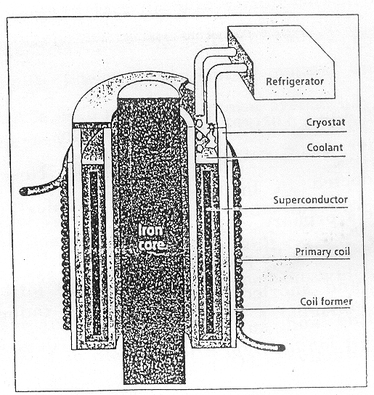

Dynamical model
In principle our SCFCL is a transformer, with a short circuited, strongly temperature dependent and highly non ohmic secondary winding (Fig. 6). If we label primary (normal) and secondary (superconducting) side by number 1 and 2 respectively the equation describing the SCFCL can be written in following way.
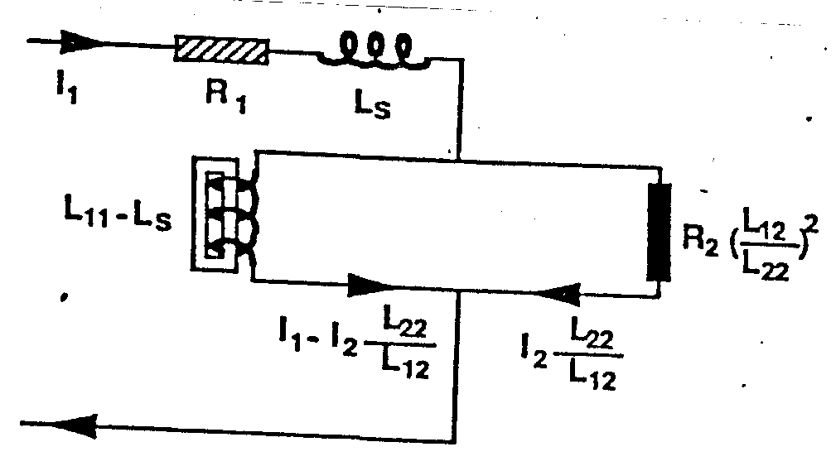

Equivalent circuit

V₁ = R₁l₁+L₁₁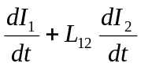
O = R₂I₂+L₁₂ 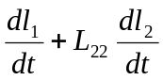
H = 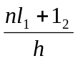
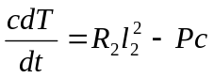
Where
I₁ = Current in normal conducting coil
R₁ = Resistance of coil
I₂ = Current in super conducting tube
R₂ = R₂ (I₂, H, T) = resistance of superconductor
M = Magnetic field due to I1 and 12
T = Temperature of superconductor
n = Number of primary turns
h = Height of primary coil and superconductor
c = Capacity of heat of superconductor
Pc = Heat power transferred to liquid nitrogen
In approximation of long coil the inductance coefficients are
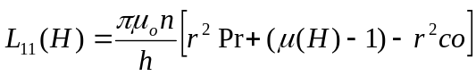

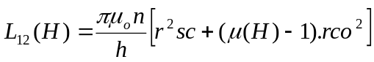
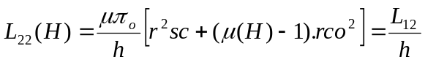
Where μ (h) = 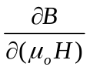 is the effective permeability of the iron core and rpr, rsc and rco are the radii of the primary coil, the superconducting tube and core respectivity. The set of equations can be mapped exactly onto the equivalent circuit shown in fig. 7 in which Ls to study impedance which is approximation of a long coil is.
Ls = 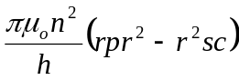
As with the resistive SCFCL can be tailored by varying the electric field induced along tube’s circumference during the fault. The decisive parameters for this SCFCL design are the number of primary turn and the height, diameter and wall thickness of the superconducting tube.
The cross section of the iron core is designed almost as with a transformer. For efficient magnetic coupling between primary and secondary and optimal use of the amount of iron, the core should be designed to stay just below saturation during the fault. A given induced field in the superconductor, a given net frequency and a given insulation distance between core and super conducting tube, determine the diameter of core and tube.

The number of primary turns is then determined by nominal voltage. The tub’s iron section (thickness times height) as in case of resistive device has to be chosen to ensure that at the nominal current, the conductor stages superconducting. Again, remember that in normal operation the superconductor is exposed to magnetic field in this case the sum of the field of primary coil and the field of the superconducting tube.
With the cross section fixed, the thickness and height of the tube can still be varied. Adding to its height in effect subtracts from the magnetic field and permits a thinner wall, so that ac loses are far less on the other hand, the device is heavier. The device will show some small reactance under normal operation essentially the short circuit reactance of a transformer, proportional to the gap between coil and tube. Since this gap is determined by the thermal and electric insulation, it is generally difficult to keep the reactance as small as for the resistive device.
The fact that the iron core is not exposed to magnetic fields in normal operation cuts costs in comparison with a real transformer. The core need not be made of expensive transformer steel but of rather cheap and thick construction steel sheets. (But insulated sheets are still required for the job of interrupting screening currents in the iron during the fault). Also, the core need not be closed, since the magnetic coupling provided by and open core usually suffices for the current limitation process.

COMPARISON
Both the shielded core and resistive types of SCFCL use the same amount of superconductor material to achieve a given limitation behavior. This is because the rated power per volume of conductor is determined by the product of fault induced field and critical current, which is the same for both devices assuming the same type of superconducting material, is employed.
The shielded core limiter works only with ac currents and is much larger and heavier than the resistive SCFCL. But it needs no current leads, and uses short conductors with high rated current (o several superconductors in parallel). Its independence of current leads is especially attractive where the protection of high current systems is involved. And avoidance of a very long superconductor with rather low rated currents answers problem that afflicts SCFCLs of the resistive type: hot spots.
It war earlier assumed that while a fault current is being limited, the voltage drop is uniform throughout the conductor. But in practice superconductors tend to develop thermal instabilities, called hot spots, connected with the strong current and temperature dependence of their resistivity in the transition state. If a part of the superconductor sees a greater voltage drop than the rest, as a result of an in homogeneity, this part will heat up faster, leading to an even greater voltage drop at that point and further accelerated heating Burn-through can result.

The common cure is to attach a normal conducting by pass in close electrical contact to the superconductor, so that the current may by pass the hot spots. Besides its electrical effect, the bypass adds to the thermal mass of the conductor and thus further enhances its stability. But of course such thermal such thermal stabilization of super conductor reduces its total normal resistances, which might have to ne lengthened in compensation.

HYBRID CURRENT LIMITER
The advantages of this scheme are the reduction of superconducting weight and current compared to the resistive system. It consists of a series resistive transformer whose primary winding is inserted in series in the line and whose secondary winding is inserted in series in the line and whose secondary windings are connected to non-inductivity wound conducting coils in two essentially different ways as shown.
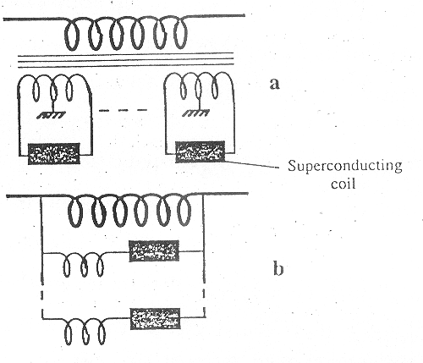
Schemes for hybrid superconducting limiters.
The transformer has two functions. A favorable ratio of the primary series turns over total secondary turns reduces the secondary current and hence the superconducting current compared to the line current. This point is important taking into account the difficulties encountered when a high ac current is passed through superconducting cable. The transformer reduces the necessary superconducting volume needed compared to resistive limiter of same characteristics (line current and voltage).
This possible reduction is brought about by the variation of the magnetic coupling between primary and secondaries. The variation of magnetic coupling may be may be performed by a saturable magnetic circuit. In steady state operation the primary and secondary winding should be magnetically coupled very well in order to reduce the self inductance of the device and hence its voltage drop under rated operation. Under fault operation the coupling is decreased in order to reduce the thermal dissipation in superconducting coils thanks to lower secondary voltages.
The magnetic circuit is not saturated under rated operation as the field is low in relation to the reduced voltage drop across the primary (some % of line voltage) and the coupling between the windings is good. Under fault operation, the high voltage across the primary (100% of line voltage, neglecting the line impedance) increase the field in the magnetic circuit, saturate it and the coupling is reduced in a natural and automatic way.
The numerous secondary windings reduce the dielectric stresses on them and the superconducting windings. As the voltage devices from the magnetic field, these quantities if sinusoidal are in quadrature and the maximum voltage occur when the field is low and they are not affected by the reduction of coupling under fault operation. So secondary voltage are proportional to the ratio of the series turns. With only one secondary, the reduction by ten for superconducting current leads to over voltages reaching ten times the line voltage for scheme (b) and five for scheme (a). this is hardly acceptable several secondaries solve these problems but they increase the cryogenic loss related to current leads. Scheme (a) is particularly adapted for over voltage reduction.

MAGNETIC SHIELDING TYPE SUPERCONDUCTING FAULT CURRENT LIMITER

The limiter uses a superconductor to shield the magnetic field generated. The design is based on using a superconductive cylinder to shield the iron core from AC magnetic field generated by the primary winding. During a fault caused, the magnetic field penetrates the superconducting shield at large impedance.
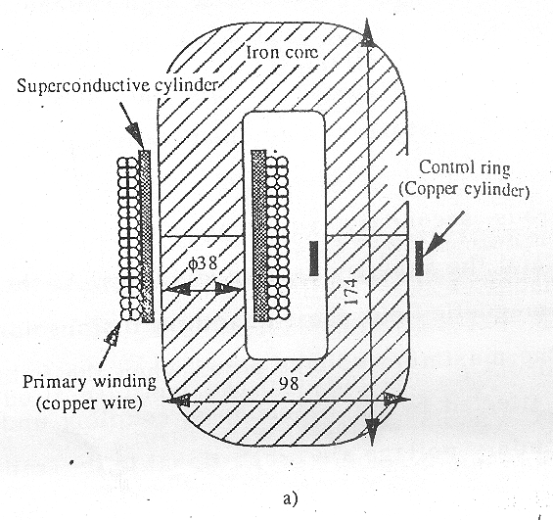
(a) schematic diagram of a SCFCL

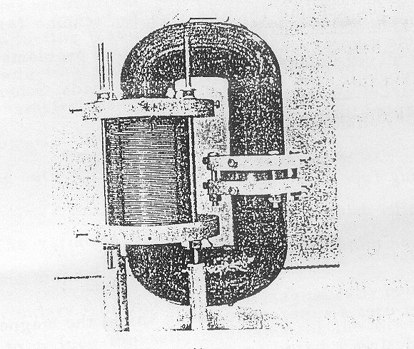
(b) The photograph
The magnetic shielding type SCFCL consists of limiting element, an iron core and a control ring. The fault current limiting element is a superconductive cylinder around which a covered copper wire for 1mm in diameter is wound. The wound part extends 60mm with two layers of 113 turns. The iron core is made from a silicon steel plate (ZT 100, 0.1t) and is cut at the centre. The iron core is 38 mm in diameter, 98mm in width and 174mm in length. The control ring is added to control the currents of superconductive cylinder in fault conditions. The control ring is a copper cylinder of 45 mm in diameter, 1.5mm in thickness and 5mm in length.

EXPERIMENTAL AND RESULT
Short circuiting test
The test circuit consists of a power source, a protecting resistance for the source, a circuit breaker (CB) a SCFCL, a load, and a short circuiting switch.
Short circuiting tests were carried out with the SCFCL socked in liquid nitrogen without the control ring. The voltage and frequency of the source were 50V and 50 Hz. The circuit took a current of 5A in normal operation and the short circuiting switch was closed in fault condition. The load was adjusted so that current in fault conditions may be about 15 times as high as normal operations.

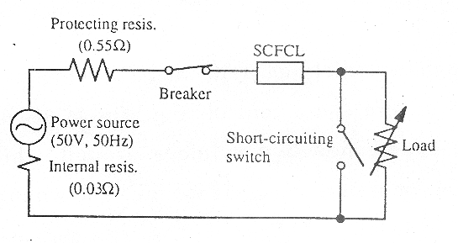
Test Circuit

The wave forms in tests of SCFCL are shown in figure below

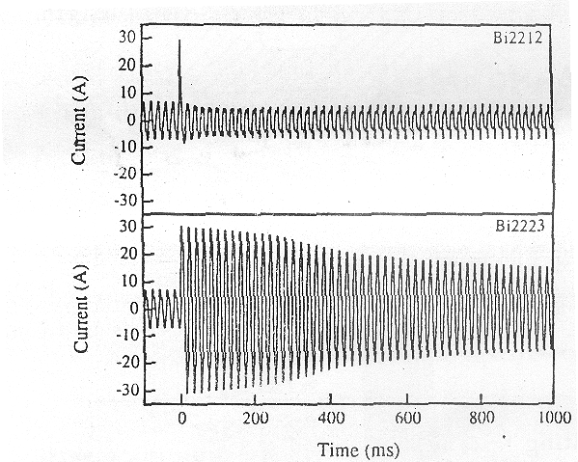
Broken lines are waveforms without SCFCL. After a fault occurs, the peak current in first cycle was about 30 A peaks. The current of Bi2212 decreased rapidly after the first cycle. The limiting to the first peak current is caused by increase of reactance for lowering the shielding effect. But after the first peak current as the superconductive cylinder quenches completely, the limiting is caused by increase in resistivity. The limiting of Bi2212 has been achieved in about 10mS. After a fault occurs, the impedance characteristics at the start point of second cycle are as shown.
Ratio of Ratio of Ratio of
Impedance resistance reactance
Bi2212 140.2 139.5 148.9

Recovery of Superconductive State
For purpose of recovering the super conduction state in a shorter time, a control ring is added to the superconductive state of SCFCL. Recovery test were performed as follows three cycles after the occurrence of a fault, a CB was opened and after certain time it was closed. When the CB is closed, if the SCFCL has reached the superconducting state the time between the openings to closing of CB is defined as recovering time.
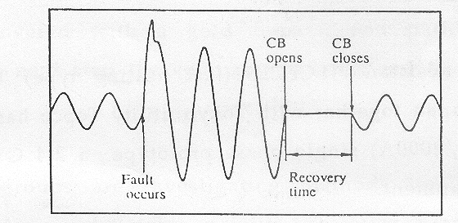
Waveform for the recovery test.

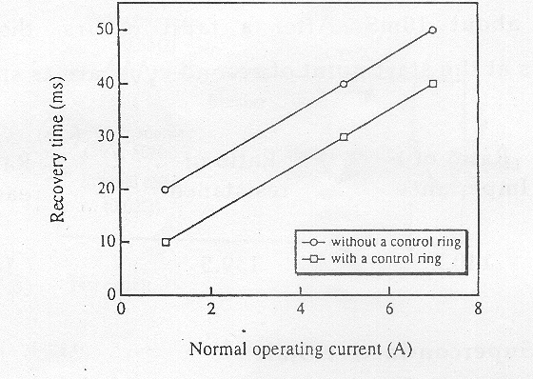
Recovery characteristics of the SCFCL

From the result of tests it is observed that the recovery time with the control ring added was shorter than that without the control ring. The reason is that control ring shares the energy for limiting, to keep down the rising temperature of the superconducting cylinder and makes the time for recovery shorter.

IDENTIFICATION
LTS
Resistance SCFCLs (fast heating type) Toshiba corp. Kawasaki, Japan together with Tokyo utility Tepco has built a 13.2 MVA (66KV/2000A) single phase prototype a 2-4 GVA device is under development.
GEC Alstom along with Electrocute de France (EDF) developed and tested a 7.6 MVA (35KV/210A) single phase device.

HTS
American superconductor corp. (ASC) and sumitomo electric Industries ltd have produced ling lengths of silver sheathed wire based on Bi 2223 with a critical current at 77K on the order of 50 KAcm-2. This wire might suit cable, motor and transformer applications but is poorly suited for SCFCL because its high silver content gives it a low normal resistance. At this stage of material development the silver sheath must be rather thick if it is not to leak Bi2223 during processing. Thus very ling lengths are needed to build up the resistance for fault limitation. So used only for constant temperature resistive type of SCFCL. The situation will change if resistvity of silver matrix can be raised. A project along these lines led by ABB in partnership with ASC and Electricite de France has been launched to develop a current timely transfer.

Siemens have demonstrated a resistive 100 KVA model base4d on YBCO Films. The were deposited on flat ceramic substrates, covered with a gold bypass, and patterned into meander. As a next step the company has planned to develop a IMVA device.
Several groups are investigating methods for fabricating YBCO film on ling and flexible metallic substrates. Based on such preliminary flexible conductor a small FCL demonstrator has been built by sumitomo electric in co operation with Tepco.
To date, the largest FCL: photo types designed around the high temperature superconducting phenomenon utilize so called bulk ceramic parts ABB has based a three phase 1.2 MVA prototype on Bi2212 material (critical current of about 2KAcm-2 at 77K). The device operated for one year under actual conditions in Swiss hydroplant

CONCLUSION

The purpose of this paper was the study of surge current protection using superconductors. The SCFCL offers efficient advantages to power system and opens up a major application for super conducting materials.

REFERENCES
- www.superconductors.com
- KE Gray, DE flower-“superconducting fault current limiter”
- IEEE transaction on Applied superconductivity – vol.3, march 1997
- www. IEEE.org

CONTENTS
- Introduction 1
- Material Issues 6
- Resistive Limiters 8
- Superconductor as Variable Resistors 10
and Switches
- Shielded Core SCFCL 14
- Comparison between Resistive and 19
Shielded Core SCFCL
- Hybrid Current Limiter 21
- Magnetic Shielding Type SCFCL 23
- Identification 29
- Conclusion 31
- References 32

ABSTRACT
The recent growth of power circuit capacities has caused fault currents to increase. Since the protection of power systems from the fault currents is very important, it is needed to develop a fault current limiter. A fault current limiter is required to assure (1) rapid reaction to fault currents, (2) how impedance in normal operation and (3) large impedance during fault conditions. A super conducting fault current limiter (SCFCL) can meet these requirements superconductors, because of their sharp transition from zero resistance at normal current to finite resistance at higher current densities, are tailor-made for use in FCLs.
Super conductors are of two types-high temperature superconductors (HITS) and low temperature superconductor (LTS). The HTS are substances that lose all resistance below temperature main tamable by liquid nitrogen. LTS are substances that lose all receptivity close to 4k, a temperature attainable only using by using liquid helium. Cost of cooling LTS (which are mostly metals, alloys and intermettalics) makes their use in many applications commercially impractical. HTS material available are all made of bismuth (BSCCO) or yttrium-cup rate (YBCO). So far, various types of SCFLS have been developed (resistance, shield core type, hybrid etc.). The SCFCL offers efficient advantages to power system and opens up a major application for superconducting materials.

ACKNOWLEDGEMENT

I express my sincere gratitude to Dr.Nambissan, Prof. & Head, Department of Electrical and Electronics Engineering, MES College of Engineering, Kuttippuram, for his cooperation and encouragement.
I would also like to thank my seminar guide Miss. Sujalakshmi (Lecturer, Department of EEE), Asst. Prof. Gylson Thomas. (Staff in-charge, Department of EEE) for their invaluable advice and wholehearted cooperation without which this seminar would not have seen the light of day.
Gracious gratitude to all the faculty of the department of EEE & friends for their valuable advice and encouragement.

