VIII- ANATOMY AND PHYSIOLOGY
The Human Nervous System
The nervous system is one of the body’s principal control and integrating centers. In humans, the nervous system serves three board functions: sensory, integrative, and motor. First, it senses certain changes within the body and in the outside environment; this is its sensory function. Second, it interprets the changes; this is the integrative function. Third, it responds to the interpretation by initiating action in the form of muscular contractions or glandular secretions; this is its motor function.
Through sensation, integration, and response, the nervous system represents the body’s most rapid means of maintaining homeostasis. Its split-second reactions, carried out by nerve impulses, can normally make the adjustments necessary to keep the body functioning efficiently.
- Central Nervous System (CNS)
The central nervous system is effectively the center of the nervous system, the part of it that processes the information received from the peripheral nervous system.
The CNS consists of the brain and spinal cord. It is responsible for receiving and interpreting signals from the PNS and also sends out signals to it, either consciously or unconsciously
The Nerve Cell
Nerve cells, called neurons, are responsible for conducting nerve impulses from one part of the body to another. Neurons have two kinds of cytoplasmic processes: dendrites and axons. Dendrites are usually highly branched, thick extensions of the cytoplasm of the cell body. Their function is to conduct nerve impulses toward the cell body. On the end of these dendrites lie the axon terminals, which ‘plug’ into a cell where the electrical signal from a nerve cell to the target cell can be made. This ‘plug’ (axon terminal) connects into a receptor on the target cell and can transmit information between cells.
Axon, is usually a single long, thin process that is highly specialized and conducts nerve impulses away from the cell body to another neuron or muscular or glandular tissue.

Classification of Neurons:
- Afferent Neurons – transmit impulses from receptors in the skin, sense organs, muscles, joints, and viscera to the CNS.
- Efferent Neurons – convey impulses from the brain and spinal cord to effectors, which may be either muscles or glands, and from high to lower centers of the CNS.
- Interneurons – carry impulses from sensory neurons to motor neurons and are located in the brain and spinal cord.
Spinal Cord
The spinal cord begins as a continuation of the medulla oblongata and terminates at about the second lumbar vertebra. It is protected by the vertebral canal, meninges, cerebrospinal fluid, and vertebral ligaments.
31 pairs of spinal nerves rise along the spinal cord. These are “mixed” nerves because each contain both sensory and motor axons. However, within the spinal column,
- all the sensory axons pass into the dorsal root ganglion where their cell bodies are located and then on into the spinal cord itself
- all the motor axons pass into the ventral roots before uniting with the sensory axons to form the mixed nerves
A major function of the spinal cord is to convey sensory nerve impulses from the periphery to the brain and to conduct motor impulses from the brain to the periphery. Another, is to serve as a reflex center. It serves as a minor reflex center.
Brain
The brain receives sensory input from the spinal cord as well as from its own nerves (ex. Olfactory and Optic nerves). It devotes most of its volume (and computational power) to processing its various sensory inputs and initiating appropriate – and coordinated- motor outputs.
White Matter and Gray Matter
Both the spinal cord and the brain consist of:
- White Matter – bundles of axons each coated with a sheath of myelin
- Gray Matter – masses of the cell bodies and dendrites – each covered with synapses.
In the spinal cord, the white matter is at the surface, they gray matter inside.
The Meninges
Both the spinal cord and brain are covered in three continuous sheets of connective tissue, the meninges. From outside in, these are the
- Dura mater – pressed against the bondy surface of the interior of the vertebrae and the cranium
- Arachnoid
- Pia Mater
The region between the arachnoid and pia mater is filled with cerebrospinal fluid (CSF)
- Brain Stem
- Medulla Oblongata
The medulla contains all ascending and descending tracts that communicate between the spinal cord and various parts of the brain. These tracts constitute the white matter of the medulla.

- Rhythmically stimulate the intercostals muscles and diaphragm making breathing possible
- Regulate heartbeat
- Regulate the diameter of arterioles thus adjusting blood flow
- Pons
The pons seems to serve as a relay station carrying signals from various parts of the cerebral cortex to the cerebellum. Nerve impulses coming from the eyes, ears, and touch receptors are sent on the cerebellum. The pons also participates in the reflexes that regulate breathing.
The reticular formation is a region running though the middle of the brain stem ( and on into the midbrain). It receives sensory input (eg. Sound) from higher in the brain and passes these back up to the thalamus. The reticular formation is involved in sleep, arousal (and vomiting)
- Midbrain
The midbrain (mesencephalon) occupies only a small region in humans (it is relatively much larger in “lower” vertebrates). We shall look at three features:

- The reticular formation: collects inpur from higher brain centers and passes it on to motor neurons.
- The substantia nigra: helps “smooth” out body movements;
- The ventral tegmental area (VTA): packed with dopamin-releasing nurons that:
  - Are actuvated by nicotinic acetylcholine receptors and
  - Whose projections synapse deep within the forebrain.
The VTA seems to be involved in pleasure: nicotine, amphetamines and cocaine bind to and activate its dopamine-releasing neurons and this may account for their addictive qualities.

- Diencephalon
- Thalamus
- All sensory input (except for olfaction) passes through these paired structures on the way up to the somatic-sensory regions of the cerebral cortex and then returns to them from there.
- Signals from the cerebellum pass through them on the way to the motor areas of the cerebral cortex.
- Hypothalamus
- The seat of the autonomic nervous system. Damage to the hypothalamus is quickly fatal as the normal homeostasis of body temperature, blood chemistry, etc. goes out of control.
- Cerebellum
The cerebellum consists of two deeply-convoluted hemispheres. Although it represents only 10% of the weight of the brain, it contains as many neurons as all the rest of the brain combined. Its most clearly-understood function is to coordinate body movements. People with damage to their cerebellum are able to perceive the world as before and to contract their muscles, but their motions are jerky and uncoordinated.
It appears to be a center for learning motor skills (implicit memory). Laboratory studies have demonstrated both long-term potentiation (LTP) and long-term depression (LTD) in the cerebellum

The Cerebral Hemispheres
The peripheral nervous system branches outside of the central nervous system and is comprised of nerves and neurons that transmit information to and from the brain. The peripheral nervous system is further divided into two parts called the somatic nervous system and the autonomic nervous system.

- The Sensory-Somatic Nervous System
The sensory somatic nervous system consists of:
- 12 pairs of cranial nerves and
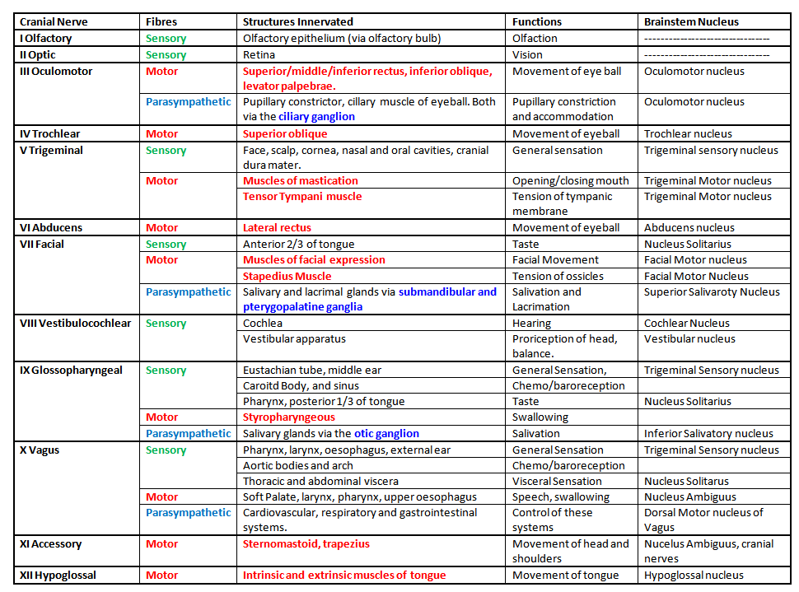
- 31 pairs of spinal nerves

The Spinal Nerves
All of the spinal nerves are “mixed”;that is, they contain both sensory and motor neurons. All our conscious awareness of the external environment and all our motor activity to cope with it operate through the sensory-somatic division of the PNS.
- The Autonomic Nervous System
The autonomic nervous system consists of sensory neurons and motor neurons that run between the central nervous system (especially the hypothalamus and medulla oblongata) and various internal organs such as the :
- Heart
- Lungs
- Viscera
- Glands (Both endocrine and exocrine)
It is responsible for monitoring conditions in the internal environment and bringing about appropriate changes in them. The contraction of both smooth muscle and cardiac muscle is controlled by motor neurons of the autonomic system.

Each hemisphere of the cerebrum is subdivided into four lobes visible from the outside:
- Frontal lobe – conscious thought; damage can result in mood changes
- Parietal lobe – plays important roles in integrating sensory information from various senses, and in the manipulation of objects; portions of the parietal love are involved with visuospatial processing
- Occipital lobe – sense of sight; lesions can produce hallucinations
- Temporal lobe – senses of smell and sound, as well as processing of complex stimuli like face and scenes.

- Peripheral Nervous System (PNS)
The actions of the autonomic nervous system are largely involuntary (in contrast to those of the sensory-somatic system). It also differs from the sensory-somatic system in using two groups of motor neurons to stimulate the effectors instead of one.
- The first, the preganglionic neurons, arise in the CNS and run to a ganglion in the body. Here they synapse with
- Postganglionic neurons, which run to the effector organ (cardiac muscle, smooth muscle, or a gland)
The autonomic nervous system has two subdivisions, the
- Sympathetic Nervous System
- Parasympathetic Nervous System
The Sympathetic system activates and prepares the body for vigorous muscular activity. Stress. And emergencies. While the Parasympatheticsystem lowers activity, operates during normal situations, permits digestion, and conservation of energy.
Major Blood Vessels of the Brain
Normal function of the brain’s control centers is dependent upon adequate supply of oxygen and nutrients through a dense network of blood vessels. Blood is supplied to the brain, face, and scalp via two major sets of vessels: the right and left common carotid arteries and the right and left vertebral arteries.
The common carotid arteries have two divisions. The external carotid arteries supply the face and scalp with blood. The internal carotid arteries supply blood to the anterior three-fifths of cerebrum, except for parts of the temporal and occipital lobes. The vertebrobasilar arteries supply the posterior two-fifths of the cerebrum, part of the cerebellum, and the brain stem.
Any decrease in the flow of blood through one of the internal carotid arteries brings about some impairment in the function of the frontal lobes. This impairment may result in numbness, weakness, or paralysis on the side of the body opposite to the obstruction of the artery.
Occlusion of one of the vertebral arteries can cause many serious consequences, ranging from blindness to paralysis.
Circle of Willis
At the base of the brain, the carotid and vertebrobasilar arteries form a circle of communicating arteries known as the circle of Willis.
From this circle otheir arteries – the anterior cerebral artery (ACA), the middle cerebral artery (MCA), the posterior cerebral artery (PCA) – arise and travel to all parts of the brain. Posterior Inferior Cerebellar Arteries (PICA), which branch from the vertebral arteries, are not shown.
Because the carotid and vertebrobasilar arteries form a circle, if one of the main arteries is occluded, the distal smaller arteries that it supplies can receive blood from the other arteries (collateral circulation).
- Anterior Cerebral Artery
The anterior cerebral artery extends upward and forward from the internal carotid artery. It supplies the frontal lobes, the parts of the brain that control logical thought, personality, and voluntary movement, especially the legs. Stroke in the anterior cerebral artery results in opposite leg weakness. If both anterior cerebral territories are affected, profound mental symptoms may result (akinetic mutism)
- Middle Cerebral Artery
The middle cerebral artery is the largest branch of the internal carotid. The artery supplies a portion of the frontal love and the lateral surface of the temporal and parietal lobes, including the primary motor and sensory areas of the face, throat, hand and arm in the dominant hemisphere, the areas of speech. The middle cerebral artery is the artery most often occluded in stroke.
- Posterior Cerebral Artery
The posterior cerebral arteries stem in most individuals from the basilar artery but sometimes originate from the ipsilateral internal carotid artery. The posterior arteries supply the temporal and occipital lobes of the left cerebral hemisphere and the right hemisphere. When infarction occurs in the territory of the posterior cerebral artery, it is usually secondary to embolism from lower segments of the vertebral basilar system or heart.
- Lenticulostriate Arteries
Small, deep penetrating arteries known as the lenticulostriate arteries branch form the middle cerebral artery. Occlusions of these vessels or penetrating brancjes of the circle of Willis or vertebral or basilar arteries are referred to as lacunar strokes.
The cells distal to the occlusion die, but since these areas are very small often only minor deficits are seen. When the infarction is critically located, however, more severe manifestations may develop, including paralysis and sensory loss. Within a few months of the infarction, the necrotic brain cells are reabsorbed by macrophage activity, leaving a very small cavity.
Renin-Angiotensin-Aldosterone System
The renin-angiotensin-aldosterone system (RAAS) plays an important role in regulating blood volume and systemic vascular resistance, which together influence cardiac output and arterial pressure. As the name implies, there are three important components to this system: 1) renin, 2) angiotensin, and 3) aldosterone. Renin, which is primarily released by the kidneys, stimulates the formation of angiotensin in blood and tissues, which in turn stimulates the release of aldosterone from the adrenal cortex.
Renin is a proteolytic enzyme that is released into the circulation primarily by the kidneys. Its release is stimulated by:
- sympathetic nerve activation (acting via β1-adrenoceptors)
- renal artery hypotension (caused by systemic hypotension or renal artery stenosis)
- decreased sodium delivery to the distal tubules of the kidney.
Juxtaglomerular (JG) cells associated with the afferent arteriole entering the renal glomerulus are the primary site of renin storage and release in the body. A reduction in afferent arteriole pressure causes the release of renin from the JG cells, whereas increased pressure inhibits renin release. Beta1-adrenoceptors located on the JG cells respond to sympathetic nerve stimulation by releasing renin. Specialized cells (macula densa) of distal tubules lie adjacent to the JG cells of the afferent arteriole. The macula densa senses the amount of sodium and chloride ion in the tubular fluid. When NaCl is elevated in the tubular fluid, renin release is inhibited. In contrast, a reduction in tubular NaCl stimulates renin release by the JG cells. There is evidence that prostaglandins (PGE2 and PGI2) stimulate renin release in response to reduced NaCl transport across the macula densa. When afferent arteriole pressure is reduced, glomerular filtration decreases, and this reduces NaCl in the distal tubule. This serves as an important mechanism contributing to the release of renin when there is afferent arteriole hypotension.
When renin is released into the blood, it acts upon a circulating substrate, angiotensinogen, that undergoes proteolytic cleavage to form the decapeptide angiotensin I. Vascular endothelium, particularly in the lungs, has an enzyme, angiotensin converting enzyme (ACE), that cleaves off two amino acids to form the octapeptide, angiotensin II (AII), although many other tissues in the body (heart, brain, vascular) also can form AII.
AII has several very important functions:
- Constricts resistance vessels (via AII [AT1] receptors) thereby increasing systemic vascular resistance and arterial pressure
- Acts on the adrenal cortex to release aldosterone, which in turn acts on the kidneys to increase sodium and fluid retention
- Stimulates the release of vasopressin (antidiuretic hormone, ADH) from the posterior pituitary, which increases fluid retention by the kidneys
- Stimulates thirst centers within the brain
- Facilitates norepinephrine release from sympathetic nerve endings and inhibits norepinephrine re-uptake by nerve endings, thereby enhancing sympathetic adrenergic function
- Stimulates cardiac hypertrophy and vascular hypertrophy
The renin-angiotensin-aldosterone pathway is regulated not only by the mechanisms that stimulate renin release, but it is also modulated by natriuretic peptides (ANP and BNP) released by the heart. These natriuretic peptides acts as an important counter-regulatory system.
Therapeutic manipulation of this pathway is very important in treating hypertension and heart failure. ACE inhibitors, AII receptor blockers and aldosterone receptor blockers, for example, are used to decrease arterial pressure, ventricular afterload, blood volume and hence ventricular preload, as well as inhibit and reverse cardiac and vascular hypertrophy.

