What Is A QuadCopter and How It Works
A QuadCopter is a helicopter with four rotors, so it’s also known as quadrotor. Because of its unique design comparing to traditional helicopters, it allows a more stable platform, making quadcopters ideal for tasks such as surveillance and aerial photography. And it is also getting very popular in UAV research in recent years.
The Quadcopters exist in many different sizes. From as small as a CD up to something as big as one meter in width.

On a regular helicopter has one big rotor to provide all the lifting power and a little tail rotor to offset the aerodynamic torque generated by the big rotor (without it, the helicopter would spin almost as fast as the propeller)
Unlike a helicopter, a quadrotor has four rotors all work together to produce upward thrust and each rotor lifts only 1/4 of the weight, so we can use less powerful and therefore cheaper motors. The quadcopter’s movement is controlled by varying the relative thrusts of each rotor.
These rotors are aligned in a square, two on opposite sides of the square rotate in clockwise direction and the other two rotate in the opposite direction. If all rotors turn in the same direction, the craft would spin would spin just like the regular helicopter without tail rotor. Yaw is induced by unbalanced aerodynamic torques. The aerodynamic torque of the first rotors pair cancelled out with the torque created by the second pair which rotates in the opposite direction, so if all four rotors apply equal thrust the quadcopter will stay in the same direction.

To maintain balance the quadcopter must be continuously taking measurements from the sensors, and making adjustments to the speed of each rotor to keep the body level. Usually these adjustments are done autonomously by a sophisticated control system on the quadcopter in order to stay perfectly balanced. A quadcopter has four controllable degrees of freedom:Yaw, Roll, Pitch, and Altitude. Each degree of freedom can be controlled by adjusting the thrusts of each rotor.

- Yaw (turning left and right) is controlled by turning up the speed of the regular rotating motors and taking away power from the counter rotating; by taking away the same amount that you put in on the regular rotors produces no extra lift (it won’t go higher) but since the counter torque is now less, the quadrotor rotates as explained earlier.3.- control becomes a matter of which motor gets more power and which one gets less.
- Roll (tilting left and right) is controlled by increasing speed on one motor and lowering on the opposite one.
- Pitch (moving up and down, similar to nodding) is controlled the same way as roll, but using the second set of motors. This may be kinda confusing, but roll and pitch are determined from where the “front” of the thing is, and in a quadrotor they are basically interchangeable; but do take note that you have to decide which way is front and be consistent or your control may go out of control.

For example, to roll or pitch, one rotor’s thrust is decreased and the opposite rotor’s thrust is increased by the same amount. This causes the quadcopter to tilt. When the quadcopter tilts, the force vector is split into a horizontal component and a vertical component. This causes two things to happen: First, the quadcopter will begin to travel opposite the direction of the newly created horizontal component. Second, because the force vector has been split, the vertical component will be smaller, causing the quadcopter to begin to fall. In order to keep the quadcopter from falling, the thrust of each rotor must then be increased to compensate.
This illustrates how the adjustments made for each degree of freedom must work together to achieve a desired motion. Now, building and flying a quadrotor from a remote control is simple and fun and stuff, but people noting the inherently stable flight (in theory with equal speed of the motors the thing keeps itself level) and ease of control (only three functions and they are all basically take speed from one and put in the other), people love to make them autonomous (flies itself) and semi-autonomous (at least keeps itself level by responding to disturbances and error).

Quadcopter Components Introduction
There are sensors connected to a microcontroller to make the decision as to how to control the motors. Depending on how autonomous you want it to be, one or more of these sensors are used in combination.
In this section, I will talk about these essential quadcopter components:
- Frame – The structure that holds all the components together. They need to be designed to be strong but also lightweight.
- Rotors – Brushless DC motors that can provide the necessary thrust to propel the craft. Each rotor needs to be controlled separately by a speed controller.
- Propeller
- Battery – Power Source
- IMU – Sensors
- Microcontroller – The Brain
- RC Transmitter
- Optional

Frame
Frame is the structure that holds all the components together. The Frame should be rigid, and be able to minimize the vibrations coming from the motors.

A QuadCopter frame consists of two to three parts which don’t necessarily have to be of the same material:
- The center plate where the electronics are mounted
- Four arms mounted to the center plate
- Four motor brackets connecting the motors to the end of the arms
Most available materials for the frame are:
- Carbon Fiber
- Aluminium
- Wood, such as Plywood or MDF (Medium-density fibreboard)
Carbon fiber is most rigid and vibration absorbent out of the three materials but also the most expensive.
Hollow aluminium square rails is the most popular for the QuadCopters’ arms due to its relatively light weight, rigidness and affordability. However aluminium could suffer from motor vibrations, as the damping effect is not as good as carbon fiber. In cases of severe vibration problem, it could mess up sensor readings.
Wood board such as MDF plates could be cut out for the arms as they are better at absorbing the vibrations than aluminium. Unfortunately the wood is not a very rigid material and can break easily in quadcopter crashes.
Although it is not as important as for the arms which of the three material to use for the center plate, plywood is most commonly seen because of its the light weight, easy to work with and good vibration absorbing features.
As for arm length, the term “motor-to-motor distance” is sometimes used, meaning the distance between the center of one motor to that of another motor of the same arm in the QuadCopter terminology.

The motor to motor distance usually depends on the diameter of the propellers. To make you have enough space between the propellers and they don’t get caught by each other.
[Give example]

Brushless Motors
A little background of Brushless motor. They are a bit similar to normal DC motors in the way that coils and magnets are used to drive the shaft. Though the brushless motors do not have a brush on the shaft which takes care of switching the power direction in the coils, and this is why they are called brushless. Instead the brushless motors have three coils on the inner (center) of the motor, which is fixed to the mounting.

On the outer side it contains a number of magnets mounted to a cylinder that is attached to the rotating shaft. So the coils are fixed which means wires can go directly to them and therefor there is no need for a brush.
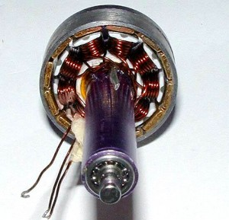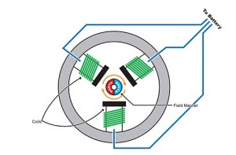
Generally brushless motors spin in much higher speed and use less power at the same speed than DC motors. Also brushless motors don’t lose power in the brush-transition like the DC motors do, so it’s more energy efficient.
Brushless motors come in many different varieties, where the size and the current consumption differ. When selecting your brushless motor you should take care of the weight, the size, which kind of propeller you are going to use, so everything matches up with the current consumption. When looking for the brushless motors you should notice the specifications, especially the “Kv-rating“.
The Kv-rating indicates how many RPMs (Revolutions per minute) the motor will do if provided with x-number of volts. The RPMs can be calculated in this way: RPM=Kv*U An easy way to calculate rating of motor you need, check out the online calculator eCalc. It’s an amazing tool that helps you decide what components to purchase depending on the payload that you want to carry.
Make sure you buy the counter-rotating to counteract the torque effect of the props.

Propellers
On each of the brushless motors there are mounted a propeller.
You might not have noticed this on the pictures, but the 4 propellers are actually not identical. You will see that the front and the back propellers are tilted to the right, while the left and right propellers are tilted to the left.
Like I mentioned before, 2 rotors rotates in the opposite directions to the other two to avoid body spinning. By making the propeller pairs spin in each direction, but also having opposite tilting, all of them will provide lifting thrust without spinning in the same direction. This makes it possible for the QuadCopter to stabilize the yaw rotation, which is the rotation around itself.

The propellers come in different diameters and pitches (tilting). You would have to decide which one to use according to your frame size, and when that decision is made you should chose your motors according to that. Some of the standard propeller sizes used for QuadCopters are:
- EPP1045 10 diameter and 4.5 pitch this is the most popular one, good for mid-sized quads
- APC 1047 10 diameter and 4.7 pitch much similar to the one above
- EPP0845 8 diameter and 4.5 pitch regularly used in smaller quads
- EPP1245 12 diameter and 4.5 pitch used for larger quads which requires lot of thrust
- EPP0938 9 diameter and 3.8 pitch used in smaller quads
Aerodynamics is just way too complex for non-academic hobbyists. It’s even unlikely we can explain all that theory stuff in a few words. But in general when selecting propellers you can always follow these rules:
- The larger diameter and pitch the more thrust the propeller can generate. It also requires more power to drive it, but it will be able to lift more weight.
- When using high RPM (Revolutions per minute) motors you should go for the smaller or mid-sized propellers. When using low RPM motors you should go for the larger propellers as you can run into troubles with the small ones not being able to lift the quad at low speed.

Analysis of Propeller Pitch, Diameter, and RPM
Pitch VS Diameter: the diameter basically means area while pitch means effective area. So with the same diameter, larger pitch propeller would generate more thrust and lift more weight but also use more power.
A higher RPM of the propeller will give you more speed and maneuverability, but it is limited in the amount of weight it will be able to lift for any given power. Also, the power drawn (and rotating power required) by the motor increases as the effective area of the propeller increases, so a bigger diameter or higher pitch one will draw more power at the same RPM, but will also produce much more thrust, and it will be able to lift more weight.

In choosing a balanced motor and propeller combination, you have to figure out what you want your quadcopter to do. If you want to fly around stably with heavy subject like a camera, you would probably use a motor that manages less revolutions but can provide more torque and a longer or higher pitched propeller (which uses more torque to move more air in order to create lift).

ESC – Electronic Speed Controller
The brushless motors are multi-phased, normally 3 phases, so direct supply of DC power will not turn the motors on. Thats where the Electronic Speed Controllers (ESC) comes into play. The ESC generating three high frequency signals with different but controllable phases continually to keep the motor turning. The ESC is also able to source a lot of current as the motors can draw a lot of power.
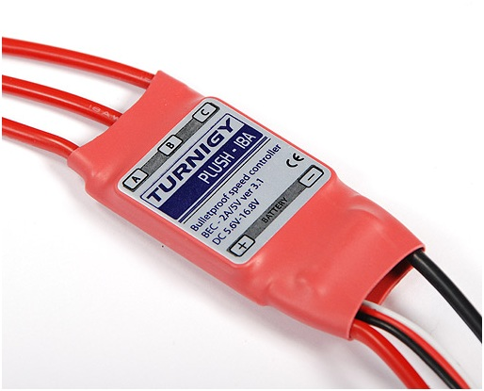
The ESC is an inexpensive motor controller board that has a battery input and a three phase output for the motor. Each ESC is controlled independently by a PPM signal (similar to PWM). The frequency of the signals also vary a lot, but for a Quadcopter it is recommended the controller should support high enough frequency signal, so the motor speeds can be adjusted quick enough for optimal stability (i.e. at least 200 Hz or even better 300 Hz PPM signal). ESC can also be controlled through I2C but these controllers are much more expensive.
When selecting a suitable ESC, the most important factor is the source current. You should always choose an ESC with at least 10 A or more in sourcing current as what your motor will require. Second most important factor is the programming facilities, which means in some ESC you are allowed to use different signals frequency range other than only between 1 ms to 2 ms range, but you could change it to whatever you need. This is especially useful for custom controller board.

Battery
As for the power source of the quadcopter, I would recommend LiPo Battery because firstly it is light, and secondly its current ratings meet our requirement. NiMH is also possible. They are cheaper, but it’s also a lot heavier than LiPo Battery.
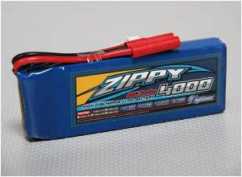

Battery Voltage
LiPo battery can be found in a single cell (3.7V) to in a pack of over 10 cells connected in series (37V). A popular choice of battery for a QuadCopter is the 3SP1 batteries which means three cells connected in series as one parallel, which should give us 11.1V.

Battery Capacity
As for the battery capacity, you need to do some calculations on:
- How much power your motors will draw?
- Decide how long flight time you want?
- How much influence the battery weight should have on the total weight?
A good rule of thumb is that you with four EPP1045 propellers and four Kv=1000 rated motor will get the number of minutes of full throttle flight time as the same number of amp-hours in your battery capacity. This means that if you have a 4000mAh battery, you will get around 4 minutes of full throttle flight time though with a 1KG total weight you will get around 16 minutes of hover.

Battery Discharge Rate
Another important factor is the discharge rate which is specified by the C-value. The C-value together with the battery capacity indicates how much current can be drawn from the battery.
Maximum current that can be sourced can be calculated as:
MaxCurrent = DischargeRate x Capacity
For example if there is a battery that has a discharge rate of 30C and a capacity of 2000 mAh. With this battery you will be able to source a maximum of 30Cx2000mAh = 60A. So in this case you should make sure that the total amount of current drawn by your motors won’t exceed 60A.
This tutorial about battery I found very informative.

IMU – Inertial Measurement Unit
The Inertial Measurement Unit (IMU) is an electronic sensor device that measures the velocity, orientation and gravitational forces of the quadcopter. These measurements allow the controlling electronics to calculate the changes in the motor speeds.
The IMU is a combination of the 3-axis accelerometer and 3-axis gyroscope, together they represent a 6DOF IMU. Sometimes there is also an additional 3-axis magnetometer for better Yaw stability (in total 9DOF).

How does IMU work
The accelerometer measures acceleration and also force, so the downwards gravity will also be sensed. As the accelerometer has three axis sensors, we can work out the orientation of the device.
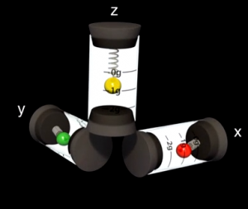
A gyroscope measure angular velocity, in other words the rotational speed around the three axis.
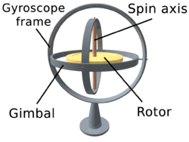

Using Only Accelerometer?
With the accelerometer alone, we should be able to measure the orientation with reference to the surface of earth. But the accelerometer tends to be very sensitive and unstable sometimes, when motor vibration is bad, it could mess up the orientation. Therefore we use a gyroscope to address this problem. With both the accelerometer and gyroscope readings we are now able to distinguish between movement and vibration.

Using Only Gyroscope?
Since the gyroscope can tell us the rotational movement, why can’t we just use the gyroscope alone?
The gyroscope tends to drift a lot, which means that if you start rotating the sensor, the gyroscope will output the angular velocity, but when you stop it doesn’t necessarily go back to 0 deg/s. If you then just used the gyroscope readings you will get an orientation that continues to move slowly (drifts) even when you stopped rotating the sensor. This is why both sensors has to be used together to calculate a good and useful orientation.

Magnetometer
The accelerometer cannot sense yaw rotation like it can with roll and pitch, and therefore a magnetometer is sometimes used.
A magnetometer measures the directions and strength of the magnetic field. This magnetic sensor can be used to determine which way is south and north. The pole locations are then used as a reference together with the Yaw angular velocity around from the gyroscope, to calculate a stable Yaw angle.
I am trying to keep the theory and maths minimal here, and I will go into more detail in the next couple of tutorials.

Buying an IMU
These three sensors are available individually on the market. But it is easier for development to get an IMU sensor board with the first two sensors (6DOF) or all three sensors (9DOF).
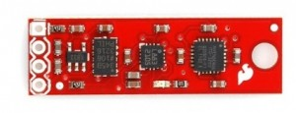
The raw sensor boards can communicate with the microcontroller via I2C or analogue. Digital boards that support I2C is easier and faster for development, but Analogue ones are cheaper.
There are even complete IMU units with processor available. Usually the processor is a small 8-bit microprocessor which runs computations some kind of algorithms to work out the Pitch, Roll and Yaw. The calculated data will then be put out on a serial bus or sometimes also available by I2C or SPI.
The choice of IMU is going to narrow down what type of controller board you can use. So before purchasing an IMU boards you should find out information about the controller boards. Some controller boards even comes with built-in sensors.
Some commercially available IMU sensors boards:
- Sparkfun 9DOF stick
- Sparkfun 6DOF combo board
- FreeIMU
IMU with processor:
- Sparkfun 9DOF Razor
- Mongoose 9DOF (10DOF)
- ArduIMU

Microcontroller – Controlling electronics
You can either buy a controller board that is specially designed for quadcopter or buy all the parts and assemble one yourself. Some of the controller boards already contain the required sensors while other requires you to buy these on a separate board.

Assembling You Own Quadcopter Controller Board
[Coming soon]

Selecting A Ready To Go Controller Board
Here are some of the quadcopter controller boards that I stumbled upon with Google.
- AeroQuad
- ArduPilot
- OpenPilot Copter Control
- ROFL
- KK Multicopter
The AeroQuad MEGA Shield The AeroQuad board is a shield for the Arduino, either the Arduino UNO or the Arduino MEGA. The AeroQuad board requires the Sparkfun 9DOF stick which is soldered to the shield.
The ArduPilot board contains an ATMEGA328, the same as on the Arduino UNO. Like the AeroQuad shield this board doesn’t contain any sensors either. You would have to buy the ArduIMU and connect it to the board to use it.
The OpenPilot is a more advanced board which contains a 72MHz ARM Cortex-M3 processor, the STM32. The board also includes a 3-axis accelerometer and 3-axis gyroscope. Together with the board comes a great piece of software for the PC to calibrate, tune and especially set waypoints for your QuadCopter if you have installed a GPS module which I will be talking more about in the next section.
QuadCopters can be programmed and controlled in many different ways but the most common ones are by RC transmitter in either Rate (acrobatic) or Stable mode. The difference is the way the controller board interprets the orientations feedback together with your RC transmitter joysticks.
In Rate mode only the Gyroscope values are used to control the quadcopter. The joysticks on your RC transmitter are then used to control and set the desired rotation speed of the 3 axes, though if you release the joysticks it does not automatically re-balance. This is useful when doing acrobatics with your quadcopter as you can tilt it a bit to the right, release your joysticks, and then your quadcopter will keep that set position.
For the beginners the Rate mode might be too difficult, and you should start with the Stable mode. All the sensors are used to determine the quadcopters orientation in the stable mode. The speed of the 4 motors will be adjusted automatically and constantly to keep the quadcopter balanced. You control and change the angle of the quadcopter with any axis using the joystick. For example to go forward, you can simply tilt one of the joysticks to change the pitch angle of the quadcopter. When releasing the joystick, the angle will be reset and the quadcopter will be balanced again.

RC Transmitter
[Coming soon]

Optional Components
After buying all the necessary parts, and you are still not broke, you might consider other popular optional components such as GPS modules, ultrasonic sensors, barometers etc. They can enhance the performance of your quadcopter, and bring more features.
A GPS module talks to the satellite and retrieve accurate location information. We can use this information to calculate speed and path. It is especially useful for autonomous quadcopters which needs to know its exact position and which way to fly.
An ultrasonic sensor measures the distance to the ground, i.e. altitude. This is useful if you want to keep your quadcopter a certain distance from the ground without having to adjust the height it’s flying at constantly yourself. Most of these sensors has a range between 20cm to 7m.
When you gets higher, you might want to use a barometer. This sensor measures humidity and pressure to work out the altitude, so when the quadcopter is close to the ground (where these two factors doesn’t change much), it becomes ineffective. Therefore it is also common to use both of them at the same time.

Conclusion
Hopefully this article has given you a better understanding what each part of the quadcopter does, and how to go about selecting the right product for your quadcopter.
Please do not hesitate writing a comment or giving us some feedback on this article. The next post will be about the software side of the quadcopter.

