BIO BATTERY

ABSTRACT
A bio-battery is an energy storing device that is powered by organic compounds, usually being glucose, such as the glucose in human blood. When enzymes in our bodies break down glucose, several electrons and protons are released. Therefore, by using enzymes to break down glucose, bio-batteries directly receive energy from glucose. These batteries then store this energy for later use. This concept is almost identical to how both plants and many animals obtain energy. Although the batteries are still being tested before being commercially sold, several research teams and engineers are working to further advance the development of these batteries.
Carbohydrates (glucose) are broken down to release energy and generate electricity. This bio battery, which is based on mechanisms used in living organism, is not only friendly to the environment but also has great potential for use as an energy source. This prototype bio battery has achieved the world’s highest power output of 50 mW*2 when employed for a passive type*1 system.
I.INTRODUCTION
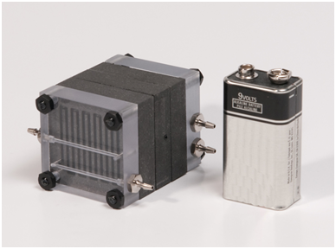
Types of Bio Batteries
Sony successfully demonstrated bio battery powered music playback with a memory type Walkman and passive speakers (which operate on power supplied by the Walkman) by connecting four bio battery units in series. The case of this bio battery, which is made from an organic plastic (polylactate), is designed to be reminiscent of a living cell.

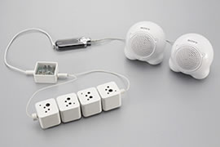
Bio Batteries used to power a Walkman

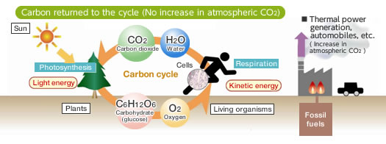

Unlike fossil fuels, carbohydrates (glucose) are carbon neutral and do not contribute to increases in carbon dioxide.
Plants create both carbohydrates and oxygen by photosynthesis from carbon dioxide and water. Animals take up those carbohydrates and oxygen and utilize them as an energy source and release carbon dioxide and water. Then this cycle starts again. Since the carbon dioxide is recycled in this system, the amount of carbon dioxide in the atmosphere does not increase. If electrical energy could be directly acquired from this cycle, we could obtain more environmentally friendly energy than that from fossil fuels. Furthermore, renewable energy sources such as glucose (which is present in plants and therefore abundantly available) have an extremely high energy density. Therefore, this bio battery, which is based on Energy for activity, that is the ATP and thermal energy commonly used in the living organism, can be obtained from the exchange of the electrons and protons through these two enzymatic reactions. To take advantage of this living organism mechanism, the energy for activity from inside the organism must be removed outside the organism as electrical energy.
That is, when the electrons and protons move from enzyme to enzyme, it is necessary to extract just the electrons and divert them through a separate path. Thus Sony used an electron transport mediator so that electrons could be exchanged smoothly between the enzymes and the electrodes that are the entrance and exit to that detour. The principles of the bio battery are based on the energy conversion mechanism in living organisms. However, in order to create the bio battery, several technologies needed to be developed. These include immobilization of enzymes that are normally incompatible with carbon and metal electrodes, electrode structures, and electrolytes. Mechanisms used in living organisms, is not only friendly to the environment but is also likely to be of practical use as an energy source. Sony has focused on these advantages since 2001 and has developed an electrical power generation device that uses mechanisms similar to those in living organisms.
II.HOW DOES IT WORK?

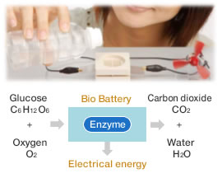

A Bio-Battery battery consists of two different metals suspended in an acidic solution. They contain an anode, cathode, separator and electrolyte, which are the basic components to any cell battery. Each component is layered on top of another component. Anodes and cathodes are the negative and positive areas on a battery. The anode is located at the top of the battery and the cathode is located at the bottom of the battery.[Anodes are components that allow electrons to flow in from outside the battery, whereas cathodes are devices that allow current to flow out from the battery.
Between the anode and the cathode lies the electrolyte which contains a separator. The main function of the separator is to keep the cathode and anode separated, to avoid electrical short circuits. This system as a whole, allows for a flow of protons (H+) and electrons (e-) which ultimately generate electricity.
The movement of protons has a moving force that pushes, this movement is called current. When this moving force (current) is measured, it is measured it what is called voltage or volts. This moving force is going to make the LED light up.

III.THE Mechanism Behind Bio Battery
Like a conventional fuel cell battery, Bio Battery basically consists of an anode, cathode, electrolyte and separator. However, Bio Battery has certain specific characteristics. First, biological enzymes are used as catalysts for the anode and cathode. Second, enzymes and electronic mediators (which transfer electrons between enzymes, and between enzymes and electrodes) are fixed on the anode and cathode.
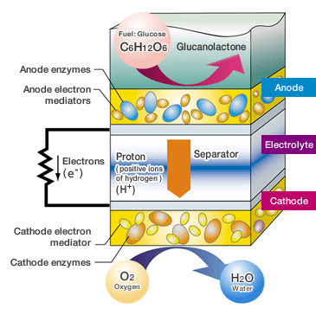Glucose is broken down on the anode side of the battery, producing protons (H⁺) and electrons (e⁻). The protons (H⁺) are transferred to the cathode side through the separator, while the electrons (e⁻) are transported to the cathode side through the mediator, which transfers them to the external circuit. The cathode uses the enzymes to drive an oxygen-reduction reaction which ultimately produces water using both the protons (H⁺) and the electrons (e⁻) transferred from the anode. These reactions at the anode and cathode generate electric energy by creating proton (H⁺) and electron (e⁻) flow in the cell system.

IV.ADVANTAGES
A significant advantage that bio-batteries have in comparison to other batteries is their ability to allow an instant recharge.In other words through a constant supply of sugar, or glucose, bio batteries are able to continuously keep themselves charged without an external power supply. Bio batteries are also a source of non-flammable, and non-toxic fuel. This provides a clean alternative renewable power source.

V.DISADVANTAGES
Compared to conventional batteries, such as lithium batteries, bio-batteries are less likely to retain most of their energy. This causes a problem when it comes to long term usage and storage of energy for these batteries. However, researchers are continuing to develop the battery in order to make it a more practical replacement for current batteries and sources of energy.
VI.APPLICATIONS
- Military Applications:
Unmanned detection of dangerous chemical/bio agents and Remote survelliances,
Soldier portable power and recharging.
- Commercial use:
Human implantable power source,
Artificial pancreas.
Backup power and instantaneous recharge for small electronic devices.
- Other Applications:
Bio Battery to power ISR functions and recharge battery.
Power source for next generation helmets, with integrated sensors containing flexible bio battery integrated onto helmet.

VI.FUTURE SCOPE
Bio-batteries have a very bright future ahead of them as test productions and research have been increasing over recent years. They serve as a new form of energy that is proving to be environmentally friendly, as well as successful, in producing and reserving energy.
While many technological challenges still remain, Bio Battery has great potential as a next-generation energy device. Advantages include its excellent harmony with the environment as a product fueled by a carbohydrate (glucose) having high energy density. Sony will continue to work toward the commercialization of this technology in the near future, initially for use in toys and other low-power products. The longer-term goal in this area is to further enhance performance to ultimately develop batteries suitable for notebook computers and other mobile devices.
VII.CONCLUSION
The technology generates electricity by turning shredded paper into sugar which in turn is used as fuel. If brought to market, the innovation could allow the public to top up the power of their mobile devices using waste material. The bio-batteries are environmentally friendly as they did not use harmful chemicals or metals.
While many exciting announcements have been made in the field of bio-batteries, it may be some time before we see them replacing nickel-cadmium, lithium-ion or the several other types of traditional batteries. Even so, the small, flexible, long-lasting and environmentally friendly battery technologies discussed here show the great possibilities researchers see in bio-batteries, especially for the field of medicine. With that in mind, scientists seem to be exploring every possible option in bio-battery and fuel-cell technology.

