BIOBATTERY
DEFINITION:
Bio battery (bio fuel cells use biocatalysts , either bio-molecules such as enzymes of even whole living organisms (microbes) to catalyze oxidation of biomass-based materials for generating electrical energy.
Energy (obtained from food through enzymatic reactions) is the basis of human movement. Enzymes are special proteins that facilitate chemical reactions inside our bodies. Sony's Bio Battery uses this same principle to produce electric energy. It is an extremely safe form of energy production since the fuel (glucose) is a carbohydrate just like bread or rice. Because glucose is a clean energy source---produced by plants through photosynthesis (a process that involves the absorption of CO2)---Bio Battery is also an eco-battery

Electric Eel Cells Inspire Energy Source

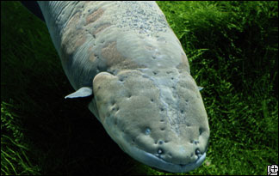
Oct. 21, 2008 -- The same cells electric eels use to shock predators and prey can be engineered to power implanted biomedical devices, say researchers from Yale University and the National Institute of Standards and Technology (NIST).
"We now understand how the natural electric eel cells work," said David LaVan of NIST. "Now we can think about how we can use those cells to power medical devices."
Natural electric eel cells generate and release electric pulses of more than 500 volts with eight different channels and pumps.
By pumping positively charged potassium and sodium ions out of the cell, the number of negatively charged ions inside the cells rises. Opening certain channels causes electrons to flood out of the cell, producing enough electricity to stun the eel's victim.
Using computer models, the scientists experimented with different combinations of those eight pumps and channels. A cell with four pumps and channels was easier to make but only about four percent as efficient at converting sugar to electricity.
Surprisingly, by eliminating one pump (an "evolutionary leftover," as LaVan calls it) and adjusting the ratio of the other pumps and channels, the scientists designed a cell that was both powerful and energy efficient.
"It's like having a Ferrari that is also the most fuel-efficient car in the world," said LaVan. Natural electric eel cells are about 14 percent efficient at converting sugar into electricity, compared to 19 percent for the engineered cells.

Living Organisms and Energy

Plants, during photosynthesis, use sunlight as an energy source to convert water and carbon dioxide into carbohydrates (glucose) and oxygen. Animals, on the other hand, obtain the energy they need by taking in oxygen through respiration and consuming carbohydrates from food. They emit (produce) carbon dioxide and water. Glucose has an extremely high energy density. For example, a 150g serving of rice, which includes large amounts of glucose, contains 240kcal of energy. This is equivalent to 96 AA batteries. As an extremely stable substance, glucose is also easy to handle, in the sense that there is no risk of injury to living organisms resulting from spontaneous collapse accompanied by a catastrophic release of energy. This is a vital requirement for an energy source to be used to support life.
- 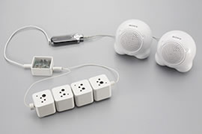
Bio Batteries were used to power a Walkman at this press event in August 2007
How do living organisms extract energy from glucose? Biological catalysts known as"enzymes" play a key role in this process. Enzymes are known to accelerate extremely specialized reactions in the body. We also know that several types of enzymes can work together to break down stubborn substances, such as glucose, into carbon dioxide. The processes involved include the glycolytic pathway and the citric acid cycle. Flows of electrons and protons (positive ions of hydrogen) released through the breakdown of these substances inside living things are used to convert energy into various forms, including heat and chemical energy, which are used to maintain biological activity. Bio Battery extracts energy directly from a carbohydrate (glucose) using the power of enzymes, which play a central role in systems used by many living organisms to obtain energy (*2). Sony pioneered the development of cells based on this technology, and (in August 2007) was able to operate a Walkman using four cells arranged in series producing 50mW/40cc (1.25mW/cc) per unit (*3).

The Mechanism behind Bio Battery

Like a conventional fuel cell battery, Bio Battery basically consists of an anode, cathode, electrolyte and separator. However, Bio Battery has certain specific characteristics. First, biological enzymes are used as catalysts for the anode and cathode. Second, enzymes and electronic mediators (which transfer electrons between enzymes, and between enzymes and electrodes) are fixed on the anode and cathode.
- 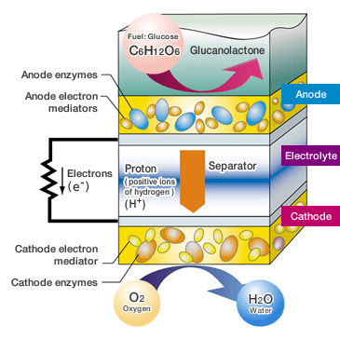

How the Bio Battery Works
Glucose is broken down on the anode side of the battery, producing protons (H⁺) and electrons (e⁻). The protons (H⁺) are transferred to the cathode side through the separator, while the electrons (e⁻) are transported to the cathode side through the mediator, which transfers them to the external circuit. The cathode uses the enzymes to drive an oxygen-reduction reaction which ultimately produces water using both the protons (H⁺) and the electrons (e⁻) transferred from the anode. These reactions at the anode and cathode generate electric energy by creating proton (H⁺) and electron (e⁻) flow in the cell system.
Refining the Technology to Increase Output

As described above, enzymes and electron mediators are immobilized on the anode and cathode of Bio Battery. The enzymes that need to be immobilized on the anode are glucose dehydrogenase and diaphorase, and the mediators are 2-methyl-1,4-naphthoquinone (vitamin K3, VK3) and nicotinamide adenine dinucleotides (NAD(H)). The immobilizing method selected by Sony to meet these requirements was a poly-ion complex method based on an anionic polymer, polyacrylate, and a cationic polymer, poly-L-lysine (PLL) (*4, 5). PLL is also used to immobilize the enzyme, bilirubin oxidase and the electron mediator (potassium ferricyanide) onto the cathode. The cathode is exposed to the air to create a three-phase interface among oxygen, water and the enzymes (*4). A highly-concentrated electrolyte (phosphate buffer solution, pH7, 1M) was chosen to ensure the efficient transfer of protons into the porous carbon electrodes. As a result, Sony was able to achieve an extremely high output of 1.5mW/cm²@0.3V by 2007 (*3).
- 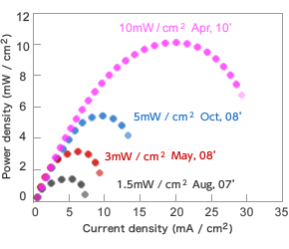
Trends in Bio Battery Output Performance per Unit of Electrode Area
Sony has since improved output to 3mW/cm²@0.5V (*5) by changing the anode electron mediator from VK³ to 2- amino-1, 4-naphthoquinone (ANQ), and to 5mW/cm²@0.5V by using a new electrolyte, an imidazole buffer solution (2M, pH7) (*6). In April 2010, the power density was doubled to 10mW/cm²@0.5V (*7, 8) by using a water-repellent cathode, which can still function even when immersed in the electrolyte, instead of the exposed cathode that had been used previously. Over the past few years, Sony has also begun to achieve positive results with a number of other initiatives. These include the addition of another enzyme on the anode to carry out a secondary decomposition of gluconic acid produced by the breakdown of glucose, and the use of biotechnology to develop highly-durable artificial enzymes (*7,9,10).
Sony is progressively creating and testing new prototypes based on these technologies. By the time of the International Hydrogen & Fuel Cell Expo (FC EXPO 2009) in February 2009, the technology had progressed to the stage where power density reached 5mW/cm², and Sony was able to demonstrate a Walkman powered by a battery that was half the size of earlier units. At Toy Forum 2010 on January 18 and 19, Sony was able to demonstrate a 10mW/cm² cell mounted in a compact remote-controlled car prototype manufactured by TOMY Company, Ltd. This product attracted keen interest as an eco toy car.
- 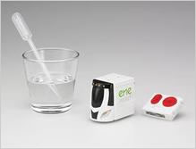A remote-controlled car equipped with Bio Battery was demonstrated at Toy Forum 2010.

Sony Develops "Bio Battery" Generating Electricity from Sugar
TOKYO, August 23, 2007- Sony today announced the development of a bio battery¹ that generates electricity from carbohydrates (sugar) utilizing enzymes as its catalyst, through the application of power generation principles found in living organisms.
Test cells of this bio battery have achieved power output of 50 mW, currently the world's highest level² for passive-type³ bio batteries. The output of these test cells is sufficient to power music play back on a memory-type Walkman.
In order to realize the world's highest power output, Sony developed a system of breaking down sugar to generate electricity that involves efficiently immobilizing enzymes and the mediator (electronic conduction materials) while retaining the activity of the enzymes at the anode. Sony also developed a new cathode structure which efficiently supplies oxygen to the electrode while ensuring that the appropriate water content is maintained. Optimizing the electrolyte for these two technologies has enabled these power output levels to be reached.
Sugar is a naturally occurring energy source produced by plants through photosynthesis. It is therefore regenerative, and can be found in most areas of the earth, underlining the potential for sugar-based bio batteries as an ecologically-friendly energy device of the future.
Sony will continue its development of immobilization systems, electrode composition and other technologies in order to further enhance power output and durability, with the aim of realizing practical applications for these bio batteries in the future.
The research results presented here have been accepted as an academic paper at the 234th American Chemical Society National Meeting & Exposition in Boston, MA USA, and were announced at 11 am local time on August 22, 2007.

The bio battery mechanism
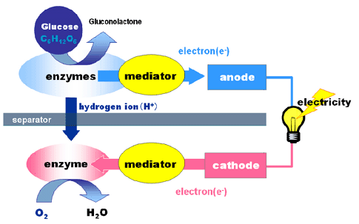The newly developed bio battery incorporates an anode consisting of sugar-digesting enzymes and mediator, and a cathode comprising oxygen-reducing enzymes and mediator, either side of a cellophane separator. The anode extracts electrons and hydrogen ions from the sugar(glucose) through enzymatic oxidation as follows:
Glucose -> Gluconolactone + 2 H⁺ + 2 e⁻
The hydrogen ion migrates to the cathode through the separator. Once at the cathode, the hydrogen ions and electrons absorb oxygen from the air to produce water:
(1/2) O₂ + 2 H⁺ + 2 e⁻ -> H₂O
Through this process of electrochemical reaction, the electrons pass through the outer circuit to generate electricity.

Key achievements of this bio battery research and development
1) Technology to enhance immobilization of enzymes and mediator on the electrode
For effective glucose digestion to occur, the anode must contain a high concentration of enzymes and mediator, with their activity retained. This technology uses two polymers to attach these components to the anode. Each polymer has opposite charge so the electrostatic interaction between the two polymers effectively secures the enzymes and mediator. The ionic balance and immobilization process have been optimized for efficient electron extraction from the glucose.
2) Cathode structure for efficient oxygen absorption
Water content within the cathode is vital to ensuring optimum conditions for the efficient enzymatic reduction of oxygen. The bio battery employs porous carbon electrodes bearing the immobilized enzyme and mediator, which are partitioned using a cellophane separator. The optimization of this electrode structure and process ensures the appropriate water levels are maintained, enhancing the reactivity of the cathode.
3) Optimization of electrolytes to meet the bio battery cell structure
A phosphate buffer of approximately 0.1 M is generally used within enzymology research, however an unusually high 1.0 M concentration buffer is used in this bio battery. This is based on the discovery that such high concentration levels are effective for maintaining the activity of enzymes immobilized on the electrodes.
4) Test cell combining high-power output and compact size
The test cells of these high-power, compact bio batteries have been fabricated using these three technologies. The bio battery does not require mixing, or the convection of glucose solution or air; as it is a passive-type battery, it works simply by supplying sugar solution into the battery unit. The cubic (39 mm along each edge) cell produces 50 mW, representing the world's highest power output among passive-type bio batteries of comparable volume. By connecting four cubic cells, it is possible to power a memory-type Walkman (NW-E407) together with a pair of passive-type speakers (no external power source). The bio battery casing is made of vegetable-based plastic (polylactate), and designed in the image of a biological cell.

Bio battery technical specifications
Enzymes | : | Glucose dehydrogenase and diaphorase (anode)  Bilirubin oxidase (cathode)
Mediators | : | Vitamin K3 and cofactor NADH (anode)  Potassium ferricyanide (cathode)
Electrode | : | Porous carbon
Current collector | : | Titanium mesh
Separator | : | Cellophane
Glucose solution | : | 0.4 M glucose in 1.0 M sodium phosphate buffer, pH 7.0
Maximum output | : | 1.5 mW/cm² (0.3V, 5 mA/cm²) at 1 min after connection
OCV | : | 0.8V

Bio battery test cell specifications
Dimensions | : | 39 (width) x 39 (height) x 39 (depth) mm
Volume | : | 40 cc (without casing)
Maximum output | : | 50 mW

Reference
  - Bio battery
An electricity generation device that utilizes energy sources such as carbohydrates, protein, amino acids, fat by digesting enzymes. Since 2001, Sony's research has been supported by Professor Kenji Kano's laboratory (formerly professor Tokuji Ikeda's laboratory) at the Division of Applied Life Sciences, Graduated School of Agriculture, Kyoto University, Kyoto, Japan, which specializes in bioelectrochemistry. The results presented here are based on Sony's original technological developments, inspired by the lab's advanced research activities.
2. 50 mW: World's highest power output as of August 23, 2007, based on Sony research.
3. Passive-type battery
A system in which reactive substances such as glucose and oxygen are absorbed into electrodes through a process of natural diffusion. In contrast, systems in which reactive substances are supplied by force (stirring, convection) are referred to as "active-type". In general, passive-type systems have a more simple structure suitable for miniaturization, whereas active type systems have a more complicated structure and are suited to higher power devices.

Advantages of bio battery

“We’re developing fuel cells, smart grids and environmental control units; harvesting wind and solar power; and examining waste-to-energy and biofuels. But one of the more novel projects we’re developing is a power source which converts commonly available sugars directly into electrical energy.
“The bio-battery (enzymatic fuel cell) uses enzymes to convert sugar into energy similar to the way your body uses enzymes to convert food into energy. Researchers have spent the last five years working on a unique recipe for a reproducible, stable bio-battery which is both low cost and green.
“The bio-battery has numerous advantages over existing batteries. The biggest of which is that it allows for instant recharge (through supply of more sugar) in comparison with traditional batteries which require access to power for two or more hours.
“In comparison to fuel cells, the bio-battery has the advantage of a non-toxic, non-flammable fuel source (sugar) which is already in the Army supply chain. This is a huge logistics bonus considering the military’s one-fuel-forward policy makes providing methanol, hydrogen and other alternative fuels difficult.
“The promise of the technology was recently demonstrated at the [2010] Power Sources Conference (sponsored by the Army) where the bio-battery was connected to an electronic device comprising a Microprocessor and LCD display. The bio-battery was able to power the system for over 10 hours using less than 20mL (milliliters, or about four teaspoons) of sugar solution. The current intent of this innovative technology is to integrate it with military systems and demonstrate it in field trials in 2011.”
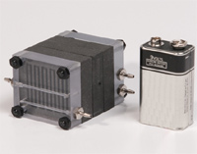
Other enzymatic solutions apparently abound. This technology could be used with the enzymes inhuman blood to power implants such as defibrillators, pacemakers, and drug dispensing mechanisms. It would seem that such devices come with a lifetime warranty. Probably not immediately transferrable to aircraft powerplant use, such solutions presage other developments, including the use of human urine to power batteries.
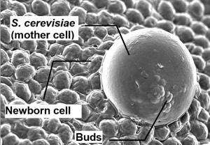
blood powered battery for implants
Nokia has even shown a soft drink-powered cell phone, using a commodity usually easier to find than a charging station or available electrical socket.

Daizi Zheng, inventor of the telephone, explains, “This is a client project aimed at designing an eco-friendly phone for Nokia. As a result of my research, I discovered that conventional phone batteries are: expensive, harmful to the environment and difficult to dispose of. In addition, the conventional battery manufacturing process consumes many valuable resources. The concept is based on the idea to create a pollution free environment by using bio-batteries as an alternative to conventional batteries. A bio-battery is an ecologically friendly, energy supply system which uses enzymes as a catalyst to generate electricity from carbohydrates (currently sugar). In order to use the bio-battery as a power source for the phone all that is required is a small supply of a sugary drink. Once the battery dies only oxygen and water remains. Bio-batteries are fully biodegradable and have, on a single charge, a potential life-span three to four times longer than conventional lithium batteries. Meanwhile, bio-batteries are a whole new way of looking at batteries and afternoon tea.”
Paper battery offers future power
The black piece of paper can power a small light
Flexible paper batteries could meet the energy demands of the next generation of gadgets, says a team of researchers.
They have produced a sample slightly larger than a postage stamp that can store enough energy to illuminate a small light bulb.
While a conventional battery contains a number of separate components, the paper battery integrates all of the battery components in a single structure, making it more energy efficient.
Integrated devices
The research appears in the Proceedings of the National Academy of Sciences (PNAS).
You can implant a piece of paper in the body and blood would serve as an electrolyte
Professor Robert Linhardt
The battery contains carbon nanotubes, each about one millionth of a centimetre thick, which act as an electrode. The nanotubes are embedded in a sheet of paper soaked in ionic liquid electrolytes, which conduct the electricity.
The flexible battery can function even if it is rolled up, folded or cut.
Because the battery consists mainly of paper and carbon, it could be used to power pacemakers within the body where conventional batteries pose a toxic threat.
"I wouldn't want the ionic liquid electrolytes in my body, but it works without them," said Professor Linhardt. "You can implant a piece of paper in the body and blood would serve as an electrolyte."
A pacemaker is a small device that's placed in the chest or abdomen to help control abnormal heart rhythms. This device uses electrical pulses to prompt the heart to beat at a normal rate.
A pacemaker can relieve some arrhythmia symptoms, such as fatigue and fainting. A pacemaker also can help a person who has abnormal heart rhythms resume a more active lifestyle.
Virus made to build tiny electrodes Bio-battery could power cars in future Technology: iPod, gadget reviews
SCIENTISTS have engineered a virus that could form a battery three times more powerful than those found in gadgets today.
The bio-battery could conceivably power mp3 players, mobile phones, and possibly even a car.
The genes in the virus, dubbed M13, were modified to collect negatively charged particles and build a powerful, tiny electrode out of metal compounds and carbon nanotubes.
Such an electrode can produce more power faster than lithium batteries, which currently power most gadgets.
"It has some of the same capacity and energy power performance as the best commercially available state-of-the-art batteries," said Angela Belcher, the Massachusetts Institute of Technology (MIT) scientist leading the research.
"We could run an iPod on it for about three times as long as current iPod batteries. If we really scale it, it would be used in a car," she added.
However such scaling is not even close, she cautioned.
The original virus was common type which infects bacteria but not humans.

Aplications:
- Paper bio battery could be used to power medical devices like hearing aid & pacemakers
- Sony used its sugar bio battery to power music play back on a memory type walkman.
- Using a miniature bio battery enabled to test the blood insulin level of diabetic patient.
Drawbacks:
- Enzymes get denatured with temperature ,ph etc changes thus power production is lost.
- The power production per cell is relatively low compared to the available batteries.

