3D Optical Data Storage

What is Optical Data Storage?
Conventional storage systems make use of magnetism and semiconductor technologies for data storing in CDs and DVDs. Optical data storage is different from that. Before talking about how the three dimensional data storage works, I shall give a very brief introduction on optical data storage. The storage is done on an Optically Readable Medium. An optical drive writes data onto the optically readable medium i.e. a storage disc. It uses a laser beam to burn pits (or bumps) into the special material on the disc. This data stream is placed in a spiral path, in this case the data begins at the innermost track and works its way out toward the edge of the disc. An optical drive is a device in a computer that can read CD-ROMs or other optical discs. It is estimated that in the year 2007, optical storage represents 27% of the world's technological capacity to store information.

What is 3D About It?
Here, information can be recorded and/or read with three-dimensional resolution (as opposed to the two dimensional resolution afforded, for example, by CD). 3D optical data storage is an experimental storage technology. It is predicted to offer exponentially more storage capacity than today’s data storage technologies. Researchers have developed working 3D optical data storage devices. But the technology is not yet commercially available due to design issues. We’ll talk about the challenges later. It shall be clear as I describe.

How Does It Differ from Other Data Storage Devices?
This innovation has the potential to provide petabyte-level (1024 TB) mass storage on DVD-sized disks. Current optical data storage media are the CD and DVD. They store data as a series of reflective marks on an internal surface of a disc. In order to increase storage capacity, two or even more of these data layers may be added. But their number is severely limited. The laser interacts with every layer that it passes through on the way to and from the addressed layer. These interactions cause noise that limits the technology to approximately 10 layers.
3D optical data storage methods dodge this issue by using methods where only the specifically addressed voxel (volumetric pixel) interacts substantially with the addressing light. This requires nonlinear data reading and writing methods, in particular nonlinear optics. Here also the laser light must travel through other data points till it reaches the point where reading or recording is desired. Nonlinearity ensures that these other data points do not interfere with the addressing of the desired point.

How is It Constructed?
A prototypical 3D optical data storage system may use a disk that looks much like a transparent DVD. The disc contains many layers of information, each at a different depth in the media and each consisting of a DVD-like spiral track. The distance between layers may be 5 to 100 micro meters, allowing >100 layers of information to be stored on a single disc. So the average thickness of a disc can be predicted to be around say 100 times 50 micro meters. This is equal to 5 millimetres. Clearly these discs are going to be thicker than the CDs and DVDs.

Writing and Reading. How is it done?

Writing Processes by Multi-photon Absorption
To record information on the disc a laser is brought to a focus at a particular depth in the media. The depth corresponds to a particular information layer. When the laser is turned on it causes a photochemical change in the media. As the disc spins and the read/write head moves along a radius, the layer is written just as a DVD-R is written. The depth of the focus may then be changed. That initiates another entirely different layer of information written on the disc.
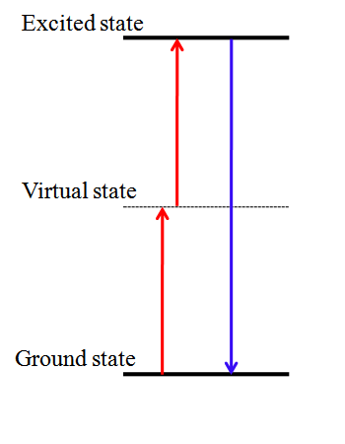
We need to see now how exactly the process of writing takes place. As I mentioned, nonlinear optics is used. Although there are many nonlinear optical phenomena, only multiphoton absorption is capable providing the media the significant energy required to electronically excite molecular species and cause chemical reactions. Two-photon absorption is the strongest multiphoton absorbance by far. But still it is a very weak phenomenon. It is weak because it is a third order nonlinear absorption phenomenon i.e. three orders lower than linear absorption. Two-photon absorption (TPA) is the simultaneous absorption of two photons of identical or different frequencies. The energy difference between the involved lower and upper states of the molecule is equal to the sum of the energies of the two photons. It results in low media sensitivity. Therefore, much research has been directed at providing chromophores with high two-photon absorption cross-sections. What is chromophores? The chromophore is a region in the molecule where the energy difference between two different molecular orbitals falls within the range of the visible spectrum. A chromophore is responsible for its colour.
Writing by 2-photon absorption is achieved by focusing the writing laser on the point where the photochemical writing process is required. The wavelength of the writing laser is chosen such that it is not linearly absorbed by the medium. Therefore it does not interact with the medium except at the focal point. At the focal point intensity is very high and nonlinear effect comes into picture. The 2-photon absorption becomes significant, because it is dependent on the square of the laser flux.
The drawback is, both the photons must arrive simultaneously because one photon alone shall not be absorbed since it is not resonant with the molecular energy levels. The solution is to use resonant photons. This allows the second photon some freedom in arrival time. But again, this no more remains a nonlinear phenomenon then. It compromises the resolution of the data in all layers.

Reading the Data
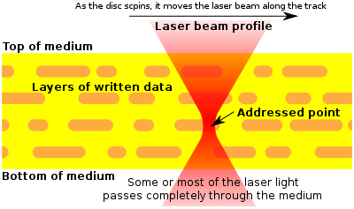
In order to read the data back (in this example), a similar procedure is used. Except this time instead of causing a photochemical change in the media the laser causes fluorescence. This is achieved e.g. by using a lower laser power or a different laser wavelength. The intensity or wavelength of the fluorescence is different depending on whether the media has been written at that point. By measuring the emitted light the data is read.

What are the current challenges?
- Particularly when 2-photon absorption is utilized, high-powered lasers may be required that can be bulky, difficult to cool, and pose safety concerns.
- Since both the reading and the writing of data are carried out with laser beams, there is a potential for the reading process to cause a small amount of writing. In this case, the repeated reading of data may eventually serve to erase it. Although this issue has been attempted to be solved by the use of different bands of absorption for reading and writing.

Let us conclude then
3D Optical Data Storage might be long way away from being commercialized yet. Research is going on in several labs but it is unclear whether it shall sustain in the competition among other techniques that include flash storage and holographic storage etc.

