Atomic Holographic Optical Storage Nanotechnology
— a new archival solution for the professional market

ABSTRACT
Holography has long held promise as a data storage technology with the potential for
vast capacity and high data rates. Recent advances in materials, multiplexing
architectures and components are finally making this vision a reality. These
technical developments are occurring just as we see an explosion in the growth of
“fixed-content” archival information. This articles describes how holographic media
could provide a long-awaited solution for broadcast archives.

KEYWORDS:
Ferroelectric, holographic, storage, volume, UV, atomic switch.

INTRODUCTION
Holographic Storage is an optical technology that allows 1 million bits of data to be written and read out in single flashes of light. Thousands of Holograms can be stored in the samelocation throughout the entire depth of the medium.
For the first time in history, a design concept for fabrication of a laser semiconductor component used for reading/writing data to an optical holographic disk drive storage product will be explained. A unique new approach never tried before by any company, corporation, research facility, university, military, independent private or public research. The FE 3 D Holographic Optical Drive technology plans to push future storage densities of optical mass storage up to 40,000 Terabits/cu.cm. A comparison with 2 D Area magnetic hard drives of today is around at 60 gigabits. Optically assisted 2 D Area drives at 45 gigabits/sq.in. and 2 D Area contact recording AFM, STM, SPM or SFM, i.e. atomic force microscope and their derivatives,at about 300 gigabits/sq.in..

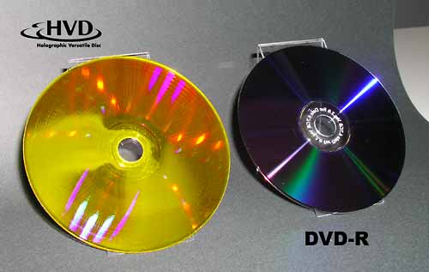

WHAT IS HOLOGRAPHIC STORAGE?
Holography breaks through the density limits of conventional storage by going beyond recording only on the surface, to recording through the full depth of the medium. Unlike other technologies that record one data bit at a time, holography records and reads over a million bits of data with a single flash of light. This enables transfer rates significantly higher than current optical storage devices. Combining high storage densities, fast transfer rates, with durable, reliable, low cost media, make holography poised to become a compelling choice for next-generation storage and content distribution needs. In addition, the flexibility of the technology allows for the development of a wide variety of holographic storage products that range from handheld devices for consumers to storage products for the enterprise. Imagine having 50 hours of high definition video on a single disk, 50,000 songs on a postage stamp, or 500,000 x-rays on a credit card. Holographic storage makes it all possible.

RECORDING DATA
Light from a single laser beam is split into two beams, thesignal beam (which carries the data) and the reference beam.The hologram is formed where these two beams intersect inthe recording medium. The process for encoding data onto thesignal beam is accomplished by a device called a spatial lightmodulator (SLM). The SLM translates the electronic data of 0’sand 1’s into anoptical “checkerboard” pattern of light and darkpixels. The data are arranged in an array orpage of over onemillion bits. The exact number of bits is determined by the pixelcount of the SLM.At the point where the reference beam and the data carrying signal beam intersect, the hologram is recorded in the light sensitive storage medium. A chemical reaction occurs causing the hologram stored. Byvarying the reference beam angle or media position hundreds of unique holograms are recorded in the samevolume of material.
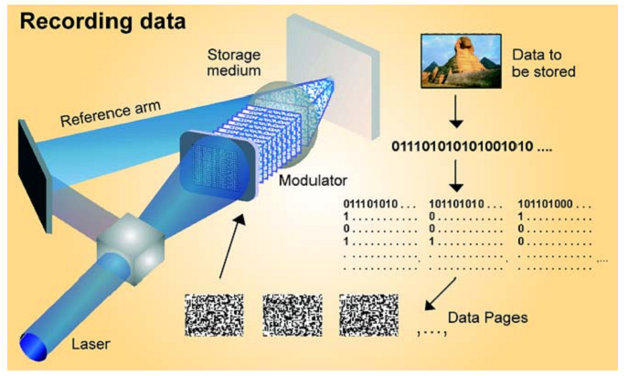

READING DATA
In order to read the data, the reference beam deflects off the hologram thus reconstructing the stored information. This hologram is then projected onto a detector that reads the entire data page of over one million bits at once. This parallel read out of data provides holography with its fast transfer rates.
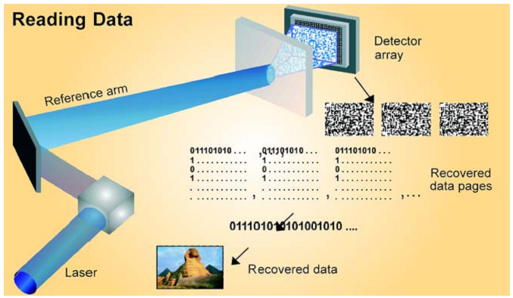
ADVANTAGE OF REWRITABLE ATOMIC HOLOGRAPHIC OPTICAL DISK DRIVE STORAGE
Colossal Storage wants its 3D Volume Holographic Optical Storage to be an "all in one" storage solution replacing Ram, Rom, DRAM, Ovonic, Flash, 2D Optical Drives, Tape Drives, and Hard Drives for "all in one" complete system hardware storage requirements.
- New novel storage media - Ferroelectric Molecular Holographic Optical
- New novel integrated semiconductor FE Read/Write Head
- New novel recording using UV/Blue Laser Diode and electric field transducer
- Potential bit density far exceeding present/future drive technology
- Extremely Fast Switch Sub nanosecond State Change
- Extremely High Read and Write Data Transfer Rates
- Extended Temperature Range
- No Altitude Requirements
- Dense Packed Crystallis with densities >200 Tbits/sq.in.
- 8 cents per Gigabyte versus Hard Drives cost of $ 1.00 cents Gigabyte
- 1 10 Terabyte Removable Rewritable Fedisk will be $ 45
- 1 10 Terabyte Fedisk = 20,000 DVD's or 4,000 Blu-Ray
- Download 6,840 raw uncompressed TV Hours
- Initial cost per gigabyte be greater than hard drives to recapture R&D expenses
- No Power Requirements for Media - Non Volatile Media
- Much higher sales margins for media, heads, and drive than data storage
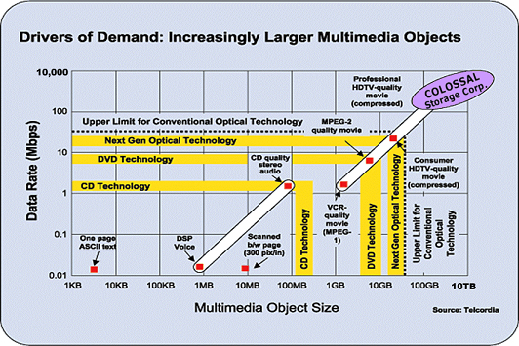

HUNDREDS OF OTHER TECHNOLOGIES WILL BE ENABLED BY THE ATOMIC SWITCH
The Photon/Laser Induced Electric Field Poling Theory has many other nanophotonic or nanomolecular uses:
- 3D Holographic Interactive Multimedia Storage Tablet
- Multiple different boot operating systems on common CPU platform Holographic Storage
- 2D/3D Holographic Disk/Card/Drum Storage
- 2D/3D Holographic Disk/Card/Drum VCR
- 2D/3D Holographic Disk/Card/Drum Camera/Photography
- 2D/3D Holographic Xerography and Maskless Lithography Tool
- Programmable UV/deep blue Laser Photon Emitter Source
- 3D Holographic Murals and Window Glass of any size for home, office, museum, skyscraper, and movie theatres
- 3D Holographic programmable camouflage coatings and programmable stealth photonic invisibility screens
- Programmable Holographic nanoSwitch for High Speed Bidirection Optical Transmission & Receiver Telecommunications
- 2D Programmable MEMS nanooptical reflective switches
- 2D/3d Programmable nanomotors, nanoconveyors, nanoneedles, nanopipes for fluid control
- 2D/3D Holographic Programmable nanoWiring
- 2D/3D photonic optical NLO crystal nanotransistor to densities > 40,000 tera-transitors/cu.cm. HP , Intel , and IBM
- Anthrax and other molecules bioparticle detection and classification
- Ferroelectrically Nanocontrolled Biological Particle/Molecule
- 2D/3D Holographic nanoIntegrated Circuit Photolithography for rewritable in circuit reformation fabrication of existing nanocircuits
- 2D/3D Photonic/Molecular/Atomic nanoSwitches for Broadband Telecommunications
- 2D/3D nanoLight Valves and nanoRelays
- Precision Reprogrammable Holographic nanoLenses
- Programmable Holographic Color Filters for UV light, etc.
- Holographic Storage for the Film Industry and other Copyrighted sources for Absolute Protection from IT Theft
- Quantum Molecular Computing

BACKGROUND OF THE STORAGE INDUSTRY AND THE NEED FOR STORAGE
As the inventor of Atomic Volume Holographic Optical Storage and a 30 year pioneer in the development of peripheral storage technologies, I am the holder of various patents, which Colossal Storage Corporation has licensed.
In 1974 I was making 5 Megabyte disk packs - the biggest at that time in the world. At the same time, IBM, Burroughs, Honeywell, and other Computer professionals said no one would ever need that much storage.
In 1989 Bill Gates (the Chairman of Microsoft) said that the personal computer would never need more than 256 kbytes of cache memory and 40 megabytes of hard drive storage. Today's PC has on average 64 megabytes of cache and 20 to 60 gigabyte hard drives.
As you can see, from a humble beginning data storage has grown considerably in size, and all market data points to its continued growth annually at > 30 %, while some predict data storage doubling every 4 months.
The need for new storage technology is evident to only to those having backgrounds in data storage. The obvious reasons are that the primary source of cheap storage has been the 2D Area hard drives for the last 40 years, IE: 2D Area Technology is technology that only allows the peripheral device to read/write the surface of the disk, tape, card, or drum (x,y).

WHO ARE SOME OF THE CURRENT PLAYERS.
- Fuji Photo Film | - Imation
- Toshiba | - Konica-Minolta
- Matsushita/Panasonic | - Memory-Tech
- Micron | - Mitsubishi Chemical
- Nippon Paint | - OPTWARE
- PulseTec | - Sony
- Toagosei | - Mitsui Chemical
- TDK | - THOMSON
- NHK Multi-Media | - Nippon Television Network
- Tokyo Broadcasting System | - Fuji Television Network
- TV Asahi Corporation | - TV Tokyo Corporation
- Warner Bros. | - Disney
- Universal | - Pioneer
- Sanyo | - JVC
- NEC | - InPhase Technologies
- Maxell | - Aprilis

CONCLUSIONS

The future FE Atomic Holographic Optical Drive will offer symmetrical infinite double sided disk or tape non-destructive read and writes for the retention of data storage for 100 years or more with drive densities of 40,000 Terabits/cu.cm. and up. This will allow the holographic optical nanotechnology drive to hold more data than any other type of drive and deliver data much faster. The patents on a semiconductor read/write head for ferroelectric optical storage media memories promises to raise data storage densities by a factor of 100 or more and will add at least 1000 times the data storage capacity per peripheral storage footprint and data transfer rates over 100 Tbits/sec

REFERENCES
[1]Colossal Storage Corporation

[2] IBM's magnetoresistive and giant magnetoresistive head technologies enable data
storage products with the industry's highest areal densities. By Jim Belleson, IBM
Storage Systems Division, & Ed Grochowski, IBM Almaden Research Center.

[3]Laboratoire de Céramique (LC) - Matériaux , Prof. Nava Setter,
Research Activities 1996/7 in ferroelectrics.

[4] http://www.physorg.com/pdf785.pdf

[5] http://www.signallake.com/innovation/ashley.pdf

