DEPARTMENT OF ELECTRONICS AND COMMUNICATION ENGINEERING
NATIONAL INSTITUTE OF TECHNOLOGY, SRINAGAR
KASHMIR – 190006 (INDIA)
3D OPTICAL DATA STORAGE | August 23  2011

KARANDEV SINGH KAMRA

7TH SEMESTER, ECE

ENROL NO. 132/08

ROLL NO. 26

DEPARTMENT OF ELECTRONICS AND COMMUNICATION ENGINEERING
NATIONAL INSTITUTE OF TECHNOLOGY, SRINAGAR
KASHMIR – 190006 (INDIA)

CERTIFICATE

This is to certify that the seminar report entitled “3D OPTICAL DATA STORAGE” has been prepared by the 7th semester student Mr. KARANDEV SINGH KAMRA under my guidance. The presentation of the seminar was given by the student on August 23, 2011 in partial fulfilment of the requirement for the award of the degree of Bachelor of Technology (B.Tech.) in Electronics and Communication Engineering by National Institute of Technology Srinagar, Kashmir.

(Seminar Supervisor)
Mrs. GAUSIA QAZI Mr. ARSHID AHMAD
Senior Lecturer Lecturer
Department of ECE Department of ECE
NIT Srinagar NIT Srinagar

DEPARTMENT OF ELECTRONICS AND COMMUNICATION ENGINEERING
NATIONAL INSTITUTE OF TECHNOLOGY, SRINAGAR
KASHMIR – 190006 (INDIA)

CANDIDATE’S DECLARATION

I hereby declare that the seminar on the topic “3D OPTICAL DATA STORAGE” has been given by me in partial fulfilment of the requirement for the award of the degree of Bachelor of Technology in Electronics and Communication Engineering. It was prepared and presented under the esteemed guidance & supervision of Mrs. Gausia Qazi (Senior Lecturer, Department of Electronics and Communication Engineering, National Institute of Technology, Srinagar) and Mr. Arshid Ahmad (Lecturer, Department of Electronics and Communication Engineering, National Institute of Technology, Srinagar)

Karandev Singh Kamra
Enroll No. 132/08
7th Semester
B.Tech, Electronics & Communication Engineering
National Institute of Technology, Srinagar
J&K-190006

Table of Contents

Preface 4
Acknowledgement…………………………………………………………………………………………………………………………………..5
Introduction 6
Optical recording technology and applications 7
History 9
Overview 10
Processes for creating written data 12
- Writing by nonresonant multiphton absorption
- Writing by sequential multiphoton absorption
- Microholography
- Data recording during manufacturing
- Other approaches to writing
Processes for reading data 17
Media design 18
Media form factor 19
Media manufacturing 19
Drive design 20
Development issues 22
Academic development 24
Commercial development 25
Comparison with holographic data storage 29
Comparison with blu-ray disc………………………………………………………………………………………………………………...32
Bibliography…………………………………………………………………………………………………………………………………………..34

PREFACE
Through this report I have made an attempt to do a study of the 3D Optical Data Storage methods. Starting with the basic optical recording and reading methods, I have given a brief description of the historical background leading to advancement in the field of 3D Optical Data Storage which is still in a stage of infancy. No 3D Optical Data Storage media are yet commercially available, and experiments are being carried out on prototype discs.

KARANDEV SINGH KAMRA

ACKNOWLEDGEMENT

It is with great affection and appreciation that I acknowledge my heartfelt gratitude to Mrs. Gausia Qazi (Senior Lecturer, Department of Electronics and Communication Engineering, National Institute of Technology, Srinagar) and Mr. Arshid Ahmad (Lecturer, Department of Electronics and Communication Engineering, National Institute of Technology, Srinagar) who gave their full guidance and cooperation in the preparation of the seminar topic “3D OPTICAL DATA STORAGE”.

My special thanks to my classmates, the distinguished faculty
members and the non-teaching employees of the department of
Electronics and Communication Engineering, N.I.T Srinagar, who
helped me in the preparation of this seminar.

KARANDEV SINGH KAMRA
Enrollment No-132/08

3D OPTICAL DATA STORAGE :

INTRODUCTION:
3D optical data storage is the term given to any form of optical data storage in which information can be recorded and/or read with three dimensional resolution (as opposed to the two dimensional resolution afforded, for example, by CD).

This innovation has the potential to provide petabyte-level mass storage on DVD-sized disks. Data recording and readback are achieved by focusing lasers within the medium. However, because of the volumetric nature of the data structure, the laser light must travel through other data points before it reaches the point where reading or recording is desired. Therefore, some kind of nonlinearity is required to ensure that these other data points do not interfere with the addressing of the desired point.

No commercial product based on 3D optical data storage has yet arrived on the mass market, although several companies are actively developing the technology and claim that it may become available soon.

OPTICAL RECORDING TECHNOLOGY AND APPLICATIONS:
Optical storage systems consist of a drive unit and a storage medium in a rotating disk form. In general the disks are pre-formatted using grooves and lands (tracks) to enable the positioning of an optical pick-up and recording head to access the information on the disk. Under the influence of a focused laser beam emanating from the optical head, information is recorded on the media as a change in the material characteristics. The disk media and the pick-up head are rotated and positioned through drive motors controlling the position of the head with respect to data tracks on the disk. Additional peripheral electronics are used for control and data acquisition and encoding/decoding.
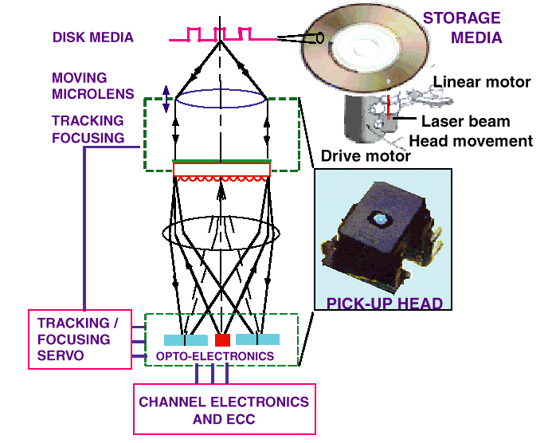

Storage Capacity:
The storage capacity of an optical storage system is a direct function of spot size (minimum dimensions of a stored bit) and the geometrical dimensions of the media. A good metric to measure the efficiency in using the storage area is the areal density (MB/sq. in.).
Data Transfer Rate:
The data transfer rate of an optical storage system is a critical parameter in applications where long data streams must be stored or retrieved, such as for image storage or backup. Data transfer rate is a combination of the linear density and the rotational speed of the drive.
Access time:
The access time of an optical storage system is a critical parameter in computing applications such as transaction processing; it represents how fast a data location can be accessed on the disk.
Cost:
The cost of an optical storage system is a parameter that can be subdivided into the drive cost and the media cost. Cost strongly depends on the number of units produced, the automation techniques used during assembly, and component yields.

HISTORY:

The origins of the field date back to the 1950s, when Yehuda Hirshberg developed the photochromic spiropyrans and suggested their use in data storage. In the 1970s, Valeri Barachevskii demonstrated that this photochromism could be produced by two-photon excitation, and finally at the end of the 1980s Peter T. Rentzepis showed that this could lead to three-dimensional data storage. This proof-of-concept system stimulated a great deal of research and development, and in the following decades many academic and commercial groups have worked on 3D optical data storage products and technologies. Most of the developed systems are based to some extent on the original ideas of Rentzepis. A wide range of physical phenomena for data reading and recording have been investigated, large numbers of chemical systems for the medium have been developed and evaluated, and extensive work has been carried out in solving the problems associated with the optical systems required for the reading and recording of data. Currently, several groups remain working on solutions with various levels of development and interest in commercialization.

OVERVIEW:

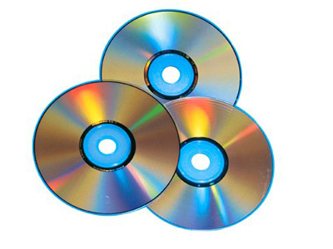
Current optical data storage media, such as the CD and DVD store data as a series of reflective marks on an internal surface of a disc. In order to increase storage capacity, it is possible for discs to hold two or even more of these data layers, but their number is severely limited since the addressing laser interacts with every layer that it passes through on the way to and from the addressed layer. These interactions cause noise that limits the technology to approximately 10 layers. 3D optical data storage methods circumvent this issue by using addressing methods where only the specifically addressed voxel (volumetric pixel) interacts substantially with the addressing light. This necessarily involves nonlinear data reading and writing methods, in particular nonlinear optics.

As an example, a prototypical 3D optical data storage system may use a disk that looks much like a transparent DVD. The disc contains many layers of information, each at a different depth in the media and each consisting of a DVD-like spiral track. In order to record information on the disc a laser is brought to a focus at a particular depth in the media that corresponds to a particular information layer. When the laser is turned on it causes a photochemical change in the media. As the disc spins and the read/write head moves along a radius, the layer is written just as a DVD-R is written. The depth of the focus may then be changed and another entirely different layer of information written. The distance between layers may be 5 to 100 micrometers, allowing >100 layers of information to be stored on a single disc.
In order to read the data back (in this example), a similar procedure is used except this time instead of causing a photochemical change in the media the laser causes fluorescence. This is achieved e.g. by using a lower laser power or a different laser wavelength. The intensity or wavelength of the fluorescence is different depending on whether the media has been written at that point, and so by measuring the emitted light the data is read.
The size of individual chromophore molecules or photoactive color centers is much smaller than the size of the laser focus (which is determined by the diffraction limit). The light therefore addresses a large number (possibly even 10⁹) of molecules at any one time, so the medium acts as a homogeneous mass rather than a matrix structured by the positions of chromophores.

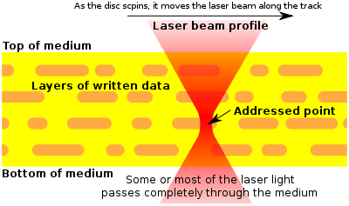
Schematic representation of a cross-section through a 3D optical storage disc (yellow) along a data track (orange marks). Four data layers are seen, with the laser currently addressing the third from the top. The laser passes through the first two layers and only interacts with the third, since here the light is at a high intensity.

PROCESSES FOR CREATING WRITTEN DATA:

Data recording in a 3D optical storage medium requires that a change take place in the medium upon excitation. This change is generally a photochemical reaction of some sort, although other possibilities exist. Chemical reactions that have been investigated include photoisomerizations, photodecompositions and photobleaching, and polymerization initiation. Most investigated have been photochromic compounds, which include azobenzenes, stilbenes, spiropyrans, fulgides and diarylethenes. If the photochemical change is reversible, then rewritable data storage may be achieved, at least in principle. Also, multilevel recording, where data is written in ‘grayscale’ rather than as on and off signals, is technically feasible.

- Writing By Nonresonant Multiphoton Absorption:

Although there are many nonlinear optical phenomena, only multiphoton absorption is capable of injecting into the media the significant energy required to electronically excite molecular species and cause chemical reactions. Two-photon absorption is the strongest multiphoton absorbance by far, but still it is a very weak phenomenon, leading to low media sensitivity. Therefore, much research has been directed at providing chromophores with high two-photon absorption cross-sections.
Writing by 2-photon absorption can be achieved by focusing the writing laser on the point where the photochemical writing process is required. The wavelength of the writing laser is chosen such that it is not linearly absorbed by the medium, and therefore it does not interact with the medium except at the focal point. At the focal point 2-photon absorption becomes significant, because it is a nonlinear process dependent on the square of the laser fluence.
Writing by 2-photon absorption can also be achieved by the action of two lasers in coincidence. This method is typically used to achieve the parallel writing of information at once. One laser passes through the media, defining a line or plane. The second laser is then directed at the points on that line or plane that writing is desired. The coincidence of the lasers at these points excited 2-photon absorption, leading to writing photochemistry.

Writing By Sequential Multiphoton Absorption:

Another approach to improving media sensitivity has been to employ resonant two-photon absorption (also known as "1+1" or "sequential" 2-photon absorbance). Nonresonant two-photon absorption (as is generally used) is weak since in order for excitation to take place, the two exciting photons must arrive at the chromophore at almost exactly the same time. This is because the chromophore is unable to interact with a single photon alone. However, if the chromophore has an energy level corresponding to the (weak) absorption of one photon then this may be used as a stepping stone, allowing more freedom in the arrival time of photons and therefore a much higher sensitivity. However, this approach results in a loss of nonlinearity compared to nonresonant 2-photon absorbance (since each 1-photon absorption step is essentially linear), and therefore risks compromising the 3D resolution of the system.

- Microholography:

In microholography, focused beams of light are used to record submicrometre-sized holograms in a photorefractive material, usually by the use of collinear beams. The writing process may use the same kinds of media that are used in other types of holographic data storage, and may use 2-photon processes to form the holograms.

- Data Recording During Manufacturing:
Data may also be created in the manufacturing of the media, as is the case with most optical disc formats for commercial data distribution. In this case, the user cannot write to the disc - it is a ROM format. Data may be written by a nonlinear optical method, but in this case the use of very high power lasers is acceptable so media sensitivity becomes less of an issue.
The fabrication of discs containing data molded or printed into their 3D structure has also been demonstrated. For example, a disc containing data in 3D may be constructed by sandwiching together a large number of wafer-thin discs, each of which is molded or printed with a single layer of information. The resulting ROM disc can then be read using a 3D reading method.

Other approaches to writing:

Other techniques for writing data in three-dimensions have also been examined, including:

- Persistent spectral hole burning (PSHB), which also allows the possibility of spectral multiplexing to increase data density. However, PSHB media currently requires extremely low temperatures to be maintained in order to avoid data loss.

- Void formation, where microscopic bubbles are introduced into a media by high intensity laser irradiation.

- Chromophore poling, where the laser-induced reorientation of chromophores in the media structure leads to readable changes.

Processes for reading data:

The reading of data from 3D optical memories has been carried out in many different ways. While some of these rely on the nonlinearity of the light-matter interaction to obtain 3D resolution, others use methods that spatially filter the media's linear response. Reading methods include:

- Two photon absorption (resulting in either absorption or fluorescence). This method is essentially two-photon microscopy.

- Measurement of small differences in the refractive index between the two data states. This method usually employs a phase contrast microscope or confocal reflection microscope. No absorption of light is necessary, so there is no risk of damaging data while reading, but the required refractive index mismatch in the disc may limit the thickness (i.e. number of data layers) that the media can reach due to the accumulated random wavefront errors that destroy the focused spot quality.

- Linear excitation of fluorescence with confocal detection. This method is essentially confocal laser scanning microscopy. It offers excitation with much lower laser powers than does two-photon absorbance, but has some potential problems because the addressing light interacts with many other data points in addition to the one being addressed.

- Second harmonic generation has been demonstrated as a method to read data written into a poled polymer matrix.

- Optical coherence tomography has also been demonstrated as a parallel reading method.

Media design:

The active part of 3D optical storage media is usually an organic polymer either doped or grafted with the photochemically active species. Alternatively, crystalline and sol-gel materials have been used.

Media form factor:

Media for 3D optical data storage have been suggested in several form factors:
- Disc: A disc media offers a progression from CD/DVD, and allows reading and writing to be carried out by the familiar spinning disc method.

- Card: A credit card form factor media is attractive from the point of view of portability and convenience, but would be of a lower capacity than a disc.

- Crystal, Cube or Sphere: Several science fiction writers have suggested small solids that store massive amounts of information, and at least in principle this could be achieved with 3D optical data storage.

Media manufacturing:

The simplest method of manufacturing - the molding of a disk in one piece - is a possibility for some systems. A more complex method of media manufacturing is for the media to be constructed layer by layer.

This is required if the data is to be physically created during manufacture. However, layer-by-layer construction need not mean the sandwiching of many layers together. Another alternative is to create the medium in a form analogous to a roll of adhesive tape.

Drive Design:

A drive designed to read and write to 3D optical data storage media may have a lot in common with CD/DVD drives, particularly if the form factor and data structure of the media is similar to that of CD or DVD. However, there are a number of notable differences that must be taken into account when designing such a drive, including:

- Laser. Particularly when 2-photon absorption is utilized, high-powered lasers may be required that can be bulky, difficult to cool, and pose safety concerns. Existing optical drives utilize continuous wave diode lasers operating at 780 nm, 658 nm, or 405 nm. 3D optical storage drives may require solid-state lasers or pulsed lasers, and several examples use wavelengths easily available by these technologies, such as 532 nm (green). These larger lasers can be difficult to integrate into the read/write head of the optical drive.

- Variable spherical aberration correction. Because the system must address different depths in the medium, and at different depths the spherical aberration induced in the wavefront is different, a method is required to dynamically account for these differences. Many possible methods exist that include optical elements that swap in and out of the optical path, moving elements, adaptive optics, and immersion lenses.

- Optical system. In many examples of 3D optical data storage systems, several wavelengths (colors) of light are used (e.g. reading laser, writing laser, signal; sometimes even two lasers are required just for writing). Therefore, as well as coping with the high laser power and variable spherical aberration, the optical system must combine and separate these different colors of light as required.

- Detection. In DVD drives, the signal produced from the disc is a reflection of the addressing laser beam, and is therefore very intense. For 3D optical storage however, the signal must be generated within the tiny volume that is addressed, and therefore it is much weaker than the laser light. In addition, fluorescence is radiated in all directions from the addressed point, so special light collection optics must be used to maximize the signal.

- Data tracking. Once they are identified along the z-axis, individual layers of DVD-like data may be accessed and tracked in similar ways to DVD discs. The possibility of using parallel or page-based addressing has also been demonstrated. This allows much faster data transfer rates, but requires the additional complexity of spatial light modulators, signal imaging, more powerful lasers, and more complex data handling.

Development Issues:

Despite the highly attractive nature of 3D optical data storage, the development of commercial products has taken a significant length of time. This results from limited financial backing in the field, as well as technical issues, including:

- Destructive reading. Since both the reading and the writing of data are carried out with laser beams, there is a potential for the reading process to cause a small amount of writing. In this case, the repeated reading of data may eventually serve to erase it (this also happens in phase change materials used in some DVDs). This issue has been addressed by many approaches, such as the use of different absorption bands for each process (reading and writing), or the use of a reading method that does not involve the absorption of energy.

- Thermodynamic stability. Many chemical reactions that appear not to take place in fact happen very slowly. In addition, many reactions that appear to have happened can slowly reverse themselves. Since most 3D media are based on chemical reactions, there is therefore a risk that either the unwritten points will slowly become written or that the written points will slowly revert to being unwritten. This issue is particularly serious for the spiropyrans, but extensive research was conducted to find more stable chromophores for 3D memories.
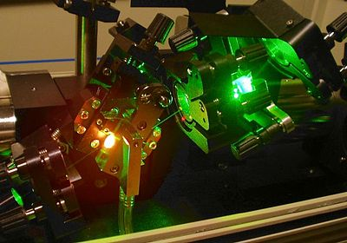
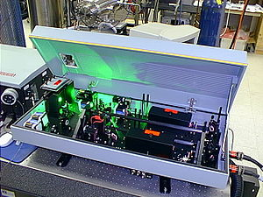
- Media sensitivity. 2-photon absorption is a weak phenomenon, and therefore high power lasers are usually required to produce it. Researchers typically use Ti-sapphire lasers or Nd:YAG lasers to achieve excitation, but these instruments are not suitable for use in consumer products.

Nd:YAG laser with lid open showing frequency-doubled 532 nm green light. | Part of a Ti:sapphire oscillator. The Ti:sapphire crystal is the bright red light source on the left. The green light is from the pump laser.

Academic Development:

Much of the development of 3D optical data storage has been carried out in universities. The groups that have provided valuable input include:

- Peter T. Rentzepis was the originator of this field, and has recently developed materials free from destructive readout.

- Watt W. Webb co-developed the two-photon microscope in Bell Labs, and showed 3D recording on photorefractive media.

- Masahiro Irie developed the diarylethene family of photochromic materials.

- Yoshimasa Kawata, Satoshi Kawata and Zouheir Sekkat have developed and worked on several optical data manipulation systems, in particular involving poled polymer systems.

- Kevin C Belfield is developing photochemical systems for 3D optical data storage by the use of resonance energy transfer between molecules, and also develops high 2-photon cross-section materials.

- Seth Marder performed much of the early work developing logical approaches to the molecular design of high 2-photon cross-section chromophores.

- Tom Milster has made many contributions to the theory of 3D optical data storage.

- Robert McLeod has examined the use of micro-holograms for 3D optical data storage.

- Min Gu has examined confocal readout and methods for its enhancement.

Commercial Development:

In addition to the academic research, several companies have been set up to commercialize 3D optical data storage and some large corporations have also shown an interest in the technology. However, it is not yet clear how the technology will perform in the market in the presence of competition from other quarters such as hard drives, flash storage, and holographic storage.

- Call/Recall was founded in 1987 on the basis of Peter Rentzepis' research. Using 2-photon recording (at 25 Mbit/s with 6.5 ps, 7 nJ, 532 nm pulses), 1-photon readout (with 635 nm), and a high NA (1.0) immersion lens, they have stored 1 TB as 200 layers in a 1.2 mm thick disk. They aim to improve capacity to >5 TB and data rates to up to 250 Mbit/s within a year, by developing new materials as well as high-powered pulsed blue laser diodes.

- Mempile are developing a commercial system with the name Teradisc. In March 2007, they demonstrated the recording and readback of 100 layers of information on a 0.6 mm thick disc, as well as low crosstalk, high sensitivity, and thermodynamic stability. They intend to release a red-laser 0.6-1.0 TB consumer product in 2010, and have a roadmap to a 5 TB blue-laser product.

- Constellation 3D developed the Fluorescent Multilayer Disc at the end of the 1990s, which was a ROM disk, manufactured layer by layer. The company failed in 2002, but the intellectual property (IP) was acquired by D-Data Inc., who are attempting to introduce it as the Digital Multilayer Disk (DMD).

- Storex Technologies has been set up to develop 3D media based on fluorescent photosensitive glasses and glass-ceramic materials. The technology derives from the patents of the Romanian scientist Eugen Pavel, who is also the founder and CEO of the company. At ODS2010 conference were presented results regarding readout by two non-fluorescence methods of a Petabyte Optical Disc.

- Landauer inc. are developing a media based on resonant 2-photon absorption in a sapphire single crystal substrate. In May 2007, they showed the recording of 20 layers of data using 2 nJ of laser energy (405 nm) for each mark. The reading rate is limited to 10 Mbit/s because of the fluorescence lifetime.

- 3DCD Technology Pty. Ltd. is a university spin-off set up to develop 3D optical storage technology based on materials identified by Daniel Day and Min Gu.

- Colossal Storage aim to develop a 3D holographic optical storage technology based on photon induced electric field poling using a far UV laser to obtain large improvements over current data capacity and transfer rates, but as yet they have not presented any experimental research or feasibility study.

- Microholas operates out of the University of Berlin, under the leadership of Prof Susanna Orlic, and has achieved the recording of up to 75 layers of microholographic data, separated by 4.5 micrometres, and suggesting a data density of 10 GB per layer.
- Several large technology companies such as Fuji, Ricoh and Matsushita have applied for patents on 2-photon-responsive materials for applications including 3D optical data storage, however they have not given any indication that they are developing full data storage solutions.
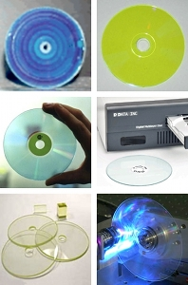

Examples of 3D optical data storage media.
Top row - Written Call/Recall media; Mempile media.
Middle row - FMD; D-Data DMD and drive.
Bottom row - Landauer media; Microholas media in action.

COMPARISON WITH HOLOGRAPHIC DATA STORAGE:

3D optical data storage is related to (and competes with) holographic data storage. Traditional examples of holographic storage do not address in the third dimension, and are therefore not strictly "3D", but more recently 3D holographic storage has been realized by the use of microholograms. Layer-selection multilayer technology (where a multilayer disc has layers that can be individually activated e.g. electrically) is also closely related.

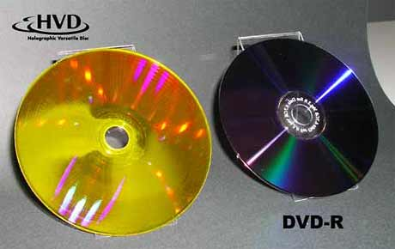

FIG: A Holographic Video Disc and a DVD

Holographic data storage is a potential replacement technology in the area of high-capacity data storage currently dominated by magnetic and conventional optical data storage. Magnetic and optical data storage devices rely on individual bits being stored as distinct magnetic or optical changes on the surface of the recording medium. Holographic data storage overcomes this limitation by recording information throughout the volume of the medium and is capable of recording multiple images in the same area utilizing light at different angles.

Additionally, whereas magnetic and optical data storage records information a bit at a time in a linear fashion, holographic storage is capable of recording and reading millions of bits in parallel, enabling data transfer rates greater than those attained by traditional optical storage.

Recording data:
Holographic data storage captures information using an optical interference pattern within a thick, photosensitive optical material. Light from a single laser beam is divided into two separate optical patterns of dark and light pixels. By adjusting the reference beam angle, wavelength, or media position, a multitude of holograms (theoretically, several thousand) can be stored on a single volume.

[]Reading data:
The stored data is read through the reproduction of the same reference beam used to create the hologram. The reference beam’s light is focused on the photosensitive material, illuminating the appropriate interference pattern, the light diffracts on the interference pattern, and projects the pattern onto a detector. The detector is capable of reading the data in parallel, over one million bits at once, resulting in the fast data transfer rate. Files on the holographic drive can be accessed in less than 200 milliseconds.

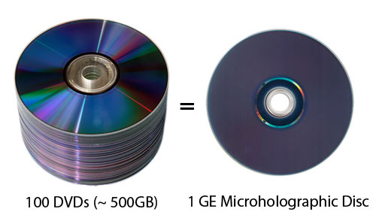

COMPARISON WITH BLU-RAY DISC:

Blu-ray Disc (official abbreviation BD) is an optical disc storage medium designed to supersede the DVD format. The disc diameter is 120 mm and disc thickness 1.2 mm plastic optical disc, the same size as DVDs and CDs. Blu-ray Discs contain 25 GB (23.31 GiB) per layer, with dual layer discs (50 GB) being the norm for feature-length video discs. Triple layer discs (100 GB) and quadruple layers (128 GB) are available for BD-XL Blu-ray re-writer drives. Currently movie production companies have not utilized the triple or quadruple layer discs; most consumer owned Blu-ray players will
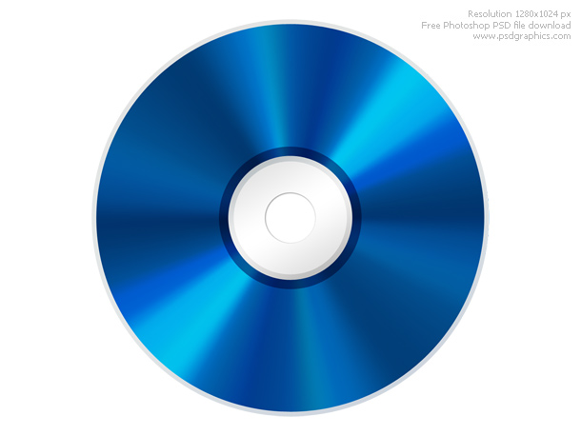
Fig: A Blu-ray Disc

not be able to read the additional layers, while newer Blu-ray players may require a firmware update to play the triple and quadruple sized discs. Compared to the 3D optical disks which will have around 100+ layers, the Blu-ray discs have much less storage capacity even the much newer quadruple layer discs. The first Blu-ray Disc prototypes were unveiled in October 2000, and the first prototype player was released in April 2003 in Japan. Afterwards, it continued to be developed until its official release in June 2006.

During the high definition optical disc format war, Blu-ray Disc competed with the HD DVD format. Toshiba, the main company that supported HD DVD, conceded in February 2008, releasing their own Blu-ray Disc player in late 2009.

BIBLIOGRAPHY:

- Wikipedia.org - 3D Optical Data Storage
- Wikipedia.org – Holographic Data Storage
- Three-Dimensional Optical Data Storage Using Photochromic Materials- S. Kawata and Y. Kawata
- Wikipedia.org – Blu-ray Disc
- Electronics.Howstuffworks.com
- Google.com
- Optics Communications 2003, 220, 59
- 3D Data Storage and Near-Field Recording, Y. Kawata and S. Kawata.
- bit-tech.net/hardware

