ACKNOWLEDGMENT

We express our humble thanks to the almighty for the kind grace shown to us to complete the report successfully
Our debts are many and we acknowledge them with much pride and delight. We would like to express our profound thanks to MR. S.R.Jhambhle H.O.D (Mechanical Engineering), for his encouragement and valuable advice. The successful completion of this report.I would also like to thanks Ravidra Ram sir for his inspiring attitude and valuable guidance, helped us work out the “SHADOW” part of the report. We convey our deep sense of gratitude for him.
Infant, it is very difficult to acknowledge all nature and help and encouragement we have received from our friends in the preparation of report work.

ASHUTOSH SINHA
100954007
TT-M.E.

ABSTRACT

The most important challenge facing car manufacturers today is to offer vehicles that deliver excellent fuel efficiency and superb performance while maintaining cleaner emissions and driving comfort. This paper deals with i-VTEC(intelligent-Variable valve Timing and lift Electronic Control) engine technology which is one of the advanced technology in the IC engine. i-VTEC is the new trend in Honda’s latest large capacity four cylinder petrol engine family. The name is derived from ‘intelligent’ combustion control technologies that match outstanding fuel economy, cleaner emissions and reduced weight with high output and greatly improved torque characteristics in all speed range. The design cleverly combines the highly renowned VTEC system - which varies the timing and amount of lift of the valves - with Variable Timing Control. VTC is able to advance and retard inlet valve opening by altering the phasing of the inlet camshaft to best match the engine load at any given moment. The two systems work in concern under the close control of the engine management system delivering improved cylinder charging and combustion efficiency, reduced intake resistance, and improved exhaust gas recirculation among the benefits. i-VTEC technology offers tremendous flexibility since it is able to fully maximize engine potential over its complete range of operation. In short Honda's i-VTEC technology gives us the best in vehicle performance.

TABLE OF CONTENTS

- CHAPTER-1 INTRODUCTION
- CHAPTER-2 NEED OF i-VTEC TECHNOLOGY
- CHAPTER-3 HISTORY
- CHAPTER-4 i-VTEC MECHANISM
- CHAPTER-5 i-VTEC SYSTEM LAYOUT
- CHAPTER-6 FUTURE OF i-VTEC
- CHAPTER-7 INTELLIGENT-VTEC THE NEXT GENERATION
- CHAPTER-8 CONTROLLING OF i-VTEC
- CHAPTER-9 OPERATING RANGE OF i-VTEC
- CHAPTER-10 DRIVING CONDITION OF i-VTEC
- CHAPTER-11 CURRENT STATE OF i-VTEC
- CHAPTER-12TYPES OF i-VTEC ENGINES
- CHAPTER-13 i-VTEC IMPLEMENTATION
- CHAPTER-14 APPLICATION
- CHAPTER-15 CASE STUDY OF ‘HONDA’ CIVIC 2006 WITH 1.8 LITRE ENGINE
- CHAPTER-16 FUTURE TRENDS
- CHAPTER-17ADVANTAGES
- CHAPTER-18 DISADVANTAGES
- CONCLUSION
- REFERENCES AND APPENDICES

1

LIST OF FIGURES, GRAPHS AND TABLES

- Figure 4.1 i-VTEC constituents
- Figure 4.3 cams and rocker arms
- Figure 4.4 different variants of VTEC
- Figure 4.5 cam & sprocket
- Figure 4.6 comparison of conventional & i-VTEC engines
- Figure 4.8 VTC operating principle
- Figure 5.1 i-VTEC system layout
- Figure 6.1 Graph between Torque & Power
- Figure 9.1 VTEC control
- Figure 10.1 operating of i-VTEC
- Figure 11.1 Driving condition
- Figure 12.1 i-VTEC engine
- Figure 13.1 performance graph of i-VTEC engines
- Figure 14.1 Opening of valves at low and high speed
- Figure 14.2 Mechanism of opening of valve at low and high speed
- Figure 16.1 performance graph of 1.8L i-VTEC engine

2
REPORT

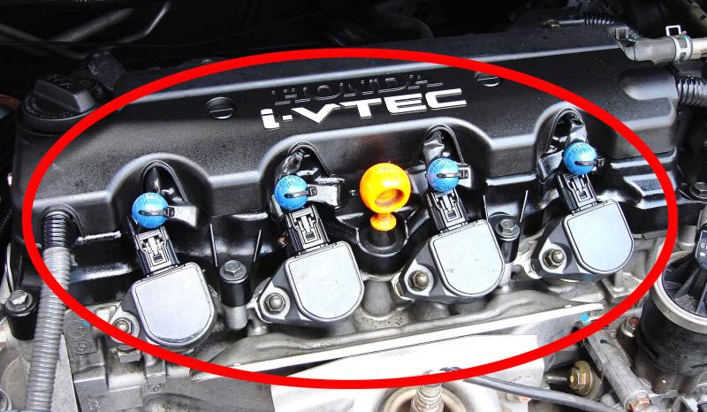

3

CHAPTER- 1 INTRODUCTION

i-VTEC
Honda i-VTEC (intelligent-VTEC) has VTC continuously variable timing of camshaft phasing on the intake camshaft of DOHC VTEC engines. The technology first appeared on Honda's K-series four-cylinder engine family in 2001 (2002 in the U.S.). In the United States, the technology debuted on the 2002 Honda CR-V.
VTC controls of valve lift and valve duration are still limited to distinct low- and high-RPM profiles, but the intake camshaft is now capable of advancing between 25 and 50 degrees, depending upon engine configuration. Phasing is implemented by a computer-controlled, oil-driven adjustable cam gear. Both engine load and RPM affect VTC. The intake phase varies from fully retarded at idle to somewhat advanced at full throttle and low RPM. The effect is further optimization of torque output, especially at low and midrange RPM. There are two types of i-VTEC K series engines which are explained in the next paragraph.

1.2 K-series
The K-Series motors have two different types of i-VTEC systems implemented. The first is for the performance motors like in the RSX Type S or the Civic Si and the other is for economy motors found in the CR-V or Accord. The performance i-VTEC system is basically the same as the DOHC VTEC system of the B16A's; both intake and exhaust have 3 cam lobes per cylinder. However the valve train has the added benefit of roller rockers and continuously variable intake cam timing. Performance i-VTEC is a combination of conventional DOHC VTEC with VTC.
The economy i-VTEC is more like the SOHC VTEC-E in that the intake cam has only two lobes, one very small and one larger, as well as no VTEC on the exhaust cam. The two types of motor are easily distinguishable by the factory rated power output: the performance motors make around 200 hp (150 kW) or more in stock form and the economy motors do not make much more than 160 hp (120 kW) from the factory.

4

CHAPTER-2 NEED OF i-VTEC TECHNOLOGY

In this modern world of car, everybody wants great mileage in his/her car, so to produce such a car which has mileage and great power the i-VTEC technology is used in engines.

As we know the price of fuel is increasing day by day, hence the proper fuel utilization in engine is very important. As in other cars, power with mileage is not possible but due to this technology it is possible to get both in one car.

5

CHAPTER-3 HISTORY

VTEC, the original Honda variable valve control system, originated from REV (Revolution-modulated valve control) introduced on the CBR400 in 1983 known as HYPER VTEC. In the regular four-stroke automobile engine, the intake and exhaust valves are actuated by lobes on a camshaft. The shape of the lobes determines the timing, lift and duration of each valve. Timing refers to an angle measurement of when a valve is opened or closed with respect to the piston position (BTDC or ATDC). Lift refers to how much the valve is opened. Duration refers to how long the valve is kept open. Due to the behaviour of the working fluid (air and fuel mixture) before and after combustion, which have physical limitations on their flow, as well as their interaction with the ignition spark, the optimal valve timing, lift and duration settings under low RPM engine operations are very different from those under high RPM. Optimal low RPM valve timing, lift and duration settings would result in insufficient filling of the cylinder with fuel and air at high RPM, thus greatly limiting engine power output. Conversely, optimal high RPM valve timing, lift and duration settings would result in very rough low RPM operation and difficult idling. The ideal engine would have fully variable valve timing, lift and duration, in which the valves would always open at exactly the right point, lift high enough and stay open just the right amount of time for the engine speed in use.

6

CHAPTER-4 i-VTEC MECHANISM

4.1 i-VTEC:-
The latest and most sophisticated VTEC development is i-VTEC ("intelligent" VTEC), which combines features of all the various previous VTEC systems for even greater power band width and cleaner emissions. With the latest i-VTEC setup, at low rpm the timing of the intake valves is now staggered and their lift is asymmetric, which creates a swirl effect within the combustion chambers. At high rpm, the VTEC transitions as previously into a high-lift, long-duration cam profile.
The i-VTEC system utilizes Honda's proprietary VTEC system and adds VTC (Variable Timing Control), which allows for dynamic/continuous intake valve timing and overlap control.
The demanding aspects of fuel economy, ample torque, and clean emissions can all be controlled and provided at a higher level with VTEC (intake valve timing and lift control) and VTC (valve overlap control) combined.
Fig.4.1
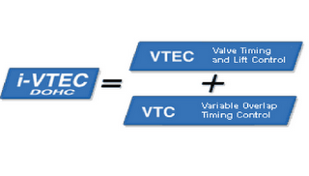
The i stands for intelligent: i-VTEC is intelligent-VTEC. Honda introduced many new innovations in i-VTEC, but the most significant one is the addition of a variable valve opening overlap mechanism to the VTEC system. Named VTC for Variable Timing Control, the current (initial) implementation is on the intake camshaft and allows the valve opening overlap between the intake and exhaust valves to be continuously varied during engine operation. This allows for a further refinement to the power delivery characteristics of VTEC, permitting fine-tuning of the mid-band power delivery of the engine.

4.2 VTEC ENGINE:
VTEC (standing for Variable valve Timing and lift Electronic Control) does Honda Motor Co., Ltd. develop a system. The principle of the VTEC system is to optimize the amount of air-fuel charge entering, and the amount of exhaust gas leaving, the cylinders over the complete range of engine speed to provide good top-end output together with low and mid-range flexibility.
VTEC system is a simple and fairly elegant method of endowing the engine with multiple camshaft profiles optimized for low and high RPM operations. Instead of only one cam lobe actuating each valve, there are two - one optimized for low RPM smoothness and one to maximize high RPM power output. Switching between the two cam lobes is controlled by the engine's management computer. As the engine speed is increased, more air/fuel mixture needs to be "inhaled" and "exhaled" by the engine. Thus to sustain high engine speeds, the intake and exhaust valves needs to open nice and wide. As engine RPM increases, a locking pin is pushed by oil pressure to bind the high RPM cam follower for operation. From this point on, the valve opens and closes according to the high-speed profile, which opens the valve further and for a longer time.

7

4.3 BASIC V-TEC MECHANISM
The basic mechanism used by the VTEC technology is a simple hydraulically actuated pin. This pin is hydraulically pushed horizontally to link up adjacent rocker arms. A spring mechanism is used to return the pin back to its original position.
To start on the basic principle, examine the simple diagram below. It comprises a camshaft with two cam-lobes side-by-side. These lobes drive two side-by-side valve rocker arms.

Fig.4.3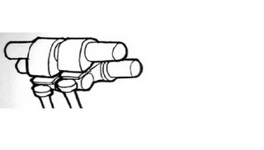
The two cam/rocker pairs operate independently of each other. One of the two cam-lobes are intentionally drawn to be different. The one on the left has a "wilder" profile, it will open its valve earlier, open it more, and close it later, compared to the one on the right. Under normal operation, each pair of cam-lobe/rocker-arm assembly will work independently of each other.

VTEC uses the pin actuation mechanism to link the mild-cam rocker arm to the wild-cam rocker arm. This effectively makes the two rocker arms operate as one. This "composite" rocker arm(s) now clearly follows the wild-cam profile of the left rocker arm. This in essence is the basic working principle of all of Honda's VTEC engines.

4.4 DIFFERENT VARIANTS OF V-TEC:-

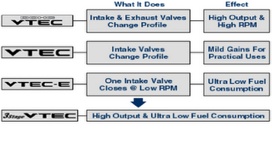
Fig.4.4

8

4.5 VARIABLE TIMING CONTROL (VTC)
VTC operating principle is basically that of the generic variable valve timing implementation (this generic implementation is also used by Toyota in their VVT-i and BMW in their VANOS/double-VANOS system). The generic variable valve timing implementation makes use of a mechanism attached between the cam sprocket and the camshaft. This mechanism has a helical gear link to the sprocket and can be moved relative the sprocket via hydraulic means. When moved, the helical gearing effectively rotates the gear in relation to the sprocket and thus the camshaft as well.
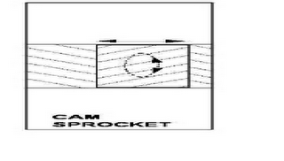
Fig.4.5
4.6 VTC principle
The drawing above serves to illustrate the basic operating principle of VTC (and generic variable valve timing). A labels the cam sprocket (or cam gear) which the timing belt drives. Normally the camshaft is bolted directly to the sprocket. However in VTC, an intermediate gear is used to connect the sprocket to the camshaft. This gear, labelled B has helical gears on its outside. As shown in the drawing, this gear links to the main sprocket which has matching helical gears on the inside. The camshaft, labelled C attaches to the intermediate gear.
The supplementary diagram on the right shows what happens when we move the intermediate gear along its holder in the cam sprocket. Because of the interlinking helical gears, the intermediate gear will rotate along its axis if moved. Now, since the camshaft is attached to this gear, the camshaft will rotate on its axis too. What we have achieved now is that we have moved the relative alignment between the camshaft and the driving cam-sprocket - we have changed the cam timing!

9

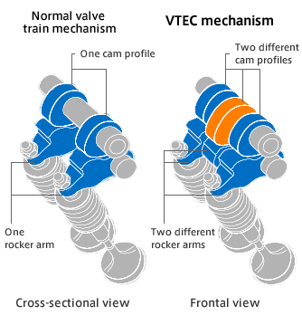
Fig.4.6

9
4.7 i-VTEC DOHC (Double Overhead Cam)
The last evolution of Honda’s VTEC system was back in 1995 where they introduced the now-famous 3-stage VTEC system. The 3-stage VTEC was then designed for an optimum balance of super fuel economy and high power with drivability. For the next 5 years, Honda still used the regular DOHC VTEC system for their top power models, from the B16B right up to the F20C in the S2000. Now Honda has announced the next evolution of their legendary VTEC system, the i-VTEC.
The i stands for intelligent: i-VTEC is intelligent-VTEC. Honda introduced many new innovations in i-VTEC, but the most significant one is the addition of a variable valve opening overlap mechanism to the VTEC system. Named VTC for Variable Timing Control, the current (initial) implementation is on the intake camshaft and allows the valve opening overlap between the intake and exhaust valves to be continuously varied during engine operation. This allows for a further refinement to the power delivery characteristics of VTEC, permitting fine-tuning of the mid-band power delivery of the engine.

4.8 Variable Timing Control Operating Principle
Honda’s VTC operating principle is basically that of the generic variable valve timing implementation (this generic implementation is also used by Toyota in their VVT-i and BMW in their VANOS/double-VANOS system). The generic variable valve timing implementation makes use of a mechanism attached between the cam sprocket and the camshaft. This mechanism has a helical gear link to the sprocket and can be moved relative the sprocket via hydraulic means. When moved, the helical gearing effectively rotates the gear in relation to the sprocket and thus the camshaft as well.

Fig.4.8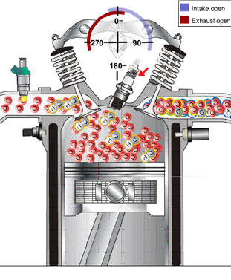 11

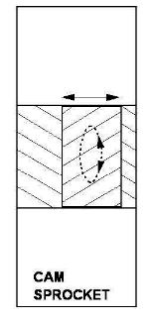
The drawing above serves to illustrate the basic operating principle of VTC (and generic variable valve timing). A labels the cam sprocket (or cam gear) which the timing belt drives. Normally the camshaft is bolted directly to the sprocket. However in VTC, an intermediate gear is used to connect the sprocket to the camshaft. This gear, labeled B has helical gears on its outside. As shown in the drawing, this gear links to the main sprocket which has matching helical gears on the inside. The camshaft, labeled C attaches to the intermediate gear.
The supplementary diagram on the right shows what happens when we move the intermediate gear along its holder in the cam sprocket. Because of the interlinking helical gears, the intermediate gear will rotate along its axis if moved. Now, since the camshaft is attached to this gear, the camshaft will rotate on its axis too. What we have achieved now is that we have moved the relative alignment between the camshaft and the driving cam-sprocket - we have changed the cam timing!
VTC and other implementations of generic variable valve timing can only change the relative alignment between the camshaft and its driving sprocket. What this effectively does is to change the relative timing between the intakes and exhaust cams and thus their valve opening cycles or the intake and exhaust valve opening overlaps. Note that no other valve timing parameters, e.g. amount of valve lift or absolute valve opening duration can be varied. The only thing that VTC varies is the valve opening overlaps. VTEC is able to vary all valve timing parameters but current implementations do so in two or three distinct stages (or profiles). Adding VTC allows the valve opening overlaps to be continuously varied and thus enables the power delivery from the standard VTEC system to be further fine-tuned. The greatest impact will be to the mid-band power delivery of the engine. Most importantly, VTC (and generic valve timing systems) will not replace VTEC but enhance its effectiveness.

12

CHAPTER-5 i-VTEC SYSTEM LAYOUT

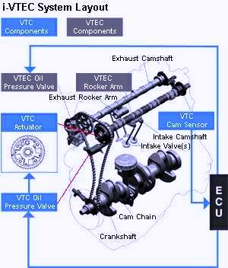
Fig.5.1

13

5.1 i-VTEC SYSTEM:-
Diagram explains the layout of the various components implementing i-VTEC. I have intentionally edited the original diagram very slightly - the lines identifying the VTC components are rather faint and their orientation confusing. I have overlaid them with red lines. They identify the VTC actuator as well as the oil pressure solenoid valve, both attached to the intake camshaft's sprocket. The VTC cam sensor is required by the ECU to determine the current timing of the intake camshaft. The VTEC mechanism on the intake cam remains essentially the same as those in the current DOHC VTEC engines except for an implementation of VTEC-E for the 'mild' cam.

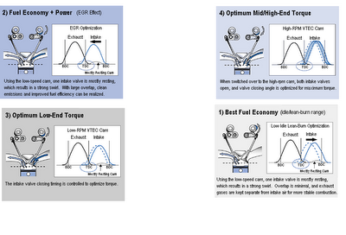
Fig.5.2

The diagrams show that VTEC is implemented only on the intake cam. Now, note that there is an annotation indicating a 'mostly resting (intake) cam' in variations 1 to 3. This is the 'approximately 1-valve' operating principle of VTEC-E. I.e. one intake valve is hardly driven while the other opens in its full glory. This instills a swirl effect on the air-flow which helps in air-fuel mixture and allows the use of the crazy 20+ to 1 air-to-fuel ratio in lean-burn or economy mode during idle running conditions. On first acquaintance, variations 1 and 3 seem identical. However, in reality they represent two different engine configurations - electronic-wise. Variation 1 is lean burn mode, 14

CHAPTER-6 GRAPH BETWEEN TORQE AND POWER

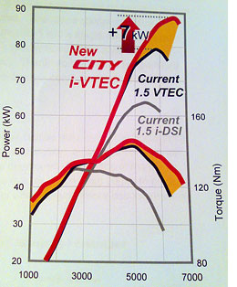
Fig.6.1

15

CHAPTER-7 FUTURES OF i-VTEC

From now onwards, there will no doubt be countless attempts to second-guess at what Honda will do to i-VTEC. There is all likelihood that Honda will implement i-VTEC on its performance engines. The most probable benefiaries will be the Integra and the Civic, the two models which have always been at the forefront to carry Honda's high-performance flag.
At this point, it is important to highlight again that the basic DOHC VTEC system is more than capable of delivering extremely high specific power outputs. i-VTEC is not needed. Witness the 125ps/liter power delivery of the F20C used on the S2000. Again what i-VTEC does allow is for Honda to go for the sky in terms of specific power output but yet still maintaining a good level of mid-range power. Already extremely authoritative reviewers like BEST MOTORing have complained about the lack of a broad mid-range power from for eg the F20C engine. In a tight windy circuit like Tsukuba and Ebisu, the S2000 finds it extremely tough going to overtake the Integra Type-R in 5-lap battles despite having 50ps or 25% more power. Watching the 'battle' brings one point painfully clear. There is a dire need of power from the F20C below 6000rpm. Every time the S2000 sneaks up behind the ITR, it fails to engage in a good overtaking move because the power from the F20C is surprisingly insufficient. The reason for this is because DOHC VTEC makes do with merging two distinct power curves. To get the extreme power levels of the F20C, the wild cams' power curve are so narrow that there is effectively a big hole in the composite power curve below 6000rpm. What i-VTEC can do to this situation is to allow fine-tuning of the power curve, to broaden it, by varying valve opening overlap. Thus this will restore a lot of mid-range power to super-high-output DOHC VTEC engines allowing Honda, if they so desire, to go for even higher specific outputs without too much of a sacrifice to mid-range power.
For the moment the 2.0l DOHC i-VTEC engine on the STREAM delivers 154ps and revs to around 6500rpm. This is relatively low-tech as far as Honda's DOHC VTEC engines go. There must be a lot of scary DOHC i-VTEC engines on Honda's design boards at the moment. TOVA readers who are interested to look at what's in the rumour mills are encouraged to visit TOVA's main-site, the Temple of VTEC for one of the best source of future Honda models information on the net.
However, readers who prefers to only read about solid facts can rest assured that once the expected super-high-powered DOHC i-VTEC engine comes out, TOVA will be the first to highlight it, just as we are now the first to explain to you what i-VTEC is all about.

16

CHAPTER-8 VTEC intelligent-VTEC- The Next Generation

The last evolution of Honda's VTEC system was back in 1995 where they introduced the now-famous 3-stage VTEC system. The 3-stage VTEC was then designed for an optimum balance of super fuel economy and high power with driveability. For the next 5 years, Honda still used the regular DOHC VTEC system for their top power models, from the B16B right up to the F20C in the S2000. Now Honda has announced the next evolution of their legendary VTEC system, the i-VTEC.

The i stands for intelligent : i-VTEC is intelligent-VTEC. Honda introduced many new intelligent-VTEC - The Next Generation
The last evolution of Honda's VTEC system was back in 1995 where they introduced the now-famous 3-stage VTEC system. The 3-stage VTEC was then designed for an optimum balance of super fuel economy and high power with driveability. For the next 5 years, Honda still used the regular DOHC VTEC system for their top power models, from the B16B right up to the F20C in the S2000. Now Honda has announced the next evolution of their legendary VTEC system, the i-VTEC.
The i stands for intelligent : i-VTEC is intelligent-VTEC. Honda introduced many new innovations in i-VTEC, but the most significant one is the addition of a variable valve opening overlap mechanism to the VTEC system. Named VTC for Variable Timing Control, the current (initial) implementation is on the intake camshaft and allows the valve opening overlap between the intake and exhaust valves to be continously varied during engine operation. This allows for a further refinement to the power delivery characteristics of VTEC, permitting fine-tuning of the mid-band power delivery of the engine.

17

CHAPTER-9 CONTROLLING OF i-VTEC

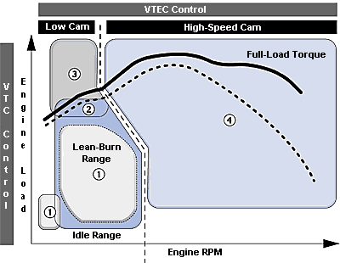
Fig.9.1

18

CHAPTER-10 OPERATINN RANGE OE i-VTEC

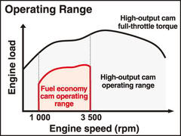
Fig.10.1

19

CHAPTER-11 DRIVING CONDITON OF i-VTEC

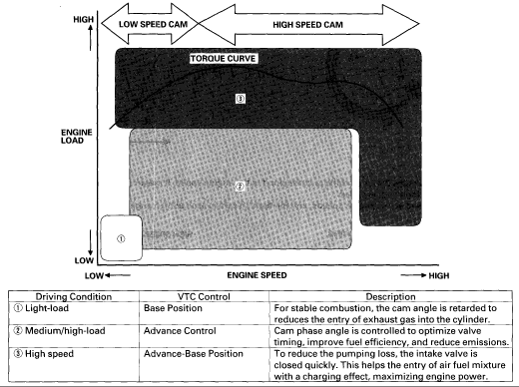
Fig.11.1

20

CHAPTER-12 CURRENT STATE OF i-VTEC

At the moment, i-VTEC is only implemented in the relatively low specific power output engine of the new JDM Honda STREAM van. Used in the 2.0l DOHC i-VTEC engine, it allows Honda to boost low-end and mid-range power of that engine, a characteristic very desirable for that model. In my opinion, VTC is the most significant innovation that Honda introduced to i-VTEC. Other important innovations includes the changing of the engine orientation (as well as its rotation direction). i-VTEC engines are mounted such that the intake valves faces the front of the vehicle and the exhaust valves the rear, just like the Japanese Grand-Touring Championship racing cars. Other improvements are in the important areas of fuel economy and emissions.
Honda announced i-VTEC via a special article in the tech section of their official web-site. As usual, TOVA's japanese article specialist Kaz Mori has translated that article which we reproduce in its entirety in the box below.
10/26/00 - The New Generation "DOHC i-VTEC" is Announced
Honda Motor Company has announced a newly developed 2-liter engine, dubbed the "DOHC i-VTEC" to be mated to the upcoming new model, "Stream." The engine combines world-class fuel-efficiency with low emissions, light weight, and high-output.
This new engine utilizes Honda's "VTEC" technology, which adjusts valve timing and lift based on the engine's RPM, but adds "VTC" - Variable Timing Control - which continuously modulates the intake valve overlap depending on engine load. The two combined yield in a highly intelligent valve timing and lift mechanism.
In addition to such technology, improvements in the intake manifold, rearward exhaust system, lean-burn-optimized catalytic converter ^{*1} help to create an engine that outputs 113kW (154PS) @ 6500rpm, ^{*2} and provides ample mid-range torque. It also satisfies the year 2010 fuel efficiency standard of 14.2km/L ^{*3} (roughly 35mpg), and receives the government standard of "LEV" ^{*4}. A highly durable lower block and a chain-driven cam were just some of the improvements in an effort to create a more compact engine - resulting in an engine that is 10% lighter ^{*5} than conventional 2-liter engines.
Fig.12.1

Honda has dubbed these engines with high fuel-economy 'intelligence' as their new "i-Series" engines. By 2005, Honda aims to
have all of their engines replaced by the "i-Series" engines. Under this plan, all vehicles sold within Japan will be certified by the government as LEV ^{*4} by the year 2002, and by the year 2005, plans on satisfying the year 2010 fuel efficiency standard across all weight classes.
The "i-Series" engine also incorporates a new method of production. In Saitama prefecture, a new engine line was set up to create the cylinder block, mechanics, and engine assembly, and became operational as of August 2000. With this new line, the engine and chassis can be produced at the same time. It also helps by reducing the amount of moving engine stock, and greatly reduces the time from initial production to completion of a vehicle. The amount of investment required for new models is cut by half, and eight different combinations can be created - making a highly efficient, flexible production line.
Honda is moving along with its plan to invest 360 billion yen (~ 3.5 billion U$) to revolutionize the four-wheel automobile production method. Even with the powertrain production line alone, it is scheduled to have spent 150 billion yen (~ 1.5 billion U$) by the year 2003. The ultimate goal is to reach double efficiency in use of resources - in order to create a "Green Factory" of the 21st century.
*1 - Lean-burn compatible NOx catalytic converters are equipped on the Stream 2.0L model iL, iS, FF
*2 - Stream 2.0L, iL, iS, FF Net
*3 - Stream 2.0L, iL, FF 10*15 mode
*4 - A designation given to vehicles that are under 50% of the year 2000 emission standards.
*5 - Compared to typical Honda 2.0 liters.
Note : Article translated verbatim from the tech section of the official Honda of Japan's web-site at http://www.honda.co.jp. This article is intended solely for the benefit of Temple of VTEC Asia's readers. The original article did not have the power curve chart. That has been added to enhance the article.

22

CHAPTER-13 TYPES OF i-VTEC ENGINES

The new 1.3L i-VTEC engine is agile and intelligent: at low engine speeds one of the two intake valves is idled. The engine sips gasoline, using a lean fuel mix at low engine speeds for further improved combustion efficiency.
The two intake valves of the new 1.5L i-VTEC engine switch modes in accordance with engine speed, opening a small amount at low engine speeds and fully opening at high engines speeds, achieving both high power and low fuel consumption.
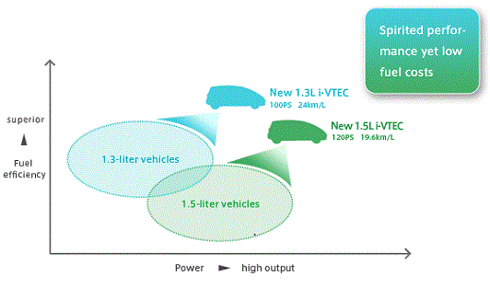
Fig.13.1

23

CHAPTER-14 i-VTEC IMPLEMENTATION

The i-VTEC system was implemented into more modern K series engine, as opposed to the VTEC system of the older B series engines. There is a performance i-VTEC system, and an economy i-VTEC system. The performance variant allowed three cam lobes per cylinder for both intake and exhaust, whereas the economy i-VTEC system only possesses two lobes on the intake cam, and no VTEC control on the exhaust cam. The performance version resulted in an additional 40 horsepower in the K series engines.

AT LOW ENGINE SPEED- Valves are opened only a small amount for lower fuel consumption.
AT HIGH ENGINE SPEED- Valves are wide open for maximum power

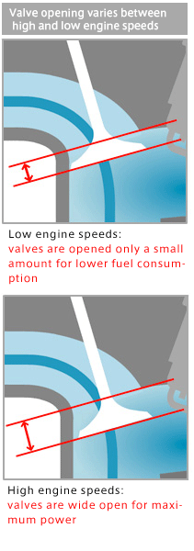
Fig.14.1

24

.
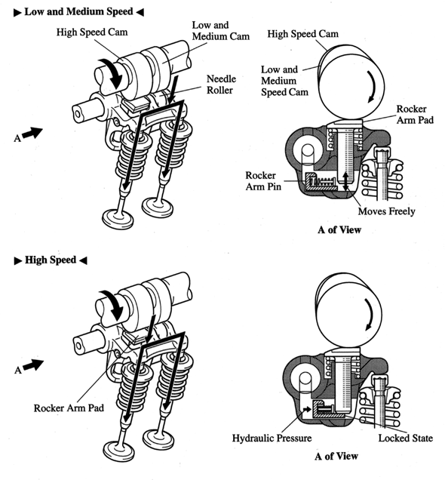
Fig.14.2

25

CHAPTER-15 APPLICATIONS

Currently i-VTEC technology is available on three Honda products;

- 2002 Honda CRV

- 2002 Acura RSX

c) Honda Civic 2006

d) 2010 Honda City i-VTEC

26

CHAPTER-16

CASE STUDY OF ‘HONDA CIVIC 2006’ WITH 1.8 litre ENGINE

16.1 The new i- VTEC system in Honda civic 2006 uses its valve timing control system to deliver acceleration performance equivalent to a 2.0-liter engine and fuel economy approximately 6% better than the current 1.7-liter Civic engine. During cruising, the new engine achieves fuel economy equivalent to that of a 1.5-liter engine.
In a conventional engine, the throttle valve is normally partly closed under low-load conditions to control the intake volume of the fuel-air mixture. During this time, pumping losses are incurred due to intake resistance, and this is one factor that leads to reduced engine efficiency.
The i-VTEC engine delays intake valve closure timing to control the intake volume of the air-fuel mixture, allowing the throttle valve to remain wide open even under low-load conditions for a major reduction in pumping losses of up to 16%. Combined with friction-reducing measures, this result in an increase in fuel efficiency for the engine itself.
A DBW (Drive By Wire) system provides high-precision control over the throttle valve while the valve timing is being changed over, delivering smooth driving performance that leaves the driver unaware of any torque fluctuations.
Other innovations in the new VTEC include a variable-length intake manifold to further improve intake efficiency and piston oil jets that cool the pistons to suppress engine knock.
In addition, lower block construction resulting in a more rigid engine frame, aluminium rocker arms, high-strength cracked connecting rods, a narrow, silent cam chain, and other innovations make the engine more compact and lightweight. It is both lighter and shorter overall than the current Civic 1.7-liter engine, and quieter as well.

SPECIFICATIONS OF 1.8l i-VTEC ENGINE

➢ Engine type and number of cylinders Water-cooled in-line 4-cylinder
➢ Displacement 1,799 cc
➢ Max power / rpm 103 kW (138 hp)/ 6300
➢ Torque / rpm 174 Nm (128 lb-ft)/4300
➢ Compression ratio 10.5:1

27

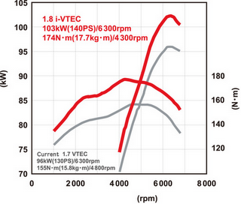
Fig.16.1

28
CHAPTER-17 FUTURE TRENDS

From now onwards, there is all likelihood that Honda will implement i-VTEC on its performance engines. Again what i-VTEC does allow is for Honda to go for the sky in terms of specific power output but yet still maintaining a good level of mid-range power. Already extremely authoritative reviewers like BEST motoring have complained about the lack of a broad mid-range power from for e.g. the F20C engine. In a tight windy circuit like Tsukuba and Ebisu, the S2000 finds it extremely tough going to overtake the Integra Type-R in 5-lap battles despite having 50ps or 25% more power. To get the extreme power levels of the F20C, the wild cams' power curve are so narrow that there is effectively a big hole in the composite power curve below 6000rpm. What i-VTEC can do to this situation is to allow fine-tuning of the power curve, to broaden it, by varying valve opening overlap. Thus this will restore a lot of mid-range power to super-high-output DOHC VTEC engines allowing Honda, if they so desire, to go for even higher specific outputs without too much of a sacrifice to mid-range power.

29

CHAPTER-18 ADVANTAGES OF i-VTEC ENGINES

- Class-leading power and fuel efficiency
High performance and low fuel consumption in a single engine.

- i-VTEC: high power + low fuel consumption

- i-VTEC regulates the opening of air-fuel intake valves and exhaust valves in accordance with engine speeds
By regulating valve opening to match engine speed, the agile i-VTEC engine adjusts its characteristics to realize both superior power and low fuel consumption.

Fig.18.1 Honda has refined the basic VTEC formula to improve power and efficiency.

30

CHAPTER-19 DISADVANTAGES OF i-VTEC ENGINES

- i-VTEC engines are very expensive.

- The mechanism of i-VTEC engine is very complicated.

- It decreases the life of the engine because the power of the engine is increased but the torque which is produced is not sufficient.

31

CONCLUSION

i-VTEC system is more sophisticated than earlier variable-valve-timing systems, which could only change the time both valves are open during the intake/exhaust overlap period on the transition between the exhaust and induction strokes. By contrast, the i-VTEC setup can alter both camshaft duration and valve lift. i-VTEC Technology gives us the best in vehicle performance. Fuel economy is increased, emissions are reduced, derivability is enhanced and power is improved.

32

REFERENCES

- http://en.wikipedia.org/wiki/i-VTEC

- http://www.i-VTEC.net

- http://www.articlesnatch.com/Article/i-VTEC/

33

