Variable Valve timing (VVT)
- Need of VVT:-
An engine is essentially a large air pump. The more an engine can suck in air to mix with fuel, the more it can create power through combustion. Thus, the more efficiently an engine removes exhaust gases from the cylinders, the better it can manage that power. The key to a strong, healthy engine is adequate air from one end to another.
Air flow is affected by many different components in the motor, but the valves in the cylinder head are what directly control the amount of air entering a cylinder, and the volume of exhaust gases leaving it. The intake valves open up just prior to combustion in order to allow air to flow in and mix with fuel, and the exhaust valves open after the ignition of this mixture in order to suck out the resulting gases. The timing of the valves is controlled by a rotating shaft called the camshaft. The camshaft has lobes which push up on the valves in order to open them and drop them back closed again.
How long these valves remain open, and at what point in the combustion cycle, can have a big impact on the drivability and power generated by an engine. For instance, if you want to have a really fast car, like a race car, you'll want the engine to produce a lot of power at high RPMs. You can adjust the camshaft to perform well at higher RPMs. This will result in poor performance at low RPMs, but that's OK with a race car. Conversely, if you want a lot of low-end torque - which is great for towing - you need to adjust the camshaft to perform well at low RPMs.This offcourse will hurt RPM performance and would not be standard one.
Unfortunately, street vehicles are a compromise between reliability, fuel efficiency and power. While race vehicles have engines with camshaft designs that generate large amounts of power while being used only at specific, high revolutions, your daily driver sees a wide range of RPMs that make a broader power band necessary. While it is ok for a race car to have a lumpy idle that barely runs below 1000 rpm, it would do you no good if your street car stalled out at every stoplight. Regular vehicles usually have to make do with a camshaft that provides a good amount of power in the most often used range of engine RPMs, but runs out of steam at high speeds.
The problem with compromise camshafts is that they're not all that efficient. Since everyday vehicles operate at a variety of different RPMs, the engine needs to be just as capable of accelerating from a dead stop as it is of zooming along at highway speeds.

- Background:-

The valves within an internal combustion engine are used to control the flow of the intake and exhaust gases into and out of the combustion chamber. The timing, duration and lift of these valve events has a significant impact on engine performance. Without variable valve timing or variable valve lift, the valve timing must be the same for all engine speeds and conditions, therefore compromises are necessary.^{[1]} An engine equipped with a variable valve timing actuation system is freed from this constraint, allowing performance to be improved over the engine operating range.
Piston engines normally use valves which are driven by camshafts. The cams open the valves (lift) for a certain amount of time (duration) during each intake and exhaust cycle. The timing of the valve opening and closing is also important. The camshaft is driven by the crankshaft through timing belts, gears or chains.
An engine requires large amounts of air when operating at high speeds. However, the intake valves may close before enough air has entered each combustion chamber, reducing performance. On the other hand, if the camshaft keeps the valves open for longer periods of time, as with a racing cam, problems start to occur at the lower engine speeds. This will cause unburnt fuel to exit the engine since the valves are still open. This leads to lower engine performance and increased emissions.
- Description:-
It is the process of altering the timing of a valve lift event, and is often used to improve performance, fuel economy or emissions. It is increasingly being used in combination with variable valve lift systems. There are many ways in which this can be achieved, ranging from mechanical devices to electro-hydraulic and camless systems. Increasingly strict emissions regulations are causing many automotive manufacturers to use VVT systems.

Variations in VVT
- Late intake valve closing:-
The first variation of continuous variable valve timing involves holding the intake valve open slightly longer than a traditional engine. This results in the piston actually pushing air out of the cylinder and back into the intake manifold during the compression stroke. The air which is expelled fills the manifold with higher pressure, and on subsequent intake strokes the air which is taken in is at a higher pressure. Late intake valve closing has been shown to reduce pumping losses by 40% during partial load conditions, and to decrease nitric oxide emissions by

24%. Peak engine torque showed only a 1% decline, and hydrocarbon emissions were unchanged.
- Early intake valve closing:-
Another way to decrease the pumping losses associated with low engine speed, high vacuum conditions is by closing the intake valve earlier than normal. This involves closing the intake valve midway through the intake stroke. Air/fuel demands are so low at low-load conditions and the work required to fill the cylinder is relatively high, so Early intake valve closing greatly reduces pumping losses.^{[2]} Studies have shown early intake valve closing reduces pumping losses by 40%, and increases fuel economy by 7%. It also reduced nitric oxide emissions by 24% at partial load conditions. A possible downside to early intake valve closing is that it significantly lowers the temperature of the combustion chamber, which can increase hydrocarbon emissions.
- Early intake valve opening:-
Early intake valve opening is another variation that has significant potential to reduce emissions. In a traditional engine, a process called valve overlap is used to aid in controlling the cylinder temperature. By opening the intake valve early, some of the inert/combusted exhaust gas will back flow out of the cylinder, via the intake valve, where it cools momentarily in the intake manifold. This inert gas then fills the cylinder in the subsequent intake stroke, which aids in controlling the temperature of the cylinder and nitric oxide emissions. It also improves volumetric efficiency, because there is less exhaust gas to be expelled on the exhaust stroke.
- Early/late exhaust valve closing
Early and late exhaust valve closing can also reduce emissions. Traditionally, the exhaust valve opens, and exhaust gas is pushed out of the cylinder and into the exhaust manifold by the piston as it travels upward. By manipulating the timing of the exhaust valve, engineers can control how much exhaust gas is left in the cylinder. By holding the exhaust valve open slightly longer, the cylinder is emptied more and ready to be filled with a bigger air/fuel charge on the intake stroke. By closing the valve slightly early, more exhaust gas remains in the cylinder which increases fuel efficiency. This allows for more efficient operation under all conditions.

VVT Technology in Automotive Companies
- BMW

- VANOS:-
The name VANOS is derived from the German term "variable Nockenwellensteuerung", meaning variable camshaft control. Operates on the intake camshaft in accordance with engine speed and accelerator pedal position.
At the lower end of the engine-speed scale, the intake valves are opened later, which improves idling quality and smoothness. At moderate engine speeds, the intake valves open much earlier, which boosts torque and permits exhaust gas re-circulation inside the combustion chambers, reducing fuel consumption and exhaust emissions.
Finally, at high engine speeds, intake valve opening is once again delayed, so that full power can be developed.
- Double-VANOS:-
In this technology system continuously adjusts the camshaft positions for both the intake and the exhaust valves. This results in significantly higher torque at low engine speeds and more power at higher engine speeds, while also reducing fuel consumption and emissions.
At lower engine speeds, the position of the camshaft is moved so the valves are opened later, as this improves idling quality and smooth power development. As the engine speed

increases, the valves are opened earlier: this enhances torque, reduces fuel consumption and lowers emissions. At high engine speeds, the valves are opened later again, because this allows full power delivery.
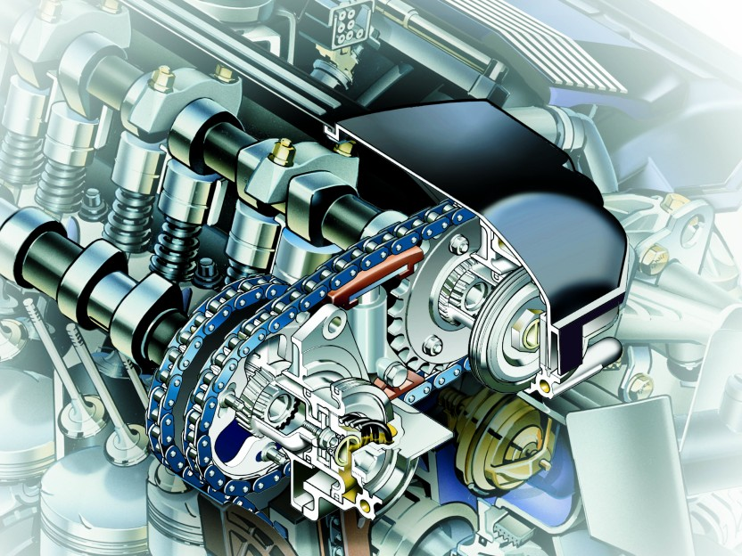

Double-VANOS also controls the amount of exhaust gas that is re-circulated back to the intake manifold, enhancing fuel economy. The system uses a special set of parameters in the engine's warming-up phase in order to help the catalytic converter reach its ideal operating temperature more quickly, lowering emissions.
The entire process is controlled by the vehicle's Digital Motor Electronics (DME). BMW first introduced the breakthrough VANOS technology in 1992. Double-VANOS entered production in 1997
- Valvetronic:-

Valvetronic varies the timing and the lift of the intake valves. The Valvetronic system has a conventional intake cam, but it also uses a secondary eccentric shaft with a series of levers and roller followers, activated by a stepper motor.

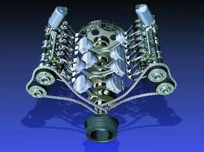
Based on signals formerly taken mechanically from the accelerator pedal, the stepper motor changes the phase of the eccentric cam, modifying the action of the intake valves.
The Valvetronic engine replaces the function of the throttle butterfly by using an infinitely variable intake valve lift. The Valvetronic engine does not require a timing belt or chain.
Valvetronic has its own computer housed in a separate unit away from the engine management system, networked with the digital engine management system incorporating a 40-megahertz, 32-bit computer

Toyota
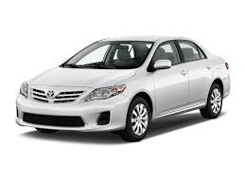

- VVT-i(Variable valve timing intelligence):-
It varies the timing of the intake valves by adjusting the relationship between the camshaft drive (belt, scissor-gear or chain) and intake camshaft. Engine oil pressure is applied to an actuator to adjust the camshaft position.
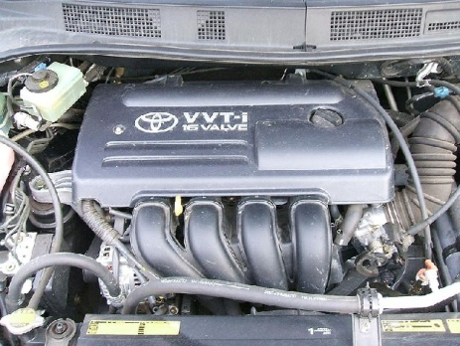

Adjustments in the overlap time between the exhaust valve closing and intake valve opening result in improved engine efficiency

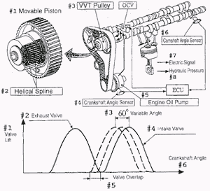

It allows the relationship between the separate inlet and exhaust camshafts to vary the valve timing overlap. The valve timing and overlap are adjusted through a series of simple mechanisms to ensure the optimum conditions apply across all the working revolution range. The advantages are lower fuel consumption, lower exhaust emissions and higher power output. Because the system is continuously variable, an ‘i’ for ‘intelligence’ has been added to the acronym.

- Dual VVT-i:-
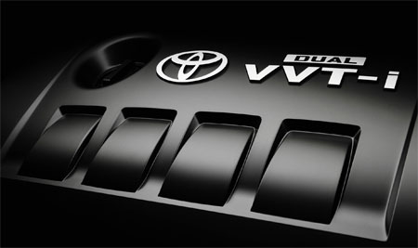
The Dual VVT-i system works similar to the VVT-I but in addition it adjusts timing on both intake and exhaust camshafts.It is used on vehicles equipped with separate intake and exhaust camshafts; setting for each can be altered independently by the computer.

- Primary benefits:-
- Easier starting
- Quicker, smoother acceleration
- Better fuel economy
- Lower emissions
VVTL-i(Variable Valve Timing Lifting Intelligence):-
VVTL-i builds on the foundation of the VVT-i system but adds an exciting sporty dimension to an engine whilst still maintaining good fuel economy and low emissions.

In addition to varying the timing of the intake valve, VVTL-i controls the amount of intake and exhaust valve lift which optimises engine power output.

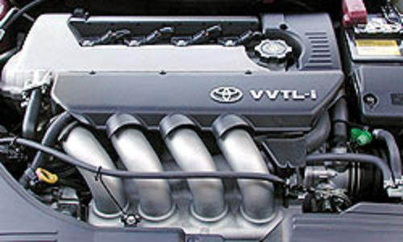

VVTL-i uses a cam changeover mechanism that increases the amount of intake and exhaust valve lift when the engine is operating at high speeds. The mechanism uses a unique rocker arm assembly with intake and exhaust camshafts that have two different types of cam lobes on them.
The lift of the intake and exhaust valves can be increased, allowing for a greater volume of fuel/mixture to enter the combustion chamberAdditional engine power at engine speeds above 6000 RPM is produced due to the dramatically improved engine breathing.

HONDA

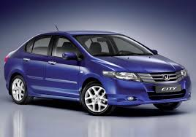

- VTEC(Variable Valve Timing and Lift Electronic Control)
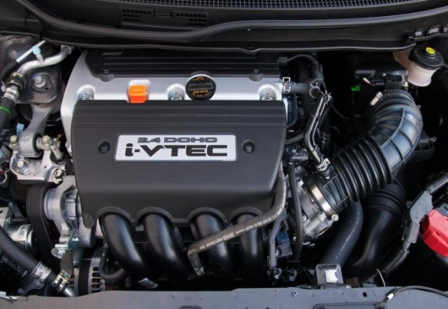

VTEC is a valvetrain (A valve train or valvetrain is a device that controls the operation of the valves., in which a sequence of components transmits motion throughout the assembly.
A traditional reciprocating internal combustion engine uses valves to control air and fuel flow into and out of the cylinders, facilitating combustion.System developed by Honda to improve the volumetric efficiency of a four-stroke internal combustion engine. The VTEC system uses two camshaft profiles and hydraulically selects between profiles

The VTEC system provides the engine with multiple cam lobe profiles optimized for both low and high RPM operations. As the engine moves into different rpm ranges, the engine's computer can activate alternate lobes on the camshaft and change the cam's timing. In this way, the engine gets the best features of low-speed and high-speed camshafts in the same engine.
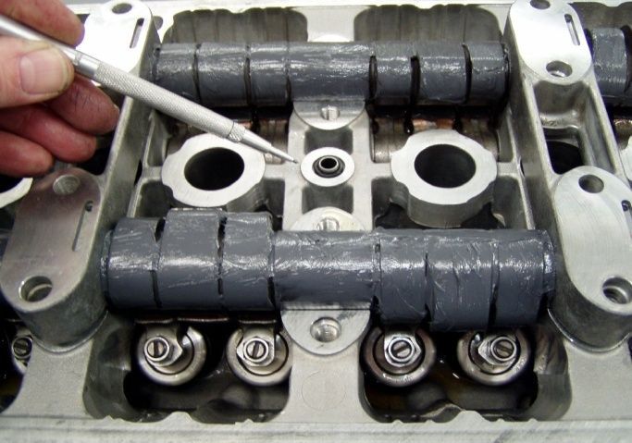
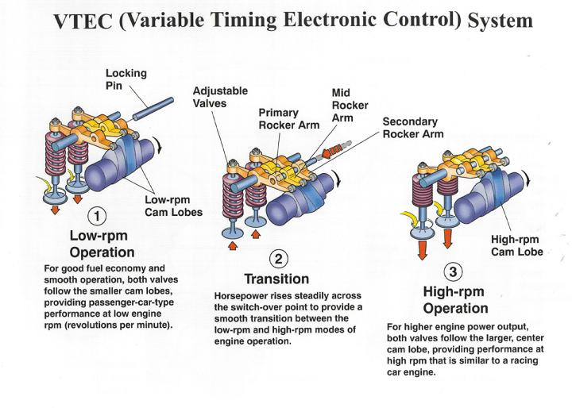
In basic form, the single barring shaft-lock of a conventional engine is replaced with two profiles: one optimized for low-RPM stability and fuel efficiency, and the other designed to maximize high-RPM power output. The switching operation between the two cam lobes is controlled by the ECU which takes account of engine oil pressure, engine temperature, vehicle speed, engine speed and throttle position. Using these inputs, the ECU is programmed to switch from the low lift to the high lift cam lobes when the conditions mean that engine output will be improved.

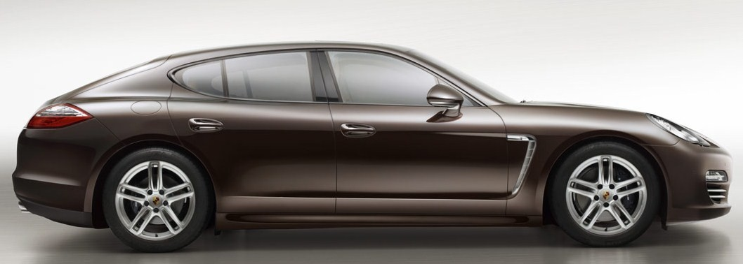
At the switch point a solenoid is actuated which allows oil pressure from a spool valve to operate a locking pin which binds the high RPM cam follower to the low RPM ones. From this point on, the valves open and close according to the high-lift profile, which opens the valve further and for a longer time. The switch-over point is variable, between a minimum and maximum point, and is determined by engine load. The switch-down back from high to low RPM cams is set to occur at a lower engine speed than the switch-up (representing a hysteresis cycle) to avoid a situation in which the engine is asked to operate continuously at or around the switch-over point.

PORCHE

- Variocam:-
VarioCam is an automobile variable valve timing technology developed by Porsche. VarioCam varies the timing of the intake valves by adjusting the tension on the timing chain connecting the intake and exhaust camshafts.
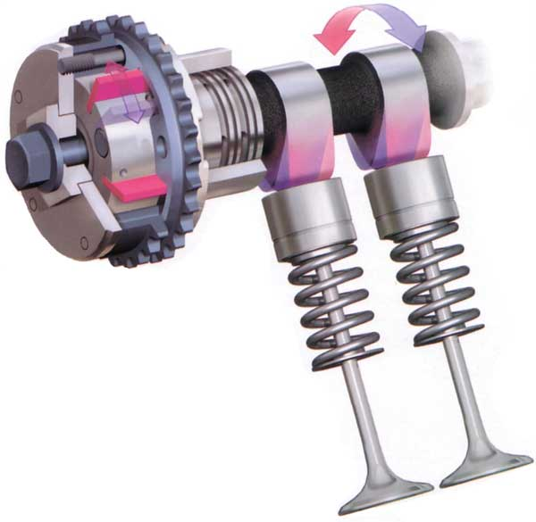

Porsche's more recent VarioCam Plus combines variable valve timing with two-stage lift on the intake side. The two-stage valve-lift function is performed by electro-hydraulically operated switchable tappets. Each of these 12 tappets consists of concentric lifters which can be locked together by means of a pin.
The inner lifter is actuated by a small cam lobe, while the outer ring element is moved by a pair of larger-profile lobes. The timing of each valve is seamlessly adjusted by means of an electro-hydraulically operated rotary vane adjuster at the head of each intake camshaft.
Valve timing and the valve profile are continuously altered according to conditions and engine load. For improved responsiveness on cold starts, VarioCam Plus raises the amount of lift and retards valve timing. At medium revs with minimal loads, the valve lift is lowered and timing advanced to help minimize fuel consumption and emissions. For maximum power and torque, the lift is raised and the timing is advanced

