ABSTRACT

Variable valve actuation in heavy duty diesel engines is not well documented, partly because of diesel engine nature, such as, unthrottled air handling, which gives little room to improve pumping loss; a very high compression ratio, which makes the clearance between the piston and valve is little when the piston reaches the top dead center. It is a long time that diesel engines are running by EGR and VGT. The goal of this research work is addressed the issue about how much fuel benefit diesel engines at 13-mode cycle could be achieved using variable valve timing in a heavy duty diesel engine. Late inlet valve closing strategy will be used. In order to see how much fuel efficiency could improve in addition to EGR and VGT, EGR and VGT are fully controlled in a closed-loop. This paper examines fuel improvement in different speeds and torques. Finally, we could see that 3.28% BSFC benefit at 13-mode cycle could be achieved. The reason of this benefit is that fixed valve lift engine makes a compromise between high speed engine performance and low speed fuel economy, late inlet valve closing optimizes valve timing at each engine torque and speed.
Introduction
The Task Of Variable Valve Timing
Variable valve timing has the task of setting the most advantageous valve timing for the particular engine for the operating modes idle, maximum power and torque as well as exhaust gas recirculation.
Idle
At idle, the camshafts are set so that the inlet camshaft opens late and, consequently, closes late as well. The exhaust camshaft is set so that it closes well before TDC. Due to the minimal gas residue from combustion, this leads to smooth idling.
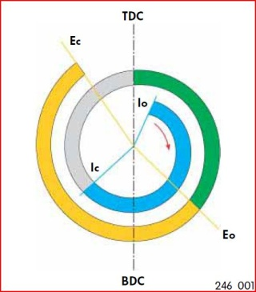
Power
To achieve good power at high engine speeds, the exhaust valves are opened late. In this way, the expansion of the burned gases can act against the pistons longer.
The inlet valves open after TDC and close well after BDC. In this way, the dynamic self-charging effect of the entering air is used to increase power.
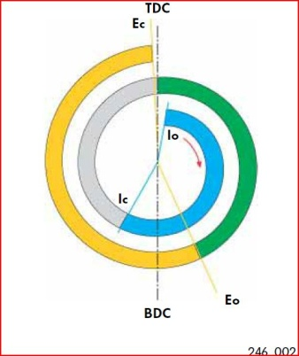
Torque
To achieve maximum torque, a high degree of volumetric efficiency must be attained. This requires that the inlet valves be opened early. Because they open early, they close early as well, which avoids pressing out the fresh gases.
The exhaust camshaft closes just before TDC.
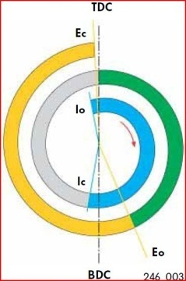
Exhaust gas recirculation
Internal exhaust gas recirculation can be achieved by adjusting the inlet and exhaust camshafts. In this process, exhaust gas flows from the exhaust port into the inlet port while the valves overlap (inlet and exhaust valves are both open). The amount of overlap determines the amount of recirculated exhaust gas. The inlet camshaft is set so that it opens well before TDC and the exhaust camshaft does not close until just before TDC. As a result, both valves are open and exhaust gas is recirculated. The advantage of internal exhaust gas recirculation over external exhaust gas recirculation is the fast reaction of the system and very even distribution of the recirculated exhaust gases
. 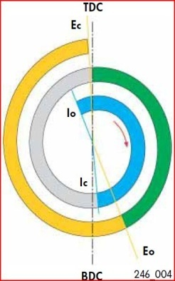

VARIABLE VALVE TIMING
Design Of Variable Valve Timing
The variable valve timing system consists of the following components:-
Two Fluted Variators
The fluted variator for adjusting the inlet camshaft is fitted directly on the inlet camshaft. It adjusts the inlet camshaft according to signals from the engine control unit. The fluted variator for adjusting the exhaust camshaft is fitted directly on the exhaust camshaft. It adjusts the exhaust camshaft according to signals from the engine control unit. Both fluted variators are hydraulically operated and are connected to the engine oil system via the control housing.
The illustration shows the arrangement of the variable valve timing system on the V5 and V6 engines.
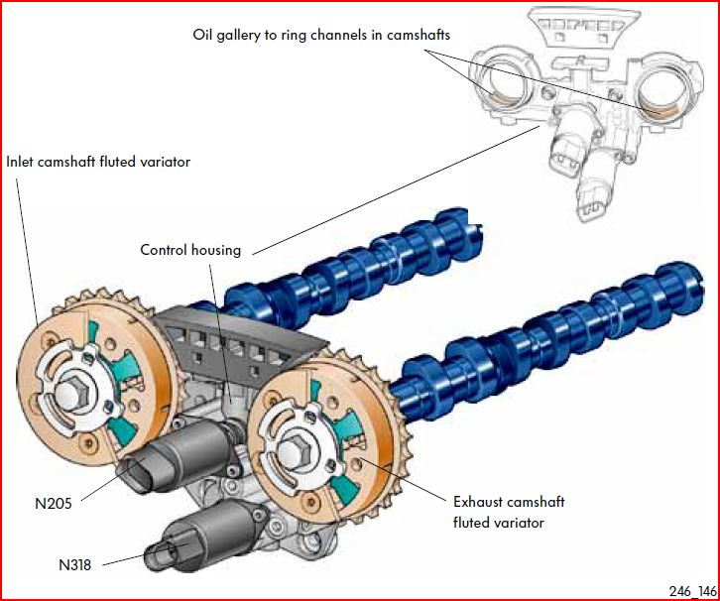
The Control Housing
The control housing is attached to the cylinder head. Oil galleries to both fluted variators are located in the control housing.
Two Solenoid Valves
There are two solenoid valves located in the control housing. They direct oil pressure to both fluted variators according to the signal from the engine control unit.
Inlet camshaft timing adjustment valve -1- (N205) is responsible for the inlet camshaft, and exhaust camshaft timing adjustment valve -1- (N318) is responsible for the exhaust camshaft.
The illustration shows the arrangement of the variable valve timing system on one cylinder head of the W8 and W12 engines.
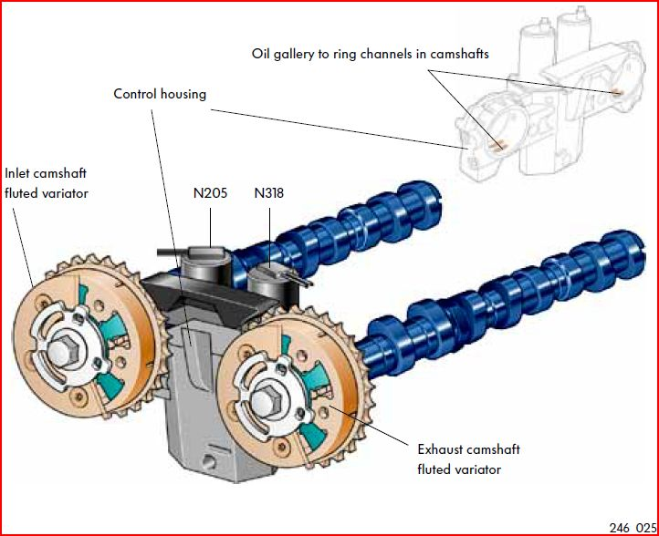
Operation Of Variable Valve Timing
The engine control unit controls the variable valve timing. To adjust the camshafts, it requires information about engine speed, engine load and temperature and the positions of the crankshaft and camshafts.
To adjust the camshaft, the engine control unit actuates the solenoid valves N205 and N318. They in turn open oil galleries in the control housing. Engine oil flows through the control housing and camshaft into the fluted variators. The fluted variators turn and adjust the camshaft according to the specifications of the engine control unit.
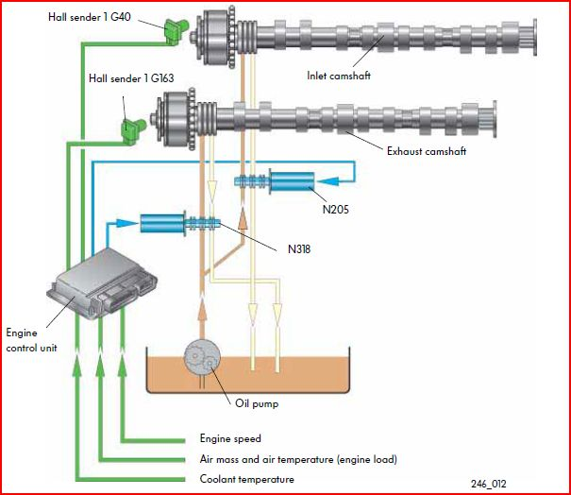
This section goes into more detail about the adjustment of the camshafts. The parts, the design and the operation are the subject of the following pages.
Inlet Camshaft Adjustment
The inlet camshaft is regulated by the engine control unit over the entire speed range of the engine. The maximum adjustment is 52° CA. The adjustment is dependent on the adjustment map stored in the engine control unit.
Design of the fluted variator for the inlet camshaft The adjusting mechanism consists of:
- Housing with outer rotor (directly joined to timing chain)
- Inner rotor (directly joined to camshaft)
Fluted Variator
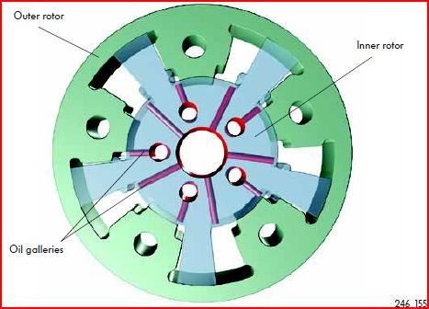

Inlet Camshaft
How the camshaft is advanced
The inlet camshaft is set in the position “inlet valves open before TDC” for exhaust gas recirculation and for increasing torque. To change the position, the engine control unit actuates inlet camshaft timing adjustment valve 1 (N205). When actuated, the valve moves the control piston.
In the control housing, the oil gallery for timing advance is opened according to the degree of adjustment. Consequently, the engine oil under pressure flows through the control housing into the ring channel in the camshaft. Then the oil flows through the five drillings in the face of the camshaft into the five advance chambers of the fluted variator. There it presses against the flutes of the inner rotor. The inner rotor turns relative to the outer rotor (and crankshaft), turning the camshaft with it. Consequently, the camshaft turns further in the direction of crankshaft rotation and the inlet valves open sooner.
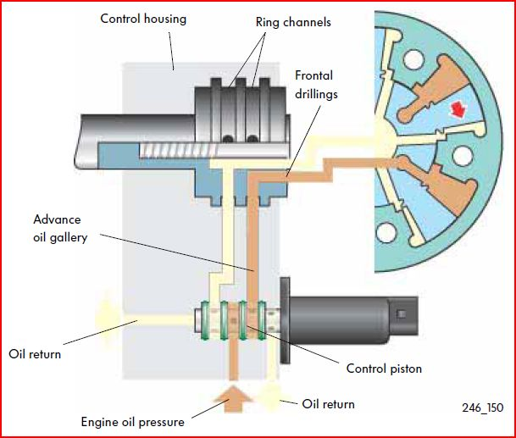
How The Camshaft Is Retarded
When the engine is idling or when a great deal of power is required from the engine, the inlet camshaft is rotated so that the inlet valves open late, that is, after TDC. To retard the inlet camshaft, the engine control unit actuates inlet camshaft timing adjustment valve 1 (N205).
The solenoid valve opens the gallery for timing retardation by moving the control piston. Oil flows through the control housing into the ring channel of the camshaft. The oil flows through drillings in the camshaft to the pocket hole of the securing bolt for the camshaft adjuster. From there, it flows through 5 drillings in the camshaft adjuster into the oil chamber for timing retardation behind the flutes of the inner rotor. The oil presses the inner rotor and the camshaft in the direction of camshaft rotation and the valves open later.
At the same time that the oil gallery for timing retardation opens, the control piston opens the oil return for the gallery for timing advance, relieving pressure in it. The rotation in the direction of retardation presses the oil out of the timing advance oil chamber which flows out through the timing advance oil gallery
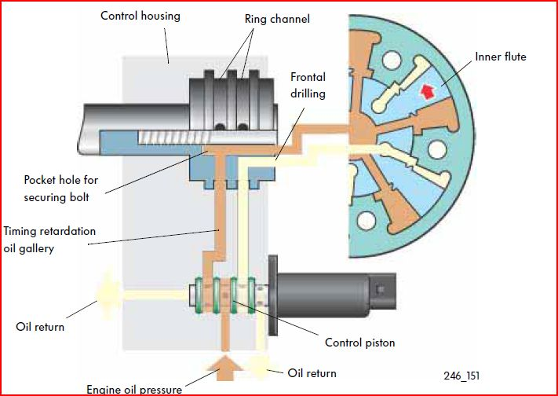
How Regulation Works
Regulation enables continuous variation of the inlet camshaft between advanced and retarded, whereby the total variation is a maximum of 52° crankshaft angle. On the basis of the Hall sender signal, the engine control unit detects the momentary position of the inlet camshaft.
The camshafts can then be adjusted according to the map saved in the engine control unit. When actuated by the engine control unit, inlet camshaft timing adjustment valve 1 (N205) pushes the control piston in the direction, for example, of advanced timing. Oil pressure travels through the control housing into the camshaft adjuster and presses the camshaft in the “advanced” position. Pushing the control piston in the “advanced” direction automatically opens the oil return of the oil channel for retarding timing. When the desired angle of adjustment is attained, the control piston is moved by the actuation of inlet camshaft timing adjustment valve 1 (N205) to a position in which the pressure is held in both chambers of the adjuster. If the timing is later retarded, the process runs in the opposite direction.
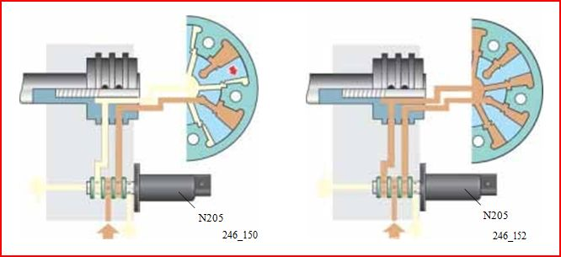

Exhaust Camshaft
Exhaust Camshaft Adjustment
As you saw in the preceding pages, the inlet camshaft is regulated by the control unit. In contrast to that, the exhaust camshaft can only be controlled. The control unit sets the variator only to the basic position or the idle position. The maximum angle of adjustment is 22° crankshaft angle.
Design Of The Fluted Variator For The Exhaust Camshaft:
The fluted variator for the exhaust camshaft is identical in design to the fluted variator for the inlet camshaft. Only the inner rotor is wider because the adjustment is only 22° crankshaft Angle.
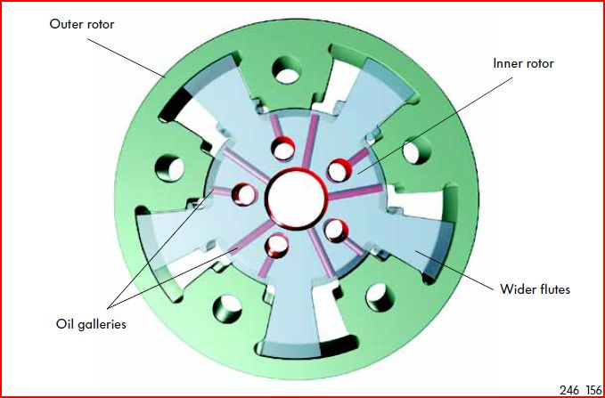
Basic Position
The exhaust camshaft is in its basic position when the engine is starting and at engine speeds above idle. The exhaust valves then close shortly before TDC. The exhaust camshaft is in this position in the operating modes power, torque and exhaust gas recirculation. The exhaust camshaft timing adjustment valve 1 (N318) is not actuated in these ranges.
How The Basic Position Works
In the basic position, the exhaust camshaft is positioned so that the valves close shortly before TDC. The exhaust camshaft timing adjustment valve 1 (N318) is not actuated by the engine control unit. In this position, the oil gallery for timing retardation is open. Through oil galleries, oil pressure reaches the ring channel of the exhaust camshaft. From there, it travels through the frontal drillings in the camshaft to the oil chamber of the camshaft adjuster. From there it presses against the flutes of the inner rotor. The flutes turn to stop, turning the camshaft along with it. The camshaft remains in this position as long as the solenoid is not actuated.
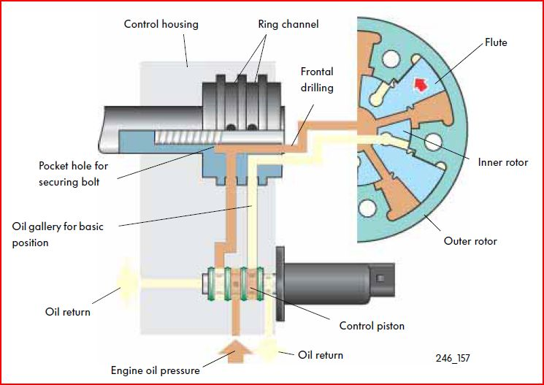

Idle
The exhaust camshaft is set to the “advanced” position from idle to engine speeds to about 1,200 rpm.
How The Idle Position Works
The exhaust camshaft timing adjustment valve 1 (N318) is actuated by the engine control unit. This pushes the control piston and opens another oil gallery in the control housing. The engine oil now flows into the other ring channel in the camshaft and through the drilled camshaft into the camshaft adjuster. There it presses against the flutes of the inner rotor. The flutes are pressed in the direction of engine rotation, taking the camshaft with them, so that the exhaust valves open and close earlier. The oil from the chamber in front of the flutes runs through the drilling in the camshaft adjuster, the pocket hole of the securing bolt and the ring channel of the camshaft back to the solenoid valve. In the solenoid valve it flows through the oil return in the control box cover.
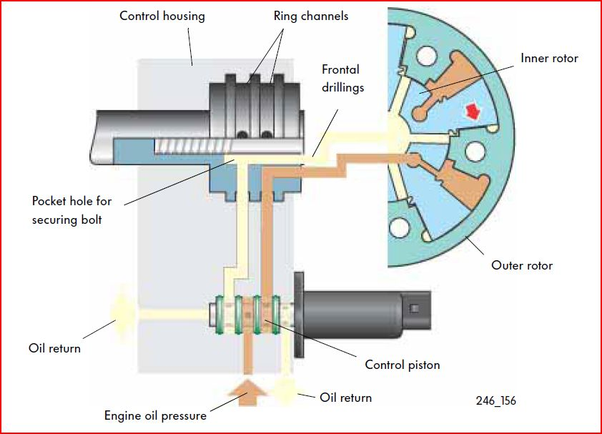
Oil System
The following pages introduce the oil system. The variable valve timing system operates at an oil pressure of 0.7 bar and above.
Course of oil under pressure
Oil pressure created by the oil pump flows through the cylinder block to the cylinder head and from there through an oil strainer into the control housing of the camshaft adjuster. Through galleries in the control housing, it reaches the ring channel in the camshaft and from there it travels through frontal drillings in the camshaft into the camshaft adjuster.
Course of oil without pressure
Oil from the chambers in the camshaft adjuster without pressure flows through the ring channel in the camshaft back to the control housing. Oil flows from the control housing back to the solenoid valve.
From the solenoid valve, it flows through the timing chain cover back to the sump.
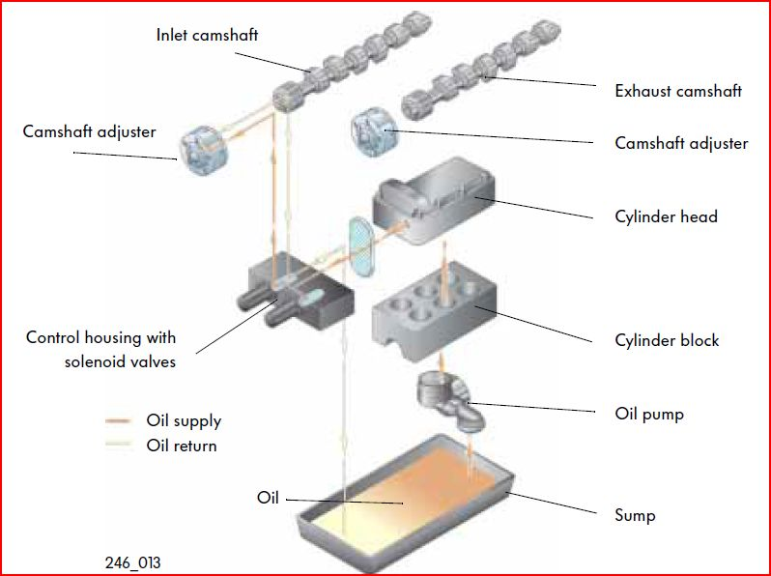
The oil course to the exhaust camshaft is identical with that to the inlet camshaft.
System overview for V5 and V6 engines
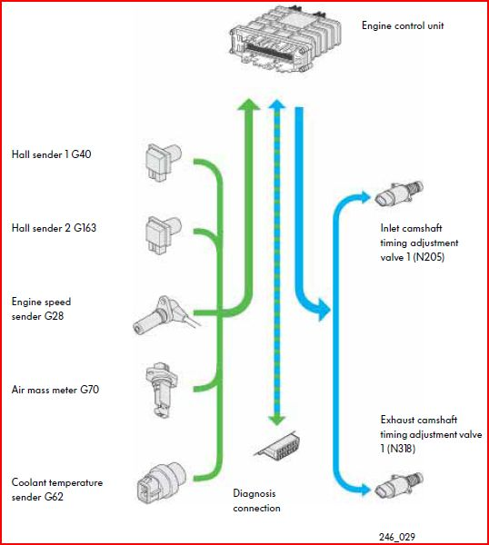
Engine Control Unit
The engine control unit, the sensors which provide it with information and the final controls which are actuated by the control unit are the subject of the following pages. The descriptions of the final controls and sensors in this self-study programme refer to engines with one exhaust and one inlet camshaft each. Engines with more than one exhaust and one inlet camshaft require, of course, a Hall sender and a valve for camshaft adjustment for each camshaft.
The engine control unit is responsible for controlling camshaft adjustment. To this end, maps for inlet and exhaust camshaft adjustment are stored in the engine control unit. These maps exist for each mode of engine operation in which camshaft adjustment is active.
For example, these operating modes:
- engine warm-up phase
- or for the engine at operating temperature.
The new functional structure of the engine control unit is based on engine torque as the base value for all further engine management measures calculated by the ECU. The base value, torque, is calculated directly in the engine control unit. To calculate torque, the control unit uses the signals from the air mass meter and the engine speed sender.
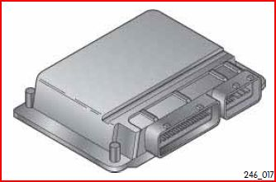

Learning Ability Of The System
The entire variable valve timing system is adaptive. This adaptability compensates for component and assembly tolerances as well as wear occurring during engine use. The engine control unit automatically initiates adaptation when the engine is idling and the coolant temperature is greater than 60° C. During adaptation at idle, the engine control unit uses signals from the engine speed sender and the Hall senders to check the idle settings of the inlet and exhaust camshafts. If the actual value does not agree with the specification stored in the control unit, the next time that the camshafts are adjusted, they will be corrected to the specification
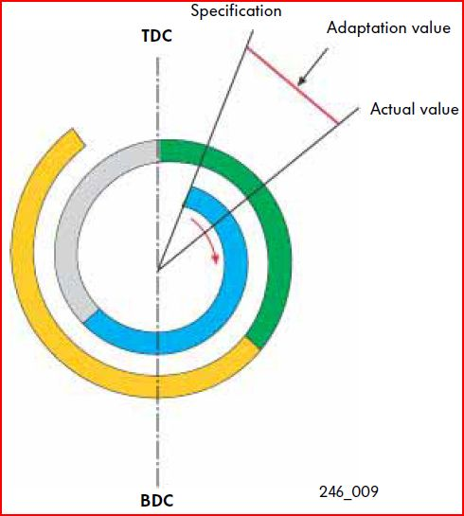

Air Mass Meter G70
The air mass meter G70 is located in the intake tract of the engine. The air mass meter signal is used by the engine control unit to calculate the volumetric efficiency. On the basis of volumetric efficiency, the lambda (O2) value and the ignition timing, the engine control unit calculates the torque.
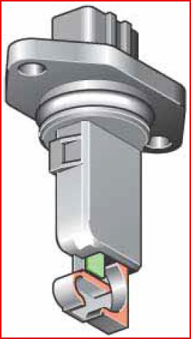
Use of signal | In the variable valve timing system, the signal is used for load-dependent adjustment of the camshaft.
Consequences of loss of signal | If the air mass meter fails, the engine control unit creates a substitute signal. Camshaft adjustment continues to operate according to the given operating conditions.

Engine Speed Sender G28
The engine speed sender G28 is located in the crankcase. It senses electromagnetically the teeth (60 minus 2) of the sender rotor on the crankshaft. With this signal, the engine control unit can detect the engine speed and the TDC position of the crankshaft. But to adjust the camshaft, the engine control unit requires the precise location of the crankshaft. To detect precisely the position of the crankshaft, the engine control unit uses the signals from the individual teeth of the sender rotor. The gap in the sender rotor serves as the zero point (TDC) and each sender rotor tooth marks 6° crankshaft angle.
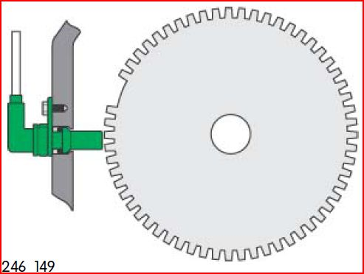
Use of signal | In the variable valve timing system, the signal is used for engine-speed-dependent adjustment of the camshaft.
Consequences of loss of signal | If this signal fails, the engine stops and cannot be started again.

Hall Sender G40 And Hall Sender 2 G163
Both Hall senders are located in the timing chain cover. The have the task of informing the engine control unit of the positions of the inlet and exhaust camshafts. They do this by reading the quick start sender rotor located on the respective camshaft. With Hall sender 1 G40 the engine control unit detects the position of the inlet camshaft and with Hall sender 2 G163, the position of the exhaust camshaft.
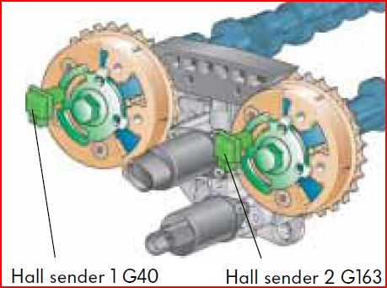
Use of signal | The engine control unit uses the engine speed sender signal to detect the position of the crankshaft. With the signals for the camshafts in addition, the control unit calculates the position of the camshafts relative to the crankshaft. The control unit needs these positions for the precise adjustment of the camshafts and to start the engine quickly.
Consequences of loss of signal | If only one Hall sender fails, camshafts will not be adjusted. But the engine will continue to run and will start after it has been stopped. If both Hall senders fail, the engine will continue to run until the next time that it is stopped. It will not be possible to restart the engine

Coolant Temperature Sender G62
The coolant temperature sender G62 is located in the thermostat housing. It informs the engine control unit of the current engine temperature.
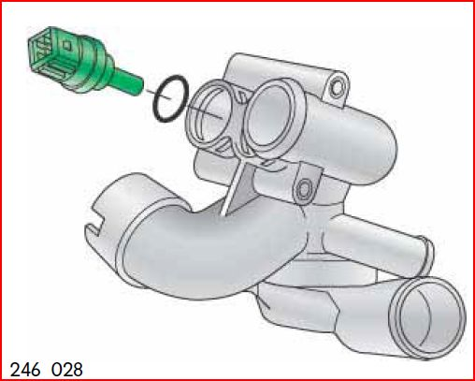
Use of signal | The sender signal is used for temperature- dependent start of camshaft adjustment.
Consequences of loss of signal | if the signal fails, the control unit uses a substitute temperature stored in it

Inlet Camshaft Timing Adjustment Valve N205 And Exhaust Camshaft Timing Adjustment Valve N318.
Both valves are integrated in the camshaft adjustment control housing. They have the task of directing oil pressure to the camshaft adjusters depending on the direction and distance of adjustment according to specifications from the control unit. To adjust the camshafts, the valves are actuated with a variable duty cycle (on-off ratio) by the control unit. Inlet camshaft timing adjustment valve N205 adjusts the inlet camshaft and exhaust camshaft timing adjustment valve N318 adjusts the exhaust camshaft.
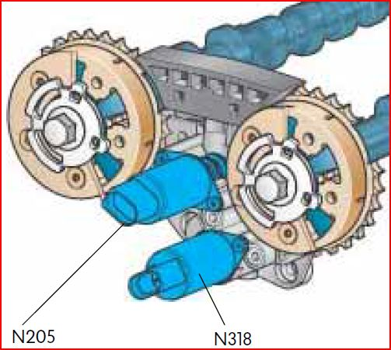
Consequences of loss of signal | If an electrical wire to the camshaft timing adjuster is defective, or a camshaft timing adjuster fails, camshaft adjustment will not be performed

Automotive Nomenclature
Manufacturers use many different names to describe their implementation of the various types of variable valve timing systems. These names include:
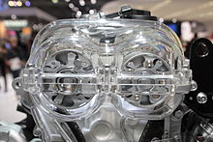
Hydraulic Vane-Type Phasers On A Cut-Out Model Of Hyundai T-GDI Engine
- AVCS (Subaru)
- AVLS (Subaru)
- CPS (Proton, Volvo)
- CVTCS (Nissan, Infiniti)
- CVVT (Alfa Romeo, Citroën, Geely, Hyundai, Iran Khodro, Kia, Peugeot, Renault, Volvo)
- DCVCP - dual continuous variable cam phasing (General Motors)
- DVVT (Daihatsu)
- MIVEC (Mitsubishi)
- N-VCT (Nissan)
- S-VT (Mazda)
- VANOS (BMW)
- VarioCam (Porsche)
- VCT (Ford, Yamaha)
- i-VTEC (Honda)
- VVC (MG Rover)
- VVL (Nissan)
- Valvelift (Audi)
- VVEL (Nissan, Infiniti)
- VVT (Chrysler, General Motors, Proton, Suzuki, Volkswagen Group)
- VVT-i (Toyota, Lexus)
- VTVT (Hyundai. Kia)

CONCLUSION

Variable valve actuation in heavy duty diesel engines is not well documented, partly because of diesel engine nature, such as, unthrottled air handling, which gives little room to improve pumping loss; a very high compression ratio, which makes the clearance between the piston and valve is little when the piston reaches the top dead center.

REFERENCE
- http://en.wikipedia.org/wiki/Variable_valve_timing
- http://auto.howstuffworks.com/camshaft2.htm
- http://jalopnik.com/how-variable-valve-timing-works-500056093
- http://www.carbibles.com/fuel_engine_bible_vvt.html
- http://www.austincc.edu/wkibbe/vvt.htm
- http://www.cnet.com/videos/car-tech-101-variable-valve-timing-explained/
- http://www.knowyourparts.com/technical-articles/vvt-diagnostic-tips/

