- INTRODUCTION

The classic problem facing high-performance street cars has always been how to maximize performance without sacrificing drivability. Short of power-adders like turbo or nitrous oxide, significant power increases are only achieved by extending the engine's rpm operating range, usually with some combination of intake, exhaust, camshaft, and cylinder head changes. But any significant gains upstairs inevitably cause a loss of low-speed performance, decreased fuel efficiency, and increased emissions.

The conundrum of camshaft selection is one of the key determinants in altering the power band. Racing engines have longer intake/exhaust timing, a higher valve lift, and a narrower lobe displacement angle (LDA) than standard engines, which for low-speed response and power tend to have short durations, low valve-lift numbers, and a wide LDA. Beginning with the '89 Honda Integra in Japan and the '90 Acura NSX supercar in the U.S., Honda implemented a novel solution to the problem, effectively combining the attributes of both passenger-car and race-car cam timing with its unique VTEC system. The initials stand for Variable Valve Timing and Lift Electronic Control, and as the name implies, a VTEC engine can actually alter the cam timing while the engine is running.

VTEC (Variable Valve Timing and Lift Electronic Control) is a system developed by Honda to improve the volumetric efficiency of a four-stroke internal combustion engine. The VTEC system uses two camshaft profiles and hydraulically selects between profiles. It was invented by Honda engineer Ikuo Kajitani, and was the first system of its kind. It is distinctly different from standard VVT (variable valve timing) which advances the valve timing only and does not change the camshaft profile or valve lift in any way.

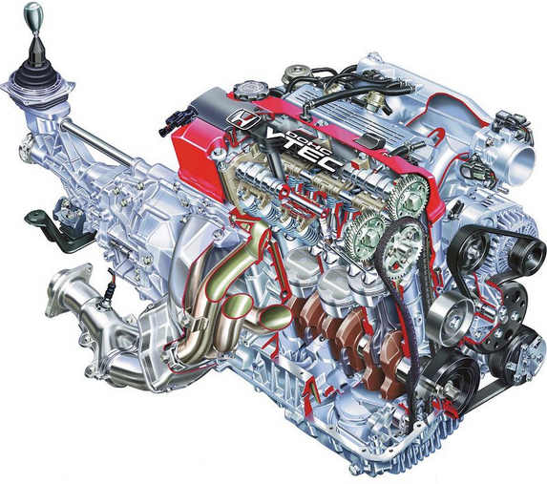
VTEC, the original Honda variable valve control system, originated from REV (Revolution-modulated valve control) introduced on the CBR400 in 1983 known as HYPER VTEC. In the regular four-stroke automobile engine, the intake and exhaust valves are actuated by lobes on a camshaft. The shape of the lobes determines the timing, lift and duration of each valve. Timing refers to an angle measurement of when a valve is opened or closed with respect to the piston position (BTDC or ATDC). Lift refers to how much the valve is opened. Duration refers to how long the valve is kept open. Due to the behavior of the working fluid (air and fuel mixture) before and after combustion, which have physical limitations on their flow, as well as their interaction with the ignition spark, the optimal valve timing, lift and duration settings under low RPM engine operations are very different from those under high RPM. Optimal low RPM valve timing, lift and duration settings would result in insufficient filling of the cylinder with fuel and air at high RPM, thus greatly limiting engine power output. Conversely, optimal high RPM valve timing, lift and duration settings would result in very rough low RPM operation and difficult idling. The ideal engine would have fully variable valve timing, lift and duration, in which the valves would always open at exactly the right point, lift high enough and stay open just the right amount of time for the engine speed in use.

VTEC was initially designed to increase the power output of an engine to 100 HP/liter or more while maintaining practicality for use in mass production vehicles. Some later variations of the system were designed solely to provide improvements in fuel efficiency.

Among Honda's many technologies, none ranks as synonymous with the brand as VTEC. The company's unique, dynamically adjustable valve train is, in large part, what helped make '90s-era Civics and Integras cooler than Ford Aspires and Daewoo Lanoses.

- VTEC SYSTEM

VTEC is one of Honda's greatest invention. Though an undisputed expert in turbo-charging as evidenced by years of Formula-1 domination while Honda was active in the sport, Honda's engineers feels that turbo charging has disadvantages, primarily bad fuel economy that made it not totally suitable for street use. At the same time, the advantages of working with smaller engines meant that smaller capacity engines with as high power output as possible (very high specific-output engines) are desirable for street engines. Thus Honda invented VTEC which allows it to extract turbo level specific output from its engines without having to suffer from the disadvantages of turbocharging.

Variable Valve Timing and Lift Electronic Control, more commonly known as VTEC, is an electronic and mechanical system that allows the engine to draw in more air while minimizing fuel consumption. As the engine moves into the upper rpm range, the engine's computer activates alternate lobes on the camshaft to increase the lift of the valves. Ultimately, VTEC is a way of effectively having multiple camshafts.

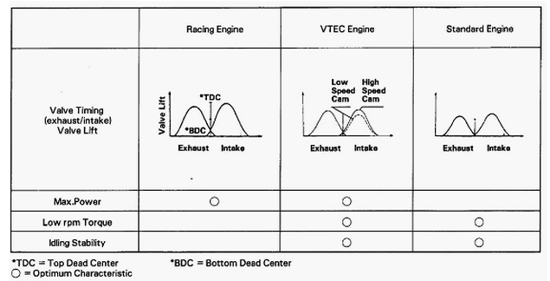

The VTEC system provides the engine with multiple cam lobe profiles optimized for both low and high RPM operations. In basic form, the single barring shaft-lock of a conventional engine is replaced with two profiles: one optimized for low-RPM stability and fuel efficiency, and the other designed to maximize high-RPM power output. The switching operation between the two cam lobes is controlled by the ECU which takes account of engine oil pressure, engine temperature, vehicle speed, engine speed and throttle position. Using these inputs, the ECU is programmed to switch from the low lift to the high lift cam lobes when the conditions mean that engine output will be improved. At the switch point a solenoid is actuated which allows oil pressure from a spool valve to operate a locking pin which binds the high RPM cam follower to the low RPM ones. From this point on, the valves open and close according to the high-lift profile, which opens the valve further and for a longer time. The switch-over point is variable, between a minimum and maximum point, and is determined by engine load. The switch-down back from high to low RPM cams is set to occur at a lower engine speed than the switch-up (representing a hysteresis cycle) to avoid a situation in which the engine is asked to operate continuously at or around the switch-over point.

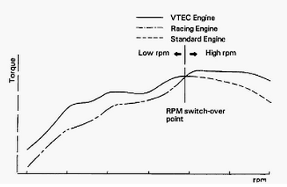

The older approach to timing adjustments is to produce a camshaft with a valve timing profile that is better suited to high-RPM operation. The improvements in high-RPM performance occur in trade for a power and efficiency loss at lower RPM ranges, which is where most street-driven automobiles operate a majority of the time. Correspondingly, VTEC attempts to combine high-RPM performance with low-RPM stability.

CAMSHAFTS AND LOBES:
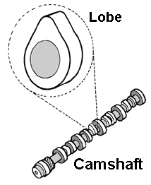
The camshafts of a VTEC engine have extra lobes. On an average cam, there are only two lobes for each cylinder -- one intake and one exhaust. As the crank turns, it spins the timing chain, which turns the cam. The VTEC system uses extra lobes to operate more than one valve at a time. This process is called VTEC crossover. It's the point at which some of the rocker arms are linked together to change the running characteristics of the engine.

ROCKER ARMS:
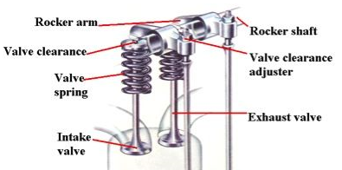
Rocker arms are the levers that pivot to push down on the valve stems, opening the valves to allow air and fuel into the combustion chambers, and to let exhaust out. Honda VTEC rocker arms have hydraulically-actuated interlocking pins that, when activated, join the arms together, enabling the simultaneous opening of multiple valves by a single cam lobe.

ENGINE CONTROL UNIT:
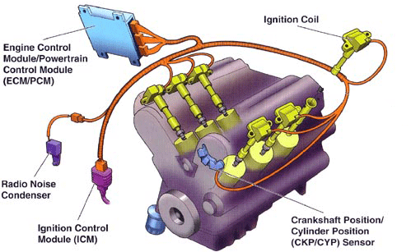
The ECU, or Engine Control Unit, monitors all of the engine's vital statistics. As the name suggests, it also operates all the servo-mechanisms on which the engine relies for normal operation.

- VTEC MECHANISMS:

  - DOHC VTEC:
With an electronically-controlled variable valve timing and lift mechanism, this “super sports” engine delivered high performance in all areas. Honda’s engineers, pursuing high RPMs and high output on a par with racing engines, developed the incredibly high-powered DOHC (Double overhead camshaft) VTEC engine, taking both high-speed and low-speed performance to a new level.

With an electronically-controlled variable valve timing and lift mechanism, this “super sports” engine delivered high performance in all areas. Honda’s engineers, pursuing high RPMs and high output on a par with racing engines, developed the incredibly high-powered DOHC VTEC engine, taking both high-speed and low-speed performance to a new level.

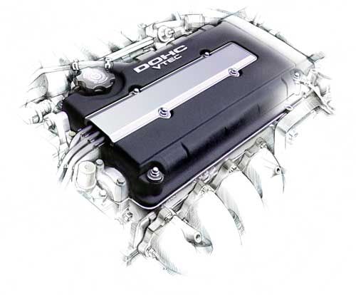

Introduced as a DOHC system in Japan in the 1989 Honda Integra XSi which used the 160 bhp (120 kW) B16A engine. The same year, Europe saw the arrival of VTEC in the Honda CRX 1.6i-VT, using a 150 bhp variant (B16A1). The United States market saw the first VTEC system with the introduction of the 1991 Acura NSX, which used a 3-litre DOHC VTEC V6 with 270 bhp (200 kW). DOHC VTEC engines soon appeared in other vehicles, such as the 1992 Acura Integra GS-R (B17A1 1.7-litre engine), and later in the 1993 Honda Prelude VTEC (H22A 2.2-litre engine with 195 hp) and Honda Del Sol VTEC (B16A3 1.6-litre engine). The Integra Type R (1995–2000) available in the Japanese market produces 197 bhp (147 kW; 200 PS) using a B18C5 1.8-litre engine, producing more horsepower per liter than most super-cars at the time. Honda has also continued to develop other varieties and today offers several varieties of VTEC, such as i-VTEC and i-VTEC Hybrid.

  - SOHC VTEC:
As popularity and marketing value of the VTEC system grew, Honda applied the system to SOHC (single overhead camshaft) engines, which share a common camshaft for both intake and exhaust valves. The trade-off was that Honda's SOHC engines benefitted from the VTEC mechanism only on the intake valves. This is because VTEC requires a third center rocker arm and cam lobe (for each intake and exhaust side), and, in the SOHC engine, the spark plugs are situated between the two exhaust rocker arms, leaving no room for the VTEC rocker arm. Additionally, the center lobe on the camshaft cannot be utilized by both the intake and the exhaust, limiting the VTEC feature to one side.

However, beginning with the J37A4 3.7L SOHC V6 engine introduced on all 2009 Acura TL SH-AWD models, SOHC VTEC was incorporated for use with intake and exhaust valves. The intake and exhaust rocker shafts contain primary and secondary intake and exhaust rocker arms, respectively. The primary rocker arm contains the VTEC switching piston, while the secondary rocker arm contains the return spring. The term "primary" does not refer to which rocker arm forces the valve down during low-RPM engine operation. Rather, it refers to the rocker arm which contains the VTEC switching piston and receives oil from the rocker shaft.
The primary exhaust rocker arm contacts a low-profile camshaft lobe during low-RPM engine operation. Once VTEC engagement occurs, the oil pressure flowing from the exhaust rocker shaft into the primary exhaust rocker arm forces the VTEC switching piston into the secondary exhaust rocker arm, thereby locking both exhaust rocker arms together. The high-profile camshaft lobe which normally contacts the secondary exhaust rocker arm alone during low-RPM engine operation is able to move both exhaust rocker arms together which are locked as a unit. The same occurs for the intake rocker shaft, except that the high-profile camshaft lobe operates the primary rocker arm.

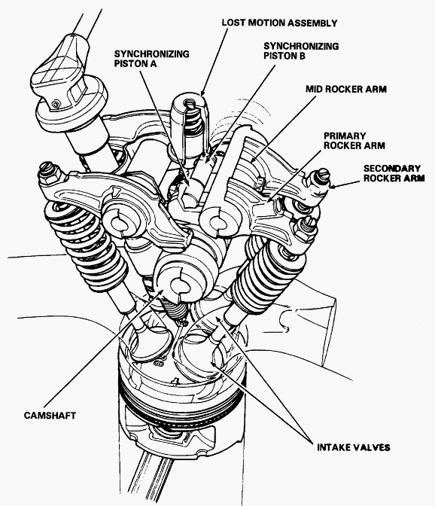

The difficulty of incorporating VTEC for both the intake and exhaust valves in a SOHC engine has been removed on the J37A4 by a novel design of the intake rocker arm. Each exhaust valve on the J37A4 corresponds to one primary and one secondary exhaust rocker arm. Therefore, there are a total of twelve primary exhaust rocker arms and twelve secondary exhaust rocker arms. However, each secondary intake rocker arm is shaped similar to a "Y" which allows it to contact two intake valves at once. One primary intake rocker arm corresponds to each secondary intake rocker arm. As a result of this design, there are only six primary intake rocker arms and six secondary intake rocker arms.

  - 3 - STAGE VTEC:
3-Stage VTEC is a version that employs three different cam profiles to control intake valve timing and lift. Due to this version of VTEC being designed around a SOHC valve head, space was limited and so VTEC can only modify the opening and closing of the intake valves. The low-end fuel economy improvements of VTEC-E and the performance of conventional VTEC are combined in this application. From idle to 2500-3000 RPM, depending on load conditions, one intake valve fully opens while the other opens just slightly, enough to prevent pooling of fuel behind the valve, also called 12-valve mode. This 12 Valve mode results in swirl of the intake charge which increases combustion efficiency, resulting in improved low end torque and better fuel economy. At 3000-5400 RPM, depending on load, one of the VTEC solenoids engages, which causes the second valve to lock onto the first valve's camshaft lobe. Also called 4-valve mode, this method resembles a normal engine operating mode and improves the mid-range power curve. At 5500-7000 RPM, the second VTEC solenoid engages (both solenoids now engaged) so that both intake valves are using a middle, third camshaft lobe. The third lobe is tuned for high-performance and provides peak power at the top end of the RPM range.

  - I - VTEC:
The last evolution of Honda's VTEC system was back in 1995 where they introduced the now-famous 3-stage VTEC system. The 3-stage VTEC was then designed for an optimum balance of super fuel economy and high power with drivability. For the next 5 years, Honda still used the regular DOHC VTEC system for their top power models, from the B16B right up to the F20C in the S2000. Now Honda have announced the next evolution of their legendary VTEC system, the i-VTEC.

The “i” stands for intelligent: i-VTEC is intelligent-VTEC. Honda introduced many new innovations in i- TEC, but the most significant one is the addition of a variable valve opening overlap mechanism to the VTEC system. Named VTC for Variable Timing Control, the current (initial) implementation is on the intake camshaft and allows the valve opening overlap between the intake and exhaust valves to be continuously varied during engine operation. This allows for a further refinement to the power delivery characteristics of VTEC, permitting fine-tuning of the mid-band power delivery of the engine.

i-VTEC is the technology used in the latest family of Honda engines. The engines incorporate a host of innovative features designed to deliver a cutting-edge combination of performance, efficiency and low emissions. The technology combines VTC (variable Timing Control) - which continually adjusts camshaft timing - with Variable Valve Timing and Lift Electronic Control (VTEC), which changes valve lift, timing and duration. The result is impressive horsepower and high torque with outstanding fuel economy and low emissions. In addition, the new engines are rotated 180 degrees from the traditional Honda layout, bringing the exhaust manifold closer to the catalyst for improved operating temperature and reduced emissions at start-up.
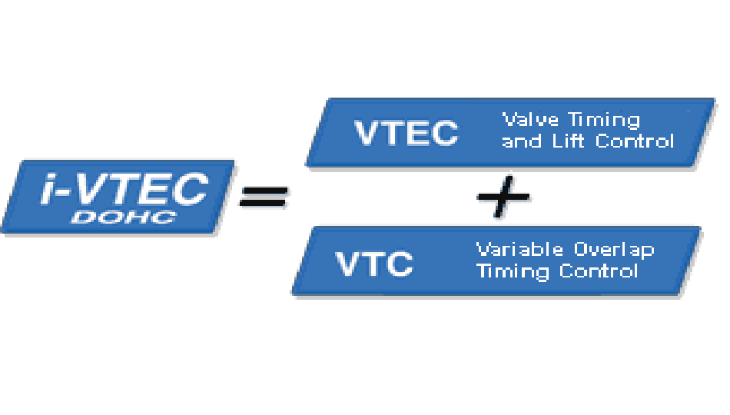

Honda i-VTEC has VTC continuously variable timing of camshaft phasing on the intake camshaft of DOHC VTEC engines. The technology first appeared on Honda's K-series four-cylinder engine family in 2001 (2002 in the U.S.). In the United States, the technology debuted on the 2002 Honda CR-V.

VTC controls of valve lift and valve duration are still limited to distinct low- and high-RPM profiles, but the intake camshaft is now capable of advancing between 25 and 50 degrees, depending upon engine configuration. Phasing is implemented by a computer-controlled, oil-driven adjustable cam sprocket. Both engine load and RPM affect VTEC. The intake phase varies from fully retarded at idle to somewhat advanced at full throttle and low RPM.

- OPTIMIZING ENGINE BREATHING: VTEC WORKING

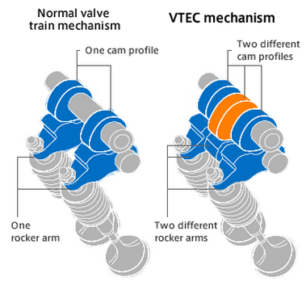
An elegant, simple mechanism Switching between high and low valve lift using two cam profiles and two rocker arms per cylinder.

The switch is made using hydraulic pressure to push/release the sliding pin, locking/unlocking the middle rocker arm and the other rocker arm.
At low engine speeds, the pin is retracted, disengaging the middle rocker arm. The valves are operated by the two outside, low-profile cams for a low valve lift.
At higher engine speeds, increased hydraulic pressure pushes the pin, engaging the middle rocker arm. The valves are operated by the middle, high profile cam for high valve lift.

- APPLICATIONS
Currently i-VTEC technology is available on many Honda products like:
- 2002 Honda CRV
- 2002 Acura RSX
- 2006 Honda Civic

  - ‘HONDA CIVIC 2006’ WITH 1.8 LITER ENGINE:

The new i- VTEC system in Honda civic 2006 uses its valve timing control system to deliver acceleration performance equivalent to a 2.0-liter engine and fuel economy approximately 6% better than the current 1.7-liter Civic engine. During cruising, the new engine achieves fuel economy equivalent to that of a 1.5-liter engine.
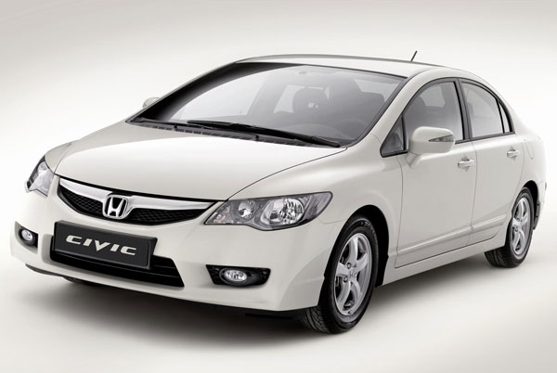

In a conventional engine, the throttle valve is normally partly closed under low-load conditions to control the intake volume of the fuel-air mixture. During this time, pumping losses are incurred due to intake resistance, and this is one factor that leads to reduced engine efficiency.
The i-VTEC engine delays intake valve closure timing to control the intake volume of the air-fuel mixture, allowing the throttle valve to remain wide open even under low-load conditions for a major reduction in pumping losses of up to 16%. Combined with friction-reducing measures, this results in an increase in fuel efficiency for the engine itself.
A DBW (Drive By Wire) system provides high-precision control over the throttle valve while the valve timing is being changed over, delivering smooth driving performance that leaves the driver unaware of any torque fluctuations.
Other innovations in the new VTEC include a variable-length intake manifold to further improve intake efficiency and piston oil jets that cool the pistons to suppress engine knock.

In addition, lower block construction resulting in a more rigid engine frame, aluminum rocker arms, high-strength cracked connecting rods, a narrow, silent cam chain, and other innovations make the engine more compact and lightweight. It is both lighter and shorter overall than the current Civic 1.7-liter engine, and quieter as well.

    - SPECIFICATIONS OF 1.8L I-VTEC ENGINE:

Engine type and number of cylinders - Water-cooled in-line 4-cylinder
Displacement - 1,799 cc
Max power / rpm - 103 kW (138 hp)/ 6300
Torque / rpm - 174 Nm (128 lb-ft)/4300
Compression ratio - 10.5:1
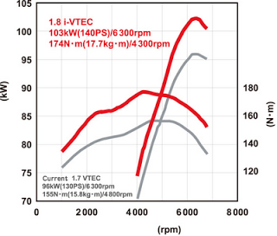

    - PERFORMANCE:
This new engine utilizes Honda's "VTEC" technology, which adjusts valve timing and lift based on the engine's RPM, but adds "VTC" - Variable Timing Control - which continuously modulates the intake valve overlap depending on engine load. The two combined yield in a highly intelligent valve timing and lift mechanism. In addition to such technology, improvements in the intake manifold, rearward exhaust system, lean-burn-optimized catalytic converter help to create an engine that outputs 103kW (140PS) @ 6300rpm,and provides ample mid-range torque.

THE FUTURE
From now onwards, there will no doubt be countless attempts to second-guess at what Honda will do to i-VTEC. There is all likelihood that Honda will implement i-VTEC on its performance engines. The most probable benefiaries will be the Integra and the Civic, the two models which have always been at the forefront to carry Honda's high-performance flag.
At this point, it is important to highlight again that the basic DOHC VTEC system is more than capable of delivering extremely high specific power outputs. i-VTEC is not needed. Witness the 125ps/litre power delivery of the F20C used on the S2000. Again what i-VTEC do allow is for Honda to go for the sky in terms of specific power output but yet still maintaining a good level of mid-range power. Already extremely authoritative reviewers like BEST MOTO Ring have complained about the lack of a broad mid-range power from for eg the F20C engine. In a tight windy circuit like Tsukuba and Ebisu, the S2000 finds it extremely tough going to overtake the Integra Type-R in 5-lap battles despite having 50ps or 25% more power. Watching the 'battle' brings one point painfully clear. There is a dire need of power from the F20C below 6000rpm. Every time the S2000 sneaks up behind the ITR, it fails to engage in a good overtaking move because the power from the F20C is surprisingly insufficient. The reason for this is because DOHC VTEC makes do with merging two distinct power curves. To get the extreme power levels of the F20C, the wild cams' power curve are so narrow that there is effectively a big hole in the composite power curve below 6000rpm. What i-VTEC can do to this situation is to allow fine-tuning of the power curve, to broaden it, by varying valve opening overlap. Thus this will restore a lot of mid-range power to super-high-output DOHC VTEC engines allowing Honda, if they so desire, to go for even higher specific outputs without too much of a sacrifice to mid-range power.

