A
SEMINAR REPORT
ON
VARIABLE VALVE TIMING MECHANISM
SUBMITTED TO
RAJASTHAN TECHNICAL UNIVERSITY
IN PARTIAL FULFILMENT OF DEGREE OF BACHELOR OF TECHNOLOGY
IN AUTOMOBILE ENGINEERING
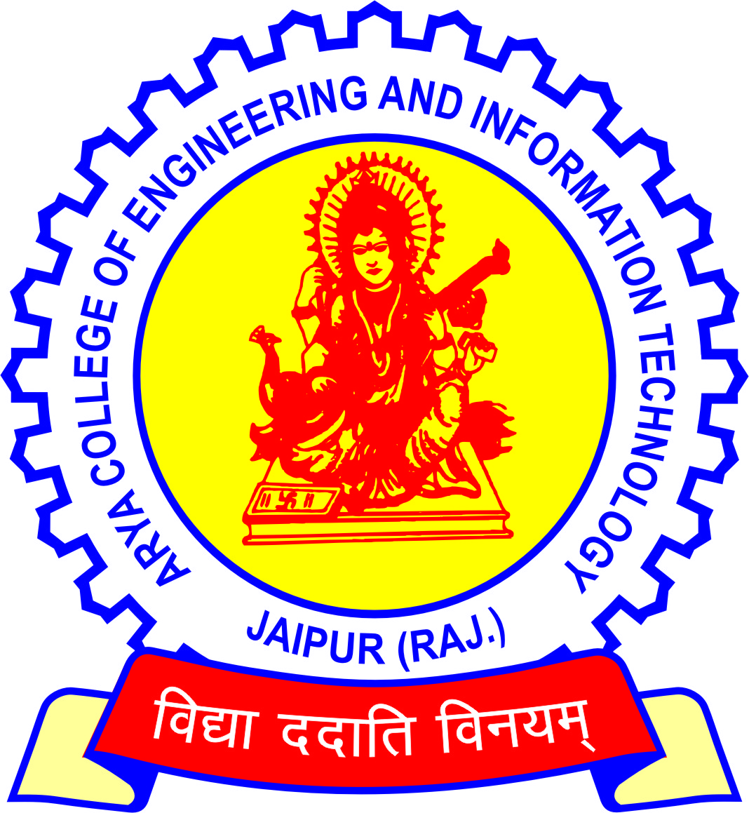

GUIDED BY: - SUBMITTED BY: -
MR. ANIL SHARMA SHRIGOPAL
07EARAE051
(AUTOMOBILE ENGG., FINAL YEAR)

DEPARTMENT OF AUTOMOBILE ENGINEERING
ARYA COLLEGE OF ENGINEERING & I.T.

CERTIFICATE

This is to certify that the seminar report entitled ‘VERIABLE VALVE TIMING MECHANISM’ has been submitted to Rajasthan Technical University, Kota by SHRIGOPAL in partial fulfillment for the award of degree, Bachelor of Technology in Automobile Engineering.

Er. Arun Kumar Arya Mr. Anil Sharma
(HOD) (GUIDE)

PREFACE

‘Practical knowledge leads a man to perfection’

In the present scenario of neck-to-neck competition in the industry, one has not only to survive but also leave others far behind in race to succeed. For this, one needs to have profound theoretical knowledge as well as sound practical aspects which can be assimilated easily and applied into practice on the technical field.

With the help of this report, we have reported the various aspects of engine valve lift and timing control systems and their features. In addition, the seminar report would serve as a good reference for the practicing engineers and associated workers.

TABLE OF CONTENTS

S.NO. PARTICULARS PAGE No.

1. Introduction 1
2. History 3
3. Need for vvt 4
4. Development of vvt 5
5. Types of vvt 7
6. Working of Variable valve timing system 9
7. Advantages of vvt 14
8. References 15

INTRODUCTION

Variable valve timing is a generic term for an automobile piston engine technology. Variable valve timing allows the lift or duration or timing of the intake or exhaust valves (or both) to be changed while the engine is in operation. Two-stroke engines use a Power valve system to get similar results to Variable valve timing.

Piston engines normally use poppet valves for intake and exhaust. These are driven by cams on a camshaft. The cams open the valves for a certain amount of time during each intake and exhaust cycle. The timing of the valve opening and closing is also important.

The camshaft is driven by the crankshaft through timing belts, gears or chains. The profile, or position and shape of the cam lobes on the shaft, is optimized for a certain engine RPM, and this tradeoff normally limits low-end torque or high-end power. Variable valve timing allows the cam profile to change, which results in greater efficiency and power.

At high engine speeds, an engine requires large amounts of air. However, the intake valves may close before all the air has been given a chance to flow in, reducing performance.

On the other hand, if the cam keeps the valves open for longer periods of time, as with a racing cam, problems start to occur at the lower engine speeds. This will cause unburnt fuel to exit the engine since the valves are still open. This leads to lower engine performance and increased emissions. For this reason, pure racing engines cannot idle at the low speeds (around 800rpm) expected of a road car, and idle speeds of 2000 rpm are not unusual Pressure to meet environmental goals and fuel efficiency standards is forcing car manufacturers to turn to VVT as a solution. Most simple VVT systems advance or retard the timing of the intake or exhaust valves. Others switch between two sets of cam lobes at a certain engine RPM.
Most piston engines today employ a camshaft to operate poppet valves. This consists of a cylindrical rod running the length of the cylinder bank with a number of oblong lobes or cams protruding from it, one for each valve.

The cams force the valves open by pressing on the valve, or on some intermediate mechanism, as they rotate. There is sliding friction between the surface of the cam and the cam follower which rides upon it. There have been attempts to reduce this such as a roller follower valve train which has significantly less friction and allows for concave cam lobes.

In addition to mechanical friction, force is required to overcome the valve springs used to close the engine's valves. This force is usually very minimal though since the compressed spring will return most of the force to compress it back to the valve train when it decompresses. Nevertheless, these losses may reduce overall efficiency.

Another problem seen with camshaft/spring operation is the valve train weight and the RPM limits inherent on this setup One of the approaches designed to overcome these problems, but which has proved difficult to implement, is Cam less valve trains using solenoids or magnetic systems which have long been investigated by BMW and Fiat, and are currently being prototyped by Valve and Ricardo. The new Fiat Nuova 500 is supposed to have this kind of engine .The earliest proposed system was on the Tucker Torpedo in 1947, which was planned use oil pressure to open the valves. However, the engine didn't reach production due to legal problems.

HISTORY

The earliest variable valve timing systems came into existence in the nineteenth century on steam engines. Stephenson valve gear, as used on early steam locomotives supported variable cut off, that is, changes to the time at which the admission of steam to the cylinders is cut off during the power stroke. Early approaches to variable cutoff coupled variations in admission cutoff with variations in exhaust cutoff. Admission and exhaust cutoff were decoupled with the development of the Corliss valve. These were widely used in constant speed variable load stationary engines, with admission cutoff, and therefore torque, mechanically controlled by a centrifugal governor. As poppet valves came into use, simplified valve gear using a camshaft came into use.
With such engines, variable cutoff could be achieved with variable profile cams that were shifted along the camshaft by the governor. The earliest Variable valve timing systems on internal combustion engines were on the Lycoming R-7755 hyper engine, which had cam profiles that were selectable by the pilot. This allowed the pilot to choose full take off and pursuit power or economical cruising speed, depending on what was needed.

NEED FOR VVT

At high engine speeds, an engine requires large amounts of air. However, the intake valves may close before all the air has been given a chance to flow in, reducing performance.

On the other hand, if the cam keeps the valves open for longer periods of time, as with a racing cam, problems start to occur at the lower engine speeds. This will cause unburnt fuel to exit the engine since the valves are still open. This leads to lower engine performance and increased emissions.

DEVELOPMENT OF VVT

Fiat was the first auto manufacturer to patent a functional automotive variable valve timing system which included variable lift. Developed by Giovanni Torazza in the late1960s, the system used hydraulic pressure to vary the fulcrum of the cam followers. The hydraulic pressure changed according to engine speed and intake pressure. The typical opening variation was 37%.

In September 1975, General Motors patented a system intended to vary valve lift. GM was interested in throttling the intake valves in order to reduce emissions. This was done by minimizing the amount of lift at low load to keep the intake velocity higher, thereby atomizing the intake charge. GM encountered problems running at very low lift, and abandoned the project Alfa romeo was the first manufacturer to use a variable valve timing system in production cars.

The 1980 Alfa Romeo Spider 2.0 L had a mechanical Variable valve timing system in SPICA fuel injected cars sold in the USA. Later this was also used in the 1983Alfet ta2.0 Quadrifoglio Oro models as well as other cars. Honda's REV motorcycle engine employed on the Japanese market-only Hondain 1983 provided a technology base for VTEC.

In 1986, Nissan developed their own form of Variable valve timing with the engine for their Mid-4 Concept. Nissan chose to focus their Nissan Valve-Timing Control System mainly at low and medium speed torque production because the vast majority of the time, engine RPMs will not be at extremely high speeds. The NVCS system can produce both a smooth idle, and high amounts of low and medium speed torque. Although it can help a little at the top-end also, the main focus of the system is low and medium range torque production. TheVG30DE engine was first used in the model in 1987, this was the first production car to use electronically controlled Variable valve timing technology.

The next step was taken in 1989 by Honda with the VTEC system. Honda had started production of a system that gives an engine the ability to operate on two completely different cam profiles, eliminating a major compromise in engine design. One profile designed to operate the valves at low engine speeds provides good road manners, low fuel consumption and low emissions output. The second is a high lift, long duration profile and comes into operation at high engine speeds to provide an increase in power output. The VTEC system was also further developed to provide other functions in engines designed primarily for low fuel consumption. The first VTEC engine Honda produced was the B16A which was installed in the Integra, CRX, and Civic hatchback available in Japan and Europe.

In 1992BMW introduced the VANOS system. Like the Nissan NVCS system it could provide timing variation for the intake cam in steps, the VANOS system differed in that it could provide one additional step for a total of three. Then in 1998 the Double Vanos system was introduced which significantly enhances emission management, increases output and torque, and offer better idling quality and fuel economy. Double Vanos was the first system which could provide electronically controlled, continuous timing variation for both the intake and exhaust valves. In 2001 BMW introduced the Valvetronic system. The Valvetronic system is unique in that it can continuously vary intake valve lift, in addition to timing for both the intake and exhaust valves. The precise control the system has over the intake valves allows for the intake charge to be controlled entirely by the intake valves, eliminating the need for a throttle valve and greatly reducing pumping loss. The reduction of pumping loss accounts for more than a 10% increase in power output and fuel economy.

Ford began using variable valve timing in 1988 for ford sigma engine. Ford became first manufacture to use Variable valve timing in a pick-up truck with the top selling ford F- series in the 2004 model year. The engine used was the 5.4L 3-valve triton.
In 2005 General Motors offered the first Variable Valve timing system for pushrod V6
engines, LZEand LZ4 .

TYPES OF VVT
BMW
Valvetronic - Provides continuously variable lift for the intake valves
used in conjunction with Double VANOS(variable nockenwellen steuerung).
VANOS is an automobile variable valve timing technology developed by BMW in close collaboration with Continental Teves. VANOS varies the timing of the valves by moving the position of the camshafts in relation to the drive gear. This movement varies from 6 degrees of advanced to 6 degrees of retarded camshaft timing.
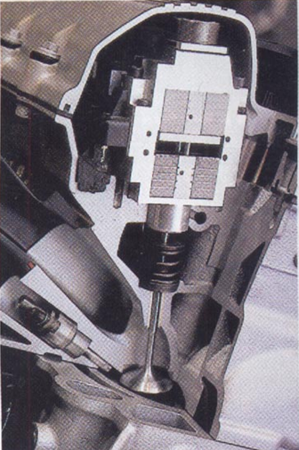

GENERAL MOTORS
VVT - Varies valve timing continuously throughout the RPM range for
both intake and exhaust for improved performance in both overhead valve and overhead cam engine applications.

HONDA
VTEC - Varies duration, timing and lift by switching between two different sets of camlobes.
i-VTEC - In high-output DOHC 4 cylinder engines the i-VTEC system adds continuous intake cam phasing (timing) to traditional VTEC. In economy oriented SOHC and DOHC 4 cylinder engines the i-VTEC system increases engine efficiency by delaying the closure of the intake valves under certain conditions and by using an electronically controlled throttle valve to reduce pumping loss. In SOHC V6 engines the i-VTEC system is used to provide Variable Cylinder Management which deactivates one bank of 3 cylinders during low demand operation.
VTEC-E - Unlike most VTEC systems VTEC-E is not a cam switching system, instead it uses the VTEC mechanism to allow for a lean intake charge to be used by closing one intake valve under certain conditions.
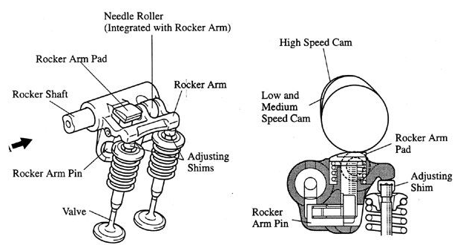

Honda Vtec

NISSAN
VVL - Varies timing, duration, and lift of the intake and exhaust valves by using two different sets of cam lobes.
Variable Valve Lift and Timing which is commonly known as VVL is an automobile variable valve timing. This technology was developed by Nissan. Nissan VVL varies the timing, duration, and lift of valves. It can be varied by using hydraulic pressure switch between two different sets of camshaft lobes. Its functions are similar to Honda's VTEC system.
TOYOTA
Variable Valve Timing with intelligence is an automobile variable valve timing technology developed by Toyota, similar to the i-VTEC technology by Honda. The Toyota variable valve timing -i system replaces the Toyota variable valve timing system offered starting in 1991 on the Valve engine.
variable valve timing, introduced in 1996, varies the timing of the intake valves by adjusting the relationship between the camshaft drive and intake camshaft. Engine oil pressure is applied to an actuator to adjust the camshaft position.

WORKING OF VARIABLE VALVE TIMING SYSTEM

GENERAL:-
In contrast to the fixed valve timing of conventional engines, the Variable Valve Timing system is a computer controlled mechanism that continually varies the timing for opening and closing the intake valves in accordance with the vehicle's operating conditions.

The Variable Valve timing system is designed to control the intake camshaft within a range of 50°(of Crankshaft Angle ) to provide valve timing i.e. optimally suited to the engine condition .This improves the torque in all the speed ranges as well as fuel economy ,and reducing exhaust emissions.

This system controls the intake camshaft valve timing so as to obtain balance between the engine output, fuel consumption & emission control performance. The actual intake side valve timing is feed back by means of the camshaft position sensor for constant control to the target valve timing.

The Variable Valve Timing system includes the engine control module, oil control valve and Variable Valve Timing controller. The engine control module sends a target duty-cycle control signal to the oil control valve. This control signal regulates the oil pressure supplied to the Variable Valve Timing controller. Camshaft timing control is performed according to engine operating conditions such as the intake air volume, throttle valve position and engine coolant temperature. The engine control module controls the oil control valve, based on the signals transmitted by several sensors. The Variable Valve Timing controller regulates the intake camshaft angle using oil pressure through the oil control valve. As a result, the relative positions of the camshaft and crankshaft are optimized, the engine torque and fuel economy improve, and the exhaust emissions decrease under overall driving conditions. The engine control module detects the actual intake valve timing using signals from the camshaft and crankshaft position sensors, and performs feedback control. This is how the target intake valve timing is verified by the engine control module
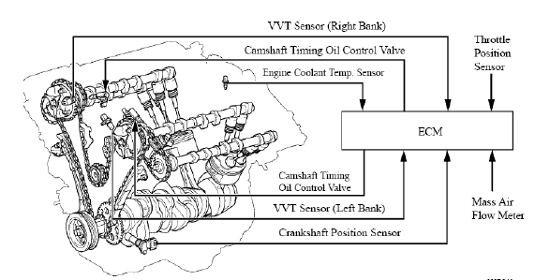
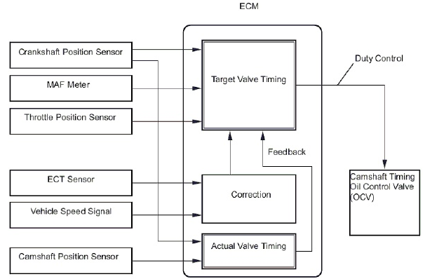
The engine control module optimizes the valve timing using the Variable Valve timing system to control the intake camshaft. The Variable Valve Timing system includes the engine control module, the oil control valve and the Variable Valve Timing controller. The engine control module sends a target duty-cycle control signal to the oil control valve. This control signal regulates the oil pressure supplied to the Variable Valve Timing controller. The Variable Valve Timing controller can advance or retard the intake camshaft. After the engine control module sends the target duty-cycle signal to the oil control valve, the engine control module monitors the oil control valve current to establish an actual duty-cycle. The engine control module determines the existence of a malfunction and sets the DTC when the actual duty-cycle ratio varies from the target duty-cycle ratio.
CONSTRUCTION:
Variable Valve Timing controller:-
It consist of the housing driven from the timing chain & the vane coupled with the intake camshaft. The oil pressure sent from the advance or retard side path at the intake camshaft causes rotation in the variable valve timing -i controller vane circumferential direction vary the intake valve timing continuously

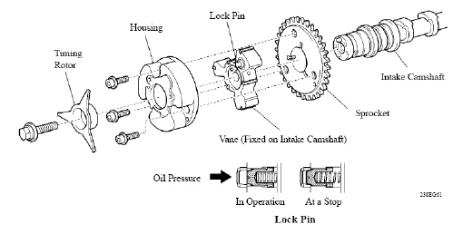

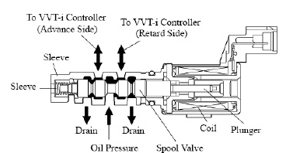
When the engine is stopped the intake camshaft will be in the most retard state to ensure start ability. When hydraulic pressure is not applied to the variable valve timing -i controller immediately after the engine has been started, the lock pin locks the movement of the variable valve timing controller to prevent a knocking noise.
The camshaft timing oil control valve controls the spool valve position in accordance with the duty-cycle control from the engine control module. This allows the hydraulic pressure to be applied to the variable valve timing -i controller advance or retard side.

OPERATION:
The camshaft timing oil control valve selects the path according to the advance, retard or hold signal from the engine control module. The variable valve timing controller rotates the intake camshaft in the timing advance or retard position or holds it according to the position where the oil pressure is applied.

1. Advance
When the camshaft timing oil control valve is positioned as illustrated below by the advance signals from the engine control module ,the resultant oil pressure is applied to the vane chamber of advance side to rotate the camshaft in the timing advance direction.

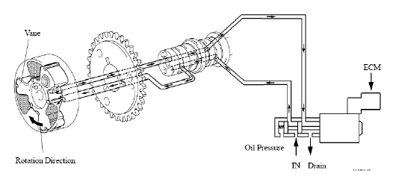

2. Retard
When the camshaft timing oil control valve is positioned as illustrated below by the retard signals from the engine control module, the resultant oil pressure is applied to the vane chamber of retard side to rotate the camshaft in the timing retard direction.
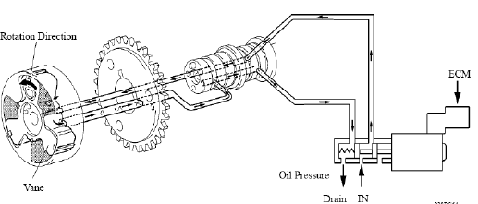

3. Hold
After reaching the target timing ,the valve time is held by keeping the cam shaft timing oil control valve in the neutral position unless the traveling state changes. This adjusts the valve timing at the desired target position & prevents the engine oil from running out when it is necessary.

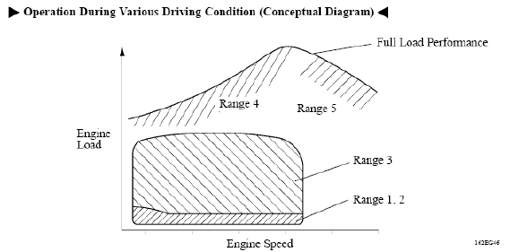

ADVANTAGES OF VVT

Smooth idle
- Valve overlap retarded to zero
- So pure mixture thus stable combustion
- Low fuel consumption
Torque improvement
- Low to mid-range torque is increased
- By increasing valve overlap
- Exhaust sucks charge and due to early closing charge does not escape
- Quicker response to sudden power requirements
EGR effect
- Egr valve used in conventional engine not required here
- Exhaust mixes with charge and dilutes it
- So low combustion temp. And low nox production
- Also unburnt gases in exhaust will get completely burnt
Better fuel economy
- Approx. 20% increase
- Due to fact that smaller vtec engine produces equal power to that of non-vtec larger engine
Improved emission control
- No nox production due to egr effect
- Due to low fuel consumption low co2 emission

REFERENCES

- Automobile Mechanics by N.K. Giri.
- www.howstuffworks.com
- www.wikipedia.org
- www.google.com - search websites

