Chapter 1
Introduction
With the exponentially increasing data demand but limited available radio spectrum, alternatives will be necessary to accommodate the needs of wire-free communication systems. This chapter will illustrate the problems of current wireless communication systems and alternatives to these systems, as well as motivations and possible applications for visible light communications.

1.1 Motivations
As societal dependence upon wireless systems continues to grow, wireless technology needs to expand to meet the demand. Phones, laptops, and global positioning systems are all devices that implement certain forms of wireless communication to send information to another location. However, the availability of current forms of wireless is very limited, and it is not necessarily safe to implement wireless radio, making it necessary to explore other alternatives to wireless communication to allow continued expansion upon communication systems and to ensure safe use.Figure 1 illustrates the frequency allocations of the radio spectrum in the United States. ct Visible light communication is a new way of wireless communication using visible light. Typical transmitters used for visible light communication are visible light LEDs and receivers are photodiodes and image sensors. We present new applications which will be made possible by visible light communication technology. Location-based services are considered to be especially suitable for visible light communication applications.

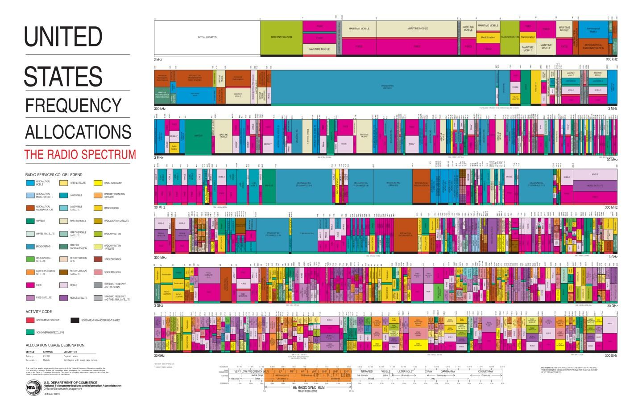
Figure 1: US Frequency Allocations
The Federal Communications Commission (FCC) regulates many wireless applications in the US, including radio, television, wire, satellite, and cable [1]. Each application is given a frequency band in which it is allowed to operate to allow efficient use of the available frequency spectrum. From Figure 1, it is quite evident that this spectrum is very crowded. At the same time, there is a huge growth in demand in the limited radio frequency spectrum. From Figure 2, predictions estimated that as soon as even 2013, the US could potentially be in a spectrum deficit. Therefore, a more efficient way of utilizing radio frequency is necessary.

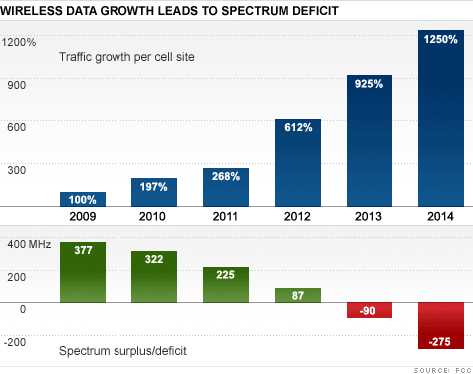

Figure 2: Wireless Data Growth

In addition to the crowding of the frequency spectrum, interference is also a concern for many existing wireless systems. Any simultaneous use of a frequency band will cause interference due to the electromagnetic nature of most wireless devices, which could result in incorrect or loss of information for those users involved. A prime example of this is the use of mobile devices on planes, which directly affects safety. Regardless of the reason, it is clear that it is not feasible to use wireless devices in certain environments in which safety, data integrity, and accuracy are highly important.

VLC systems have more flexibility and integrity than other communication systems in many regards. Since the medium for transmission in VLC systems is visible light and not RF waves that can penetrate walls, the issue of security is inherently solved because light cannot leave the room, containing data and information in one location. There is no way to retrieve and access the information unless a user is in a direct path of the light being used to transmit the data. In addition, LEDs are highly efficient and becoming more durable, adding to the integrity of these systems.

1.2 Alternatives in Progress
Currently, several alternatives to radio frequency communications exist. For example, there are cognitive radio, which utilizes radios programmed to adapt to surroundings by constantly analyzing the frequency spectrum to determine how the surrounding spectrum is currently being utilized, and laser communication systems, which transmits data through free space by shooting a laser with wavelengths close to the infrared spectrum to a receiver.

1.2.1 Cognitive Radio
Given that one major issue in wireless communication is the crowded frequency spectrum, many engineers spend their time and effort focusing on determining solutions for this issue. Since there is limited access to the frequency spectrum, these engineers are focusing on options that could optimize the spectrum. By optimizing the frequency spectrum’s usage, it would be possible to provide all end users a portion of the spectrum. As the current trend continues, devices that normally would not be able to wirelessly communicate, such as lamps or temperature sensors, will be connected to some type of wireless network. This will increase the number of end users and further crowd the frequency spectrum.

One area that engineers are focusing on to optimize the frequency spectrum involves cognitive radios. The difference between a cognitive radio and a typical radio system is that a cognitive radio is programmed to adapt to its surroundings. A cognitive radio is constantly analyzing the frequency spectrum to determine how the surrounding spectrum is being used. The system could potentially monitor the entire frequency spectrum, but that would require an antenna that has a large bandwidth. Since most antennas operate at a range of frequencies, cognitive radios will monitor that specific bandwidth and determine how it is occupied. Once the radio has determined how the spectrum is being occupied, it will choose non-occupied frequencies to transmit its information. While it is transmitting information, it continues to monitor the spectrum to determine whether other signals are attempting to access the same frequencies. If there are other signals, the radio will stop transmitting and switch to another unused frequency slot. This whole process is called Dynamic Spectrum Access and is a vital part of how a cognitive radio functions.

The idea of using cognitive radios for optimizing the use of the frequency spectrum will require the systems to focus on more than one frequency band. Since a majority of these bands have been dedicated to certain organizations, those organizations have priority or full control over the frequencies. Out of all the divided frequency bands, researchers are looking at the television bands. There are multiple television bands ranging between 54-72 MHz, 76-88 MHz, 174-216 MHz, 512-608 MHz, and 614-698 MHz which are used to provide certain television signals to the set top boxes in homes. Each band’s bandwidth is then further divided to allow all channels to have access to transmission. The reason the television band is the band of focus is how the spectrum is being used. At the Illinois Institute of Technology in Chicago, IL, a team of researchers monitored the frequency spectrum over a span of three years to determine how each frequency band was occupied. The occupancy was measured by monitoring the frequency band’s spectral density to a threshold. The following figure represents the occupancies of certain frequency bands .

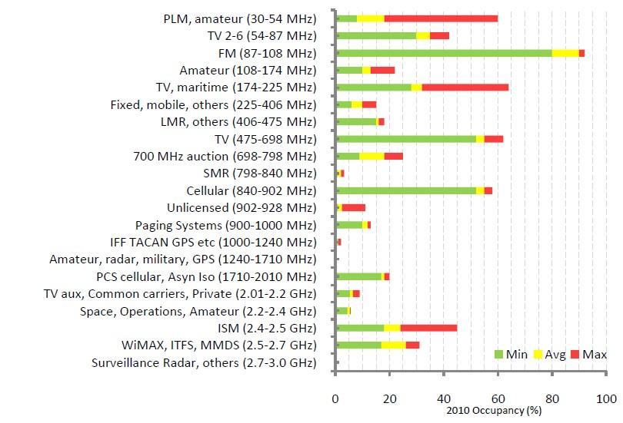

Figure 3: Estimated occupancy for 2010

From the data collected in 2010, the researchers determined that the three television bands, TV2-6 (54-87MHz), TV maritime (174-225MHz), and TV (475-698MHz), had an average occupancy of 32%, 30%, and 50% respectively. Given that the largest television frequency band was only occupied half the time, researchers believe that the band can be shared with other transmissions. While observing the entire spectrum, the average occupancy was measured at 14%. This low number suggests how inefficiently the radio frequency spectrum is used. With cognitive radios, other signals that are not television signals can monitor the band and use it if that specific area is not being used. As mentioned earlier, the system will have to monitor any surrounding systems to see if signals are attempting to access this specific frequency. In this case, if a radio is operating at a specific frequency that corresponds to a television channel and the channel needs to transmit, then the radio will have to stop transmitting because the television signal has a higher priority.

1.2.2 Laser Communication

Laser communication systems utilize wireless connections through the atmosphere, transmitting data through free space by shooting a laser. This form of wireless communication can be effective because it is not regulated by the government as it operates in a near infrared spectrum, hence avoiding any additional overcrowding of the spectrum with this form of communication. This allows for quick establishment of communication links, as it does not need to go through the various regulatory processes that would be necessary to set up an RF system. The system can work for a distance of up to 6 km with bitrates up to 1.25 Gbps. The system also uses relatively low power and has a low noise ratio. It is also secure, as any sort of eavesdropping on the data transmission will require viewing directly into the transmitter path, causing an interruption in transmission.

Unfortunately, the system requires a line-of-sight path from the transmitter to receiver. This renders the two functional blocks relatively immobile. If the path is not calibrated precisely, the laser could miss the receiver by a large distance, resulting in no data transmission. In addition, although invisible to the naked eye, the lasers used could result in damage to one’s eye if there is an extended exposure to the laser.

Chapter 2
Design Approach
This chapter will discuss the specifications required for each block of the system architecture, and how it was implemented. These functional blocks are the same for both the transmitter and receiver side, but with different functionalities and implementations. The blocks include power sources, analog circuitry, a microcontroller or digital signal processing (DSP) chip, and a computer.

2.1 Functional Block Diagram
Figure 5 shows the overall functional block diagram of our system. The transmitter side consists of a signal source, a microcontroller, and analog circuitry incorporating LEDs, all of which are powered in some fashion. The receiver side is similar, containing analog circuitry incorporating photodiodes, a microcontroller and a device capable of receiving and interpreting the output, all of which are also being powered in some fashion.

The microcontroller is used as the signal source for our design by utilizing a binary system to transmit text. Each voltage maximum corresponds to a single binary ‘high’ digit and each voltage minimum corresponds to a single ‘low’ digit. This scheme is used in conjunction with the ASCII binary values, found in Appendix B, to encode a text message which is sent to the receiver side of the design utilizing LED flashes.

A power MOSFET is used to amplify the strength of the signal for increased transmission range. This particular MOSFET includes a built-in gate driver which is necessary for applications involving low- voltage logic such as the microcontroller used in this design. The device works in a way such that the signal is transmitted exactly as intended, however the logic highs and lows are inverted. To make up for this voltage inversion, the output data signal from the computer will also be inverted to produce the correct signal after the MOSFET block.

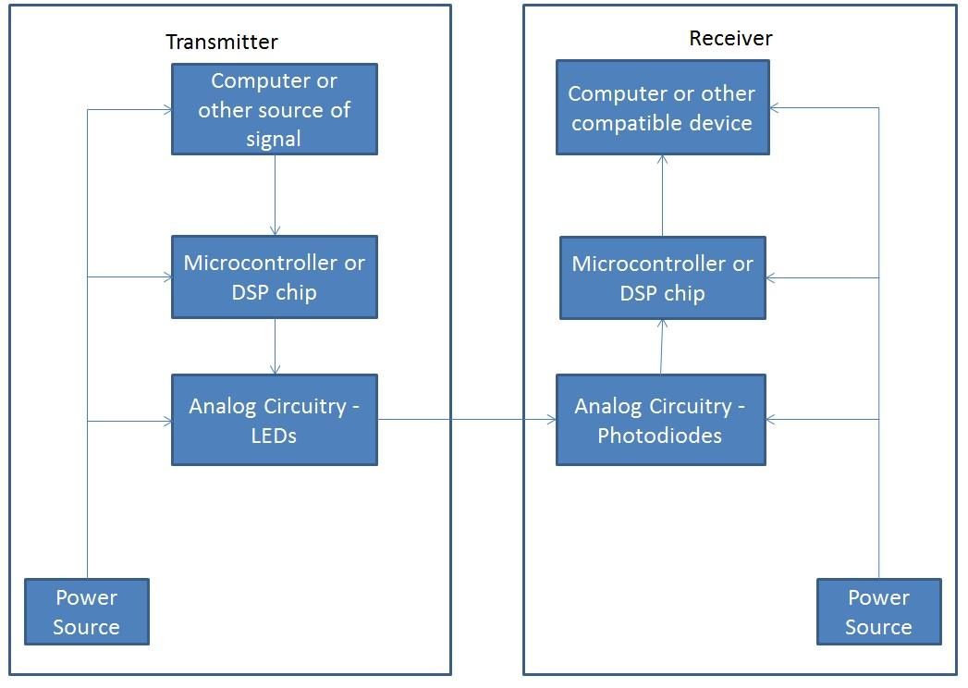

Figure 2.1: Functional Block Diagram

The power source for the receiver will be AAA batteries that will supply power to the analog circuitry. The analog circuitry on the transmitter side will be powered by an outlet. The computer will also be powered by an outlet and will either provide a message on the transmission side, or read a message on the receiver side. The DSP chip will be powered by the computer and will decode the message on the transmission side to send a signal through the analog circuit containing the LEDs, or will decode the message from the analog circuit containing the photodiodes. The LEDs will be blinking at a rate corresponding to the message being sent, which the photodiodes will receive at a distance away from this transmission block.

2.2 Modules

Each block has its own specifications that need to be met in order for the system to function. The following sections will address these specifications. Many of the modules, such as the MCU, power source and analog circuitry, are present on both the transmitter and receiver.
2.2.1 Power Source
Both transmitter and receiver need some source of power; however, each component needs varying amounts of power. The transmitter end of the design utilizes the same power source but converts that power differently for different components. Both the MCU and MOSFET utilize a wall output with 120V AC output, however neither of these devices are connected directly to the AC power.

The MCU is connected to a computer using a USB connection cord which outputs 5V DC. This voltage is used to power the MCU while the actual signal is sent to the MCU using CCS. The MCU then outputs either a logic high, 3.3V, or logic low, 0V, to the gate of the next component; the MOSFET. The signal sent from the MCU is applied to the Gate of the MOSFET device which, when high, turns the device on and, when low, turns the device off effectively controlling current flow to the LEDs.

Explaining the power source for the MOSFET device is more involved than specifying a single voltage. This is due to the nature of the MOSFET where the device is only in the Active region and behaves as desired when there are differing voltages applied to both the Gate and the Drain of the device. The operation of this device is explained in greater detail in Section 2.2.4.3 MOSFET. The voltage applied to the Gate is the signal being transmitted while the voltage applied to the Drain is the converted voltage from the wall outlet. This 120V AC travels through an AC to DC converter which then outputs a 5V/2A DC signal to the Drain of the MOSFET. This scheme allows for a higher signal amplitude and therefore results in brighter LEDs. The brighter the LEDs are, the further away they can be from the photodiodes and have minimal loss in signal integrity.

On the receiver side of the design the only device that needs powering other than the MCU is the Op-Amp. The AD848 Op-Amp can have rails set to as high as +/-15V and has typical values listed in the datasheet for 5V and 15V. For our purposes the ratings at 5V were more than sufficient so this setting was chosen. In order to achieve this voltage rating, 4 AAA batteries, rated at 1.5V each, are connected to the rails of the Op-Amp. Even though the batteries at rated at 1.5V each, the typical output voltage is 1.3V which puts the rails at 5.2V instead of 6V. This means that the typical values listed in the datasheet are accurate guidelines for predicting the behavior of the device. The Op-Amp device is explained more thoroughly in Section 2.2.4.4 OP-AMP.

2.2.2 Signal Source

On the transmitter side, the signals that will be transmitted are text signals. These signals could be produced by a computer, but could potentially be produced by some other compatible device, such as a cell phone. This signal will then be sent to the microcontroller or digital signal processing (DSP) chip for processing. On the receiver side, another computer or compatible device needs to be able to interpret the original signal by taking the received signal from the receiver microcontroller or DSP chip.
2.2.3 Microcontroller
The microcontroller or DSP on the transmitter side will convert the signal from the source into bits through an “On/Off” keying scheme using logic 1s and 0s. This could require some coding with MATLAB to first convert the data into a waveform for processing. The resulting waveform will then be sent to the analog circuitry for the LEDs. On the receiver side, the microcontroller or DSP will need to be able to take the signal from the photodiodes set a threshold voltage that will offset the voltage that will be picked up from the ambient light in the room. Next, the bits will need to be decoded into voltages for the computer or compatible device. Again, MATLAB will be useful in producing these filters, and some C programming will be necessary for setting the threshold voltage and converting the bits back into voltages that can be deciphered by a computer or corresponding device. More on this block will be discussed in Section 2.5 Micro Controller.

2.2.4Analog Circuitry
The analog circuitry on the transmitter side needs to take a pulse from the MCU and light LEDs at a rate equal to the frequency of the pulse. This can be done with a few resistors and an array of LEDs.22 high-brightness white LEDs are used and connected in parallel for current limiting reasons. The receiver side analog circuitry will contain photodiodes to detect the fluctuations of pulses from the LEDs. Resistors and operational amplifiers are also used, as the signal produced by the photodiodes are very small, and thus need to be amplified in order to produce a signal for further process. This will be further discussed in Section 2.3 Analog Design.

2.2.4.1 LEDs
The medium being used to transmit data in our design is light with this light being provided via LEDs. The most important parameter associated with the LEDs is the brightness of the device which is measured in units of Lumens. It is important to note that the Lumens unit of light is not the same as the Candela unit.

Lumens refers to the ‘total’ amount of light that a device emits whereas Candela refers to the power emitted by a light source in a particular direction. This means that if an LED emits 1 Candela towards a photodiode but there is a wall in between them that does not allow for light to travel through it, the photodiode actually sees the LED as emitting 0 Candela.
The LEDs used in our design are measured in Lumens instead of Candelas because our LEDs emit light in a viewing angle of 15: instead of a single direction. This means that not all of the power in Lumens actually reaches the photodiode, but we set up our design so that the center of the viewing angle is level with the photodiodes’ 75: viewing angle center of receiving light. This is possible because both the receiver and transmitter circuits are constructed on breadboards of equal size so when both LED and photodiode are angled correctly their centers align.

The next thing to note about the LEDs in this design is the amount of current, and therefore power, drawn from each device used. According to the datasheet of the LEDs selected for our design, the current draw for each device is approximately 20mA. Since 22 LEDs are used in the design to provide more light to be received by the photodiode, this means that the total current drawn from all of the LEDs is equal to approximately 440mA.

where I_{F} is the forward current of a single LED and V_{F} is the forward voltage of a single LED. Substituting the values of 20mA and 3.2V for current and voltage respectively, the power dissipated by a single LED is found to be 64mW. Taking this value and multiplying by the total number of LEDs, 22, results in the total power dissipation of the LEDs in the system, totaling 1.408W.

An important characteristic to note about both the LEDs and photodiodes are the frequencies at which each device emit light and react to light, respectively. From Figure 6, shown below, it is clear that the LEDs being utilized in this design are most effective at a lower wavelength than the half-way point in the range of photodiode detection. This means that both devices are not ideal for one another which leads to the need for an Op-Amp to increase the amplitude. Visible light communication has properties that are both advantageous and disadvantageous compared to radio-wave wireless communication. Its disadvantages are communication distance and data rate. The communication distance using visible light communication is typically between 1 to 100 meters. This distance is short compared to radio-wave communication, due to the fact that visible light communication is basically line-of sight communication, which means that communication is interrupted when there is an object between a transmitter and a receiver.

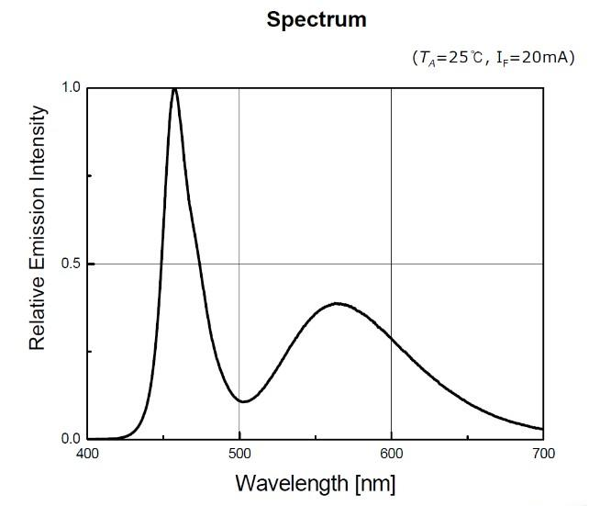

Figure 6: Emission Spectrum of LEDs for Various Frequencies

2.2.4.2 Photodiodes
In order for data transmission to have any significance there must be a way to receive the signal at the other end of the design. This is the purpose of the photodiodes as they react to the light emitted from the LEDs and allow for current to flow to the rest of the receiver circuit. When there is no light emitted from the LEDs the photodiodes do not allow current to flow through to the MCU on the receiver.

As mentioned above, the photodiode reacts to the light emitted from the LEDs to create a signal for the MCU on the receiver end of the design to process and decode. Our design works exceedingly well in a dark room, as one might expect, since there is no ambient light to interfere with the photodiodes receiving the LED signal. Our design also works in a lit room with ambient lighting that creates noise.

A simple fix is required to adjust for the ambient lighting in a lit room. The ambient lighting can be viewed as a approximately a constant signal that, when combined with LED lighting, simply adds as DC bias to our transmitted data. To resolve this problem with the photodiode, there is digital processing on the digital receiver circuit to ensure that this biasing does not affect the sampling of the MCU. More on this will be addressed in Section 2.2.6 Receiver.

Our design implements seven total photodiodes with the purpose of covering the entire breadboard such that at least two LEDs are aligned directly with each photodiode’s center. According to the datasheet for the selected photodiodes, the power dissipation for each photodiode is approximately 100mW. Using the same equation used to calculate the power dissipation of each LED..

Like with the LEDs, the photodiodes have a spectrum of frequencies at which they react to light more so than other frequencies. This spectrum, shown below in Figure 7, is the sensitivity of the photodiodes to each frequency of emission from the LEDs. As mentioned above, the disparity between the two peaks of these spectrums requires the use of the AD848 Op-Amp for easier signal processing purposes.

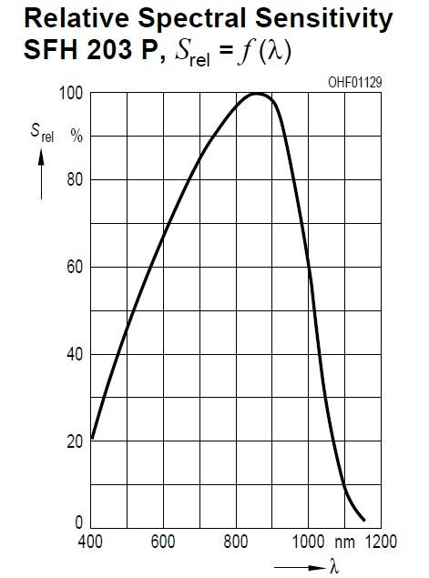
Figure 7: Relative Spectral Sensitivity of Photodiodes at Various Frequencies

2.2.4.3 MOSFET
An analog part implemented solely to amplify the transmitter signal amplitude, the N-Channel FQP30N06L MOSFET, utilizes an internal gate driver which solves all current limitation issues. In order to get the LEDs to emit a brighter light and increase the possible transmission distance of our design, it was necessary to provide more current to the LEDs since the logic output of the MCU was too low.

In order to explain how the MOSFET device increases the current provided to the LEDs, it is necessary to have a basic understanding of how such a device functions. There are three primary modes that a MOSFET device can operate in. Those three modes are Cutoff, Triode, and Active or Saturation. For this design, it is better to operate in the Active region as this region provides the most consistent measure for Drain current. While a device is in the Active region, the Drain current is nearly constant and mainly dependent on the Gate to Source voltage. This equation ignores the channel-length modulation effect that occurs, but since our device operates at lower voltages and currents this can beneglected for simplicity.
The only parameter that can be controlled in our design is V_{GS} which is the voltage differential between the Gate and the Source of the MOSFET since the other parameters are determined in fabrication of the device. The above equation holds only when the MOSFET is in the active region; or when V_{GS} is greater than the threshold voltage, V_{th}, and when the Drain to Source voltage, V_{DS}, is greaterthan the effective voltage, (V_{GS} – V_{th}).

When the above conditions are not met, the device operates in either the non-ideal Triode region or is in Cutoff and does not operate at all. The problem with the Triode region is that the Drain current, I_{D}, is not constant with increasing values of V_{DS} but rather is ohmic and linear in nature. This makes the exact value of the drain current difficult to evaluate and makes other calculations approximations rather than accurate representations. The issue with the Cutoff region is that there is no current flowing through the Drain of the device, and therefore there is no current flowing into the LEDs.

In order to use a Power MOSFET with a low voltage logic device such as the one used in our design, there must be a Gate Driver to ensure the device can operate at the desired frequency. A MOSFET device is capable of switching on-states rapidly as long as the Gate Capacitance is charged fast enough for the device to turn on and off again. When MOSFETs are used in standard DC applications there is no need to have a Driver because once the device is on there is no need to turn it off unless the power is cut to the system. However, with our logic input being applied to the Gate of the MOSFET the V_{GS} is constantly changing from 3.3V to 0V. The MOSFET device selected for our design has a built-in Driver that takes care of the Gate charging that is needed in order for the device to switch at our desired frequency.

The power dissipation of this device is the only drawback to this device. According to the datasheet, the device has a typical power dissipation of 0.53W/:C where the temperature is the ambient temperature around the device. Assuming a room temperature operation of around 25:C, this would mean the MOSFET dissipates 13.25W of power. This is by far the most power consuming device in the entire analog design. However, since the wall outlet is the primary source of this device there is not much concern in the amount of power consumed through that medium since the typical wall outlet contains 120V AC in the United States which is connected to a circuit breaker of typically 15-20A. This means a standard wall outlet is capable of providing 1800-2400W.

However, because the device is switching so quickly there is a noticeable heating of the device. When a MOSFET’s junction temperature is increased, the on-resistance, R_{on}, is increased which increases the power dissipation of the device. This means that while the device is left on for transmission the actual power dissipation of the device is increasing due to the increased R_{on} with the rising temperature. This phenomena is known as thermal-runaway and is common when the load of the MOSFET is a continuous current draining device such as the LEDs used in the design. The absolute maximum power dissipation for this device is listed on the datasheet at 79W which, while significant when compared to other aspects of our design, is still not enough for concern when using a wall outlet for power.

2.2.4.4 OP AMP

Another analog part that is implemented on the receiver end of the circuit along with the photodiode is the AD848 operational amplifier. The purpose of this Op-Amp is to amplify the received signal of the photodiodes. Since the amount of current released from the photodiodes depends on how close the LEDs are with respect to the photodiodes, it is necessary to amplify the received signal when the transmission distance is increased.

Another issue with the emission and sensitivity spectrums of each device becomes apparent as well. Both of these charts are shown above in their respective sections; Section 2.2.4.1 LEDs and Section 2.2.4.2 Photodiodes. Because the peak values for these two charts are not equal, the Op-Amp is required in order to increase the received signal to an amplitude high enough to be able to perform signal processing. Although there is amplification on the transmitter end of the circuit utilizing the MOSFET, the signal is further amplified with the Op-Amp in order to allow for more accurate sampling by the MCU.
2.2.4.5 USB-B to Circuit Board
As stated in Section 2.2.4.3 MOSFET, the MOSFET device is powered utilizing an AC/DC converter from a wall outlet. However, the output of the converter is not directly able to be applied to our breadboard. This is due to the output being USB-A and not wires. In order to get around this problem we utilized a USB-B breadboard adapter.The device, shown below in Figure 8, is an adapter that interfaces a USB-B connection to leads that can be placed on our breadboard. The device has 4 pins with the two middle unused pins being differential voltages to add to the power from the USB connection. The two pins being used are the ground and power pins with the power flowing into the Drain of the MOSFET device.

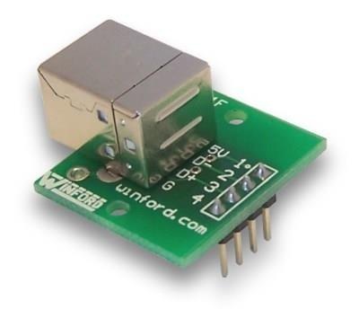

Figure 8: USB-B to Breadboard Adapter

The biggest distinction to make in this part of the design is the difference between USB-A and USB-B. A USB-A and USB-B side-by-side comparison is shown below in Figure 9. The USB-A variety is a flat, rectangular interface that holds the connection in place with friction. USB-B is more square shaped than the rectangular type A, and has slightly beveled corners on the top ends of the connector. Type A connectors are used on hosts that supply power whereas type B connectors are used on hosts that receive power. This scheme is implemented in order to prevent a user from connecting two devices that give power to one another which would lead to dangerous circuit conditions such as high currents or extreme heat resulting in a fire.

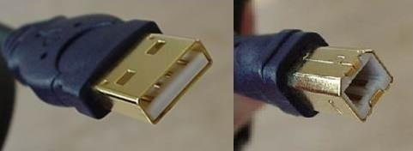

Figure 9: USB-A (left) and USB-B (right) Comparison

2.2.5 Transmitter
The entire purpose of a communication system is to send data from one location to another in order to convey information to a user on the end of the system. A transmitter, and in turn a receiver, are required to achieve this goal so that data can be sent wirelessly. Both analog and digital components are used on both ends of the system and work simultaneously to transmit and receive data using only visible light.

The transmitter, although incorporating analog parts, is mostly digital when processing the actual data itself. Most of the data manipulation is done on a computer program made for use in conjunction with the C2000 Piccolo LaunchPad being used to transmit data. The specific digital signal processing chip being used, the F28027, allows for communication between the computer and LaunchPad through micro USB connection. This board is also referred to as the LAUNCHXL-F28027.

The program used with the F28027, Code Composer Studio (CCS), allows a user to write and implement C/C+ code to the digital board. After a one-time configuration of connection settings, CCS is ready to execute all code written onto the board. Data is converted into binary in order for simple transmission in a digital sense. Once this data was entered into the transmitter C code, and processed at the specified frequency, the F28027 would output a waveform to the analog circuit board using the an edited version of the pulse-width modulator (PWM) Texas Instruments (TI) example code to create a square wave with the appropriate frequency and duty cycle.

The transmitter analog circuit leads to an array of LEDs. The LEDs would stay off when the input from the F28027 was low and would light when the input was high. This on-off behavior is not visible to the human eye so the constant switching of the LED would not bother or distract someone in the area as the light would appear to be either constantly on or off.

2.2.6 Receiver
The switching of the LEDs would serve as the wireless means for data transmission as the receiver analog circuit would pick up on this changing behavior. Photodiodes were used as a way to let the receiver “know” that data is being transmitted. When the photodiodes detect a change in lighting from the LEDs, current flows into the next stage of the circuit, the op-amp. The op-amp is configured in a way so that the waveform from the photodiodes would be amplified for use in the second F28027 board. The digital aspect of the receiver is the most complicated part of the entire design because this signal is not being created but rather decoded in the F28027 board’s Analog to Digital Converter (ADC). Although initially, much of the initial testing and implementation was done with the C2000 board, we eventually chose to switch from this C2000 board to the MSP430F5529 Launch Pad Evaluation Kit. An elaboration on the functional aspects of this block will be in Section 2.7 Digital Side of Receiver, and an explanation on why we ended up switching to the MSP430F5529 will be in Section 2.5 Micro Controller.

CHAPTER 3

VLC MERITS,DE-MERITS,APPLICATIONS,GOALS AND FUTURE

3.1 Visible Light Communications
The focus of this project will be Visible Light Communications (VLC). We aim to investigate this system by designing our own analog circuit to integrate with a computer, and then sending some form of data using visible light LEDs from a transmitter, and decoding it with a receiver.

Information will be converted into bits through some coding scheme by a microcontroller and will be transmitted with blinking LEDs. The blinking of these LEDs will not be visible to the human eye as they are blinking at a high frequency. Photodiodes on the receiving side will detect the fluctuation of the LEDs from the transmitter and will send signals to a microcontroller which is integrated with a computer to determine the originally transmitted message. The transmitting system will be powered from a wall outlet whereas the receiving system will be powered by batteries and the computer/microcontroller combination.

3.1.1 Advantages
Visible light should be considered as the medium for wireless transmission because it has a few advantages over other standard wireless transmissions. The first reason to consider is visible light’s frequency spectrum bandwidth, which ranges from 430 THz to 750 THz [11]. The bandwidth is much larger than the radio frequency bandwidth, which ranges from 3 kHz to 300 GHz [1]. With a larger bandwidth it is possible to accommodate more users and potentially achieve higher transfer rates because each user can be given a larger portion of the bandwidth to transfer information. If the communication system will be used in hospitals, the transmissions will not occur in the Industrial, Scientific, and Medical (ISM) band, therefore not interfering with medical devices. On top of having a higher bandwidth, the frequency spectrum has less regulation than the radio spectrum. With little regulation, the user will be able to choose any frequency to transfer information. If visible light communication systems become more popular, regulations could be placed on these forms of data transmission for the same reasons that they were placed for the radio spectrum.

The next major advantage that visible light systems have over other communication systems is its abundance. Light sources are everywhere, and can be more efficiently used by increasing its simultaneous functionality by transmitting data in addition to lighting an area. On typical work days, company buildings, restaurants, grocery stores, etc. will have lights on for at least the duration of hours of operation, of which could be used for visible light communications.

There are also a few drawbacks to visible light in standard situations that could potentially be used as advantages for a visible light communication system. Unlike radio waves, light cannot propagate through walls. Since light cannot propagate out of an enclosed room, the only way to access the information is if the receiver is in the same room; thus, no outside sources will be able to acquire the information. Therefore, light sources are more secure than radio waves because they are not broadcasted for external sources to receive.

Visible light was chosen for a variety of reasons, but primarily because it will not add to the cluttering of the radio frequency spectrum, which is heavily regulated by the FCC, and also because it will avoid the issue of interference in sensitive settings such as hospitals and airplanes. Figure 4 shows the wavelength range of visible light.

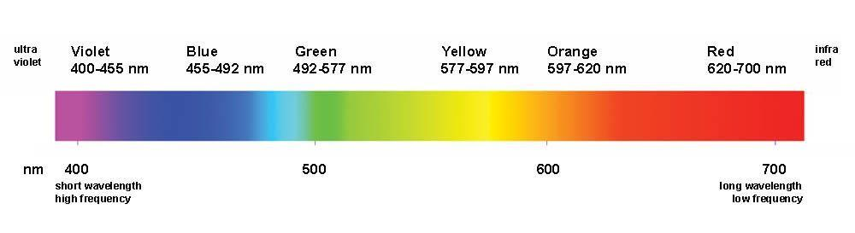
Figure 4: Visible Light Spectrum

3.1.2 Disadvantages
Limitations and drawbacks that we have to consider include noise from ambient light and the line-of-sight of the system. If the intensity of ambient light is greater than that of the light from our system, the signal-to-noise ratio (SNR) is low, which will distort transmitted data. To compensate for this, the SNR will be maximized by setting thresholds on the microcontroller based on voltage signals produced by the ambient light in conjunction with the transmitter signal.
Also, the system will only be maximized when the LEDs are directly facing the sensor. If the angle is changed even slightly, the maximum range of the system will decrease significantly. The easiest solution is to ensure that the transmitter and receiver are facing directly at each other.

3.2 Potential Applications of Visible Light Communications
Lights in the visible spectrum are used everywhere, providing several opportunities to apply visible light communications. There are many applications in which data transfer via VLC systems could be useful including traffic lights, which could utilize systems to optimize traffic flow; television sets, which could supply a user with information on current show listings; and hospitals, which could utilize the systems for more secure transfer of data.

3.2.1 Traffic Lights
There are many modern applications that use visible light to portray information. Using a visible communication system in tandem with these devices can increase the devices’ functionality. An example of a device that can benefit from a visible communication system is a traffic or stop light. In a busy intersection, traffic lights use visible lighting to maintain the flow of traffic. Because these lights are common in major cities, incorporating some sort of communication system in them to allow our society to stay connected and up to date with all sorts of information improves overall efficiency through multi- tasking. When dealing with traffic lights, a driver or pedestrian remains idle while waiting for their turn to proceed. The majority of the time, this time is simply wasted by remaining idle. If a visible light communication system was connected to a traffic light, the user could potentially use his/her Phone or car head lights to connect to the traffic lights and retrieve some form of information. The information may be about local traffic, or even directions to a specific location. The system could even be used as a local connection to access the internet. By doing this, the user can have an alternative means of accessing data instead of his/her costly and limited 3G or 4G data connection.

While having an alternative connection point could be beneficial, it could promote drivers to use handsets while driving, which can be dangerous. If a driver would like to access information, it should be done in a manner that does not cause harm to or endanger the driver or other drivers. One way to do so is to incorporate a visible communication system in the vehicle and use the vehicle’s head lights to send information. Along with this, a voice activated system could be implemented so the driver can access information hands-free.

While it may be possible to get data transmission over visible light, there are many scenarios that require consideration in order to ensure a reliable and useful system. Since traffic lights are all outdoors, natural light can become an issue and cause bad connections due to noise. One way to minimize the noise from the natural light is to use specific colored lighting to transmit information. By using a certain colored light, the photodiode used to retrieve the information can be designed to only recognize certain wavelengths and attenuate all others. Another issue that may arise is the number of users that the system can handle. One way to resolve this is to use multiple colors to transmit information. Since every visible color light has a different wavelength, they will operate at different frequencies and common communication principles can be used to minimize the interference between the different signals.

3.2.2 Television Application

Another piece of modern technology that uses visible light to portray information is a television. Unlike a traffic light, a television contains thousands of pixels that are constantly changing colors to project an image to its viewers. Because there are many individual LEDs in a television, it could be possible to allocate to a few of them the task of transmitting information through a visible light communication system. When a user is watching television, there is a possibility that the user may wish to see what else is airing on other channels. To do this with today’s technology, the user will have to either constantly switch the channels to see shows that are currently airing on other channels or minimize what was being watched to bring up the TV guide. If the user has access to a smartphone or a computer, he/she could use that to look at the guide. Unfortunately, this requires internet access. Instead of using the internet connection, the smartphone or computer could also incorporate a visible the TV guide. If the user has access to a smartphone or a computer, he/she could use that to look at the guide. Unfortunately, this requires internet access. Instead of using the internet connection, the smartphone or computer could also incorporate a visible communication system and retrieve the information from the television and display it on the second device, and not affect what is occurring on the television. Also, if the user is really intrigued by what he or she is currently watching but does not know what it is, they could use the communication system to transmit the program information to their other device.

One drawback to using a visible communication system on a television is the fact that a few pixels are dedicated to transmission and potentially could affect what is being displayed. To not disrupt the user experience, the LEDs must be placed somewhere that will not affect what is being displayed. One way to accomplish this is to place the LEDs away from the display, or use the LED to indicate that the television is ready to transmit the information. Similar to the traffic light scenario, the receiver will need to minimize the noise that may come from other light sources. This could be accomplished by filtering out all but a few light color frequencies.

3.2.3 Hospitals
Hospitals have many reasons to employ wireless technology. Applications of wireless technology in hospitals include updating information by wirelessly maintaining patient records, collecting data as a real-time handheld patient monitor to detect changes in a patient’s condition, or even observing medical images via ultrasound.

However, many concerns follow with the use of wireless technology in hospitals, and must be addressed when implementing a wireless communication system in such a sensitive environment.

Accuracy of information via wireless communication is imperative in a hospital setting. In real - time applications in which a patient’s physiological conditions are monitored, data loss is intolerable with a packet error rate (PER) of less than 10⁻⁴.Operational efficiency is necessary to ensure reliability and short delay time between two communicating devices. For real-time applications, the devices must be reliable and must have a delay of less than 300 milliseconds. For office-related applications, reliability is still important, but not critical, and delay time can be on the order of around 1 second.

3.3 Goals and Features

The goal of this system is to ultimately be able to send data from one point to another using only visible light. Ideally, this system would be able to transfer any type of data at a high speed. However, the success of this design does not depend on the creation of a new type of communication system that will instantly replace all other means of data transfer. The objective of this system is to be able to send data reliably and accurately over a short distance at a fair speed.

Initial goals for the functionality of this system include being able to send text or pictures over a distance of approximately one meter at a data rate of at least 1 Mbps. To do this, the transmitter portion of the design would receive a signal from a computer and control the flashing of an LED to send bits to the receiver which would, with the help of another microcontroller, decode the signal and present the data back in the original format. The system would be powered by external AAA batteries to allow for more flexibility as the system will be mobile.

Additional functions that would enhance the project but are not mandatory goals of this design include sending video, sending data at a distance greater than one meter, and transmitting data at a minimum of 1 Gbps. Other features include using different colored LEDs simultaneously to increase data transfer rate and/or allow simultaneous use by multiple users, as well as somehow permitting omnidirectional transmission. The reasons for not including these features include time constraints, budget concerns, as well as stability issues. When trying to transmit at higher frequencies, stability becomes more on an issue as parts become less ideal. Also, in order to transmit at a higher frequency the quality of our design parts would have to increase which would cost more money and consume more time.

Chapter 4:
Failure, Hazard Analysis, Limitations, and Future
Improvements
Several issues occurred along the way of our design and implementation, causing many of our initial goals to change and adjustments were made accordingly to meet deadlines and absolutely necessary functional requirements. These ranged from power issues on the analog transmission side of the system, to digital issues on the digital receiver side of the system.

Our final system met several, but not all, of our initial design goals. While the system is operational, it is able to transmit text at a transmission frequency of 500 Hz at a transmission distance of roughly 25 cm without the implementation of our power source. Certainly, these achieved goals leave much room for improvement and extensions.

4.1 Digital Issues
There have been many issues with the programming of the C2000 Launchpad evaluation kits. TI has several versions of example code that may not be the most up-to-date set of files, which caused compilation errors, initialization errors, etc. Often times to circumvent this issue, it was necessary to re- download sets of files on different computers to achieve for any sort of functionality.

Code Composer Studio, the integrated development environment (IDE) used to program our boards would frequently have issues reading files or would not compile due to errors, but not display what the error was. One major problem was an unresolvable error that occurred consistently on line 18 of our code no matter the fix we tried. The line was commented out and the code would not compile even though it had no significance on the functionality of the code. Many times, restarting the IDE solved the issue, but sometimes a complete reinstallation was necessary.

4.2 Analog Issues
4.2.1 LED Brightness
The original LEDs that were chosen and implemented in the prototype proved to be too dim to achieve a transmission distance of more than 20 cm. The initial goal of the design was be able to transmit data at a distance of at least one meter using solely visible light. In an attempt to achieve this goal, further research and value analysis on LEDs was conducted in hopes of finding brighter LEDs that fit the same specifications of the previous LEDs. The value analysis on LEDs can be found, and is explained more in-depth, in Section 2.3.1.1 LEDs.

Once the brighter LEDs were placed into the circuit the measurement was taken again to see if the transmission distance had improved as expected. The distance, however, did not improve by more than 10 cm. The LEDs were not receiving enough current from the MCU output to reach their brightest potential. In order to remedy this problem a Power MOSFET device was added with the purpose of supplying enough current to the LEDs, but only when the transmitted signal is ‘on’ or logic high. This ensures that the LEDs will only flash and activate the photodiodes when desired.

4.2.2 MOSFET Limitations
One version of our design involved using a MOSFET to increase the signal strength from the MCU that powered the LEDs on the transmitter end of the circuit. Our initial design is depicted below in Figure 26 but was quickly changed over to Figure 27 upon further investigation of how the MOSFET drain current works. In the first design the LEDs are connected in series with the drain of the MOSFET in an attempt to take the current from the MOSFET and power the LEDs when the device is on. However, being connected in series, the LEDs had no ground reference which made current flow impossible. After testing this in the lab, the design was quickly altered to that of the second picture to ensure the drain current flows through the LEDs as intended.

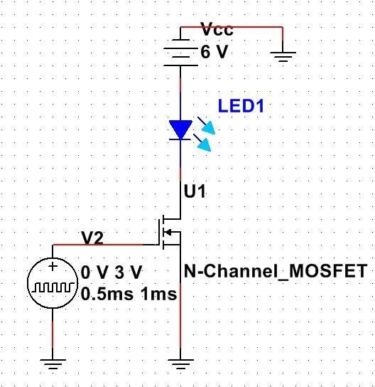

Figure 4.1: Original MOSFET Design Interfacing MCU Output and LEDs

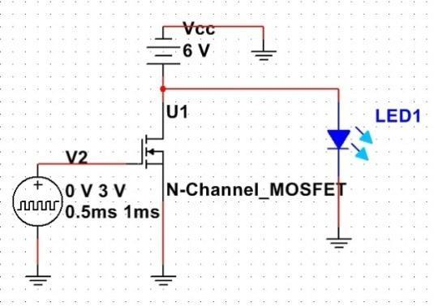

Figure 4.2: Updated MOSFET Design Interfacing MCU Output and LEDs

Another design fault was the lack of knowledge of using a MOSFET in a power application. Since the MOSFET is switching on and off at a high speed and has a high input capacitance, the logic output of the MCU does not supply enough current to charge the MOSFET gate fast enough. In order to bypass this problem, a Gate Driver was required to interface the two devices. This Gate Driver generates the current necessary to turn MOSFETs on and off from the input logic of a DSP or microcontroller. A lack of experience with MOSFETs in power applications was the cause of this problem and resulted in an inappropriate MOSFET for the design burning out during testing. When looking for a suitable Gate Driver it was found that the most of the devices available were surface mount which is not compatible with our design. Later in the design process, it was found the MOSFET had heating issues that caused failure in one of our boards so the MOSFET was excluded from the final design.
4.3 Future Improvements
4.3.1 Digital Improvements
Throughout the entire project, many of the issues that arose were from the digital components, the microprocessors. As mentioned earlier, it was needed to switch from the C2000 processor to the MSP430F5529 processor at the receiver because there were issues regarding sampling with the ADC on the C2000. The MSP430F5529 was a quick fix to the problem because it was familiar and available at the time of consideration. However, because its sampling rate is rather slow, it is not the best option for communication systems. In this section, we discuss other digital options such as FPGAs, and other digital signal processing chips.

4.3.1.1 FPGAs
A Field-Programmable Gate Array, or FPGA for short, is an integrated circuit that contains a large resource of logic gates and memory to implement digital computations. It is possible to customize the logic through a hardware description language such as Verilog. With an FPGA, it is possible to have parallel executions. This would allow the ADC to sample the incoming data without affecting any other process. Another process could take the data from the ADC and perform a spectral energy computation or even decoding the samples back into ASCII text.

FPGAs are also better suited for high frequency signals because the combinational logic inside the integrated chip typically can run as fast as the built in clock on the FPGA. In most cases, an FPGA’s internal clock can be as high as 100MHz or higher. With the high frequency operation, it would be possible to achieve a higher transmission rate as long as the ADC that is used can sample fast enough. It is possible to choose which ADC can be used because the ADC can be an external module that will be interfaced with the rest of the FPGA development board.

Unlike a FPGA, a microcontroller performs its functionality sequentially. Since the microcontroller’s ADC functions through interrupts, the time the interrupt takes to finish its process can have an effect on how fast data can be processed. In order to get a faster sampling rate, the number of computations in the interrupt needs to be done within as little processing cycles as possible or a faster processor may be needed.

4.3.1.2Better Processing Chips

When determining the initial microprocessors to use, the deciding factor to use the C2000 boards was their high sampling rate ADCs. Unfortunately, there were many issues that arose when using the board’s ADC which is why it was discarded on the receiver side. Due to the limiting time, the MSP430F5529 was chosen to replace the C2000. While the MSP430F5529 may have not been the best option for the Visible Communication System, it was a quick fix to produce a working prototype.

If a microprocessor is going to be considered again for future Visible Communication Systems, there are a few factors that should be considered before selecting the specific chip. The first factor is the ADCs sampling rate. Without a fast sampling rate, the entire systems transmission’s rate will be limited by the ADC. The second factor would be available sample code. One issue that arose with the C2000 was its lack of working sample code. By having sample code, it is much easier to design code for projects because there are models such as how to set an ADC to produce samples. The third factor is memory and processing speed. Without memory, it would be impossible to store the sampled data from the ADC. With a small amount of memory, the number of bits that can be transmitted at a time is limited because the memory has been filled. On top of having a sufficient amount of memory, it is ideal to have a fast processing processor. In order to decode the received message, the instructions to decode the received samples must run within a certain amount of samples that is not larger than the ADC’s sampling rate. If it takes too long to initiate instructions, it could affect how fast the ADC is actually sampling. Since most ADCs operate using interrupts, if the interrupt takes longer to process than the ADC’s sample period, the function is not operating in real time and can cause the receiver to not function properly.

4.3.1.3 Computer Interface

One of the main components of a Visible Communication System is its interface with other devices, such as computers or smartphones. A computer is an excellent source of interfacing the prototype system because the software that is used to program the digital side is a computer application. Since the processor used did not have enough memory to process the incoming data, the data had to be transferred to the computer to be processed in MATLAB. While it would have been better to process the data on the chip itself, there still needs to be a way to transfer the data to the computer. Due to the many issues that arose with transferring data to the computer, one short term fix was to export the collected ADC samples through CCS’s console. Once on the console, it would be possible to copy the information to a file to be later processed by MATLAB. To make the system function better, it would be better to have the data exported instantaneously to a file. While attempting to create an instantaneous process, one source that was looked at was the MSP430f5529’s sample code, emul Storage Keyboard.

The program was able to output data to a file depending on which button on the development board was pressed. We attempted to modify the code to run with the ADC interrupt to produce the data that would be outputted. Also the data would have been outputted to the file once all the information from the transmitter was received. Unfortunately, no progress was made with this approach. Because of this, other methods of transmitting data was looked into.

Another method that was looked into was the USB UART interface between the microcontroller and computer. With the UART interface, it was possible to send the data to a hyper terminal once all the information was received from the transmitter. A GUI interface could have then be used along with the hyper terminal to send the data to a file and initiate MATLAB to process the information. With the limited amount of time, it was decided to not pursue this option.

CHAPTER 5
CONCLUSION

Visible light communication is a new way of wireless communication using visible light. Typical transmitters used for visible light communication are visible light LEDs and receivers are photodiodes and image sensors. We present new applications which will be made possible by visible light communication technology. Location-based services are considered to be especially suitable for visible light communication application. We showed advantages and disadvantages of
visible light communication and explained the effectiveness of location-based services for visible light communication by showing some examples. It is expected that visible light communication will be widely used as LED light market expands worldwide.

CHAPTER 6
REFERENCES

[1] NEC, Matsushita Electric Works Ltd, Keio University, CEATEC demonstration,Japan (2004)
[2] S. Miyauchi et al., Proc. IEEE Radio and Wireless Symposium, pp. 191 - 194 (2006)
[3] K. D. Langer et al., Proc. 11th International Conference on Transparent Optical Networks
(ICTON), pp. 1 – 6 (2009)
[4] H. Ikawa et al., Proc. International Symposium on Optical Engineering and Photonic Technology (OEPT) (2009)
[5] O. Bouchet et al., Proc. IEEE GLOBECOM Workshops, pp. 1042 - 1046 (2010)
[6] http://www.sdm.keio.ac.jp/en/pdf/sdmnews/sd mnews_en_201201.pdf (2012)
[7] N. Iizuka, Casio Computer Co., Ltd., Demonstration of Image Sensor Receiver (2008
[8] H. Uchiyama et al., Proc. 34th Annual Conference of IEEE Industrial Electronics Society (IECON), pp.1771-1776 (2008)
[9] H. Mikami et al., Reports of Technical Research and Development of Sumitomo Mitsui Construction Co., Ltd., No.9, pp. 79-84 (2011)

