A semi-autonomous subaquatic robot for surveillance navigated by stereovision and sonar
SARSTION
Final Year Project - Proposal
Aadil Jaleel Choudhry
Saad Mahmood
Sheheryar Mehmood

Supervisor : Dr. Amir Ali Khan
Contents
Abstract 2
Project Modules 3
• Control Unit 3
• Inertial Unit 3
• Electronics 3
• Mechanical Structure 3
• Stereo Vision Unit 3
• Sonar/Laser Sensing Unit 3
Block Diagram 4
Timeline 4
Resource Requirement 4

Abstract
The “SARSTION” is a semi-autonomous robot for underwater surveillance. Using propellers and ballast tank administered by an elaborate control system based on various positional feedback sensors, can provide 6 degrees of freedom. It uses the techniques of stereo-vision and sonar/laser scanning for analyzing its environment, creating a 3D map and henceforth communicating the processed visual information to the control room. It also uses the same processed information for its own navigation and locomotion.
The potential applications of SARSTION include, but are not limited to, oceanography, underwater construction and repairs, underwater oil field exploration, underwater imaging for submarines and ships. It can also be employed as coastline underwater monitoring unit against enemy attacks and other suspicious activities.

Project Modules
This project can be divided into following major modules:

Control Unit
A control system to manage the motion of robot based on data from inertial unit, stereo vision and sonar.

Inertial Unit
A unit comprising to accelerometers, magnetometers and gyroscopes to act as feedback for controlling the motion of robot.

Electronics
An electrical network to drive motors, ballast tanks, on-board controller, cameras and other sensors.

Mechanical Structure
A hydrodynamic assembly which can house waterproof chamber for electronic equipment. It will also be equipped with motors and ballast tank. Assembly needs to be agile and robust. Also the assembly should be buoyant but should sink easily when desired.

Stereo Vision Unit
Comprising of stereo camera and a computational device, this unit will generate 3D image of surroundings for surveillance as well as navigation.

Sonar/Laser Sensing Unit
Sonar or laser is to be employed to calculate absolute distance form objects underwater as well as depth of robot underwater to navigate and control its motion.

Block Diagram
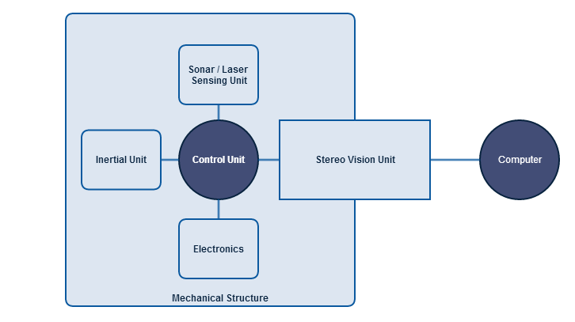

Timeline
Objective | Time Duration
Feasibility Study | July 2014
Mechanical Assembly | July 2014 – August 2014
Motion Control | Sept 2014 – Nov 2014
Stereo Imaging and Sonar/Lasing Sensing | Sept 2014 – Nov 2014
Integration | Dec 2014 – Jan 2015
Testing and Validation | Jan 2015 – April 2014

Resource Requirement
Exact resources required to successfully complete the project shall be listed after feasibility study has been carried out. A tentative list has been provided below:
- Inertial Unit
- Stereo camera
- Sonar / Laser Range Finder
- Motors
- Mechanical Workshop
- Testing Facility (A water reservoir)

