CHAPTER I

INTRODUCTION

The GSM based e-notice board also called Campus Display System (CDS) is aimed at the colleges and universities for displaying day-to-day information continuously or at regular intervals during the working hours. Being GSM-based system, it offers flexibility to display flash news or announcements faster than the programmable system. GSM-based campus display system can also be used at other public places like schools, hospitals, railway stations, gardens etc. without affecting the surrounding environment. The CDS mainly consists of a GSM receiver and a display toolkit which can be programmed from an authorized mobile phone. It receives the SMS, validates the sending Mobile Identification Number (MIN) and displays the desired information after necessary code conversion.
This project aims at integrating the expansiveness of a wireless cellular network and the ease of information transfer through the SMS with the coverage of campus display boards. It can also be a modest effort to realize the complete potential of public display boards in instantaneous information broadcast in swift response to events of interests.

CHAPTER II

CIRCUIT DIAGRAM

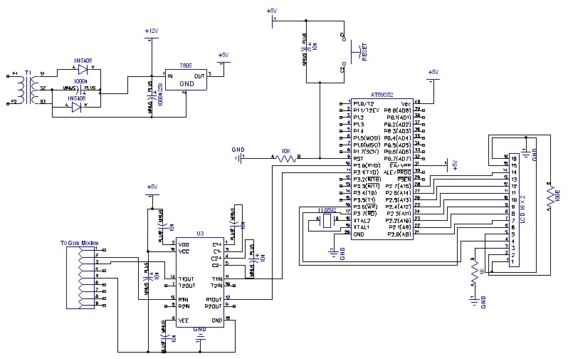
Fig-1 circuit diagram of gsm based electronic notice board

CHAPTER III

CONSTRUCTION AND WORKING

We use transformer to convert 220v ac to 12v ac, -> we use diode(1N5408) and one electrolytic capacitor (1000u/25) to make 12ac to 12dc, 12v dc supply goes to 7805 ic, it use to convert 12dc to 5v dc, after getting 5v supply system wait for input, when authorized mobile (which number is saved in program) is send a sms to our gsm modem sim number, micro controller get sms and check the mobile number with saved mobile number in the chip if compared massage will display on the lcd.

We use 16 x 2 lcd to display 32 character at time, Pin 18 and 19 is used as crystal oscillator, it provide fix frequency to microcontroller, pin 9
of microcontroller is used as reset pin. Max 232 is used to interfacing between gsm modem and microcontroller we AT89S52 MICRO CONTROLLER.

3.1 WIRELESS NOTICE BOARD
Mobile Phones and the related technologies are becoming more and more ubiquitous. Various technical arenas in the field of Telecommunication and Embedded Systems have come very near to the common people. The number of people with cell phones is on the rise. A day will come, somewhere in the near future, when a mobile phone is referred to in the same class of Food, clothing and shelter". Improvements in the Networking technologies have fostered growth of very dense networks. Land line telephones have been becoming less and less popular and people now prefer communicating while on the move.
A Remote Control is perhaps the most popular gadget today. Right from the intense creativity of remotely controlling laser chip markers to the highly destructive remotely ignitable bombs, from the pins to the planes, remote control is not only occupying a omnipresence state, but is also enhancing its scope and domains. When people have a good connectivity at their disposal, with tremendous power of mobile computing to supplement the same, we can think of connecting their home appliances to a mobile phone wirelessly. With this, people would be able to turn on and off, and to some extent, control the appliances at their home even from a distant place. One of the very basic examples of an utility of this is switching on the air conditioner in the room just some time before reaching home, so that the room is sufficiently cool by then. The usefulness of a longrange remote control to home appliances has no limits. A setup facilitating such a thing would be to connect the home appliances to a microcontroller interfaced to a GSM modem that receives the controls from the user, the means of sending signals to the appliances being a mobile phone. This project is an implementation to the idea of the wireless communication between a mobile phone and a microcontroller.
3.2 SMS Messages can be Sent and Read at Any Time: Nowadays, almost every person has a mobile phone and carries it most of the time. With a mobile phone, you can send and read SMS messages at any time, no matter you are in your office, on a bus or at home.

3.3 SMS Messages can be Sent to an Offline Mobile Phone: Unlike a phone call, you can send an SMS message to your friend even when he/she has not switched on the mobile phone or when he/she is in a place where the wireless signal is temporarily unavailable. The SMS system of the mobile network operator will store the SMS message and later send it to your friend when his/her
mobile phone is online.
3.4 SMS Messaging is Less Disturbing While You can Still Stay in Touch: Unlike a phone call, you do not need to read or reply an SMS message immediately. Besides, writing and reading SMS messages do not make any noise. While you have to run out of a theater or library to answer a phone call, you do not need to do so if SMS messaging is used.

SMS Messages are Supported by 100% GSM Mobile Phones and they can be exchanged between different wireless c arriers : SMS messaging is a very mature technology. All GSM mobile phones support it. Not only that you can exchange SMS messages with mobile users of the same wireless carrier, but you can also exchange SMS messages with mobile users of many other wireless carriers worldwide.
3.5 SMS is a Suitable Technology for Wireless Applications to Build on: Here are some of the reasons that make SMS a suitable technology for wireless applications to build on:
1. Firstly, SMS messaging is supported by 100% GSM mobile phones. Building wireless applications on top of the SMS technology can maximize the potential user base.
2. Secondly, SMS messages are capable of carrying binary data besides text. They can be used to transfer ringtones, pictures, operator logos, wallpapers, animations, V Cards, V Cals (calendar entries), etc.
3. Thirdly, SMS supports reverse billing, which enables payment to be made conveniently. For example, suppose you want to develop a commercial ringtone download application that charges a fee from the user for each ringtone downloaded. One way to accept payment is to use a reverse billing phone number obtained from a wireless carrier. To buy a ringtone, the user will write an ordinary SMS text message that contains the ID of the ringtone he/she wants to buy and send it to your SMS application's reverse billing phone number. Your SMS application will then send back one or more reverse billing SMS messages that carry the ringtone. The user will be charged a fee for the reverse billing SMS messages he/she received. The fee will be included in the user's monthly mobile phone bill or be deducted from his/her prepaid card credits. Depending on the agreement between you and the wireless carrier, all or part of the money received will be given to you.

3.6 CURRENT SCENARIO
Currently we rely on putting up notices on the notice boards using papers. This is time consuming since we need time for preparing notices. Also there is wastage of paper. If we need to renew the notice then we have to take a new hardcopy.

3.7 WHAT IS WIRELESS NOTICE BOARD?
Wireless notice board is a means of wireless data transfer for quick display of messages in real time.

Notice Board is primary thing in any institution / organization or public utility places like bus stations, railway stations and parks. But sticking various notices day-to-day is a difficult process. A separate person is required to take care of this notices display. This projects deals about an advanced hi-tech wireless notice board.
An embedded system is a combination of software and hardware to perform a dedicated task. Some of the main devices used in embedded products are Microprocessors and Microcontrollers, Microprocessors are commonly referred to as general purpose processors as they simply accept the inputs, process it and give the output. In contrast, a microcontroller not only accepts the data as inputs but also manipulates it, interfaces the data with various devices, controls the data and thus finally gives the result. As everyone in this competitive world prefers to make the things easy and simple to handle, this projects sets an example to some extent.

CHAPTER IV

TRANSMISSION TECHNIQUE

4.1 GSM TECHNOLOGY: Global System for Mobile Communication is a globally accepted standard for digital cellular communication. GSM is the name of a standardization group established in 1982 to create a common European mobile telephone standard.
4.2 RF MODULES: An RF wireless communication system operating in the presence of a periodic noise environment, includes first and second wireless devices, each such device having, a source of power, a transceiver coupled to the power source, for transmitting and receiving wireless information and a controller/CPU for controlling the operation of the transceiver.
4.3 BLUETOOTH: Bluetooth is an open wireless protocol for exchanging data over short distances from fixed and mobile devices, creating personal area networks (PANs). It was originally conceived as a wireless alternative to RS232 data cables. It can connect several devices, overcoming problems of synchronization.

4.4 GSM
GSM (Global System for Mobile communications: originally from Groupe Spécial Mobile) is the most popular standard for mobile phones in the world. Its promoter, the GSM Association, estimates that 80% of the global mobile market uses the standard. GSM is used by over 3 billion people across more than 212 countries and territories. Its ubiquity makes international roaming very common between mobile phone operators, enabling subscribers to use their phones in many parts of the world. GSM differs from its predecessors in that both signaling and speech channels are digital, and thus is considered a second generation (2G) mobile phone system. This has also meant that data communication was easy to build into the system.
4.5 TECHNICAL DETAILS
GSM is a cellular network, which means that mobile phones connect to it by searching for cells in the immediate vicinity. There are five different cell sizes in a GSM network—macro, micro, pico, femto and umbrella cells. The coverage area of each cell varies according to the implementation environment. Macro cells can be regarded as cells where the base station antenna is installed on a mast or a building above average roof top level. Micro cells are cells whose antenna height is under average roof top level; they are typically used in urban areas. Picocells are small cells whose coverage diameter is a few dozen meters; they are mainly used indoors. Femtocells are cells designed for use in residential or small business environments and connect to the service provider’s network via a broadband internet connection. Umbrella cells are used to cover shadowed regions of smaller cells and fill in gaps in coverage between those cells. Cell horizontal radius varies depending on antenna height, antenna gain and propagation conditions from a couple of hundred meters to several tens of kilometres. The longest distance the GSM specification supports in practical use is 35 kilometres (22 mi). There are also several implementations of the concept of an extended cell, where the cell radius could be double or even more, depending on the antenna system, the type of terrain and the timing advance. Indoor coverage is also supported by GSM and may be achieved by using an indoor picocell base station, or an indoor repeater with distributed indoor antennas fed through power splitters, to deliver the radio signals from an antenna outdoors to the separate indoor distributed antenna system. These are typically deployed when a lot of call capacity is needed indoors, for example in shopping centers or airports. However, this is not a prerequisite, since indoor coverage is also provided by in-building penetration of the radio signals from nearby cell.
The modulation used in GSM is Gaussian minimum-shift keying (GMSK), a kind of continuous-phase frequency shift keying. In GMSK, the signal to be modulated onto the carrier is first smoothed with a Gaussian low-pass filter prior to being fed to a frequency modulator, which greatly reduces the interference to neighboring channels (adjacent channel interference).

4.6 GSM FREQUENCIES
GSM networks operate in a number of different frequency ranges (separated into GSM frequency ranges for 2G and UMTS frequency bands for 3G). Most 2G GSM networks operate in the 900 MHz or 1800 MHz bands. Some countries in the Americas (including Canada and the United States) use the 850 MHz and 1900 MHz bands because the 900 and 1800 MHz frequency bands were already allocated. Most 3G GSM networks in Europe operate in the 2100 MHz frequency band.

4.7 NETWORK STRUCTURE

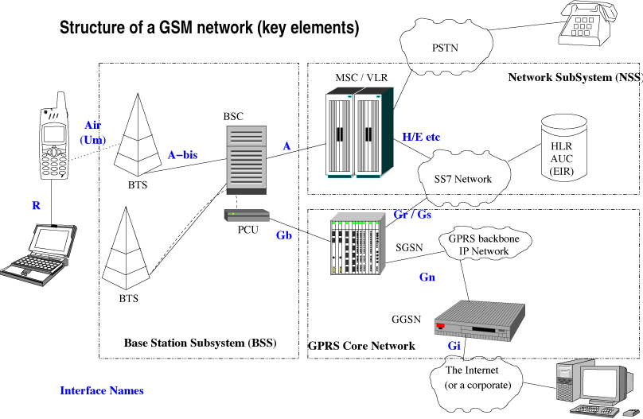
Fig-2 GSM network structure
The network behind the GSM seen by the customer is large and complicated in order to provide all of the services which are required. It is divided into a number of sections and these are each covered in separate articles.
1. The Base Station Subsystem (the base stations and their controllers).
2. The Network and Switching Subsystem (the part of the network most similar to a fixed network). This is sometimes also just called the core network.
3. The GPRS Core Network (the optional part which allows packet based Internet connections).
4. All of the elements in the system combine to produce many GSM services such as voice calls and SMS.

4.8 SUBSCRIBER IDENTITY MODULE (SIM)
One of the key features of GSM is the Subscriber Identity Module, commonly known as a SIM card. The SIM is a detachable smart card containing the user's subscription information and phone book. This allows the user to retain his or her information after switching handsets. Alternatively, the user can also change operators while retaining the handset simply by changing the SIM. Some operators will block this by allowing the phone to use only a single SIM, or only a SIM issued by them; this practice is known as SIM locking, and is illegal in some countries.

4.9 GSM SECURITY
GSM was designed with a moderate level of security. The system was designed to authenticate the subscriber using a pre-shared key and challenge-response. Communications between the subscriber and the base station can be encrypted. The development of UMTS introduces an optional USIM, that uses a longer authentication key to give greater security, as well as mutually authenticating the network and the user - whereas GSM only authenticates the user to the network (and not vice versa). The security model therefore offers confidentiality and authentication, but limited authorization capabilities, and no non-repudiation. GSM uses several cryptographic algorithms for security. The A5/1 and A5/2 stream ciphers are used for ensuring over-the-air voice privacy. A5/1 was developed first and is a stronger algorithm used within Europe and the United States; A5/2 is weaker and used in other countries.

4.10 BASIC MODEL OF THE SYSTEM

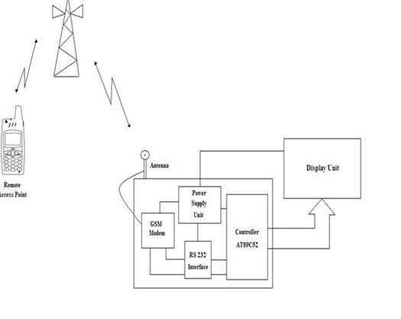
Fig-3 basic model of GSM system

CHAPTER V

LIST OF COMPONENTS

5.1 TABLE INDEX OF COMPONENTS

SR NO. | NAME OF THE COMPONENT | DESCRIPTION
1. | GSM MODULE /MODEM | SIM 300
2. | LCD DISPLAY | 16*2
3. | MICROCONTROLLER | AT89C52
4. | MAX 232 IC | INTERFACING IC
5. | CAPACITOR | 10µf , 50V
6. | RESISTOR | 10K
 |  | 1K
 |  | 100Ω
7. | (1)CRYSTAL OSCILLATOR | 11.0592
 | (2) SWITCH | 4-leg
8. | POWER SUPPLY | 12V, 2Amp

5.2 Microcontroller

CDS is based on AT89S52 microcontroller which is a variant of 8052. It is an 8- bit microcontroller with 8KB on-chip Flash memory, 256 bytes RAM, three timer / counters, one serial and four 8-bit parallel ports. It can also address up to 64KB of external data memory RAM and program memory.

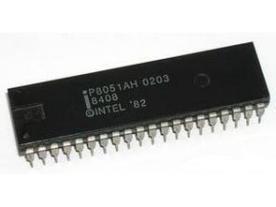

Fig-4 microcontroller(AT89C51)

A microcontroller is a computer-on-a-chip, or, if you prefer, a single-chip computer. Micro suggests that the device is small, and controller tells you that the device might be used to control objects, processes, or events. Another term to describe a microcontroller is embedded controller, because the microcontroller and its support circuits are often built into, or embedded in, the devices they control. You can find microcontrollers in all kinds of things these days. Any device that measures, stores, controls, calculates, or displays information is a candidate for putting a microcontroller inside. The largest single use for microcontrollers is in automobiles ,just about every car manufactured today includes at least one microcontroller for engine control, and often more to control additional systems in the car. In desktop computers, you can find microcontrollers inside keyboards, modems, printers, and other peripherals. In test equipment, microcontrollers make it easy to add features such as the ability to store measurements, to create and store user routines, and to display messages and waveforms. Consumer products that use microcontrollers include cameras, video recorders, compact-disk players, and ovens. And these are just a few examples.

microcontroller (sometimes abbreviated µC, uC or MCU) is a small computer on a single integrated circuit containing a processor core, memory, and programmable input/output peripherals. Program memory in the form of NOR flash or OTP ROM is also often included on chip, as well as a typically small amount of RAM. Microcontrollers are designed for embedded applications, in contrast to the microprocessors used in personal computers or other general purpose applications.
Microcontrollers are used in automatically controlled products and devices, such as automobile engine control systems, implantable medical devices, remote controls, office machines, appliances, power tools, toys and other embedded systems. By reducing the size and cost compared to a design that uses a separate microprocessor, memory, and input/output devices, microcontrollers make it economical to digitally control even more devices and processes. Mixed signal microcontrollers are common, integrating analog components needed to control non-digital electronic systems.
Some microcontrollers may use four-bit words and operate at clock rate frequencies as low as 4 kHz, for low power consumption (single-digit milliwatts or microwatts). They will generally have the ability to retain functionality while waiting for an event such as a button press or other interrupt; power consumption while sleeping (CPU clock and most peripherals off) may be just nanowatts, making many of them well suited for long lasting battery applications. Other microcontrollers may serve performance-critical roles, where they may need to act more like a digital signal processor (DSP), with higher clock speeds and power consumption.
The 8051 family of micro controllers is based on an architecture which is highly optimized for embedded control systems. It is used in a wide variety of applications from military equipment to automobiles to the keyboard on your PC. Second only to the Motorola 68HC11 in eight bit processors sales, the 8051 family of microcontrollers is available in a wide array of variations from manufacturers such as Intel, Philips, and Siemens. These manufacturers have added numerous features and peripherals to the 8051 such as I2C interface analog to digital converters, watchdog timers, and pulse width modulated outputs. Variations of the 8051 with clock speeds up to 40MHz and voltage requirements down to 1.5 volts are available. This wide range of parts based on one core makes the 8051 family an excellent choice as the base architecture for a company's entire line of products since it can perform many functions and developers will only have to learn this oneplatform.

The basic architecture consists of the following features:
One 8051 processor cycle consists of twelve oscillator periods. Each of the twelve oscillator periods is used for a special function by the 8051 core such as op code fetches and samples of the interrupt daisy chain for pending interrupts. The time required for any 8051 instruction can be computed by dividing the clock frequency by 12, inverting that result and multiplying it by the number of processor cycles required by the instruction in question. Therefore, if you have a system which is using an 11.059MHz clock, you can compute the number of instructions per second by dividing this value by 12. This gives an instruction frequency of 921583 instructions per second. Inverting this will provide the amount of time taken by each instruction cycle (1.085 microseconds).

Block Diagram:

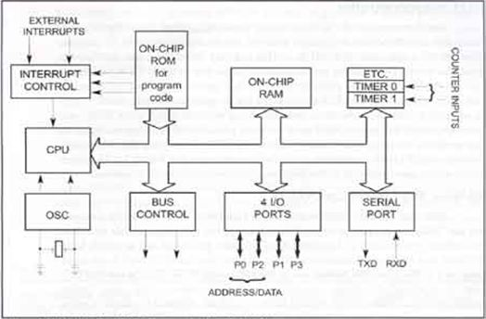

FiG-5:Block Diagram of 8051

Features of Microcontroller:
A micro-controller is a single integrated circuit, commonly with the following features:
- central processing unit - ranging from small and simple 4-bit processors to complex 32- or 64-bit processors
- volatile memory (RAM) for data storage
- ROM, EPROM, EEPROM or Flash memory for program and operating parameter storage
- discrete input and output bits, allowing control or detection of the logic state of an individual package pin
- serial input/output such as serial ports (UARTs)
- other serial communicationsinterfaces like I²C, Serial Peripheral Interface and Controller Area Network for system interconnect
- peripherals such as timers, event counters, PWM generators, and watchdog
- clock generator - often an oscillator for a quartz timing crystal, resonator or RC circuit
- many include analog-to-digital converters, some include digital-to-analog converters
- in-circuit programming and debugging support
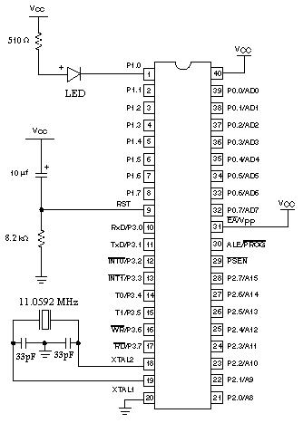
Fig -6 Pin description of 8051 microcontroller

By applying logic zero to this pin, the program starts execution from the beginning. Pin 9 is the RESET pin. It is an input and is active high. Upon applying a high pulse to this pin the microcontroller well reset and terminate all activities. This is often referred to as a power on reset .Activating a power on reset will cause all values the registers to be lost. It will set program counter to all 0s.In order for the RESET input to be effective it must have a minimum duration of two machine cycles. In other words the high pulse must be high for a minimum of two machine cycles before it is allowed to go low.

Pin 10-17(Port 3): Similar to port 1, each of these pins can serve as general input or output. Besides, all of them have alternative functions:
Pin 10(RXD):Serial asynchronous communication input or Serial synchronous communication output.
Pin 11(TXD):Serial asynchronous communication output or Serial synchronous communication clock output.
Pin 12(INT0):Interrupt 0 input.
Pin 13(INT1):Interrupt 1 input.
Pin 14(T0):Counter 0 clock input.
Pin 15(T1):Counter 1 clock input.
Pin 16(WR):Write to external (additional) RAM.
Pin 17(RD):Read from external RAM.
Pin 18, 19(X2,X1):Internal oscillator input and output. The 8051 has an on chip oscillator butrequires an external clock to run it. Most often a quartz crystal oscillator is connected to inputs XTAL1 (pin 19) and XTAL2 (pin 18). The quartz crystal oscillator connected to XTAL1 and XTAL2 also needs two capacitors of 30pf value. One side of each capacitor is connected to the ground. Speed refers to the maximum oscillator frequency connected to XTAL.

Pin 20(GND):Ground.

Pin 21-28(Port 2):If there is no intention to use external memory then these port pins are configured as general inputs/outputs. In case external memory is used, the higher address byte, i.e. addresses A8-A15 will appear on this port. Even though memory with capacity of 64Kb is not used, which means that not all eight port bits are used for its addressing, the rest of them are not available as inputs/outputs.

Pin 29(PSEN):This is an output pin. PSEN stands for “program store enable”. If external ROM is used for storing program then a logic zero (0) appears on it every time the microcontroller reads a byte from memory.
Pin 30(ALE):ALE stands for “address latch enable. It is an output pin and is active high. When connecting an 8031 to external memory, port 0 provides both address and data. In other words the 8031 multiplexes address and data through port 0 to save pins. The ALE pin is used for de-multiplexing the address and data.
Prior to reading from external memory, the microcontroller puts the lower address byte (A0-A7) on P0. In other words, this port is used for both data and address transmission.

Pin 31(EA):EA which stands for “external access” is pin number 31 in the DIP packages. It is an input pin and must be connected to either Vccor GND. In other words it cannot be unconnected. By applying logic zero to this pin, P2 and P3 are used for data and address transmission with no regard to whether there is internal memory or not.
It means that even there is a program written to the microcontroller, it will not be executed. Instead, the program,Writtento external ROM will be executed. By applying logic one to the EA pin, the microcontroller will use both memories, first internal then external (if exists).

Pin 32-39(Port 0): Similar to P2, if external memory is not used, these pins can be used as general inputs/outputs. Otherwise, P0 is configured as address output (A0-A7) when the ALE pin is driven high (1) or as data output (Data Bus) when the ALE pin is driven low (0).

Pin 40(Vcc):+5V power supply.

5.3 LCD
The GSM based CDS uses LCD for displaying the text data. It is 16character x 2 line display module. But in practice, it should be replaced by the large multiline, multicolor commercial display units
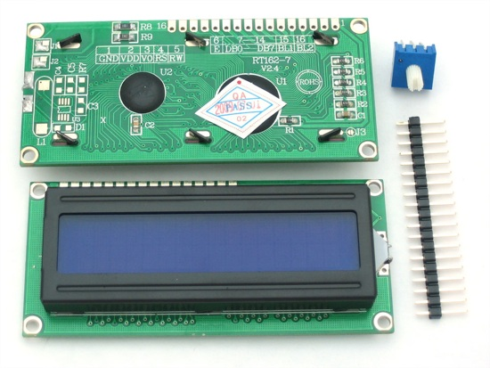
Fig-7 LCD 16x2
LCD (Liquid Crystal Display) screen is an electronic display module and find a wide range of applications. A 16x2 LCD display is very basic module and is very commonly used in various devices and circuits. These modules are preferred over seven segment and other multi segment LED’s. The reasons being: LCDs are economical; easily programmable; have no limitation of displaying special & even custom charactors (unlike in seven segments), animations and so on.
A 16x2 LCD means it can display 16 characters per line and there are 2 such lines. In this LCD each character is displayed in 5x7 pixel matrix. This LCD has two registers, namely, Command and D The command register stores the command instructions given to the LCD. A command is an instruction given to LCD to do a predefined task like initializing it, clearing its screen, setting the cursor position, controlling display etc. The data register stores the data to be displayed on the LCD. The data is the ASCII value of the character to be displayed on the LCD. Click to learn more about internal structure of a LCD.

PIN DESCRIPTION OF LCD (16x2):-

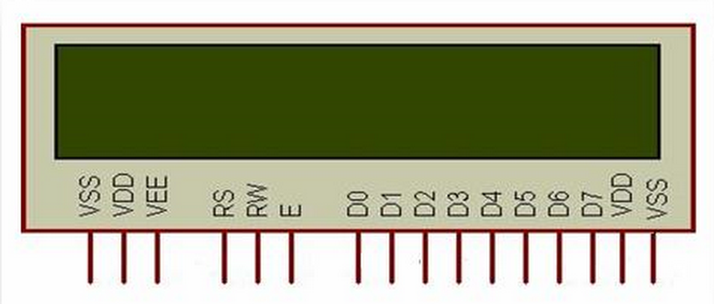

Fig-8 PIN Out diagram of LCD 16x2

VSS, VDD and VEE
Pin 1 (VSS) is a ground pin and it is certainly needed that this pin should be grounded for LCD to work properly. VEE and VDD are given +5 vlots normally. However VEE may have a potentiometer voltage divider network to get the contrast adjusted. But VDD is always at +5V.

RS, R/W and E
These three pins are numbered 4, 5 and 6 as shown above. RS is used to make the selection between data and command register. For RS=0, commandregister is selected and for RS=1 data register is selected.

R/W gives you the choice between writing and reading. If set (R/W=1) reading is enabled. R/W=0 when writing.

Enable pins is used by the LCD to latch information presented to its data pins. When data is supplied to data pins, a high to low pulse must be applied to this pin in-order for the LCD to latch in the data present at the data pins. It maybe noted here that the pulse must be of minimum 450ns wide.

D0-D7
The 8-bit data pins, D0-D7, are used to send information to the LCD or read the contents of LCD's internal register.

Probably this very post should have come before the number of other posts related to 8051 LCD interfacing, but its never too late. This post will describeyou about the pins of LCD normally available in the market. It looks almost like the one shown below. As you guys can see that there are 8 data pins along with 3 control pins. One ground and two power pins are also there. Lets study about these pins of LCD

VSS, VDD and VEE
Pin 1 (VSS) is a ground pin and it is certainly needed that this pin should be grounded for LCD to work properly. VEE and VDD are given +5 vlots normally. However VEE may have a potentiometer voltage divider network to get the contrast adjusted. But VDD is always at +5V.

RS, R/W and E
These three pins are numbered 4, 5 and 6 as shown above. RS is used to make the selection between data and command register. For RS=0, commandregister is selected and for RS=1 data register is selected.

R/W gives you the choice between writing and reading. If set (R/W=1) reading is enabled. R/W=0 when writing.

Enable pins is used by the LCD to latch information presented to its data pins. When data is supplied to data pins, a high to low pulse must be applied to this pin in-order for the LCD to latch in the data present at the data pins. It maybe noted here that the pulse must be of minimum 450ns wide.

D0-D7
The 8-bit data pins, D0-D7, are used to send information to the LCD or read the contents of LCD's internal register.

5.4 GSM Modem
A GSM modem is a wireless modem that works with a GSM wireless network. A wireless modem behaves like a dial-up modem. The main difference between them is that a dial-up modem sends and receives data through a fixed telephone line while a wireless modem sends and receives data through radio waves. Like a GSM mobile phone, a GSM modem requires a SIM card in order to operate.
In this project, we must take into account the fact that the modem requires a wired connection at one end and wireless at the other. It is a Fixed Cellular Terminal (FCT) for data applications. It is a compact and portable terminal that can satisfy various data communication needs over GSM.

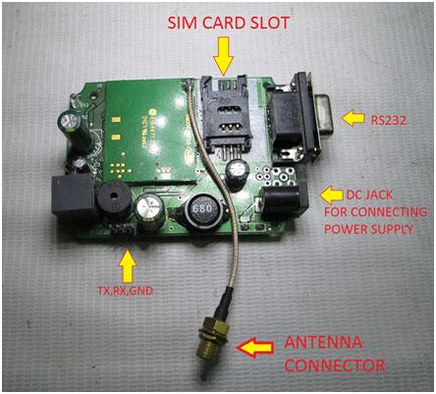
Fig-9 GSM module SIM 300
It can be connected to a computer with the help of a standard RS232C serial port. SIM 300 offers features like Short Message Services (SMS), Data Services (sending and receiving data files), Fax Services and Web Browsing. The Sim 300 is easy to set up. Computers use AT commands to control modems. Both GSM modems and dialup modems support a common set of standard AT commands. GSM modem can be used just like a dialup modem. In addition to the standard AT commands, GSM modems support an extended set of AT commands. These extended AT commands are defined in the GSM.Computer Interface Finally, this project uses RS232 serial interface for interfacing the GSM modem with a PC.
GSM (Global System for Mobile Communications, originally Groupe Spécial Mobile), is a standard developed by the European Telecommunications Standards Institute (ETSI) to describe protocols for second-generation (2G) digital cellular networks used by mobile phones. As of 2014 it has become the default global standard for mobile communications - with over 90% market share, operating in over 219 countries and territories.
2G networks developed as a replacement for first generation (1G) analog cellular networks, and the GSM standard. This expanded over time to include data communications, first by circuit-switched transport, then by packet data transport via GPRS (General Packet Radio Services) and EDGE (Enhanced Data rates for GSM Evolution or EGPRS).
Subsequently, the 3GPP developed third-generation (3G) UMTS standards followed by fourth-generation (4G) LTE Advanced standards, which do not form part of the ETSI GSM standard.
"GSM" is a trademark owned by the GSM Association.

TECHNICAL DETAILS:-
The network is structured into a number of discrete sections:
- Base Station Subsystem – The base stations and their controllers explained

- Network and Switching Subsystem – the part of the network most similar to a fixed network, sometimes just called the "core network"

- GPRS Core Network – the optional part which allows packet-based Internet connections

- Operations support system (OSS) – network maintenance
- BASE STATION SUBSYSTEM

GSM is a cellular network, which means that cell phones connect to it by searching for cells in the immediate vicinity. There are five different cell sizes in a GSM network—macro, micro, pico, femto, and umbrella cells. The coverage area of each cell varies according to the implementation environment. Macro cells can be regarded as cells where the base station antenna is installed on a mast or a building above average rooftop level.

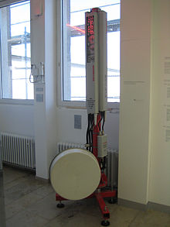

Fig:-10.GSM cell site antennas
Micro cells are cells whose antenna height is under average rooftop level; they are typically used in urban areas. Picocells are small cells whose coverage diameter is a few dozen metres; they are mainly used indoors. Femtocells are cells designed for use in residential or small business environments and connect to the service provider’s network via a broadband internet connection. Umbrella cells are used to cover shadowed regions of smaller cells and fill in gaps in coverage between those cells.
Cell horizontal radius varies depending on antenna height, antenna gain, and propagation conditions from a couple of hundred meters to several tens of kilometers. The longest distance the GSM specification supports in practical use is 35 kilometers (22 mi). There are also several implementations of the concept of an extended cell where the cell radius could be double or even more, depending on the antenna system, the type of terrain, and the timing advance.
Indoor coverage is also supported by GSM and may be achieved by using an indoor picocell base station, or an indoor repeater with distributed indoor antennas fed through power splitters, to deliver the radio signals from an antenna outdoors to the separate indoor distributed antenna system. These are typically deployed when significant call capacity is needed indoors, like in shopping centers or airports. However, this is not a prerequisite, since indoor coverage is also provided by in-building penetration of the radio signals from any nearby cell.

GSM carrier frequencies:-
GSM networks operate in a number of different carrier frequency ranges (separated into GSM frequency ranges for 2G and UMTS frequency bands for 3G), with most 2G GSM networks operating in the 900 MHz or 1800 MHz bands. Where these bands were already allocated, the 850 MHz and 1900 MHz bands were used instead (for example in Canada and the United States). In rare cases the 400 and 450 MHz frequency bands are assigned in some countries because they were previously used for first-generation systems.
Most 3G networks in Europe operate in the 2100 MHz frequency band. For more information on worldwide GSM frequency usage, see GSM frequency bands.
Regardless of the frequency selected by an operator, it is divided into timeslots for individual phones. This allows eight full-rate or sixteen half-rate speech channels per radio frequency. These eight radio timeslots (or burst periods) are grouped into a TDMA frame. Half-rate channels use alternate frames in the same timeslot. The channel data rate for all 8 channels is 270.833 kbit/s, and the frame duration is 4.615 ms.
The transmission power in the handset is limited to a maximum of 2 watts in GSM 850/900 and 1 watt in GSM 1800/1900.

VOICE CODECS:-
GSM has used a variety of voice codecs to squeeze 3.1 kHz audio into between 6.5 and 13 kbit/s. Originally, two codecs, named after the types of data channel they were allocated, were used, called Half Rate (6.5 kbit/s) and Full Rate (13 kbit/s). These used a system based on linear predictive coding (LPC). In addition to being efficient withbitrates, these codecs also made it easier to identify more important parts of the audio, allowing the air interface layer to prioritize and better protect these parts of the signal.
As GSM was further enhanced in 1997 with the Enhanced Full Rate (EFR) codec, a 12.2 kbit/s codec that uses a full-rate channel. Finally, with the development of UMTS, EFR was refactored into a variable-rate codec called AMR-Narrowband, which is high quality and robust against interference when used on full-rate channels, or less robust but still relatively high quality when used in good radio conditions on half-rate channel.

Phone locking:-
Sometimes mobile network operators restrict handsets that they sell for use with their own network. This is called locking and is implemented by a software feature of the phone. A subscriber may usually contact the provider to remove the lock for a fee, utilize private services to remove the lock, or use software and websites to unlock the handset themselves.
In some countries (e.g., Bangladesh, Brazil, Chile, Germany, Hong Kong, India, Lebanon, Malaysia, Nepal, Pakistan, Singapore, South Africa) all phones are sold unlocked.

GSM service security:-
GSM was designed with a moderate level of service security. The system was designed to authenticate the subscriber using a pre-shared key and challenge-response. Communications between the subscriber and the base station can be encrypted. The development of UMTS introduces an optional Universal Subscriber Identity Module (USIM), that uses a longer authentication key to give greater security, as well as mutually authenticating the network and the user, whereas GSM only authenticates the user to the network (and not vice versa). The security model therefore offers confidentiality and authentication, but limited authorization capabilities, and no non-repudiation.
GSM uses several cryptographic algorithms for security. The A5/1, A5/2, and A5/3 stream ciphers are used for ensuring over-the-air voice privacy. A5/1 was developed first and is a stronger algorithm used within Europe and the United States; A5/2 is weaker and used in other countries. Serious weaknesses have been found in both algorithms: it is possible to break A5/2 in real-time with a ciphertext-only attack, and in January 2007, The Hacker's Choice started the A5/1 cracking project with plans to use FPGAs that allow A5/1 to be broken with a rainbow table attack. The system supports multiple algorithms so operators may replace that cipher with a stronger one.
On 28 December 2010 German computer engineer Karsten Nohl announced that he had cracked the A5/1 cipher. According to Nohl, he developed a number of rainbow tables (static values which reduce the time needed to carry out an attack) and have found new sources for known plaintext attacks. He also said that it is possible to build "a full GSM interceptor...from open-source components" but that they had not done so because of legal concerns. Nohl claimed that he was able to intercept voice and text conversations by impersonating another user to listen to voicemail, make calls, or send text messages using a seven-year-old Motorola cellphone and decryption software available for free online.
New attacks have been observed that take advantage of poor security implementations, architecture, and development for smartphone applications. Some wiretapping and eavesdropping techniques hijack the audio input and output providing an opportunity for a third party to listen in to the conversation.
GSM uses General Packet Radio Service (GPRS) for data transmissions like browsing the web. The most commonly deployed GPRS ciphers were publicly broken in 2011.
The researchers revealed flaws in the commonly used GEA/1 and GEA/2 ciphers and published the open-source "gprsdecode" software for sniffing GPRS networks. They also noted that some carriers do not encrypt the data (i.e., using GEA/0) in order to detect the use of traffic or protocols they do not like (e.g., Skype), leaving customers unprotected. GEA/3 seems to remain relatively hard to break and is said to be in use on some more modern networks. If used with USIM to prevent connections to fake base stations and downgrade attacks, users will be protected in the medium term, though migration to 128-bit GEA/4 is still recommended.

5.5 MAX-232
The MAX232 is a dual driver/receiver that includes a capacitive voltage generator to supply EIA-232 voltage levels from a single 5-V supply. Each receiver converts EIA 232 inputs to 5-V TTL/CMOS levels. These receivers have a typical threshold of 1.3 V and a typical hysteresis of 0.5 V, and can accept ±30-V inputs.
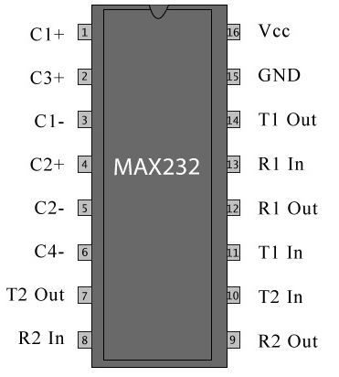
PIN DESCRIPTION OF MAX 232:-

Fig-11PIN OUT diagram of MAX 232

MAX 232 has 16 pins. It requires four external capacitors for its proper configuration. Capacitors can range between 8uf to 10uf and are of upto 16v. Pin names With functions are listed below. Suppose max-232 is connected to Pc or microcontroller.
PIN 1(C1+) Connect positive leg of a capacitor to it.
PIN 2(Vs+) Connect positive leg of a capacitor to it, and make negative leg of same capacitor ground.
PIN 3(C1-) Connect negative leg of a capacitor to it, whose positive leg is connected to Pin#1.
PIN 4(C2+) Connect positive leg of a capacitor to it.
PIN 5(C2-) Connect negative leg of a capacitor to it, whose positive leg is connected to Pin#4.
PIN 6(Vs-) Connect negative leg of a capacitor to it and apply 5 volts to positive leg of the same capacitor.

PIN 7(T2OUT)
Outputs the converted Transmitted signal. Signal is received from Pc or microcontroller etc at T1IN Pin. Connect this pin to Pin#2 of DB-9 serial port of your PC or Rxd Pin of youe microcontroller, actually this pin transmits the transformed signal from TTL to RS-232 level or Rs-232 to TTL. Pin#2 of DB-9 port is Rxd(Rxd means This pin receives Transmitted Signal(data)).
PIN 8(R2IN)
This pin Receives transmitted signal from Pc or microcontroller etc. This pin receives signal transmitted from Txd pin. Connect this pin to Pin#3 of DB-9 port of your PC or Txd pin of microcontroller. Pin#3 of DB-9 port is Txd(Txd means This pin transmits data).
PIN 9(R2OUT)
Outputs the converted received signal. Signal is recevied from Pc or microcontroller etc at R1In Pin.Connect this pin to your module Rxd pin which receives the signal.

PIN 10(T2IN)
Recevies the transmitted signal from pc or microcontroller etc. Signal is transmitted from txd pin.Connect this pin to your module Txd pin.
- PIN 11(T1IN) Woks same as T1IN.
- PIN 12(R1OUT) Works same as R2OUT.
- PIN 13(R1IN) Works same as R2IN.
- PIN 14(T1OUT) Works same as T2OUT.
- PIN 15(GND) Ground this pin.
- PIN 16(vcc) Apply 5 volts to this pin.

5.6 CRYSTAL OSCILLATOR
A crystal oscillator is an electronic oscillator circuit that uses the mechanical resonance of a vibrating crystal of piezoelectric material to create an electrical signal with a very precise frequency.
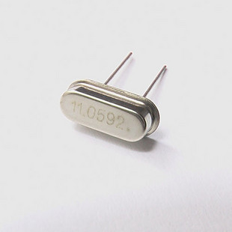

Fig-12 crystal oscillator
5.7 CAPACITOR
A capacitor (originally known as a condenser) is a passive two-terminal electrical component used to store energy electrostatically in an electric field. The forms of practical capacitors vary widely, but all contain at least two electrical conductors (plates) separated by a dielectric (i.e. insulator).
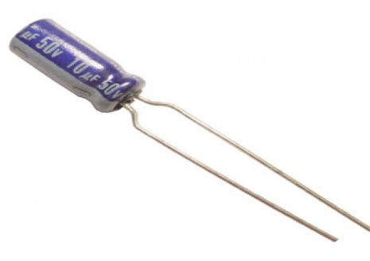

Fig-13 capacitor
We used 10uf,50V in this project.

5.8 RESISTOR
A resistor is a passive two-terminal electrical component that implements electrical resistance as a circuit element. Resistors act to reduce current flow, and, at the same time, act to lower voltage levels within circuits.
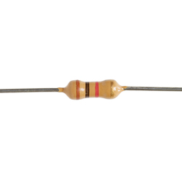
Fig-14 resistor

Mainly we have used 1K, 10K and 100 ohm resistor in this project.
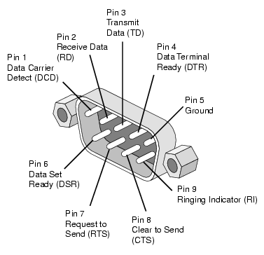
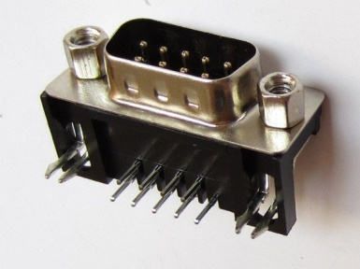
5.9 DB9 CONNECTOR

Fig-15 DB9 connector and PINOUT of DB9 connector

DB9 connectors were once very common on PCs and servers. DB9 connectors are designed to work with the EIA/TIA 232 serial interface standard, which determined the function of all nine pins as a standard, so that multiple companies could design them into their products.

D-sub-9 PIN OUT:-
Pin out and diagram of DE9 connector (DB9 connector), commonly used for serial ports (RS-232).
These DB-9 connectors are useful for a wide variety of electronics projects. DB-9 connectors are handy for connection points to projects and are commonly used for serial port connections on electronic and computer equipment.

Pin | SIG. | Signal Name | DTE (PC)
1 | DCD | Data Carrier Detect | In
2 | RXD | Receive Data | In
3 | TXD | Transmit Data | Out
4 | DTR | Data Terminal Ready | Out
5 | GND | Signal Ground | -
6 | DSR | Data Set Ready | In
7 | RTS | Request to Send | Out
8 | CTS | Clear to Send | In
9 | RI | Ring Indicator | In

Applications of DB9 connector:-
- The DB style connector is a common connector used in many computer, audio/video, and data applications.The connector gets its name from its trapezoidal shape that resembles the letter "D".
- In the name, DB stands for D-Sub-miniature or D-sub but its actual name is DE-9. Db-xx is now commonly used for all serial connectors and in today's market DE-9 connectors are sold as DB-9 connectors which instead of its correct terminology.
- A DB9 connector has 9 pins arranged in two rows as shown in figure having 5 pins in top row and remaining in the bottom.
- It is also known as COM port and is used to interface device with data rate less than 20kbps.

CHAPTER VI

LAYOUT DESIGN
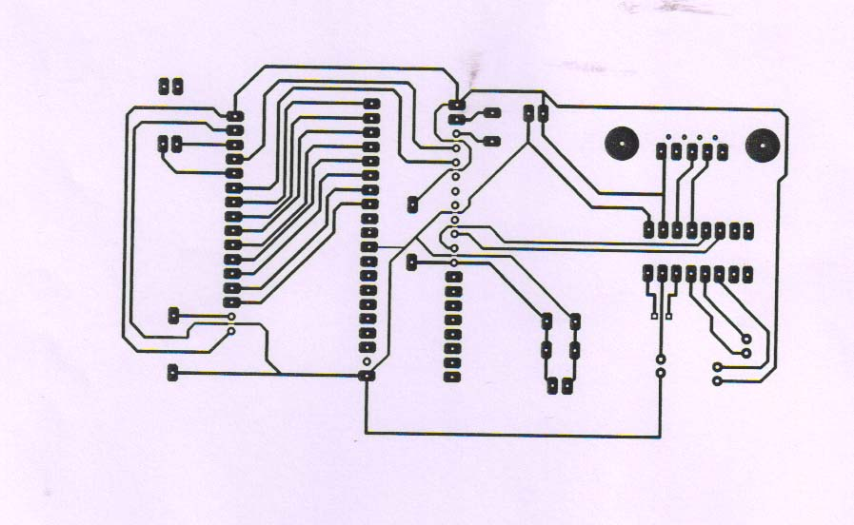

CHAPTER VII

VIEW OF PROJECT

CHAPTER VIII

APPLICATION AND ADVANTAGES

8.1 APPLICATION:-

- This project can be used in industries, offices , shops, schools, university campus.
- This project is easy to use.
- It is useful thing to send sms anywhere as a information.
- GSM modem works as a mobile phone in this project.

8.2 ADVANTAGES:-
- No need of any complex wires to display the message on LCD as it is wireless.
- Consumes less power and easy to operate.
- The circuit is portable.

8.3 LIMITATIONS:-
- Display unit must have the network to receive the message wirelessly
- As there is no password any one can send the message to display.
- Network failure problem occurs sometimes in gsm module so the
Message not received and nothing will show on the display.

CHAPTER - IX

CONCLUSION
9.1 CONCLUSION
The prototype of the GSM based display toolkit was efficiently designed. This prototype has facilities to be integrated with a display board thus making it truly mobile. The toolkit accepts the SMS, stores it, validates it and then displays it in the LCD module. The SMS is deleted from the SIM each time it is read, thus making room for the next SMS. The major constraints incorporated are the use of „*‟ as the termination character of the SMS and the display of one SMS as a time. These limitations can be removed by the use of higher end microcontrollers and extended RAM. The prototype can be implemented using commercial display boards. In this case, it can solve the problem of instant information transfer in the campus.
9.2 FUTURE IMPROVEMENTS
The use of microcontroller in place of a general purpose computer allows us to theorize on many further improvements on this project prototype. Temperature display during periods wherein no message buffers are empty is one such theoretical improvement that is very possible. The ideal state of the microcontroller is when the indices or storage space in the SIM memory are empty and no new message is there to display. With proper use of interrupt routines the incoming message acts as an interrupt, the temperature display is halted and the control flow jumps over to the specific interrupt service routine which first validates the sender‟s number and then displays the information field. Another very interesting and significant improvement would be to accommodate multiple receiver MODEMS at the different positions in a geographical area carrying duplicate SIM cards. With the help of principles of TDMA technique, we can choose to simulcast and /or broadcast important notifications. After a display board receives the valid message through the MODEM and displays it, it withdraws its identification from the network & synchronously another nearby MODEM signs itself into the network and starts to receive the message. The message is broadcast by the mobile switching center for a continuous time period during which as many possible display board MODEMS “catch” the message and display it as per the constraint of validation.
Multilingual display can be another added variation of the project. The display boards are one of the single most important media for information transfer to the maximum number of end users. This feature can be added by programming the microcontroller to use different encoding decoding schemes in different areas as per the local language. This will ensure the increase in the number of informed users.
Graphical display can also be considered as a long term but achievable and target able output. MMS technology along with relatively high end microcontrollers to carry on the tasks of graphics encoding and decoding along with a more expansive bank of usable memory can make this task a walk in the park.

REFERENCES
Websites:
- http://en.wikipedia.org/wiki/Wikipedia
- http://www.atmel.com/
- http://images.google.com
- http://www.8052.com
- http://www.datasheetcatalog.com
- http://www.keil.com/forum/docs

