CHAPTER – 1

INTRODUCTION TO THE STUDY

Introduction:

Human Body is a very complex and sophisticated structure and comprises of millions of functions. All these complicated functions have been understood by man him, part-by-part their research and experiments. As science and technology progressed, medicine became an integral part of the research. Gradually, medical science became an entirely new branch of science. As of today, the Health Sector comprises of Medical institutions i.e. Clinicals, CLINICALs etc. research and development institutions and medical colleges. Thus the Health sector aims at providing the best medical facilities to the common man.

Medical Institutions in India

Still being a developing nation India has seen a tremendous growth of the Health sector in the field of research as well as in the field of development of numerous large and small scale Clinical institutions still lacking in inter-structure facilities. Government of India has still aimed at providing medical facilities by establishing Clinical. The basic working of various Clinicals in India is still on paper as compared to Clinicals in European countries where computers have been put in to assist the Clinical personals their work. The concept of automation of the administration and management of Clinical is now being implemented in India also, with large Clinicals like APPOLO and AIIMS in Delhi, ESCORTS in Chennai, having automated their existing system.

Our project is based on the above concept i.e. automation of Administration and Management of Clinical. The project has been developed keeping in-view the following aspects: -
(i) Working environment of the Clinical.
(ii) The thought-process and attitude of Indian people.
(iii) The literacy rate of India.
(iv) The Existing system, being used in the majority of Clinicals.
(v) The availability of Infra-structural facilities likes finance, skilled personals, and working environment.

DEFINITION OF PROBLEM:

Since CLINICAL is associated with the lives of common people and their day-to-day routines so I decided to work on this project.

The manual handling of the record is time consuming and highly prone to error. The purpose of this project is to automate or make online, the process of day-to-day activities like Room activities, Admission of New Patient, Discharge of Patient, Assign a Doctor, and finally compute the bill etc.

I have tried my best to make the complicated process Clinical Management System as simple as possible using Structured & Modular technique & Menu oriented interface. I have tried to design the software in such a way that user may not have any difficulty in using this package & further expansion is possible without much effort. Even though I cannot claim that this work to be entirely exhaustive, the main purpose of my exercise is perform each Clinical’s activity in computerized way rather than manually which is time consuming.

I am confident that this software package can be readily used by non-programming personal avoiding human handled chance of error.

DRAWBACKS OF CURRENT MANUAL- SYSTEM

- The current manual system has a lot of paper work and it does not deal with old and new car purchase and sale.
- To maintain the records of sale and service manually, is a Time-consuming job.
- With the increase in database, it will become a massive job to maintain the database.
- Requires large quantities of file cabinets, which are huge and require quite a bit of space in the office, which can be used for storing records of previous details.
- The retrieval of records of previously registered patients will be a tedious job.
- Lack of security for the records, anyone disarrange the records of your system.
- If someone want to check the details of the available doctors the previous system does not provide any necessary detail of this type.

ESTABLISH THE NEED OF NEW SYSTEM

- Problem of Reliability: Current system is not reliable. It seems to vary in quality from one month to the, next. Sometimes it gives good output, but some times the output is worst.
- Problem of Accuracy: There are too many mistakes in reports.
- Problem of timeliness: In the current system the reports and output produced is mostly late and in most of the cases it is useless because it is not on time.
- Problem of Validity: The output and reports mostly contains misleading information. The customer's information is sometimes not valid.
- Problem of Economy: The current system is very costly. We have to spend lots of money to keep the system up and going, but still not get the desired results.
- Problem of Capacity: The current system is suffering from problem of capacity also. The staff for organization is very less and the workload is too much. Few peoples cannot handle all the work.

PROPOSED SYSTEM

l. Employee Details: The new proposed system stores and maintains all the employees details.

2. Calculations: The new proposed system calculates salary and income tax automatically and it is very fast and accurate.

3. Registers: There is no need of keeping and maintaining salary and employee register manually. It remembers each and every record and we can get any report related to employee and salary at any time.

4. Speed: The new proposed system is very fast with 100% accuracy and saves time.

5. Manpower: The new proposed system needs less manpower. Less people can do the large work.

6. Efficiency: The new proposed systems complete the work of many salesperson in less time.

7. Past details: The new proposed system contains the details of every past doctor and patients for future assistance.

8. Reduces redundancy: The most important benefit of this system is that it reduces the redundancy of data within the data.

9. Work load: Reduces the work load of the data store by helping in easy updates of the products and providing them with the necessary details together with financial transactions management.

10. Easy statements: Month-end and day-end statement easily taken out without getting headaches on browsing through the day end statements.

NEED:

I have designed the given proposed system in the JSP to automate the process of day to day activities of Clinical like Room activities, Admission of New Patient, Discharge of Patient, Assign a Doctor, and finally compute the bill etc., online facilities to the multiple users etc.

The complete set of rules & procedures related to Clinical’s day to day activities and generating report is called “CLINICAL MANAGEMENT SYSTEM”. My project gives a brief idea regarding automated Clinical activities.

The following steps that give the detailed information of the need of proposed system are:

Performance: During past several decades, the Clinical management system is supposed to maintain manual handling of all the Clinical daily activities. The manual handling of the record is time consuming and highly prone to error. To improve the performance of the Clinical management system, the computerized Clinical management system is to be undertaken. The computerized Clinical project is fully computerized and user friendly even that any of the Clinical’s members can see the patient’s report and the doctor’s report.

Efficiency: The basic need of the project is efficiency. The project should be efficient so that whenever a new patient is admitted, and automatically a bed is assigned and also a doctor is assigned to the patient according to the patient’s disease. And if any patient is getting discharged, the bed assigned to him/her should automatically free in the computer.

Control: The complete control of the project is under the hands of authorized person who has the password to access this project and illegal access is not supposed to deal with. All the control is under the administrator and the other members have the rights to just see the records not to change any transaction or entry.

Security: Security is the main criteria for the proposed system. Since illegal access may corrupt the database and it will affect not only the Clinical but also it also affects the patient’s life. So security has to be given in this project.

SOFTWARE & HARDWARE REQUIREMENTS:

Adding dynamic content via expressions

As we saw in the previous section, any HTML file can be turned into a JSP file by changing its extension to .jsp. Of course, what makes JSP useful is the ability to embed Java. Put the following text in a file with .jsp extension (let us call it hello.jsp), place it in your JSP directory, and view it in a browser.
<HTML>
<BODY>
Hello! The time is now <%= new java.util.Date() %>
</BODY>
</HTML>
Notice that each time you reload the page in the browser, it comes up with the current time.
The character sequences <%= and %> enclose Java expressions, which are evaluated at run time.
This is what makes it possible to use JSP to generate dynamic HTML pages that change in response to user actions or vary from user to user.
Exercise: Write a JSP to output the values returned by System.getProperty for various system properties such as java.version, java.home, os.name, user.name, user.home, user.dir etc.

Scriptlets

We have already seen how to embed Java expressions in JSP pages by putting them between the <%= and %> character sequences.
But it is difficult to do much programming just by putting Java expressions inside HTML.
JSP also allows you to write blocks of Java code inside the JSP. You do this by placing your Java code between <% and %> characters (just like expressions, but without the = sign at the start of the sequence.)
This block of code is known as a "scriptlet". By itself, a scriptlet doesn't contribute any HTML (though it can, as we will see down below.) A scriptlet contains Java code that is executed every time the JSP is invoked.
Here is a modified version of our JSP from previous section, adding in a scriptlet.
<HTML>
<BODY>
<%
// This is a scriptlet. Notice that the "date"
// variable we declare here is available in the
// embedded expression later on.
System.out.println( "Evaluating date now" );
java.util.Date date = new java.util.Date();
%>
Hello! The time is now <%= date %>
</BODY>
</HTML>
If you run the above example, you will notice the output from the "System.out.println" on the server log. This is a convenient way to do simple debugging (some servers also have techniques of debugging the JSP in the IDE. See your server's documentation to see if it offers such a technique.)
By itself a scriptlet does not generate HTML. If a scriptlet wants to generate HTML, it can use a variable called "out". This variable does not need to be declared. It is already predefined for scriptlets, along with some other variables. The following example shows how the scriptlet can generate HTML output.
<HTML>
<BODY>
<%
// This scriptlet declares and initializes "date"
System.out.println( "Evaluating date now" );
java.util.Date date = new java.util.Date();
%>
Hello! The time is now
<%
// This scriptlet generates HTML output
out.println( String.valueOf( date ));
%>
</BODY>
</HTML>
Here, instead of using an expression, we are generating the HTML directly by printing to the "out" variable. The "out" variable is of type javax.servlet.jsp.JspWriter.
Another very useful pre-defined variable is "request". It is of type javax.servlet.http.HttpServletRequest
A "request" in server-side processing refers to the transaction between a browser and the server. When someone clicks or enters a URL, the browser sends a "request" to the server for that URL, and shows the data returned. As a part of this "request", various data is available, including the file the browser wants from the server, and if the request is coming from pressing a SUBMIT button, the information the user has entered in the form fields.
The JSP "request" variable is used to obtain information from the request as sent by the browser. For instance, you can find out the name of the client's host (if available, otherwise the IP address will be returned.) Let us modify the code as shown:
<HTML>
<BODY>
<%
// This scriptlet declares and initializes "date"
System.out.println( "Evaluating date now" );
java.util.Date date = new java.util.Date();
%>
Hello! The time is now
<%
out.println( date );
out.println( "<BR>Your machine's address is " );
out.println( request.getRemoteHost());
%>
</BODY>
</HTML>
A similar variable is "response". This can be used to affect the response being sent to the browser. For instance, you can call response.sendRedirect( anotherUrl ); to send a response to the browser that it should load a different URL. This response will actualy go all the way to the browser. The browser will then send a different request, to "anotherUrl". This is a little different from some other JSP mechanisms we will come across, for including another page or forwarding the browser to another page.
Exercise: Write a JSP to output the entire line, "Hello! The time is now ..." but use a scriptlet for the complete string, including the HTML tags.

Mixing Scriptlets and HTML

We have already seen how to use the "out" variable to generate HTML output from within a scriptlet. For more complicated HTML, using the out variable all the time loses some of the advantages of JSP programming. It is simpler to mix scriptlets and HTML.
Suppose you have to generate a table in HTML. This is a common operation, and you may want to generate a table from a SQL table, or from the lines of a file. But to keep our example simple, we will generate a table containing the numbers from 1 to N. Not very useful, but it will show you the technique.
Here is the JSP fragment to do it:
<TABLE BORDER=2>
<%
for ( int i = 0; i < n; i++ ) {
%>
<TR>
<TD>Number</TD>
<TD><%= i+1 %></TD>
</TR>
<%
}
%>
</TABLE>
You would have to supply an int variable "n" before it will work, and then it will output a simple table with "n" rows.
The important things to notice are how the %> and <% characters appear in the middle of the "for" loop, to let you drop back into HTML and then to come back to the scriptlet.
The concepts are simple here -- as you can see, you can drop out of the scriptlets, write normal HTML, and get back into the scriptlet. Any control expressions such as a "while" or a "for" loop or an "if" expression will control the HTML also. If the HTML is inside a loop, it will be emitted once for each iteration of the loop.
Another example of mixing scriptlets and HTML is shown below -- here it is assumed that there is a boolean variable named "hello" available. If you set it to true, you will see one output, if you set it to false, you will see another output.
<%
if ( hello ) {
%>
<P>Hello, world
<%
} else {
%>
<P>Goodbye, world
<%
}
%>
It is a little difficult to keep track of all open braces and scriptlet start and ends, but with a little practice and some good formatting discipline, you will acquire competence in doing it.
Exercise: Make the above examples work. Write a JSP to output all the values returned by System.getProperties with "<BR>" embedded after each property name and value. Do not output the "<BR>" using the "out" variable.

JSP Directives
We have been fully qualifying the java.util.Date in the examples in the previous sections. Perhaps you wondered why we don't just import java.util.*;
It is possible to use "import" statements in JSPs, but the syntax is a little different from normal Java. Try the following example:
<%@ page import="java.util.*" %>
<HTML>
<BODY>
<%
System.out.println( "Evaluating date now" );
Date date = new Date();
%>
Hello! The time is now <%= date %>
</BODY>
</HTML>
The first line in the above example is called a "directive". A JSP "directive" starts with <%@ characters.
This one is a "page directive". The page directive can contain the list of all imported packages. To import more than one item, separate the package names by commas, e.g.
<%@ page import="java.util.*,java.text.*" %>
There are a number of JSP directives, besides the page directive. Besides the page directives, the other most useful directives are include and taglib. We will be covering taglib separately.
The include directive is used to physically include the contents of another file. The included file can be HTML or JSP or anything else -- the result is as if the original JSP file actually contained the included text. To see this directive in action, create a new JSP
<HTML>
<BODY>
Going to include hello.jsp...<BR>
<%@ include file="hello.jsp" %>
</BODY>
</HTML>
View this JSP in your browser, and you will see your original hello.jsp get included in the new JSP.
Exercise: Modify all your earlier exercises to import the java.util packages.

JSP Declarations

The JSP you write turns into a class definition. All the scriptlets you write are placed inside a single method of this class.
You can also add variable and method declarations to this class. You can then use these variables and methods from your scriptlets and expressions.
To add a declaration, you must use the <%! and %> sequences to enclose your declarations, as shown below.
<%@ page import="java.util.*" %>
<HTML>
<BODY>
<%!
Date theDate = new Date();
Date getDate()
{
System.out.println( "In getDate() method" );
return theDate;
}
%>
Hello! The time is now <%= getDate() %>
</BODY>
</HTML>
The example has been created a little contrived, to show variable and method declarations.
Here we are declaring a Date variable theDate, and the method getDate. Both of these are available now in our scriptlets and expressions.
But this example no longer works! The date will be the same, no matter how often you reload the page. This is because these are declarations, and will only be evaluated once when the page is loaded! (Just as if you were creating a class and had variable initialization declared in it.)
Exercise: Modify the above example to add another function computeDate which re-initializes theDate. Add a scriptlet that calls computeDate each time.
Note: Now that you know how to do this -- it is in general not a good idea to use variables as shown here. The JSP usually will run as multiple threads of one single instance. Different threads would interfere with variable access, because it will be the same variable for all of them. If you do have to use variables in JSP, you should use synchronized access, but that hurts the performance. In general, any data you need should go either in the session object or the request object (these are introduced a little later) if passing data between different JSP pages. Variables you declare inside scriptlets are fine, e.g. <% int i = 45; %> because these are declared inside the local scope and are not shared.

JSP Tags

Another important syntax element of JSP are tags. JSP tags do not use <%, but just the < character. A JSP tag is somewhat like an HTML tag. JSP tags can have a "start tag", a "tag body" and an "end tag". The start and end tag both use the tag name, enclosed in < and > characters. The end starts with a / character after the < character. The tag names have an embedded colon character : in them, the part before the colon describes the type of the tag. For instance:
<some:tag>
body
</some:tag>
If the tag does not require a body, the start and end can be conveniently merged together, as
<some:tag/>
Here by closing the start tag with a /> instead of > character, we are ending the tag immediately, and without a body. (This syntax convention is the the same as XML.)
Tags can be of two types: loaded from an external tag library, or predefined tags. Predefined tags start with jsp: characters. For instance, jsp:include is a predefined tag that is used to include other pages.
We have already seen the include directive. jsp:include is similar. But instead of loading the text of the included file in the original file, it actually calls the included target at run-time (the way a browser would call the included target. In practice, this is actually a simulated request rather than a full round-trip between the browser and the server). Following is an example of jsp:include usage
<HTML>
<BODY>
Going to include hello.jsp...<BR>
<jsp:include page="hello.jsp"/>
</BODY>
</HTML>
Try it and see what you get. Now change the "jsp:include" to "jsp:forward" and see what is the difference. These two predefined tags are frequently very useful.
Exercise: Write a JSP to do either a forward or an include, depending upon a boolean variable (hint: The concepts of mixing HTML and scriptlets work with JSP tags also!)

JSP Sessions

On a typical web site, a visitor might visit several pages and perform several interactions.
If you are programming the site, it is very helpful to be able to associate some data with each visitor. For this purpose, "session"s can be used in JSP.
A session is an object associated with a visitor. Data can be put in the session and retrieved from it, much like a Hashtable. A different set of data is kept for each visitor to the site.
Here is a set of pages that put a user's name in the session, and display it elsewhere. Try out installing and using these.
First we have a form, let us call it GetName.html
<HTML>
<BODY>
<FORM METHOD=POST ACTION="SaveName.jsp">
What's your name? <INPUT TYPE=TEXT NAME=username SIZE=20>
<P><INPUT TYPE=SUBMIT>
</FORM>
</BODY>
</HTML>
The target of the form is "SaveName.jsp", which saves the user's name in the session. Note the variable "session". This is another variable that is normally made available in JSPs, just like out and request variables. (In the @page directive, you can indicate that you do not need sessions, in which case the "session" variable will not be made available.)
<%
String name = request.getParameter( "username" );
session.setAttribute( "theName", name );
%>
<HTML>
<BODY>
<A HREF="NextPage.jsp">Continue</A>
</BODY>
</HTML>
The SaveName.jsp saves the user's name in the session, and puts a link to another page, NextPage.jsp.
NextPage.jsp shows how to retrieve the saved name.
<HTML>
<BODY>
Hello, <%= session.getAttribute( "theName" ) %>
</BODY>
</HTML>
If you bring up two different browsers (not different windows of the same browser), or run two browsers from two different machines, you can put one name in one browser and another name in another browser, and both names will be kept track of.
The session is kept around until a timeout period. Then it is assumed the user is no longer visiting the site, and the session is discarded.

MY SQL:
Introduction
My SQL is an application used to create computer databases for the Microsoft Windows family of server operating systems. It provides an environment used to generate databases that can be accessed from workstations, the web, or other media such as a personal digital assistant (PDA). MY SQL is probably the most accessible and the most documented enterprise database environment right now. This also means that you can learn it a little quicker than most other database environments on the market
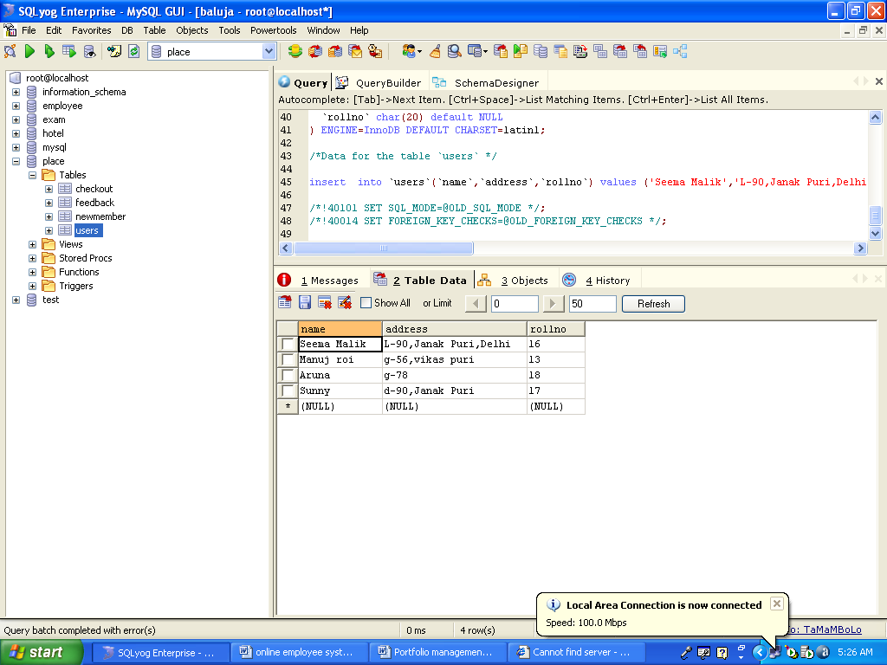
To start, you must have a computer that runs an appropriate operating system like Microsoft Windows >= XP Home Edition: that includes Windows XP Home Edition, Windows XP Professional, Windows 2000 Professional, or any version of Windows Server 2003. In this case, you must install MY SQL Yog.
What is SQL Used for:

Using SQL one can create and maintain data manipulation objects such as table, views, sequence etc. These data manipulation objects will be created and stored on the server's hard disk drive, in a table space, to which the user has been assigned.
Once these data manipulation objects are created, they are used extensively in commercial applications.

DML, DCL, DDL:

In addition to the creation of data manipulation objects, the actual manipulation of data within these objects is done using SQL.

The SQL sentences that are used to create these objects are called DDL's or Data Definition Language. The SQL sentences used to manipulate data within these objects are called DML's or Data Manipulation Language. The SQL sentences, which are used to control the behavior of these objects, are called DCL's or Data Control Language.

CHAPTER – 2

AIMS & OBJECTIVES OF THE STUDY

Objective:

Clinical are the essential part of our lives, providing best medical facilities to people suffering from various ailments, which may be due to change in climatic conditions, increased work-load, emotional trauma stress etc. It is necessary for the Clinicals to keep track of its day-to-day activities & records of its patients, doctors, nurses, ward boys and other staff personals that keep the Clinical running smoothly & successfully.

But keeping track of all the activities and their records on paper is very cumbersome and error prone. It also is very inefficient and a time-consuming process Observing the continuous increase in population and number of people visiting the Clinical. Recording and maintaining all these records is highly unreliable, inefficient and error-prone. It is also not economically & technically feasible to maintain these records on paper.

Thus keeping the working of the manual system as the basis of our project. We have developed an automated version of the manual system, named as “ADMINISTRATION SUPPORT SYSTEM FOR MEDICAL INSTITUTIONS”.

The main aim of our project is to provide a paper-less Clinical up to 90%. It also aims at providing low-cost reliable automation of the existing systems. The system also provides excellent security of data at every level of user-system interaction and also provides robust & reliable storage and backup facilities.

AIM:

The aim of the study to fully related with Clinical Management system.

- The Software is for the automation of Clinical Management System.
- It maintains two levels of users:-
_ Administrator Level
_ User Level
- The Software includes:-
_ Maintaining Patient details.
_ Providing Prescription, Precautions and Diet advice.
_ Providing and maintaining all kinds of tests for a patient.
_ Billing and Report generation.

CHAPTER – 3

LITERATURE REVIEW

Clinical Management System provides the benefits of streamlined operations, enhanced administration & control, superior patient care, strict cost control and improved profitability.
HMS is powerful, flexible, and easy to use and is designed and developed to deliver real conceivable benefits to Clinicals and CLINICALs. More importantly it is backed by reliable and dependable support.
This HMS is designed for multispecialty Clinicals, to cover a wide range of Clinical administration and management processes. It is an integrated end-to-end Clinical Management System that provides relevant information across the Clinical to support effective decision making for patient care, Clinical administration and critical financial accounting, in a seamless flow.

A Clinical is a place where Patients come up for general diseases. Clinicals provide
facilities like:-

- Consultation by Doctors on Diseases.
- Diagnosis for diseases.
- Providing treatment facility.
- Facility for admitting Patients (providing beds, nursing, medicines etc.)
- Immunization for Patients/Children
Various operational works that are done in a Clinical are:-
- Recording information about the Patients that come.
- Generating bills.
- Recording information related to diagnosis given to Patients.
- Keeping record of the Immunization provided to children/patients.
- Keeping information about various diseases and medicines available to cure them.

These are the various jobs that need to be done in a Clinical by the operational staff and
Doctors. All these works are done on papers. The work is done as follows:-

- Information about Patients is done by just writing the Patients name, age and gender. Whenever the Patient comes up his information is stored freshly.
- Bills are generated by recording price for each facility provided to Patient on a separate sheet and at last they all are summed up.
- Diagnosis information to patients is generally recorded on the document, which contains Patient information. It is destroyed after some time period to decrease the paper load in the office.
- Immunization records of children are maintained in pre-formatted sheets, which are kept in a file.
- Information about various diseases is not kept as any document. Doctors themselves do this job by remembering various medicines.

All this work is done manually by the receptionist and other operational staff and lot of
papers are needed to be handled and taken care of. Doctors have to remember various
medicines available for diagnosis and sometimes miss better alternatives as they can’t
remember them at that time.

The limited time and resources have restricted us to incorporate, in this project, only main activities that are performed in a CLINICAL Management System, but utmost care has been taken to make the system efficient and user friendly. “CLINICAL Management System” has been designed to computerize the following functions that are performed by the system:

- On Line Appointments for the Patients
- Admission of New Patient

- Free Medical Advice For the Patients

- Discharge Detail Functions
- Discharge of Patient
- Doctor Assigning related to Patient’s Disease

- Training Courses Provided by the Clinical

- Statement of Patient Details
1) Admitted Patient
2) Discharged Patient
3) Doctor Details
- Total number of Patients admitted in the Clinical

- Doctors available in the Clinical

- Preventive Health Checkups

- Administrator Links
a.Login Form
b.To add new doctors in the site
c.List of patients
d.List of Doctors

CHAPTER – 4

RESEARCH METHODOLOGY

The project ‘Clinical Management System’ is based on the database, object oriented and networking techniques. As there are many areas where we keep the records in database for which we are using MY SQL software which is one of the best and the easiest software to keep our information. This project uses JAVA as the front-end software which is an Object Oriented Programming and has connectivity with MY SQL. It is a web based application in which number of clients can also access with a server.

HARDWARE

Processor : Pentium 2.4 GHz or above

Memory : 256 MB RAM or above

Cache Memory : 128 KB or above

Hard Disk : 3 GB or above [at least 3 MB free space required]

Pen Drive : 5 GB

Printer : Laser Printer

SOFTWARE

Operating System : Windows XP (Professional).

Font-End Tool : JSP, Servlets, Java Script

Back-End : My Sql

FRONT END

We have implemented JavaScript for all the Client side validations. Client side JavaScript is designed to reside inside HTML document & ensure they run properly. It is object based, event driven, platform independent. These are important parts of any Web application to implement Client side Validations and the invalid data is not submitted. The form is not submitted until user fills in correct data. It is extremely useful to restrict mistakes by user.

BACK END

We have used My Sql. My Sql provides efficient/effective solution for major database tech.
- Large database and space management.
- Many concurrent database users.
- High transaction processing requirement
- High Availability
- Industry accepted standards
- Manageable security
- Portability

CHAPTER – 5

SYSTEM ANALYSIS

PRINCIPLES OF SYSTEM ANALYSIS:

PRINCIPLES:
- Understand the problem before you begin to create the analysis model.
- Develop prototypes that enable a user to understand how human machine interaction will occur.
- Record the origin of and the reason for every requirement.
- Use multiple views of requirements like building data, function and behavioral models.
- Work to eliminate ambiguity
System Analysis is a separation of a substance into parts for study and their implementation and detailed examination.

Before designing any system it is important that the nature of the business and the way it currently operates are clearly understood. The detailed examination provides the specific data required during designing in order to ensure that all the client's requirements are fulfilled. The investigation or the study conducted during the analysis phase is largely based on the feasibility study. Rather it would not be wrong to say that the analysis and feasibility phases overlap. High-level analysis begins during the feasibility study. Though analysis is represented as one phase of the system development life cycle (SDLC), this is not true. Analysis begins with system initialization and continues until its maintenance. Even after successful implementation of the system, analysis may play its role for periodic maintenance and up gradation of the system. One of the main causes of project failures is inadequate understanding, and one of the main causes of inadequate understanding of the requirements is the poor planning of system analysis.

Analysis requires us to recall the objectives of the project and consider following three questions:

• What type of information is required?

• What are the constraints on the investigation?
• What are the potential problems that may make the task more difficult?

Keeping the above questions in mind and considering the survey conducted to determine the need of the system; the total system was designed and can be described as under:

The three major parts of the system are:
- Providing Information:

The system is effectively used to provide large variety of information to the interested customer. The major purpose of the site is to easily provide access to records of various Job seekers & users of matrimonial such as resume & profile of boys and girls those who want to search a life partner with quick update to latest modifications in the records. This thing is not at all possible in printed material, which are updated only once a few weeks. It also gives information about the general usage of the system for first time visitors. The system itself works as a information provider for company & life partner seekers.

Preliminary Investigation

System development, a process consisting of two major steps of system analysis and design, start when management or sometimes system development personnel feel that a new system or an improvement in the existing system is required. The system development life cycle is classically thought of as the set of activities that analysts, designers and users carry out to develop and implement an information system. The system development life cycle consists of the following activities:
- Preliminary investigation
- Determination of system requirements
- Design of system
- Development of software
- System testing
- Implementation, evaluation, and maintenance

A request to take assistance from information system can be made for many reasons, but in each case someone in the organisation initiates the request is made, the first system activity the preliminary investigation begins. This activity has three parts:

- Request clarification
- Feasibility study
- Request approval

Request clarification: Many requests from employees and users in the organisations are not clearly defined, Therefore it becomes necessary that project request must be eximined and clarified properly before considering systems investigation.

FEASIBILITY STUDY:

The feasibility study proposes one or more conceptual solution to the problem set of the project. In fact, it is an evaluation of whether it is worthwhile to proceed with project or not.

- Evaluation of feasibility of such solutions. Such evaluation often indicates shortcomings in the initial goals. This step is repeated as the goals are adjusted and the alternative solutions are evaluated.

Feasibility analysis usually considers a number of project alternatives, one that is chosen as the most satisfactory solution. These alternatives also need to be evaluated in a broad way without committing too many resources. Various steps involved in feasibility analysis are:

- To propose a set of solution that can realize the project goal. These solutions are usually descriptions of what the new system should look like.

Four primary areas of interest in feasibility study are:

Economic Feasibility: An evaluation of development cost weighed against the ultimate income of benefit derived from the development system of product. In economic feasibility, cost benefit analysis is done in which expected cost and benefits are evaluated.

COST AND BENEFIT ANALYSIS:

Developing an IT application is an investment. Since after developing that application it provides the organization with profits. Profits can be monetary or in the form of an improved working environment. However, it carries risks, because in some cases an estimate can be wrong. And the project might not actually turn out to be beneficial.

Cost benefit analysis helps to give management a picture of the cost, benefits and risks. It usually involves comparing alternate investments.

Cost benefit determines the benefits and savings that are expected from the system and compares them with the expected costs.

In performing cost and benefit analysis it is important to identify cost and benefits factors. Cost and benefits can be categorized into the following categories:

- Development Costs – Development costs is the costs that are incurred during the development of the system. It is one time investment.
- Operating Costs – Operating Costs are the expenses required for the day to day running of the system. Examples of Operating Costs are Wages, Supplies and Overheads.
- Hardware/Software Costs – It includes the cost of purchasing or leasing of computers and it’s peripherals. Software costs involves required S/W costs.
- Personnel Costs – It is the money spent on the people involved in the development of the system.
- Facility Costs – Expenses that are incurred during the preparation of the physical site where the system will be operational. These can be wiring, flooring, acoustics, lightning, and air-conditioning.
- Supply Costs – These are variable costs that are very proportionately with the amount of use of paper, ribbons, disks, and the like.

- BENEFITS

We can define benefits as

Profit or Benefit = Income – Costs

Benefits can be accrued by:

- Increasing income, or
- Decreasing costs, or
- Both

TECHNICAL FEASIBILITY:

Technical Feasibility includes existing and new H/W and S/W requirements that are required to operate the project using JSP. The basic S/W requirement is J2EE in which the front end of the online Clinical management project has been done. The basic entry forms are developed in JSP and the data is stored in the MY SQL.

OPERATIONAL FEASIBILITY:

Operational feasibility is mainly concerned with issues like whether the system will be used if it is developed and implemented. Whether there will be resistance from users that will affect the possible application benefits? The essential questions that help in testing the technical feasibility of a system are following:

- Does management support the project?
- Are the users not happy with current business practices? Will it reduce the time considerably? If yes, then they will welcome the change and the new system.
- Have the users involved in the planning and development of the project? Early involvement reduced the probability of resistance towards the new system.
- Will the proposed system really benefit the organization? Does the overall response increase? Will accessibility of information be lost? Will the system affect the customers in considerable way?

Legal Feasibility:

A determination of any infringement, violation, or liability that could result from development of the system. Legal feasibility tells that the software used in the project should be original purchased from the legal authorities and they have the license to use it or the software are pirated.

Alternatives:

An evaluation of alternative approaches to the development of system or product.

SYSTEM LIFE CYCLE:

System life cycle is an organizational process of developing and maintaining systems. It helps in establishing a system project plan, because it gives overall list of processes and sub-processes required for developing a system.

System development life cycle means combination of various activities. In other words we can say that various activities put together are referred as system development life cycle. In the System Analysis and Design terminology, the system development life cycle means software development life cycle.

Following are the different phases of software development cycle:
• System study
• Feasibility study
• System analysis
• System design
• Coding
• Testing
• Implementation
• Maintenance

The different phase of software development life cycle is shown below.

PRELIMINARY INVESTIGATIONN
DETERMINATION OF REQUIREMENTS
REVIEW RUNNING SYSTEM AND SYSTEM MAINTENANCE
SYSTEM IMPLEMENTATIONN
SYSTEM TESTING
DEVELOPMENT OF SOFTWARE AND CODING
DESIGN OF SYSTEM
DEVELOPMENT OF PROTOTYPE SYSTEM

SYSTEM
ANALYSIS

50% DESIGN OF
SYSTEM 30%

CODING
20%

OF
SYSTEM
30%

CODING
20%

FIG: SHOWING GENERAL LIFE CYCLE PROCESS AND PERCENTAGE OF TIME DEVOTED

IDENTIFICATION OF NEED:

I have designed the given proposed system in the JSP to automate the process of news sites. Many different people use Usenet, for many different reasons, ranging from discussions of various topics, requests for help or to trade media, which is often seen as the ‘dark side’ to Usenet — the abuse of public news groups to trade copyrighted or offensive material. Thankfully however, those that use Usenet responsibly far out weight the few who use it as a tool for piracy etc.
Many of the people using and contributing to Usenet are people who work with computer technology. These people often use Usenet to seek help with a piece of software or suggest improvements, indeed one of the early functions of Usenet was to help users identify and report bugs found in software.
Unfortunately, the massive growth seen within Usenet has also made it a difficult medium to keep track of, the great variety and number of articles can take considerable time to filter through in order to find those of interest. There have been a variety of software applications created to help deal with this problem and many are freely available for personal use.
The following steps that give the detailed information of the need of proposed system are:

Performance: During past several decades, the records are supposed to be manually handled for all activities. The manual handling of the record is time consuming and highly prone to error. To improve the performance of the Company system, the computerized system is to be undertaken. The computerized project is fully computerized and user friendly even that any of the members can see the report and status of the company.

Efficiency: The basic need of this website is efficiency. The website should be efficient so that whenever a new user submit his/her details the website is updated automatically. This record will be useful for other users instantly.

Control: The complete control of the project is under the hands of authorized person who has the password to access this project and illegal access is not supposed to deal with. All the control is under the administrator and the other members have the rights to just see the records not to change any transaction or entry.

Security: Security is the main criteria for the proposed system. Since illegal access may corrupt the database. So security has to be given in this project.

FACT FINDING TECHNIQUES:

The functioning of the system is to be understood by the system analyst to design the proposed system. Various methods are used for this and these are known as fact-finding techniques. The analyst needs to fully understand the current system.

The analyst needs data about the requirements and demands of the project undertaken and the techniques employed to gather this data are known as fact-finding techniques. Various kinds of techniques and the most popular among them are interviews, questionnaires, record views, case tools and also the personal observations made by the analyst himself.

- Interviews

Interview is a very important data gathering technique as in this the analyst directly contacts system and the potential user of the proposed system.

One very essential aspect of conducting the interview is that the interviewer should first establish a rapport with the interviewee. It should also be taken into account that the interviewee may or may not be a technician and the analyst should prefer to use day to day language instead of jargon and technical terms.

The advantage of the interview is that the analyst has a free hand and the he can extract almost all the information from the concerned people but then as it is a very time consuming method, he should also employ other means such as questionnaires, record reviews, etc. This may also help the analyst to verify and validate the information gained. Interviewing should be approached, as logically and from a general point of view the following guides can be very beneficial for a successful interview:

- Set the stage for the interview.
- Establish rapport; put the interview at ease.
- Phrase questions clearly and succinctly.
- Be a good listener; a void arguments.
- Evaluate the outcome of the interview.

The interviews are of the two types namely structured and unstructured.

I . Structured Interview

Structured interviews are those where the interviewee is asked a standard set of questions in a particular order. All interviews are asked the same set of questions. The questions are further divided into two kinds of formats for conducting this type if interview.

II. Unstructured Interview

The unstructured interviews are undertaken in a question-and-answer format. This is of a much more flexible nature than the structured and can be very rightly used to gather general information about the system.
- Questionnaires:

Questionnaires are another way of information gathering where the potential users of the system are given questionnaires to be filled up and returned to the analyst.

Questionnaires are useful when the analyst need to gather information from a large number of people. It is not possible to interview each individual. Also if the time is very short, in that case also questionnaires are useful. If the analyst guarantees the anonymity of the respondent then the respondent answers the questionnaires very honestly and critically.

The analyst should sensibly design and frame questionnaires with clarity of it’s objective so as to do just to the cost incurred on their development and distribution.

- Record Reviews

Records and reports are the collection of information and data accumulated over the time by the users about the system and it’s operations. This can also put light on the requirements of the system and the modifications it has undergone. Records and reports may have a limitation if they are not up-to-date or if some essential links are missing. All the changes, which the system suffers, may not be recorded. The analyst may scrutinize the records either at the beginning of his study which may give him a fair introduction about the system and will make him familiar with it or in the end which will provide the analyst with a comparison between what exactly is/was desired from the system and it’s current working.

- On-Site Observation

On-site observations are one of the most effectively tools with the analyst where the analyst personally goes to the site and discovers the functioning of the system. As a observer, the analyst can gain first hand knowledge of the activities, operations, processes of the system on-site, hence here the role of an analyst is of an information seeker. This information is very meaningful as it is unbiased and has been directly taken by the analyst. This exposure also sheds some light on the actual happenings of the system as compared to what has already been documented, thus the analyst gets closer to system. This technique is also time-consuming and the analyst should not jump to conclusions or draw inferences from small samples of observation rather the analyst should be more patient in gathering the information. This method is however less effective for learning about people’s perceptions, feelings and motivations.

ANALYST’S INTERVIEW WITH CLINICAL ADMINISTRATOR:

Analyst: Hi, I have come to talk to you regarding the functioning of your Clinical project.
Administrator: hello, do come in. I was expecting you.

Analyst: I’ll come straight to the point. Don’t hesitate, you can be as much open you want. There are no restrictions.
Administrator: I’ll give you my whole contribution.

Analyst: Tell me are you excited about the idea of having an automated system for your Clinical?
Administrator: Yes, I do. Very much. After all it’s gonna reduce our loads of work.

Analyst: Will you elaborate on it?
Administrator: Major problem is managing the rooms and admission and discharge of patients. There are so many of rooms and the numbers of patients are admitted in the room. At the time of discharging of a patient, it becomes more difficult to handle the rooms condition, and re-admitting the patients in that room.

Analyst: What do you think be ideal solution to this?
Administrator: All the information of rooms, patients and discharged patients should be put into computer. It’ll be easy for us to check how many rooms are not available and which patient has to be allotted what room.

Analyst: Could you explain how?
Administrator: Look whenever a new patient is admitted he/she is allotted a bed number and the bed is reserved for the patient till the patient gets discharged. And when the patient is discharged, the bed allotted to him/her is freed and now the bed should again automatically ready for new patient to be admitted.

Analyst: Do you have different patient categories?
Administrator: No, we don’t have any categorization for patients. All are treated at par.

Analyst: How do you categorize your patients?
Administrator: By Bed number.

Analyst: Do you have any other expectations or suggestion for the new system?
Administrator: It should be able to produce reports faster.

Analyst: Reports? I completely forgot about them. What reports you people produce presently?
Administrator: Well first is for room status, another for patient’s list being admitted and discharged patients and reports for doctors.

Analyst: Do you have some format for them?
Administrator: Yes we do have and we want that the same format be used by the new system.

Analyst: Yes we’ll take care of that. Any other suggestions?
Administrator: No. You have already covered all the fields.

Analyst: Thanks for your co-operation. It was nice talking to you.
Administrator: My pleasure. Bye.

QUESTIONNAIRES FOR CLINICAL STAFF:

Instructions: Answer as specified by the format. Put NA for non-application situation.

- What are your expectations out of the new system (computerized)? Rate the following on a scale of 1-4 giving allow value for low priority.
- better cataloguing
- better managing of users
- better account and patients management
- computer awareness
- any other________________

- How many users are you expecting?
____________________________

- How many rooms are there in the Clinical?
____________________________

- How you want the patients to be categorized for searching (like by room number, bed number)?
____________________________

- Is there any difference in the roles (privileges) of two or more patients?
Yes/No Please specify if Yes
________________________________________________________________________________________________

- Do you want facility of reserving a bed from phone in advance?
Yes/No

- Do you have data of patients entered into some kind of database?
Yes/No

- How do you want users to be categorized?
_______________________or
_______________________

- Would you like online registration for users rather than the printed form?
Yes/No

- Do you already have some existing categorization of patients on the basis as specified in question 4 above?
Yes/No

- Any other specific suggestion/expectation out of the proposed system.
____________________________________________________________________________________________________

SOFTWARE REQUIREMENT SPECIFICATION (SRS):

    - What are the benefits of a SRS?

The IEEE 830 standard defines the benefits of a good SRS:
- Establish the basis for agreement between the customers and the suppliers on what the software product is to do. The complete description of the functions to be performed by the software specified in the SRS will assist the potential users to determine if the software specified meets their needs or how the software must be modified to meet their needs. [NOTE: We use it as the basis of our contract with our clients all the time].
- Reduce the development effort. The preparation of the SRS forces the various concerned groups in the customer’s organization to consider rigorously all of the requirements before design begins and reduces later redesign, recoding, and retesting. Careful review of the requirements in the SRS can reveal omissions, misunderstandings, and inconsistencies early in the development cycle when these problems are easier to correct.
- Provide a basis for estimating costs and schedules. The description of the product to be developed as given in the SRS is a realistic basis for estimating project costs and can be used to obtain approval for bids or price estimates. [NOTE: Again, we use the SRS as the basis for our fixed price estimates]
- Provide a baseline for validation and verification. Organizations can develop their validation and Verification plans much more productively from a good SRS. As a part of the development contract, the SRS provides a baseline against which compliance can be measured. [NOTE: We use the SRS to create the Test Plan].
- Facilitate transfer. The SRS makes it easier to transfer the software product to new users or new machines. Customers thus find it easier to transfer the software to other parts of their organization, and suppliers find it easier to transfer it to new customers.
- Serve as a basis for enhancement. Because the SRS discusses the product but not the project that developed it, the SRS serves as a basis for later enhancement of the finished product. The SRS may need to be altered, but it does provide a foundation for continued production evaluation.

    - What should the SRS address?

Again from the IEEE standard:
The basic issues that the SRS writer(s) shall address are the following:
- Functionality.
What is the software supposed to do?
  - Our System aims at automating the manual system being used in the Clinical for maintaining the records of the patients & employees of the Clinical.
- External interfaces.
How does the software interact with people, the system’s hardware, other hardware, and other software?
  - Our system uses various forms and reports through which users can interact with the system.
  - As we can have a centralized database so our system interact it with database software through network and as network comes in, it uses network peripheral likes switches etc.

  - Software Engineering Paradigm :

Software engineering paradigm can be defined as a development strategy that encompasses the process, methods, tools layers and generic phases such as definition phase, development phase and support phase to solve real lives problems in an industry, research institute etc used by software engineers or team of engineers.
The most useful software engineering paradigm that I incorporate in developing my project is the “Spiral Model”. This process model is suitable and useful for my project because the following reasons:
- The all requirements of the project are not well understood by me at the beginning.
- Relatively small but too complex project.
- This project is a complete new research. No one has already implemented the logics and all necessary factors governing the project.
- The target of this process model is that a complete system will be developed after the number of refinement.

This approach to software development begins at the system level and progresses towards through analysis, design, coding, testing and support. The details discussion of these steps is beyond the consideration of the project but all these steps have been applied through out the SDLC of my project.

  - Process Logic

- User verification Process :-
The module receives input from the user who logs on the system. The module checks for the validity of the user from within the system itself. The module generate the output, displaying the validity or non-validity of the user . the module then grants access rights to the user depending on the level of the user. The log file is updated after the user logs-on successfully.

- OPD Registration Process :-
The module is operated on by the operational level user. The module receives input from the patients, which includes their details. System will record these details & generate a OPD No. and list of Doctors available in OPD on that day. The output generated is the OPD Card No and patient is directed to the required Doctor with that card. The revenue generated from OPD is recorded & updated in the Master Revenue Database after every 24 hours.

- Admission Registration Process :-

This module receives input from two areas:-

  - From the patient himself who has to get admitted to the Clinical. This process record patient details and issues a Admission No. .This no. is used as reference in other modules. The module generates a admission slip as the output indicating the ward & Bed allotted to the patient.

  - The record input is received from the OPD Registration module, if the OPD Doctor recommends patient for immediate admission to the Clinical. The Card No. taken as reference so that patient details do not required entering again. The card no is now replaced by the admission no. and output generated is same as in the case (i).

- Duty Allocation Process :-
This module is operated by the super user in collaboration with top management who together build-up the schedule for all employees of the Clinical. The process receives input from the employee Master database and the process prepares schedule for a period. The output of the process is the schedule report for the period in the consideration.

- Financial Activity Process :-
This process receives two types of inputs:-
  - First input, which is received, is for the Patient. It receives input from the admission-registration module, and test & treatment-undertaken module, as well as the patient master database. It records & process all the financial transactions taken place between the Clinical and the patient and generates the final bill as the output.
  - Second input, which is received, is for the employees of the Clinical. It receives input from the duty allocation process and the employee database for the preparation of a salary-slip. The module records & processes various calculations and generates the salary-slip as the output.
- Test and Treatment Undertaken Process :-
This module receives input in the form of prescription written by the doctor for the types of tests and treatment to be undertaken by the patient. It records and process, the various details about the test and generates the lab-report as the output of the module. It also generates the receipt for the tests undertaken. These receipts serve as one of the input to the financial-activity module.

- Medical supply Process: -
This module is fairly independent of the other modules. It maintains the inventory of the various medicines. It takes input in the form of prescription and generates output in the form of bill containing the number of medicines purchased and their respective rates, along with the total amount to be paid by the patient. The module also maintains a database of the medicines and provides a check for their availability and non-availability. In case of low inventory of any medicine, a message is sent to the Clinical, which replenishes the inventory-level of that medicine.

- Maintenance Process: -
This module is the most important module. It receives input from every other module of the system, and its functionality is to maintain the working and processing of other modules as well as the maintenance of the various databases. Thus, it aims at the overall maintenance of the whole system.

ACD (Architectural Context Diagram

Registration & Discharge
Registration form
User Login and Security system
User Login and
Password
Access to system granted
Access Denied
Admission system
Test & Treatment system
Medicine Shop system
Financial activity system
Prescription
Discharge Slip
OPD Card
Opd system
Registration form
Admission Granted
Admission Rejected
Report +Result
Receipt of Payment
Receipt of Payment
Verification & Validation

PERT CHART

D (12) E (8)
2
5
7
1
4
12
9
8
6
3
10
11

D (0)
A (8)

B (12) F (8) J (10) K (8) L (5)

C (5)
I (12)

G (12) H (5)

Critical Path
Activity
Dummy Activity
Node

A=Order computing Platform
B=Prepare site
C=Review Specification
D=Install equipment

E= Test hardware
F=Training
G=Write Programs
H=Test programs
I=Test software
J=Convent Systems
K=Implement follow-up
L= Accept

E-R- DIAGRAM

Clinical

Patients

Patient information
Admit

Room

Doctor record

Clinical

Doctor

Discharge

Patient

Room

On Line Appointment

Clinical

SYSTEM DEVELOPMENT LIFE CYCLE

User Revised Requirement
Requirement Specification
Initial Requirement Investigation
System Implementation
System Design
System Evaluation
Hardware Study
Requirement Determination
Feasibility Analysis

Decision to
Design Information
System

Feasibility
Test Plan Study
.

Logical System Design Functional Spec.
System Specification Analysis

Physical
Requirement
System Configuration
Data
Schedule Budget

System Modification Improved System
Maintenance

CLINICALMANAGEMENT SYSTEM
DATA FLOW DIAGRAM

Context Level DFD

Medical Advice

Carrier & Job Clinical

PG Programmer

Patient Status

Patient Appointment

Bill Payment

CLINICAL MANAGEMENT SYSTEM

DFD for Medical Advice

Patient
1. Read the Data from patient
2. Search for disease from Knowledge
3. Copy Selected Record

Output Unit

Data base

DFD for patient Appointment

USER
1. Read patient request
2. Search from Doctor Data base
3. Give the Time and Number

Output UNIT

Database

DFD for Patient Search

Patient
1. Read the Data from patient
2. Search the patient in patient-ID
3. Copy Selected Record

Output Unit

Database

DFD for PG Course

Doctor
1. Accept Data for specializing
2. Search for Seat Availability
3. Display the Admission status for PG Course

Output Unit

Database

DFD For Bill Payment

Accountant
1. Read the Patient Data & Treatment
2. Generate the bill

Print Bill
Output Device
Patient
DATABASE

DFD For Job Opportunity In Clinical
User/
Doctor
Search the web Site
Apply Only
Get Online Id

Database

DFD For Online Searching For Patient

User
Read
Patient
Name
Patient Data
CRT
Data base

DFD For Searching a Doctors

User
Read the
Data of Doctor & Specialisation
Doctor’s
With Specialties
CRT
Data Base

DFD Online Medical Advice

User
Read Patient Data and Disease
Display the Remedies & Treatments
Output

Data Base

DFD For Login Of User

User
Read User Id & Password
Authenticate User & Login
Output

Data Base

Bed Details

1 Admitted

PATIENT
1.1 Display Form
1.2 Get Details
1.4 Update

FILE

Process

Update Table

Patient Document
1.3 assign bed

DATA FLOW DIAGRAM
ADMISSION OF A NEW PATIENT

PATIENT
1.1 Display Form
1.2 Get Details
1.4 Update
1 Admitted

FILE

Process

Update Table

Patient Details
1.3 Assigning a Doctor

DATA FLOW DIAGRAM
RECORD MODIFICATION

1
Read the patient
2 Show the Details of Record
3 Modify Details of Record

USER

Scan Record

FILE

Processing
Update

DATA FLOW DIAGRAM
DISCHARGE OF PATIENT

PATIENT
1.1 Display Form
1.4 Update
1 Scan the patient name

FILE

Process
Update Table

Patient Details
1.2 Get Details

DATA FLOW DIAGRAM
LISTING OF PATIENTS

FILE

1 Read the Bed number
2 Select Record from Database
3 Copy Selected Record
4 Compute Total
6 Copy Selected Record
5 Select Records
8 Generate Total List
7 Compute Bill
PATIENT

Processing

Scan Record
Processing
Output

Final Output

To Screen/Printer
OUTPUT UNIT

DATA FLOW DIAGRAM
LIST OF ALL RECORDS

FILE

MANAGEMENT

Processing
Final Output
Processing
3 Copy Selected Record

Scan All Record

Output
1 Read the Request
2 Select Record from File
5 Select Record
7 Copy Selected Record
4 Compute Total
7 Compute bill
8 Generate Total List

To Screen/Printer

OUTPUT UNIT

CHAPTER – 6

SYSTEM DESIGN

System Design:

The design document that we will develop during this phase is the blueprint of the software. It describes how the solution to the customer problem is to be built. Since solution to complex problems isn’t usually found in the first try, iterations are most likely required. This is true for software design as well. For this reason, any design strategy, design method, or design language must be flexible and must easily accommodate changes due to iterations in the design. Any technique or design needs to support and guide the partitioning process in such a way that the resulting sub-problems are as independent as possible from each other and can be combined easily for the solution to the overall problem. Sub-problem independence and easy combination of their solutions reduces the complexity of the problem. This is the objective of the partitioning process. Partitioning or decomposition during design involves three types of decisions: -
Define the boundaries along which to break;
Determine into how money pieces to break; and

Identify the proper level of detail when design should stop and implementation should start. Basic design principles that enable the software engineer to navigate the design process suggest a set of principles for software design, which have been adapted and extended in the following list:

Free from the suffer from "tunnel vision." A good designer should consider alternative approaches, judging each based on the requirements of the problem, the resources available to do the job.

The design should be traceable to the analysis model. Because a single element of the design model often traces to multiple requirements, it is necessary to have a means for tracking how requirements have been satisfied by the design model.
The design should not repeat the same thing. Systems are constructed using a set of design patterns, many of which have likely been encountered before. These patterns should always be chosen as an alternative to reinvention. Time is short and resources are limited! Design time should be invested in representing truly new ideas and integrating those patterns that already exist.

The design should "minimize the intellectual distance" between the software and the problem as it exists in the real world. That is, the structure of the software design should (whenever possible) mimic the structure of the problem domain. The design should exhibit uniformity and integration. A design is uniform if it appears that one person developed the entire thing. Rules of style and format should be defined for a design team before design work begins. A design is integrated if care is taken in defining interfaces between design components.

The design activity begins when the requirements document for the software to be developed is available. This may be the SRS for the complete system, as is the case if the waterfall model is being followed or the requirements for the next "iteration" if the iterative enhancement is being followed or the requirements for the prototype if the prototyping is being followed. While the requirements specification activity is entirely in the problem domain, design is the first step in moving from the problem domain toward the solution domain. Design is essentially the bridge between requirements specification and the final solution for satisfying the requirements.

The design of a system is essentially a blueprint or a plan for a solution for the system. We consider a system to be a set of components with clearly defined behavior that interacts with each other in a fixed defined manner to produce some behavior or services for its environment. A component of a system can be considered a system, with its own components. In a software system, a component is a software module. The design process for software systems, often, has two levels. At the first level, the focus is on deciding which modules are needed for the system, the specifications of these modules, and how the modules should be interconnected. This is what is called the system design or top-level design. In the second level, the internal design of the modules, or how the specifications of the module can be satisfied, is decided. This design level is often called detailed design or logic design. Detailed design essentially expands the system design to contain a more detailed description of the processing logic and data structures so that the design is sufficiently complete for coding.

Because the detailed design is an extension of system design, the system design controls the major structural characteristics of the system. The system design has a major impact on the testability and modifiability of a system, and it impacts its efficiency. Much of the design effort for designing software is spent creating the system design.

The input to the design phase is the specifications for the system to be designed. Hence, reasonable entry criteria can be that the specifications are stable and have been approved, hoping that the approval mechanism will ensure that the specifications are complete, consistent, unambiguous, etc. The output of the top-level design phase is the architectural design or the system design for the software system to be built. This can be produced with or without using a design methodology. A reasonable exit criteria for the phase could be that the design has been verified against the input specifications and has been evaluated and approved for quality.

A design can be object-oriented or function-oriented. In function-oriented design, the design consists of module definitions, with each module supporting a functional abstraction. In object-oriented design, the modules in the design represent data abstraction (these abstractions are discussed in more detail later). In the function-oriented methods for design and describe one particular methodology the structured design methodology in some detail. In a function- oriented design approach, a system is viewed as a transformation function, transforming the inputs to the desired outputs. The purpose of the design phase is to specify the components for this transformation function, so that each component is also a transformation function. Hence, the basic output of the system design phase, when a function oriented design approach is being followed, is the definition of all the major data structures in the system, all the major modules of the system, and how the modules interact with each other. Once the designer is satisfied with the design he has produced, the design is to be precisely specified in the form of a document. To specify the design, specification languages are used. Producing the design specification is the ultimate objective of the design phase. The purpose of this design document is quite different from that of the design notation. Whereas a design represented using the design notation is largely to be used by the designer, a design specification has to be so precise and complete that it can be used as a basis of further development by other programmers. Generally, design specification uses textual structures, with design notation helping in understanding.

DATA MODELING:

Users table

Field | Type | Constraint
Name | Char (30) | Not Null
Emp Id | Char (30) | Primary Key
Email Id | Char (30) | Not Null
Password | Char (30) | Not Null

Admin

Field | Type | Constraint
Username | Char (30) | Not Null
Password | Char (30) | Not Null

Pateint table

Field | Type | Constraint
Card_no | Char (30) | Primary key
Name | Char (30) | Not Null
Gender | Char (30) | Not Null
Age | Numeric | Not Null
Address | Char (60) | Not Null
Phone | Numeric | Not null
Relative_name | Char (30) | Not null
Relative_address | Char(60) | Not null
Department | Char (60) | Not Null
Doctor_name | Char (30) | Not null

Doctor Master

Field | Type | Constraint
Dr_code | Char (30) | Not null
Dr_name | Char (30) | Not null
Gemder | Char (30) | Not null
Date_of_birth | Date | Not null
Address | Char (30) | Not null
Date_of_join | Date | Not null
Desgination |  | Not null

Bed_details

Field | Type | Constraint
Bed_no | Char(30) | Not null
Satus | Char(30) | Not null

OPD_master

Field | Type | Constraint
Name | Char (30) | Not Null
Card_no | Char (30) | Primary key
Patient_name | Char (30) | Not null
Gender | Char (30) | Not null
Age | Numeric | Not null
Address | Char(60) | Not null
Phone | Numeric | Not null
Rel_name | Char (30) | Not Null
Date | Date | Not null
Dr_unit | Char (30) | Not null
Days | Char(60) | Not null
Dep_name | Char (30) | Not null

Test_details

Field | Type | Constraint
Receipt_no | Char(30) | Primary key
Patient_id | Char (30) | Not null
Name | Char (30) | Not null
Date | Date | Not null
Report | Char (60) | Not null

Test_master

Field | Type | Constraint
Test_code | Char(30) | Not null
Test_test | Char(30) | Not null
Rate_per_test | Char (30) | Not null

Feedback
Field | Type | Constraint
Name | Char (30) | Not Null
Email Id | Char (30) | Not Null
Phone | Char (30) | Not Null
State | Char (30) | Not null
Comment | Char (60) | Not null

SCHEDULING:

Scheduling of a software project does not differ greatly from scheduling of any multi- task engineering effort. Therefore, generalized project scheduling tools and techniques can be applied with little modification to software projects.

Program evaluation and review technique (PERT) and critical path method (CPM) are two project scheduling methods that can be applied to software development. Both techniques are driven by information already developed in earlier project planning activities.

Estimates of Effort

- A decomposition of the product function.
- The selection of the appropriate process model and task set.
- Decomposition of tasks.
Interdependencies among tasks may be defined using a task network. Tasks, sometimes called the project Work Breakdown Structure (WBS) are defined for the product as a whole or for individual functions.

Both PERT and CPM provide quantitative tools that allow the software planner to (1) determine the critical path-the chain of tasks that determines the duration of the project; (2) establish "most likely" time estimates for individual tasks by applying statistical models; and (3) calculate "boundary times" that define a time window" for a particular task.
Boundary time calculations can be very useful in software project scheduling. Slippage in the design of one function, for example, can retard further development of other functions. It describes important boundary times that may be discerned from a PERT or CPM network: (I) the earliest time that a task can begin when preceding tasks are completed in the shortest possible time, (2) the latest time for task initiation before the minimum project completion time is delayed, (3) the earliest finish-the sum of the earliest start and the task duration, (4) the latest finish- the latest start time added to task duration, and (5) the total float-the amount of surplus time or leeway allowed in scheduling tasks so that the network critical path maintained on schedule. Boundary time calculations lead to a determination of critical path and provide the manager with a quantitative method for evaluating progress as tasks are completed.

Both PERT and CPM have been implemented in a wide variety of automated tools that are available for the personal computer. Such tools are easy to use and take the scheduling methods described previously available to every software project manager.

SOURCE CODE

Index.jsp

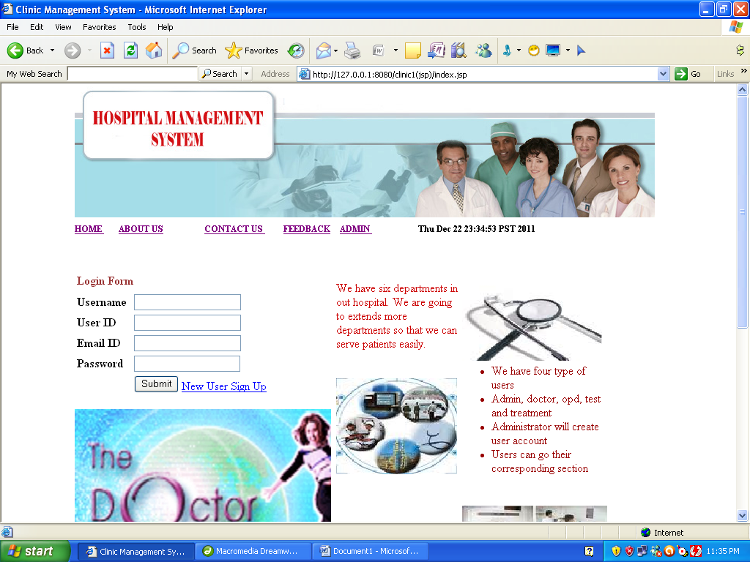
<%@ page language="java" %>
<%@ page session="true" %>
<html>
<head>
<title>CLINICAL Management System</title>
<style type="text/css">
<!--
.style7 {
font-family: Arial, Helvetica, sans-serif;
font-size: 16px;
font-weight: bold;
color: #0000FF;
}
.style8 {
font-size: 18px;
color: #CC3300;
}
.style10 {font-size: 16px}
.style13 {
color: #993333;
font-weight: bold;
font-size: 16px;
}
body {
margin-left: 0px;
margin-top: 0px;
}
.style14 {font-size: 12px}
.style20 {color: #CC0000}
.style21 {color: #990000}
.style22 {
color: #330066;
font-weight: bold;
}
-->
</style>
<meta http-equiv="Content-Type" content="text/html; charset=iso-8859-1"></head>
<body>
<table width="778" border="0" align="center" cellspacing="0">
<tr>
<td><%@ include file="header.jsp" %></td>
</tr>

<tr>
<td width="696" align="left" valign="top" bgcolor="#FFFFFF"><form name="form1" method="post" action="naw.jsp">
<table width="740" border="0">
<tr>
<td width="325" align="left" valign="top"><table width="325" border="0">
<tr>
<td height="29" colspan="3"><span class="style13"> Login Form</span></td>
</tr>
<tr>
<td width="72"><strong>Username</strong></td>
<td width="188"><input type="text" name="textfield"></td>
<td width="43" rowspan="3">&nbsp;</td>
</tr>
<tr>
<td><strong>User ID</strong></td>
<td><input type="text" name="textfield2"></td>
</tr>
<tr>
<td><strong>Email ID</strong></td>
<td><input type="text" name="textfield3"></td>
</tr>
<tr>
<td><strong>Password</strong></td>
<td><input type="password" name="textfield4"></td>
<td>&nbsp;</td>
</tr>
<tr>
<td>&nbsp;</td>
<td><input type="submit" name="Submit" value="Submit">
<a href="new user details.jsp">New User Sign Up</a></td>
<td>&nbsp;</td>
</tr>
</table>
<p><img src="images/mind-technologies__thedoctorxonline-homeopathic-CLINICAL-management-software.jpg" width="350" height="260"></p></td>
<td width="386" colspan="2" align="left" valign="top">
<span class="style14">
<label> </label>
</span> <label></label>
<table width="386" height="278" border="0">
<tr>
<td width="169"><span class="style20">We have six departments in out Clinical. We are going to extends more departments so that we can serve patients easily.</span></td>
<td width="197"><img src="images/h2.jpg" width="191" height="123"></td>
<td width="6">&nbsp;</td>
</tr>
<tr>
<td><img src="images/h1.jpg" width="165" height="131"></td>
<td><ul type="bullet type">
<li class="style21">We have four type of users
<li class="style21">Admin, doctor, opd, test and treatment
<li class="style21">Administrator will create user account
<li class="style21"> Users can go their corresponding section
</ul>
</td>
<td>&nbsp;</td>
</tr>
<tr>
<td><marquee direction="up"><ul type="byllet type">
<li class="style22">We are providing good service
<li class="style22">We are using lattest technology
<li class="style22">We have well experienced doctors
<li class="style22">Our services available 24*7
</ul></marquee>
</td>
<td><img src="images/CLINICAL.jpg" width="198" height="162"></td>
<td>&nbsp;</td>
</tr>
</table></td>
</tr>
</table>
</form>
<p class="style10" __designer:dtid="1688858450198550">&nbsp;</p>
<p align="justify" class="style10" __designer:dtid="1688858450198550">&nbsp;</p>
<p align="justify" class="style10" __designer:dtid="1688858450198550">&nbsp;</p>
<h1 align="justify" class="style8">&nbsp;</h1>
<p>&nbsp;</p>
<h1>&nbsp;</h1> <p class="style7" __designer:dtid="281479271677962">&nbsp;</p> </td>
</tr>
</table>
</body>
</html>
Aboutus.jsp

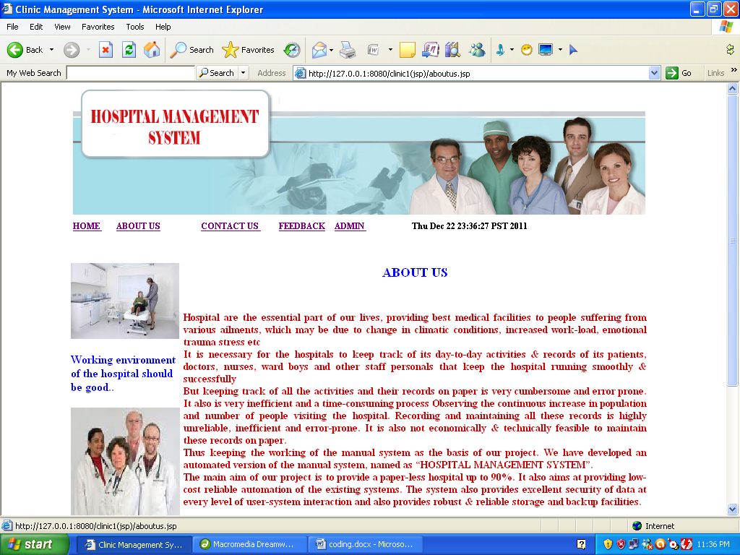
<%@ page language="java" %>
<%@ page session="true" %>
<html>
<head>
<title>CLINICAL Management System</title>
<style type="text/css">
<!--
.style7 {
font-family: Arial, Helvetica, sans-serif;
font-size: 16px;
font-weight: bold;
color: #0000FF;
}
.style8 {
font-size: 18px;
color: #CC3300;
}
.style9 {
color: #0000FF;
font-weight: bold;
font-size: 18px;
}
body {
margin-left: 0px;
margin-top: 0px;
}
.style10 {font-size: 14px}
.style11 {
color: #0000FF;
font-weight: bold;
}
.style12 {font-size: 14px; color: #CC0000; }
-->
</style>
<meta http-equiv="Content-Type" content="text/html; charset=iso-8859-1"></head>
<body>
<table width="731" border="0" align="center" cellspacing="0">
<tr>
<td colspan="2" height="120"><%@ include file="header.jsp" %></td>
</tr>

<tr>
<td width="150" align="left" valign="top"><p><img src="images/doc2.jpg" width="150" height="105"></p>
<p class="style11">Working environment of the Clinical should be good.. <br>
</p>
<p><span class="style10"><img src="images/doc1.jpg" width="151" height="191"></span></p></td>
<td width="750" align="left" valign="top" bgcolor="#FFFFFF"><form name="form1" method="post" action="">
<table width="647" height="166" border="0">
<tr>
<td width="641" height="61"><div align="center" class="style9">
<p>ABOUT US </p>
<p>&nbsp;</p>
</div></td>
</tr>
<tr>
<td align="left"><h2 align="justify" class="style12">Clinical are the essential part of our lives, providing best medical facilities to people suffering from various ailments, which may be due to change in climatic conditions, increased work-load, emotional trauma stress etc<br>
It is necessary for the Clinicals to keep track of its day-to-day activities &amp; records of its patients, doctors, nurses, ward boys and other staff personals that keep the Clinical running smoothly &amp; successfully<br>
But keeping track of all the activities and their records on paper is very cumbersome and error prone. It also is very inefficient and a time-consuming process Observing the continuous increase in population and number of people visiting the Clinical. Recording and maintaining all these records is highly unreliable, inefficient and error-prone. It is also not economically &amp; technically feasible to maintain these records on paper.<br>
Thus keeping the working of the manual system as the basis of our project. We have developed an automated version of the manual system, named as &ldquo;CLINICAL MANAGEMENT SYSTEM&rdquo;.<br>
The main aim of our project is to provide a paper-less Clinical up to 90%. It also aims at providing low-cost reliable automation of the existing systems. The system also provides excellent security of data at every level of user-system interaction and also provides robust &amp; reliable storage and backup facilities.<br>
</h2>
<p><BR __designer:dtid="1125904201809957" />
<BR __designer:dtid="1125904201809958" />
</p></td>
</tr>
<tr>
<td><label></label></td>
</tr>
</table>
</form>
<h1 class="style8">&nbsp;</h1>
<p>&nbsp;</p>
<h1>&nbsp;</h1> <p class="style7" __designer:dtid="281479271677962">&nbsp;</p> </td>
</tr>
</table>
</body>
</html>
Contacus.jsp

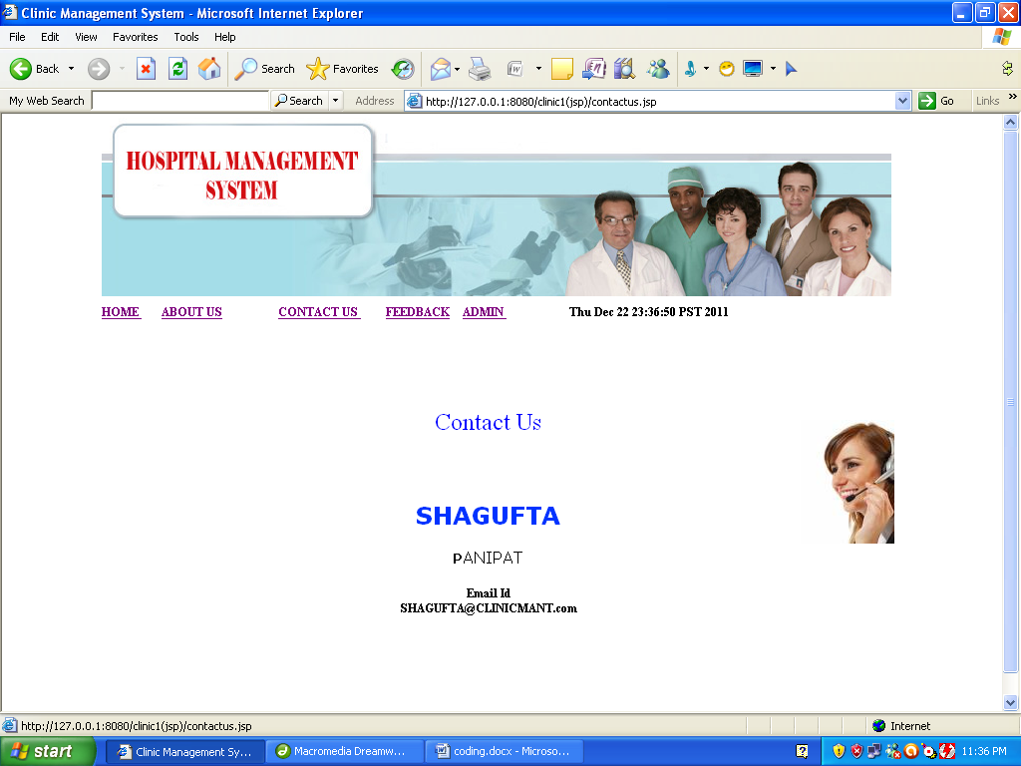
<%@ page language="java" %>
<%@ page session="true" %>
<html>
<head>
<title>CLINICAL Management System</title>
<style type="text/css">
<!--
.style7 {
font-family: Arial, Helvetica, sans-serif;
font-size: 16px;
font-weight: bold;
color: #0000FF;
}
.style8 {
font-size: 18px;
color: #CC3300;
}
.style11 {font-size: 24px; color: #0000FF;}
.style3 {color: #000080}
.style12 {font-size: 14px}
.style14 {
font-size: 14;
font-weight: bold;
}
.style15 {color: #000080; font-size: 14px; }
.style16 {color: #000080; font-size: 16px; }
.style6 {font-size: 16px; color: #0000FF; font-weight: normal; }
.style17 {color: #0033ff}
.style18 {color: #000000}
-->
</style>
</head>
<body>
<table width="773" height="511" border="0" align="center" cellspacing="0">
<tr>
<td colspan="3" height="120"><%@ include file="header.jsp" %></td>
</tr>

<tr>
<td width="150" align="left" valign="top">
</td>
<td width="750" align="left" valign="top" bgcolor="#FFFFFF"><div align="center" class="style11">
<p>&nbsp;</p>
<p>Contact Us </p>
<p>&nbsp;</p>
<p><strong><font face="Verdana"><span class="style17">SHAGUFTA</span></font></strong></p>
<p> <span class="style14"><font face="Verdana"><span class="style18">P</span><span class="style15" style="font-weight: normal;
color: #000000"><span class="style16" style="color: #000000"><span class="style3" style="color: #000000">ANIPAT</span></span></span></font> </span></p>
<p><span class="style6">Email Id<br />
SHAGUFTA@CLINICALMANT.com</span></p>
<p class="style12">&nbsp;</p>
<p class="style12">&nbsp;</p>
</div></td>
<td width="130" align="left" valign="top" bgcolor="#FFFFFF"><form name="form1" method="post" action="">
<label>

<div align="right"> <br>
<br>
<br>
<input type="image" name="imageField" src="images/contactus.jpg">
</div></label>
</form>
<h1 class="style8">&nbsp;</h1>
<p>&nbsp;</p>
<h1>&nbsp;</h1> <p class="style7" __designer:dtid="281479271677962">&nbsp;</p> </td>
</tr>
</table>
</body>
</html>
Feedback.jsp

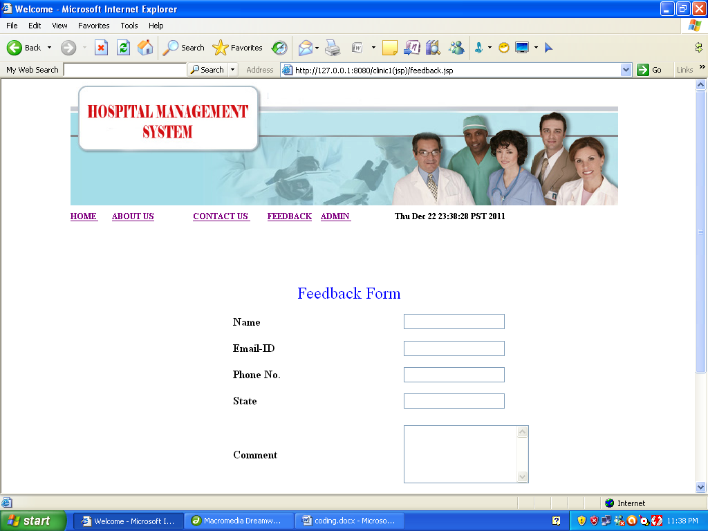
<%@ page language="java" %>
<%@ page session="true" %>
<html>
<head>
<title>Welcome</title>
<style type="text/css">
<!--
.style7 {
font-family: Arial, Helvetica, sans-serif;
font-size: 16px;
font-weight: bold;
color: #0000FF;
}
.style8 {
font-size: 18px;
color: #CC3300;
}
.style10 {
color: #0000FF;
font-size: 24px;
}
body {
margin-left: 0px;
margin-top: 0px;
}
-->
</style>
<meta http-equiv="Content-Type" content="text/html; charset=iso-8859-1"></head>
<body>

<script language="javascript">

function validate(form)
{
if (form.name.value=="")
{ alert("Name should not be blank. Please enter it.");
form.name.focus(); return false;
}

if (form.email.value=="")
{ alert("Email should not be blank. Please enter it.");
form.email.focus(); return false;
}

if (form.phone.value=="")
{ alert("phone should not be blank. Please enter it.");
form.phone.focus(); return false;
}

if (form.state.value=="")
{ alert("state should not be blank. Please enter it.");
form.state.focus(); return false;
}

if (form.com.value=="")
{ alert("Comment should not be blank. Please enter it.");
form.com.focus(); return false;
}

if(isNaN(form.phone.value))
{
alert("Charges. Should be a number ");
form.phone.focus();
return false;
}

}

</script>

<table width="731" border="0" align="center" cellspacing="0">
<tr>
<td colspan="2" height="120"><p>
<%@ include file="header.jsp" %>
</p>
<p>&nbsp;</p></td>
</tr>

<tr>
<td width="150" align="left" valign="top">&nbsp;</td>
<td width="750" align="left" valign="top" bgcolor="#FFFFFF"><form name="form" onSubmit="return validate(this)" method="post" action="feedbackins.jsp">
<table width="674" height="353" border="0">
<tr>
<td width="147">&nbsp;</td>
<td width="243"><div align="center" class="style10">
<div align="right">
<p>Feedback Form </p>
</div>
</div></td>
<td width="270">&nbsp;</td>
</tr>
<tr>
<td>&nbsp;</td>
<td><strong>Name</strong></td>
<td><label>
<input type="text" name="name">
</label></td>
</tr>
<tr>
<td>&nbsp;</td>
<td><strong>Email-ID</strong></td>
<td><input type="text" name="email"></td>
</tr>
<tr>
<td>&nbsp;</td>
<td><strong>Phone No. </strong></td>
<td><input type="text" name="phone"></td>
</tr>
<tr>
<td>&nbsp;</td>
<td><strong>State</strong></td>
<td><input type="text" name="state"></td>
</tr>
<tr>
<td height="115">&nbsp;</td>
<td><strong>Comment</strong></td>
<td><label>
<textarea name="com" rows="5"></textarea>
</label></td>
</tr>
<tr>
<td>&nbsp;</td>
<td><label>
<div align="right">
<input type="submit" name="Submit" value="Submit">
</div>
</label></td>
<td>&nbsp;</td>
</tr>
</table>
</form>
<h1 class="style8">&nbsp;</h1>
<p>&nbsp;</p>
<h1>&nbsp;</h1> <p class="style7" __designer:dtid="281479271677962">&nbsp;</p> </td>
</tr>
</table>
</body>
</html>

Admin.jsp

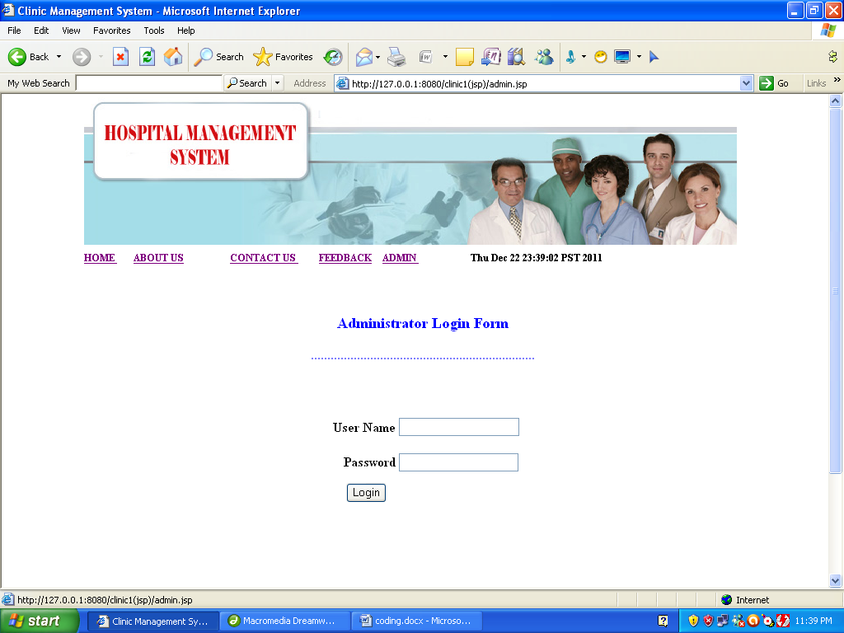
<%@ page language="java" %>
<%@ page session="true" %>
<html>
<head>
<title>CLINICAL Management System</title>
<style type="text/css">
<!--
.style7 {
font-family: Arial, Helvetica, sans-serif;
font-size: 16px;
font-weight: bold;
color: #0000FF;
}
.style8 {
font-size: 18px;
color: #CC3300;
}
.style10 {
font-size: 16px;
font-weight: bold;
}
.style11 {color: #0000FF}
.style12 {color: #0000FF; font-size: 18px; }
-->
</style>
</head>
<body>

<script language="javascript">

function validate(form)
{
if (form.textfield.value=="")
{ alert("Username should not be blank. Please enter it.");
form.textfield.focus(); return false;
}

if (form.textfield2.value=="")
{ alert("Password should not be blank. Please enter it.");
form.textfield2.focus(); return false;
}
}
</script>

<table width="731" border="0" align="center" cellspacing="0">
<tr>
<td colspan="2" height="120"><%@ include file="header.jsp" %></td>
</tr>

<tr>
<td width="150" align="left" valign="top">&nbsp;</td>
<td width="750" align="left" valign="top" bgcolor="#FFFFFF"><form name="form" onSubmit="return validate(this)" method="post" action="naw1.jsp">
<table width="647" height="326" border="0">
<tr>
<td height="129" colspan="3"><div align="center" class="style10">
<p class="style12">Administrator Login Form</p>
<p class="style11">....................................................................</p>
<p class="style11">&nbsp;</p>
</div></td>
</tr>
<tr>
<td width="287" height="43"><div align="right"><strong>User Name </strong></div></td>
<td width="212"><label>
<input type="text" name="textfield">
<br>
</label></td>
<td width="134">&nbsp;</td>
</tr>
<tr>
<td height="38"><div align="right"><strong>Password</strong></div></td>
<td><label>
<input type="password" name="textfield2">
</label></td>
<td>&nbsp;</td>
</tr>
<tr>
<td colspan="2"><label>
<div align="center">
<input type="submit" name="Submit" value="Login">
</div>
</label></td>
<td>&nbsp;</td>
</tr>
<tr>
<td><label> <br>
<br>
<br>
</label></td>
<td>&nbsp;</td>
<td>&nbsp;</td>
</tr>
</table>
</form>
<h1 class="style8">&nbsp;</h1>
<p>&nbsp;</p>
<h1>&nbsp;</h1> <p class="style7" __designer:dtid="281479271677962">&nbsp;</p> </td>
</tr>
</table>
</body>
</html>
Naw1.jsp
<%@ page contentType="text/html; charset=iso-8859-1" language="java" import="java.sql.*" errorPage="" %>
<!DOCTYPE html PUBLIC "-//W3C//DTD XHTML 1.0 Transitional//EN" "http://www.w3.org/TR/xhtml1/DTD/xhtml1-transitional.dtd">
<html xmlns="http://www.w3.org/1999/xhtml">
<head>
<meta http-equiv="Content-Type" content="text/html; charset=iso-8859-1" />
<title>CLINICAL Management System</title>
</head>

<body>
<%

String str=request.getParameter("textfield");
String str1=request.getParameter("textfield2");

Class.forName("com.mysql.jdbc.Driver");
Connection connection = DriverManager.getConnection("jdbc:mysql://localhost/CLINICAL","root","1234");
Statement statement = connection.createStatement();
String query="select * from admin where user='"+str+"' and pass='"+str1+"'";
ResultSet x = statement.executeQuery(query);

if(x.next()==true)
{
response.sendRedirect("admin menu.jsp");
}
else
{
out.println("INVALID USERNAME OR PASSWORD");
//response.sendRedirect("home.jsp");
}

%>

</body>
</html>
Adminmenu.jsp

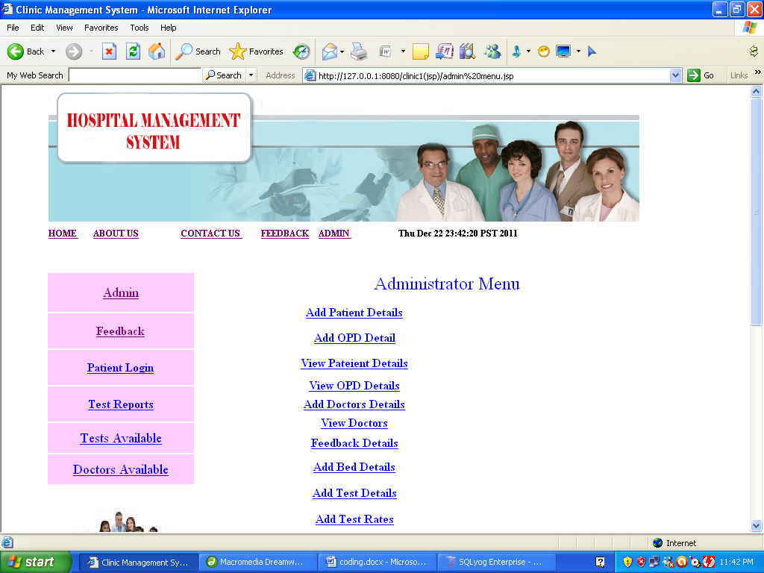
<%@ page language="java" %>
<%@ page session="true" %>
<html>
<head>
<title>CLINICAL Management System</title>
<style type="text/css">
<!--
.style7 {
font-family: Arial, Helvetica, sans-serif;
font-size: 16px;
font-weight: bold;
color: #0000FF;
}
.style8 {
font-size: 18px;
color: #CC3300;
}
.style10 {font-size: 24px; color: #0000FF;}
.style12 {
font-size: 16px;
font-weight: bold;
}
.style13 {
color: #0000FF;
font-weight: bold;
}
.style14 {color: #0000FF}
.style17 {color: #990000; font-weight: bold; }
.style19 {color: #000000; font-weight: bold; }
-->
</style>
</head>
<body>
<table width="731" border="0" align="center" cellspacing="0">
<tr>
<td colspan="2" height="120"><%@ include file="header.jsp" %></td>
</tr>

<tr>
<td width="150" align="left" valign="top">
<%@ include file="menu.jsp"%></td>
<td width="750" align="left" valign="top" bgcolor="#FFFFFF"><form name="form1" method="post" action="">
<table width="671" height="667" border="0">
<tr>
<td height="35" colspan="2" align="left" valign="top"><div align="center" class="style10">
<p>Administrator Menu </p>
</div></td>
</tr>

<tr>
<td width="417"><div align="center"><span class="style17 style14"><a href="patient.jsp">Add Patient Details </a></span></div></td>
<td width="244">&nbsp;</td>
</tr>
<tr>
<td><div align="center"><span class="style17 style14"><a href="opd det.jsp">Add OPD Detail</a></span></div></td>
<td>&nbsp;</td>
</tr>

<tr>
<td><div align="center"><span class="style17 style14"><a href="pateintdetails.jsp">View Pateient Details</a> </span></div></td>
<td>&nbsp;</td>
</tr>
<tr>
<td height="23"><div align="center"><a href="opdpateintdetails.jsp"><strong>View OPD Details </strong></a></div></td>
<td>&nbsp;</td>
</tr>
<tr>
<td height="23" align="center" valign="middle"><a href="doctor.jsp"><strong>Add Doctors Details </strong></a></td>
<td>&nbsp;</td>
</tr>
<tr>
<td height="23" align="center"><a href="drdetails.jsp"><strong>View Doctors </strong></a></td>
<td>&nbsp;</td>
</tr>

<tr>
<td height="27"><div align="center"><strong><a href="feedback details.jsp">Feedback Details</a> </strong></div></td>
<td>&nbsp;</td>
</tr>

<tr>
<td><div align="center" class="style19"><a href="bed_det.jsp">Add Bed Details</a> </div></td>
<td>&nbsp;</td>
</tr>
<tr>
<td><div align="center" class="style19"><a href="test_det.jsp">Add Test Details </a> </div></td>
<td>&nbsp;</td>
</tr>

<tr>
<td><div align="center" class="style12"><a href="test_rates.jsp">Add Test Rates </a></div></td>
<td>&nbsp;</td>
</tr>
<tr>
<td align="center"><a href="bill.jsp"><strong>Add Bill Details </strong></a></td>
<td>&nbsp;</td>
</tr>
<tr>
<td align="center"><a href="nameSearch books.jsp"><span class="style13"><a href="user details.jsp">Users Detail </a></span></a></td>
<td>&nbsp;</td>
</tr>
<tr>
<td align="center"><a href="catSearch books.jsp"></a></td>
<td>&nbsp;</td>
</tr>
<tr>
<td><p align="center" class="style13">&nbsp;</p>
<p align="center">&nbsp;</p>
<p align="center" class="style14">&nbsp;</p>
<p align="center" class="style14">&nbsp;</p></td>
<td>&nbsp;</td>
</tr>
</table>
</form>
<h1 class="style8">&nbsp;</h1>
<p>&nbsp;</p>
<h1>&nbsp;</h1> <p class="style7" __designer:dtid="281479271677962">&nbsp;</p> </td>
</tr>
</table>
</body>
</html>
Patient.jsp

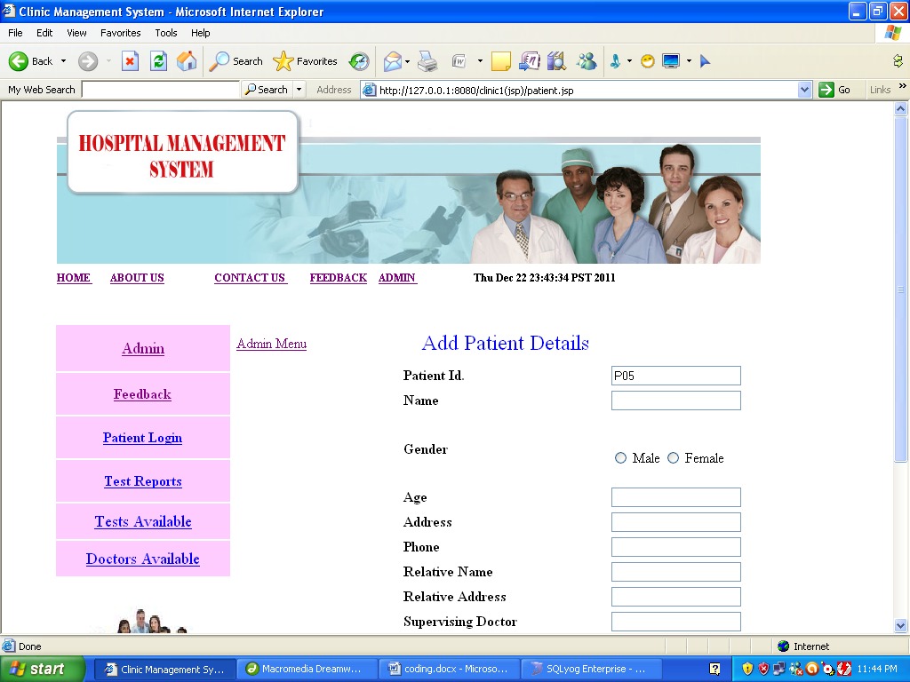
<%@ page language="java" import="java.sql.*"%>
<%@ page session="true" %>
<html>
<head>
<title>CLINICAL Management System</title>
<style type="text/css">
<!--
.style7 {
font-family: Arial, Helvetica, sans-serif;
font-size: 16px;
font-weight: bold;
color: #0000FF;
}
.style8 {
font-size: 18px;
color: #CC3300;
}
.style10 {
color: #0000FF;
font-size: 24px;
}
body {
margin-left: 0px;
margin-top: 0px;
}
-->
</style>
<meta http-equiv="Content-Type" content="text/html; charset=iso-8859-1"></head>
<body>

<script language="javascript">

function validate(form)
{
if (form.textfield.value=="")
{ alert("Should not be blank. Please enter it.");
form.textfield.focus(); return false;
}

if (form.textfield2.value=="")
{ alert("Field should not be blank. Please enter it.");
form.textfield2.focus(); return false;
}
if (form.textfield3.value=="")
{ alert("Field should not be blank. Please enter it.");
form.textfield3.focus(); return false;
}

if (form.textfield4.value=="")
{ alert("Field should not be blank. Please enter it.");
form.textfield4.focus(); return false;
}

if (form.textfield5.value=="")
{ alert("Field should not be blank. Please enter it.");
form.textfield5.focus(); return false;
}

if (form.textfield6.value=="")
{ alert("Field should not be blank. Please enter it.");
form.textfield6.focus(); return false;
}

if (form.textfield7.value=="")
{ alert("Field should not be blank. Please enter it.");
form.textfield7.focus(); return false;
}

if (form.textfield8.value=="")
{ alert("Field should not be blank. Please enter it.");
form.textfield8.focus(); return false;
}

if (form.textfield9.value=="")
{ alert("Field should not be blank. Please enter it.");
form.textfield9.focus(); return false;
}

if(isNaN(form.textfield3.value))
{
alert("Age Should be a number ");
form.textfield3.focus();
return false;
}

if(isNaN(form.textfield5.value))
{
alert("Phone No. Should be a number ");
form.textfield5.focus();
return false;
}

}
</script>

<table width="731" border="0" align="center" cellspacing="0">
<tr>
<td colspan="2" height="120"><%@ include file="header.jsp" %></td>
</tr>

<tr>
<td width="150" align="left" valign="top">
<%@ include file="menu.jsp"%></td>
<td width="750" align="left" valign="top" bgcolor="#FFFFFF"><form name="form" method="post" onSubmit="return validate(this)" action="addpatient.jsp">
<table width="673" height="356" border="0">
<tr>
<td width="184" height="42"><a href="admin menu.jsp">Admin Menu</a> </td>
<td width="230"><div align="center" class="style10">
<p>Add Patient Details</p>
</div></td>
<td width="245"><label></label></td>
</tr>
<tr>
<td>&nbsp;</td>
<td><strong>Patient Id.</strong> <%

Class.forName("com.mysql.jdbc.Driver");
Connection connection = DriverManager.getConnection("jdbc:mysql://localhost/CLINICAL","root","1234");
Statement statement = connection.createStatement();

String query="select * from patient";
ResultSet rs = statement.executeQuery(query);
int i=0;

while(rs.next())
{
i++;
}
String id="P0" +(i+1);
%> </td>
<td><input type="text" name="textfield" value='<%=id%>' ></td>
</tr>
<tr>
<td>&nbsp;</td>
<td><strong>Name </strong></td>
<td><label>
<input name="textfield2" type="text" >
</label></td>
</tr>
<tr>
<td height="62">&nbsp;</td>
<td><strong>Gender</strong></td>
<td><p>&nbsp;</p>
<p>
<label>
<input type="radio" name="radio" value="Male">
Male</label>
<input type="radio" name="radio" value="Female">
<label>Female</label>
<br>
<label></label>
</p>
<label></label></td>
</tr>

<tr>
<td>&nbsp;</td>
<td><strong>Age</strong></td>
<td><label>
<input name="textfield3" type="text" id="textfield3">
</label></td>
</tr>
<tr>
<td>&nbsp;</td>
<td><strong>Address</strong></td>
<td><label>
<input name="textfield4" type="text" id="textfield4">
</label></td>
</tr>
<tr>
<td>&nbsp;</td>
<td><strong>Phone</strong></td>
<td><label>
<input name="textfield5" type="text" id="textfield5" >
</label></td>
</tr>
<tr>
<td>&nbsp;</td>
<td><strong>Relative Name </strong></td>
<td><input name="textfield6" type="text" id="textfield6"></td>
</tr>
<tr>
<td>&nbsp;</td>
<td><strong>Relative Address </strong></td>
<td><input name="textfield7" type="text" id="textfield7"></td>
</tr>
<tr>
<td>&nbsp;</td>
<td><strong>Supervising Doctor </strong></td>
<td><input name="textfield8" type="text" id="textfield8"></td>
</tr>
<tr>
<td>&nbsp;</td>
<td><strong>Department</strong></td>
<td><input name="textfield9" type="text" id="textfield9"></td>
</tr>
<tr>
<td>&nbsp;</td>
<td>&nbsp;</td>
<td><input type="submit" name="Submit" value="Submit"></td>
</tr>

<tr>
<td>&nbsp;</td>
<td><label>

<div align="right"></div>
</label></td>
<td>&nbsp;</td>
</tr>
</table>

</form>
<h1 class="style8">&nbsp;</h1>
<p>&nbsp;</p>
<h1>&nbsp;</h1> <p class="style7" __designer:dtid="281479271677962">&nbsp;</p> </td>
</tr>
</table>
</body>
</html>

Opd det.jsp

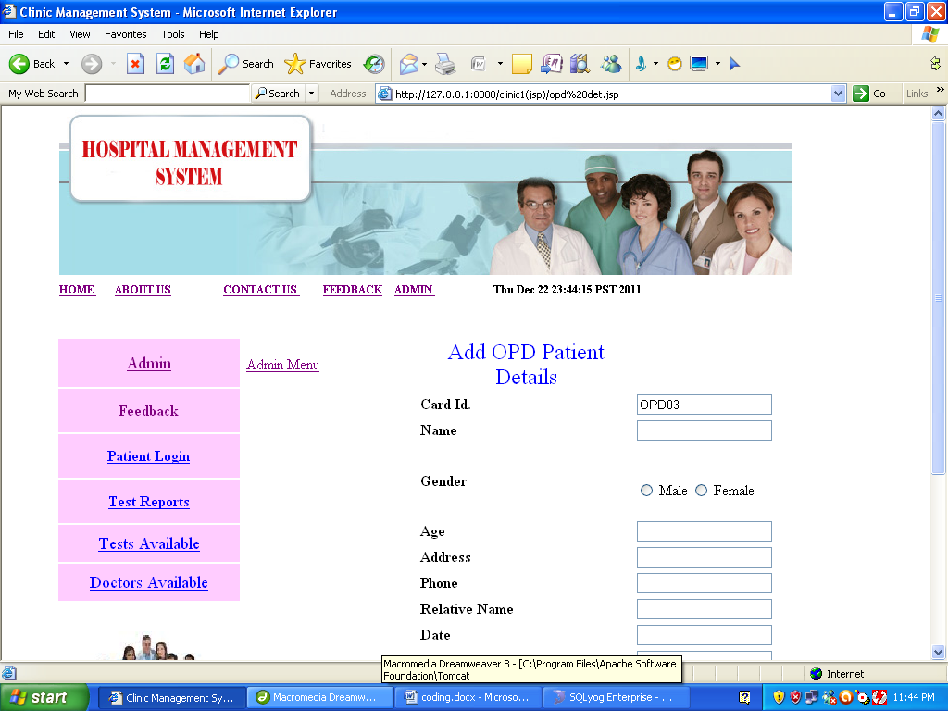
<%@ page language="java" import="java.sql.*"%>
<%@ page session="true" %>
<html>
<head>
<title>CLINICAL Management System</title>
<style type="text/css">
<!--
.style7 {
font-family: Arial, Helvetica, sans-serif;
font-size: 16px;
font-weight: bold;
color: #0000FF;
}
.style8 {
font-size: 18px;
color: #CC3300;
}
.style10 {
color: #0000FF;
font-size: 24px;
}
body {
margin-left: 0px;
margin-top: 0px;
}
-->
</style>
<meta http-equiv="Content-Type" content="text/html; charset=iso-8859-1"></head>
<body>

<script language="javascript">

function validate(form)
{
if (form.textfield.value=="")
{ alert("Should not be blank. Please enter it.");
form.textfield.focus(); return false;
}

if (form.textfield2.value=="")
{ alert("Field should not be blank. Please enter it.");
form.textfield2.focus(); return false;
}
if (form.textfield3.value=="")
{ alert("Field should not be blank. Please enter it.");
form.textfield3.focus(); return false;
}

if (form.textfield4.value=="")
{ alert("Field should not be blank. Please enter it.");
form.textfield4.focus(); return false;
}

if (form.textfield5.value=="")
{ alert("Field should not be blank. Please enter it.");
form.textfield5.focus(); return false;
}

if (form.textfield6.value=="")
{ alert("Field should not be blank. Please enter it.");
form.textfield6.focus(); return false;
}

if (form.textfield7.value=="")
{ alert("Field should not be blank. Please enter it.");
form.textfield7.focus(); return false;
}

if (form.textfield8.value=="")
{ alert("Field should not be blank. Please enter it.");
form.textfield8.focus(); return false;
}

if (form.textfield9.value=="")
{ alert("Field should not be blank. Please enter it.");
form.textfield9.focus(); return false;
}

if(isNaN(form.textfield3.value))
{
alert("Age Should be a number ");
form.textfield3.focus();
return false;
}

if(isNaN(form.textfield5.value))
{
alert("Phone No. Should be a number ");
form.textfield5.focus();
return false;
}

}
</script>

<table width="731" border="0" align="center" cellspacing="0">
<tr>
<td colspan="2" height="120"><%@ include file="header.jsp" %></td>
</tr>

<tr>
<td width="150" align="left" valign="top">
<%@ include file="menu.jsp"%></td>
<td width="750" align="left" valign="top" bgcolor="#FFFFFF"><form name="form" method="post" onSubmit="return validate(this)" action="addopd.jsp">
<table width="673" height="356" border="0">
<tr>
<td width="184" height="42"><a href="admin menu.jsp">Admin Menu</a> </td>
<td width="230"><div align="center" class="style10">
<p>Add OPD Patient Details</p>
</div></td>
<td width="245"><label></label></td>
</tr>
<tr>
<td>&nbsp;</td>
<td><strong>Card Id.</strong> <%

Class.forName("com.mysql.jdbc.Driver");
Connection connection = DriverManager.getConnection("jdbc:mysql://localhost/CLINICAL","root","1234");
Statement statement = connection.createStatement();

String query="select * from opd_master";
ResultSet rs = statement.executeQuery(query);
int i=0;

while(rs.next())
{
i++;
}
String id="OPD0" +(i+1);
%> </td>
<td><input type="text" name="textfield" value='<%=id%>' ></td>
</tr>
<tr>
<td>&nbsp;</td>
<td><strong>Name </strong></td>
<td><label>
<input name="textfield2" type="text" >
</label></td>
</tr>
<tr>
<td height="62">&nbsp;</td>
<td><strong>Gender</strong></td>
<td><p>&nbsp;</p>
<p>
<label>
<input type="radio" name="radio" value="Male">
Male</label>
<input type="radio" name="radio" value="Female">
<label>Female</label>
<br>
<label></label>
</p>
<label></label></td>
</tr>

<tr>
<td>&nbsp;</td>
<td><strong>Age</strong></td>
<td><label>
<input name="textfield3" type="text" id="textfield3">
</label></td>
</tr>
<tr>
<td>&nbsp;</td>
<td><strong>Address</strong></td>
<td><label>
<input name="textfield4" type="text" id="textfield4">
</label></td>
</tr>
<tr>
<td>&nbsp;</td>
<td><strong>Phone</strong></td>
<td><label>
<input name="textfield5" type="text" id="textfield5" >
</label></td>
</tr>
<tr>
<td>&nbsp;</td>
<td><strong>Relative Name </strong></td>
<td><input name="textfield6" type="text" id="textfield6"></td>
</tr>
<tr>
<td>&nbsp;</td>
<td><strong>Date</strong></td>
<td><input name="textfield7" type="text" id="textfield7"></td>
</tr>
<tr>
<td>&nbsp;</td>
<td><strong>Supervising Doctor </strong></td>
<td><input name="textfield8" type="text" id="textfield8"></td>
</tr>
<tr>
<td>&nbsp;</td>
<td><strong>Days</strong></td>
<td><input name="textfield9" type="text" id="textfield9"></td>
</tr>
<tr>
<td>&nbsp;</td>
<td><strong>Department</strong></td>
<td><input name="textfield10" type="text" id="textfield10"></td>
</tr>

<tr>
<td>&nbsp;</td>
<td><label>

<div align="right"></div>
</label></td>
<td><input type="submit" name="Submit" value="Submit"></td>
</tr>
</table>

</form>
<h1 class="style8">&nbsp;</h1>
<p>&nbsp;</p>
<h1>&nbsp;</h1> <p class="style7" __designer:dtid="281479271677962">&nbsp;</p> </td>
</tr>
</table>
</body>
</html>
Patient details.jsp

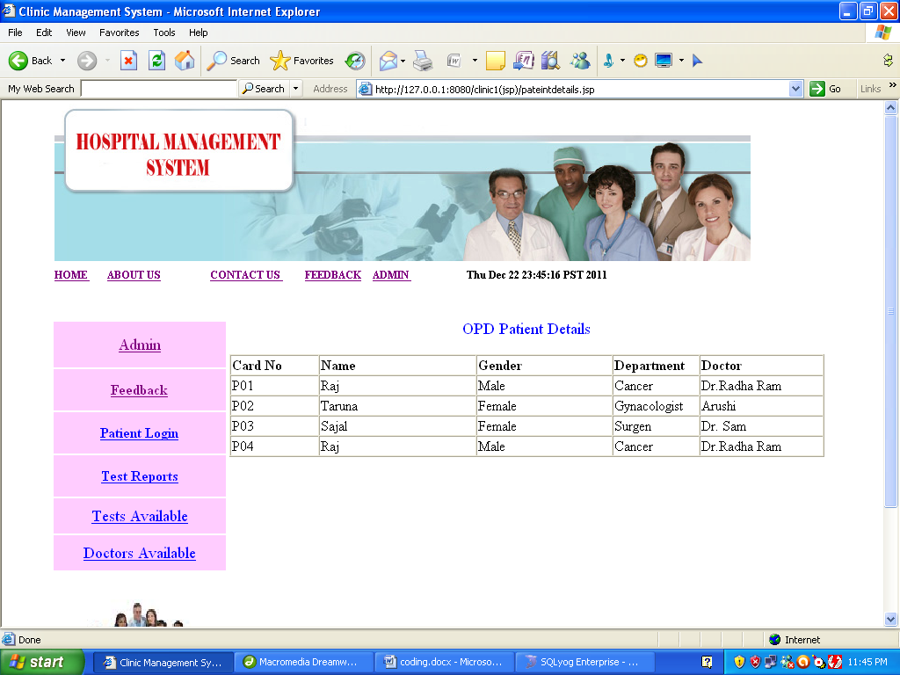
<%@ page language="java" import="java.sql.*" %>
<%@ page session="true" %>
<html>
<head>
<title>CLINICAL Management System</title>
<style type="text/css">
<!--
.style7 {
font-family: Arial, Helvetica, sans-serif;
font-size: 16px;
font-weight: bold;
color: #0000FF;
}
.style11 {
color: #0000FF;
font-size: 18px;
}
body {
margin-left: 0px;
margin-top: 0px;
}
-->
</style>
<meta http-equiv="Content-Type" content="text/html; charset=iso-8859-1"></head>
<body>
<table width="731" border="0" align="center" cellspacing="0">
<tr>
<td colspan="2" height="120"><%@ include file="header.jsp" %></td>
</tr>

<tr>
<td width="150" align="left" valign="top">
<%@ include file="menu.jsp"%></td>
<td width="750" align="left" valign="top" bgcolor="#FFFFFF"><form action="" method="post" name="form1" class="style11">
<div align="center">
<p>OPD Patient Details </p>
</div>
</form>
<table width="677" border="1" cellspacing="0">
<tr>
<td width="81"><strong>Card No </strong></td>
<td width="148"><b>Name</b></td>
<td width="128"><strong>Gender</strong></td>
<td width="62"><strong>Department</strong></td>

<td width="116"><strong>Doctor</strong></td>
</tr>
<%
Class.forName("com.mysql.jdbc.Driver");
Connection connection = DriverManager.getConnection("jdbc:mysql://localhost/CLINICAL","root","1234");
Statement statement = connection.createStatement();

String query="select * from patient";
ResultSet rs = statement.executeQuery(query);
while(rs.next())
{

%>
<tr>
<td><%=rs.getString(1)%></td>
<td><%=rs.getString(2)%></td>
<td><%=rs.getString(3)%></td>
<td><%=rs.getString(10)%></td>

<td><%=rs.getString(9)%></td>
</tr>
<%}%>
</table>
</p>
<h1>&nbsp;</h1> <p class="style7" __designer:dtid="281479271677962">&nbsp;</p> </td>
</tr>
</table>
</body>
</html>
Opdpateintdetails.jsp

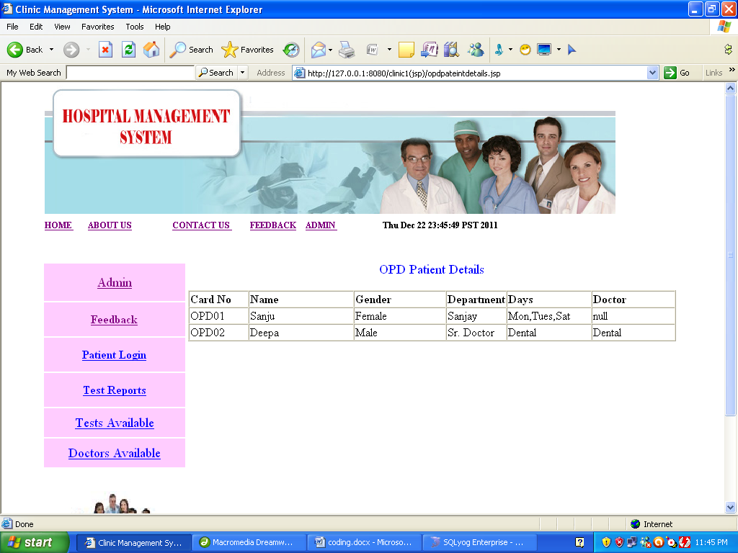
<%@ page language="java" import="java.sql.*" %>
<%@ page session="true" %>
<html>
<head>
<title>CLINICAL Management System</title>
<style type="text/css">
<!--
.style7 {
font-family: Arial, Helvetica, sans-serif;
font-size: 16px;
font-weight: bold;
color: #0000FF;
}
.style11 {
color: #0000FF;
font-size: 18px;
}
body {
margin-left: 0px;
margin-top: 0px;
}
-->
</style>
<meta http-equiv="Content-Type" content="text/html; charset=iso-8859-1"></head>
<body>
<table width="731" border="0" align="center" cellspacing="0">
<tr>
<td colspan="2" height="120"><%@ include file="header.jsp" %></td>
</tr>

<tr>
<td width="150" align="left" valign="top">
<%@ include file="menu.jsp"%></td>
<td width="750" align="left" valign="top" bgcolor="#FFFFFF"><form action="" method="post" name="form1" class="style11">
<div align="center">
<p>OPD Patient Details </p>
</div>
</form>
<table width="677" border="1" cellspacing="0">
<tr>
<td width="81"><strong>Card No </strong></td>
<td width="148"><b>Name</b></td>
<td width="128"><strong>Gender</strong></td>
<td width="62"><strong>Department</strong></td>
<td width="116"><strong>Days</strong></td>
<td width="116"><strong>Doctor</strong></td>
</tr>
<%
Class.forName("com.mysql.jdbc.Driver");
Connection connection = DriverManager.getConnection("jdbc:mysql://localhost/CLINICAL","root","1234");
Statement statement = connection.createStatement();

String query="select * from opd_master";
ResultSet rs = statement.executeQuery(query);
while(rs.next())
{

%>
<tr>
<td><%=rs.getString(1)%></td>
<td><%=rs.getString(2)%></td>
<td><%=rs.getString(3)%></td>
<td><%=rs.getString(9)%></td>
<td><%=rs.getString(10)%></td>
<td><%=rs.getString(11)%></td>
</tr>
<%}%>
</table>
</p>
<h1>&nbsp;</h1> <p class="style7" __designer:dtid="281479271677962">&nbsp;</p> </td>
</tr>
</table>
</body></html>
Doctor.jsp

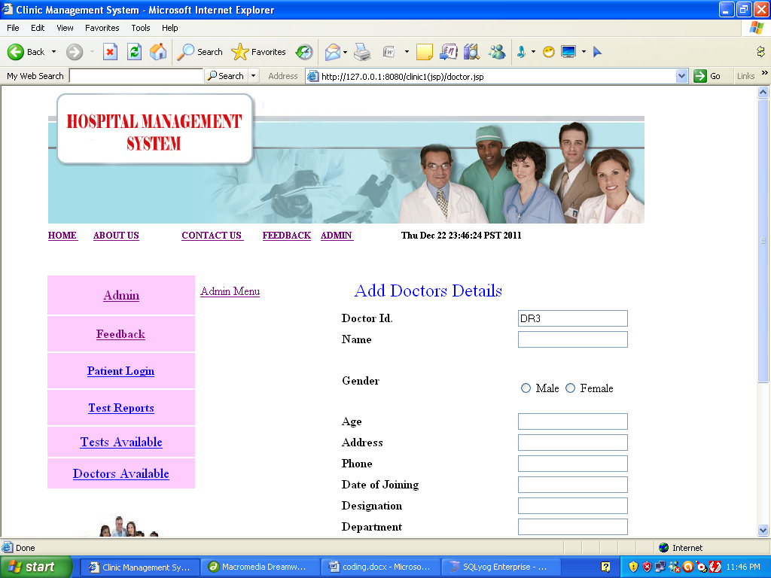
<%@ page language="java" import="java.sql.*"%>
<%@ page session="true" %>
<html>
<head>
<title>CLINICAL Management System</title>
<style type="text/css">
<!--
.style7 {
font-family: Arial, Helvetica, sans-serif;
font-size: 16px;
font-weight: bold;
color: #0000FF;
}
.style8 {
font-size: 18px;
color: #CC3300;
}
.style10 {
color: #0000FF;
font-size: 24px;
}
body {
margin-left: 0px;
margin-top: 0px;
}
-->
</style>
<meta http-equiv="Content-Type" content="text/html; charset=iso-8859-1"></head>
<body>

<script language="javascript">

function validate(form)
{
if (form.textfield.value=="")
{ alert("Should not be blank. Please enter it.");
form.textfield.focus(); return false;
}

if (form.textfield2.value=="")
{ alert("Field should not be blank. Please enter it.");
form.textfield2.focus(); return false;
}
if (form.textfield3.value=="")
{ alert("Field should not be blank. Please enter it.");
form.textfield3.focus(); return false;
}

if (form.textfield4.value=="")
{ alert("Field should not be blank. Please enter it.");
form.textfield4.focus(); return false;
}

if (form.textfield5.value=="")
{ alert("Field should not be blank. Please enter it.");
form.textfield5.focus(); return false;
}

if (form.textfield6.value=="")
{ alert("Field should not be blank. Please enter it.");
form.textfield6.focus(); return false;
}

if (form.textfield7.value=="")
{ alert("Field should not be blank. Please enter it.");
form.textfield7.focus(); return false;
}

if (form.textfield8.value=="")
{ alert("Field should not be blank. Please enter it.");
form.textfield8.focus(); return false;
}

if (form.textfield9.value=="")
{ alert("Field should not be blank. Please enter it.");
form.textfield9.focus(); return false;
}

if(isNaN(form.textfield3.value))
{
alert("Age Should be a number ");
form.textfield3.focus();
return false;
}

if(isNaN(form.textfield5.value))
{
alert("Phone No. Should be a number ");
form.textfield5.focus();
return false;
}

}
</script>

<table width="731" border="0" align="center" cellspacing="0">
<tr>
<td colspan="2" height="120"><%@ include file="header.jsp" %></td>
</tr>

<tr>
<td width="150" align="left" valign="top">
<%@ include file="menu.jsp"%></td>
<td width="750" align="left" valign="top" bgcolor="#FFFFFF"><form name="form" method="post" onSubmit="return validate(this)" action="adddr.jsp">
<table width="673" height="356" border="0">
<tr>
<td width="184" height="42"><a href="admin menu.jsp">Admin Menu</a> </td>
<td width="230"><div align="center" class="style10">
<p>Add Doctors Details</p>
</div></td>
<td width="245"><label></label></td>
</tr>
<tr>
<td>&nbsp;</td>
<td><strong>Doctor Id.</strong> <%

Class.forName("com.mysql.jdbc.Driver");
Connection connection = DriverManager.getConnection("jdbc:mysql://localhost/CLINICAL","root","1234");
Statement statement = connection.createStatement();

String query="select * from dr_master";
ResultSet rs = statement.executeQuery(query);
int i=0;

while(rs.next())
{
i++;
}
String id="DR" +(i+1);
%> </td>
<td><input type="text" name="textfield" value='<%=id%>' ></td>
</tr>
<tr>
<td>&nbsp;</td>
<td><strong>Name </strong></td>
<td><label>
<input name="textfield2" type="text" >
</label></td>
</tr>
<tr>
<td height="62">&nbsp;</td>
<td><strong>Gender</strong></td>
<td><p>&nbsp;</p>
<p>
<label>
<input type="radio" name="radio" value="Male">
Male</label>
<input type="radio" name="radio" value="Female">
<label>Female</label>
<br>
<label></label>
</p>
<label></label></td>
</tr>

<tr>
<td>&nbsp;</td>
<td><strong>Age</strong></td>
<td><label>
<input name="textfield3" type="text" id="textfield3">
</label></td>
</tr>
<tr>
<td>&nbsp;</td>
<td><strong>Address</strong></td>
<td><label>
<input name="textfield4" type="text" id="textfield4">
</label></td>
</tr>
<tr>
<td>&nbsp;</td>
<td><strong>Phone</strong></td>
<td><label>
<input name="textfield5" type="text" id="textfield5" >
</label></td>
</tr>
<tr>
<td>&nbsp;</td>
<td><strong>Date of Joining</strong></td>
<td><input name="textfield6" type="text" id="textfield6"></td>
</tr>
<tr>
<td>&nbsp;</td>
<td><strong>Designation</strong></td>
<td><input name="textfield7" type="text" id="textfield7"></td>
</tr>
<tr>
<td>&nbsp;</td>
<td><strong>Department</strong></td>
<td><input name="textfield8" type="text" id="textfield8"></td>
</tr>
<tr>
<td>&nbsp;</td>
<td><strong>Specialization</strong></td>
<td><input name="textfield9" type="text" id="textfield9"></td>
</tr>
<tr>
<td>&nbsp;</td>
<td><strong>Timings</strong></td>
<td><input name="textfield10" type="text" id="textfield10"></td>
</tr>
<tr>
<td>&nbsp;</td>
<td>&nbsp;</td>
<td>&nbsp;</td>
</tr>

<tr>
<td>&nbsp;</td>
<td><label>

<div align="right"></div>
</label></td>
<td><input type="submit" name="Submit" value="Submit"></td>
</tr>
</table>

</form>
<h1 class="style8">&nbsp;</h1>
<p>&nbsp;</p>
<h1>&nbsp;</h1> <p class="style7" __designer:dtid="281479271677962">&nbsp;</p> </td>
</tr>
</table>
</body>
</html>

Drdetails.jsp

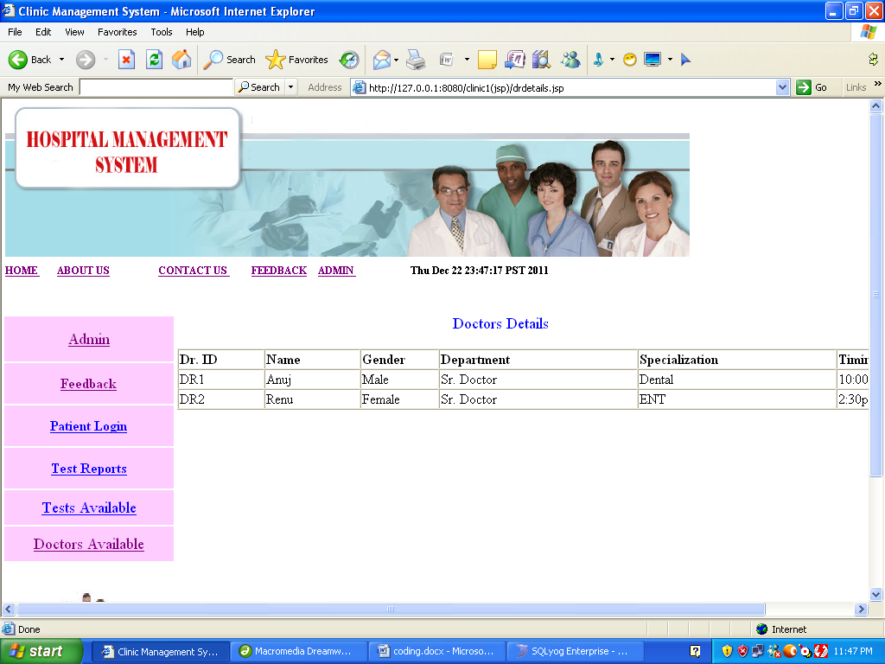
<%@ page language="java" import="java.sql.*" %>
<%@ page session="true" %>
<html>
<head>
<title>CLINICAL Management System</title>
<style type="text/css">
<!--
.style7 {
font-family: Arial, Helvetica, sans-serif;
font-size: 16px;
font-weight: bold;
color: #0000FF;
}
.style11 {
color: #0000FF;
font-size: 18px;
}
body {
margin-left: 0px;
margin-top: 0px;
}
-->
</style>
<meta http-equiv="Content-Type" content="text/html; charset=iso-8859-1"></head>
<body>
<table width="731" border="0" align="center" cellspacing="0">
<tr>
<td colspan="2" height="120"><%@ include file="header.jsp" %></td>
</tr>

<tr>
<td width="150" align="left" valign="top">
<%@ include file="menu.jsp"%></td>
<td width="750" align="left" valign="top" bgcolor="#FFFFFF"><form action="" method="post" name="form1" class="style11">
<div align="center">
<p>Doctors Details </p>
</div>
</form>
<table width="907" border="1" cellspacing="0">
<tr>
<td width="96"><strong>Dr. ID </strong></td>
<td width="107"><b>Name</b></td>
<td width="87"><strong>Gender</strong></td>
<td width="226"><strong>Department</strong></td>
<td width="226"><strong>Specialization</strong></td>

<td width="139"><strong>Timings</strong></td>
</tr>
<%
Class.forName("com.mysql.jdbc.Driver");
Connection connection = DriverManager.getConnection("jdbc:mysql://localhost/CLINICAL","root","1234");
Statement statement = connection.createStatement();

String query="select * from dr_master";
ResultSet rs = statement.executeQuery(query);
while(rs.next())
{

%>
<tr>
<td><%=rs.getString(1)%></td>
<td><%=rs.getString(2)%></td>
<td><%=rs.getString(3)%></td>
<td><%=rs.getString(9)%></td>
<td><%=rs.getString(10)%></td>

<td><%=rs.getString(11)%></td>
</tr>
<%}%>
</table>
</p>
<h1>&nbsp;</h1> <p class="style7" __designer:dtid="281479271677962">&nbsp;</p> </td>
</tr>
</table>
</body>
</html>

Bed_det.jsp

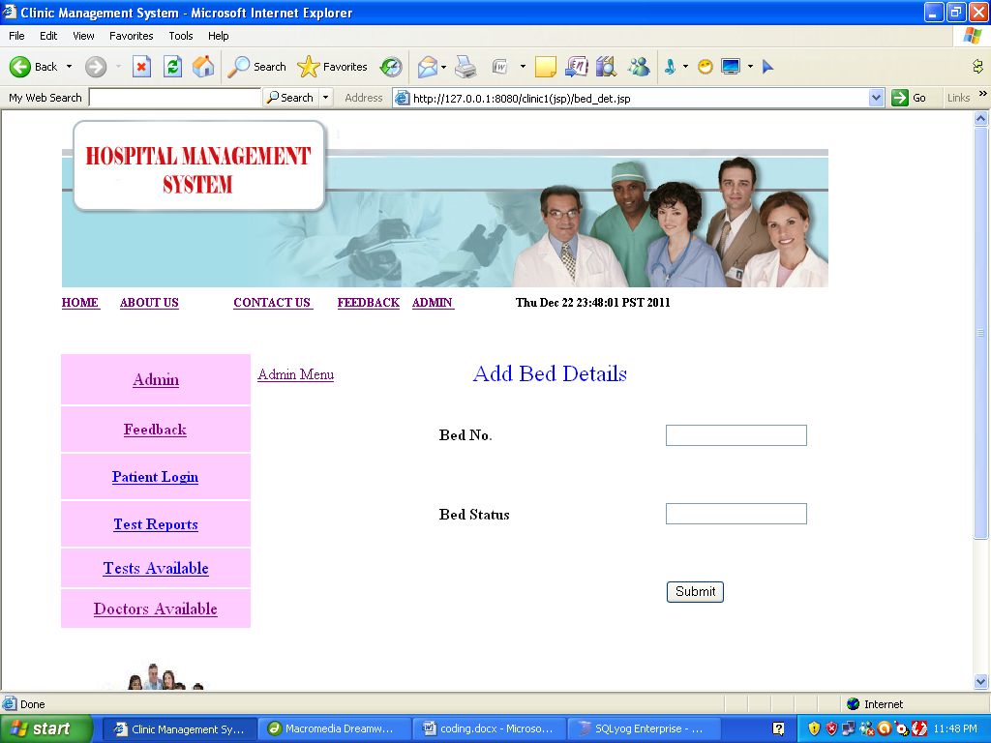
<%@ page language="java" import="java.sql.*"%>
<%@ page session="true" %>
<html>
<head>
<title>CLINICAL Management System</title>
<style type="text/css">
<!--
.style7 {
font-family: Arial, Helvetica, sans-serif;
font-size: 16px;
font-weight: bold;
color: #0000FF;
}
.style8 {
font-size: 18px;
color: #CC3300;
}
.style10 {
color: #0000FF;
font-size: 24px;
}
body {
margin-left: 0px;
margin-top: 0px;
}
-->
</style>
<meta http-equiv="Content-Type" content="text/html; charset=iso-8859-1"></head>
<body>

<script language="javascript">

function validate(form)
{
if (form.textfield.value=="")
{ alert("Should not be blank. Please enter it.");
form.textfield.focus(); return false;
}

if (form.textfield2.value=="")
{ alert("Field should not be blank. Please enter it.");
form.textfield2.focus(); return false;
}

}
</script>

<table width="731" border="0" align="center" cellspacing="0">
<tr>
<td colspan="2" height="120"><%@ include file="header.jsp" %></td>
</tr>

<tr>
<td width="150" align="left" valign="top">
<%@ include file="menu.jsp"%></td>
<td width="750" align="left" valign="top" bgcolor="#FFFFFF"><form name="form" method="post" onSubmit="return validate(this)" action="addbed.jsp">
<table width="673" height="356" border="0">
<tr>
<td width="184" height="42"><a href="admin menu.jsp">Admin Menu</a> </td>
<td width="230"><div align="center" class="style10">
<p>Add Bed Details</p>
</div></td>
<td width="245"><label></label></td>
</tr>
<tr>
<td>&nbsp;</td>
<td><strong>Bed No.</strong></td>
<td><input type="text" name="textfield" ></td>
</tr>
<tr>
<td>&nbsp;</td>
<td><strong>Bed Status</strong> </td>
<td><label>
<input name="textfield2" type="text" >
</label></td>
</tr>

<tr>
<td>&nbsp;</td>
<td>&nbsp;</td>
<td><input type="submit" name="Submit" value="Submit"></td>
</tr>

<tr>
<td>&nbsp;</td>
<td><label>

<div align="right"></div>
</label></td>
<td>&nbsp;</td>
</tr>
</table>

</form>
<h1 class="style8">&nbsp;</h1>
<p>&nbsp;</p>
<h1>&nbsp;</h1> <p class="style7" __designer:dtid="281479271677962">&nbsp;</p> </td>
</tr>
</table>
</body>
</html>

Test_det.jsp

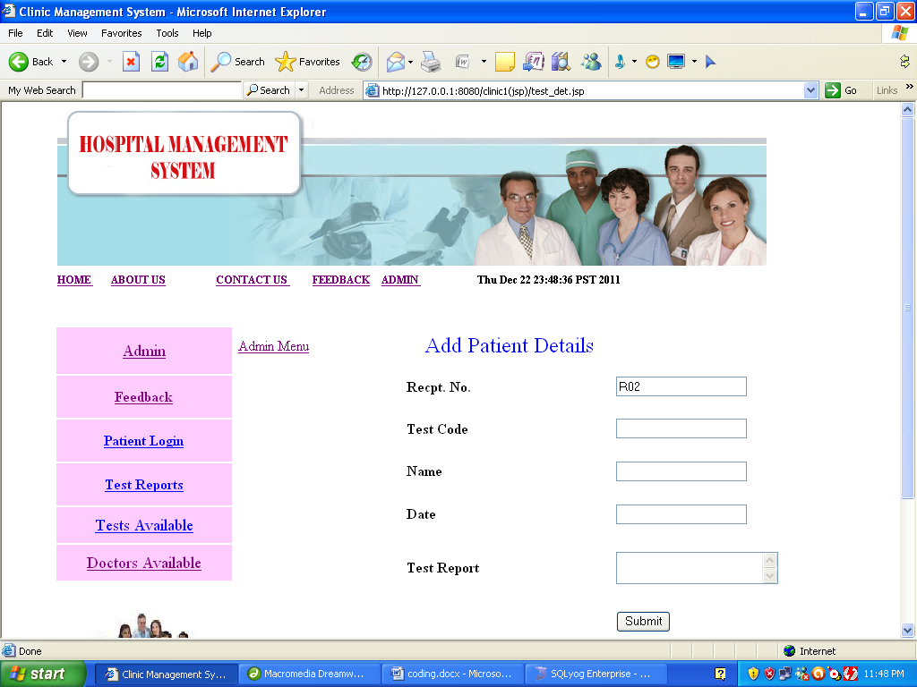
<%@ page language="java" import="java.sql.*"%>
<%@ page session="true" %>
<html>
<head>
<title>CLINICAL Management System</title>
<style type="text/css">
<!--
.style7 {
font-family: Arial, Helvetica, sans-serif;
font-size: 16px;
font-weight: bold;
color: #0000FF;
}
.style8 {
font-size: 18px;
color: #CC3300;
}
.style10 {
color: #0000FF;
font-size: 24px;
}
body {
margin-left: 0px;
margin-top: 0px;
}
-->
</style>
<meta http-equiv="Content-Type" content="text/html; charset=iso-8859-1"></head>
<body>

<script language="javascript">

function validate(form)
{
if (form.textfield.value=="")
{ alert("Should not be blank. Please enter it.");
form.textfield.focus(); return false;
}

if (form.textfield2.value=="")
{ alert("Field should not be blank. Please enter it.");
form.textfield2.focus(); return false;
}
if (form.textfield3.value=="")
{ alert("Field should not be blank. Please enter it.");
form.textfield3.focus(); return false;
}

if (form.textfield4.value=="")
{ alert("Field should not be blank. Please enter it.");
form.textfield4.focus(); return false;
}

}
</script>

<table width="731" border="0" align="center" cellspacing="0">
<tr>
<td colspan="2" height="120"><%@ include file="header.jsp" %></td>
</tr>

<tr>
<td width="150" align="left" valign="top">
<%@ include file="menu.jsp"%></td>
<td width="750" align="left" valign="top" bgcolor="#FFFFFF"><form name="form" method="post" onSubmit="return validate(this)" action="addtest.jsp">
<table width="673" height="356" border="0">
<tr>
<td width="184" height="42"><a href="admin menu.jsp">Admin Menu</a> </td>
<td width="230"><div align="center" class="style10">
<p>Add Patient Details</p>
</div></td>
<td width="245"><label></label></td>
</tr>
<tr>
<td>&nbsp;</td>
<td><strong>Recpt. No.</strong> <%

Class.forName("com.mysql.jdbc.Driver");
Connection connection = DriverManager.getConnection("jdbc:mysql://localhost/CLINICAL","root","1234");
Statement statement = connection.createStatement();

String query="select * from Test_det";
ResultSet rs = statement.executeQuery(query);
int i=0;

while(rs.next())
{
i++;
}
String id="R0" +(i+1);
%> </td>
<td><input type="text" name="textfield" value='<%=id%>' ></td>
</tr>
<tr>
<td>&nbsp;</td>
<td><strong>Test Code </strong></td>
<td><label>
<input name="textfield2" type="text" >
</label></td>
</tr>

<tr>
<td>&nbsp;</td>
<td><strong>Name</strong></td>
<td><input name="textfield3" type="text" id="textfield3"></td>
</tr>
<tr>
<td>&nbsp;</td>
<td><strong>Date</strong></td>
<td><input name="textfield4" type="text" id="textfield4"></td>
</tr>
<tr>
<td>&nbsp;</td>
<td><strong>Test Report</strong> </td>
<td><textarea name="textfield5" id="textfield5"></textarea></td>
</tr>

<tr>
<td>&nbsp;</td>
<td><label>

<div align="right"></div>
</label></td>
<td><input type="submit" name="Submit" value="Submit"></td>
</tr>
</table>

</form>
<h1 class="style8">&nbsp;</h1>
<p>&nbsp;</p>
<h1>&nbsp;</h1> <p class="style7" __designer:dtid="281479271677962">&nbsp;</p> </td>
</tr>
</table>
</body>
</html>
Test_rates.jsp

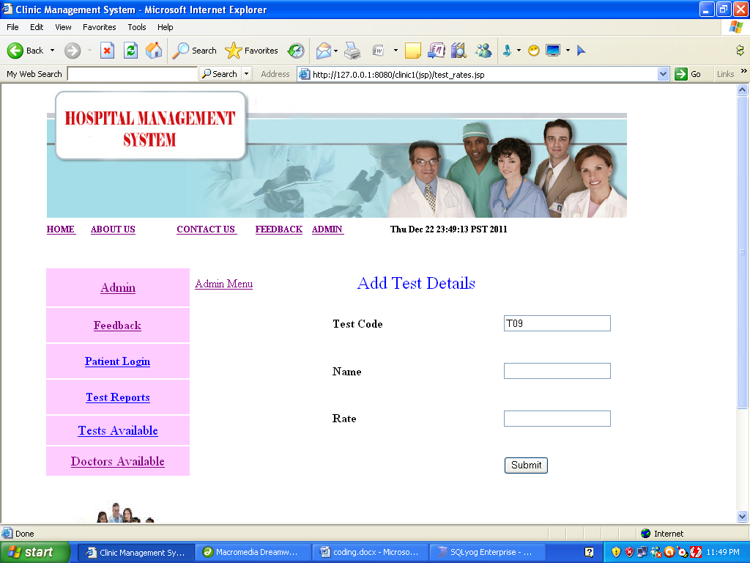
<%@ page language="java" import="java.sql.*"%>
<%@ page session="true" %>
<html>
<head>
<title>CLINICAL Management System</title>
<style type="text/css">
<!--
.style7 {
font-family: Arial, Helvetica, sans-serif;
font-size: 16px;
font-weight: bold;
color: #0000FF;
}
.style8 {
font-size: 18px;
color: #CC3300;
}
.style10 {
color: #0000FF;
font-size: 24px;
}
body {
margin-left: 0px;
margin-top: 0px;
}
-->
</style>
<meta http-equiv="Content-Type" content="text/html; charset=iso-8859-1"></head>
<body>

<script language="javascript">

function validate(form)
{
if (form.textfield.value=="")
{ alert("Should not be blank. Please enter it.");
form.textfield.focus(); return false;
}

if (form.textfield2.value=="")
{ alert("Field should not be blank. Please enter it.");
form.textfield2.focus(); return false;
}
if (form.textfield3.value=="")
{ alert("Field should not be blank. Please enter it.");
form.textfield3.focus(); return false;
}

if (form.textfield4.value=="")
{ alert("Field should not be blank. Please enter it.");
form.textfield4.focus(); return false;
}

}
</script>

<table width="731" border="0" align="center" cellspacing="0">
<tr>
<td colspan="2" height="120"><%@ include file="header.jsp" %></td>
</tr>

<tr>
<td width="150" align="left" valign="top">
<%@ include file="menu.jsp"%></td>
<td width="750" align="left" valign="top" bgcolor="#FFFFFF"><form name="form" method="post" onSubmit="return validate(this)" action="addrate.jsp">
<table width="673" height="356" border="0">
<tr>
<td width="184" height="42"><a href="admin menu.jsp">Admin Menu</a> </td>
<td width="230"><div align="center" class="style10">
<p>Add Test Details</p>
</div></td>
<td width="245"><label></label></td>
</tr>
<tr>
<td>&nbsp;</td>
<td><strong>Test Code </strong>
<%

Class.forName("com.mysql.jdbc.Driver");
Connection connection = DriverManager.getConnection("jdbc:mysql://localhost/CLINICAL","root","1234");
Statement statement = connection.createStatement();

String query="select * from Test_master";
ResultSet rs = statement.executeQuery(query);
int i=0;

while(rs.next())
{
i++;
}
String id="T0" +(i+1);
%> </td>
<td><input type="text" name="textfield" value='<%=id%>' ></td>
</tr>
<tr>
<td>&nbsp;</td>
<td><strong>Name</strong></td>
<td><label>
<input name="textfield2" type="text" >
</label></td>
</tr>

<tr>
<td>&nbsp;</td>
<td><strong>Rate</strong></td>
<td><input name="textfield3" type="text" id="textfield3"></td>
</tr>

<tr>
<td>&nbsp;</td>
<td>&nbsp;</td>
<td><input type="submit" name="Submit" value="Submit"></td>
</tr>

<tr>
<td>&nbsp;</td>
<td><label>

<div align="right"></div>
</label></td>
<td>&nbsp;</td>
</tr>
</table>

</form>
<h1 class="style8">&nbsp;</h1>
<p>&nbsp;</p>
<h1>&nbsp;</h1> <p class="style7" __designer:dtid="281479271677962">&nbsp;</p> </td>
</tr>
</table>
</body>
</html>
Bill.jsp

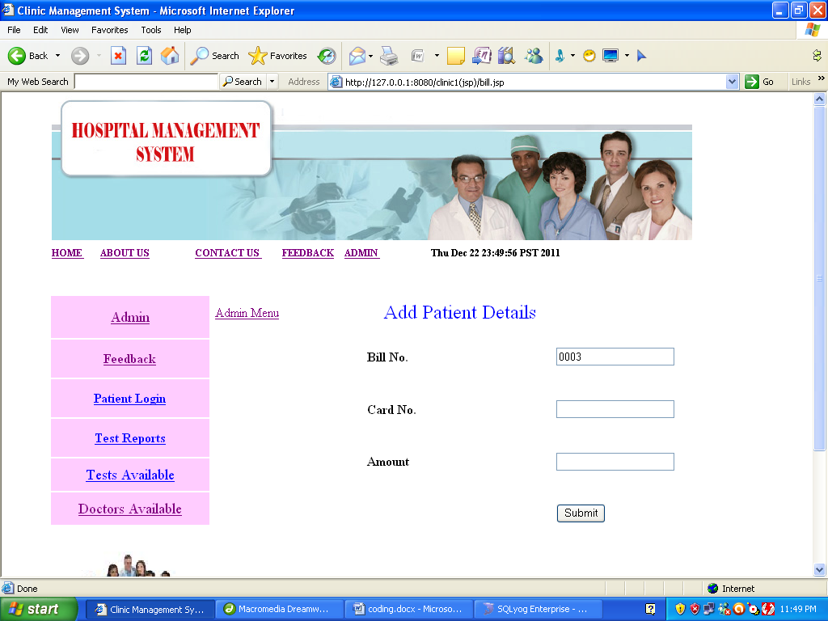
<%@ page language="java" import="java.sql.*"%>
<%@ page session="true" %>
<html>
<head>
<title>CLINICAL Management System</title>
<style type="text/css">
<!--
.style7 {
font-family: Arial, Helvetica, sans-serif;
font-size: 16px;
font-weight: bold;
color: #0000FF;
}
.style8 {
font-size: 18px;
color: #CC3300;
}
.style10 {
color: #0000FF;
font-size: 24px;
}
body {
margin-left: 0px;
margin-top: 0px;
}
-->
</style>
<meta http-equiv="Content-Type" content="text/html; charset=iso-8859-1"></head>
<body>

<script language="javascript">

function validate(form)
{
if (form.textfield.value=="")
{ alert("Should not be blank. Please enter it.");
form.textfield.focus(); return false;
}

if (form.textfield2.value=="")
{ alert("Field should not be blank. Please enter it.");
form.textfield2.focus(); return false;
}
if (form.textfield3.value=="")
{ alert("Field should not be blank. Please enter it.");
form.textfield3.focus(); return false;
}

}
</script>

<table width="731" border="0" align="center" cellspacing="0">
<tr>
<td colspan="2" height="120"><%@ include file="header.jsp" %></td>
</tr>

<tr>
<td width="150" align="left" valign="top">
<%@ include file="menu.jsp"%></td>
<td width="750" align="left" valign="top" bgcolor="#FFFFFF"><form name="form" method="post" onSubmit="return validate(this)" action="addbill.jsp">
<table width="673" height="356" border="0">
<tr>
<td width="184" height="42"><a href="admin menu.jsp">Admin Menu</a> </td>
<td width="230"><div align="center" class="style10">
<p>Add Patient Details</p>
</div></td>
<td width="245"><label></label></td>
</tr>
<tr>
<td>&nbsp;</td>
<td><strong>B</strong><strong>ill No. </strong>
<%

Class.forName("com.mysql.jdbc.Driver");
Connection connection = DriverManager.getConnection("jdbc:mysql://localhost/CLINICAL","root","1234");
Statement statement = connection.createStatement();

String query="select * from bill";
ResultSet rs = statement.executeQuery(query);
int i=0;

while(rs.next())
{
i++;
}
String id="000" +(i+1);
%> </td>
<td><input type="text" name="textfield" value='<%=id%>' ></td>
</tr>
<tr>
<td>&nbsp;</td>
<td><strong>Card No. </strong></td>
<td><label>
<input name="textfield2" type="text" >
</label></td>
</tr>

<tr>
<td>&nbsp;</td>
<td><strong>Amount</strong></td>
<td><input name="textfield3" type="text" id="textfield3"></td>
</tr>

<tr>
<td>&nbsp;</td>
<td>&nbsp;</td>
<td><input type="submit" name="Submit" value="Submit"></td>
</tr>

<tr>
<td>&nbsp;</td>
<td><label>

<div align="right"></div>
</label></td>
<td>&nbsp;</td>
</tr>
</table>

</form>
<h1 class="style8">&nbsp;</h1>
<p>&nbsp;</p>
<h1>&nbsp;</h1> <p class="style7" __designer:dtid="281479271677962">&nbsp;</p> </td>
</tr>
</table></body></html>
Userdetails.jsp

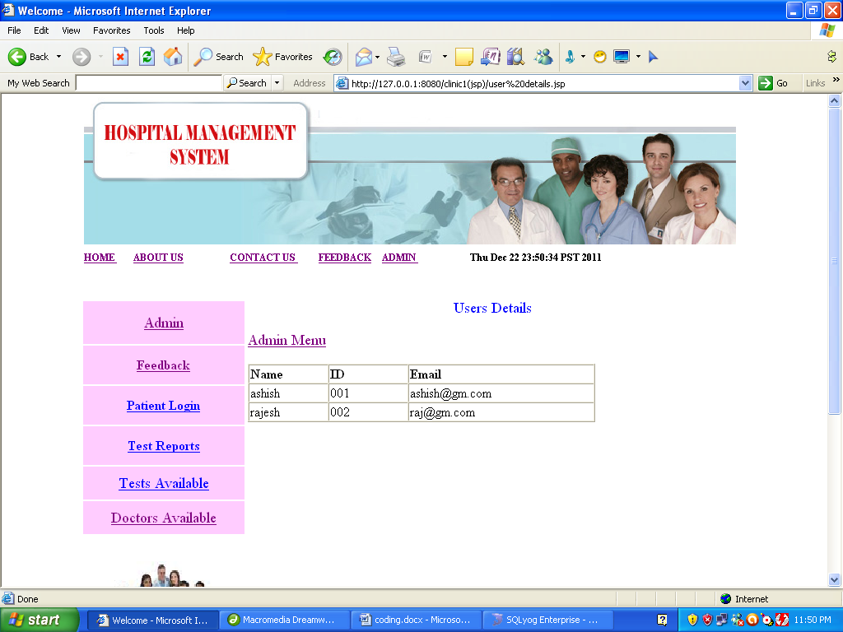
<%@ page language="java" import="java.sql.*" %>
<%@ page session="true" %>
<html>
<head>
<title>Welcome</title>
<style type="text/css">
<!--
.style7 {
font-family: Arial, Helvetica, sans-serif;
font-size: 16px;
font-weight: bold;
color: #0000FF;
}
.style11 {
color: #0000FF;
font-size: 18px;
}
body {
margin-left: 0px;
margin-top: 0px;
}
-->
</style>
<meta http-equiv="Content-Type" content="text/html; charset=iso-8859-1"></head>
<body>
<table width="731" border="0" align="center" cellspacing="0">
<tr>
<td colspan="2" height="120"><%@ include file="header.jsp" %></td>
</tr>

<tr>
<td width="150" align="left" valign="top">
<%@ include file="menu.jsp"%></td>
<td width="750" align="left" valign="top" bgcolor="#FFFFFF"><form action="" method="post" name="form1" class="style11">
<div align="center">
<p>Users Details </p>
</div>
<a href="admin menu.jsp">Admin Menu</a>
</form>
<p>
<%
Class.forName("com.mysql.jdbc.Driver");
Connection connection = DriverManager.getConnection("jdbc:mysql://localhost/CLINICAL","root","1234");
Statement statement = connection.createStatement();

String query="select * from user";
ResultSet rs = statement.executeQuery(query);
%>
</p>
<table width="422" border="1" cellspacing="0">
<tr>
<td width="93"><strong>Name </strong></td>
<td width="93"><strong>ID</strong></td>
<td width="222"><strong>Email</strong></td>
</tr>
<%
while(rs.next())
{
%>
<tr>
<td><%=rs.getString(1)%></td>
<td><%=rs.getString(2)%></td>
<td><%=rs.getString(3)%></td>
</tr>
<%}%>
</table>
</p>
<h1>&nbsp;</h1> <p class="style7" __designer:dtid="281479271677962">&nbsp;</p> </td>
</tr>
</table>&nbsp;</h1>
<p>&nbsp;</p>
<h1>&nbsp;</h1> <p class="style7" __designer:dtid="281479271677962">&nbsp;</p> </td>
</tr>
</table></body></html>
Testdetails.jsp

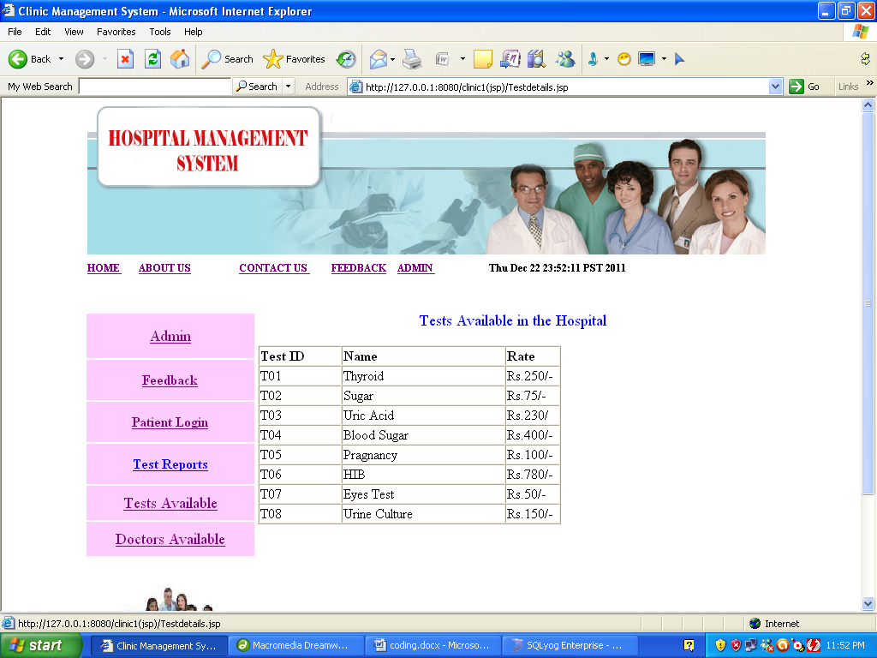
<%@ page language="java" import="java.sql.*" %>
<%@ page session="true" %>
<html>
<head>
<title>CLINICAL Management System</title>
<style type="text/css">
<!--
.style7 {
font-family: Arial, Helvetica, sans-serif;
font-size: 16px;
font-weight: bold;
color: #0000FF;
}
.style11 {
color: #0000FF;
font-size: 18px;
}
body {
margin-left: 0px;
margin-top: 0px;
}
-->
</style>
<meta http-equiv="Content-Type" content="text/html; charset=iso-8859-1"></head>
<body>
<table width="731" border="0" align="center" cellspacing="0">
<tr>
<td colspan="2" height="120"><%@ include file="header.jsp" %></td>
</tr>

<tr>
<td width="150" align="left" valign="top">
<%@ include file="menu.jsp"%></td>
<td width="750" align="left" valign="top" bgcolor="#FFFFFF"><form action="" method="post" name="form1" class="style11">
<div align="center">
<p>Tests Available in the Clinical </p>
</div>
</form>
<table width="354" border="1" cellspacing="0">
<tr>
<td width="84"><strong>Test ID </strong></td>
<td width="169"><b>Name</b></td>
<td width="54"><strong>Rate</strong></td>
</tr>
<%
Class.forName("com.mysql.jdbc.Driver");
Connection connection = DriverManager.getConnection("jdbc:mysql://localhost/CLINICAL","root","1234");
Statement statement = connection.createStatement();

String query="select * from test_master";
ResultSet rs = statement.executeQuery(query);
while(rs.next())
{

%>
<tr>
<td><%=rs.getString(1)%></td>
<td><%=rs.getString(2)%></td>
<td><%=rs.getString(3)%></td>
</tr>
<%}%>
</table>
</p>
<h1>&nbsp;</h1> <p class="style7" __designer:dtid="281479271677962">&nbsp;</p> </td>
</tr>
</table>
</body>
</html>

Testrepo.jsp

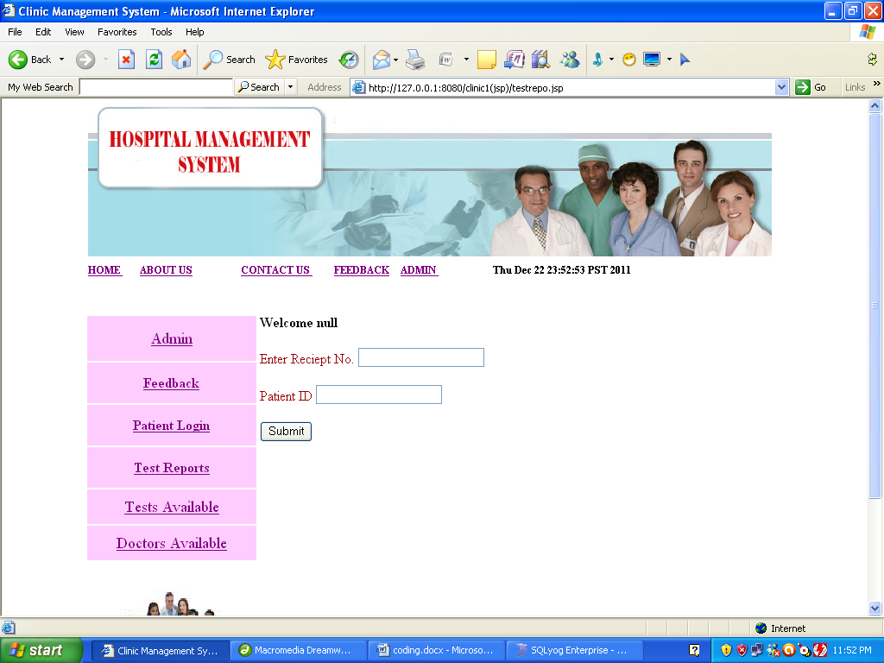
<%@ page language="java" %>
<%@ page session="true" %>
<html>
<head>
<title>CLINICAL Management System</title>
<style type="text/css">
<!--
.style7 {
font-family: Arial, Helvetica, sans-serif;
font-size: 16px;
font-weight: bold;
color: #0000FF;
}
.style8 {
font-size: 18px;
color: #CC3300;
}
.style10 {font-size: 16px}
.style11 {color: #990000}
-->
</style>
</head>
<body>
<table width="778" border="0" align="center" cellspacing="0">
<tr>
<td colspan="2" height="120"><%@ include file="header.jsp" %></td>
</tr>

<tr>
<td width="78" align="left" valign="top">
<%@ include file="menu.jsp"%></td>
<td width="696" align="left" valign="top" bgcolor="#FFFFFF"><form name="form1" method="post" action="testrepo2.jsp">

<b>Welcome <%=session.getAttribute("empid")%></b> <p class="style11 style10" __designer:dtid="1688858450198550"><a href="status.jsp"></a><strong> </strong>Enter Reciept No.
<input type="text" name="textfield">
</p>
<p class="style11 style10" __designer:dtid="1688858450198550">Patient ID
<input type="text" name="textfield2">
</p>
<p class="style11 style10" __designer:dtid="1688858450198550">
<input type="submit" name="Submit" value="Submit">
</p>
</form>
<p>&nbsp;</p>
<h1>&nbsp;</h1> <p class="style7" __designer:dtid="281479271677962">&nbsp;</p> </td>
</tr>
</table>
</body>
</html>

Code Efficiency:

Reviewing of Code efficiency for a module is carried out after the module is successfully compiled and all the syntax errors eliminated. Code efficiency review is extremely cost-effective strategies for reduction in coding errors in order to produce high quality code. Normally, two types of efficiency are carried out on the code of a module - code optimization and code inspection. The procedure and final objective of these two efficiency techniques are very different as discussed below.

Optimization of Code:

Code optimization is an informal code analysis technique. In this technique, after a module has been coded, it is successfully compiled and all syntax errors are eliminated. Some members of the development team are given the code a few days before the optimization meeting to read and understand the code. Each member selects some test cases and simulates execution of the code by hand (i.e. trace execution through each statement and function execution). The main objectives of the optimization are to discover the algorithmic and logical errors in the code. The members note down their findings to discuss these in a optimization meeting where the coder of the module is also present.
Even though a code optimization is an informal analysis technique, several guidelines have evolved over the years for making this naïve technique more effective and useful. Of course, these guidelines are based on personal experience, common sense, and several subjective factors. Therefore are based on personal experience, common sense, and several subjective factors. Therefore, guidelines should be considered as examples rather than as rules to be applied dogmatically. Some of these guidelines are the following:

The team performing the code optimization should not be either too big or too small. Ideally, it should consist of three to seven members.

CHAPTER – 8

TESTING PHASE

One of the purposes of the testing is to validate and verify the system. Verification means checking the system to ensure that it is doing what the function is supposed to do and Validation means checking to ensure that system is doing what the user wants it to do.
No program or system design is perfect; communication between the user and the designer is not always complete or clear, and time is usually short. The result is errors and more errors. Theoretically, a newly designed system should have all the pieces in working order, but in reality, each piece works independently. Now is the time to put all the pieces into one system and test it to determine whether it meets the user's requirements. This is the best chance to detect and correct errors before the system is implemented. The purpose of system testing is to consider all the likely variations to which it will be subjected and then push the system to its limits. If we implement the system without proper testing then it might cause the problems.

1. Communication between the user and the designer.
2. The programmer's ability to generate a code that reflects exactly the system specification.
3. The time frame for the design.

Theoretically, a new designed system should have all the pieces in working order, but in reality, each piece works independently. Now is the time to put all the pieces into one system and test it to determine whether it meets the requirements of the user. The process of system testing and the steps taken to validate and prepare a system for final implementation are:

LEVELS OF TESTING:
The different types of testing are as follows:

UNIT TESTING
VALIDATION
INTREGRATIONN
SYSTEM

1. Unit Testing:

This is the smallest testable unit of a computer system and is normally tested using the white box testing. The author of the programs usually carries out unit tests.

2. Integration Testing:

In integration testing, the different units of the system are integrated together to form the complete system and this type of testing checks the system as whole to ensure that it is doing what is supposed to do. The testing of an integrated system can be carried out top-down, bottom-up, or big-bang. In this type of testing, some parts will be tested with white box testing and some with black box testing techniques. This type of testing plays very important role in increasing the systems productivity. We have checked our system by using the integration testing techniques.

3. System Testing:

A part from testing the system to validate the functionality of software against the requirements, it is also necessary to test the non-functional aspect of the system. Some examples of non-functional tools include tests to check performance, data security, usability/user friendliness, volume, load/stress that we have used in our project to test the various modules.

System testing consists of the following steps:

1. Program(s) testing.
2. String testing.
3. System testing.
4. System documentation.
5. User acceptance testing.

4. Field Testing:
This is a special type of testing that may be very important in some projects. Here the system is tested in the actual operational surroundings. The interfaces with other systems and the real world are checked. This type of testing is very rarely used. So far our project is concerned, we haven't tested our project using the field testing.

- Acceptance Testing:
After the developer has completed all rounds of testing and he is satisfied with the system, then the user takes over and re-tests the system from his point of view to judge whether it is acceptable according to some previously identified criteria. This is almost always a tricky situation in the project because of the inherent conflict between the developer and the user. In this project, it is the job of the bookstores to check the system that whether the made system fulfills the goals or not.

Why System Testing?

Testing is vital to the success of the system. System testing makes a logical assumption that if all the parts of the system are correct, the goal will be successfully achieved. Inadequate testing results in two types of problems:

1. The time lag between the cause and the appearance of the problem.
2. The effect of system errors on the files and records within the system.
Another reason for system testing is its utility as a user-oriented vehicle before implementation.

Activity Network for System Testing

The test plan entails the following activities:
1. Prepare test plan.
2. Specify conditions for user acceptance testing.
3. Prepare test data for program testing.
4. Prepare test data for transaction path testing.
5. Plan user training.
6. Compile/assemble programs.
7. Prepare job performance aids.
8. Prepare operational documents.

Prepare Test
A workable test plan must be prepared in accordance with established design specifications. It includes the following items:
• Outputs expected from the system.
• Criteria for evaluating outputs.
• A volume of test data.
• Procedure for using test data.
• Personnel and training requirements.
Specify Conditions for User Acceptance Testing
Planning for user acceptance testing calls for the analyst and the user to agree on conditions for the test.

Prepare Test Data for Program Testing
As each program is coded, test data are prepared and documented to ensure that all aspects of the program are properly tested.

Prepare Test Data for Transaction Path Testing
This activity develops the data required for testing every condition and transactions to be introduced into the system. The path of each transaction from origin to destination is carefully tested reliable results.

Plan User Training

User training is designed to prepare the user for testing and converting the system. User involvement and training take place parallel with programming for three reasons:
• The system group has time available to spend on training while the programs are being written.
• Initiating a user-training program gives the systems group a clearer image of the user's interest in the new system.
• A trained user participates more effectively in system testing.

The training plan is followed by preparation of the user training manual and other text materials.

Compile / Assemble Programs
All programs have to be compiled / assembled for testing.
Prepare Job Performance Aids
In this activity the materials to be used by personnel to run the system are specified and scheduled. This includes a display of materials.

Prepare Operational Documents
During the test plan stage, all operational documents are finalized including copies of the operational formats required by the candidate system.

Systems testing
The computer department to ensure that the system functions as specified does this testing. This testing is important to ensure that a working system is handed over to the user for acceptance testing.

Acceptance testing.
The user to ensure that the system functions, as the user actually wanted performs this testing. With prototyping techniques, this stage becomes very much a formality to check the accuracy and completeness of processing. The screen layouts and output should already have been tested during the prototyping phase.

An error in the program code can remain undetected indefinitely. To prevent this from happening the code was tested at various levels. To successfully test a system, each condition, and combinations of conditions had to be tested. Each program was tested and linked to other programs. This unit of program is tested and linked to other units and so on until the complete system has been tested.

The purpose of testing is to ensure that each program is fully tested. To do so a test plan had to be created. The test plan consists of a number of test runs such as the valid paths through the code, and the exception and error handling paths. For each test run there is a list of conditions tested, the test data used and the result expected. The test plan was then reviewed to check that each path through the code is tested correctly. It is the responsibility of the programmer to collect the data that will produce the required test condition.

VERIFICATION AND VALIDATION (V&V):

The objectives of verification, validity activities are to assess and improve the quality of the work products generated during development and modification of the software. Quality depends upon the various attributes like correctness, completeness, consistency, reliability, usefulness, usability, efficiency and conformance to standards.

The terms verification and validation are used synonymously. These are defined as under: -
Verification: “Are we building the product right?”
Validation: “Are we building the right product?”

Verification activities include proving, testing, and reviews. Validation is the process of evaluating software at the end of the software development to ensure compliance with the software requirements. Testing is a common method of validation. Clearly, for high reliability we need to perform both activities. Together, they are often called V&V activities.

The major V&V activities for software development are inspection, reviews, and testing (both static and dynamic). The V&V plan identifies the different V&V tasks for the different phases and specifies how these tasks contribute to the project V&V goals. The methods to be used for performing these V&V activities, the responsibilities and milestones for each of these activities, inputs and outputs for each V&V task, and criteria for evaluating the outputs are also specified.

The two major V&V approaches are testing and inspections. Testing is an activity that can be generally performed only on code. It is an important activity and is discussed in detail in a later chapter. Inspection is a more general activity that can be applied to any work product, including code. Many of the V&V tasks are such that for them, an inspection type of activity is the only possible way to perform the tasks (e.g. trace ability and document evaluation). Due to this, inspections play a significant role in verification.
- SYSTEM IMPLEMENTATION

System Implementation Maintenance and Review

As we know, creating software is one thing and the implementation of the created software is another. The process of implementing software is much difficult as compared to the task of creating the project. First we have to implement the software on a small scale for removing the bugs and other errors in the project and after removing them we can implement the software on a large scale. Before we think in terms of implementing the Software on a large basis, we must consider the Hardware requirements.
Whenever we develop software or project a certain hardware and software is being used by the programmer for developing the project. The hardware and software to be used by the programmer for developing the project should be such that it would result in the development of a project, which would satisfy all the basic needs for which the project has been created by the programmer. The Hardware should be such that cost constraints of the Client should also be taken into account without affecting the performance.

HARDWARE EVALUATION FACTORS:

When we evaluate computer hardware, we should first investigate specific physical and performance characteristics for each hardware component to be acquired. These specific questions must be answered concerning many important factors. These hardware evaluation factors questions are summarized in the below figure.

Notice that there is much more to evaluating hardware than determining the fastest and cheapest computing device. For e.g. the question of possible obsolescence must be addressed by making a technology evaluation. The factor of ergonomics is also very important. Ergonomics is the science and technology that tries to ensure that computers and other technologies are "user-friendly", that is safe, comfortable and easy to use. Connectivity is another important evaluation factor, since so many computer systems are now interconnected within wide area or local area telecommunications networks.

HARDWARE EVALUATION FACTORS:
1) Performance
2) Cost
3) Reliability
4) Availability
5) Compatibility
6) Modularity
7) Technology
8) Ergonomics
9) Connectivity
10)Environmental requirements
11)Software
12)Support

SOFTWARE EVALUATION FACTORS:

Software can be evaluated according to many factors similar to the hardware evaluation. Thus the factors of performance, cost, reliability, compatibility, modularity, technology, ergonomics, and support should be used to evaluate proposed software acquisitions. In addition, however, the software evaluation factors are summarized in below figure. For e.g. some software packages require too much memory capacity and are notoriously slow, hard to use, or poorly documented. They are not a good selection for most end users, even if offered at attractive prices.

1) Efficiency: is the software a well-written system of computer instructions that does not use much memory capacity or CPU time?
2) Flexibility: can it handle its processing assignments easily without major modifications?
3) Security: does it provide control procedures for errors, malfunctions and improper use?
4) Language: do our computer programmers and users write it in a programming language that is used?
5) Documentation: is the s/w well documented? Does it include helpful user instructions?
6) Hardware: does existing hardware have the features required to best use this software?
7) Other characteristics of hardware such as its performance, what about the cost, how much is reliable and etc.

- SECURITY MEASURES

Security Performed In CLINICALManagement System
User Name & Password security implemented so that no unauthorised person
can handle any operation without username and Password.
- Only authorized person can log-on the system.
- Only authorized person can update the records.
- Only authorized person can handle the reservation.
- Only authorized person can print the report.

It has two kinds of users:

- Administrator
- User1

Administrator: He has complete authority (Read, Add, Modify) of operating the software. The User Name and Password provided to the Administrator in this project is:

User Id: Admin
Password: admin123

User1: When this user logs onto the system, he can only view information and other reports. He can generate different reports.

User Id: User1
Password: user123

- FURTHER SCOPE OF THE APPLICATION

- Though maximum efforts have been put in to make this report authentic in all aspects and to take all necessary presentation to ensure that the information gathered is true, some uncomfortable factors may have crept in.
- Some of the respondents were reluctant to part with certain information on the pretext of the sensitivity of the information. Also some facts of figures were not divulged as the company policy came in the way for free revelation of the desired input.
- An element of bias might have crept in from the side of the official interviewed. This could also have resulted in some kind of modification of the information divulged.
- Through an attempt was make to collect information from the best possible source in the company, it was difficult to meet the top officials due to their busy schedules.
- Most of the analysis and interpretations, made for this report, are based on secondary data obtained. This data could have some inherent mistakes and errors.
- Finally, although due care has been taken those can be typing and compilation errors in the report itself.

The tasks specified were not well defined because nothing was mentioned regarding validations in the project. Though we gave maximum effort to check the software with different validation tests, a few of them might be present in this version.

- Due to limited time available survey could not be undertaken for intended 20 consumers and thus had to be limited to 10.
- Communication gaps exist between employees and management, as seniors don't share problem with subordinates resulting in violation of psychological contract.
- Poor rewarding system(slow)
- Poor working conditions

The limitations may be many and the magnitude of the influence of these limiting factors may have a bearing on the report, but it in no way alters the ultimate aim of the project and because it's highly USER FRIENDLY, it would be the choice of all kinds of personnel.

- CONCLUSIONS

This project has been a rewarding experience in more than one way. The entire project work has enlightened us in the following areas.

a) We have gained an insight into the working of the CLINICAL. This represents a typical real world situation.

b) Our understanding of database design has been strengthened this is because in order to generate the final reports of database designing has to be properly followed.

c) Scheduling a project and adhering to that schedule creates a strong sense of time management.

d) Sense of teamwork has developed and confidence of handling real life project has increased to a great extent.

e) Initially, there were problem with the validation but with discussions, we were to implement validations.

