## **Energy Efficient Motor Drive Systems**

### Introduction

Since the industrial revolution, motors have replaced humans and animals as the primary source of useful work. James Watt observed that a horse pulling 180 pounds of force made 144 trips around the circle in an hour, at an average speed of 181 feet per minute. The horse generated 33,000 ft. lbs. per minute, which Watt called one “horsepower”. At the time, generating 1 hp required a 1,000 pound, 6 foot tall horse that in today’s dollars costs about $5,000 per year to board. Today, generating 1 hp requires a 32 lb motor (30x less than a horse), which is about 4 x 6 inches (12x less than a horse) and costs about $250 per year to power (20x less than a horse). Thus, motors are essential to our modern economy and can be viewed as a primary generator of wealth in modern society.

|  |  |
| --- | --- |
|  |  |

Today, motors consume about 75% of all the electricity used by industry. Their popularity is a testament to their reliability, versatility and efficiency. However, the large quantity of energy consumed by motors means that small improvements in motor drive system efficiency result in large savings. This chapter discusses fundamentals of motor drive systems and how to make them more efficient.

### How Motors Work

Motors produce useful work by causing a shaft to rotate. By far the most common type of motor is the squirrel cage induction motor; its operation is described here. Other motor types include shaded pole, synchronous, permanent magnet, reluctance and DC motors for precise speed control.

Squirrel cage induction motors consist of a rotating shaft to which a rotor is attached. The rotor is made of solid, uninsulated metal bars connected to solid metal rings of the same material at each end. The rotor has no external electrical connections. The stator surrounds the rotor, and has two or more poles. Each pole consists of an iron bar wrapped in conductive aluminum or copper wire. The poles create magnetic fields when electrical current passes through their wire wrappings. The magnetic fields are rotated from pole to pole around the stator, causing the rotor to rotate.

The rotor rotates at a synchronous speed given by the following equation:

rpm = frequency of applied voltage (Hz) x 60 / number of pair poles

Thus, a two pole motor with a 60 Hz power supply rotates at 3,600 rpm and a four pole motor rotates at 1,800 rpm. The difference between the synchronous speed and the actual speed is called the slip. For example, most motors with a synchronous speed of 1,800 rpm rotate at about 1,750 rpm. Slip generally decreases with motor size.

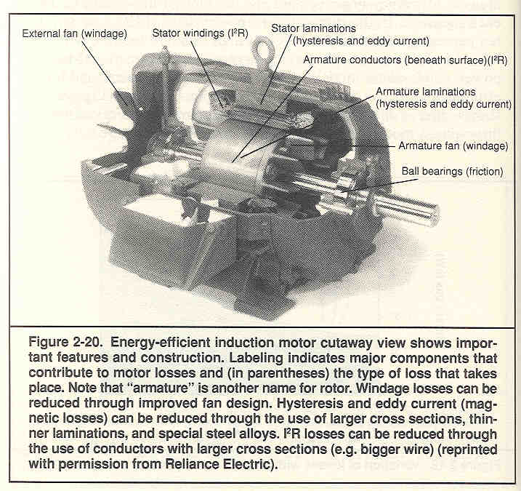

Source: Nadel et al., 1991

#### Synchronous Motors

Synchronous motors can run at low speeds, and are thus good fits for low speed applications such as reciprocating compressors. Synchronous motors are also slightly more efficient than induction motors. Finally, synchronous motors can generate or absorb reactive power, whereas induction motors can only absorb reactive power. Thus, large synchronous motors are sometimes able to correct the power factor of an entire plant.

#### Direct Current Motors

Direct current motors use direct, rather than alternating, current. In DC motors, the speed can be varied simply by varying the voltage.

### Motor Selection

#### NEMA Class

The National Electric Manufacturers Association (NEMA) classifies motors as NEMA A, B, C, and D, depending on the relationship between torque and speed. Design B motors are by far the most common and are used for most fan, pump and compressor applications.

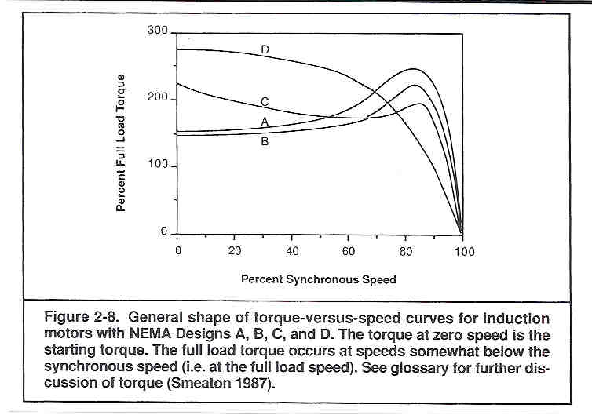

Source: Nadel et al., 1991

#### Motor Speed

Motors are also selected according to synchronous speed. Common speeds are 3,600, 1,800, 1,200, …, rpm. The most common motor speed is 1,800 rpm.

#### Enclosure Type

Motors come with different enclosure types for different surroundings. NEMA defines about 20 enclosure types divided into two basic groups: open and totally enclosed. The most common types are open drip proof (ODP) and totally enclosed fan cooled (TEFC).

#### Service Factor

The service factor indicates the capacity of the motor to withstand prolonged overloading. Service factor 1.0 indicates that the motor should only be operated at 100% load or less. Service factor 1.3 indicates that the motor could be operated at 130% capacity without failing, although the life of the insulation may be reduced.

#### Frame Size

The frame defines the shape and size of the motor. For motor replacements, the frame size of the new motor must match the frame size of the older motor to avoid expensive mounting modifications. In 1952, the industry standardized U-frames, such that all 254U frames were identical. In 1964, the industry standardized T-frames, which are smaller and lighter. Most current motors are T-frames.

### Determining Motor Input Power

The best way to determine motor power consumption is with a power meter. Power meters simultaneously measure the current, voltage and power factor and combine these measurements to determine power. For a three-phase motor, the power consumption is:

Power (kW) = Average Current of 3 Phases (A) x Voltage (V) x  x PF (W/VA)

Many motors are sized to be 75% to 80% loaded. Thus, power can be estimated as:

Power (kW) = 

Example:

If a motor draws 100 A at 480 V with PF = 0.80, calculate input power:

Pin = 100 A x 480 V x 0.8 kW/kVA x 31/2 / 1,000 VA/kVA = 66 kW

Alternately, if motor power input is measured, fraction loaded can be determined as the ratio of actual output power to rated output power.

Example:

Calculate fraction loaded of a 100 hp, 95% efficient motor drawing 66 kW

Output Power = 66 kW x 0.95 / 0.75 kW/hp = 84 hp

Fraction Loaded = 84 hp / 100 hp = 84%

### Motors and Power Factor

Many types of electrical equipment, such as motors or lighting ballasts, require that more power be supplied to the equipment than is actually consumed by the equipment. The ratio of the actual power consumed by equipment (Pa) to the power supplied to equipment (Ps) is called the power factor. The reactive power (Pr) is a measure of the unusable power.



In inductive motors, the current lags the voltage, creating unusable reactive power. Because of this, the power factor of inductive motors is always less than 1.0 and declines under decreasing load. Typical power factors as functions of rated load and horsepower are shown in the table below.

|  |  |  |  |  |
| --- | --- | --- | --- | --- |
| Load / hp | 0.25 | 0.50 | 0.75 | 1.00 |
| 10 | 0.54 | 0.70 | 0.77 | 0.80 |
| 20 | 0.58 | 0.72 | 0.79 | 0.81 |
| 25 | 0.58 | 0.73 | 0.79 | 0.81 |
| 30 | 0.59 | 0.73 | 0.79 | 0.81 |
| 40 | 0.61 | 0.74 | 0.80 | 0.82 |
| 50 | 0.63 | 0.76 | 0.81 | 0.82 |
| 60 | 0.65 | 0.77 | 0.82 | 0.83 |
| 75 | 0.67 | 0.78 | 0.83 | 0.84 |
| 100 | 0.70 | 0.80 | 0.84 | 0.85 |

**Moving Motor Use to Off-Peak Shift**

Some motors are used only during one shift. Moving use to an off-peak shift can reduce electrical demand charges.

Example:

Calculate the savings from moving a grinding operation to off-peak shift, if the 50-hp grinder motor is 80% loaded and 90% efficient. The cost of electrical demand is $10 /kW-month.

Annual Savings:

50-hp x 80% / 90% x 0.75 kW/hp = 33 kW

33 kW x $10 /kW-mo x 12 mo/yr = $4,000 /yr

Note that most motors operate at 900, 1,800 or 3,600 RPM.

Thus, although motors typically draw more current (power) as the motor comes up to speed, they typically come up to speed in a few seconds. Most utilities calculate peak electrical demand over a 15 or 30 minute period. Thus, a few seconds of high power draw is rarely enough time to significantly increase total use during demand period. Hence, there is negligible demand penalty from motor start up, and motors should be turned off motors when not in use.

### Turning Off Motors When Not Equipment is Idle

Motor power consumption depends on the load on the motor. In some types of manufacturing equipment, such as CNC machines, the load on the motor powering the lathe is very small when the equipment is idling. Thus, the savings from turning off CNC machines when the equipment idles are relatively small. However, motors in other equipment, such as stamping machines with flywheels and hydraulic power systems, are typically highly loaded even when the equipment is idling. Thus, turning off this this type of equipment when not in use can result in large savings.

|  |  |
| --- | --- |
|  |  |

Example

A stamping press motor is 80% loaded while stamping and 65% loaded when the press is idle. Thus, 81% of peak power is dissipated as heat due to friction. Calculate the savings from turn off a 90% efficient, 50-hp stamping press motor for 2,000 hr/yr when the press idles. The cost of electricity is $0.10 /kWh.

Annual Savings:

50 hp x .65 / 90% x .75 kW/hp x 2,000 hr/yr = 54,167 kWh/yr

54,167 kWh/yr x $0.10 /kWh = $5,417 /yr

Example

A 20-hp hydraulic system motor draws 8 kW while the machine it powers is loaded and 5 kW while the machine idles. Thus, it draws 63% of loaded power when the machine idles by forcing the unneeded hydraulic fluid through a bypass valve. Calculate the savings from turning off the hydraulic motor for 2,000 hr/yr when the equipment it powers idles. The cost of electricity is $0.10 /kWh.

Annual Savings:

5 kW x 2,000 hr/yr = 10,000 kWh/yr

10,000 kWh/yr x $0.10 /kWh = $1,000 /yr

### Power Transmission

The drivetrain, or transmission, connects the motor shaft to the load. The most common types of drivetrains are direct shaft couplings, gears, belt drives and chains.

#### Direct Shaft Couplings

Direct shaft couplings transfer virtually 100% of the power from the motor to the load and are the most energy efficient type of power transmission.

#### Gear Drives

Gears are typically used for loads which must run slowly and which require high torque such that a belt may slip. Helical and bevel gears are widely used and have an efficiency of about 98% per stage. Worm gears allow a large reduction ratio in a single stage and are usually cost less than helical or bevel gears. Worm gears have efficiencies between 55% and 95%. Gear drive efficiency decreases significantly at low load and low speeds.

#### V-Belt Drives

Belt drives allow flexibility in the positioning of the motor and load. In addition, the desired rotating speed of the load can be achieved by selecting pulleys (sheaves) with the proper diameters. Because of these advantages, belt-drives are very common.

The most common type of belt is a V-belt. As V-belts travel around the pulleys, they flex and heat up. This heat is energy supplied to from the motor and reduces the efficiency of power transmission between the motor and the load.

Standard V-belts have a smooth inner surface. Cogged, or notched, V-belts work are identical to standard V-belts, but are notched on their inner circumference. The notches make them more flexible and improve the efficiency of power transmission.

|  |  |
| --- | --- |
|  |  |

Standard and cogged V-belts. Source: Dayco CPT, www.cptbelts.com

A belt manufacturer (Dayco, www.cptbelts.com) reports that:

* Cogged V-belts are 98% efficient compared to 94-95% efficient standard V-belts.
* Life of cogged V-belts is 50% longer than standard V-belts
* Cost of cogged V-belts is about 50% more than standard V-belts

Another study of motor electricity consumption with variable loads showed electricity savings of 2% to 3.75% when standard V-belts were replaced with cogged V-belts. In general, the savings increased with motor loading (see Figure and reference below).

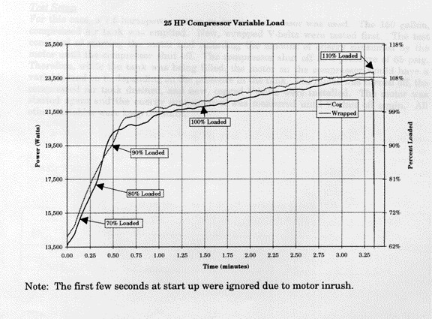

Source: **Michigan Manufacturing Technology Center,** Manufacturing Efficiency Decision Support, Case Study - Cog Belts, <http://meds.mmtc.org/casestudy.asp?X=Cog%20Belts>

Another source reports that cogged V-belts increase the efficiency of transmission by about 2% (Energy Tips: Replace V-Belts with Cogged or Synchronous Belt Drives, DOE/GO-102000-0972, Office of Industrial Technologies, U.S. Department of Energy).

In addition to significantly improving power-transmission efficiency, cogged V-belts also last at least 50% longer than standard V-belts. Some maintenance personnel report that cogged V-belts last four times as long as standard V-belts. This longevity reduces equipment downtime and replacement costs, which more than compensates for the 20% to 50% higher cost of cogged V-belts.

Because of these advantages, we recommend using cogged V-belts in virtually all V-belt applications except for clutching applications because of their aggressive grip (Grainger, 2001-2002) or in noise sensitive environments since cogged V-belts are slightly noisier than standard V-belts.

Example

Replace smooth with notched V-belts on 100-hp, 91% efficient motor if the end use load is 75% of rated motor output. The motor operates 6,000 hours per year and the cost of electricity is $0.10 /kWh.

Annual Savings

100 hp x 75% / 0.91 x (1/.92-1/.95) x 0.75 kW/hp = 2.12 kW

2.12 kW x 6,000 hours/yr x $0.10 /kWh = $1,273 /year

Implementation Cost

Notched belts last 50% to 400% longer than smooth belts, but cost only 30% more than smooth belts, thus implementation cost is negligible

Simple Payback

Immediate

#### Synchronous Belt Drives

|  |  |
| --- | --- |
| Synchronous belts have teeth that engage in the teeth of the sprocket pulley. Because synchronous belts are designed for maximum flexibility and have virtually no slippage, they are about 98% efficient and last about 4 times as long as V-belts.  However, synchronous belt drives are more costly than V-belts and typically require more attention to alignment to operate properly. Thus, they are typically used on large motors with long operating hours where energy savings outweighs the other issues.  De Almeida and Greenberg estimate that synchronous belts last about 24,000 hours, and cost between $8 and $16 per horsepower, with large drives at the low end of this spectrum. | Source: Nadel et al., 1991 |

Example

Replace smooth V-belt with synchronous belt drive on 100 hp, 91% efficient motor if end use load is 75% of rated motor power output. The motor operates 6,000 hours per year and the cost of electricity is $0.10 /kWh.

Annual Savings

100 hp x 75% / 0.91 x (1/.92-1/.98) x 0.75 kW/hp = 4.11 kW

4.11 kW x 6,000 hours/yr = 24,680 kWh/year

24,680 kWh/year x $0.10 /kWh = $2,468 /year

Implementation Cost

$12 /hp x 100 hp = $1,200

Simple Payback

$1,200 / $2,468 = 6 months

### Motor Efficiency

The cost of electricity for operating a motor is typically many times greater that the cost of the motor. The figure below shows typical electricity costs for various size motors and annual operation hours.

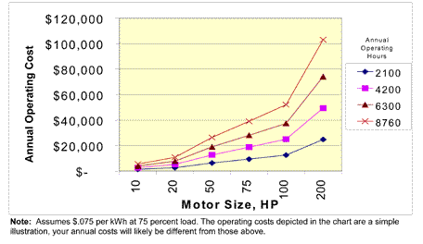

Source: Motor Decisions Matter, [www.motorsmatter.org](http://www.motorsmatter.org)).

In fact, the cost of energy during the first year of use alone typically exceeds the purchase cost.

Example

Compare the $1,200 purchase cost of a 20-hp, 93% efficient motor to the annual energy cost if the motor operates 6,000 hours per year, is 75% loaded, and the cost of electricity is $0.10 /kWh.

Annual energy cost:

20 hp x 75% / 93% x .75 kW/hp x 6,000 hr/yr x $0.10 /kWh = $7,258 /yr

Ratio of 1 year energy to purchase cost:

$7,258 / $1,200 = 6x !

Ratio of 10 year energy to purchase cost:

($7,258 x 10) / $1,200 = 60x !

Thus, it is usually highly cost effective to purchase the highest efficiency motor available. Besides energy savings, high-efficiency motors offer several other important benefits. First, high-efficiency motors run cooler than standard motors because of lower losses and because they operate at a higher power factor. In addition, high-efficiency motors often use heavier duty bearings. Because of these changes, high-efficiency motors typically run longer than standard motors.

In the 1980s, most motor manufacturers began offering energy-efficient motors (EEMs) with efficiencies 2% to 10% higher than standard-efficiency motors (SEMs). As of October 1997, all motors manufactured or imported into the United States had to meet new, higher efficiency standards. Today, these motors are typically called "energy-efficient" motors (EEMs). Today’s highest efficiency motors are called "premium-efficiency" motors (PEMs). The table below shows the efficiency of standard motors before 1997, minimum efficiency ratings for all motors after 1997 (energy-efficient motors), and minimum efficiency ratings to qualify as a NEMA premium-efficiency motor after 1997.

Efficiencies for Totally Enclosed Fan Cooled, 4 Pole, ~1740 RPM Motors.

|  |  |  |  |
| --- | --- | --- | --- |
| Size (hp) | Std Eff  Before 10/1997 | Engy Eff  After 10/1997 | Prem Eff  After 10/1997 |
| 1 | 78.5 | 82.5 | 85.5 |
| 2 | 84.0 | 84.0 | 86.5 |
| 5 | 86.5 | 87.5 | 89.5 |
| 10 | 88.5 | 89.5 | 91.7 |
| 15 | 88.5 | 91.0 | 92.4 |
| 20 | 90.2 | 91.0 | 93.0 |
| 25 | 91.0 | 92.4 | 93.6 |
| 30 | 91.0 | 92.4 | 93.6 |
| 40 | 91.7 | 93.0 | 94.1 |
| 50 | 93.0 | 93.0 | 94.5 |
| 60 | 92.4 | 93.6 | 95.0 |
| 75 | 93.0 | 94.1 | 95.4 |
| 100 | 93.0 | 94.5 | 95.4 |
| 125 | 93.0 | 94.5 | 95.4 |
| 150 | 93.6 | 95.0 | 95.8 |
| 200 |  | 95.0 | 96.2 |

Source: Std Eff Before 10/1997: Grainger 1995

Source: Engy Eff After 10/1997: The Impacts of the Energy Policy Act of 1992 on Industrial End Users of Electric Motor-Driven Systems, U.S. Department of Energy, http://www.oit.doe.gov/bestpractices/motors/factsheets/e-pact92.pdf.

Source: Prem Eff After 10/1997: NEMA Premium, Product Scope and Nominal Efficiency Levels, www.nema.org/premiummotors.

### Replace or Repair?

Most motors failures are due to electrical or mechanical failure. The primary cause of electrical failure is degradation of winding insulation. Over time, winding insulation degrades due to heating, aging and over-voltage transients. As winding insulation degrades, the efficiency of the motor may also degrade, causing its operating temperature to increase. Another indication of winding failure is a greater than 10% difference in the amperage drawn by each leg of a three-phase motor. Eventually, winding failure can lead to shock, fire hazard and total motor failure. Sometimes motor failures are related to mechanical breakdowns, especially for motors in high-vibration environments. 75% of all mechanical failures are due to bearing failure.

#### Deciding Whether to Repair or Replace Motors

When motors fail, they can be replaced or repaired. The decision to replace or repair must often be made quickly, because the costs of lost production may outweigh energy savings. For this reason, we recommend establishing a motor replacement plan before motors fail. This plan may include pre-selecting energy-efficient replacement motors before key existing motors fail. It may also include working with your motor vendor to ensure that the replacement motors you want can be obtained quickly.

Efficiency and cost data to determine the economics of replacing or repairing motors is incorporated into the MotorMaster+ software. MotorMaster+ includes a database of most motors currently on the market, is available free of charge from the U.S. D.O.E. Typical costs and efficiencies from MotorMaster+ are shown in the table below.

Source: US DOE Motor Master+ 4.0 (2007)

|  |  |  |  |  |
| --- | --- | --- | --- | --- |
| **Size (hp)** | **Efficiency Rwd** | **Cost Rwd** | **Efficiency Premium Motor** | **Cost Premium Motor** |
| 1 | 74.0% | $213 | 85.6% | $333 |
| 1.5 | 76.8% | $223 | 86.5% | $352 |
| 2 | 79.3% | $237 | 87.0% | $406 |
| 3 | 80.5% | $249 | 89.9% | $489 |
| 5 | 83.0% | $271 | 90.4% | $495 |
| 7.5 | 84.9% | $319 | 91.8% | $706 |
| 10 | 85.7% | $377 | 92.0% | $805 |
| 15 | 86.5% | $463 | 92.8% | $1,089 |
| 20 | 88.3% | $536 | 93.5% | $1,286 |
| 25 | 88.9% | $614 | 93.9% | $1,696 |
| 30 | 89.2% | $722 | 94.1% | $2,104 |
| 40 | 89.4% | $858 | 94.4% | $2,747 |
| 50 | 91.1% | $1,033 | 94.9% | $3,183 |
| 60 | 91.4% | $1,171 | 95.1% | $4,400 |
| 75 | 91.5% | $1,365 | 95.5% | $5,118 |
| 100 | 91.7% | $1,716 | 95.5% | $6,167 |
| 125 | 91.1% | $2,028 | 95.3% | $8,075 |
| 150 | 92.3% | $2,420 | 95.6% | $9,301 |
| 200 | 92.8% | $2,985 | 96.2% | $11,281 |
| 250 | 93.6% | $3,571 | 96.3% | $14,051 |
| 300 | 93.7% | $4,211 | 96.1% | $19,846 |
| 350 | 94.0% | $4,734 | 95.8% | $24,404 |
| 400 | 93.1% | $5,168 | 95.8% | $26,750 |
| 450 | 94.0% | $5,722 | 95.8% | $27,896 |
| 500 | 93.7% | $6,212 | 95.8% | $29,436 |

These data can be used to determine the payback of replacing rather than repairing failed motors. In general, the payback time for replacing rather than repairing failed motors is short, but increases with motor size.

Example

Determine the simple payback of replace rather than rewinding a 20-hp motor. The motor operates 6,000 hours per year, is 75% loaded, and the cost of electricity is $0.10 /kWh.

Annual Savings

20 hp x 75% x (1/.883-1/.935) x 0.75 kW/hp = 0.71 kW

0.71 kW x 6,000 hours/yr = 4,251 kWh/year

4,251 kWh/year x $0.10 /kWh = $425 /year

Implementation Cost

$1286 - $536 = $750

Simple Payback

$750 / $425 = 21 months

Example

Determine the simple payback of replace rather than rewinding a 100-hp motor. The motor operates 6,000 hours per year, is 75% loaded, and the cost of electricity is $0.10 /kWh.

Annual Savings

100 hp x 75% x (1/.917-1/.955) x 0.75 kW/hp = 2.44 kW

2.44 kW x 6,000 hours/yr = 14,645 kWh/year

14,645 kWh/year x $0.10 /kWh = $1,464 /year

Implementation Cost

$6,167 - $1,716 = $4,451

Simple Payback

$4,451 / $41,464 = 36 months

### Motor Maintenance

A good motor maintenance program can extend the lifetime of motors, reduce production downtime from unexpected motor failures and reduce motor repair costs. Key elements of a good motor maintenance program are discussed below.

#### Cleaning

Clean motors run better. Dirt acts as an insulator and causes the motor to run hotter. Dirt can also damage lubricants, bearings and insulation.

#### Lubrication

Most small motors and motors with factory-sealed bearings do not require lubrication. For motors that do require lubrication, we recommend carefully following manufacturer guidelines. Do not over lubricate and be careful not to introduce contaminants. For motors used seasonally, we recommend lubrication before the season of use.

#### Mounting

Check the mounting system and hold-down bolts at every maintenance interval. Loose bolts, cracks or failure of the mounting structure can cause vibration and deflection that can damage bearings.

#### Belt Drives

Check belt drives for proper tension or wear frequently. Loose v-belts vibrate, wear rapidly and waste energy. If the belts are too tight, high lateral loading may damage motor bearings. Always replace all belts on a drive at the same time. Check belts frequently until they are broken in, usually after about 48 hours of use.

#### Electrical, Thermal and Vibration Tracking

We recommend measuring and logging the current draw, voltage, temperature and vibration of large, process-critical motors. By tracking these key indices, process downtime can be avoided and repair expenses minimized.

Measure and log motor current draw and voltage across each phase. Voltage imbalances are not usually indicative of motor problems, but can cause current imbalances. Balanced voltage with unbalanced current may indicate motor problems. Some maintenance personnel send motors in for repair when the current imbalance between legs exceeds 10%. Changes in the current draw usually indicate changes in the load. This may indicate clogged filters or other problems.

Always make temperature and vibration measurements on the same spot on the motor. Simple hand-held contact thermometers and vibration meters work well. Make measurements after the motor is warmed up and when under the same motor loading conditions. An increasing temperature trend can indicate electrical or bearing problems. An increasing vibration trend indicates bearing wear.

#### Storage and Transport

Motors can have a shorter life in storage than while operating. If the motor shaft is not periodically rotated, lubricant may drain away from bearings causing metal-to-metal contact and rust. Stored motors are especially susceptible to bearing damage from vibration, since lubricant may be pushed away allowing metal-to-metal contact. Insulation on the motor windings can absorb moisture from humid air.

When storing motors, rotate the shaft or operate the motor at least once per month. Avoid storing motors near vibratory machinery. Don’t store motors in cold or damp spaces where the relative humidity exceeds 70%. Before shipping a motor, block the shaft, drain the oil, and label the motor as needing oil.

### Oversized Motors

Most motors are sized to operate at 75% to 80% of full load power. At this level of loading, motor efficiency and power factor remain relatively high. However, motor efficiency and power factor decrease rapidly at less than 25% loading. Thus, dramatically oversized motors should be replaced with appropriately sized motors.

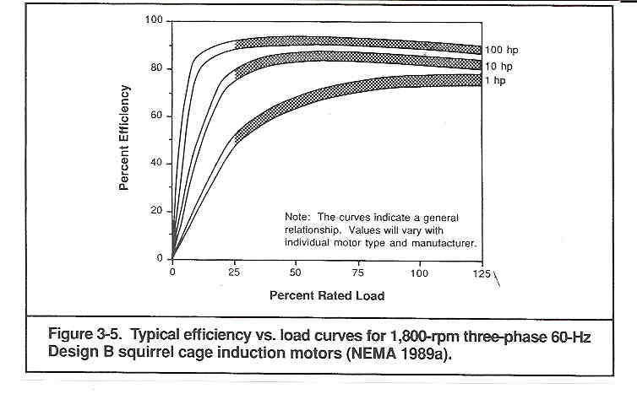

Example

Right-size a 100-hp, 10% loaded motor. The motor operates 6,000 hours per year and the cost of electricity is $0.10 /kWh.

From the figure above, the efficiency of a 100-hp motor at 10% load is about 60%. At this load and efficiency, input power is:

100 hp x 10% / 60% x .75 kW/hp = 12.50 kW

Output power is:

100 hp x 10% = 10 hp.

Thus, the load could be driven with a 10-hp motor. From the figure above, the efficiency of a 10-hp motor at 100% load is about 82%. Input power of a 10-hp motor at 82% efficiency is:

10 hp / 82% x .75 kW/hp = 9.15 kW

Annual savings:

(12.5 kW - 9.15 kW) x 6,000 hr/yr = 20,100 kWh/yr

20,100 kWh x $0.10 /kWh = $2,012 /yr

Implementation Cost

A 10-hp motor costs about $500

Simple Payback

$500 / $2,012 /yr x 12 mo/yr = 3 months

### Soft-Start Controls

When a motor starts under a high-torque load, it typically draws much more than full load power as it comes up to speed. The time for a motor to come up to speed varies according to the load, but is usually less than 10 seconds. Over time, full-voltage hard starts with high in-rush currents can damage the motor. The high in-rush current may also trip circuit breakers.

|  |  |  |
| --- | --- | --- |
|  |  |  |

Source: Power Efficiency Corporation product literature, [www.performancecontrol.com](http://www.performancecontrol.com), 734-975-9111.

Soft-start controls limit the in-rush of current during motor startup to create smoother but longer starts. Because of this, soft-start controls may extend motor life, especially for motors that frequently cycle on and off. Soft-start controls have minimal affect on peak electrical demand because the high inrush startup current typically lasts only a few seconds and the peak demand is usually averaged over 15 minutes to one hour.

Soft-start controls can also reduce electricity consumption for under-loaded motors by modifying the voltage waveform. Soft-start controller manufacturers claim energy savings of between 20% and 50% for lightly-loaded motors. The controllers react fast enough to track variable loads without difficulty. Reduced energy consumption also results in cooler running motors. In addition, soft-start controls may also reduce current imbalance between phases and improve power factor.

Ideal applications for soft-start controls are motors that are frequently cycled on and off, and/or motors that run at reduced load most of the time. Typical prices for soft-start controls are shown below.

|  |  |
| --- | --- |
| Motor Size | Cost (including installation kit) |
| <= 20 hp | $840 |
| 40 hp | $2,100 |
| 100 hp | $2,800 |
| 200 hp | $5,700 |

Source: Power Efficiency Corporation

[www.performancecontrol.com](http://www.performancecontrol.com), 734-975-9111.

In addition, manufactures report that the installation time for a qualified electrician is about two hours.

### References

Ambs, L. and Frerker, M., 1997, “The Use of Variable Speed Drives to Retrofit Hydraulic Injection Molding Machines”, National Industrial Energy Technology Conference, Houston, TX, April.

Danfoss, “Application Reference Guide”, Version 0.00, Danfoss, Inc.

Machelor, J., 1999, “Root Cause Failure Analysis on AC Induction Motors”, Energy Matters, Office of Industrial Technologies, US Department of Energy, May 1999.

McCoy, G. and Douglass, J., 1997, “Energy Management for Motor-Driven Systems”, Motor Challenge Program, US Department of Energy, Washington, DC.

MotorMaster+ 3.0, U.S. Department of Energy, Office of Industrial Technologies, Washington, D.C.

Nadel, S., Shepard, M., Greenberg, S., Katz, G., and Almeida, A., 1991, “Energy Efficient Motor Systems”, American Counsel for an Energy Efficient Economy, Washington D.C.

De Almeida and Greenberg , "Technology assessment: Energy-Efficient Belt Transmissions."