AMBIENT BACKSCATTER

Small computing devices are increasingly embedded in objects and environments such as thermostats, books, furniture, and even implantable medical devices . A key issue is how to power these devices as they become smaller and numerous; wires are often not feasible, and batteries add weight, bulk, cost, and re- quire recharging or replacement that adds maintenance cost and is difﬁcult at large scales.

Ambient RF from TV and cellular communications is widely available in urban areas (day and night, indoors and out- doors). Further, recent work has shown that one can harvest tens to hundreds of microwatts from these signals. Thus, a positive answer would enable ubiquitous communication at unprecedented scales and in locations that were previously inaccessible.

Designing such systems, however, is challenging as the simple act of generating a conventional radio wave typically requires much more power than can be harvested from ambient RF signals. Ambient backscatter, a novel communication mechanism that enables devices to communicate by backscattering ambient RF. In traditional backscatter communication (e.g., RFID), a device communicates by modulating its reﬂections of an incident RF signal (and not by generating radio waves). Hence, it is orders of magnitude more energy-efﬁcient than conventional radio communication.
Ambient backscatter differs from RFID-style backscatter in three key respects. Firstly, it takes advantage of existing RF signals so it does not require the deployment of a special-purpose power infrastructure—like an RFID reader—to transmit a high-power (1W) signal to nearby devices. This avoids installation and maintenance costs that may make such a system impractical, especially if the environment is outdoors or spans a large area. Second, and related, it has a very small environmental footprint because no additional energy is consumed beyond that which is already in the air. Finally, ambient backscatter provides device-to-device communication. This is unlike traditional RFID systems in which tags must talk exclusively to an RFID reader and are unable to even sense the transmissions of other nearby tags.

To understand ambient backscatter in more detail, consider two nearby battery-free devices, Alice and Bob, and a TV tower in a metropolitan area as the ambient source, as shown in Fig. 1. Sup- pose Alice wants to send a packet to Bob. To do so, Alice backscatters the ambient signals to convey the bits in the packet—she can indicate either a ‘0’ or a ‘1’ bit by switching her antenna between reﬂecting and non-reﬂecting states.

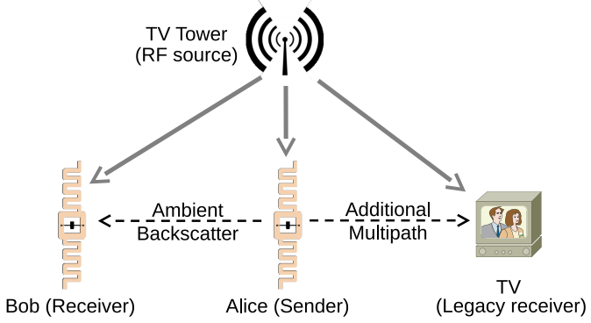

The signals that are reﬂected by Alice effectively create an additional path from the TV tower to Bob and other nearby receivers. Wideband receivers for TV and cellular applications are designed to compensate for multi-path wire- less channels, and can potentially account for the additional path. Bob, on the other hand, can sense the signal changes caused by the backscattering, and decode Alice’s packet.

