PG DEPARTMENT OF COMPUTER APPLICATIONS
marian college kuttikkanam

SEMINAR ROUGH DRAFT ON
AMBIENT BACKSCATTER TECHNOLOGY

SUBMITTED TO:
SR. REGINA SABS
SUBMITTED BY:
RINTO P JOSEPH
III MCA, 143
AMBIENT BACKSCATTER TECHNOLOGY
ABSTRACT
We present the design of a communication system that enables two devices to communicate using ambient RF as the only source of power. Our approach leverages existing TV and cellular transmissions to eliminate the need for wires and batteries, thus enabling ubiquitous communication where devices can communicate among themselves at unprecedented scales and in locations that were previously inaccessible.
To achieve this, we introduce ambient backscatter, a new communication primitive where devices communicate by backscattering ambient RF signals. Our design avoids the expensive process of generating radio waves; backscatter communication is orders of magnitude more power-efficient than traditional radio communication. Further, since it leverages the ambient RF signals that are already around us, it does not require a dedicated power infrastructure as in traditional backscatter communication. To show the feasibility of our design, we prototype ambient backscatter devices in hardware and achieve information rates of 1 kbps over distances of 2.5 feet and 1.5 feet, while operating outdoors and indoors respectively. We use our hardware prototype to implement proof-of concepts for two previously infeasible ubiquitous communication applications.
CATEGORIES AND SUBJECT DESCRIPTORS
1. INTRODUCTION
Small computing devices are increasingly embedded in objects and environments such as thermostats, books, furniture, and even implantable medical devices. A key issue is how to power these devices as they become smaller and numerous; wires are often not feasible, and batteries add weight, bulk, cost, and require recharging or replacement that adds maintenance cost and is difficult at large scales.
In this paper, we ask the following question: can we enable devices to communicate using ambient RF signals as the only source of power? Ambient RF from TV and cellular communications is-
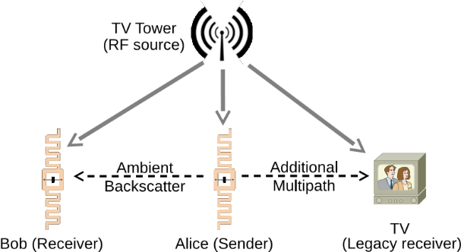
Figure 1—Ambient Backscatter: Communication between two battery-free devices. One such device, Alice, can backscatter ambient signals that can be decoded by other ambient backscatter devices. To legacy receivers, this signal is simply an additional source of multi-path, and they can still decode the original transmission.
-widely available in urban areas (day and night, indoors and outdoors). Further, recent work has shown that one can harvest tens to hundreds of microwatts from these signals. Thus, a positive answer would enable ubiquitous communication at unprecedented scales and in locations that were previously inaccessible.
Designing such systems, however, is challenging as the simple act of generating a conventional radio wave typically requires much more power than can be harvested from ambient RF signals. In this paper, we introduce ambient backscatter, a novel communication mechanism that enables devices to communicate by backscattering ambient RF. In traditional backscatter communication (e.g., RFID), a device communicates by modulating its reflections of an incident RF signal (and not by generating radio waves). Hence, it is orders of magnitude more energy-efficient than conventional radio communication.
Ambient backscatter differs from RFID-style backscatter in three key respects. Firstly, it takes advantage of existing RF signals so it does not require the deployment of a special-purpose power infrastructure—like an RFID reader—to transmit a high-power (1W) signal to nearby devices. This avoids installation and maintenance costs that may make such a system impractical, especially if the environment is outdoors or spans a large area. Second, and related, it has a very small environmental footprint because no additional energy is consumed beyond that which is already in the air. Finally, ambient backscatter provides device-to-device communication. This is unlike traditional RFID systems in which tags must talk exclusively to an RFID reader and are unable to even sense the transmissions of other nearby tags.
To understand ambient backscatter in more detail, consider two nearby battery-free devices, Alice and Bob, and a TV tower in a metropolitan area as the ambient source, as shown in Fig. 1. Suppose Alice wants to send a packet to Bob. To do so, Alice backscatters the ambient signals to convey the bits in the packet—she can indicate either a ‘0’ or a ‘1’ bit by switching her antenna between-
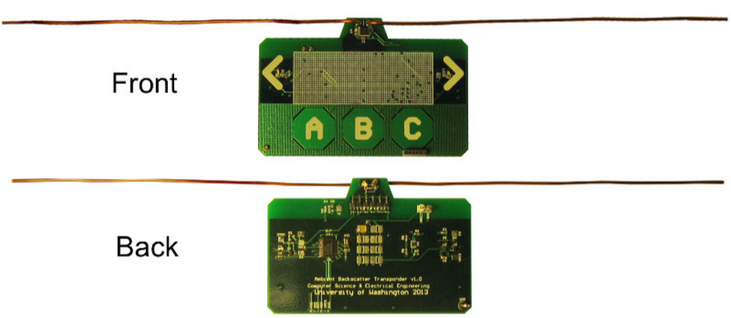
Figure 2—Prototype: A photo of our prototype PCB that can harvest, transmit and receive without needing a battery or powered reader. It also includes touch sensors (the A, B and C buttons), and LEDs (placed near the two arrows) that operate using harvested energy and can be programmed by an onboard microcontroller.
-reflecting and non-reflecting states. The signals that are reflected by Alice effectively create an additional path from the TV tower to Bob and other nearby receivers. Wideband receivers for TV and cellular applications are designed to compensate for multi-path wireless channels, and can potentially account for the additional path. Bob, on the other hand, can sense the signal changes caused by the backscattering, and decode Alice’s packet.
Designing an ambient backscatter system is challenging for at least three reasons.
- Since backscattered signals are weak, traditional backscatter uses a constant signal to facilitate the detection of small level changes. Ambient backscatter uses uncontrollable RF signals that already have information encoded in them. Hence it requires a different mechanism to extract the backscattered information.
- Traditional backscatter receivers rely on power-hungry components such as oscillators and ADCs and decode the signal with relatively complex digital signal processing techniques. These techniques are not practical for use in a battery-free receiver.
- Ambient backscatter lacks a centralized controller such as an RFID reader to coordinate all communications. Thus, it must operate a distributed multiple access protocol and develop functionalities like carrier sense that are not available in traditional backscattering devices.
Our approach is to co-design the hardware elements for ambient backscatter along with the layers in the network stack that make use of it. The key insight we use to decode transmissions is that there is a large difference in the information transfer rates of the ambient RF signal and backscattered signal. This difference allows for the separation of these signals using only low-power analog operations that correspond to readily available components like capacitors and comparators. We are similarly able to realize carrier sense and framing operations with low-power components based on the physical properties of ambient backscatter signals. This in turn lets us synthesize network protocols for coordinating multiple such devices.
To show the feasibility of our ideas, we have built a hardware prototype, shown in Fig. 2, that is approximately the size of a credit card.¹ Our prototype includes a power harvester for TV signals, as well as the ambient backscatter hardware that is tuned to communicate by using UHF TV signals in a 50 MHz wide frequency band centered at 539 MHz. The harvested energy is used to provide the small amounts of power required for ambient backscatter and to run the microcontroller and the on-board sensors. Our prototype also includes a low-power flashing LED and capacitive touch sensor for use by applications.
We experiment with two proof-of-concept applications that show the potential of ambient backscatter in achieving ubiquitous communication. The first application is a bus pass that can also transfer money to other cards anywhere, at any time. When a user swipes the touch sensor in the presence of another card, it transmits the current balance stored in the microcontroller and confirms the transaction by flashing the LED. The second is a grocery store application where an item tag can tell when an item is placed in a wrong shelf. We ask 10 tags to verify that they do not contain a misplaced tag and flash the LED when they do.
We evaluate our system in both indoor and outdoor scenarios and at varying distances between the transmitter and receiver. To account for multi-path effects, we repeat our measurements with slight perturbations of the receiver position for a total of 1020 measurements. Results show that our prototypes can achieve an information rate of 1 kbps between two ambient backscattering devices, at distances of up to 2.5 feet in outdoor locations and 1.5 feet in indoor locations. Furthermore, we test a variety of locations and show that our end-to-end system (which includes communication, an LED, touch sensors and a general-purpose microcontroller) is able to operate battery-free at distances of up to additional paths from the transmitter to the TV receiver, the existing a 6.5 miles from the TV tower. Finally, we test the interference of ambient backscattering and find that, even in less favourable conditions, it does not create any noticeable glitches on an off-the-shelf TV, as long as the device is more than 7.2 inches away from the TV antenna. ²
Our Contributions: We make the following contributions:
- We introduce ambient backscatter, the first wireless primitive to let devices communicate without either requiring them to generate RF signals (as in conventional communications) or reflect signals from a dedicated powered reader (as in RFID).
- We develop a network stack that enables multiple ambient backscattering devices to co-exist. Specifically, we show how to perform energy detection without the ability to directly measure the energy on the medium and hence enable carrier sense.
- We present designs and a prototype which show how all of the above, from ambient backscatter through to the multi-access protocols of our network, can be implemented on ultra-low-power devices using simple analog components.
While the performance of our prototype is a modest start, we hope that the techniques we present will help realize ubiquitous communication, and allow computing devices embedded into the physical world to communicate amongst themselves at an unprecedented scale.
2. BACKGROUND ON TV TRANSMISSIONS
In principle, ambient backscatter is a general technique that can leverage RF signals including TV, radio and cellular transmissions. In this paper we have chosen to focus on demonstrating the feasibility of ambient backscatter of signals from TV broadcast sources. TV towers transmit up to 1 MW effective radiated power ( ERP ) and can serve locations more than 100 mi away from the tower in very flat terrain and up to 45 mi in denser terrain. The coverage of these signals is excellent, particularly in urban areas with the top four broadcast TV channels in America reaching 97% of households and the average American household receiving 17 broadcast TV stations. It is this pervasive nature of TV signals that make them attractive for use in our first ambient backscatter prototype.
There are currently three main TV standards that are used around the world: ATSC (N. America and S. Korea), DVB-T (Europe, Australia, New Zealand, etc.) and ISDB-T (Japan, most of S. America). While our prototype targets ATSC transmissions, our method for communicating using ambient signals leverages the following properties of TV signals that hold across all standards:
Firstly, TV towers broadcast uninterrupted, continuous signals at all hours of the day and night. Thus, they provide a reliable source of both power and signal for use in ambient backscatter. Secondly, TV transmissions are amplitude-varying signals that change at a fast rate. For example, in ATSC, which uses an 8-level vestigial sideband (8VSB) modulation to transmit one of eight amplitude values per symbol, symbols are sent over a 6 MHz wideband channel, resulting in a very fast fluctuation in the signal.
Lastly, TV transmissions periodically encode special synchronization symbols that are used by the receiver to compute the multipath channel characteristics. In ATSC, the 8VSB symbols are organized first into data segments of 832 symbols and then fields of 313 segments. Before every data segment, the transmitter sends a data segment sync that consists of four symbols and is intended to help the receiver calibrate the 8VSB amplitude levels. Before every field, the transmitter sends a field sync data segment that is also used by the receiver to compute the channel information. Since ambient backscatter effectively creates a ability of TV receivers to account for multipath distortion make them resistant to interference from backscattering devices that operate _{at} a lower rate than these sync segments. We note that the other common TV standard in the world—DVB-T, which uses OFDM modulation—includes cyclic prefixes and guard intervals, and hence has an even higher resistance to multipath distortion compared to the ATSC standard.
Legality: In general, it is illegal to broadcast random signals on spectrum reserved for TV (or cellular) channels. However, battery free backscattering devices (e.g. RFID tags) are unregulated and not tested by FCC because the emission levels from such devices is very low and because they are only modulating their reflection of a pre-existing signal rather than actively emitting a signal in reserved spectrum. Ambient backscatter also falls into this category, and would therefore be legal under current policies.
3. AMBIENT BACKSCATTER DESIGN
Ambient backscatter is a new form of communication in which devices can communicate without any additional power infrastructure (e.g., a nearby dedicated reader). An ambient backscattering device reflects existing RF signals such as broadcast TV or cellular transmissions to communicate. Since the ambient signals are preexisting, the added cost of such communication is negligible.
Designing such devices, however, is challenging for three main reasons: First, the ambient signals are random and uncontrollable. Thus, we need a mechanism to extract the backscattered information from these random ambient signals. Second, the receiver has to decode these signals on a battery-free device which significantly limits the design space by placing a severe constraint on the power requirements of the device. Third, since there is no centralized controller to coordinate communications, these devices need to operate a distributed multiple access protocol and develop functionalities like carrier sense. In the rest of this section, we describe how our design addresses the above challenges.

3.1 Overview
Fig. 3 shows a block diagram of our ambient backscattering device design. It consists of a transmitter, a receiver and a harvester that all use the same ambient RF signals and thus are all connected to the same antenna. The transmitter and receiver use modulated backscattering of ambient signals to communicate, and-
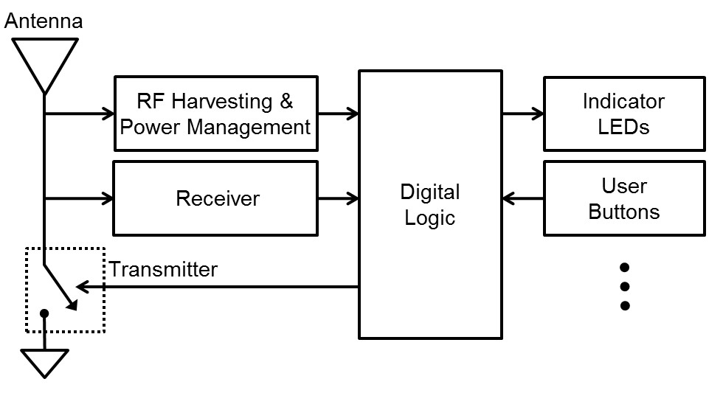
Figure 3—Block diagram of an ambient backscattering device. The transmitter, receiver, and the harvester are all connected to a single antenna and use the same RF signals. The transmitter and receiver communicate by backscattering the ambient signals. The harvester collects energy from the ambient signals and uses it to provide the small amount of power required for communication and to operate the sensors and the digital logic unit.
-the harvester extracts energy from those same ambient signals to provide power for the device. Further, they operate independent of each other. However, while the transmitter is active and backscattering signals, the receiver and harvester cannot capture much signal/power. The harvested energy is used to provide the small amounts of power required for ambient backscatter communication and to power the sensors and the digital logic units (e.g., microcontroller). We reproduce the harvester circuit in and use it as a black box. The main difference from is that we operate the harvester using a small dipole antenna, instead of a large horn antenna. Next, we describe our design of the ambient backscattering transmitter and receiver in more detail.

3.2 Ambient Backscattering Transmitter
The design of our ambient backscattering transmitter builds on conventional backscatter communication techniques. At a high level, backscattering is achieved by changing the impedance of an antenna in the presence of an incident signal. Intuitively, when a wave encounters a boundary between two media that have different impedances/densities, the wave is reflected back . The amount of reflection is typically determined by the difference in the impedance/density values. This holds whether the wave is a mechanical wave that travels through a rope fixed to a point on a wall or an electromagnetic wave encountering an antenna. By modulating the electrical impedance at the port of the antenna one can modulate the amount of incident RF energy that is scattered, hence enabling information to be transmitted.
To achieve this, the backscatter transmitter includes a switch that modulates the impedance of the antenna and causes a change in the amount of energy reflected by the antenna. The switch consists of a transistor connected across the two branches of the dipole antenna. The input signal of the switch is a sequence of one and zero bits. When the input is zero, the transistor is off and the impedences are matched, with very little of the signal reflected. When the switch input signal is one, the transistor is in a conducting stage which shorts the two branches of the antenna and results in a larger scattered signal amplitude. Thus, the switch toggles between the backscatter (reflective) and non-backscatter (absorptive) states to convey bits to the receiver.
We note the following about our design: Firstly, the communication efficiency is high when the antenna topology is optimized for the frequency of the ambient signals. Our implementation uses a 258 millimeter dipole antenna, optimized for a 50 MHz subset ( in this case, from 515-565 MHz) of the UHF TV band. Other antenna topologies such as meandered antennas and folded dipoles can result in smaller dimensions, and further design choices can be made to increase the bandwidth of the antenna in order to make it capable of utilizing a larger frequency band. However, exploring this design space is not within the scope of this paper.
Secondly, RF switches can have a large difference between their conducting and non-conducting impedance values, but only in the specific frequency range that they are designed for. For example, using a switch that is optimized for use in RFID tags that operate in 915 MHz would not be optimal for ambient backscatter of lower frequency TV signals. Thus, the ambient backscattering transmitter should select a switch that is optimal for the operational frequencies of the ambient signals.
Finally, the switches and antennas are not designed to specifically backscatter and receive on a particular TV channel. For example, in ATSC, each TV channel has a 6 MHz bandwidth and different TV channels are typically allocated to adjacent non-overlapping frequencies. Since ambient backscattering devices backscatter all these signals, they do not require fine tuning for each frequency and can work as long as there are TV transmissions on at least one of the frequencies.

3.3 Ambient Backscattering Receiver
Designing an ambient backscatter receiver is challenging for two main reasons: First, ambient signals already encode information and hence backscattering additional information over these signals can be difficult. Second, the backscattered information should be decodable on an ultra-low-power device without using powerhungry hardware components such as ADCs and oscillators. To address these challenges, we first show how one can extract the backscattered information from the ambient signals using a conventional digital receiver. We then describe an ultra-low-power receiver design that uses only analog components.

3.3.1 Extracting Backscatter Information from Ambient Signals
Ambient signals like TV and cellular transmissions encode information and hence are not controllable. To illustrate this, Fig. 4(a) shows an example of the time-domain ambient TV signal captured on a USRP operating at 539 MHz. For comparison, Fig. 4(b) plots the typical time domain signal received on a USRP from an RFID reader transmitting at 915 MHz. While the traditional RFID transmission is a constant amplitude signal, the ambient TV signal varies significantly in its instantaneous power. This is expected because the captured ATSC TV signals encode information using 8 VSB modulation, which changes the instantaneous power of the trans-
mitted signal. Thus, the receiver should be capable of decoding the backscattered signals in the presence of these fast changing signals.
In this section, we describe our mechanism assuming a powerful digital receiver that samples the analog signal and performs demodulation and decoding in the digital domain. In the next section, we extend it to work using only analog components.
Our key insight is that if the transmitter backscatters information at a lower rate than the ambient signals, then one can design a receiver that can separate the two signals by leveraging the difference in communication rates. Specifically, ambient TV signals encode information at a bandwidth of 6 MHz, so if we ensure that the transmitter backscatters information at a larger time-scale than 6 MHz, then the receiver can extract the backscattered information using averaging mechanisms. Intuitively, this works because the wideband ambient TV signals change at a fast rate and hence adjacent samples in TV signals tend to be more uncorrelated than the adjacent samples in the backscattered signals. Thus, averaging the received signal across multiple samples effectively removes the variations in-
0
100
200
300
400
500
600
700
800
900
1000
0
0.1
0.2
0.3
0.4
Time Sample #
Amplitude
(
Signal
TV
Captured
)
a
0
50
100
150
200
250
300
350
0
0.05
0.1
0.15
0.2
0.25
0.3
0.35
Time Sample #
Amplitude
RFID Reader
starts transmitting
a constant wave
signal

(b) Captured RFID Reader Signal
Figure 4—Comparison of the incident signal on a backscattering transmitter’s antenna in both (a), ambient backscatter, and (b), conventional RFID.
-the wideband ambient TV signals, allowing the backscattered signals to be decoded.
For completeness, we formally describe why this works. Say we have a digital receiver that samples the received signal at the Nyquist-information rate of the TV signal. The received samples, y[n], can then be expressed as a combination of the wideband TV signals and the backscattered signals, i.e., y[n] = x[n] + αB[n]x[n] + w[n]
where x[n]s are the samples corresponding to the TV signal as received by the receiver, w[n] is the noise, α is the complex attenuation of the backscattered signals relative to the TV signals, and B[n] are the bits transmitted by the backscattering transmitter. Since the receiver samples at the TV Nyquist rate, the adjacent samples in x[n] are uncorrelated. Now, if the backscatterer conveys information at a fraction of the rate, say _{N}¹ , then B[Ni + j]s are all equal for j = 1 to N.
If the receiver averages the instantaneous power in the N receiver samples corresponding to a single backscattered bit, then we get:
N N
1
N N i=1 i
where B is either ‘0’ or ‘1’. Since the TV signal, x[n], is uncorrelated with noise, w[n], we can rewrite the above equation as:
N N N
i=1 i=1 i=1
|1 + α|²P and P when the transmitter is in the reflecting and nonreflecting states, respectively. The receiver can distinguish between the two power levels, |1 + α|²P and P, to decode the information from the backscattering transmitter. Thus, even in the presence of changes in the TV signal, the receiver can decode information from the backscattering transmitter.
0
100
200
300
400
500
600
700
800
900
1000
0
0.1
0.2
0.3
0.4
0.5
0.6
Time Sample #
Power
signal
Backscatter
)
plus
TV
Original
a
(
0
100
200
300
400
500
600
700
800
900
1000
0.19
0.21
0.23
0.25
0.27
Time Sample #
Power

(b) Signal After Averaging
Figure 5—Comparison of backscattered signal received both with (b) and without (a) averaging.
We apply the above mechanism to the ambient ATSC TV signals. Specifically, we set our ambient backscattering transmitter to transmit an alternating sequence of ones and zeros at a rate of 1kbps. Fig. 5(a) plots the received signal on an USRP that is placed one foot from the transmitter. Fig. 5(b) plots the effect of averaging every 100 received samples. As the figure shows, averaging reduces the effect of the fast-varying ambient TV signals. Further, the receiver can now see two average power levels which it can use to decode the backscattered information.
We note that ambient backscatter can either increase or decrease the average power of the received signal. Specifically, the channel, α, is a complex number and hence |1 + α| can be either less than or greater than one. This means that a zero bit can be either a lower power than the average power, P, in the TV signal, or can have a higher power than the average. Intuitively, this is because the additional multi-path created by the backscattering transmitter can either constructively or destructively interfere up with the existing signal. We use differential coding to eliminate the need to know the extra mapping between the power levels and the bits (see §4.1).

3.3.2 Decoding on an Ultra-Low-Power Device
The above design assumes that the receiver can get digital samples on which it can perform operations like averaging and comparison of power levels. However, acquiring digital samples requires an analog-to-digital converter (ADC) which can consume a significant amount of power and is typically avoided in ultra-low-power designs. In this section, we imitate the above operations in analog hardware by selecting an appropriate analog circuit topology.
As shown in Fig. 6, our receiver has two stages: an envelope detection and averaging circuit that smoothens out the natural variations in the TV signal, and a compute-threshold circuit that produces a threshold between the two levels. A comparator compares the average envelope signal to the threshold to generate output bits.
Average Envelope stage: This circuit is implemented using an envelope detector and RC (resistive/capacitive) circuit to smooth/average out the natural variations in the TV signals. As shown in Fig. 6, it has two simple hardware elements: a diode and a capacitor C₁, and also makes use of a current path through two serial resistors, R₁ and R₂. To a first approximation, diodes act as-

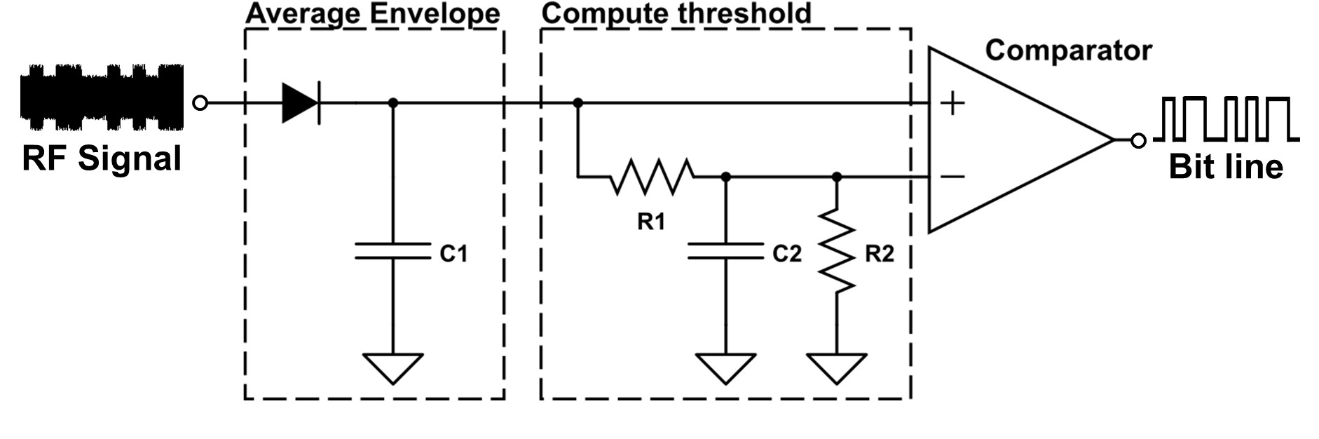
Figure 6—Circuit Diagram for the Demodulator: The demodulator has two stages: an envelope detection and averaging stage that produces an average envelope of the signal, and a computethreshold stage that compares the averaged signal with a threshold value computed by taking a longer-term average of the signal.
-one-way valves, allowing current to flow in one direction but not the other, capacitors are charge storage elements, and resistors regulate current flow. In this circuit, the diode provides charge whenever the input voltage is greater than the voltage at the capacitor. During the time period when the input is lower than the voltage on the capacitor, the diode does not provide charge and the resistors slowly dissipate the energy stored on the capacitor, lowering the voltage. The rate of drop of voltage is roughly determined by the product C₁(R₁ + R₂). Thus, by balancing the values of R₁ and R₂ against the effective resistance of the diode and selecting an appropriate capacitance, the circuit shown can act as a low-pass filter, averaging out the fast natural variations in the TV signals but preserving the slowly varying backscattered bits.
Compute-Threshold stage: The output of the averaging circuit produces two signal levels, corresponding to the ‘0’ and the ‘1’ bits. In principle, a receiver with an ADC can distinguish between the two signal levels by processing the digital samples. Specifically, say we have two signals with different voltages, V ₀ and V₁, V₁ > V₀, where V ₀ and V₁ correspond to the power levels for the zero and one bits. To distinguish between them, the receiver would first compute a threshold value which is the average of the two signal levels, i.e., V0+V ¹ 2 . When the received signal is greater than this threshold, we conclude that the received signal is V₁; otherwise, we conclude that the received signal is V ₀.
Since we choose to eliminate the need for a full ADC in order to reduce power, the receiver imitates this operation using analog hardware. Fig. 6 shows the hardware elements used by the comparison circuit. It consists of an RC circuit and a comparator. The RC circuit re-uses the two resistors (R ₁ and R₂) and adds a capacitor (C₂) to perform further averaging, producing a threshold value of near ^{V0+}₂ ^{V1} . The comparator takes two voltage values as inputs and produces either a one or a zero to indicate which of the two values is larger. The first input to the comparator is the output of our average envelope circuit and the second input is the threshold value.
We note that the bit rate of the prototype dictates the choice of values for the RC circuit elements (e.g., a receiver operating at 10 kbps requires different RC values than one at 1 kbps). This is because, at lower rates, each bit occupies more time on the channel and hence requires more averaging to correctly compute the threshold value. §5 describes the parameters used in our implementation. Finally, while in theory we can distinguish between any two power levels by sufficient averaging, each comparator comes with a minimum gap below which it cannot distinguish between the two power levels. This gap determines the maximum distance at which two devices can communicate with each other.
4. NETWORK STACK DESIGN
The network stack design for ambient backscatter communication is closely integrated with the properties of the circuits and the-
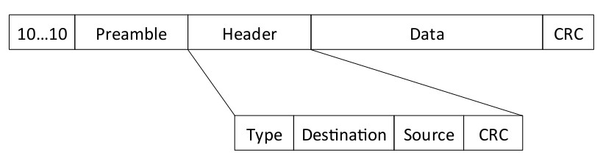
Figure 7—Packet Format: Each packet starts with an alternating sequence of ‘1’s and ‘0’s followed by a preamble that is used by the receiver to detect packets. The preamble is followed by a header and then the data, which both include CRCs used to detect bit errors.
-hardware described so far. In this section, we explore the physical layer and the link layer design for ambient backscatter.

4.1 Physical Layer
The physical layer for ambient backscatter communication addresses questions such as what modulation and coding to use, how to perform packet detection, and how to find bit boundaries.
Modulation and Bit Encoding: Since a backscattering transmitter works by switching between reflecting and non-reflecting states, it effectively creates an ON-OFF keying modulation. However, as described earlier, the backscattered signal could either constructively or destructively interfere with the ambient TV signal. Thus, depending on the receiver’s location, a ‘1’ bit could appear as either an increase or a decrease in the received power. To address this issue, the physical layer uses FM0 coding. FM0 coding turns every bit into two symbols and encodes information using symbol transitions. FM0 has a symbol transition at the beginning of every bit period along with an additional mid-bit transition to represent a ‘1’, and no such transition in the ‘0’ bit. Thus, bits are encoded using transitions in the power level, rather than the actual power levels; further, it guarantees an equal number of ‘0’ and ‘1’ symbols.
Detecting the Beginning of a Packet Transmission: At the beginning of each packet transmission, an ambient backscattering transmitter sends a known preamble that the receiver detects using bitlevel correlation on the digital hardware (in our case, the microcontroller). However, unlike RFID communication, where the tags correlate only when they are powered by a nearby reader, an ambient backscatter device does not know when nearby devices will transmit and hence might have to continuously correlate, which is power-consuming and impractical for a low-power device.
We avoid continuous correlation by only activating the relatively expensive correlation process when the comparator detects bit transitions. The comparator hardware takes very little power and has a built-in threshold before it detects bit transitions (in our implementation, this threshold is 2.4 mV). It is only when the power difference crosses this threshold that an interrupt is sent to the digital hardware to wake it up from its idle state (to perform correlation). Since the averaging circuit eliminates the large variations in the ambient TV signal, it is unlikely that ambient signals alone create changes in the power level in the absence of a packet transmission. To provide the hardware with sufficient leeway to wake up the digital hardware, as shown in Fig. 7, the transmitter sends a longer preamble that starts with an alternating 0-1 bit sequence before sending the actual preamble. The alternating bit sequence is long enough (8 bits in our implementation) to wake up the digital hardware, which then uses traditional mechanisms to detect bit boundaries and perform framing.

4.2 Link Layer
Next we describe the following aspects of an ambient backscatter link layer design: error detection, acknowledgments, and carrier sense for mediating access to the channel.
Fig. 7 depicts the high-level packet format for ambient backscatter systems. The packet starts with a few bits of the preamble that are used to wake up the receiver’s hardware; the rest of the preamble is then used by the receiver to detect the beginning of a packet. The preamble is followed by a header containing the type of packet (data/ACK), destination and source addresses, and the length of the packet. This is followed immediately by the packet’s data. Both the header and the data include CRCs, which the receiver can use to detect bit errors in either field. Data may also be protected using simple error correction codes that do not consume significant power, e.g., hamming codes, repetition codes, etc.. The receiver successfully receives a packet when both the CRC checks pass. It then sends back an acknowledgment within a pre-set time that is determined by the time it takes to successfully decode the packet at the receiver and switch to a transmitting state. In the rest of this section, we design carrier sense to arbitrate the wireless medium between these backscattering transmitters.

4.2.1 Carrier Sense
The discussion so far focuses on the communication aspects of a single ambient backscattering transmitter-receiver pair. However, when many of these devices are in range of each other, we need mechanisms to arbitrate the channel between them. In traditional RFID, a centralized, powered reader performs the task of an arbitrator for the wireless medium. Ambient backscatter communication, however, cannot rely on such a powered reader and thus requires a different set of mechanisms to provide media access control.
The advantage we have over traditional backscatter is that ambient backscattering devices can decode each other’s transmissions. Thus, they can potentially perform carrier sense: detect the beginning of other packet transmissions (preamble correlation), and detect energy in the middle of a packet transmission (energy detection). Preamble correlation for carrier sense is operationally similar to that performed by the receiver for decoding packets. Energy detection, however, is challenging because the digital hardware does not have access to the power levels.
To see this, let us look at communication systems like WiFi where energy detection is performed by computing the average power in the signal and detecting a packet when the average power is greater than a threshold. Such operations require a full ADC to get the digital samples on which to operate. Since an ambient backscattering device does not have access to a full ADC it does not have access to these power levels.
We show that one can perform energy detection by leveraging the property of the analog comparator. Specifically, unlike a traditional receiver where, even in the absence of nearby transmitters, it sees random changes in the received signal due to environmental noise; the bits output by our analog comparator are constant in the absence of a backscattering transmitter. This is because, as described in §4.1, the analog comparator has a minimum threshold below which it does not register any changes. Since the averaging circuit smoothens out the variations in the ambient signals, they typically do not create signal changes that are above this threshold. This means that in the absence of a nearby backscattering transmitter, the comparator typically outputs either a constant sequence of ones or a constant sequence of zeros. A nearby transmission, on the other hand, results in changes that are greater than the comparator’s threshold and therefore bit transitions at the comparator’s output. Since the transmitted bits have an equal number of ones and zeros (due to FM0 encoding), the comparator outputs the same number of ones and zeros. Thus comparing the number of ones and zeros allows the receiver to distinguish between the presence and absence of a backscatter transmission. More formally, the receiver performs energy detection by using the following equation:
D = 1 −
#ones + #zeros
where #ones and #zeros denote the number of zeros and ones seen at the receiver over some time interval. In the presence of a backscattering transmitter, the average number of ones and zeros is about the same, and hence D is close to one. But in the absence of any close-by backscattering transmitters, the bits output by the comparator are either mostly ones or mostly zeros; thus, D is close to zero. Our results in §6 show that the above ideas hold even with mobility and in dynamic environments.
We note that the transmitter performs carrier sense only when it has data to transmit and before it starts transmitting. Upon detection of a competing transmission, microcontrollers (including the one used in our prototype) are able to sleep for the duration of the packet by masking interrupts caused by bit transitions.³ Thus, the power drain of the above operations is minimal.

4.3 Further Discussion
So far we described the key functionalities (carrier sense, startof-frame detection, etc.) required to build a network out of ambient backscatter devices. However, there are optimizations that can increase the performance of such systems; We outline some of them:
- Multiple bit-rates: Our current prototypes operate at a specific bit rate (either 100 bps, 1 kbps or 10 kbps). In principle, one can design a single device that has demodulators for different rates and switches between them. Further, one can design rate adaptation algorithms that adapt the rate to the channel conditions and can significantly increase the performance.
- Collision Avoidance: Carrier sense enables MAC protocols like CSMA that allow devices to share the medium. One can further reduce the number of collisions by designing collision avoidance mechanisms. Prior work on random number generation on lowpower RFIDs [12] can, in principle, be leveraged to achieve this.
- Hidden Terminals: The devices can, in principle, use the RTSCTS mechanism to address the hidden terminal problem. The overhead of RTS-CTS can be reduced by stripping the RTS-CTS messages of the data and header information, and having the transmitter send a unique preamble to denote the RTS message; the receiver sends back another unique preamble as a CTS message. Any nodes that hears these messages will not transmit for a fixed predetermined amount of time, i.e., the time required to transmit the data packet and receive the ACK.
5. PROTOTYPE IMPLEMENTATION
We implement our prototype on a 4-layer printed circuit board (PCB) using off-the-shelf circuit components. The PCB was designed using Altium design software and was manufactured by Sunstone Circuits. A total of 20 boards were ordered at a cost of $900. The circuit components were hand-soldered on the PCBs and individually tested which required a total of 50 man-hours. As shown in Fig. 2, the prototype uses a dipole antenna that consists of two 2 sections of 5.08 in long 16 AWG magnetic copper wire. The prototype’s harvesting and communication components are tuned to use UHF TV signals in the 50 MHz band centered at 539 MHz⁴.
The transmitter is implemented using the ADG902 RF switch connected directly to the antenna. The packets sent by the transmitter follow the format shown in Fig. 7. Further, it is capable of transmitting packets at three different rates: 100 bps, 1 kbps, and 10 kbps. We also implement both preamble correlation and energy detection in digital logic to perform carrier sense at the transmitter. Our implementation currently does not use error correction codes and has a fixed 96-bit data payload with a 64-bit preamble.
Our implementation of the receiver circuit, described in §3.3 , uses TS881, which is an ultra-low-power comparator. The output of the comparator is fed to the MSP430 microcontroller which performs preamble correlation, decodes the header/data and verifies the validity of the packet using CRC. We implement different bit rates by setting the capacitor and resistor values, R₁, R₂, C₁, and C₂ in Fig. 6, to (150 kΩ, 10 MΩ, 27 nF,200 nF) for 100 bps, (150 kΩ, 10 MΩ, 4.7 nF,10 nF) for 1 kbps, and (150 kΩ, 10 MΩ, 680 pF,1 µ F) for 10 kbps.
Table 1 compares the power consumption of the analog portion of our transmitter/receiver with that of the WISP, an RFID-based platform. The table shows that the power consumption numbers for ambient backscatter are better than the WISP platform, and almost negligible given the power budget of our device. This is because ambient backscatter operates at lower rates (10 kbps) when compared to existing backscatter systems like the WISP, which operates at 256 kbps. So, we were able to optimize the power consumption of our prototype and achieve lower power consumption values.
Our prototype also includes two sensing and I/O capabilities for our proof-of-concept applications that are controlled by the microcontroller: low-power flashing LEDs and capacitive touch buttons implemented on the PCB using a copper layer. However, these sensors as well as the microcontroller that drives them can significantly add to the power drain. In fact, in the smart card application (see §7.1), the transmit modulator consumed less than 1% of the total system power, while the demodulator required another 1 %; demonstrating that ambient backscatter significantly reduces the communication power consumption. The power management circuitry required an additional 8% of the total power. Flashing the LEDs and polling the touch sensors at the intervals used in §7.1 consumed 26% of the total power. The remaining 64% was consumed by the microcontroller.⁵
We note that in scenarios where the TV signal strength is weak, our prototype uses duty cycling to power the sensors and the microcontroller. Specifically, when the prototype is in the sleep mode, it only harvests RF signals and stores it on a storage capacitor. Once enough energy has been accumulated on the capacitor, it goes into active mode and performs the required operations. In hardware, the duty cycle is implemented by a voltage supervisor that outputs a high digital value (indicating active mode) when the voltage on the storage capacitor is greater than 1.8 V.

6. EVALUATION
We evaluate our prototype design in the Seattle metropolitan area in the presence of a TV tower broadcasting in the 536-542 MHz range. We ran experiments at six total locations to account for attenuation of the TV signal and multipath effects in different environments. The TV signal power in the 6MHz target band for the given locations ranged between -24 dBm and -8 dBm. These locations consist of:
- Location 1 (Indoor and near): Inside an apartment 0.31 mi away from the TV tower. The apartment is on the seventh floor of a large complex with 140 units and is located in a busy neighborhood of a metropolitan area.
- Location 2 (Indoor and far): Inside an office building 2.57 mi away from the TV tower. The office tested is on the sixth floor of the building.
- Location 3 (Outdoor and near): On the rooftop of the above apartment.
- Location 4 (Outdoor and far): On the rooftop of the above office building.
- Location 5 (Outdoor and farther): On a street corner 5.16 mi away from the TV tower.
- Location 6 (Outdoor and farthest): On the top level of a parking structure 6.50 mi away from the TV tower.
We evaluate the various aspects of our design including our ambient backscattering transmitter and receiver, carrier sense, and interference at TV receivers. Most of our experiments were limited to locations 1-4 due to limited extended access to space in locations 5 and 6. The latter two locations, however, were included to demonstrate that ambient backscatter can operate at longer ranges and were tested using our smart card application.
Those test verified that we were able to get our end-to-end system to operate battery-free up to 6.5 mi away from the TV tower. Note, however, that the operational distance of our prototype is dependent on the operating voltage of the device. In our prototype, the bottleneck was the microcontroller, which requires 1.8 V. In principle, an ASIC-based design should work with much lower voltage requirements and hence can operate at farther distances.

6.1 Effectiveness of Ambient Backscattering
The effectiveness of a backscattering transmitter is determined by the extent to which it affects the received signal. To quantify this, we compute the ratio of the received power, after averaging, between the non-reflecting and reflecting states of the transmitter. Specifically, if P₁ and P₂, P₁ ≥ P₂, are the two average power levels at the receiver, we compute the ratio, ^{P}_{P}¹2 . A ratio close to one means that the receiver cannot distinguish between the two power levels; while a higher ratio increases the ability of the receiver to distinguish between them.
Experiments: We configure our prototype to send an alternating sequence of bits—switching between reflecting and non-reflecting states—at a rate of 100 bps. The results are similar for the other bit rates. Since our receiver prototype does not provide the exact power values, we instead use an USRP-N210 as a receiver to compute the power ratio between the two states. The USRP is connected to the same dipole antenna used by our receiver prototype to ensure that the antenna gains are identical. We configure the USRP to gather raw signals centered at 539 MHz using a bandwidth of 6.25 MHz—the bandwidth of the ambient TV signals. We average the received signal, as described in §3.3, and compute the ratio between the two average power levels. We repeat the experiments for different distances (from 0.5 feet to 3 feet) between the transmitter and the receiver in locations 1-4.
0
0.2
0.4
0.6
0.8
1
1
1.5
2
2.5
3
3.5
4
4.5
Cumulative Fraction
Power Ratio
Figure 8—Performance of an ambient backscattering transmitter: The x-axis plots a CDF of the ratio of the average power received during the reflecting and non-reflecting states of the backscattering transmitter. The CDF is taken across multiple positions in both indoor/outdoor and near/far scenarios.
Results: Fig. 8 plots the CDF of the observed power ratios at the receiver. The CDF is taken across both indoor/outdoor and near/far locations to provide an overall characterization of ambient backscatter that we delve into next. The figure shows the following:
- The median power ratio is about 1.4, which is in the range targeted by traditional backscatter communication in RFID devices and is a favourable ratio. To get an intuition for why this is the case, consider a hypothetical scenario where the transmitter and a receiver see the same ambient TV signal strength and the transmitter backscatters all its incident signals in the direction of the receiver. In this case, even if the transmitter and receiver are placed next to each other, the average received power with backscatter is twice the received power without backscatter, i.e., the power ratio is 2. In practice, however, the ratio is often much lower than this idealized value, as a transmitter reflects only a fraction of its incident signal in the receiver’s direction; larger distances further attenuates the signal strength.
- The power ratio can be as high as 4.3. This is due to the wireless multipath property. Specifically, because of multipath, nodes that are located at different locations see different signal strengths from the TV tower. So when the transmitter is in locations where it sees a much higher TV signal strength than the receiver, its backscattered signal can be significantly higher in amplitude than the direct TV signal.

6.2 BER at the Ambient Receiver v/s Distance
Next, we evaluate our low-power receiver described in §3.3.
Experiments: We repeat the previous experiments, but with our prototype ambient receiver receiving from the backscattering transmitter. We measure the bit error-rate (BER) observed at the receiver as a function of the distance between the transmitter and the receiver. For each distance value, we repeat the experiments at ten different positions to account for multipath effects; the transmitter sends a total of 10⁴ bits at each position. The BER is computed by comparing the transmitted bits with the bits output by the prototype’s demodulator circuit. Since the total number of bits transmitted at each position is 10⁴, we set the BER of experiments that see no errors to 10⁻⁴ (the upper bound on the BER for these experiments). Finally, since the BER depends on the transmitter’s bit rate, we evaluate three different prototypes that are designed to work at 100 bps, 1 kbps, and 10 kbps. We note that, in total, we perform 1020 measurements across bit rates and locations.
Results: We plot the results in Fig. 9. The figures show that:
- As the distance between the transmitter and receiver increases, the BER across bit rates and locations increases. Further, the BER is better in outdoor locations than in indoor locations. This
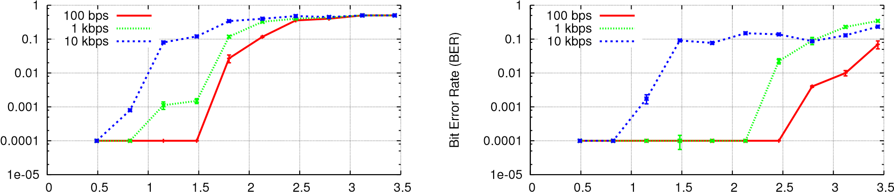
Bit Error Rate (BER)
Distance (in ft) | Distance (in ft)
(a) Location 1: Indoor and Near | (b) Location 3: Outdoor and Near
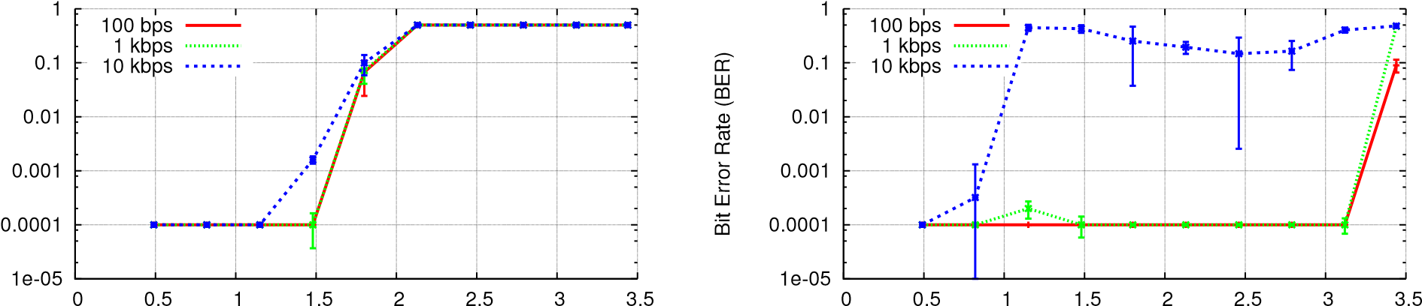
Bit Error Rate (BER)
Distance (in ft) | Distance (in ft)
(c) Location 2: Indoor and Far | (d) Location 4: Outdoor and Far
Figure 9—BER v/s Distance. BER for transmitter-receiver pairs in a range of environments, both outdoor and indoor, close to the TV tower, and far away. We show BER for distances of over three feet and three different rates.
is because TV signals are significantly attenuated in indoor locations and hence the ambient signal strength is much lower.
- Locations 1 and 3 perform slightly worse than locations 2 and 4, even though they are closer to the TV tower. This is due to the fact that the TV tower is not an ideal isotropic antenna: the radiated power is less at low angles, and thus the signal strength is less at the near locations.
- For a target BER of 10⁻², the receiver can receive at a rate of 1 kbps at distances up to 2.5 feet in outdoor locations and up to 1.5 feet in indoor locations. Such rates and distances are sufficient to enable ubiquitous communication in multiple scenarios, including our proof-of-concept applications.

6.3 Evaluating Carrier Sense
We implement carrier sense using both energy detection and preamble correlation. Energy detection is performed by computing D 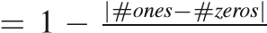_{#ones+#zeros} , where #ones and #zeros denote the number of ones and zeros seen at the receiver, within a 10-bit interval. Preamble correlation is performed by correlating with a known 64-bit preamble.
We place a transmitter and receiver, both designed for 1 kbps, in random locations within two feet of each other in both of the indoor locations. These distance are enough to include configurations where a 1 kbps receiver can hear the transmitter, but experiences high bit error rate (>10%). This is corroborated by the fact that the BER observed across the tested locations is in the range of 10⁻⁴ to 0.17. The experiments are performed both in the presence and absence of backscattering from the transmitter. We repeat the experiments at 300 locations and for three different scenarios: no motion near the receiver, human motion near the receiver, and a human holding the receiver and waving her hand in front of it.
In Fig. 10(a) we plot the CDF of the computed energy detection values (Ds). The plot shows the following: Firstly, in the absence of

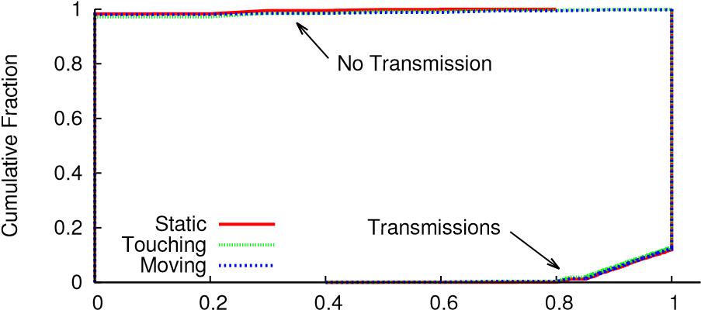
Energy Detection Parameter D

(a) Energy Detection
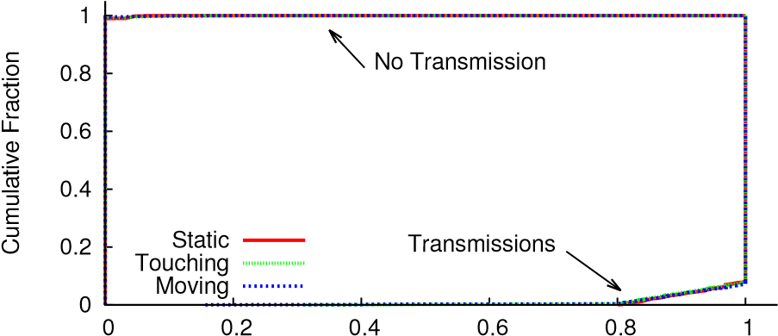
Normalized Correlation

(b) Preamble Correlation
Figure 10—Performance of Carrier Sense: These figures show that we can effectively perform energy detection and preamble correlation—the two main components of CSMA—on ambient backscattering devices.
backscatter, D is exactly zero in more than 98% of the experiments. This happens because, as described in §4.1, the analog comparator used in the receiver, typically, outputs either a constant sequence of ones or a constant sequence of zeros in the absence of a backscattered signal. Thus, the receiver sees the same bit during a 10- bit interval. Secondly, human mobility does not create statistically significant differences in the computed D values. This is because while motion can change the signal strength at the receiver and the corre-
0
0.2
0.4
0.6
0.8
1
0
1
2
3
4
5
6
7
8
Cumulative Fraction
bps
100
1
kbps
10
kbps
Distance (inches)
Figure 11—Interference with TV Receivers: CDF of the minimum distance at which ambient backscatter transmitters of various rates do not interfere with traditional TV receivers.
sponding bits output by the comparator, it is unlikely that it either creates bit changes at the rate of 1 kbps or creates an equal number of bit changes in a 10-bit interval. Finally, the plot shows that in more than 99% of the experiments there is a clear distinction between the presence and absence of a backscattering transmitter.
We also plot in Fig. 10(b) the CDF for preamble correlation both in the presence and absence of a packet that starts with a preamble. The correlation values are normalized by the length of the preamble (64). The plot shows a clear distinction between the presence and absence of a preamble, in more than 99.5% of the experiments. This is again because of the property of the comparator which outputs sequences of either constant one bits or constant zero bits in the absence of backscatter, which are unlikely to be confused with a pseudo-random preamble.

6.4 Interference with TV Receivers
Since the backscattered signals are reflections of existing TV signals, in theory, one could either synchronize ambient backscatter with the TV transmissions or modulate data at a slow enough rate that TV receivers would be immune to interference. However, even without these constraints, the backscattered signals are weak enough that they do not affect TV receivers except in less favourable conditions. In this section, we stress-test ambient backscatter to get a sense for the upper bound of its effects on TV receivers. To that end, we tested very small antenna-tag distances (less than a foot) and performed the experiments inside the office building of location 2, which has the weakest TV signal power.⁷
We use an off-the-shelf Panasonic Plasma HDTV (Model No: TC-P42G25) connected to a cheap tuner (Coby DTV102) and a basic RCA indoor antenna (Model No: ANT111). We tune the TV channel to the transmissions at 539 MHz. To evaluate the worst case behaviour where the transmitter always backscatters information, we connect the transmitter to a power source and set it to continuously transmit random bits. The transmit antenna is placed parallel to the TV antenna to maximize the effects of backscatter on the TV receiver. The transmitter is placed at a random location one foot away from the TV antenna. It is then moved towards the TV antenna until we first notice visual glitches in the video; we measure the distance at which this happens. Note that, in digital television, interference is relatively easy to quantize as errors result in corrupted portions of the image, rather than just noise as is the case in analog television. To quantify visually observable glitches, we had two users simultaneously looking for any momentary, visually observable artifact (including misplaced squares of pixels) on the screen.
Results from locations that have stronger TV signals show that the TV receiver was more resilient to interference. The majority of the time, there were no visual artifacts for distances above 1 in, and we never observed any glitches for any bit rate at distances above 3 in.
Fig. 11 plots the CDF of the glitch distance for different bit rates at the transmitter. The CDF is taken across multiple experiments. The plots show the following:
- A 100 bps backscattering transmitter does not create any noticeable glitches at the TV receiver unless it is less than 2.3 inches from the TV antenna. This is because the backscattered signal effectively creates a new path from the transmitter to the TV receiver. Since TV receivers are designed to compute the multipath channel parameters, they can estimate the effects of this new path and decode the TV transmissions without interference. However, for small distances (less than 2.3 inches), the nearfield effects dominate and hence the linearity model, typically assumed while estimating the multi-path channel, does not hold; resulting in video glitches.
- The distance at which the video glitches are noticeable is larger for higher transmission rates: the median distances is about 4.1 inches and 3.7 inches for 1 kbps and 10 kbps respectively. At high transmission rates, the transmitter changes the multipath channel at a higher rate; hence, making it difficult for the TV receiver to estimate the fast-changing multipath channel.
- Across bit rates, the TV receiver does not see any noticeable glitches for distances greater than 7.2 inches.
7. PROOF-OF-CONCEPT APPLICATIONS
Ambient backscatter enables devices to communicate using only ambient RF as the source of power. We believe that this opens up a new form of ubiquitous communication where devices can communicate by backscattering ambient RF signals without any additional power infrastructure. In this section, we demonstrate proof-of-concepts for two applications that are enabled by ambient backscatter: a bus card that can transfer money to other cards anywhere and a grocery store application where item tags can tell when an item is placed in a wrong shelf. These proof-of-concepts are similar to existing RFID applications, but differ in ways that were previously impossible—they are able to function anywhere and with no maintenance. They are only a glimpse into the possibilities opened by this technique, and we consider fully exploring the potential uses and addressing issues such as security or usability to be out of the scope of this paper.

7.1 Smart Card Application
We use our prototype design to evaluate a smart card application where passive cards can communicate with each other anywhere, any time, without the need for a powered reader. Such an application can be used in multiple scenarios, such as money transfer between credit cards, paying bills in a restaurant by swiping the credit card on the bill or to implement a digital paper technology which can display digital information using e-ink [39] and transfer content to other digital paper using ambient backscatter.
In this section, we implement and evaluate a simple proof-ofconcept of the smart card application. We leverage our prototype that comes complete with an ambient backscattering transmitter/receiver, MSP430 microcontroller, capacitive touch sensor, and LEDs. When a user swipes the touch sensors (marked by A, B, C in Fig. 2), in the presence of another card, it transmits the phrase "Hello World". The receiver on the other card decodes the transmission, checks the CRC, and confirms a successful packet decoding by flashing the LED. We perform this experiment at three different locations including the two locations farthest from the TV tower.
Experiments: We place the cards 4 inches from each other and have the user perform the swipe. The transmitter and receiver communicate at a bit rate of 1 kbps. The microcontroller is programmed to-
0
20
40
60
80
100
retries
0
retries
1
retry
2
Number of Experiments
Location 5
Location 6
Figure 12—Smart Card Application: The number of retries necessary to successfully communicate between two battery-free smart cards. 94% of tests were successful without any retries.
-detect changes at the touch sensors and trigger transmissions. The transmitter backscatters a packet with a 96 bit "Hello World" payload and a 4-bit CRC. The receiver decodes the packet and if the CRC check passes, blinks the LED (for 1 ms) to provide a visual confirmation to the user. The devices are powered completely by harvested TV energy. The user performs the swipe 100 times at an interval of three seconds between the swipes. Since blinking the LED drains the capacitor in the harvester, the three second time interval allows the harvester to duty-cycle and accumulate charge on the capacitor to perform the LED blinking operations again.
Results: Fig. 12 plots, for locations 5 and 6, the number of retries required by the user to successfully perform the whole operation: the user swiping the touch sensors, the card transmitting the packet, and finally, the LED blinking on the other card. The plot shows that in 94% of cases, the user only had to perform one swipe to see the LED blink on the other card, and even in the worst case, the user did not require more than two retries to successfully complete the operation. Furthermore, automation of communication startup (i.e., removing the user and touch sensor from the process) decreased the failure rate to nearly zero, indicating that it was not the communication mechanism that was failing, but rather user input error.

7.2 Grocery Store Application
Ambient backscatter can also be used to tell when an item is missing or out of place on a shelf in a grocery store. In this section, we use our prototype to evaluate a proof-of-concept for this application. The algorithm we use is simple: each device broadcasts its ID periodically (every 5 sec). Neighboring tags listen to these transmissions and store the successfully decoded IDs. Each tag determines on its own if it is out-of-place by computing the difference between its ID and that of the overheard IDs. If the tag has at least two different stored IDs that have this distance to be greater than a threshold, it concludes that it is out-of-place and flashes the LED.
Experiments: We attach ten of our prototype tags to ten cereal boxes, and place those boxes next to one another on a shelf. We set the IDs for nine of these tags to be between 201 and 209 and place them in-order. We then set the ID for the tenth tag to be 100 and place it in the 8 locations between the in-order tags, for a total of 40 experiments. A nearby antenna broadcasts an RFID signal, and we measure the time it takes for the out-of-place tag to flash the LED.
Results: We plot the results in Fig. 13. The plot shows that in about 50% of the experiments, the out-of-place tag requires less than 20 seconds to flash the LED. Further, in the worst case, the out-ofplace tag starts blinking within 190 seconds. We note, however, that-
0
0.2
0.4
0.6
0.8
1
0
20
40
60
80
100
120
140
160
180
200
Cumulative Fraction
Time (in secs)
Figure 13—Grocery Store Application: The CDF of the time it takes for the out-of-order item to blink its LED.
-the results in this section are not optimized and are only presented to demonstrate the application’s feasibility.
8. RELATED WORK
Prior work mainly falls in the following two domains:
- Wireless Communication: Today, wireless communication is limited to two main approaches: radio communication and backscatter communication. Conventional radio communication requires devices to generate radio signals. This approach is problematic from a power perspective since it requires power-hungry analog components such as digital-to-analog converters (DACs), mixers, oscillators and power amplifiers at the transmitter [30, 16] and low noise amplifiers, mixers, oscillators and ADCs at the receiver [30 , 16]. While prior research has focused on reducing the power consumption of these analog components [23, 10, 6, 28, 13], backscatter communication is two orders of magnitude more power-efficient than state-of-the-art radio communication [25, 35, 11]; and hence is more appropriate for battery-free devices [31, 38].
Traditional backscatter communication (e.g., RFID), however, requires a powered device called the reader to generate a high power constant signal which battery-free devices backscatter back to the reader. These battery-free devices are rendered unusable in the absence of the powered reader and hence require an infrastructure of powered readers that can be expensive and infeasible.
This paper introduces ambient backscatter, a new approach to communication where devices can communicate without either generating signals (as in radio communication) or backscattering from a dedicated reader (as in traditional backscatter). Ambient backscatter eliminates the need for a power infrastructure and hence can enable new forms of ubiquitous communication at locations and scales that were previously infeasible.
The closest to our work is recent work in [20] that demonstrates direct communication between two RFID tags placed 25 mm away from each other. However, it works only in the presence of a dedicated RFID reader that generates a constant high-power signal. Our work is orthogonal to [20] in that we enable devices to communicate using ambient RF signals. We note, however, that in principle the techniques in this paper can also be used to enable RFID tag-to tag communication at much larger distances than 25 mm.
- Power Harvesting: In this domain, our work is most directly related to wireless power and ambient RF power harvesting. Wireless power aims to wirelessly charge and power devices by transmitting energy from a dedicated power source [32]. Ambient backscatter is complementary to this work. Specifically, it focuses on enabling communication using ambient RF as the only source of power, without requiring any additional power sources.
Recent work on ambient RF power harvesting demonstrated that one can harvest useful amounts of power from ambient TV [32] and cellular signals [24]. Our work is motivated by this work and takes it one step further. Specifically, we introduce a new communication system that enables devices to communicate with each other using ambient RF. We achieve this by introducing ambient backscatter where devices communicate by backscattering ambient RF signals.
- CONCLUSION
For the first few decades of their existence, computers were fundamentally limited by the infrastructure on which they rely. Computers were tethered by their power cords and were rendered useless without a nearby power outlet. Wireless communication combined with battery packs liberated these devices for short periods of time so that they could compute and communicate, untethered, as long as their batteries were occasionally recharged or replaced.
In this paper, we introduce ambient backscatter, a new form of communication that provides connectivity between computers out of what is essentially thin air. In this technique, TV signals and other source of RF signals serve as both the source of power and the means of communication. Because ambient backscatter avoids the maintenance-heavy batteries and dedicated power infrastructure of other forms of low-power communication (e.g., RFID and NFC), it enables a bevy of new applications that were previously impossible or at least impractical. We believe that ambient backscatter provides a key building block that enables ubiquitous communication (with no restrictions except the existence of ambient RF signals) among pervasive devices which are cheap and have near-zero maintenance.

