Advantages of Gabions
...............................................................................................................................................................
Flexibility
An outstanding advantage of the gabion is its flexibility. Its double-twist hexagonal mesh construction permits it to tolerate differential settlement without fracture. this property is especially important when a structure is on unstable groung or in an area where scour from waves or currents can undermine it.
Strength
The strength and flexibility of the steel wire hexagonal mesh from which gabions and mattress are made is utilized to withstand and absorb the forces generated by retained earth or flowing water.
Permeability
Hydrostatic heads do not develop behind gabion structures because of their permeable nature. Their ability to combine drainage and retention functions make them ideal structure for slope stabilization.
Durability
A Geo gabion or Reno mattress is a heavy monolithic gravity unit able to withstand earth thrust. Its efficiency increases instead of decreasing with age since further consolidation takes place as silt and soil collect in the voids and vegetation establishes itself.
Ecology
Because gabions permit the growth of vegetation and maintain the existing environment, they provide attractive and natural building blocks for decorative landscaping.
Economy
Gabion installations are more economical than rigid or semi-rigid structures for a number of reasons. the following are the most important ones :
* Little maintenance is required.
* Gabion construction is simple, does not require skilled labour.
* Suitable stone fill is available normally on site or from nearby quarries.
* Minimum foundation preparation is required, the surface needs to be only reasonably plane.
* No costly drainage provision is required, as gabions are permeable

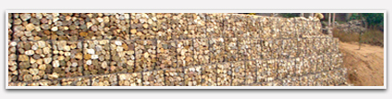Although it is known that gabions have been used from ancient times, it is ony in the last few decades that their widespread use has led them to become an accepted construction material in civil engineering. Modern technology has made possible the manufacture of these reliable and sound products, using mild steel wire mesh. The wire is woven into an hexagonal pattern, with double twist joints which prevent the whole mesh from unravelling should a wire break or be cut
Applications
................................................................................................................................................................

Gabion designs
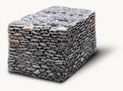
Gabion designs represent volumetric mesh designs (casings) with hex – shaped the cells, covered with zinc or polymer. Gabion designs are applied in road construction and filled by stones or a ground. As against concrete, gabion designs (mesh designs) are more economic. Gabion designs (mesh designs) ideally merge with agent, not interfering with growth of vegetation. It does gabion mesh designs by an excellent building material which merges with a landscape and looks maximum naturally.

Road designs
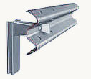
Road protections interfere with congress of a vehicle with berm or the bridge, and also do not allow to cross a dividing strip. Due to these holding protections the number of collisions of automobiles on a line is reduced.

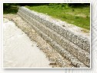
Gabions (net-shaped constraction)
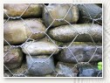
Gabion constractions

Gabions
Commonly used for earth retention and erosion control, Gabions are rectangular, compartmented baskets made of heavy gauge galvanized wire mesh. The compartments are filled with stones. Diaphragms between the compartments help to maintain the baskets uniform shape and to evenly distribute the stone infill. Special fasteners are used to close and secure the Gabions, preventing movement of the stone and maintaining the integrity of the system. They are available in a variety of sizes that can be easily connected to create any configuration required. Unlike rigid structures, Gabions remain flexible and are well suited to projects over unstable foundations. They possess tremendous strength and require little maintenance. Gabions remain permeable, limiting the need for costly drainage provisions and promote growth of vegetation. GSI carries Terra Aqua Gabions. Made in America, Terra Aqua Gabions utilize a double twisted wire mesh for superior strength, durability and flexibility. Terra Aqua
Gabions can also be ordered with a PVC coating.
- Bridge Abutments and Wing Walls  - Drop Structures and Weirs  - Channel Linings and Retaining Walls | 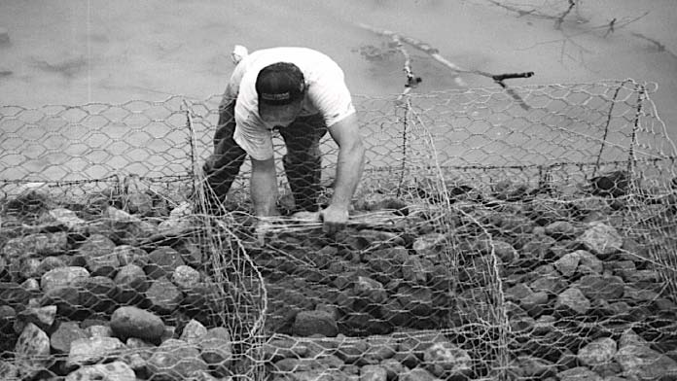  A uniform shape is maintained by internal support wires. Tact Ties®, as show here, make the process almost effortless.

Our Services
We provide the following services :-
A) Retaining Walls:
Gabion walls can be built with speed and economy and are particularly suitable for landslide control in mountainous. In ground liable to subside, the capacity of gabions to deform makes them preferable to a
B) Energy Dissipaters:
The pervious structure of Gabions gives two advantages over impervious structures. First, when pounded by heavy masses of water, the impact, instead of being taken instantaneously, is gradually absorbed. Again, flexibility offers distinct advantages in coastal defenses. Huge sea walls can be constructed with high speed using these gabions.
C) River Bank Protection Walls and Revetments:
Gabions walls are constructed to protect the seacoast or the River Coast against the erosion due to water and waves. Gabions will withstand alternative tension and compression without losing structural passage of water throughout the structure. Also they are found to be more advantageous than other gabions in marine and river environment as they are inert to alkaline and acidic attack. They are mush reliable and long lasting than marine structures constructed using the dumping of stones.
D) Flexible Aprons :
Flexible Aprons Designed to protect super-structures against the undermining action of river or sea water, Gabion aprons will closely follow the changing contours of the bed as scouring progresses, until eventually the erosion is completely sealed off.
E) Dikes and Groins :
These structures are built to protect a particular area from erosion as well as to silt up the previously eroded areas. The dykes are also used for the protecting the harbours against the Built across the front of an eroded area will collect silt left behind by floodwaters. The silt gradually builds up until the required reclamation is met without any financial outlay.
F) Weirs :
Gabion weirs, check dams are constructed across watercourses as grade control structures, sediment collectors, as well as to form water reservoirs. Gabion weirs are normally provided with a Gabion scour protection apron both on their downstream side and at the upstream approach zone.
G) Soil Conservation:
Gabion are applied here as (a) terracing on steep slopes to retain the top soil, (b) linings for the beds and sides of water courses, (c) check dams for grade reducing weirs in steeply sloping gullies or valleys.
H) Navigation Channels and Ship Docking Areas:
Gabion can be used for construction of structures for maintaining the geometry of the Navigational Channel. These products can also be used for construction of retaining walls of Ship docking areas.
I) Protection of Scour around Bridge Piers and Structure :
The Gabions can be used to protect scouring around the bridge piers and other important structures

