1. **INTRODUCTION**

Stress ribbon is a structure similar to a simple suspension bridge. It is a tension structure. Unlike the simple span, the ribbon is stressed in compression which adds to the stiffness of the structure. The supports in turn support upward thrusting arcs that allow the grade to be changed between the spans in the case where multiple spans are used. Such bridges are typically made from concrete reinforced by steel tensioning cables. If such bridges are to carry heavy vehicle traffic, then a certain degree of stiffness is required to prevent excessive flexure of the structure obtained by stressing the concrete in compression. The main advantage of these structures is their minimal impact on the environment because they use very little material and they can be erected with expansion joints, the bridges require only minimal long-term maintenance. So it can be concluded that stress ribbon bridges are economical, aesthetic and almost maintenance free.

Stress ribbon looks at how slender concrete decks are used in the design of suspension and cable stayed structures. The main concerns are their characteristic features, their rigidity, which is mainly given by the tension stiffness of pre-stressed concrete decking so much so that movements caused by pedestrians or wind does not cause any discomfort to the users. In usual suspension bridges the loads are carried by cables, while in stress ribbon bridges, the cables and decks between the abutments are tensioned so that the deck shares the axial tension forces. The anchorage forces are seen to be unusually large since structure is tightly tensioned. Usually the deck of stress ribbon structures is made of precast segments of a double tee cross section that is stiffened by diaphragms at the joints.



Fig. 1.1 Lake Hodges Pedestrian Bridge

The bearing and pre-stressing cables are situated in troughs made in edge girders. The bending moments that originate in the stress ribbon deck near supports are resisted by cast-in-place saddles designed as partially pre-stressed members.



Fig. 1.2 Rogue River Bridge, Grants Pass, Oregon, USA

An excellent example of such type of structure is the Lake Hodges Pedestrian Bridge in San Diego as shown in figure 1.1. So far it is said to be the longest stress ribbon bridge existing, which has three continuous spans, each of length 100.58m.The sag in all spans is 1.41m.Recent studies and analyses proves that these decks can be made even more lighter. Therefore a new type of cross-section has been developed by slender slab that is carried and pre-stressed by external cables as shown in figure 1.3. In stress ribbon structure, the precast segments are assembled of high strength concrete and external cables are formed by mono-strands that are laid through stainless pipes. At supports, the pipes are composite with the stress-ribbon deck and thus act as a composite member that is capable to resist a positive bending moment originating at the supports.



Fig. 1.3 Segments on external cables

1. **STRESS RIBBON BRIDGES SUPPORTED OR SUSPENDED ON ARCHES**

A main disadvantage of the classical stress-ribbon type structure is their need to resist very large horizontal forces at the abutments, which determines the economy of that structure in many cases. For that reason nowadays stress-ribbon is supported or is suspended on an arch. This structure forms a self-anchoring system where the horizontal force from the stress ribbon is transferred by inclined concrete struts to the foundation, where it is balanced against the horizontal component of the arch.

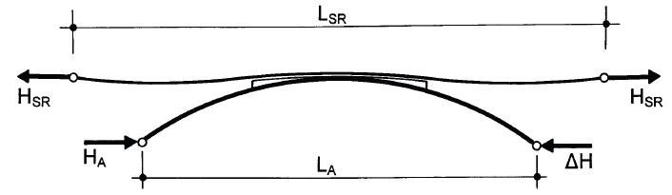

Fig. 2.1.1 Stress ribbon supported on arch

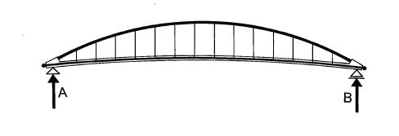

Fig. 2.1.2 Stress ribbon suspended on arch

**2.1. Structural system**

The above figures 2.1.1 and 2.1.2 clearly shows stress ribbon supported and suspended on arch. For these bridges, the intermediate support can also be maintained in the shape of arches so that these serve as a saddle from which the stress-ribbon can rise during post-tensioning process and during temperature drops so that the centre band can rest during a temperature rise. Initially the stress ribbon acts as a two spanned cable supported by the saddle and is fixed at the end abutments as shown in figure 2.1.3.

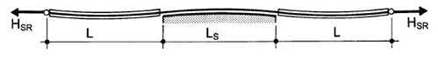

Fig. 2.1.3 Cable fixed at end abutments

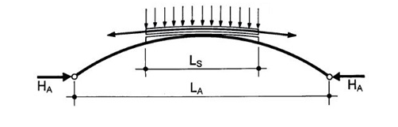

Fig. 2.1.4 Forces on arch

The loads coming on the arches are self weight of the arch, weight of the saddle segments and the radial forces acted up by the bearing tendons as shown in figure 2.1.4. After post-tensioning, the stress ribbon and arch behaves as one structure. The shape and initial stresses in the stress ribbon is fixed by balancing the horizontal forces HSR and HA with each other. Then the stress ribbon and the arch footings are connected with each other with inclined compression struts that balance these horizontal forces. Thus the moment HSR.h created will be resisted by ∆V.LP as shown in figure 2.1.5.

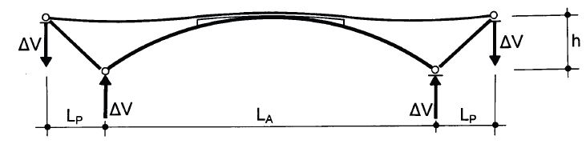

Fig. 2.1.5 Self-anchored system

When stress ribbon is suspended from arch as shown in figure 2.1.6, it is also possible to develop several self-anchored systems. Here the arch is fixed at the anchor blocks of the slender pre-stressed concrete deck. As in the above case, the arch is loaded by its self weight and that of the stress ribbon and with the radial forces of the pre-stressing tendons. Figure clearly shows a structure in which the slender pre-stressed concrete band has increased bending stiffness in the portion of the structure not suspended from the arch.

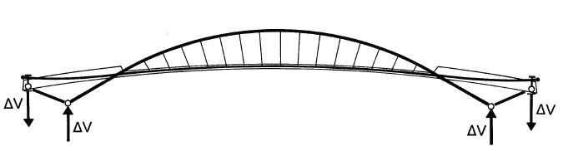

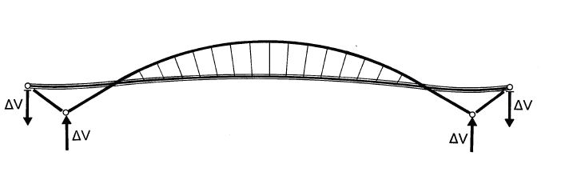

Fig. 2.1.6 Stress-ribbon suspended on arch

# 3. FINSTERWALDER’S STRESS RIBBON BRIDGE THEORY

Stress Ribbon Bridge uses the theory of a catenary transmitting loads via tension in the deck to abutments which are anchored to the ground. This concept was first introduced by a German engineer Ulrich Finsterwalder. The first stress ribbon bridge was constructed in Switzerland in 1960s. The new bridge at Lake Hodges is the sixth ribbon bridge in North America, with three equal spans of 100.584m is the longest of this type. The stress ribbon bridge combines a suspended concave span and a supported convex span. The concave span utilizes a radius of about 2500m while the convex span, depending on the design speed of the bridge, utilizes an approximate radius of 2987.04m.

The stress ribbon itself is a reinforced concrete slab with a thickness of about 25.4cm. This reinforcement consists of three to four layers of 2.5cm to 1.2cm diameter, high strength steel. The layers are spaced so that the pre-stressing pipe sleeve couplings can be used as spacers both vertically and horizontally. To resist bending moments from traffic, the slab is heavily reinforced at the top and bottom in the transverse direction. The high strength steel tendons are stressed piece by piece during erection to produce the desired upward deflection radius of 2500m under dead load of the superstructure plus the pavement. A temporary catwalk is provided to stress the first tendons. The formwork for the bridge is hung from the tendons and then removed once the concrete is cured. Concrete is placed from the middle of the freely hanging 63 suspended concave part and continues without interruption to the supports.

1. **MODEL TESTS**

**4.1. Model test**

The author believed that a structural system made up of stress-ribbon supported by an arch would considerably increase the potential application of stress-ribbon structures. Several analyses and tests were undertaken to verify this. The structures were checked for detailed static and dynamic analysis. The tests verified the design assumptions and behavior of structure under wind loading that determined the ultimate capacity of the whole system.

The model tests were mainly done for a pedestrian bridge proposed across River in Czech Republic. This structure was designed to combine a steel pipe arch having a span length of 77m and the deck made of precast segments. The tests proved that the analytical model can effectively describe the static function of the structure both at the service and ultimate load.



Fig. 4.1.1 Static Model Test

Dimensions of the model and cross-section, loads, and pre-stressing forces were determined according to rules of similarity. The stress-ribbon was assembled with precast segments of 18mm depth and the haunches were anchored in anchor blocks made with steel channel sections. The arch consisted of two steel pipes, and the end struts consisted of two steel boxes fabricated from channel sections. The saddle was made by two steel angles supported on longitudinal plates strengthened with vertical stiffeners. The footings common to the arch and inclined struts were assembled from steel boxes fabricated with two channel sections. They were supported by steel columns consisting of two I sections. The end ties consisted of four rectangular tubes. The steel columns and the ties were supported by a longitudinal steel beam that was anchored to the test floor.

In the processes such as erection of segments, casting of the joints, post-tensioning of the structure, the deformations of the arch and the deck, the precast segments were made from micro-concrete of 50MPa characteristic strength. The stress-ribbon was supported and post-tensioned by 2 mono-strands situated outside the section. Their position was determined by two angles embedded in the segments. The loads, determined according to the rules of similarity, consisted of steel circular bars suspended on the transverse diaphragms and on the arch. The number of bars was modified according to desired load. The erection of the model corresponded to the erection of the actual structure. After the assembly of the arch and end struts, the mono-strands were stranded. Then the segments were placed on the mono-strands and the loads were applied. Next, the joints between the segments and the haunches were cast. When the concrete reached the minimum prescribed strength, the mono-strands were tensioned to the design force. Before erection of the segments, strain gauges were attached to the steel members and the initial stresses in the structure were measured. The strain gauges were attached at critical points and the forces in the mono-strands were measured by dynamometers placed at their anchors. The model was tested for the 5 positions of live load.  At the end of the tests the ultimate capacity of the overall structure was determined. It was clear that the capacity of the structure was not given by the capacity of the stress-ribbon since, after the opening of the joints, the whole load would be resisted by the tension capacity of the mono-strands.

Since the capacity of the structure would be given by the buckling strength of the arch, the model was tested for a load situated on one side of the structure. The structure was tested for an increased dead load (1.3 G) applied using the additional suspended steel rods, and then for a gradually increasing live load P applied with force control using a hydraulic jack reacting against a loading frame. The structure failed by buckling of the arch at a load 1.87 times higher than the required ultimate load Qu = 1.3 G + 2.2 P. The stress-ribbon itself was damaged only locally by cracks that closed after the overloads were removed. The structure also proved to be very stiff in the transverse direction. The buckling capacity of the structure was also calculated with a nonlinear analysis in which the structure was analyzed for a gradually increasing load. The failure of the structure was taken at the point when the analytic solution did not converge. Analysis was performed for the arch with and without fabrication imperfections. The imperfections were introduced as a sinus-shaped curve with nodes at arch springs and at the crown. Maximum agreement between the analytical solution and the model was achieved for the structure with a maximum value of imperfection of 10 mm. This value is very close to the fabrication tolerance. The test has proven that the analytical model can accurately describe the static function of the structure both at service and at ultimate load. The dynamic behavior of the proposed structure was also verified by dynamic.

**4.2. Static and dynamic loading tests**

The design assumptions and quality of workmanship for the first stress-ribbon structure built in the Czech Republic and of the first stress ribbon bridge built in United States were checked by measuring the deformations of the superstructure at the time of pre-stressing and during loading tests. Dynamic tests were also performed on these structures. Only a few key results of a typical structure are obtained by these tests. Since the shape of a stress ribbon structure is extremely sensitive to temperature change, the temperature of the bridge was carefully recorded at all times. The pedestrian bridge in Prague-Troja was tested by 38 vehicles weighing between 2.8 and 8.4 tons. First, the vehicles were placed along the entire length of the structure, and then they were placed on each span. During the test only the deformations in the middle of the spans and the horizontal displacements of all supports were measured. Results of these tests were utilized in the design of following structure.

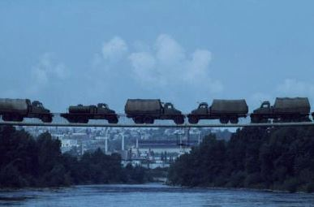

Fig. 4.2.1 Load Test for Prague-Troja Bridge

1. **PEDESTRIAN BRIDGE ACROSS THE EXPRESSWAY R35**

The bridge crosses expressway R3508 built near a city of Olomouc, Czech Republic. The bridge is formed of stress-ribbon of two spans supported by an arch as shown in figure 5.2. Stress-ribbon of length 76.50m is assembled of precast segments 3.00m long supported and pre-stressed by two external tendons.

The precast deck and precast end struts are made of high-strength concrete of characteristic strength 80MPa.The cast-in-place arch on other hand is made of concrete of characteristic strength 70MPa.The external cables are formed by two bundles of 31-0.6” diameter mono-strands grouted inside stainless steel pipes. They are anchored at the end abutments and are deviated on saddles formed by arch crown.

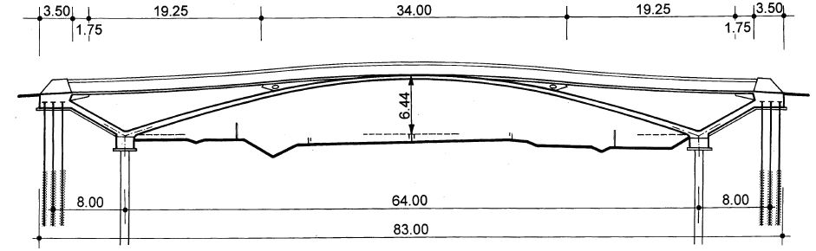

Fig. 5.1 Bridge Elevation

The steel pipes are connected to the deck segments by bolts located in the joints between the segments. At the abutments, the tendons are supported by short saddles formed by cantilevers that protrude from the anchor blocks. The stress-ribbon and arch are connected to each other at the central band of the bridge. The arch footings are founded on drilled shafts and anchor blocks on micro-piles. The micro-piles are additionally substituted by cast ballast to prevent its failure.



Fig. 5.2 Bridge across the expressway R3508, Czech Republic

The bridge was erected in several steps. After the placing of the piles, the end struts were erected and the arch footings and anchor blocks were casted. The arch was casted in formwork supported by light scaffolding. When the concrete of the arch has attained sufficient strength, the external cables were assembled and tensioned. Then the precast segments were erected. After adjusting the forces in the external cables, the joints between the segments were casted and subsequently the external tendons were tensioned up to design stress. The structural solution was developed on the basis of the detailed static and dynamic tests described above.

1. **FORM OF A STRESS RIBBON BRIDGE**

**6.1. Superstructure**

A typical stress ribbon bridge deck consists of precast concrete planks with bearing tendons to support them during construction and separate pre-stressing tendons which are tensioned to create the final designed geometric form. The joints between the planks are most often sealed with concrete before stressing the deck. The pre-stressing tendons transfer horizontal forces in to the abutments and then to the ground most often using ground anchors. The tendons are encased in ducts which are generally grouted after tensioning in order to lock in the stress and protect them from corrosion. Since the bending in the deck is low, the depth can be minimized and thus results in reduction of dead load and horizontal forces in abutments.

**6.2. Substructure**

The abutments are designed to transfer the horizontal forces from the deck cables into the ground via ground anchors. Pedestrians, wind and temperature loads can cause large changes in the bending moments in the deck close to the abutments and accordingly crack widths and fatigue in reinforcement must be considered. The ground anchors are normally tensioned in 2 stages, the first step is tensioned before the deck is erected and the rest, after the deck is complete. If stressed as only one stage, there will be a large out of balance force to be resisted by the abutments as temporary condition. The soil pressure, overturning and sliding has to be checked for construction as well as permanent condition.

**6.3. Ground Conditions**

The ideal ground condition for resisting large horizontal forces from the ribbon is a rock base. This occurs rarely, so even competent soils can be used as suitable alternative that is only found at some depth below the abutments. In some cases where soil conditions do not permit the use of anchors, piles can also be used. Horizontal deformations can be significant and are considered in the design. It is also possible to use a combination of anchors and drilled shafts. Battered micro piling is another alternative which can resist the load from the ribbon because of its compression and tension capacity.

1. **COMPARISON WITH A SIMPLE SUSPENSION BRIDGE**

A stress ribbon bridge is a tension structure similar in many ways to a simple suspension bridge. The suspension cables are embedded in the deck which follows a catenary arc between the supports. As opposed to suspension bridges, where the cables carry the load, in stress ribbon, by tensioning the cables and the deck between abutments, the deck shares axial tension forces. Unlike the simple span the ribbon is stressed in compression, which adds to the stiffness of the structure. A simple suspension span tends to sway and bounce. The supports in turn support upward thrusting arcs that allow the grade to be changed between spans, where multiple spans are used.

Such bridges are typically made from concrete reinforced by steel tensioning cables. When such bridges are to carry vehicle traffic, a certain degree of stiffness is required to prevent excessive flexure of the structure, obtained by stressing the concrete in compression. Anchorage forces are unusually large since the structure is tightly tensioned.

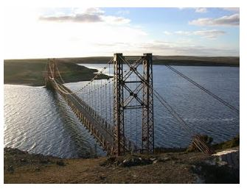

Fig. 7.1 Bodie Creek Suspension Bridge, Falkland Islands

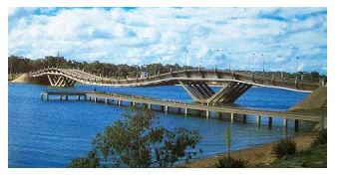

Fig. 7.2 Maldonado Stress Ribbon Bridge, Uruguay

1. **CONSTRUCTION TECHNIQUES**

The construction of the bridge is relatively straight forward. The abutments and piers are built first. Next the bearing cables were stretched from abutment to abutment and draped over steel saddles that rested at top the piers. The bearing tendons generally support the structure during construction, and thus an additional false work is used rarely. Once the bearing cables were tensioned to the specified design force, precast panels were suspended via support rods located at the four corners of each panel. At this point the bridge sagged into its catenary shape.

The next step was to place post tensioning ducts in the bridge. The ducts were placed directly above the bearing cables and support rods, which were all located in two longitudinal troughs that run along the length of the bridge. After the ducts were placed, the cast-in place concrete was placed in the longitudinal troughs in small transverse closure joints. Concrete is poured in the joints between the planks and then allowed to harden before carrying out the final tensioning. Retarding admixtures may also be used in the concrete mix to allow all the concrete to be placed before their hardening. Once the final tension has been jacked into the tendons and the deflected shape is verified, the ducts containing the tendons are grouted.

After allowing the cast in place concrete to cure and achieve its full strength, the bridge was post tensioned. The post tensioning lifts each span, closes the gap between the panels, puts the entire bridge in to compression and transforms the bridge in to continuous ribbon of pre-stressed concrete.

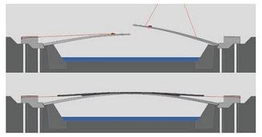

Fig. 8.1 Construction Technique

1. **ADVANTAGES AND APPLICATIONS**

**9.1. Advantages**

* Stress ribbon pedestrian bridges are very economical, aesthetical and almost maintenance free structures.
* They require minimal quantity of materials.
* They are erected independently from existing terrain and therefore they have a minimum impact upon the environment during construction.
* They are quick and convenient to construct if given appropriate conditions, without false work.
* A stress ribbon bridge allows for long spans with a minimum number of piers and the piers can be shorter than those required for cable stayed or suspension bridges.

**9.2. Applications of Stress Ribbon Principle**

**Eco duct**: A tunnel which was built as part of a large network of motorways. The theory is the same as a self-anchored arch but the geometry is much more complex. It is 50m wide and spans 70m.A finite element program was used in its design.

**Stuttgart trade fair hall roof**: The suspended asymmetric roof comprises a regular repetition of stressed trusses with individual I-beam ribbons of steel between them. The trusses function as strut and tie A-frames based on concrete strip foundations and are tied back to the ground with anchors. The stresses in the ribbons and weight of its ‘green roof’ were used to resist wind uplift.

**10. MODIFIED STRESS RIBBON BRIDGES**

One disadvantage of the traditional stress-ribbon type bridges is the need to resist very large horizontal forces at the abutments. Another characteristic feature of the stress-ribbon type structures is that in addition to their very slender concrete decks, the stiffness and stability is mainly given by the whole structural system using predominantly the geometric stiffness of the deck. At present research on the development of new structures combining classical stress-ribbon deck with arches or cables is being carried out.

**10.1. Stress Ribbon Bridges Stiffened by Cables**

In this, a suspension structure formed by a straight or arched stress ribbon fixed at the abutments is studied. External bearing cables stiffen the structure both in the vertical and horizontal directions. Horizontal movements caused by live load are eliminated by stoppers, which only allow horizontal movement due to temperature change and shrinkage of concrete.

Support of the deck in a horizontal direction is provided by a stopper which was designed and analyzed during the study and development of this structural type. This device allows horizontal movement due to the creep and shrinkage of concrete. At the same time the devices stops horizontal movement due to short term loads like a live load, wind load or earthquake. Deck deflections and bending moments are reduced to zero or very small horizontal movement. Natural frequencies and mode shapes were also determined during dynamic analysis. The influence of the aforementioned structural arrangements on frequencies and mode shapes were studied. The structure allows one to place an observation platform at mid-span. But dynamic behavior is influenced by platform positioning, weight and area. For this reason the aerodynamic stability of the structure was checked in a wind tunnel.

**11. CURVED STRESS RIBBON & FLAT ARCH BRIDGES**

Recently, several noteworthy curved pedestrian bridges, in which decks are suspended on their inner edges on suspension or stay cables, have been built. However, curved stress ribbon or flat arch bridges have not been built so far. Therefore it is decided to study these structures analytically and verify their function on a static model.

The above curved structures have to be designed in such a way that for the dead load there is no torsion in the deck. One possibility is to supplement the deck with stiff L shaped members and suspend the deck at their top portions. The cable geometry has to be designed in such a way that suspenders or stay cables direct to the decks shear centers. This approach was also sometimes used in design of existing stress-ribbon structures as shown in figure 11.1. The structure is formed by slender deck that is supplemented by steel L frames supporting the slab. The tops of their vertical portion are connected by steel pipes in which the strands are placed. Radial forces originating in the strands during their post-tensioning load the structure. The vertical components of these radial forces balance the dead load. The horizontal components balance the dead load’s torsion moment and load the structure by horizontal radial forces. Since the stress ribbon is fixed into the abutments, these forces create uniform compression in the deck.

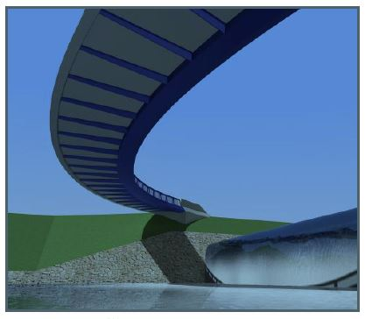

Fig. 11.1 Stress ribbon and arch structure

This design has been developed from the above approach of curved stress-ribbon. However, for resisting of the effects of the live load, it is necessary to add additional cables that have very complicated arrangement. Therefore a torsion ally stiff member of the pentagon cross section is added. The maximum longitudinal slope at the abutments is 7%. Both the concrete slab and the steel girder are fixed into the anchor blocks. The external cables are situated in the handrail pipe and are anchored in end concrete walls that are fixed into the anchor blocks. Horizontal forces are resisted by battered micro piles. The detailed static and dynamic analyses have proved that the structure is able to resist all the design loads.

**12. CONCLUSION**

Stress ribbon bridges are a versatile form of bridge. The adaptable form of this structure is applicable to a variety of requirements. The slender decks are visually pleasing and have a visual impact on surroundings giving a light aesthetic impression. Post tensioned concrete minimizes cracking and assures durability. Bearings and expansion joints are rarely required minimizing maintenance and inspections. There are also many advantages in construction method, since erection using pre-cast segments does not depend on particular site condition and permits labor saving erection and a short time to delivery. Usage of bearing tendons can eliminate the need for site form work and large plant, contributing to fast construction programs and preservation of the environments. There is a wide range of different topographies and soil conditions found and a number of areas which require aesthetic yet cost effective pedestrian bridges to be built. Stress ribbon bridges could provide elegant solutions to these challenges.

**REFERENCES**

1. Strasky J**,** 2005, “Stress Ribbon and Cable-Supported Pedestrian Bridges”, PCI JOURNAL.

2. Strasky J, 1987, “Pre-cast stress ribbon pedestrian bridges in Czechoslovakia”, PCI JOURNAL.

3. Strasky J, 1999, “Stress Ribbon Pedestrian Bridges”, International Bridge Conference, Pittsburgh.

4. Strasky J, 2005, “Stress Ribbon and Cable-Supported Pedestrian Bridges”.

5. Strasky J, 2010, “Stress ribbon & arch pedestrian bridges”, 6th International Conference on Arch Bridges.