Solar Collectors
There are two common kinds of solar collectors, and they are chosen based on the specificities of the solar system requirements. The flat panels are composed by a layer of glass that allows radiation to get through with minimal reflection; A black sheet that absorbers the radiation, and it is generally made either of copper or aluminum; Copper flow pipes, in which the incoming cold water is heated up. And finally, there is an insulation layer.

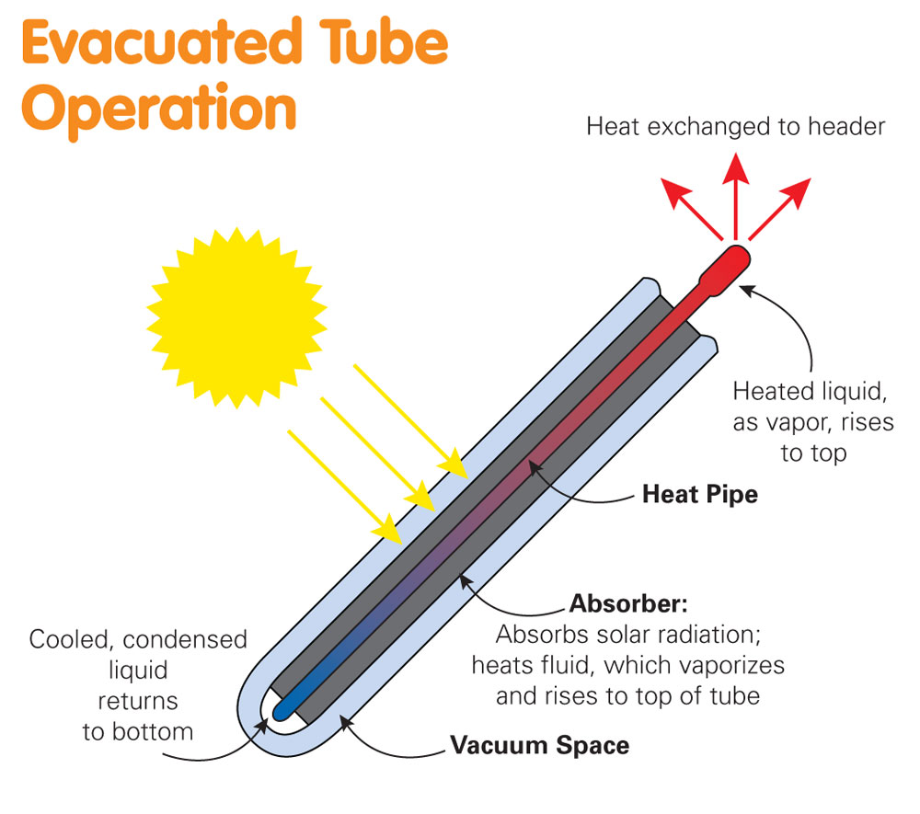
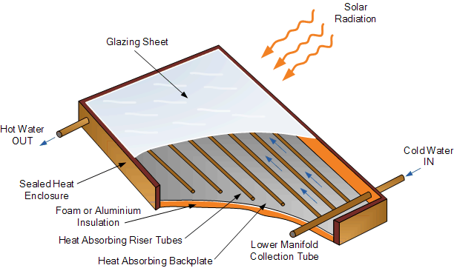
The evacuated tubes are also composed of a glass layer and absorber. However, the vacuum between the layers leads to a lower heat loss, and their round shape positively affects the radiation absorption by increasing the period when the sun radiation is perpendicular to the tubes.

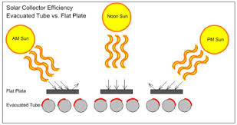

Evacuated Tubes
Heat Pipes: A mixture composed of water and some additives is kept inside a heat pipe, whose temperature is increased by the absorbed heat. Due to vacuum, low pressure is created, so the water evaporates in lower temperatures. Therefore, when the heat is absorbed, the water mixture evaporates and goes up to a small heat exchanger, where heat is transferred to the cold water that flows in the manifold. Then, the mixture condensates and flows down due to the gravity action.
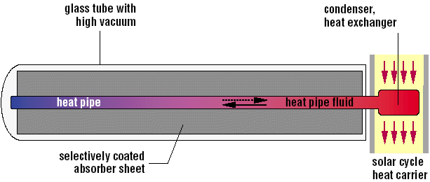

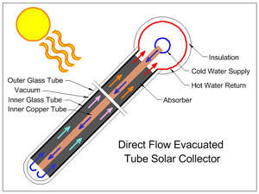
Direct Flow: It differs from the heat pipes because of the chilled water that flows inside the tube, it is heated, and flows back to the manifold.

Equations

The chosen collector is an evacuated tube model, which is manufactured by kingspan, model HP. The manufacturer provides the equation for the collector efficiency. This equation depends on the first heat loss coefficient, second heat loss coefficient, aperture area and also the “efficiency of the layers of the material”

Power input by the sun

$\dot{Q_{in, sun}}=G ∙A$ (1)

Power Output

$\dot{Q}=η_{c} × G × A$ (2)

Collector efficieny(reduced equation)
$η_{c}= η_{0}-α_{1}\frac{t_{m }–t_{a}}{G}-α_{2}{\frac{{(t}_{m }–t_{a})}{G}}^{2}$ (3)

$$T_{m }=\frac{t_{m }–t_{a}}{G}$$

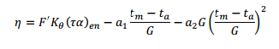
Effiency (considering the incidence angle modifier)

(5)

Incidence angle modifier for an evacuated tube collector

$K_{θ}=K_{θlong }∙ K_{θtrans}$ (6)

(7)

*$η_{0}, a_{1 }, a_{2 }{, K}_{θ},K_{θlong },K_{θtrans}$ are given by the manafacturer.
** The heat loss coefficients $a_{1 }, a_{2 }$ are determined with the steady state method.
*** Eq. (5) and (7) do not consider the effect of flow rate.

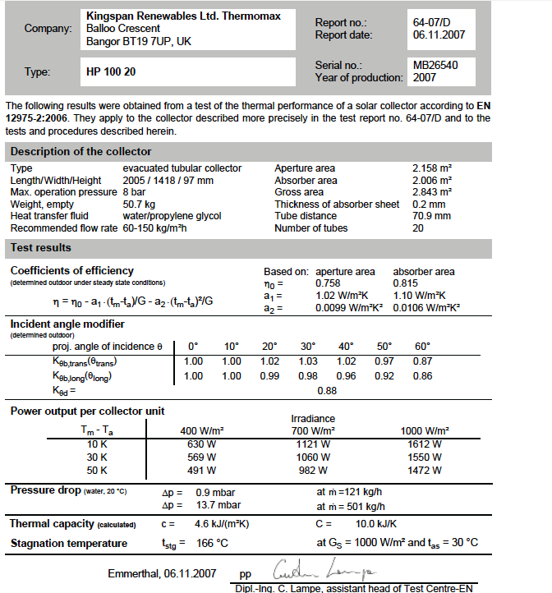
Test conditions :
Facing south, Tilt angle : 45º
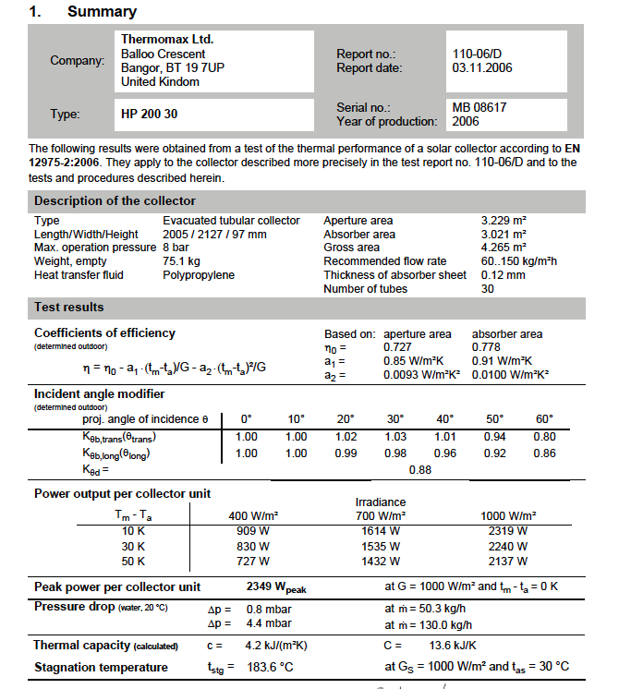

1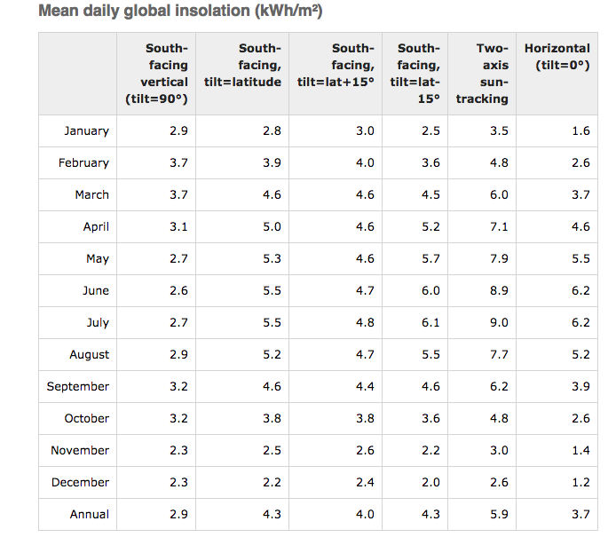
Energy required to heat the water

$$Q_{dhw}=V_{dhw}∙C_{w}∙(T_{}-T_{cold water})$$

3.5.8. Collector Efficiency Factor (F′)
Is the ratio of the real energy output of the collector to the energy output in the case
when the total absorber area was at the average fluid temperature with the same fluid
quantity of flowing water.
3.5.9. Collector Flow Factor (F″)
Is the ratio of the energy that the collector can deliver at the average temperature of the
fluid to the energy that the collector can supply at the inlet collector temperature. For a
certain collector the flow factor is a function of the flowing water quantity.
3.5.10. Collector Heat Removal Factor (FR)
Is the ratio of the energy collector output to the energy output of the collector in
temperature of the inlet fluid. It is temperature dependent. The thermal output factor is
connected to the flow factor and to efficiency factor by the relationship: FR = F′×F″.

