School of Sciences and Engineering
Mechanical Engineering Department
MENG 375 (System Dynamics)
Project Report
Active Suspension system
Submitted:
To:
Prof. Maki K. Habib
By:
Ahmed Al Meghalawy 900114647
Karim Taha 900112498
Mahmoud Kamel 900090139
Marwan Kamel 900112300
Mohie El Din Zaki 900114938
Seif El Saie 900112577
Due Date:
29/10/2015
Submitted Date:
29/10/2015

Summary

In this project report we will be studying the active car suspension system by developing a set of equations and modelling through MATLAB and SEMIULINK software. In order to be able to develop these equations, we first carried out a large amount of research on the dynamics of the active suspension system. We will thus be analysing each component of the system separately by developing the mathematical model for each component and combining these separate models in order to establish a transfer function for the whole system.

Table of Contents

Summary 2
1.0 Introduction & Background 4
1.1 Advantages and applications of suspension system 4
1.2 Previous work with highlight of technique, strength & weaknesses 5
1.3 Constraints of the Projects 7
1.4 Technical challenges for further Development 8
1.5 Objectives 9
2.0 System under Consideration 9
2.1 Intro 9
2.2 Active suspension system 10
2.3 Car suspension basic components 12
2.4 Damper System 13
3.0 Mathematical Modelling 15
3.1 Quarter Model: 15
4.0 conclusion 19
5.0 References 20
6.0 Appendices 21
Appendix 1: Calculation for the Quarter Model 21
Appendix 2: Work Break Down Structure 22
Appendix 3: Calendar: 22
Appendix 4: MATLAB done 23

Table of Figures

Figure (1) Schematic for a spring and damper in series 4
Figure (2) MR fluid based semi- active suspension 6
Figure (3) Basic representation of active suspension 10
Figure (4) Front wheel Drive Suspension components 11
Figure (5) Conventional Suspension Components 12
Figure (6) Car Suspension basic components 13
Figure (7) Simplified Transfer Function on wolfram alpha 17
Figure (8) MATLAB Transfer Function Response 18

1.0 Introduction & Background

The handling and the quality of the ride in a car is always affected by the car’s most essential part which is the suspension system. The suspension system is a mechanical system that consists of springs and shock absorbers (dampers) which links the axle and wheels to the chassis of the car. One of the laid-backs of the suspension system structure that it gets very tough trying to improve the ride of the quality and the handling at the same time.
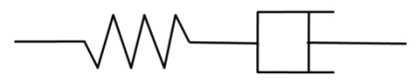
The springs and the shock absorbers are the main components of any suspension system as mentioned before. Starting with the spring it absorbs the shock from road bumps and change into the spring’s potential energy. While the main function of the shock absorber is concerned with the stability of the car as it depletes the shock energy without causing extreme oscillations to the moving vehicle.
Figure (1) Schematic for a spring and damper in series

http://www.intechopen.com/source/html/42681/media/image17.jpeg

There are three types of suspension systems: conventional/passive one (the oldest, first designed one), semi-active and the active suspension. The aim of the project to design the control strategy of the active suspension system using the mathematical models and new algorithms.

1.1 Advantages and applications of suspension system

Any suspension system in any car is considered as the most important of it as it carry more than one function. Firstly, it carries the static weight of the vehicle, plus it tries to maximize the friction between the car wheels and the tires. In addition to providing steering stability with good handling, in other word minimizing the body roll. Finally, the comfort factor for the passengers by smoothing out any bumpy road. These were the advantages of any basic suspension system in any car.

1.2 Previous work with highlight of technique, strength & weaknesses

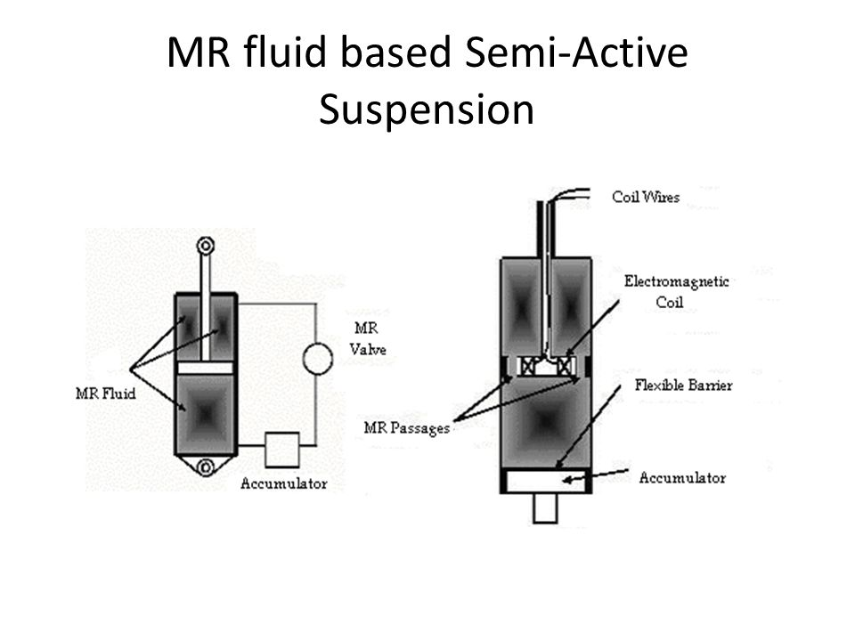
Semi-active suspension can only affect the damping coefficient of the shock absorber and do not add energy to the system, there are two types of the semi-active suspension system which are solenoid/valve actuated and magnetorheological damper. The solenoid actuated consists of a solenoid valve which changes the flow of the hydraulic medium inside the shock absorber, which changes the damping characteristics of the setup of the suspension. The solenoids are connected by wires to the controlling computer, then sends the commands based on controlling algorithms. This system is mainly used in Cadillac cars. As for the magnetorheological actuated system (shown in figure 2), the magnetorheological (MR) fluid is composed of oil and different percentages of ferrous particles that have been coated with anti-coagulant material. The viscosity of the MR fluid changes based on changing the magnetic field strength.
Figure (2) MR fluid based semi- active suspension

http://images.slideplayer.com/19/5716455/slides/slide_8.jpg
The advantages of the semi-active suspension system are simple design and easy installation and easier control than active suspension system. It has a low implementation cost and low power consumption. On the other hand, this kind of system has a major disadvantage which is the limitation of the damper, as the force is limited resulting in less performance in handling than the active suspension system.
The advantages of the active suspension system are having a wider range of forces, no force-velocity constraint and can achieve high performance regarding the dynamics of the vehicle. On the other hand, it has got some disadvantages, the power consumption is considered to be very high, also has a higher ratio relating the weight to the power ratio & costly suspension system.

1.3 Constraints of the Projects

First of all, we encountered an issue involving the equations that we initially developed for the quarter model active suspension system. After carrying out some research on the topic, we discovered that the quarter model for the suspension system could actually be developed schematically in two different manners. The first method involves separating the actual body of the car from the car’s chassis. This means that in the schematic diagram we would have a spring connected to the wheel at one end and the mass of the car’s chassis at the other end. Another spring, a damper and a force actuator are then connected to the mass of the car’s chassis at one end and the car’s body mass at the other end above. The second schematic diagram that could be developed for this system basically combines the car’s chassis and body masses into one larger mass, which is the total mass of the two components. This in turn meant that the structure of the schematic diagram would certainly change, as the locations of the components now vary. This particular area was quite confusing for us, as we were unsure at first if we were supposed to treat the two different masses separately or combine them together into one mass.
Another difficulty that we faced during our development of the equations for the quarter system involved simplifying the final transfer function for the system. After developing the transfer function for the quarter model active suspension system, we noticed that the equation contained too many different symbols making it extremely long and difficult to simplify. In order for us to avoid this difficulty and be able to solve this long transfer function, we were forced to make use of a mathematical software as a tool to help us simplify and solve the equation. This mathematical software is found in the website www.wolframalpha.com which is a very useful tool that is used for simplifying long mathematical equations.
The force actuator, which is one of the main active suspension system components that is located in between the mass of the chassis and the mass of the car’s body above, proved to be quite a challenge for us when we were developing the equations for the system. From our knowledge of the System Dynamics course we are currently studying with Professor Habib K. Maki, we were successfully able to understand how exactly the spring and damper components in the active suspension system function, and therefore were able to develop equations for these components and solve them. However, the force actuator is out of the scope of the course, and thus we did face a difficulty when attempting to study how exactly the force actuator functions as a part of the system.

1.4 Technical challenges for further Development

One of the main technical difficulties of active suspension systems that need to be addressed and developed is the power requirement of the system. The force actuator located in between the chassis and car body masses consumes a fairly large amount of power (typically 4-5 horsepower), which in turn affects the overall performance of the vehicle negatively. If the power consumed by the suspension system is too large, the system may fail as a whole, affecting the whole vehicle drastically. Therefore, the amount of power consumed by the active suspension system should be monitored and developed in such a way that restricts the system from consuming more than a certain amount, as this would cause the system to fail.
Another huge technical disadvantage of the active suspension system that certainly requires more development is that the systems can sometimes have modes of failure that are unacceptable. For example, if in an unfortunate situation the force actuator fails, the vehicle would be left almost undamped and possibly unsprung. This of course would have a disastrous result on both the vehicle and its operator as the vehicle would then not be able to absorb any shock it receives.

1.5 Objectives

1) Study the operation of active suspension car models.
2) Establish mathematical model for the active suspension system of a quarter (one wheel) car model.
3) Analyze the mathematical model for the system in order to improve its performance.
Variables: Force, Spring Constant

2.0 System under Consideration

2.1 Intro

According to the control principle and control functions, the suspension system can be divided into passive suspension, semi-active suspension and active suspension; this suspension system is very different in the performance aspects.

2.2 Active suspension system

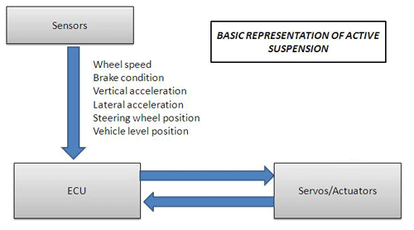
The vehicles must have a suspension system for basic comfort, control and safety for any given car. This typically includes a spring and a shock absorber to help isolate the vibrations from any road bumps (vertical displacement).The chassis of the car is linked with the axles and/ or wheel assemblies and this is further explained in the basic components of a suspension system.
Figure (3) Basic representation of active suspension
http://www.cvel.clemson.edu/auto/systems/active_suspension.html

Active suspension systems sense the forces being applied (vertical displacement) to the wheels and constantly adjust the connections in between (mechanical connections) as the chassis and the wheel connections. With the increased computer control, the driver while driving can adjust various options of suspension travel and response. Typical examples include a "Sport" mode that yields a more dynamic response.
The automotive active suspension, according to road conditions and vehicles load, controls their own working status. Active suspension requirement should make powerful control method with settle on the suspension to accomplish the execution required to achieve
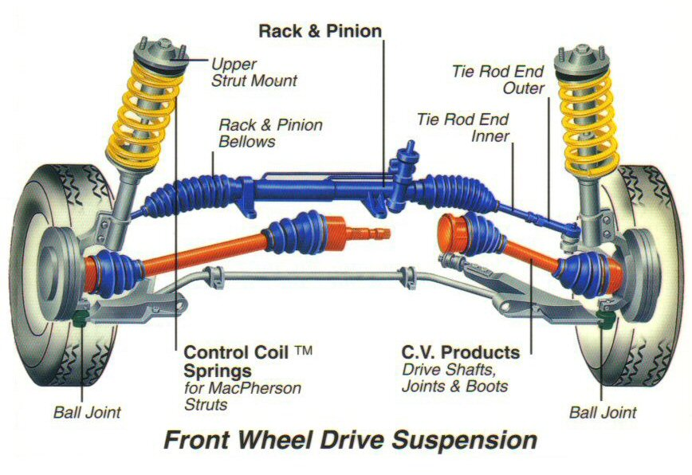

Figure (4) Front wheel Drive Suspension components
http://www.snipview.com/q/Suspension_(vehicle

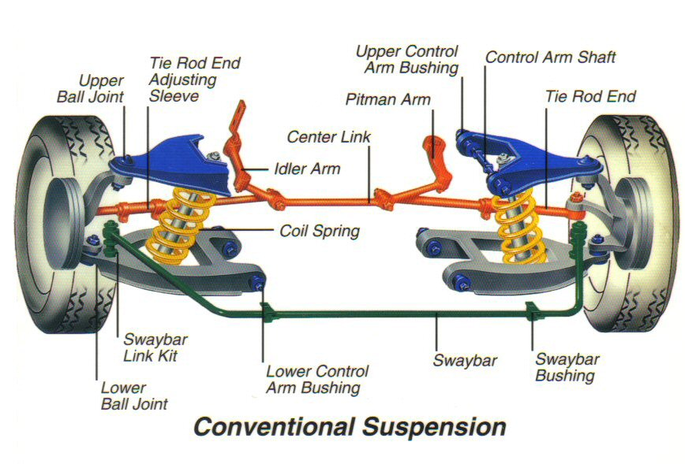

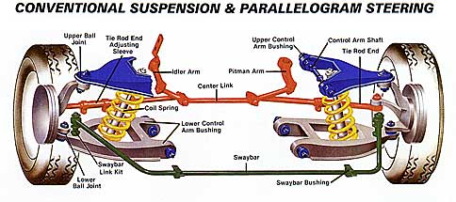

Figure (5) Conventional Suspension Components
http://www.snipview.com/q/Suspension_(vehicle

2.3 Car suspension basic components

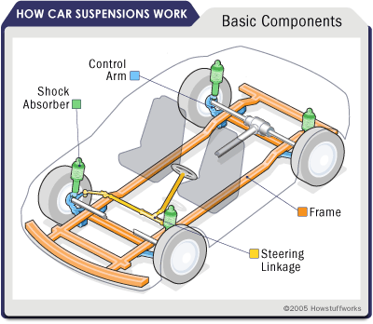
Figure (6) Car Suspension basic components

2.4 Damper System

Unless a dampening structure is introduced the spring used will absorb the shock and will continue to vibrate at the rate of the natural frequency and it would lead to an extremely bouncy ride.
The shock absorber is the device that controls the unwanted spring motion known as dampening. How the shock absorber works is reducing the vibrating motion by turning the kinetic energy of the suspension movement into heat energy lost in the hydraulic fluid.
It’s basically an oil pump placed between the frame of the car and the wheels. The upper mount of the shock connects to the frame (i.e., the sprung weight), while the lower mount connects to the axle, near the wheel (i.e., the unsprung weight).
Twin-tube design is one of the common designs used in cars, the diagram clearly illustrates. The upper mount is connected to a piston rod; this converts the physical motion to pressurize the pressure tube and allowing hydraulic fluid to pass through. Orifices perforate the piston and allow fluid to leak through as the piston moves up and down in the pressure tube. The outer tube is known as a reserve tube storing excess hydraulic fluid.

3.0 Mathematical Modelling

3.1 Quarter Model:

Symbol | Description | Value
$$m_{1}$$ | Car Weight ( Chassis and Body ) | 300 kg
$$m_{2}$$ | Wheel Weight | 60 kg
$$K_{1}$$ | Spring Between Car body and Wheel | 16000 N/m
$$K_{2}$$ | Spring Between Road and Wheel
$$b_{1}$$ | Damper Between Car body and Wheel | 19000 N/m
f(t) | Actuator Force
$$z_{1}$$ | Displacement of the Car Weight
$$z_{2}$$ | Displacement of Car Wheel

- Assuming Compression:
For $m_{1}:$

 | $$m_{1}{\ddot{z}}_{1}=K_{1}\left(z_{2}-z_{1}\right)+b_{1}\left({\dot{z}}_{2}-{\dot{z}}_{1}\right)+f\left(t\right)$$ | [1]
 | $$m_{1}{\ddot{z}}_{1}+K_{1}Z_{1}+b_{1}{\dot{Z}}_{1}=K_{1}Z_{2}+b_{1}{\dot{Z}}_{2}+f(t)$$ | [2]
 | $$m_{1}s^{2}Z_{1}\left(s\right)+K_{1}Z_{1}\left(s\right)+b_{1}sZ_{1}\left(s\right)=K_{1}Z_{2}\left(s\right)+b_{1}sZ_{2}\left(s\right)+F(s)$$ | [3]
 | $$Z_{1}\left(s\right) \left[ ms^{2}+ b_{1}s+ K_{1}\right]= Z_{2}\left(s\right) \left(b_{1}s+K_{1}\right)+F(s)$$ | [4]
 | $$Z_{1}\left(s\right)=\frac{Z_{2}\left(b_{1}s+K_{1}\right)+F(S)}{m_{1}s^{2}+b_{1}s+K_{1}}$$ | [5]

For $m_{2}:$
 | $$m_{2}{\ddot{z}}_{2}=K_{2}\left(z_{3}-z_{2}\right)-K_{1}\left({\dot{z}}_{2}-{\dot{z}}_{1}\right)-b_{1}\left({\dot{z}}_{2}-z_{1}\right)-f\left(t\right)$$ | [6]
 | $$m_{2}{\ddot{z}}_{2}= K_{2}z_{2}+ K_{1}z_{2}+b_{1}{\dot{z}}_{1}= K_{2}z_{3}+ K_{1}Z_{1}+b_{1}{\dot{z}}_{1}- f\left(t\right)$$ | [7]
 | $m_{2}s^{2}Z_{2}\left(s\right)+ K_{2}z_{2}\left(s\right)+ K_{1}z_{2}\left(s\right)+b_{1}sZ_{2}\left(s\right)= K_{2}z_{3}\left(s\right)+ K_{1}z_{1}\left(s\right)+ b_{1}sZ_{1}\left(s\right)-F\left(s\right)$ | [8]
 | $$Z_{2}\left(s\right) \left[m_{2}s^{2}+ b_{1}s{K_{2}+K}_{1}\right]= K_{2}Z_{3}\left(S\right)+{K_{1}Z}_{1}\left(S\right)+b_{1}sZ_{1}\left(S\right)-F(S)$$ | [9]
 | $$Z_{2}\left(s\right)=\frac{K_{2}Z_{3}\left(S\right)+Z_{1}\left(S\right)\left(b_{1}s+K_{1}\right)-F(S)}{m_{2}s^{2}+b_{1}s+{K_{2}+K}_{1}}$$ | [10]

For $m_{v}:$
 | $$m_{v}{\ddot{Z}}_{3}=-K_{2}(Z_{3}-Z_{2})$$ | [11]
 | $$0 = {-K}_{2}Z_{3}+ K_{2}Z_{2}$$ | [12]
 | $$K_{2}Z_{3}= K_{2}Z_{2}$$ | [13]
 | $$K_{2}Z_{3} \left(S\right)= K_{2}Z_{2} (S)$$ | [14]
 | $$Z_{3}\left(s\right)=\frac{K_{2}Z_{2}\left(S\right)}{K_{2}}$$ | [15]
 | $$Z_{3}\left(S\right)=Z_{2}\left(S\right)$$ | [16]

Therefore Replacing $Z_{3}\left(S\right)$ by $Z_{2}\left(S\right)$

 | $Z_{2}\left(s\right)=\frac{K_{2}Z_{2}\left(S\right)+Z_{1}\left(S\right)\left(b_{1}s+K_{1}\right)-F(S)}{m_{2}s^{2}+b_{1}s+{K_{2}+K}_{1}}$ | [17]
 | $Z_{2}\left(s\right)=\frac{1+Z_{1}\left(S\right)\left(b_{1}s+K_{1}\right)-F(S)}{m_{2}s^{2}+b_{1}s{+K}_{1}}$ | [18]

Replacing equation # 10 into equation #1
 | $Z_{1}\left(s\right)[1-\frac{{(b_{1}s+K_{1})}^{2}}{{(m_{2}s^{2}+b_{1}s+K_{1})}^{3}}$ ]=F(S)[$\frac{1}{{m_{1}s}^{2}+b_{1}s+K_{1}}-\frac{b_{1}s+K_{1}}{{({m_{1}s}^{2}+b_{1}s+K_{1})}^{2}}$] | [19]
 | $\frac{Z_{1}\left(s\right)}{F(S)}$=$\frac{\frac{1}{m_{2}s^{2}+b_{1}s+K_{1}}-\frac{b_{1}s+K_{1}}{{{(m_{1}s}^{2}+b_{1}s+K_{1})}^{2}}}{[1-\frac{{\left(b_{1}s+K_{1}\right)}^{2}}{({m_{2}s^{2}+b_{1}s+K_{1})}^{3}}]}$  = $\frac{\frac{1}{{60s}^{2}+1000s+16000}-\frac{1000s+16000}{{{(300s}^{2}+1000s+16000)}^{2}}}{[1-\frac{{\left(1000s+16000\right)}^{2}}{({60s^{2}+1000s+16000)}^{3}}]}$ | [20]

- Using Mathematica (wolfram alpha) to simplify equation #10

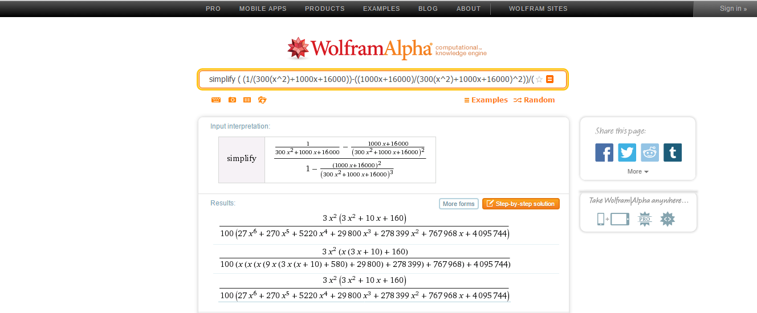
Figure (7) Simplified Transfer Function on wolfram alpha

http://www.wolframalpha.com/input/?i=simplify+%28+%281%2F%28300%28x%5E2%29%2B1000x%2B16000%29%29%28%281000x%2B16000%29%2F%28300%28x%5E2%29%2B1000x%2B16000%29%5E2%29%29%2F%281%28%28%281000x%2B16000%29%5E2%29%29%2F%28%28300%28x%5E2%29%2B1000x%2B16000%29%5E3%29%29

After using the Wolfram Alpha website to simplify the equation, MATLAB was used to plot the transfer function.
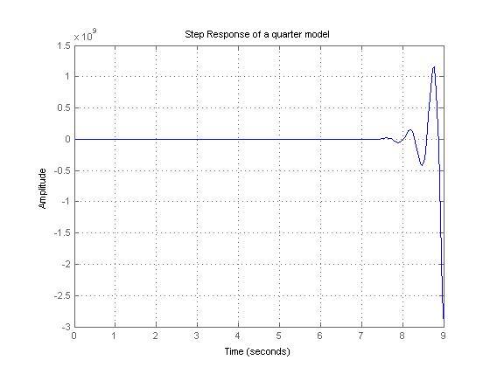

Figure (8) MATLAB Transfer Function Response

4.0 conclusion

In this project, Active suspension system, the system was analyzed for the quarter car model. The equation of motion was developed and then simplified. the equations of motion were then used to obtain the transfer function. The transfer function obtained was for the deflection of the total mass to the force of the actuator $\frac{Z_{1}(S)}{F(s)}$where $Z_{1}(S)$ is the defeclection of the car body and $F(s)$ is force of the actuator. This transfer function was simplified using Mathematica “Wolfram alpha website”. The simplified equation was used in matlab to develop the output response graphically

5.0 References

Arslan, S. (n.d.). CONTROL OF ACTIVE VEHICLE SUSPENSION SYSTEMS.ELECO'99 INTERNATIONAL CONFERENCE ON ELECTRICAL AND ELECTRONICS ENGINEERING, 160-165.
Chih-Hsuan Lee, Chiu-Ling Chen, Shun-Hsu Tu, Wes S. Jeng, Jeng-Fu Shen and Feng Tyan, "Modeling and simulation of half car suspension system with a MR damper using RecurDyn and Simulink" CSME-1254.
Franklin, G; Powell, J D; Emami-Naeini, A. Feedback Control of Dynamic Systems, 3^e. ASME -PUBLICATIONS- DSC, 55. 2 (1994): 1053-1054
Sun, Jianmin; Sun, Yi. Comparative study on control strategy of active suspension system. Proceedings - 3rd International Conference on Measuring Technology and Mechatronics Automation, ICMTMA 2011, 1. (2011): 729-732. IEEE Computer Society
Yagiz, Nurkan; Hacioglu, Yuksel. Backstepping control of a vehicle with active suspensions. CONTROL ENGINEERING PRACTICE, 16. 12 (2008): 1457-1467. PERGAMON-ELSEVIER SCIENCE LTD

6.0 Appendices

Appendix 1: Calculation for the Quarter Model

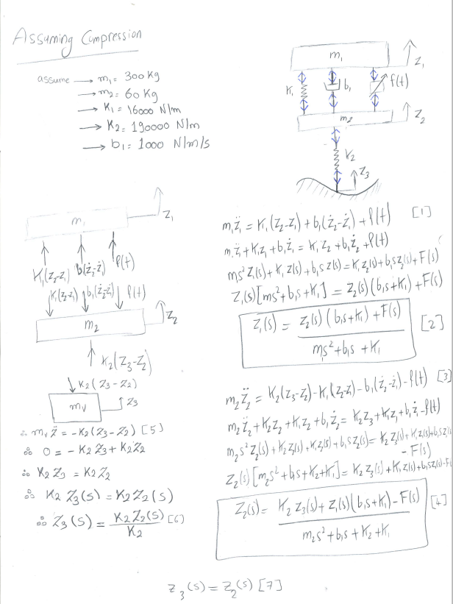

Appendix 2: Work Break Down Structure

Work Breakdown | Team Members
Research | Seif El Saie, Mohie El Deen Zaki & Ahmed Almeghalawy
Development of Quarter Model Equations | Karim Taha, Mahmoud Kamel & Marwan Kamel

Appendix 3: Calendar:
All dates are subject to changes.
Wednesday 7th October: Meeting to discuss the system and assign tasks for first report.
Monday 12th October: Report to each other on the assigned tasks and assign tasks regarding the math modeling.
Thursday 15th October: Discuss with each other different kind of mathematical models for the chosen suspension system and choose the system that will be modeled.
Thursday 19th October: Discuss the control techniques that will be used.
Wednesday 21st October: Compile and finish the first draft report.
Monday 26th October: First Report Due.
Thursday 29th October: Each group member would solve the model differential equation that he or she is responsible for and meet after one week check our answers and review them.
Monday 2nd of November: Receive first Report and discuss comments and how to improve the project.
Thursday 5th November: Allocate tasks for each members to improve the sections that they were responsible for in the first report.
Monday 9th November: Check with Dr. Maki K. Habib, solution for the differential equation of all the models (full, half and quarter car model)
Thursday 12th November: Start building the model on the semiu-link and analyze it.
Monday 16th November: Finish the semiu-link and start on drafting the progress report.
Thursday 19th November: Complete the progress report and be print it for submission.
Monday 23rd November: Submit progress report progress report.
Monday 30th November: Prepare for Presentation and receive progress report.
Thursday 3rd December: Finish project presentation and update the report with the feedback from the instructor.
Monday 7th December: Practice for Project Presentation and finish the final report.
Thursday 10th December: Review final report and run the presentation for practice.
Monday 14th December: Submit final report and present the project.

Appendix 4: MATLAB done

num=[0 0 9 30 480 0 0];
den=[270 27000 52000 2980000 27839900 76796800 409574400];
step(num,den)
grid
title('Step Response of a quarter model')

