Flying Windmills

Published on Jan 10, 2016

Abstract

High Altitude Wind Power uses flying electric generator (FEG) technology in the form of what have been more popularly called flying windmills, is a proposed renewable energy project over rural or low-populated areas, to produce around 12,000 MW of electricity with only 600 well clustered rotorcraft kites that use only simple autogyro physics to generate far more kinetic energy than a nuclear plant can.

According to Sky WindPower; the overuse of fossil fuels and the overabundance of radioactive waste from nuclear energy plants is taking our planet once again down a path of destruction, for something that is more expensive and far more dangerous in the long run. FEG technology is just cheaper, cleaner and can provide more energy than those environmentally unhealthy methods of the past, making it a desirable substitute/alternative.

The secret to functioning High Altitude Wind Power is efficient tether technology that reaches 15,000 feet in the air, far higher than birds will fly, but creating restricted airspace for planes and other aircraft.

The same materials used in the tethers that hold these balloons in place can also hold flying windmills in place; and with energy cable technology getting ever lighter and stronger .Flying windmills appear to be 90 percent more energy efficient in wind tunnel tests than their land-based counterparts; that is three times more efficiency due to simple yet constantly abundant and effective high altitude wind power, available only 15,000 feet in the air by way of clustered rotor craft kites tethered with existing anti-terrorist technologies like those used on the Mexican/American border radar balloons.

Introduction:

Two major jet streams, the Sub-Tropical Jet and the Polar Front Jet exist in both Earth hemispheres. These enormous energy streams are formed by the combination of tropical region sunlight falling and Earth rotation. This wind resource is invariably available wherever the sun shines and the Earth rotates. These jet stream winds offer an energy benefit between one and two orders of magnitude greater than equalrotor- area, ground mounted wind turbines operating in the lowest regions of the Earth’s boundary layer.

In the USA,Caldeira and O’Doherty and Roberts have shown that average power densities of around 17 kW/m2 are available. In Australia, Atkinson et al show that 19 kW/m2 is achievable.These winds are available in northern India, China, Japan,Africa, the Mediterranean, and elsewhere.

Various systems have been examined to capture this energy, and these include tethered balloons, tethered fixed-winged craft, tether climbing and descending kites, and rotorcraft.

Our preferred option is a tethered rotorcraft, a variant of the gyroplane, where conventional rotors generate power and simultaneously produce sufficient lift to keep the system aloft. This arrangement, using a twin-rotor configuration, has been described and flown at low altitude by Roberts and Blackler (Fig. 1).

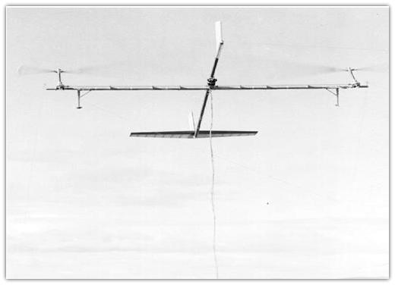

The Best Spots To Place Fegs

Based on the ERA-15 reanalysis of the European Centre for Medium-Range Weather Forecasts, we calculated the seasonal-mean, climate-zone wind power density from December 1978 to February 1994 .Computed power densities in high altitude winds exceed a 10 kW/m2 seasonal average at the jet stream’s typical latitudes and altitudes. This is the highest power density for a large renewable energy resource anywhere on Earth. It exceeds the power densities of sunlight, near surface winds, ocean currents, hydropower, tides, geothermal, and other large-scale renewable resources. For comparison, Earth surface solar energy is typically about 0.24 kW/m2 , and photovoltaic cell conversion of energy into electricity has an efficiency several times less than that of wind power.

Electrodynamic Tether

An electrodynamic tether is attached to an object, the tether being oriented at an angle to the local vertical between the object and a planet with a magnetic field. When the tether cuts the planet's magnetic field, it generates a current, and thereby converts some of the orbiting body's kinetic energy to electrical energy. As a result of this process, an electrodynamic force acts on the tether and attached object, slowing their orbital motion. The tether's far end can be left bare, making electrical contact with the ionosphere via the phantom loop.

Functionally, electrons flow from the space plasma into the conductive tether, are passed through a resistive load in a control unit and are emitted into the space plasma by an electron emitter as free electrons. In principle, compact high-current tether power generators are possible and, with basic hardware, 10 to 25 kilowatts appears to be attainable.

Energy Storage Issues

Electric utilities want constantly available “dispatchable” power, which cannot be provided economically if capacity factors are low, such as the thirty percent that is typical of ground based wind turbine sites. However, with the high capacity factors, such as 85 percent, that are expected at average FEG sites in the United States and many other places in the world (especially in the mid-latitudes), this dispatchable electricity becomes economical. This is because the expected storage requirement in connection with FEG derived electrical energy is storage for only the shorter periods when FEGs are grounded due to inadequate winds or bad storms.

Pumped water storage, where available, is a very economical means used now for such temporary storage. A well known example is used by the utility PG&E in California to pump water up to a high lake during low electrical-use hours and then have that water generate electricity at high demand times on the way back to a lower lake.

Flight Control Using Gps And Gyro Data

Very accurate control is needed to precisely maintain a desired position in the sky. GPS with gyroscopes is an ideal way to provide the reference data necessary to provide this control.

The Global Positioning System (GPS) consists of a constellation of 24 satellites that provide a continuous navigation capability to users at any location on (or near) Earth in all weather conditions. With this system, currently operating with 29 satellites, real-time, three dimensional position information with accuracies on the order of 5-10 m can be achieved.

Main error sources for the system include signal propagation effects through the atmosphere, satellite orbit and timing errors, and GPS receiver noise and signal reflection(multipath). When used in differential mode, where measurement corrections are computed at a GPS reference station sited on a known location, accuracies can be improved quite easily to within a few meters (DGPS).

Although generally used for positioning and navigation, GPS can also be used for platform attitude determination and control. If three or more GPS receivers and antennas are mounted on a platform, such as an FEG, the GPS carrier phase data can be used to directly estimate the roll, pitch, and heading of the platform in real-time at a rate of 1-20 Hz [18].  
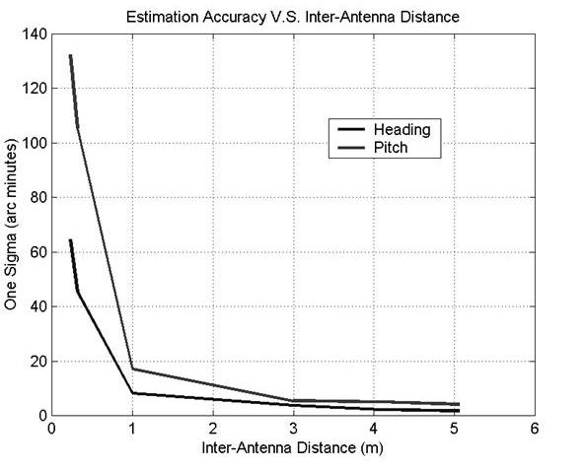

Conclusions

It has been shown that flying electric generators can harness the powerful and persistent winds aloft to supply electricity for grid connection, for hydrogen production or for hydro-storage. Globally, upper atmospheric winds provide an enormous resource for this application. The environmental impacts at altitude are minimal with virtually no visual, or noise intrusion and no bird strikes. The proposed systems lead logically to rural/remote area installations in regions of restricted airspace. Full-scale facilities, using individual FEG units of rated power around 30 MW, could easily form wind-farms equivalent in output to regular coal, gas and nuclear facilities. These wind-farms would give capacity (generating) factors around three times greater than that from conventional wind-farms.