STRESS RIBBON BRIDGES

ABSTRACT

A stress ribbon bridge is a tension structure, similar in many ways to a simple suspension bridge. The stress ribbon design is rare. Few people including bridge engineers are familiar with this form and fewer than 50 have been built worldwide. The suspension cables are embedded in the deck which follows a catenary arc between supports. Unlike the simple span the ribbon is stressed in compression which adds to the stiffness of the structure. Such bridges are typically made from concrete reinforced by steel tensioning cables. They are used mainly for pedestrian and cycling traffic. Stress ribbon bridges are very economical, aesthetic and almost maintenance free structure. They require minimal quantity of materials. At present studies, on combining stress ribbon bridges with cables or arches, to build most economical stress ribbon bridges. It makes the study of features of these particular bridges as an important one.

ACKNOWLEDGEMENT

Many people had inspired, helped and supported me to present this seminar in a successful manner. I would like to express my gratitude to all of the here. I am extremely happy and thankful to our director Dr. P.R Radhakrishnan and our principal Dr. K.Prasadh for this valuable support through this seminar work. I would like to thank my guide Mr. Udhayan (Lecturer in Civil Engineering). Next I express my sincere gratitude to our Dean Mr. Divakaran.M.R and Head of the Department Ms. Jitha.K.Wilson her insight, expertise and energy contributed greatly to this work. Last I would like to thank all my friends for the inspirations and encouragement from their part.

CONTENTS

- INTRODUCTION
- FINSTERWALDER’S STRESS RIBBON BRIDGE THEORY
- FORM OF A STRESS RIBBON BRIDGE
- COMPARISON WITH A SIMPLE SUSPENSION BRIDGE
- CONSTRUCTION TECHNIQUES
- STRUCTURAL SYSTEM
- MODEL TESTS
- ADVANTAGES AND APPLICATIONS
- MODIFIED STRESS RIBBON BRIDGES
- A CASE STUDY
- STRESS RIBBON BRIDGES AROUND THE GLOBE
- CONCLUSION
- REFERENCES

FIGURE LIST

- Fig 1 Ulrich Finsterwalder
- Fig 2 Bodie Creek Suspension Bridge , Falkland Islands
- Fig 3 Maldonado Stress Ribbon Bridge, Uruguay
- Fig 4 Construction Technique
- Fig 5 Structural System
- Fig 6 Structural System
- Fig 7 Static model – cross section
- Fig 8 Static model
- Fig 9 Static model – ultimate load
- Fig 10 Wind tunnel test
- Fig 11 Prague-Troja Bridge - load test

TABLE LIST

- Table .1 Stress Ribbon Bridges

INTRODUCTION

A stressed ribbon bridge (also stress-ribbon Bridge) is a tension structure (similar in many ways to a simple suspension bridge). The suspension cables are embedded in the deck which follows a catenary arc between supports. Unlike the simple span the ribbon is stressed in compression, which adds to the stiffness of the structure (simple suspension spans tend to sway and bounce). The supports in turn support upward thrusting arcs that allow the grade to be changed between spans (where multiple spans are used). Such bridges are typically made from concrete reinforced by steel tensioning cables. Where such bridges carry vehicle traffic a certain degree of stiffness is required to prevent excessive flexure of the structure, obtained by stressing the concrete in compression.
Stress Ribbon Bridges Philosophers, thinkers, intellectuals all appeal, please build bridges and not walls between different communities, nationalities, countries, languages etc, to achieve universal brotherhood. This can be achieved by constructing stress ribbon bridges.
Stress ribbon bridges are very economical, aesthetic and almost maintenance free structure. They require minimal quantity of materials. They are erected independently from the existing terrain and therefore they have minimum impact upon the environment during construction.
Stress ribbon bridge is the term used to describe structures formed by a very slender concrete deck in the shape of a catenary. They can be designed with one or more spans and are characterized by successive and complementary smooth curves. These curves blend in to natural environment and their forms, the most simple and basic of structural solutions. The stress ribbon bridge can be erected without undue pressure on the environment.
Stress ribbon bridges looks at how slender concrete deck are used in the design of suspension and cable stayed structures. It looks at their characteristic feature; their rigidity, which is mainly given by the tension stiffness of prestressed concrete decking so much so that movement caused by pedestrians or wind does not register as discomfort by users. As opposed to suspension bridges, where the cables carry the load, in stress ribbon, by tensioning the cables and the deck between the abutments, the deck shares the axial tension forces. Anchorage forces are unusually large since the structure is tightly tensioned.

- FINSTERWALDER’S STRESS RIBBON BRIDGE THEORY

Stress Ribbon Bridge uses the theory of a catenary transmitting loads via tension in the deck to abutments which are anchored to the ground. This concept was first introduced by a German engineer Ulrich Finsterwalder. The first stress ribbon bridge was constructed in Switzerland in the 1960s. The new bridge at Lake Hodges is the sixth ribbon bridge in North America, with three equal spans of 330 feet is the longest of this type.
The stress ribbon bridge combines a suspended concave span and a supported convex span. The concave span utilizes a radius of about 8200 ft while the convex span, depending on the design speed of the bridge, utilizes an approximate radius of 9800 ft (1965).
The stress ribbon itself is a reinforced concrete slab with a thickness of about 10 inches (25.4cm). This reinforcement consists of three to four layers of 1 inch (2.5cm) to 1 ¼ inch (1.2cm) diameter, high strength steel. The layers are spaced so that the prestressing pipe sleeve couplings can be used as spacers both vertically and horizontally. To resist bending moments from traffic, the slab is heavily reinforced at the top and bottom in the transverse direction.

The high strength steel tendons are stressed piece by piece during erection to produce the
desired upward deflection radius of 8200 feet (2500m) under dead load of the superstructure plus the pavement. A temporary catwalk is provided to stress the first tendons. The formwork for the bridge is hung from the tendons and then removed once the concrete is cured. Concrete is placed from the middle of the freely hanging 63 suspended concave part and continues without interruption to the supports (Finsterwalder 1965).
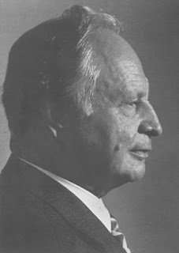Fig 1 Ulrich Finsterwalder

3. FORM OF A STRESS RIBBON BRIDGE

3.1 Superstructure
A typical stress ribbon bridge deck consists of precast concrete planks with bearing tendons to support them during construction and separate prestressing tendons which are tensioned to create the final designed geometric form. The joints between the planks are most often sealed with in-situ concrete before stressing the deck. The prestressing tendons transfer horizontal forces in to the abutments and then to the ground most often using ground anchors. The tendons are encased in ducts which are generally grouted after tensioning in order to lock in the stress and protect them from corrosion. Since the bending in the deck is low, the depth can be minimized and results in reduction in dead load and horizontal forces in abutments.
3.2 Substructure
The abutments are designed to transfer the horizontal forces from the deck cables into the ground via ground anchors. Pedestrians, wind and temperature loads can cause large changes in the bending moments in the deck close to the abutments and accordingly crack widths and fatigue in reinforcement must be considered. The ground anchors are normally tensioned in 2 stages, the first step is tensioned before the deck is erected and the rest, after the deck is complete. If stressed in one stage only, there will be a large out of balance force to be resisted by the abutments in the temporary case. The soil pressure, overturning and sliding has to be checked for construction as well as permanent condition.
3.3 Ground Conditions
The ideal ground condition for resisting large horizontal forces from the ribbon is a rock base. This occurs rarely but suitable foundations can be devised even if competent soils are only found at some depth below the abutments. In some cases where soil conditions do not permit the use of anchors, piles can also be used. Horizontal deformations can be significant and are considered in the design. It is also possible to use a combination of anchors and drilled shafts. Battered micropiling is another alternative which can resist the load from the ribbon because of its compression and tension capacity.

4. COMPARISON WITH A SIMPLE SUSPENSION BRIDGE

A stress ribbon bridge is a tension structure similar in many ways to a simple suspension bridge. The suspension cables are embedded in the deck which follows a catenary arc between the supports. As opposed to suspension bridges, where the cables carry the load, in stress ribbon, by tensioning the cables and the deck between abutments, the deck shares axial tension forces. Unlike the simple span the ribbon is stressed in compression, which adds to the stiffness of the structure. A simple suspension span tends to sway and bounce. The supports in turn support upward thrusting arcs that allow the grade to be changed between spans, where multiple spans are used.
Such bridges are typically made from concrete reinforced by steel tensioning cables. Where such bridges carry vehicle traffic a certain degree of stiffness is required to prevent excessive flexure of the structure, obtained by stressing the concrete in compression. Anchorage forces are unusually large since the structure is tightly tensioned.
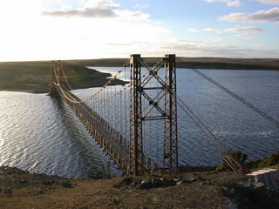
Fig 2 Bodie Creek Suspension Bridge, Falkland Islands

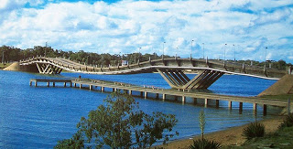
Fig 3 Maldonado Stress Ribbon Bridge, Uruguay

5. CONSTRUCTION TECHNIQUES

The construction of the bridge is relatively straight forward. The abutments and piers are built first. Next the bearing cables were stretched from abutment to abutment and draped over steel saddles that rested atop the piers. The bearing tendons generally support the structure during construction, and only rarely is additional false work used. Once the bearing cables were tensioned to the specified design force, precast panels were suspended via support rods located at the four corners of each panel. At this point the bridge sagged into its catenary shape.
The next step was to place post tensioning ducts in the bridge. The ducts were placed directly above the bearing cables and support rods, which are all located in two longitudinal troughs that run the length of the bridge. After the ducts were in place, the cast-in place concrete was placed in the longitudinal troughs in small transverse closure joints. Concrete is poured in the joints between the planks and allowed to harden before the final tensioning is carried out. Retarding admixtures may be used in the concrete mix to allow all the concrete to be placed before hardening occurs. Once the final tension has been jacked into the tendons and the deflected shape is verified, the ducts containing the tendons are grouted.
After allowing the cast in place concrete to cure and achieve its full strength, the bridge was post tensioned. The post tensioning lifts each span, closes the gap between the panels, puts the entire bridge in to compression and transforms the bridge in to continuous ribbon of prestressed concrete.
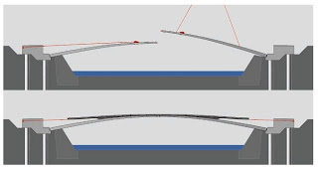
Fig 4 Construction Technique

6. STRUCTURAL SYSTEM

The development of the self-anchored stress-ribbon structure supported by an arch is evident from Fig. 1. It is clear that the intermediate support of a multi-span stress-ribbon can also have the shape of an arch (Figure 1a). The arch serves as a saddle from which the stress-ribbon spans can rise during post-tensioning and during temperature drop, and where the center "band" can rest during a temperature rise.
In the initial stage, the stress-ribbon behaves as a two-span cable supported by the saddle that is fixed to the end abutments (Figure 1b). The arch is loaded by its self-weight, the weight of the saddle segments and the radial forces caused by the bearing tendons (Figure 1c). After post-tensioning the stress-ribbon with the prestressing tendons, the stress-ribbon and arch behave as one structure.
The shape and initial stresses in the stress-ribbon and in the arch can be chosen such that the horizontal forces in the stress-ribbon HSR and in the arch HA are the same. It is then possible to connect the stress-ribbon and arch footings with inclined compression struts that balance the horizontal forces. The moment created by horizontal forces HSR.h is then resisted by the ΔV.LP. In this way a self-anchored system with only vertical reactions is created (Figure 1d).
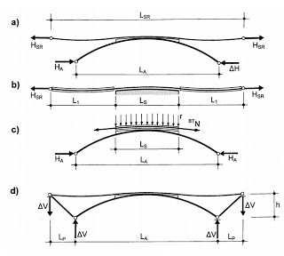
Fig 5 Structural System

It is also obvious that the stress-ribbon can be suspended from the arch. It is then possible to develop several self-anchored systems. Figure 2 presents some concepts using such systems. Figure 2a shows an arch fixed at the anchor blocks of the slender prestressed concrete deck. The arch is loaded not only by its self-weight and that of the stress-ribbon, but also with the radial forces of the prestressing tendons. Figure 2b shows a structure that has a similar static behavior as the structure presented in Figure 1d. To reduce the tension force at the stress-ribbon anchor blocks, it is possible to connect the stress-ribbon and arch footings by inclined compression struts that fully or partially balance the stress-ribbon horizontal forces. Figure 2c shows a similar structure in which the slender prestressed concrete band has increased bending stiffness in the portion of the structure not suspended from the arch.

7. MODEL TESTS

7.1 MODEL TESTS
The authors believe that a structural system made up of a stress-ribbon supported by an arch increases the potential application of stress-ribbon structures. Several analyses were under taken to verify this. The structures were checked not only with detailed static and dynamic analysis, but also on static and full aero elastic models. The tests verified the design assumptions and behavior of the structure under wind loading that determined the ultimate capacity of the full system.
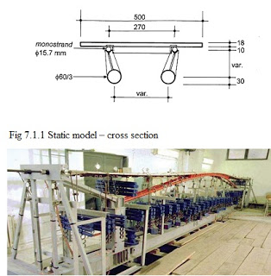
Fig 7 Static model

The model tests were done for a proposed pedestrian bridge across the Radbuza River in Plzen, Czech Republic. This structure was designed to combine a steel pipe arch having a span length of 77 m and the deck assembled of precast segments. The static physical model was done in a 1:10 scale. The shape is shown in Figures 3 and 4. Dimensions of the model and cross-section, loads, and prestressing forces were determined according to rules of similarity. The stress-ribbon was assembled with precast segments of 18 mm depth and the cast-in-place haunches were anchored in anchor blocks made with steel channel sections. The arch consisted of two steel pipes, and the end struts consisted of two steel boxes fabricated from channel sections. The saddle was made by two steel angles supported on longitudinal plates strengthened with vertical stiffeners. The footings common to the arch and inclined struts were assembled from steel boxes fabricated with two channel sections. They were supported by steel columns consisting of two I sections. The end ties consisted of four rectangular tubes. The steel columns and the ties were supported by a longitudinal steel beam that was anchored to the test floor.
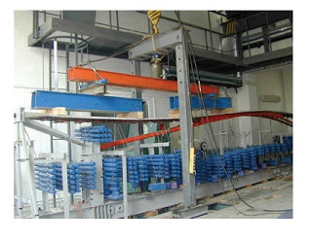
Fig 8 Static model – ultimate load

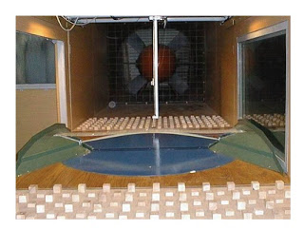
Fig 9 Wind tunnel test

The stress-ribbon before casting of the joints. During erection of the segments, casting of the joints and post-tensioning of the structure, the deformations of the arch and the deck where the precast segments were made from micro-concrete of 50 MPa characteristic strength. The stress-ribbon was supported and post-tensioned by 2 monostrands situated outside the section. Their position was determined by two angles embedded in the segments. The loads, determined according to the rules of similarity, consisted of steel circular bars suspended on the transverse diaphragms and on the arch. The number of bars was modified according to desired load. The erection of the model corresponded to the erection of the actual structure. After the assembly of the arch and end struts, the monostrands were stranded. Then the segments were placed on the monostrands and the loads were applied. Next, the joints between the segments and the haunches were cast. When the concrete reached the minimum prescribed strength, the monostrands were tensioned to the design force. Before erection of the segments, strain gauges were attached to the steel members and the initial stresses in the structure were measured. The strain gauges were attached at critical points of carefully monitored and the forces in the monostrands were measured by dynamometers placed at their anchors (Figure 4). The model was tested for the 5 positions of live load. At the end of the tests the ultimate capacity of the overall structure was determined. It was clear that the capacity of the structure was not given by the capacity of the stress-ribbon since, after the opening of the joints, the whole load would be resisted by the tension capacity of the monostrands. Since the capacity of the structure would be given by the buckling strength of the arch, the model was tested for a load situated on one side of the structure (Figure 5). The structure was tested for an increased dead load (1.3 G) applied using the additional suspended steel rods, and then for a gradually increasing live load P applied with force control using a hydraulic jack reacting against a loading frame. The structure failed by buckling of the arch at a load 1.87 times higher than the required ultimate load Qu = 1.3 G + 2.2 P. The stress-ribbon itself was damaged only locally by cracks that closed after the overloads were removed. The structure also proved to be very stiff in the transverse direction. The buckling capacity of the structure was also calculated with a nonlinear analysis in which the structure was analyzed for a gradually increasing load. The failure of the structure was taken at the point when the analytic solution did not converge. Analysis was performed for the arch with and without fabrication imperfections. The imperfections were introduced as a sinus-shaped curve with nodes at arch springs and at the crown. Maximum agreement between the analytical solution and the model was achieved for the structure with a maximum value of imperfection of 10 mm. This value is very close to the fabrication tolerance. The test has proven that the analytical model can accurately describe the static function of the structure both at service and at ultimate load. The dynamic behavior of the proposed structure was also verified by dynamic

STATIC AND DYNAMIC LOADING TESTS
The design assumptions and quality of workmanship of the author's first stress ribbon structure built in the Czech Republic and of the first stress ribbon bridge built in United States were checked by measuring the deformations of the superstructure at the time of prestressing and during loading tests. Dynamic tests were also performed on these structures. Only a few key results of a typical structure are given here. Since the shape of a stress ribbon structure is extremely sensitive to temperature change, the

temperature of the bridge was carefully recorded at all times.
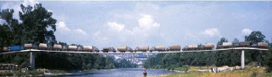
Fig 10 Prague-Troja Bridge - load test

The pedestrian bridge in Prague-Troja was tested by 38 vehicles weighing between 2.8 and 8.4 tons – see Fig.4.7.1. First, the vehicles were placed along the entire length of the structure, and then they were placed on each span. During the test only the deformations in the middle of the spans and the horizontal displacements of all supports were measured

8. ADVANTAGES AND APPLICATIONS

8.1 Advantages
- Stress ribbon pedestrian bridges are very economical, aesthetical and almost maintenance free structures.
- They require minimal quantity of materials.
- They are erected independently from existing terrain and therefore they have a minimum impact upon the environment during construction.
- They are quick and convenient to construct if given appropriate conditions, without false work.
- A stress ribbon bridge allows for long spans with a minimum number of piers and the piers can be shorter than those required for cable stayed or suspension bridges.
8.2 Applications of stress ribbon principle
· Eco duct: A tunnel which was built as part of a large network of motorways outside Brno. The theory is the same as a self-anchored arch but the geometry is much more complex. It is 50m wide and spans 70m a finite element programme was used in its design.
· Stuttgart trade fair hall roof: The suspended asymmetric roof comprises a regular repetition of stressed trusses with individual I-beam ribbons of steel between them. The trusses function as strut and tie A-frames based on concrete strip foundations and are tied back to the ground with anchors. The stresses in the ribbons and weight of its ‘green roof’ were used to resist wind uplift.

9. MODIFIED STRESS RIBBON BRIDGES

One disadvantage of the traditional stress ribbon type bridges is the need to resist very large horizontal forces at the abutments. Another characteristic feature of the stress ribbon type structures, in addition to their very slender concrete decks, is that the stiffness and stability are given by the whole structural system using predominantly the geometric stiffness of the deck. At present research on the development of new structures combining classical stress-ribbon deck with arches or cables is being carried out.
9.1 Stress stiffened by arches ribbon bridges
The stress ribbon deck is fixed in the side strut. Both the arches and struts are founded on the same footings. Due to the dead load the horizontal force both in the arch and in the stress ribbon have the same magnitude, but they act in opposite directions. Therefore the foundation is loaded only by vertical reactions. This self-anchoring system allows a reduction in the cost of the substructure.
The arches serves as a saddle from which the stress ribbon can rise during post tensioning and during temperature drop, and where the bond can rest during a temperature rise. In the initial stage the stress ribbon behaves as a two span cable supported by the saddle that is fixed to end abutments. After post tensioning the stress ribbon with the prestressing tendons, the stress ribbon and arch behaves as one structure.
9.2 Stress ribbon bridges stiffened by cables
The second type of studied structure is a suspension structure formed by a straight or arched stress ribbon fixed at the abutments. External bearing cables stiffen the structure both in the
vertical and horizontal directions. Horizontal movements caused by live load are eliminated by stoppers, which only allow horizontal movement due to temperature change and shrinkage of concrete.
Support of the deck in a horizontal direction provided by a stopper was designed and analyzed during the study and development of this structural type. This device allows horizontal movement due to the creep and shrinkage of concrete. At the same time the devices stops horizontal movement due to short term loads like a live load, wind load or earthquake. Deck deflections and bending moments are reduced to zero or very small horizontal movement. Natural frequencies and mode shapes were also determined during dynamic analysis. The influence of the aforementioned structural arrangements on frequencies and mode shapes were studied. The structure allows one to place an observation platform at midspan. But dynamic behavior is influenced by platform positioning, weight and area. For this reason the aerodynamic stability of the structure was checked in a wind tunnel.

10. A CASE STUDY

Location: Over Lake Hodges, San Diego, USA
Length: 3 spans of 330 feet
This is the world’s longest stress ribbon bridge. Earlier, there was only a 9 mile road connecting the north and south sides of the lake. Bicyclists and pedestrians had to use the shoulder for travelling to and fro from work. Now this elegant structure keeps pedestrians and bicyclists of the freeway without exacting a toll on the environment or visual landscape.
The firm behind this evaluated a broad range of bridge types that might be viable for this location. They included the pre-fabricated steel truss design, various concrete girder alternatives, a laminated timber bridge in which glue is used for lamination (“glulam”) and such long-span alternatives as cable-stayed and suspension bridges. The steel ribbon concept was also considered. Steel truss, concrete and glulam have bulky super structure and long span concepts were avoided due to the very high towers. It was quite clear that the chosen bridge type had to have the following features:-
· Minimal environmental effects.
· A long span with a minimum number of piers in the lake.
· An ability to be constructed above water without false-work.
· A visual effect so minimal that the structure would blend into the landscape.
· The design should work well in both dry and wet conditions.
After considering the above options, aesthetically and functionally stress ribbon design was the perfect choice.

11. STRESS RIBBON BRIDGES AROUND THE GLOBE
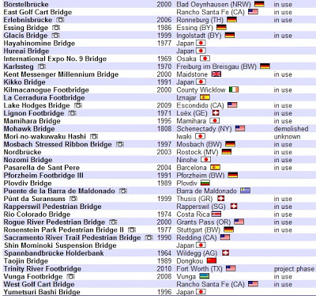

Table .1 Stress Ribbon Bridges

12. CONCLUSION

Stress ribbon bridges are a versatile form of bridge, the adaptable form of structure is applicable to a variety of requirements. The slender decks are visually pleasing and have a visual impact on surroundings giving a light aesthetic impression. Post tensioned concrete minimizes cracking and assures durability. Bearings and expansion joints are rarely required minimizing maintenance and inspections. There are also advantages in construction method, since erection using pre-cast segments does not depend on particular site condition and permits labour saving erection and a short time to delivery. Using bearing tendons can eliminate the need for site form work and large plant, contributing to fast construction programmes and preservation of the environments. There is a wide range of different topographies and soil conditions found and a number of areas which require aesthetic yet cost effective pedestrian bridges to be built: Stress ribbon bridges could provide elegant solutions to these challenges.

REFERENCES

v Strasky, J (2005) Stress Ribbon and Cable-Supported Pedestrian Bridges. London:
Thomas Telford.
v Strasky, J (1987) Precast stress ribbon pedestrian bridges in Czechoslovakia. PCI JOURNAL, May-June 1987.

