ACKNOWLEDGEMENT

It gives us the great pleasure while submitting this project on “TYPES OF BUDGET”

This project has been completed with the sincere efforts of all my group members and assistance of our respected teacher
Prof: Murli.sir.

We have sought the information regarding the project from so many books. We have also collected the necessary information from the people which have knowledge about budget.

we essentially thank to PROF. Murli.sir Who had helped us at every stage of our project. Their guidance enabled us the successful completion of our project.

GROUP MEMBERS

GROUP NO: -

STD: - S.Y.B.C.B.I (SEM 4)

SUB: - TYPES OF BUDGET

PROJECT TYPE: - GROUP
PROJECT

SUBMITTED TO: - PROF.MURLI.SIR

INDEX
- ACKNOWLEDGEMENT
- INTRODUCTION
- SALES BUDGET
- CASH BUDGET
- REVENUE BUDGET
- OTHER BUDGET
- CONCLUSION
- BIBLIGRAPHY

INTRODUCTION:-
A budget is a detailed plan of operations that is predetermined for a particular period. Budgets are quantitative or financial statements prepared for the purpose of attaining a particular objective.
Businesses use budgets to plan for future activities and to set various goals and objectives within the company. They help the organization set specific expectations which aid in evaluating performance throughout the company. Budgeting helps organizations implement specific strategies to meet goals and objectives. It is important to note that a budget is an estimate and will often need to be adjusted over time.

Budgeting Process:-
Budgeting is the formal procedure of preparing budgets. It involves the following basic steps:
- Identifying expenses
- Determining different sources of income
- Preparing the budget
- Establishing the budget period
- Laying down the budget procedure
- Allocating income for expenses
- Monitoring the efficiency of the budget

- WHY TO PREPARE THE BUDGET?

- To determine how much money you will need to carry out business activities.
- When you will need a certain amount of money for certain activities.
- Keeps you focused on your ultimate plans and goals.
- You will be able to monitor your sales and expenses so you can investigate any differences.
- When you are applying for a loan at a financial institution.

TYPES OF BUDGET:-
In order to properly plan and set goals, several different budgets must be created. This article discusses some of the more common budgets used by businesses.
The types of budgets include master, operating (for income statement items comprised of revenue and expenses), financial (for balance sheet items), cash, static (fixed), flexible, capital expenditure (facilities), and program (appropriations for specific activities such as research and development, and advertising). These budgets are briefly explained below.

- Sales budget:-
The sales budget is an estimate of future sales, often broken down into both units and dollars. It is used to create company sales goals.
Preparation of a sales budget is the starting point in budgeting since sales volume influences nearly all other items.
Sales budget is the most important budget while making the overall budget for the organization for a fiscal year. It is important in this sense that how would anybody make fiscal budget for organization if he don't know about how much to sale or what are the organization's sale would be. If you know the sales volume of units of product you want to sale in a fiscal year then you will make production budget according to that sales requirement in mind you will have production information in mind you will purchase raw material, hire labour according to requirements. So if you don't know about how much you want to sale then how would you budget other things and how would you compare your performance at the end of fiscal year.

Example or Sample of a Sales Budget:
Following is the sales budget of Hampton Freeze Inc.
HAMPTON FREEZE, INC.
Sales Budget
For the Year Ended December 31, 2003
 |  | Quarter
 |  | 1 | 2 | 3 | 4 | Year
 | Budgeted sales in cases | 10,000 | 30,000 | 40,000 | 20,000 | 100,000
 | Selling price per case | $ 20.00 | $ 20.00 | $ 20.00 | $ 20.00 | $ 20.00
 |  | ------------ | ------------ | ------------ | ------------ | ------------
 | Total sales | $ 200,000 | $600,000 | $800,00 | $400,000 | 2,000,000
 |  | ====== | ====== | ====== | ====== | ======
 | Percentage of sales collected in the period of the sales |  |  | 70%
 | Percentage of sales collected in the period after the sales |  |  | 30%
 |  | 70% | 30%

 | Schedule of Expected Cash Collections
1 | Accounts receivable, beginning balance | $90,000 |  |  |  | $90,000
2 | First quarter sales | 140,000 | $60,000 |  |  | 200,000
3 | Second quarter sales |  | 420,000 | $180,000 |  | 600,000
4 | Third quarter sales |  |  | 560,000 | $240,000 | 800,000
5 | Fourth quarter sales |  |  |  | 280,000 | 280,000
 |  | ----------- | ----------- | ----------- | ----------- | -----------
6 | Total cash collections | $230,000 | $480,000 | $740,000 | $520,000 | $1,970,000
 |  | ====== | ====== | ====== | ====== | ======
1 | Cash collections from last years fourth-quarter sales.
2 | $200,000 × 70%; $200,000 × 30%
3 | $600,000 × 70%; $600,000 × 30%
4 | $800,000 × 70%; $800,000 × 30%
5 | $400,000 × 70%
6 | Uncollected fourth quarter sales appear as accounts receivable on the company's end of year balance sheet.

Explanation of sales budget for Hampton Freeze Inc.
After preparing sales budget, a schedule of expected cash collections is also prepared such as the one that appear in our example. Cash collections consist of sales made to customers in prior periods plus collections on sales made in the current budget period. In our example, 70% of sales are collected in the quarter in which the sales are made and the remaining 30% are collected in the following quarter. For example, 70% of the first quarter sales of $200,000 (or 140,000) is collected during the first quarter and 30% (or $60,000) is collected during the second quarter.

- Cash Flow/Cash budget:-

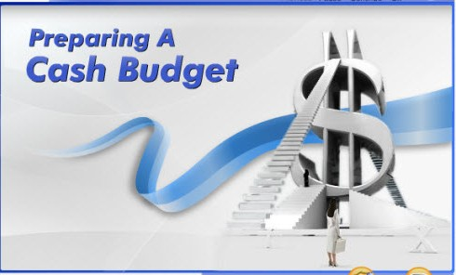
The cash budget is a prediction of future cash receipts and expenditures for a particular time period. It usually covers a period in the short term future. The cash flow budget helps the business determine when income will be sufficient to cover expenses and when the company will need to seek outside financing.
The cash budget is for cash planning and control. It presents expected cash inflow and outflow for a designated time period. The cash budget helps management keep cash balances in reasonable relationship to its needs and aids in avoiding idle cash and possible cash shortages.
The cash budget typically consists of four major sections:
1. Receipts section, which is the beginning cash balance, cash collections from customers, and other receipts
2. Disbursement section, comprised of all cash payments made by purpose
3. Cash surplus or deficit section, showing the difference between cash receipts and cash payments
4. Financing section, providing a detailed account of the borrowings and repayments expected during the period
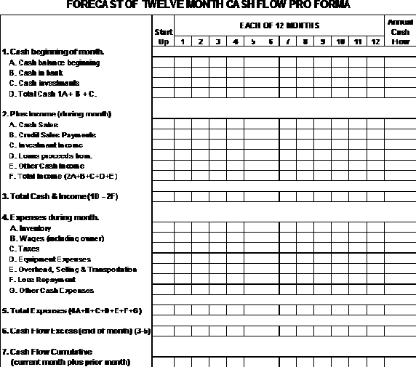
- REVENUE BUDGET:-
A revenue budget identifies each of the individual revenue sources for which the organization is to be responsible; estimates the amount of revenue each is to "earn" in the budget year; documents the basis for the estimate and other important information about each source; and assigns responsibility for revenue management (including estimate updating) to a specific organization unit/manager. A management responsibility to be associated with revenue budgeting is the development of monthly plans for revenue recognition and collection.
BENEFITS:

The main benefit of a revenue budget is that it requires looking into the future. The revenue budget should contain the assumptions made about the future and the details about the number of units to be sold, the expected selling prices, and so on.
The
budgeted amount of revenue is then compared to the budgeted amount of expenses in order to determine if the revenues are adequate. Learning of a potential problem before the year begins is a huge benefit because it allows for alternative actions to be developed prior to the start of the new year. In other words, monthly revenue budgets allow you to monitor revenues as the year progresses instead of being surprised at the end of the year.

Drafting a Revenue Budget:-
Use past performance and future expectations as a guide to drafting a revenue budget. This budget must be realistic. Many factors, including new entrants into a market, current economic conditions and demand for the goods or services offered, have a direct effect on potential revenue. Management must closely monitor macro- and micro-economic factors by reading industry periodicals, financial magazines, weekly new periodicals and market research.

- Other Types of Budget:-

- Production budget:-
Product oriented companies create a production budget which estimates the number of units that must be manufactured to meet the sales goals. The production budget also estimates the various costs involved with manufacturing those units, including labor and material.
- Marketing budget:-
The marketing budget is an estimate of the funds needed for promotion, advertising, and public relations in order to market the product or service.
- Project budget:-
The project budget is a prediction of the costs associated with a particular company project. These costs include labor, materials, and other related expenses. The project budget is often broken down into specific tasks, with task budgets assigned to each.
- Capital Budget:-
The capital budget is a prediction of company needs in regard to fixed assets, such as buildings, vehicles, machinery, and other equipment. It includes the cost of upgrading present assets, the cost of acquiring new assets, costs associated with maintenance of the assets, and fees associated with the assets. The capital budget helps the company plan for the acquisition and upkeep of these assets, which may include use of available cash or outside financing.

Conclusion:
While budget is a financial statement, which provides details of the proposed revenues and their utilization for expenditure for a specific period, the budget is the process of comparing what was planned with what has been accomplished during the period. A budget is the system helps to measure the progress made towards goals, to uncover deviations, to initiate corrective actions, to know the causes for deviations and hence to avoid leaving things to happen as they happen. The process of budget starts with estimating the revenues expected for the year, followed by planning the expenses that equal revenues and then trying to prepare time schedule for both revenues (grants) and expenses with all the restrictions relating to allocation and use of funds with provision for reallocation.

HOW WE CARRIED OUT THIS PROJECT?

Bibliography

- Business world.

- Business Today.

Webliography

- www.indiabudget.nic.in
- www.timesofindia.indiatimes.com/budgetspecial.cms

- www.Moneycontrol.com

